**BASIC FILTERING AND SORTING:**

***Objective :***

To write queries that filter records and sort the result set.

***Queries :***

**select * from Employees where department='sales';**

// Retrieves all employees who work in the "Sales" department.

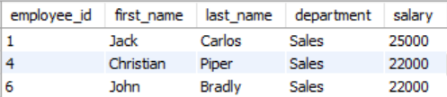

**select * from Employees where salary >= 20000;**

// Retrieves all employees whose salary is greater than or equal to 20000.

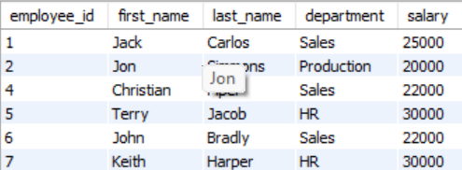

**select * from Employees where department='sales' order by last_name;**

// Retrieves all employees in the "Sales" department and orders the results by their last name alphabetically.

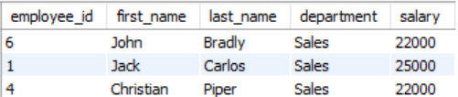

**select * from Employees where department='Production' order by salary desc;**

// Retrieves all employees in the "Production" department and orders them by salary in descending order.

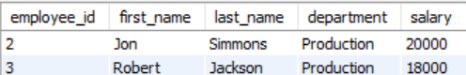

**select * from Employees where salary >= 20000 and department="Sales";**

// Retrieves all employees in the "Sales" department with a salary greater than or equal to 20,000.

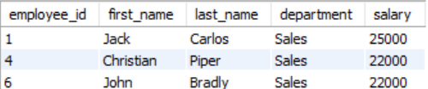

**select * from Employees where department="HR" or salary<25000;**

// Retrieves all employees who are either in the "HR" department or have a salary less than 25,000.

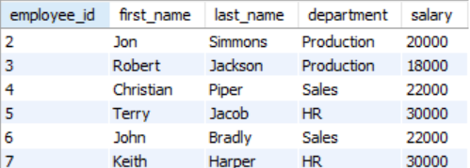

**select * from Employees where department="Sales" and salary>20000 order by salary;**

// Retrieves all employees in the "Sales" department with a salary greater than 20,000 and orders them by salary in ascending order.

