**SIMPLE AGGREGATION AND GROUPING:**

***Objective :***

To summarize data using aggregate functions and grouping.

Aggregation in SQL refers to the process of summarizing or calculating a single result from a set of data using aggregate functions.

Aggregate functions in SQL:

**MIN()** - returns the smallest value within the selected column

**MAX()** - returns the largest value within the selected column

**COUNT()** - returns the number of rows in a set

**SUM()** - returns the total sum of a numerical column

**AVG()** - returns the average value of a numerical column

***Queries :***

**select count(*) from Employees;**

// Counts the total number of employees in the "Employees" table.



**select department, count(*) as total from Employees group by department;**

// Counts the number of employees in each department.

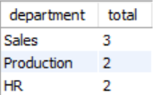

**select min(salary),max(salary),sum(salary) from Employees where department = 'Sales' ;**

// Finds the minimum, maximum, and total salary for employees in the "Sales" department.



select department, avg(salary) from Employees group by department;

// Calculates the average salary for each department.

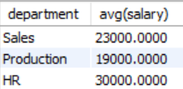

**select department, sum(salary) from Employees group by department having sum(salary) > 50000;**

// Finds departments with a total salary sum greater than 50,000.

