**MULTI-TABLE JOINS:**

***Objective :***

To combine data from two related tables using JOIN operations.

A join allows you to combine records from two or more tables based on a related column.

***Queries*** :

**create table Customers(**

**customer_id int primary key,**

**name varchar(30),**

**mobile varchar(15) not null**

**);**

// Schema for Customers table

**create table Orders(**

**order_id int primary key,**

**price float,**

**customer_id int,**

**foreign key(customer_id) references Customers(customer_id)**

**);**

// Schema for Orders table

**insert into Customers values**

**(1,"John","9876543210"),**

**(2,"Jake","9361679209"),**

**(3,"Jim","9976543230"),**

**(4,"Jade","9810101010");**

// Inserted above records into Customers table

**insert into Orders values**

**(100,120.70,2),**

**(101,150.00,1),**

**(102,320.50,1),**

**(103,450.00,3),**

**(104,376.35,2);**

// Inserted above records into Orders table

**select * from Customers;**

// Display all records from the Customers table.

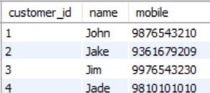

**select * from Orders;**

// Display all records from the Orders table.

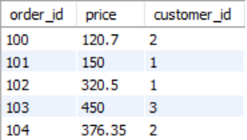

**select Customers.customer_id, Customers.name, Orders.order_id, Orders.price from Customers inner join Orders on Customers.customer_id=Orders.customer_id;**

// Retrieves customer details and their corresponding orders only for customers with matching order records.

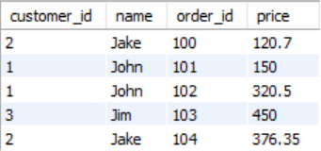

**select Customers.customer_id, Customers.name, Orders.order_id, Orders.price from Customers left join Orders on Customers.customer_id=Orders.customer_id;**

// Retrieves all customers and their orders, including customers with no orders with missing matches as null.

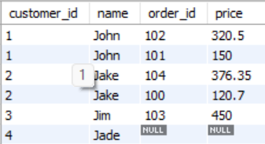

**select Customers.customer_id, Customers.name, Orders.order_id, Orders.price from Customers right join Orders on Customers.customer_id=Orders.customer_id;**

// Retrieves all orders and their associated customers, including orders with no matching customer.

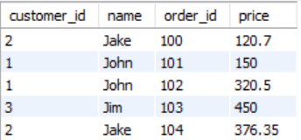

**select * from Customers full join Orders;**

// Retrieves all customers and all orders, including those with no matching record in the other table.

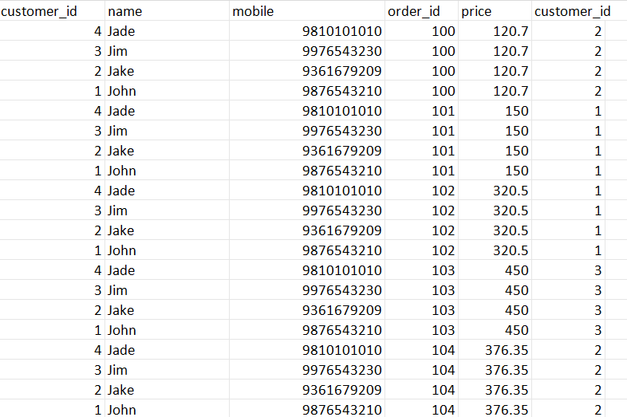

**select * from Customers cross join Orders;**

// Returns all possible combinations of customers and orders (Cartesian product).

