**SUBQUERIES AND NESTED QUERIES:**

***Objective :***

To use subqueries to filter or compute values within a main query.

A subquery (also known as an inner query or nested query) is a query that is embedded within another SQL query.

***Queries*** ***:***

**select * from Employees where salary=(select max(salary) from Employees);**

// Selects employees whose salary is equal to the highest salary in the company.



**select distinct(department),**

**(select avg(salary) from Employees where department=e.department) as Avg_Dept_Salary from Employees e;**

// Selects distinct departments from the Employees table along with the average salary for each department.

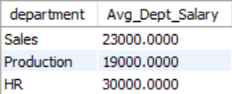

***Correlated subqueries*** ***:***

A correlated subquery depends on the values from the outer query. The subquery is executed for each row processed by the outer query, meaning it is evaluated once for every row in the outer query.

**select employee_id, first_name, last_name, department, salary,**

**(select avg(salary) from Employees where department=e.department) as Avg_Dept_Salary from Employees e;**

// Selects each employee along with the average salary of their respective department.

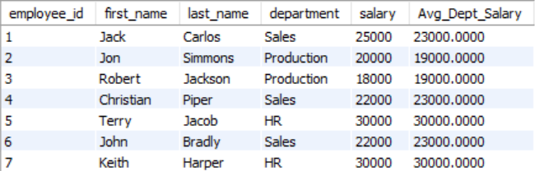

***Non-correlated subqueries :***

A non-correlated subquery is independent of the outer query. It does not refer to any columns of the outer query and is executed only once, regardless of the number of rows in the outer query.

**select employee_id, salary from Employees where salary>=(select avg(salary) from Employees);**

// Selects employees whose salary is greater than or equal to the average salary of all employees.

