**DATE AND TIME FUNCTIONS:**

***Objective :***

To manipulate and query data based on date and time values.

***Queries :***

**create table Details(**

**name varchar(30),**

**date_of_birth datetime**

**);**

// Schema for Details

**insert into Details values**

**("John","2003-01-01 07:00:00"),**

**("Jimmy","2004-10-10 11:20:00"),**

**("Jack","2004-07-07 09:45:00");**

**select name, datediff(now(), Details.date_of_birth) as days_after_birth from Details;**

// Calculates the number of days between the current date and each person's date of birth.

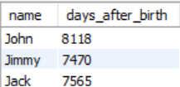

**select name, date_add(date_of_birth, interval 1 year) as modified_year from Details;**

// Adds one year to each person's date of birth and returns the updated date.

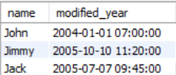

**select name, date(date_of_birth) as BirthDate from Details;**

// Extracts and returns only the date part from each person's date of birth.

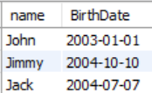

**select name, time(date_of_birth) as BirthDate from Details;**

// Extracts and returns only the time part from each person's date of birth.

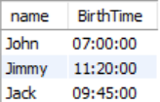

**select date_format(date_of_birth, '%d/%m/%y') as formatted_date from Details;**

// Formats the date_of_birth in DD/MM/YY format.

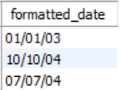

**select * from Details where date_of_birth between '2003-01-01' and '2004-08-01';**

// Retrieves all records where the date of birth is between January 1, 2003, and August 1, 2004.

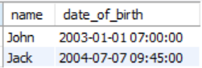

**select convert(date_of_birth, char) as birth_date_string from Details;**

// Converts the date of birth to a string format.

