**COMMON TABLE EXPRESSIONS (CTEs):**

***Objective :***

To simplify complex queries and process hierarchical data using CTEs.

A Common Table Expression (CTE) is the result set of a query which exists temporarily and for use only within the context of a larger query. Much like a derived table, the result of a CTE is not stored and exists only for the duration of the query.

***Queries :***

**with cte_join as**

**(select Customers.customer_id, Customers.name, Orders.order_id, Orders.price from Customers inner join Orders on Customers.customer_id = Orders.customer_id**

**)**

**select * from cte_join having price >= (select avg(price) from orders);**

// The CTE joins the Customers and Orders tables, selecting the customer_id, name, order_id, and price for each customer and their order and selects all records from the cte_join where the price is greater than or equal to the average price of all orders.

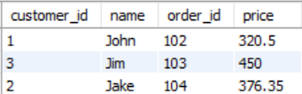

**with cte_employee as**

**(select employee_id, first_name, last_name, department, salary,**

**(select avg(salary) from Employees where department=e.department) as Avg_Dept_Salary**

**from Employees e**

**)**

**select * from cte_employee where salary > Avg_Dept_Salary;**

// The CTE selects employee_id, first_name, last_name, department, salary, and calculates the average salary for each department (Avg_Dept_Salary) for each employee and retrieves all records from the cte_employee where the employee's salary is greater than the calculated Avg_Dept_Salary for their department.

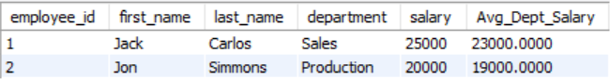

**RECURSIVE QUERIES :**

A recursive CTE (Common Table Expression) allows a query to reference itself. It is typically used for hierarchical or tree-like data structures, such as organization charts, bill of materials, or file directory structures.

A recursive CTE consists of two parts:

1) Anchor Member: This is the initial query that provides the base result set.

2) Recursive Member: This is the part of the query that references the CTE itself, forming a loop to repeatedly process data.

**create table Employee_Details(**

**employee_id int primary key,**

**name varchar(30),**

**manager_id int**

**)**

// Employee_Details Schema

**with recursive employee_hierarchy as**

**(**

*-- Anchor*

**select * from Employee_Details where employee_id = 7**

**union all**

*-- Recursive member*

**select e.employee_id, e.name, e.manager_id from Employee_Details e join employee_hierarchy eh**

**on e.employee_id = eh.manager_id**

**)**

**select * from employee_hierarchy;**

// This SQL query uses a recursive CTE (Common Table Expression) to find all employees under a specific employee, starting from employee_id = 7. This is a typical approach for navigating hierarchical data like organizational structures.

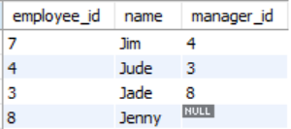

**Note:**  A CTE is temporary and exists only during the execution of the query.