**Project Name:**

**Festive Dresses and Related Accessories for Different States of India.**

**Project Member:**

**Akshay Salunkhe 210543181089**

**Supriya Birnale 210543181109**

**Shubham Rote 210543181082**

**Rahul Chavan 210543181017**

**Abstract:**

This project is a web-based shopping system. The project is an attempt to provide the advantages of online shopping to customers of a real shop. It helps buying the products in the shop anywhere through internet.

The “**ONLINE SHOPPING PORTAL**” is developed according to the current need in different Fields. This is online shopping Website which provides facility for purchasing festive Dresses, festive accessories, and many more items. So, by using this Online Shopping Portal users which want to purchase some products will first Register an account on this portal then Login through their Username and Password, and then Select items which they want to purchase and add them to cart. So by using this portal users can easily purchase products from their home.

Here we have added additional feature like admin can upload Products state wise and Festival wise so user can filter the projects accordingly and buy the products.

To develop this shopping portal, a number of Technologies must be studied and understood. These include multi-tiered architecture, server and client-side scripting techniques, implementation technologies such as Spring Boot, programming language (such as Core Java, Advance Java), relational databases (such as MySQL).

**AIM:** The primary aim of this project is to demonstrate that with better interactive features in State wise Shopping website could provide Festival accessories and select accessories related to State wise Festival.

**Objectives:**Providing a unique customer experience.

Increasing the number of loyal customers.

Reduce management costs.

Boosting the efficiency of services

Making responsive ecommerce website.

Increasing sales.

**Model Used:**

The Agile model was primarily designed to help a project to adapt to change requests quickly. So, the main aim of the Agile model is to facilitate quick project completion. Agile model refers to a group of development processes. Agile model is the combination of iterative and incremental process models. Steps involve in agile SDLC models are:

* Requirement gathering
* Requirement Analysis
* Design
* Coding
* Unit testing
* Acceptance testing

**Implementation Technologies:**

**1.Spring Boot:**

Spring Boot makes it easy to create stand-alone, production-grade Spring based Applications that you can "just run".

We take an opinionated view of the Spring platform and third-party libraries so you can get started with minimum fuss. Most Spring Boot applications need minimal Spring configuration.

**1.1 Features of Spring Boot:**

* Create stand-alone Spring applications
* Embed Tomcat, Jetty or Undertow directly (no need to deploy WAR files)
* Provide opinionated 'starter' dependencies to simplify your build configuration
* Automatically configure Spring and 3rd party libraries whenever possible
* Provide production-ready features such as metrics, health checks, and externalized configuration
* Absolutely no code generation and no requirement for XML configuration

**1.2 Advantages of Spring Framework:**

* Spring Framework can be employed on all architectural layers used in the development of web applications.
* Uses the very lightweight POJO model when writing classes.
* Allows you to freely link modules and easily test them.
* Supports declarative programming.
* Eliminates the need to independently create factory and singleton classes.
* Supports various configuration methods.
* Provides middleware-level service.

**2.MySQL**

MySQL, the most popular Open-Source SQL database management system, is developed, distributed, and supported by Oracle Corporation.

**Features of MySQL:**

* **MySQL is a database management system.**

A database is a structured collection of data. It may be anything from a simple shopping list to a picture gallery or the vast amounts of information in a corporate network. To add, access, and process data stored in a computer database, you need a database management system such as MySQL Server. Since computers are very good at handling large amounts of data, database management systems play a central role in computing, as standalone utilities, or as parts of other applications.

* **MySQL databases are relational.**

A relational database stores data in separate tables rather than putting all the data in one big storeroom. The database structures are organized into physical files optimized for speed. The logical model, with objects such as databases, tables, views, rows, and columns, offers a flexible programming environment.

* **MySQL software is Open Source.**

Open Source means that it is possible for anyone to use and modify the software. Anybody can download the MySQL software from the Internet and use it without paying anything.

* **The MySQL Database Server is very fast, reliable, scalable, and easy to use.**

MySQL Server was originally developed to handle large databases much faster than existing solutions and has been successfully used in highly demanding production environments for several years. Although under constant development, MySQL Server today offers a rich and useful set of functions. Its connectivity, speed, and security make MySQL Server highly suited for accessing databases on the Internet.

* **MySQL Server works in client/server or embedded systems.**

The MySQL Database Software is a client/server system that consists of a multithreaded SQL server that supports different back ends, several different client programs and libraries, administrative tools, and a wide range of application programming interfaces (APIs).

1. **Hardware and Software Requirements (Minimum):**

**Hardware:**

1. Intel i3 processor 3rd generation or later / AMD Ryzen 200 2nd generation or later

2. 2 GB ddr3 ram.

3. Windows 7 Home edition or later.

4. 200 GB Sata HDD Space

5. Data Connection 200 kbps

**Software:**

1. Eclipse 16.0.1
2. MySQL 8.0 with Workbench 8.0
3. Google Chrome version 93.0
4. **ER Diagram:**

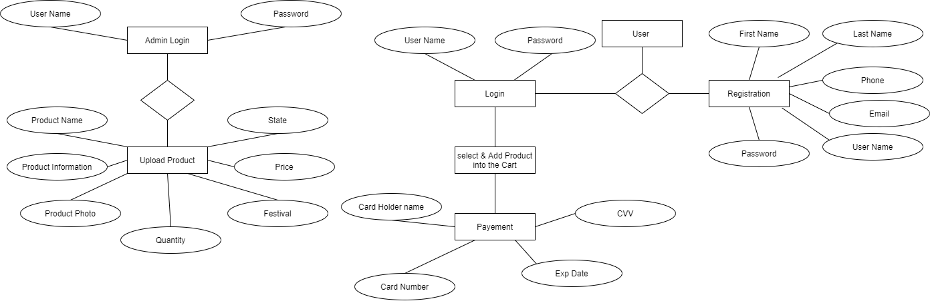

Figure 1: ER Diagram

1. **Table Structures:**
2. **Table name: Admin**

1. **Table name: Product**

1. **Table name: User**

1. **Table name: Cart**

1. **UML Diagrams:**

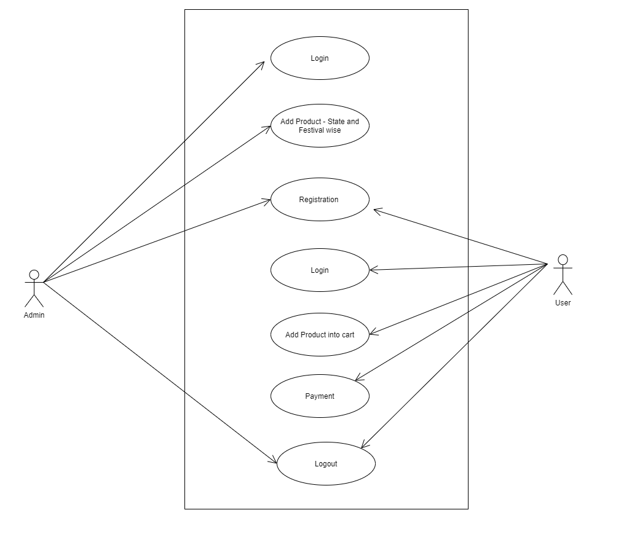

Figure 2: Use Case

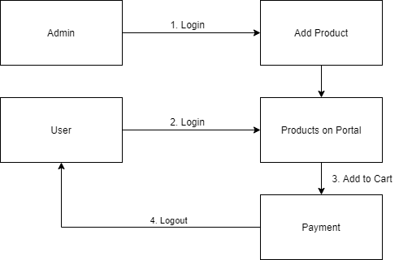

Figure 3: Collaboration Diagram

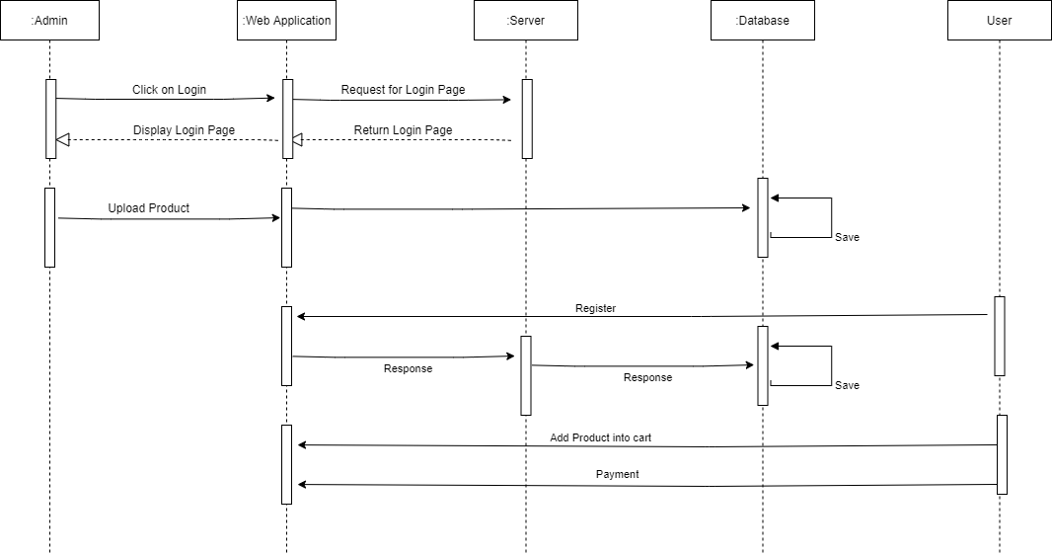

Figure 4: Sequence Diagram

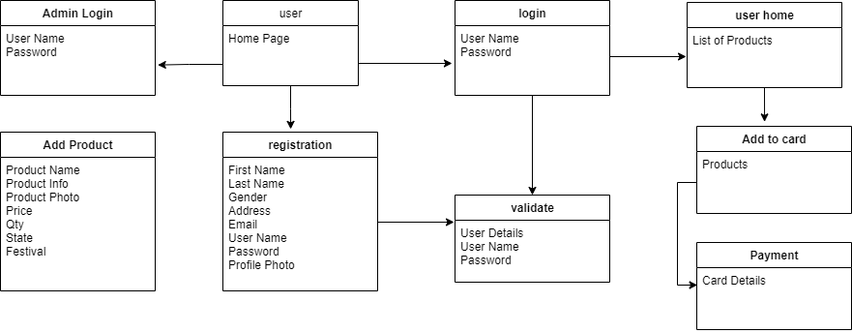

Figure 5: Component Diagram

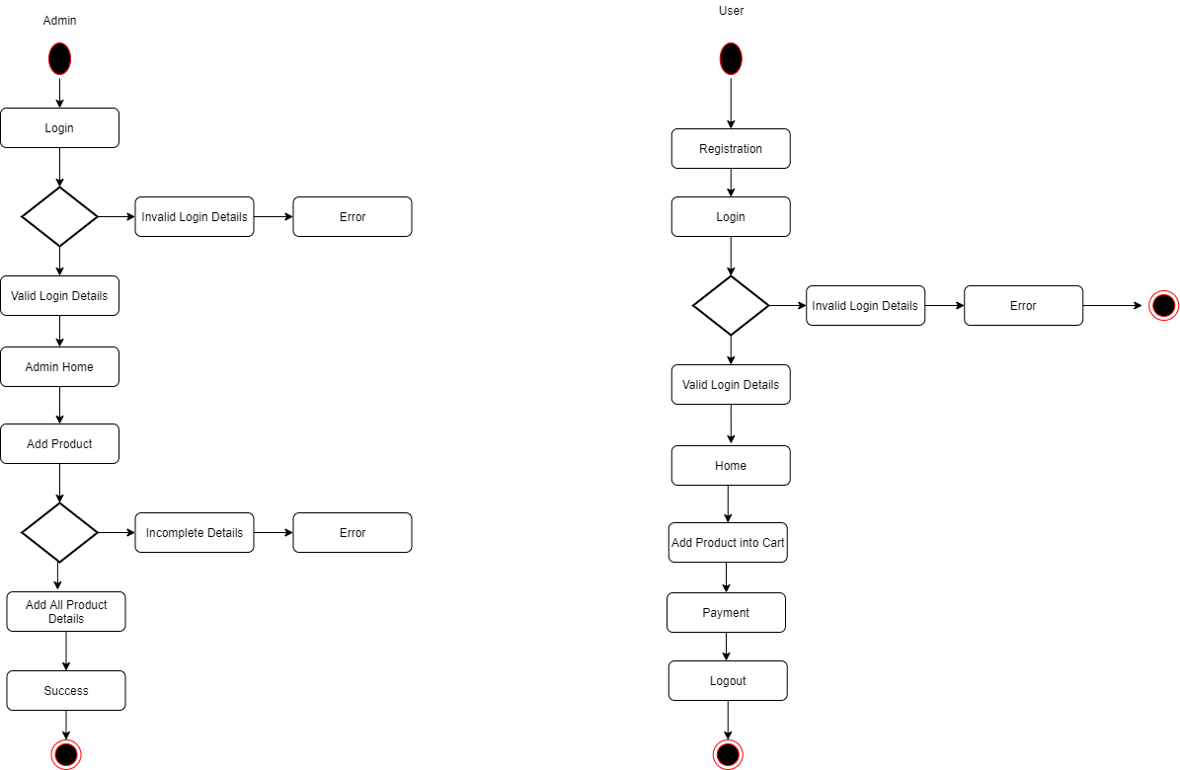

Figure 6: Activity Diagram

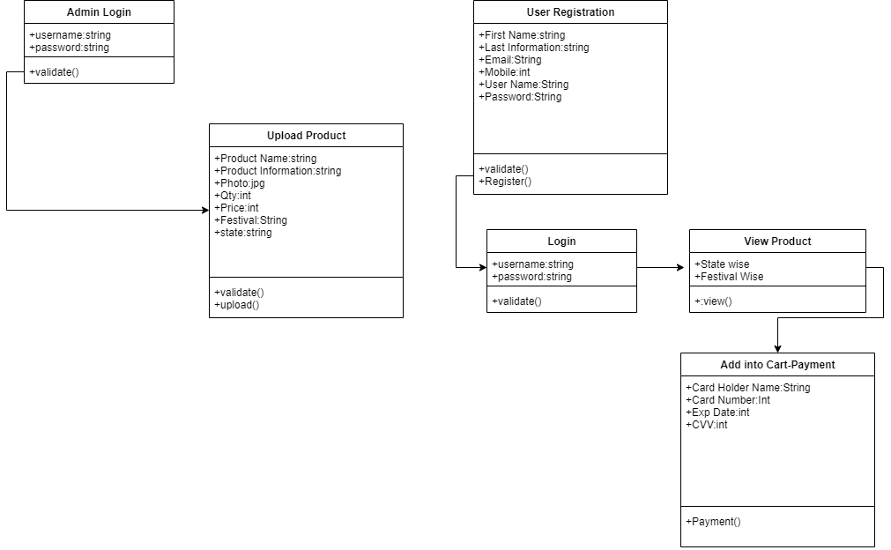

Figure 7: Class Diagram

1. **End to End Flow of Application:**

**User:**

* 1. User will login to the portal or will have to register if he is not a registered user.
  2. After registration User will login and Dashboard page will be displayed to him which will display the Add Product list.
  3. From that page User can filter the products State wise of festival wise.
  4. Select the Product and add to the cart.
  5. After that User can make payment for the product which is added into the cart.

**Admin:**

1. Admin will login as Admin from the ‘**Admin login**’ page and he can upload/add the product (State wise and Festival wise).
2. **Future Scope :**

The elimination of long distances and geographical limitations is possible due to the e-commerce business. E-commerce is increasing day-by-day due to the growing use of the internet. Add all States of India as well as we can add all countries.Add all accessories State wise.

Open Market for Local Manufacturer.

**Thank You!**