Program – Set of instructions to perform a specific task by computer.

Level of program

1. High Level
2. Low Level – directly interact with hardware

Searching

Counting

Optimization – limited resources due to which optimization needed

Sorting

Decision

How to solve problem

The solution to any problem involves the below three aspects:

Algorithm & its Representation

In mathematics and computer science, an algorithm is a finite sequence of well-defined, computer-implementable instructions, typically to solve a class of problems or to perform a computation.

Representation of an algorithm

Algorithm should be represented from our mental thoughts into a form which others can understand. There are primarily two ways of representing an algorithm:

* Flow chart: Diagrammatic way of representing the algorithm.
* Pseudo-code: Representation of the algorithm in a way that is in between a program and normal English.

For example, here is a pseudo-code and a flowchart.

**Pseudo-code:**                                                                                                                                             **FlowChart:**

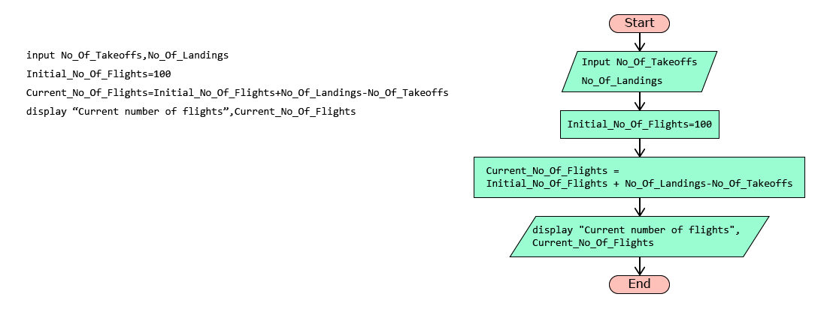

Pseudo-code cannot be executed by a computer. It is just a representation of an algorithm for us to understand.

Variables & Operators

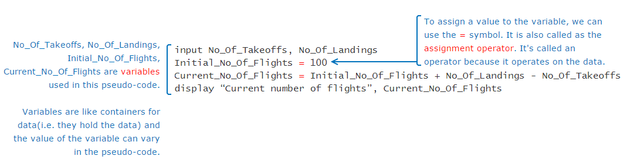

Variable - Container for any value

Like assignment operator, there are other operators also which can be used to perform various operations.  
Arithmetic operators: Used for performing arithmetic operations

|  |  |
| --- | --- |
| **Operators** | **Description** |
| **+** | Addition |
| **-** | Subtraction |
| **\*** | Multiplication |
| **/** | Division |
| **%** | Modulus |

Relational operators: Also known as comparison operators, are used to compare values. Result of a relational expression is always either true or false.

|  |  |
| --- | --- |
| **Operators** | **Description** |
| **==** | Equal to |
| **<** | Less than |
| **>** | Greater than |
| **<=** | Less than or equal to |
| **>=** | Greater than or equal to |
| **!=** | Not equal to |

Logical operators are used to combine one or more relational expressions.

|  |  |
| --- | --- |
| **Operators** | **Description** |
| AND | Result will be true, if both the expressions are true. If any one or both the expressions are false, the result will be false |
| OR | Result will be true, even if one of the expression is true. If both the expressions are false, the result will be false |
| NOT | If the expression is true, result will be false and vice versa |

If A and B are two relational expressions, say A = (Num1>2000), B= (Num2>100), the result of combining A and B using logical operator is based on the result of A and B as shown below:

|  |  |  |
| --- | --- | --- |
| **A** | **B** | **A AND B** |
| True | True | True |
| True | False | False |
| False | True | False |
| False | False | False |

Decision Constructs

Flow of control

In a pseudo-code, typically the instructions are performed one by one or line by line. But there may be situations when all the statements in a pseudo-code are not performed. Parts of the pseudo-code which change the flow of instructions or in other word, change the flow of control are called as control structures.

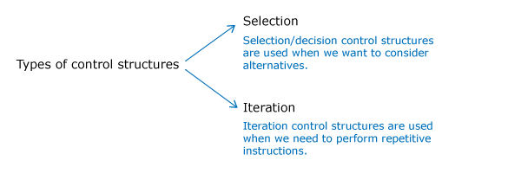

Selection using if statement

ATC takes lot of decisions as part of its air traffic control operations.

For example, if a flight is approaching the runway, ATC has to check if the runway is free. If the runway is not free, then the flight should not land immediately. It should circle in the air and wait for further instructions from the ATC.

Such decision making process can be conveniently represented in a pseudo-code using an if statement.

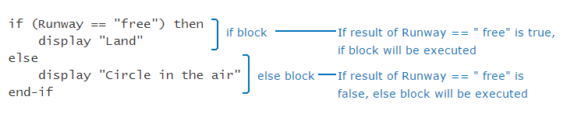

Sometimes, ATC may have more than one alternatives for a given situation. For example, if the runway is free, the flight can land. But if the flight has less fuel, then it should be allowed an emergency landing. Otherwise, it should circle in the air.

if (Runway=="free") then

   display "Land"

else if (Fuel_Status=="low") then

   display "Emergency landing"

else

   display "Circle in the air"

end-if

Iteration Constructs

Immigration check needs to be done for all the passengers in the flight. Suppose the flight had only 5 passengers, the pseudo-code can be written as follows:

display "Flight has landed"

display "Proceed for Immigration Check"

Passenger_Count=1

display "Immigration check done for passenger,", Passenger_Count

Passenger_Count=Passenger_Count+1

display "Immigration check done for passenger,", Passenger_Count

Passenger_Count=Passenger_Count+1

display "Immigration check done for passenger,", Passenger_Count

Passenger_Count=Passenger_Count+1

display "Immigration check done for passenger,", Passenger_Count

Passenger_Count=Passenger_Count+1

display "Immigration check done for passenger,", Passenger_Count

Sometimes, we may want to execute some statements specific (known) number of times as in the case of immigration check. In such cases we can use a **for loop**as shown below.

No_Of_Passengers=5

for(Passenger_Count=1,Passenger_Count<=No_Of_Passengers,Passenger_Count=Passenger_Count+1)

     display "Immigration check done for passenger,", Passenger_Count

end-for

When we want to repeatedly execute a statement as long as a condition is met, we can use the iteration statement called as **while loop**.

display "The flight has landed"

display "Immigration check done"

display " Collect the baggage from the conveyor belt"

Baggage_Count=150

while(Baggage_Count>0) do

    input No_Of_Baggage_Picked

    Baggage_Count=Baggage_Count-No_Of_Baggage_Picked

end-while

Go through the below two pseudo-codes and guess the output.

|  |  |
| --- | --- |
| **Pseudo-code 1 :** | **Pseudo-code 2 :** |
| 1. Counter=5 2. while(Counter>=5) do 3. display Counter 4. Counter = Counter + 1 5. end-while | 1. input Limit 2. for(Counter=5, Counter<=Limit, Counter=Counter-1) 3. display Counter 4. end-for   Assume that the input value provided to variable Limit is |

Beware of infinite loops. The logic that we are writing in loops should ensure that the loop will terminate in finite number of iterations.

What is the outcome of the following pseudo-code?

input Counter

while(Counter<5) do

  Counter=Counter+1

  display Counter

end-while

Assume that the input value provided to variable, Counter is 1.

2,3,4,5

2,3,4

1,2,3,4

1,2,3,4,5

Programming languages

Pseudo-code helped us to represent the algorithms and learn few basics of programming. But to instruct the computer we need to write a program in a programming language. There are many languages available in which we can write our programs.

Different languages are created for different purposes. This involves trade-offs. For example a large flight can carry many passengers, but also consumes lot of fuel. Similarly different languages have different advantages.

Datatypes

Data

We know that a program works on data or values. Some examples of values are 1, 1.0 and "Hello".For a program to use a data, it must be stored in a memory location. The values are stored in binary form in computer memory.

How do we know how many bits are required to represent a value or how much space it needs in memory?

This is determined by the data type of the value and the programming language. e.g. number, string etc. Thus every value will have a type.

Datatypes

Data Type determines the operations that can be performed on a value. For e.g. we can perform operations like addition, multiplication, division, subtraction etc. on numerical data types. We can concatenate, convert case, extract substring etc. on string data types.

1. print(1 + 2)
2. print("Hello " + "World")
3. print(True and False)
4. print(4.0 / 2.0)

The above program uses 8 values of different data types.

A program may have data belonging to different types. Common data types used in programming are:

|  |  |  |
| --- | --- | --- |
| **Category** | **Data Type** | **Example** |
| Numeric | int | 123 |
| long | 1237126381763817 |
| Numeric with decimal point | float | 123.45 |
| double | 123123.32345324 |
| Alphanumeric | char | A |
| String | hello |
| Boolean | boolean | True, False |

Python programming language supports the following datatypes:

|  |  |
| --- | --- |
| **Category** | **Python** |
| Numeric | int |
| long |
| complex |
| Numeric with decimal point | float |
| Alphanumeric | String |
| Boolean | boolean |

### **Problem Statement**

In Python, the data type of a value can be identified by using **type**(value).

Try out the below program and observe the results.

print(type(3))

print(type("Hello World"))

print(type(False))

print(type(2.0))

Output:

<class 'int'>  
<class 'str'>  
<class 'bool'>  
<class 'float'>

Variables

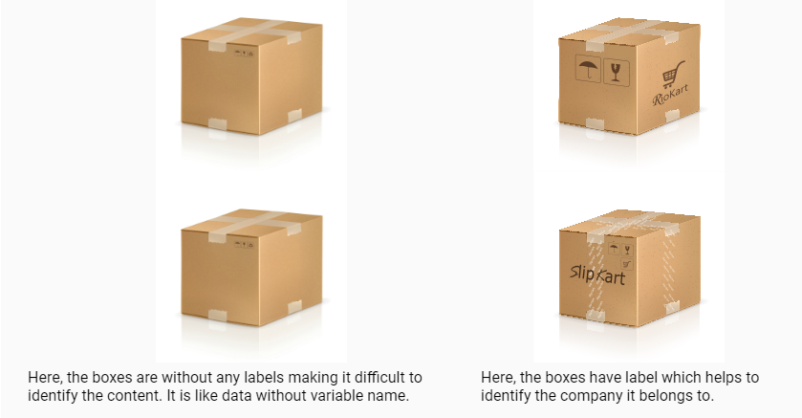

If everything is a value, then what is a variable?

A variable is a name that is assigned to a value. It is done so that we can refer to that value at some later point in the program.

Let us see the usage of values and variables in a program.

* During input, we receive values and assign them to variables.
* During processing, we perform operations on values and variables to generate more values. These computed values are also assigned to variables.
* During output, we display the computed values in variables to the end users.

Let’s have a look at the python program to display the number of landings and number of takeoffs in an airport:

Note: In Python, print() can be used to display output in the console

### **Problem Statement**

Try out the below program. This is the program for a pseudo-code which we had discussed earlier.  
Change the value of no_of_landings, no_of_takeoffs and initial_no_of_flights, execute and observe the output.

no_of_landings=356

no_of_takeoffs=245

initial_no_of_flights=100

current_no_of_flights=initial_no_of_flights+no_of_landings-no_of_takeoffs

print("Current number of flights:",current_no_of_flights)

Output:

Current number of flights: 211

Static typed language fast – java

Dynamic typed language slow - python

Variables & Datatypes

Let’s see how can we associate a data type with a variable.

|  |
| --- |
| **Python** |
| num=100  msg="Hello" |

Why do you think the data type is not mentioned in Python?

Static and dynamic typing

Languages like Python are dynamically typed whereas C,Go etc are statically typed.

**Dynamic Typing**is a technique in some languages where depending on how a value is used, the data type of the variable is dynamically and automatically assigned. Consider the below code in Python,

num=65 #Line 1

num="A" #Line 2

In Line 1, variable num is considered to be of type int and in Line 2, its type is reassigned to String.

**Static Typing** is used in some languages where the data type has to be declared before a variable is used. Consider the below code in Go,

var num int=65; //Line 1

num="A"; //Line 2

var name string = "A"; //Line3

Here, Line 1 is a valid statement which declares a variable num of type int. But Line 2 is invalid as we cannot assign a string value to variable num which is already declared to be of type int. Line 3 is a valid statement where name is declared and used as a string.

Reserved words

Any name can be given to a variable however, we cannot use some of the built-in keywords of the language. These keywords are known as **reserved words**. Some of the reserved words in Python are:

|  |  |
| --- | --- |
| **Python** | if, else, for, while, def, print, raise, try, except |

Storing data

If you put a small product in a big box, you may end up wasting space. Similarly if you put a big product in a small box you may end up damaging the product.

Just like product is placed in a box, data occupies memory. Some data need more memory whereas some other data require less memory based on the data type.

In Python language, automatically creates just the right memory needed – neither less nor more.

Variable and its dimensions

We have seen that a variable will have a name, value, type and it will occupy memory. Apart from these, it has two more dimensions – scope and lifetime. Thus we can say that any variable will have the following six dimensions.

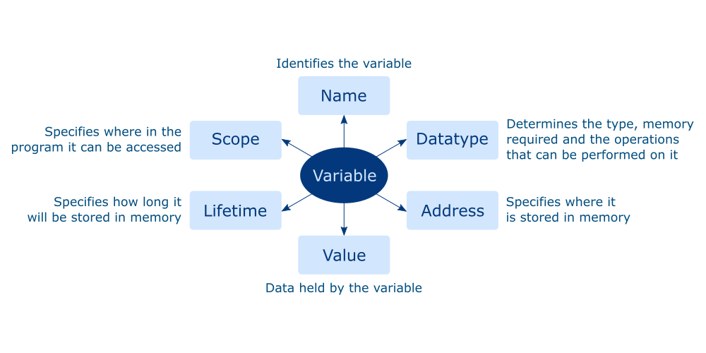

Operators

As we discussed in pseudo-code, operators help to perform an operation.

Some of the most common operators used in Python are listed below.

|  |  |
| --- | --- |
| **Common Operators** | **Python** |
| Arithmetic Operators | +,-,*,/, %,// |
| Relational Operators | ==,!=,>,<,>=,<= |
| Assignment Operators | =,+=,-=,*=,/=,%= |
| Logical Operators | and,or,not |

Note: In Python, // indicates integer division.

         Example: 11//2=5

True or False

The result of a relational or logical expression is always a boolean (true or false). Apart from the boolean values, other values can also be used to represent a true or false value.

For example, in python, value zero is considered to be equivalent to false.

The common false values in Python are given below. Any other value is considered to be true.

|  |
| --- |
| **Python** |
| None |
| False |
| 0 |
| ''/"" (Empty string - two single quotes/double quotes) |

Precedence of operators

What do you think is the output of **5+4*9%(3+1)/6-1**?  
How do you think the result of this expression is computed?

It is done based on the precedence of the operators. Precedence of an operator can be identified based on the rule - BODMAS. Brackets followed by Orders (Powers, Roots), followed by modulo, Division and Multiplication, followed by Addition and Subtraction.

1. Brackets have the highest precedence followed by orders.
2. Modulo, Division and Multiplication have the same precedence. Hence if all appear in an expression, they are evaluated from Left to Right.
3. Addition and Subtraction have the same precedence. Hence if both appear in an expression, they are evaluated from Left to Right.

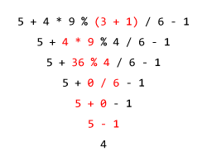

Though its not compulsory to have brackets to denote the precedence of operators in an expression, it is always preferred to have brackets as it makes the expression readable and brings in a lot more clarity.

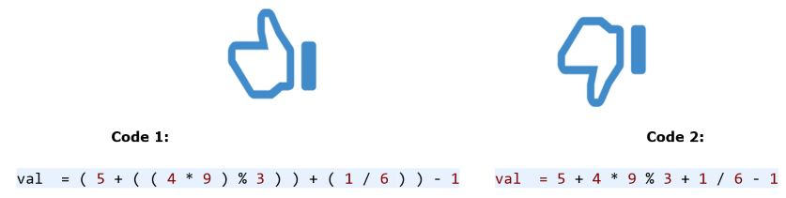

Implicit & Explicit Type Conversion

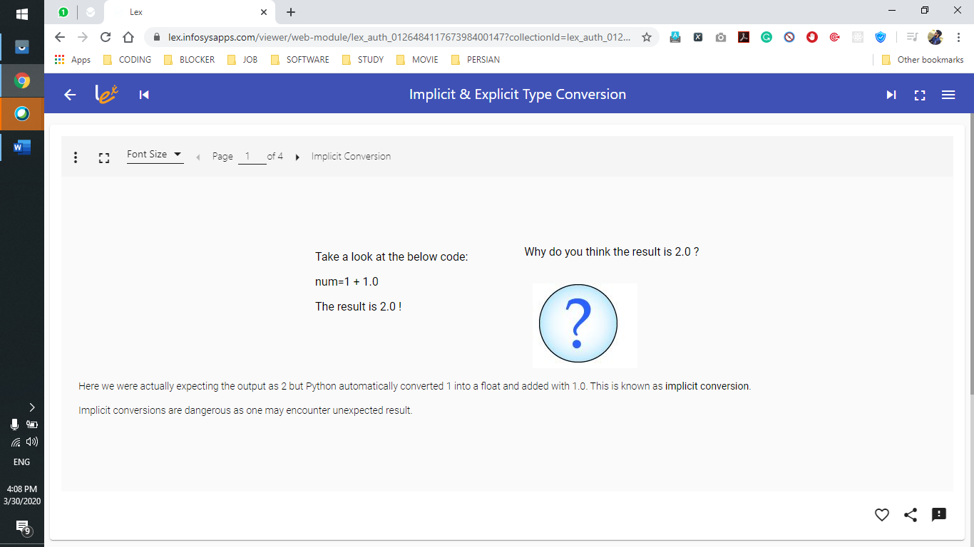

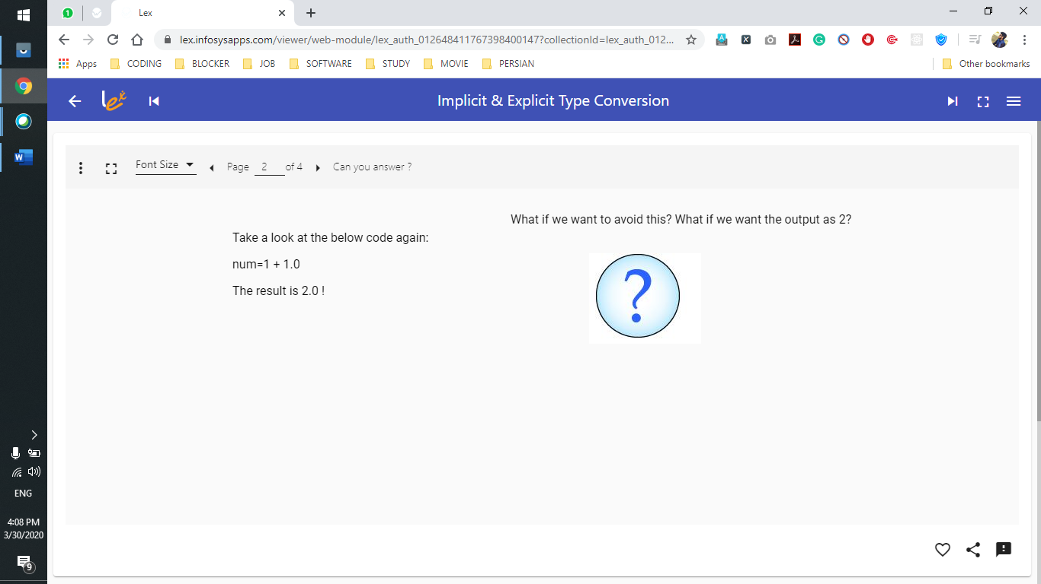

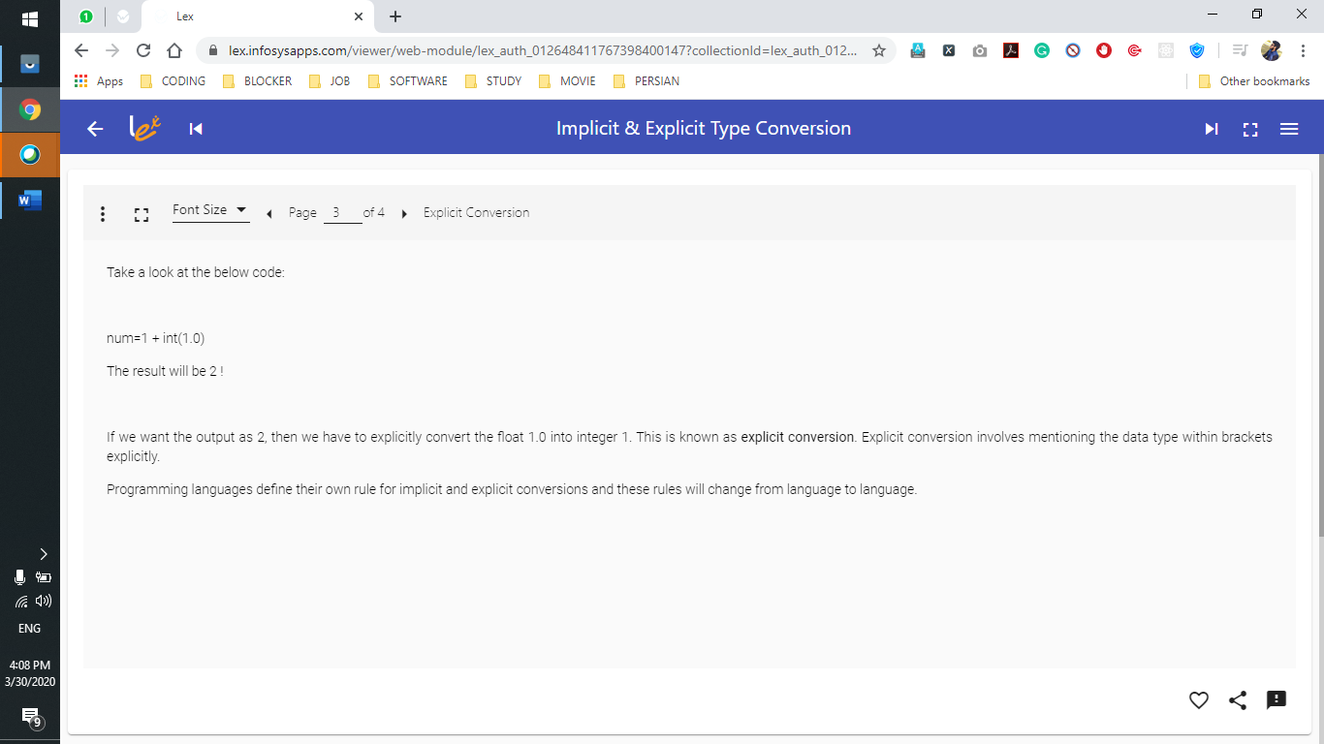

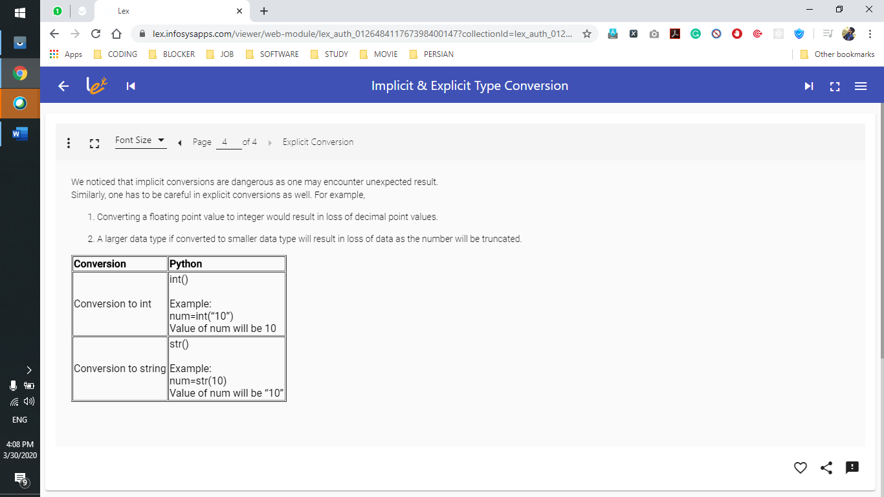

DAY 2 March 31st