**MAC**

Introduction

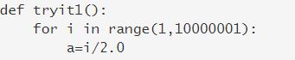

tryit2() executes faster than tryit1() !!

( we will soon see why )

from time import time

def tryit1():

for i in range(1,10000001):

a=i/2.0

def tryit2():

for i in range(1,10000001):

a=i/2

t=time()

tryit1()

print("Duration:",time()-t)

t1=time()

tryit2()

print("Duration:",time()-t1)

Output:

Duration: 0.7513930797576904  
Duration: 0.4044015407562256

You have already learnt:

* Algorithms
* Data structures
* Coding practices

But apart from these, to be a better programmer you need to understand:

* How a computer works
* How a programming language works

We will be seeing the practical application of these points in this course.

Computer Internals

Computer is an electronic device which uses electricity to do all that it does.  
Various electronic components play vital roles in its functionality.

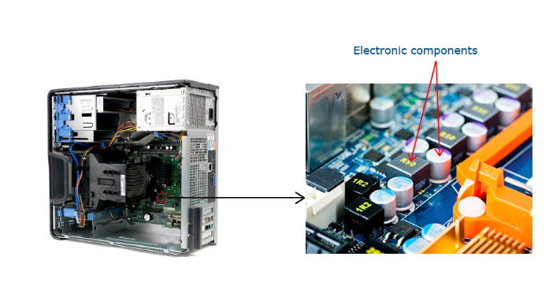

Transistors

Computers have small electronic components called transistors which can either be switched on or off. This property of the transistors is used in computers to represent data.

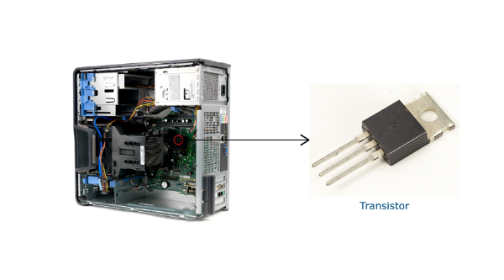

A transistor switched ON can be used to represent 1  
A transistor switched OFF can be used to represent 0  
  
This is the minimum information that be handled by a computer.

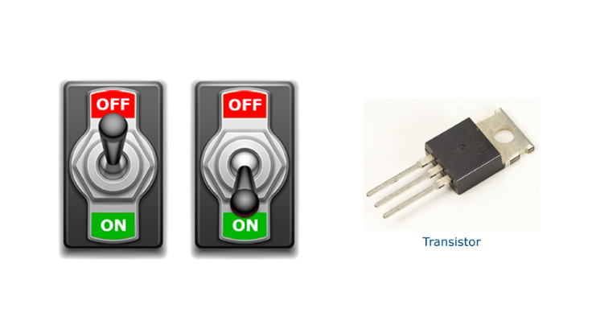

Binary system

Since computers can deal with only two types of information (ON and OFF), we can use the binary system to represent information in computers.  
  
A binary system is a way of representing numbers using just 0 and 1. In decimal system, each position in a number is represented in powers of 10. For example, 135 = 1 X 10 2 + 3 X 101 + 5 X 100  
  
In binary system, each position is represented in powers of 2.  
  
**Activity:** Imitate a computer. Turn some switches ON and OFF to see how computers represent numbers.

|  |  |  |  |  |  |  |  |
| --- | --- | --- | --- | --- | --- | --- | --- |
|  |  |  |  |  |  |  |  |
|  |  |  |  |  |  |  |  |  |
|  |  |  |  |  |  |  |  |  |

Bit and Byte

One transistor can be used to represent either 0 or 1. This smallest unit of information is called Bit ( Binary Digit). A byte is a collection of 8 bits.

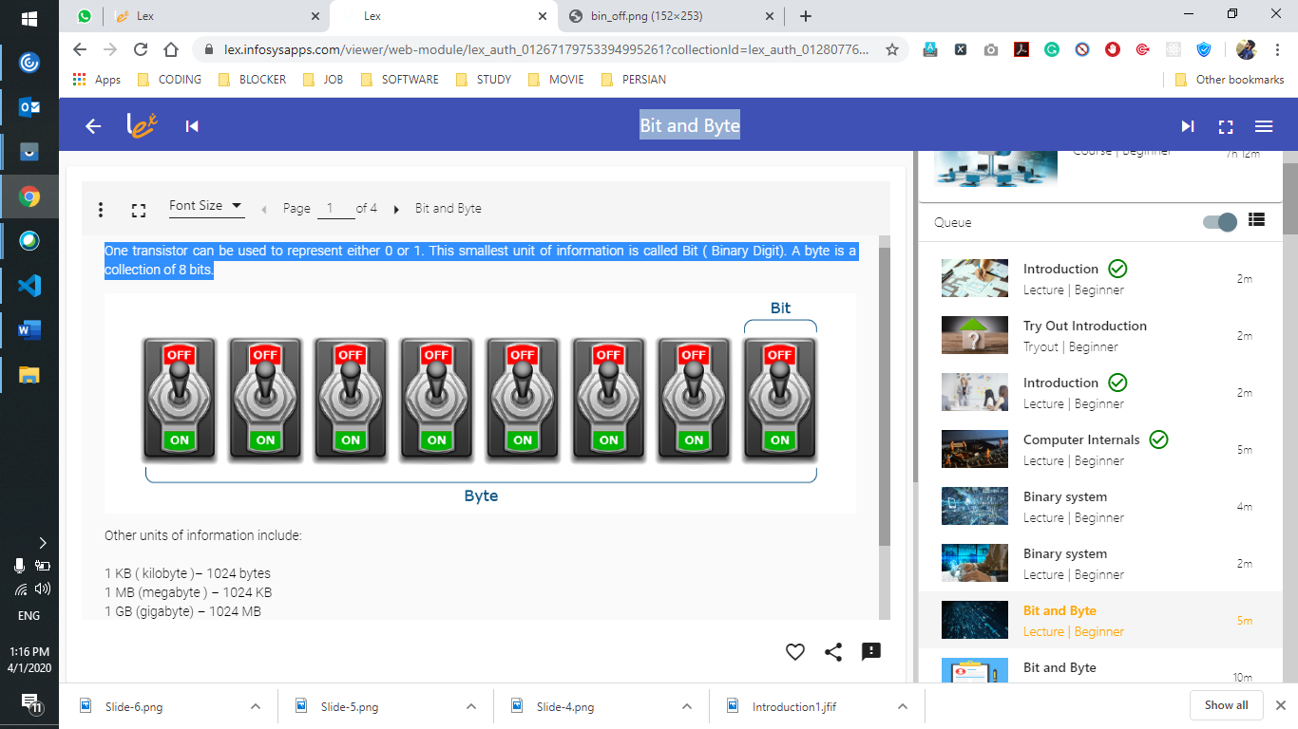

Different programming languages use different bytes to store their data. For example, Java uses 32 bits for storing integer values and C language uses 16 bits.  
  
**Activity:**  
Calculate the largest positive number you can represent using 32 bits in Java and 16 bits in C.

The maximum integer value you can represent in Java is 231-1 ( -1 is for including 0. 1 bit is used for +/- . So it uses 31 bits ). If we have to account for negative numbers as well, the value drops by half.  
  
231-1 = 2,147,483,647  
  
Any value larger than that is going to crash your code!

Did you know ?

In 2015 it was found that if a plane was continuously kept switched on for 248.55134814815 days, then it would shutdown even in mid air. Do you know why?  
  
248.55134814815 days = 231 centa seconds. A value more than this crashes the code, and in this case the plane!

Write a python program to convert a decimal number ( from 0 to 10,000 ) to binary.

# WAP to convert decimal to binary

for i in range(1,10001):

    b_no=s=""

    temp=i

    while i>0:

        rem=str(i%2)

        b_no=b_no+rem

        i//=2

    for j in b_no:

        s = j + s

    print("Decimal value of ",temp,":",s)

Write a python program to convert one data capacity to another.  
  
Example:  
4 terrabytes = ? GB

# Write a python program to convert one data capacity to another.

# Example:

# 4 terrabytes = ? GB

no=int(input("Enter no to convert : "))

print(no," terrabytes = ", (no*1024) , " GB")

**Quiz-1:**  
What is the maximum value that can be represented by 4 bits?  
  
**Estimated Time: 5 minutes**

**Options:**



10



12



15



17

ASCII

A character set is a mapping of characters to numbers. The two popular character sets are ASCII and Unicode.  
For example, in ASCII, the character ‘A’ is represented as 65.  
  
**Activity:** Represent the first character of your name using the below switches and ASCII values.

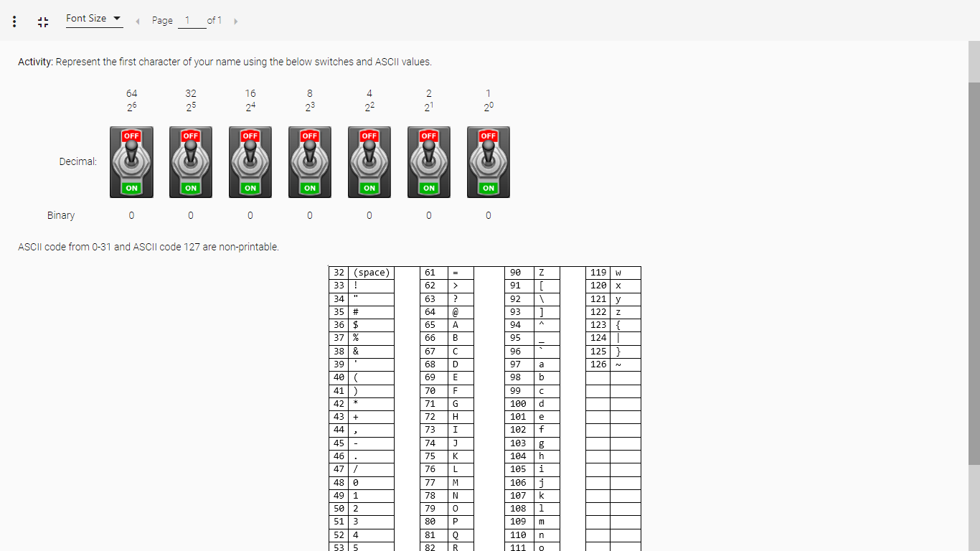

ASCII code from 0-31 and ASCII code 127 are non-printable.

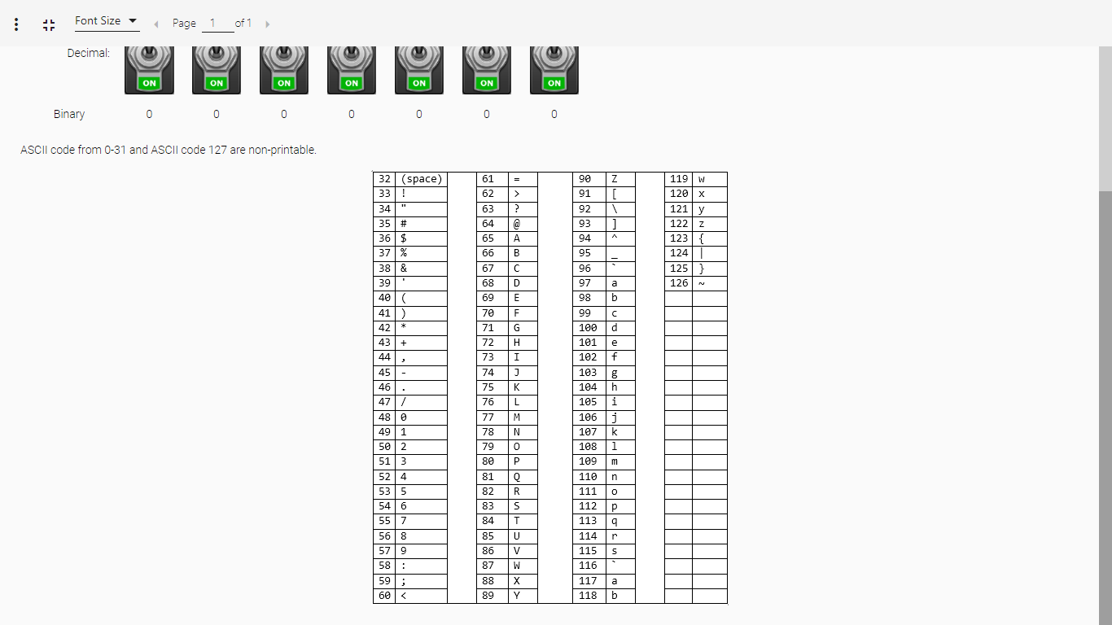

Memory Devices

So where does the computer store all these 0’s and 1’s??  
It uses memory devices like:

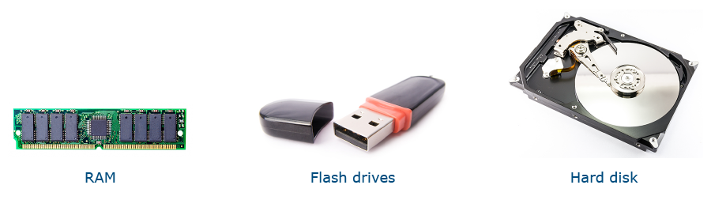

Volatile and Non-volatile

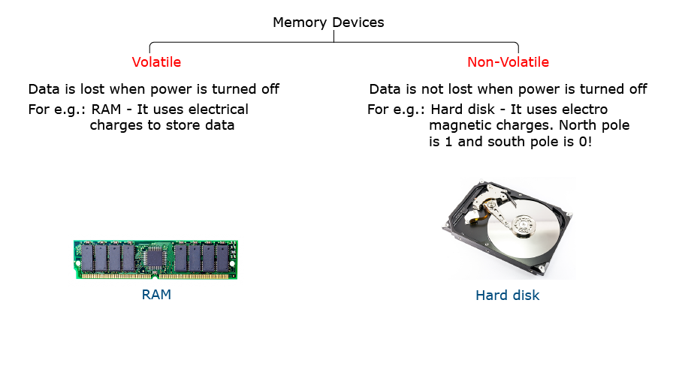

Just like we would choose a vehicle based on speed, capacity and cost, similarly a memory device is also chosen.

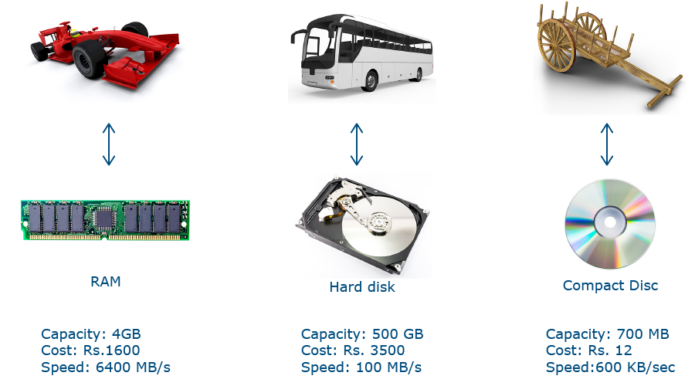

In 2015, the largest hard disk can store 16 TB of data ( 16 x 1000 GB )!  
  
Yottabyte is largest form of data which is 1 trillion terabytes! To make 1 yottabyte, if you place 1 TB hard disks, one next to the other, it would be almost 10000 times the size of the 330 acre mysore campus!

Write a python program to convert a given character into its ASCII value.

# Program to find the ASCII value of the given character

c = 'a'

print("The ASCII value of '" + c + "' is", ord(c))

If the memory device loses data after the power is turned off, then it is called as:  
Volatile

If you need 10 GB of storage, which would cost you the most?  
RAM

Websites displaying content in Hindi use which of the following character set?  
Unicode

Which of the below mentioned memory devices would you purchase to get the maximum speed of access?

RAM

Files

Not just numbers and characters, every file in your hard disk is represented as 0’s and 1’s.  
  
Even the calculator program in your computer is represented as 0’s and 1’s. Run the calc.exe file located in your hard disk. Now who ran the file?

CPU

Every action that happens in your computer is performed by an entity called the CPU, also called the processor.  
  
Processor, in one sense, is your actual computer. The processor is an extremely complicated electronic component.

The CPU in your computer might have 5.5 billion transistors in it. Each transistor is just a few nanometers long, which means you can store about 5000 transistors in the thickness of your hair!

Life Cycle of a program

Instructions and CPU  
  
A CPU just executes instructions. It does not do anything on its own. If an instruction is supplied to it, it executes it. Else it remains idle.  
  
Even the programs we write are actually instructions to the CPU.

Life cycle of a program

Consider a simple python code, MyCalc.py : print(2+2)  
By the time our code is converted into its output, lot of things happen in the background.  
  
Many components play roles during the life cycle of a program execution. The common components are:

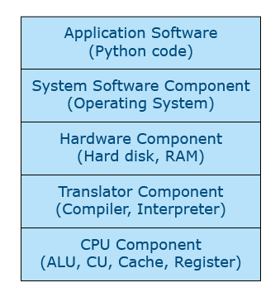

Application Software

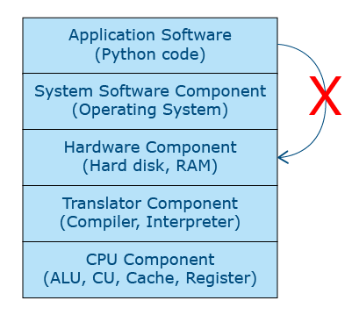

Application software don’t directly access the hardware.  
  
They are meant to solve specific application requirements

System software

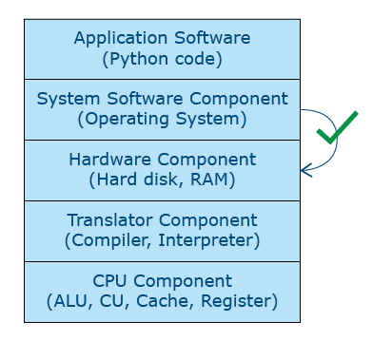

System softwares directly access the hardware.  
  
Example: Operating System (OS), Device drivers, BIOS software, etc.

Interrupt

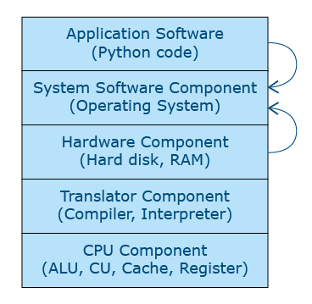

Software interrupt  
Example: File I/O, Date, etc  
  
Hardware Interrupt  
Example: Keypress, mouse click/move, etc

Interrupt is a signal by which the hardware or software can seek the attention of the OS.

Interrupt signals should be kept minimal to improve performance.

Software interrupt  
Example: File I/O, Date, etc  
  
Hardware Interrupt  
Example: Keypress, mouse click/move, etc

import time

def tryit1():

    for i in range(1,1000000):

        x=time.strftime("%d/%m/%Y")

t = time.time()

tryit1()

print('duration:', time.time()-t)

duration: 4.35084342956543

Paging, Translator, Machine code

Paging