Event Loop: The Node.js event loop is a core component that enables Node.js to perform non-blocking I/O operations despite being single-threaded. It allows Node.js to handle asynchronous tasks efficiently, making it suitable for high-concurrency applications like web servers.

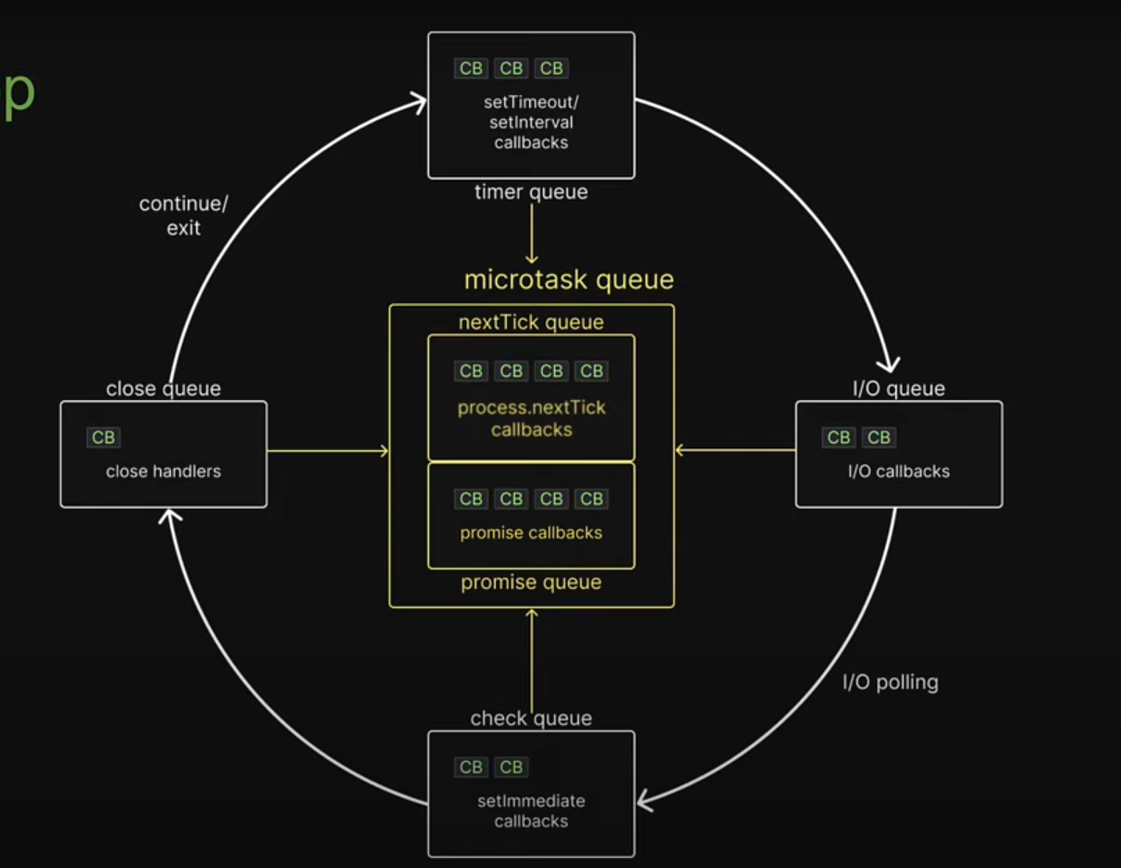

Phases of Eventloop
- 1.Microtask queue :
      - nextTick queue callbacks.
      - promise queue callbacks.
- 2.Timer Queue :
      - setTimeout callbacks.
      - setInterval callbacks.
- I/O Queue : I/O callbacks
- I/O Polling.
- Check Queue: 1. SetImmediate callbacks.
- Close Handlers.

How the Event Loop Works:
The event loop continuously cycles through different phases, processing callbacks associated with various event types. These phases execute in a specific order:
Timers:
This phase executes callbacks scheduled by setTimeout() and setInterval() when their specified time thresholds are met.
Pending Callbacks (I/O Callbacks):
This phase executes callbacks for completed I/O operations (e.g., file system, network) that were deferred from the previous loop iteration.
Poll:
This phase serves two primary functions:
• It processes events in the poll queue and executes their callbacks.
• It determines how long the event loop should block and poll for new I/O events if there are no other pending tasks.
Check:
This phase executes callbacks scheduled by setImmediate().
Close Callbacks:
This phase handles 'close' event callbacks, typically for resources that have been closed (e.g., sockets).
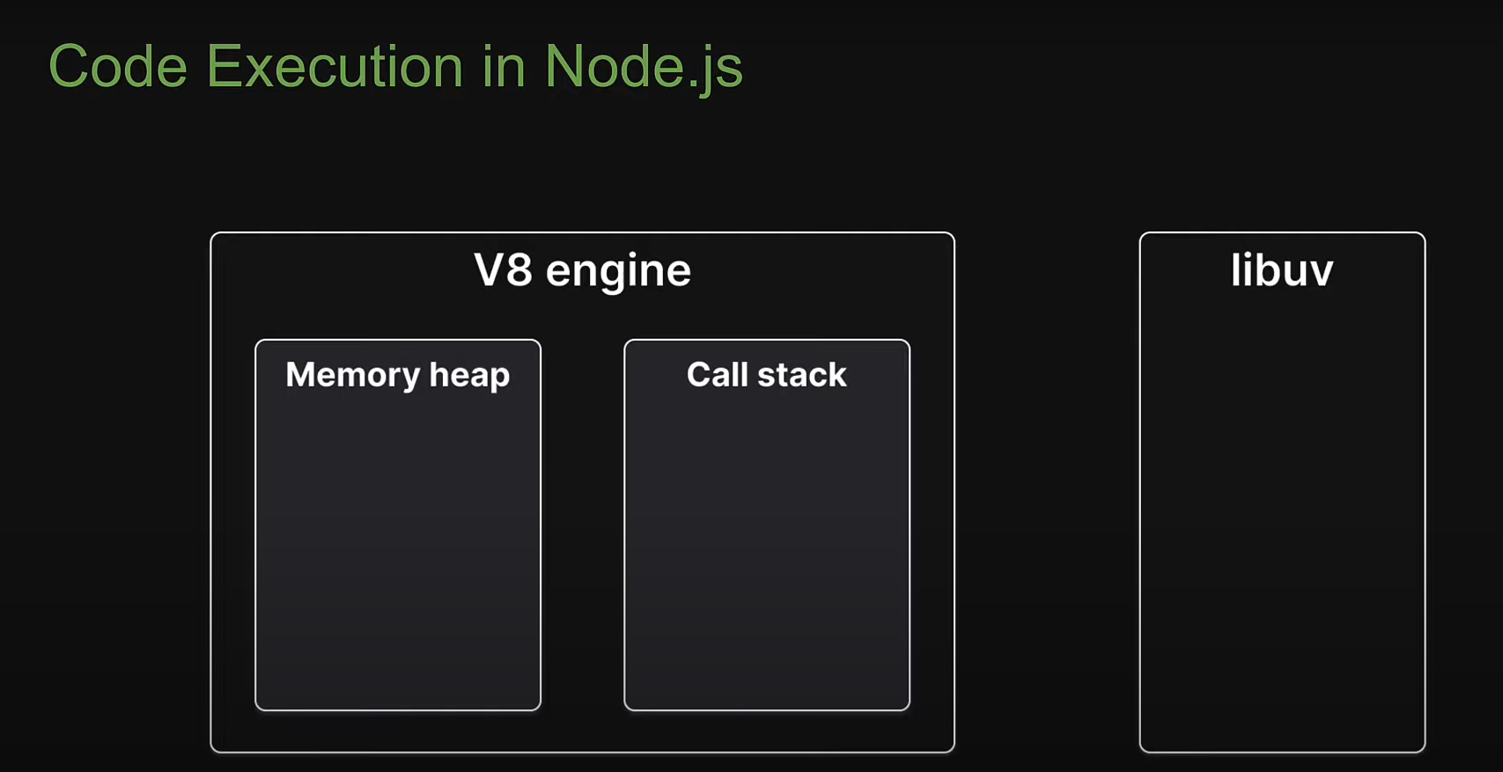

1.The V8 Engine executes the JavaScript code , it comprises memory heap and call stack.
Whenever execute the code functions are pushed to the call stack and when the functions return it is popped off the call stack , Like Last In First Out.
Libuv : Whenever execute the an async method its offloaded to libuv , libuv will then run the task using native async mechanism of the operating system and if that is not possible it will utilize its thread pool to run the task ensuring the main thread is not blocked.

Asynchronus Code Execution in Node Js.
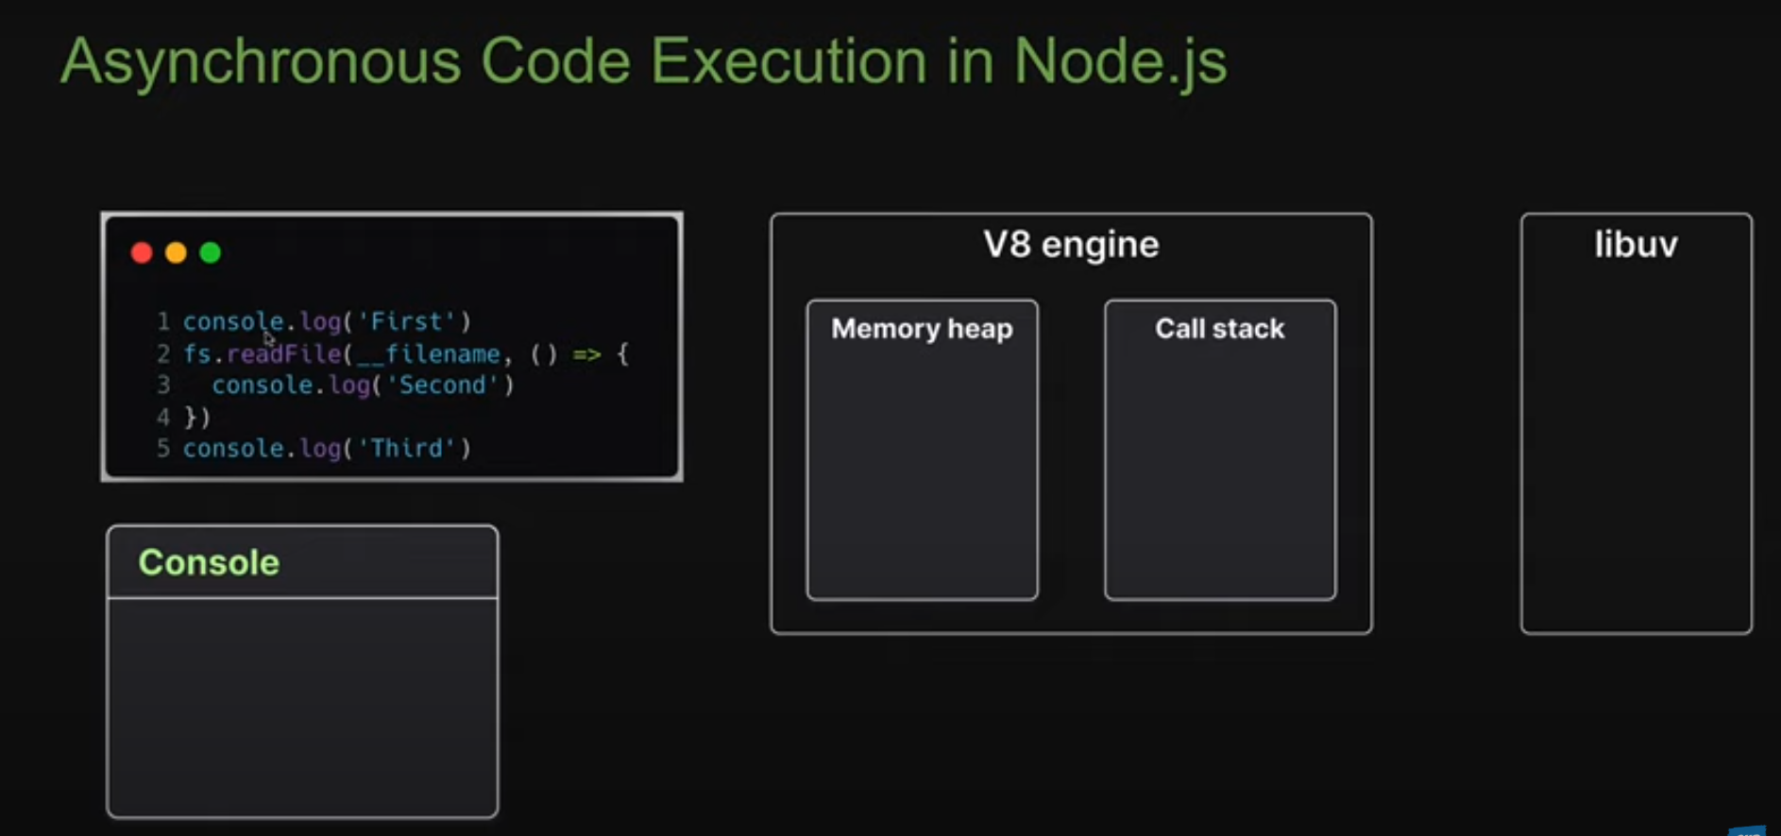
Code:
console.log(‘first’);
fs.readFile(__filename , () => {
console.log(‘second’);
});
Console.log(‘Third’);

Output:
First
Third
Second

1.First console pushed to the stack after first output in console function will be popped out from stack.
2.On second line readFile method pushed to the stack but its an async method and it will always have a callback function.
And Callback function is handed over to libuv and readFile method will be popped off from the call stack. In the background libuv started to read file contents with separate thread.
3.On third console function pushed to stack and Third log to the console and function popped out of stack.
4.Now there is no more code to run but in libuv readfile task completed in thread pool. The callback function pushed now to stack and inside callback we have log statemets.

Event Loop : It is a C program and is part of libuv.

Timer Queue : It contain callbacks associated with setTimeout / setInterval.
I/O Queue: It Contain callbacks associated with all the async methods like fs.readFile and Http module.
Check Queue : This contain callbacks associated with function called setImmediate.
Close queue : This contain callbacks associated with close events of an async task.
Microtask queue : This is actually two separate queues.
1.nextTick queue: It contain callbacks associated with process.nextTick callbacks
2.promise queue: It contain callbacks associated with promise callbacks.

Timer , I/O , check , close are all part of libuv but two microtask are not part of libuv.

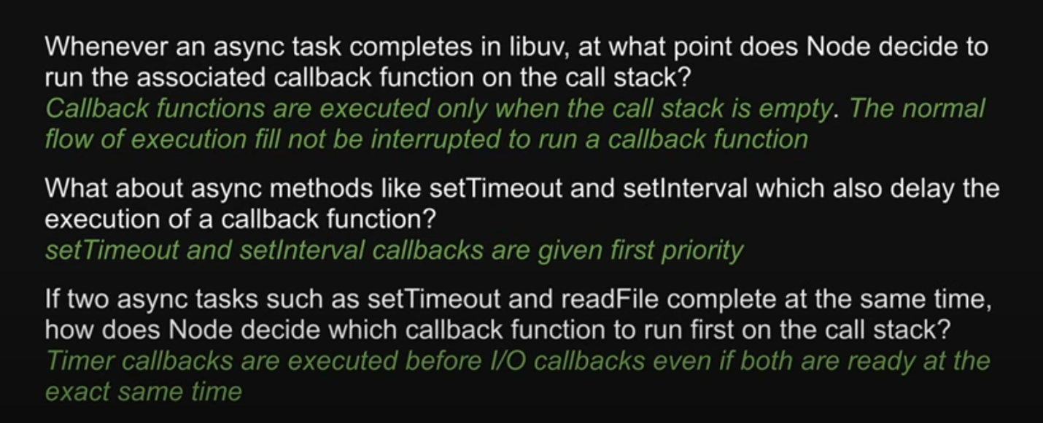
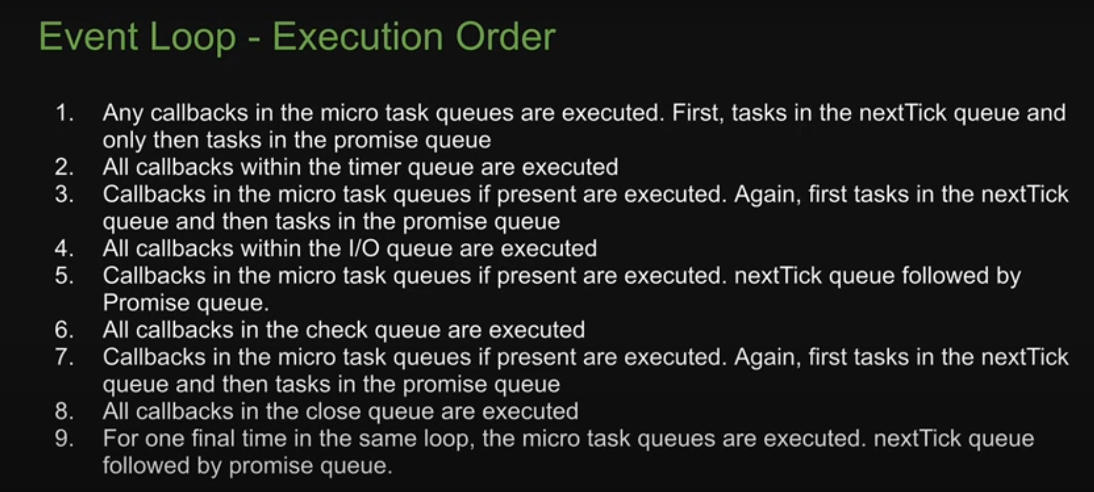

MicroTask Queue :
console.log("console.log1");
process.nextTick(()=> console.log("This is process next 1"));
console.log("console.log2");

Output :
console.log1
console.log2
This is process next 1
1.first console enter into stack and print console and popped off.
2.second async function pushed into stack and it has one callback function which is pushed into next.tick callback queue. And async function popped off the stack.
3.we still have user written code to execute so callback function has to wait for its turn.
4.Console.log pushed to stack and print into console and popped off.
5.Now no more code to execute, control enters the eventloop.
6.The callback function from next.Tick queue dequeued from the to the stack , console.log pushed in to stack and printed console and popped off the stack.

Promise.resolve().then( () =>{
console.log("Promise 1")
});
process.nextTick(()=> console.log("This is process next 1"));
This is process next 1
Promise1
// Ex3
// console.log("Start");
// process.nextTick(() => {
// console.log("process.nextTick 1");
// });
// Promise.resolve().then(() => {
// console.log("Promise 1");
// });
// console.log("End");

// // Start
// // End
// // process.nextTick 1
// // Promise 1

process.nextTick(()=> console.log("This is process next 1"));

process.nextTick(()=>{
console.log("This is process next 2");
process.nextTick(()=>{
console.log("This is process next 2.1");
});
});
process.nextTick(()=> console.log("This is process next 3"));

Promise.resolve().then(() => {
console.log("Promise 1");
});

Promise.resolve().then(() => {
console.log("Promise 2");
process.nextTick(()=> console.log("This is promise process next 3.1"));

});

Promise.resolve().then(() => {
console.log("Promise 4");
});

// This is process next 1
// This is process next 2
// This is process next 3
// This is process next 2.1
// Promise 1
// Promise 2
// Promise 4
// This is promise process next 3.1

