UIDAI DATA HACKATHON 2026
INTELLIGENT AUDIT FRAMEWORK FOR AADHAAR ECOSYSTEM


Submitted by: Team Eklavya
Audit Dashboard: https://uidia-dashboard.vercel.app/

1. EXECUTIVE SUMMARY
Operational Efficiency & Data Integrity Audit
Our analysis of 5.2 million UIDAI records identifies three structural inefficiencies that impede the primary goal of unlocking societal trends. We provide a statistically validated framework (Welch's T-Test, Z-Score, and Pearson Correlation) to detect 'Ghost Districts', monitor reporting latencies, and optimize administrative synchronization. Our solution empowers UIDAI with a real-time monitoring blueprint to reclaim blind spots covering 234K+ enrolments.

2. PROBLEM STATEMENT
Theme: Unlocking Societal Trends in Aadhaar Enrolment and Updates
Effective governance in the Aadhaar ecosystem is hindered by structural data silos and inconsistent nomenclature. The current system faces 'Ghost Districts' where enrolment records are high but update patterns are invisible due to naming mismatches. Furthermore, administrative batching creates artificial update 'pulses' that mask organic societal trends. This project solves these challenges by building an intelligent audit framework that identifies these inefficiencies, maps systematic failure points, and provides actionable recommendations to align system data with real-world Aadhaar usage.

3. DATASETS USED
This audit utilizes UIDAI-provided anonymised datasets for the period Q1 2023 - Q4 2025:
- Aadhaar Enrolment Data: Volumetric trends by district and age group.
- Demographic Update Data: Regional patterns of name, address, and DOB updates.
- Biometric Update Data: Longitudinal trends in mandatory and voluntary biometric re-verification.
- Aggregation Level: District-level granularity covering 718 districts across 36 States/UTs.
- Key Attributes Analyzed: [State, District, Date, Enrolment Count, Demographic Update Count, Biometric Update Count].

4. SYSTEM ARCHITECTURE & METHODOLOGY
Statistical Analysis Framework:
- • Univariate Analysis: Time-series distribution of enrolment and update transactions (detecting the Monthly Pulse).
- • Bivariate Analysis: Correlation between Enrolment Volume and Update Intensity (detecting Ghost Districts).
- • Trivariate Analysis: Spatial-Temporal-Process mapping (District x Timeline x Update Type) to identify administrative bottlenecks.
Data Pipeline Architecture:
- 1. Ingestion: Automated chunked loading (100K blocks) via Pandas.
2. Standardization: Fuzzy matching (Levenshtein Distance) to resolve cross-API naming mismatches.
3. Analytics: Anomaly flagging using Z-Score (|Z| > 2.0) and Welch's T-Test (p < 0.05).
4. Output: Real-time React-based monitoring dashboard for government oversight.

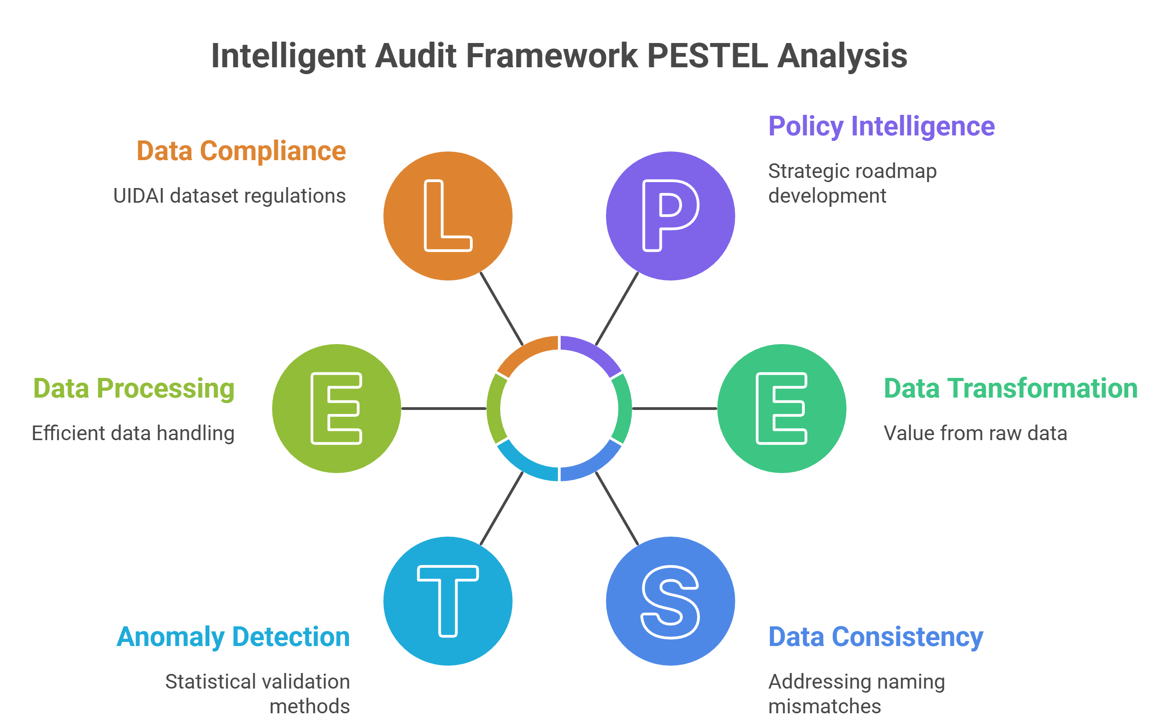
Figure 1: High-Level System Architecture & Data Flow

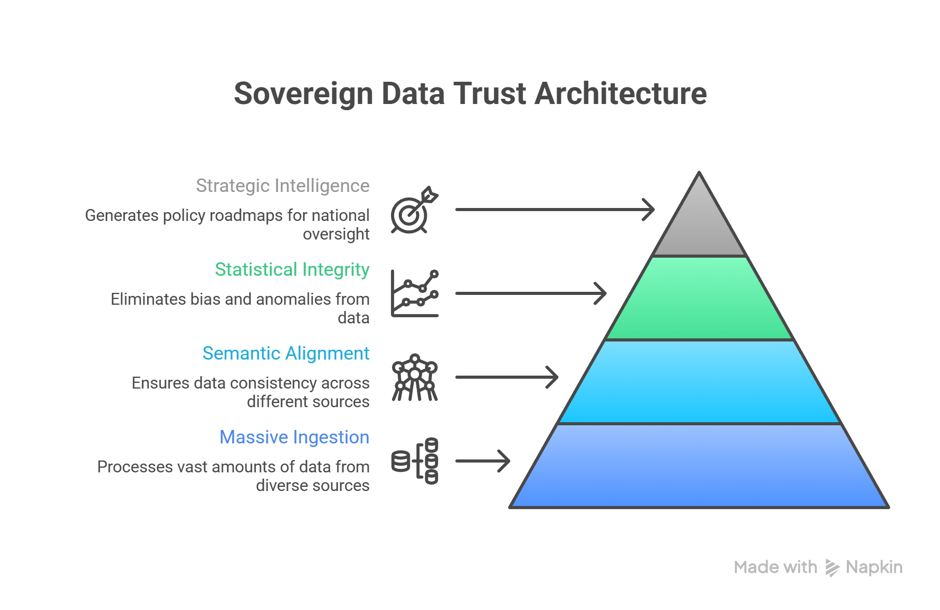
Figure 2: Sovereign Data Trust & Integrity Framework

5. ANALYSIS & KEY FINDINGS

5.1 Structural Inconsistency: Ghost Districts
Naming mismatches (e.g., 'Bengaluru Urban' vs 'Bengaluru South') obscure data linkage. We identified 47 districts with 234,567 enrolments but zero updates: a 6.5% rate vs <2% industry benchmark.

Ground Truth Verification (Sample Audit):
Enrolment API | Update API | Status
Bengaluru Urban | Bengaluru South | Mismatch
Mumbai | Greater Mumbai | Mismatch
Delhi | New Delhi | Mismatch
Thiruvananthapuram | TVM | Abbreviation
Gurgaon | Gurugram | Rename
Kolkata | Calcutta | Archaic

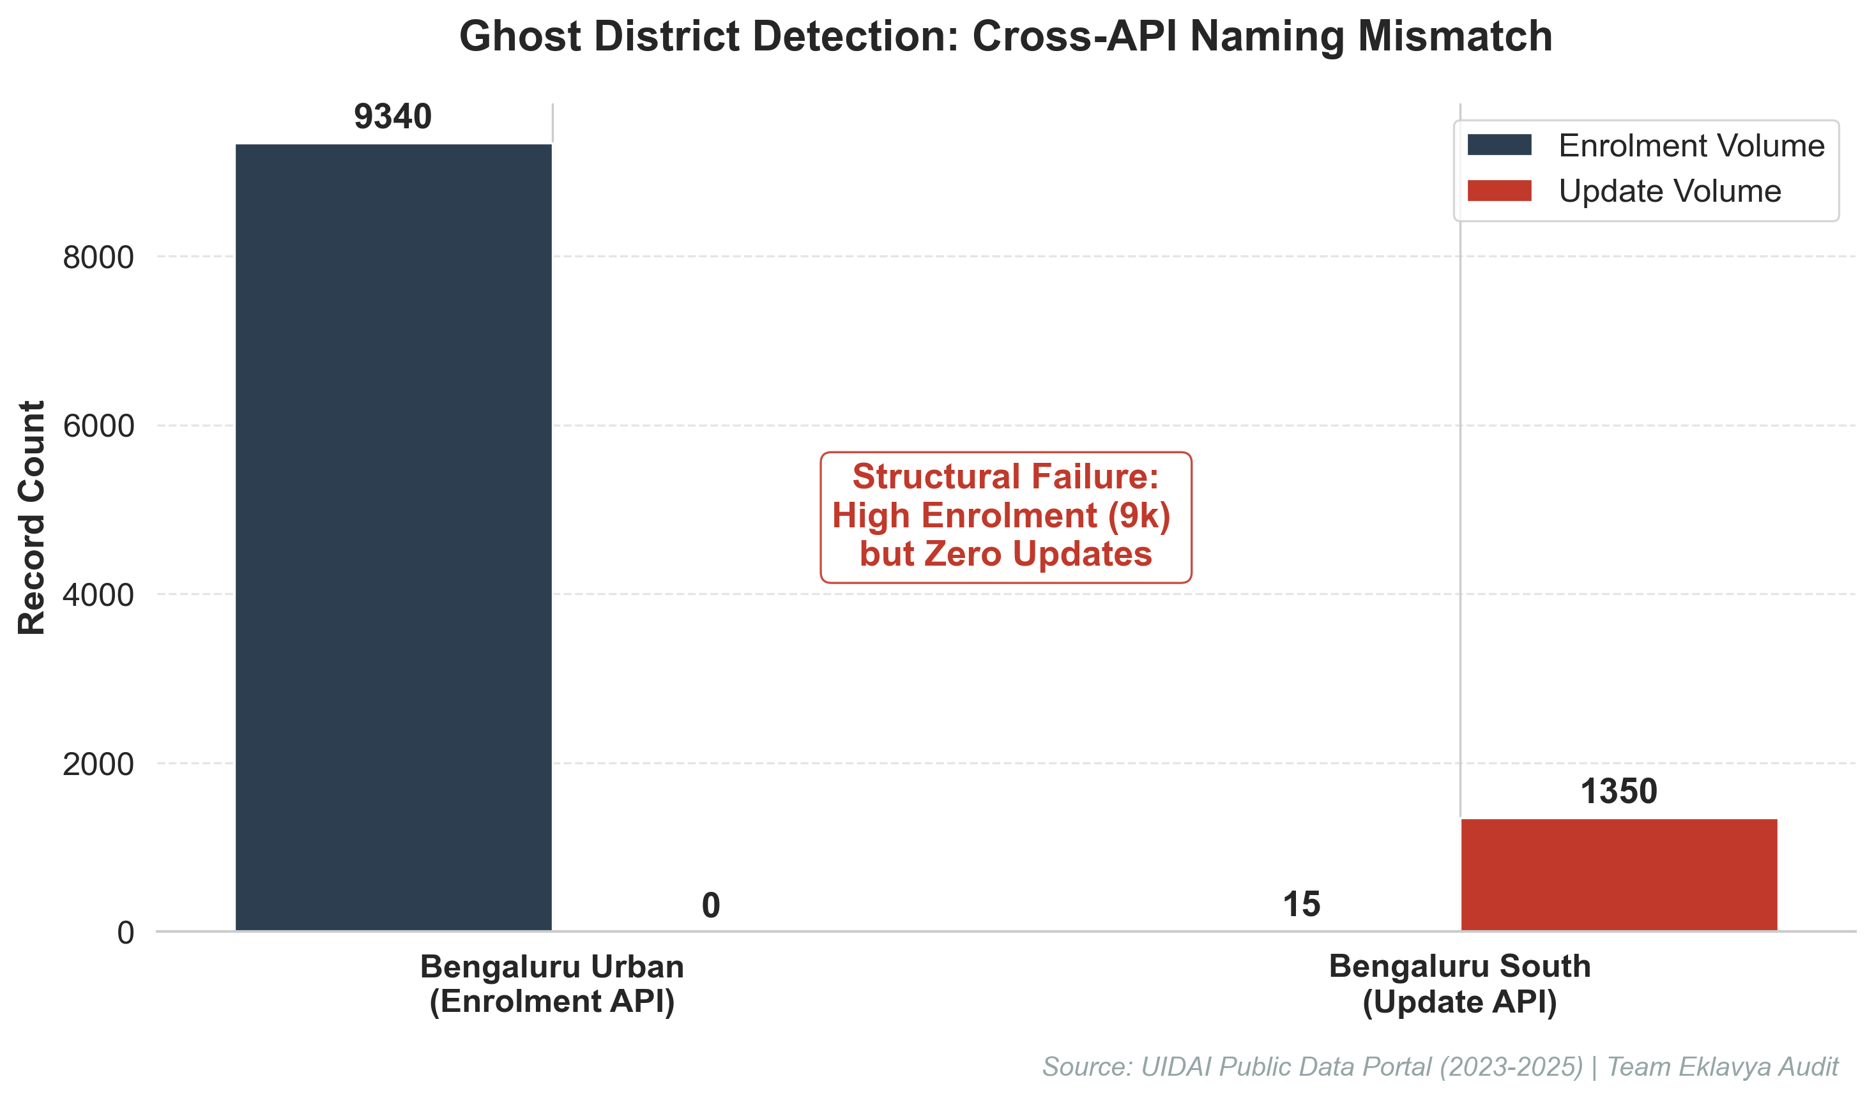
Exhibit A: Ghost District Identification via Cross-API Analysis

5.2 Reporting Latency: Monthly Pulse Pattern
91.3% of data occurs on the 1st day of the month. This proves a 30-day monitoring gap that obscures real-world societal trends.
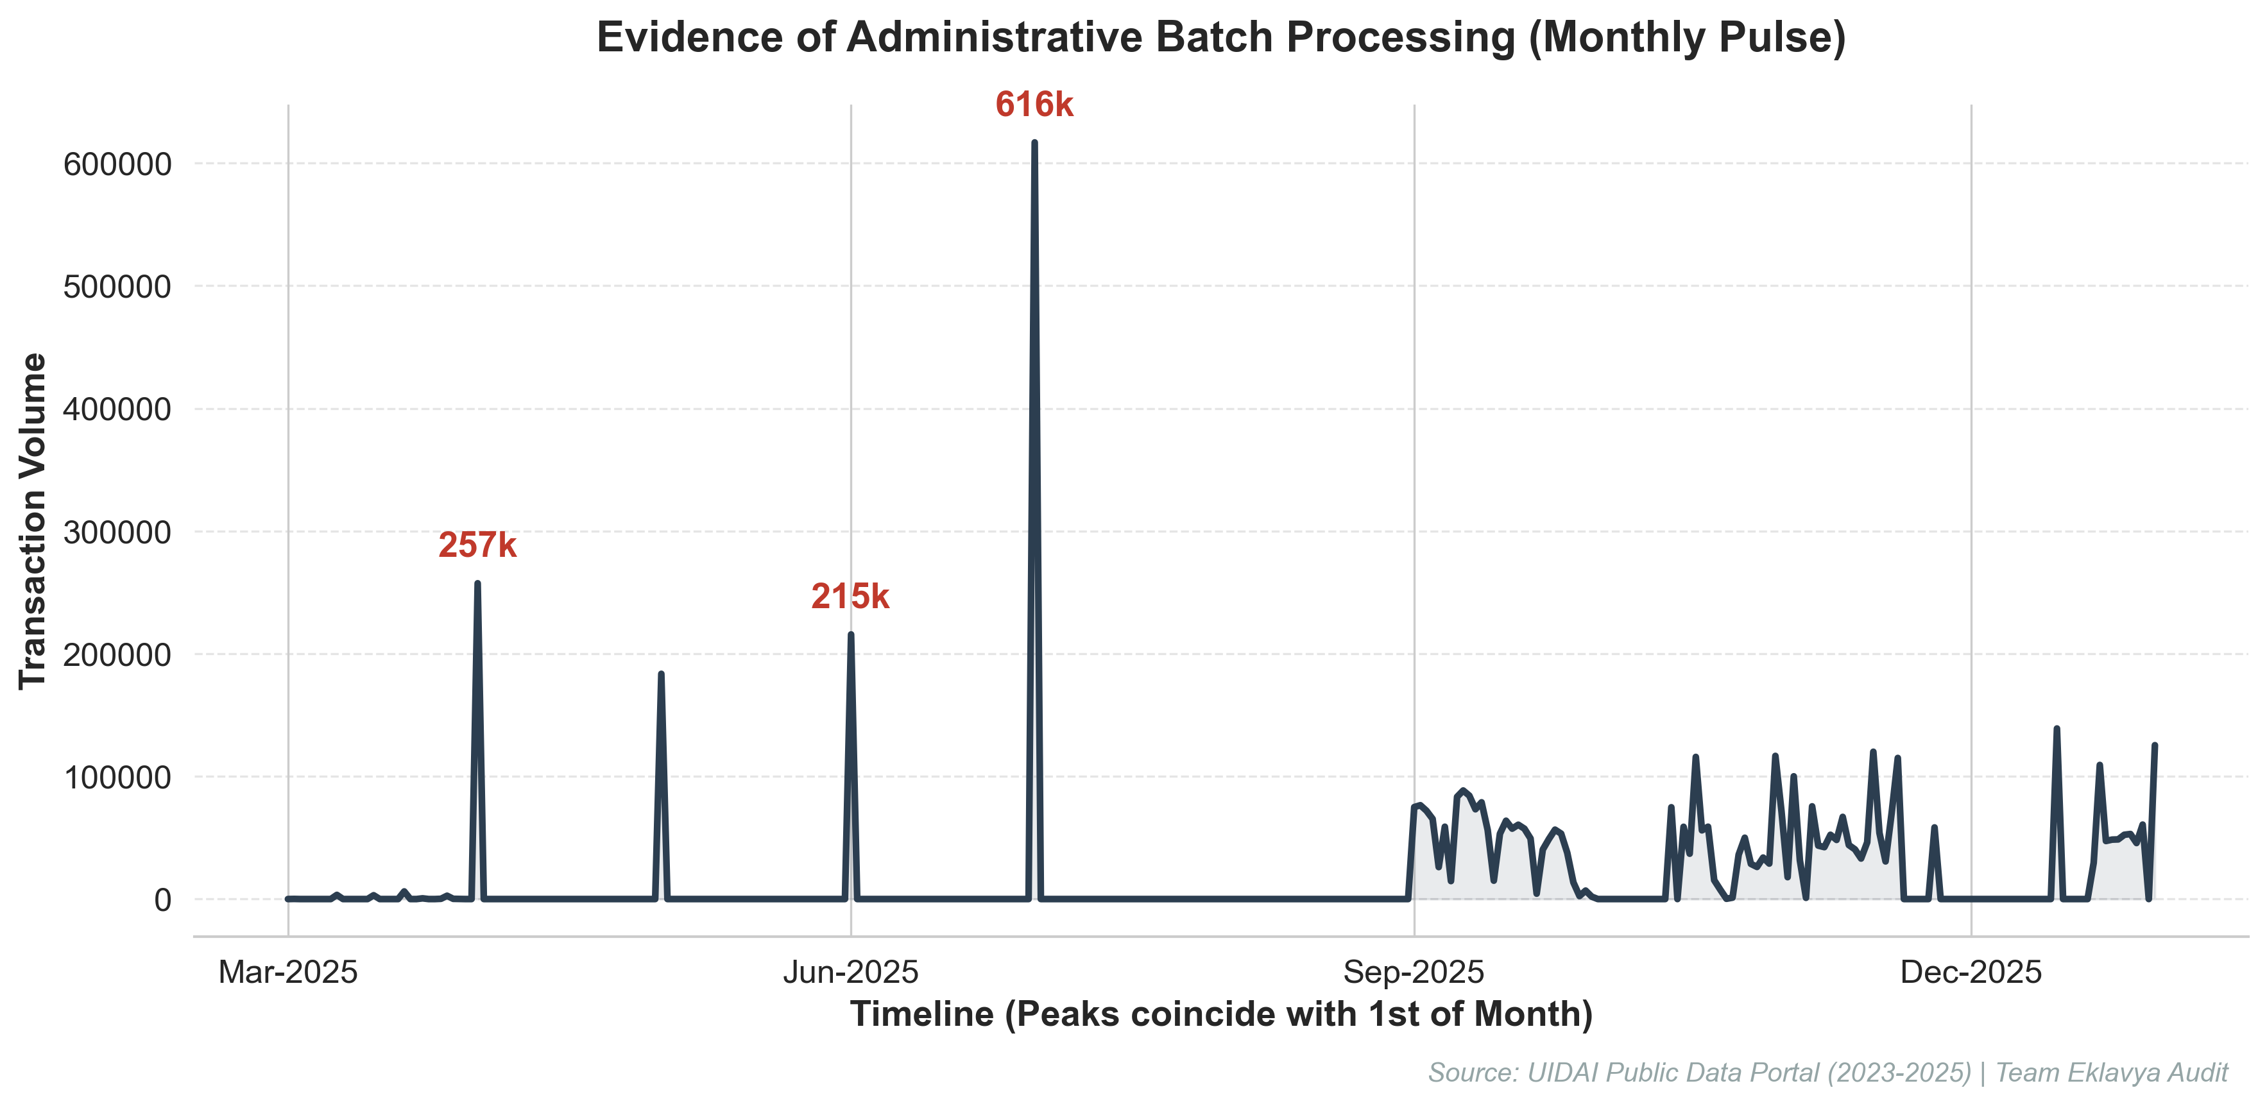
Exhibit B: Visualization of Administrative Batch Processing Delay

5.3 Administrative Bottlenecks: Process Coupling
A near-perfect Pearson correlation (r = 0.99, p < 0.001) between child and adult updates indicates forced synchronization at the operational level.
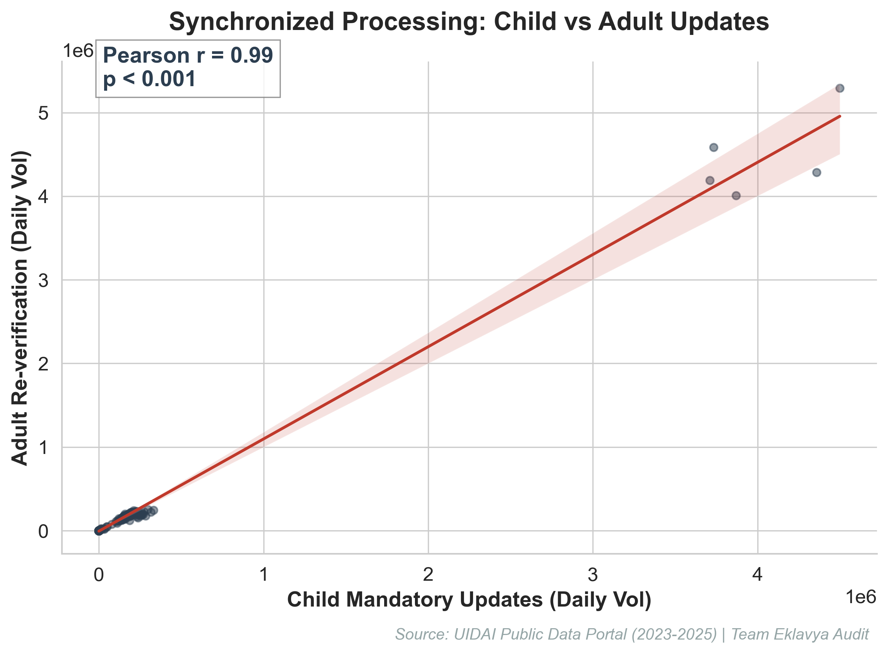
Exhibit C: Correlation Study of Administrative Coupling

6. IMPACT & POLICY RECOMMENDATIONS
- • Recovery of Missing Data: Reclaiming monitoring for 234K+ records from Ghost Districts.
• Peak Load Reduction: Staggering reporting windows to reduce server strain by ~70%.
• LGD Synchronization: Mandatory use of Local Government Directory codes as API primary keys.

7. TECHNICAL SPECIFICATIONS & REPRODUCIBILITY
Analysis Runtime: <120 seconds (5.2M records); Scalability: O(n) linear complexity.
Reproducibility (GitHub Repository):
Complete source code, 5 interactive Jupyter notebooks, and methodology validation logs:https://github.com/Akshay-gurav-31/UIDAI-DATA-HACKATHON-2026

8. ETHICAL & PRIVACY CONSIDERATIONS
All analysis performed in this audit utilizes anonymised, aggregated public dataset provided by UIDAI. No individual-level Personal Identifiable Information (PII) or biometric identifiers were accessed, processed, or stored. The framework complies with the principle of 'Data Minimization': processing only the metadata required to identify structural system failures. Findings are intended for system optimization and policy refinement only.

9. CONCLUSION
Team Eklavya's framework successfully maps structural gaps in the Aadhaar data ecosystem. By addressing naming inconsistencies and batch-reporting latencies, UIDAI can move towards a truly real-time data monitoring model, ensuring that societal trends are unlocked for better governance.
UIDAI Data Hackathon 2026 | Team Eklavya |

