Geometry image
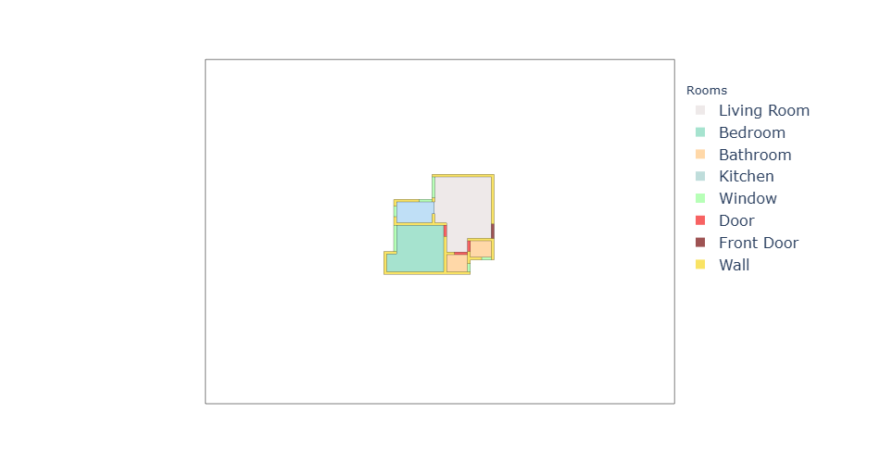
Graph – accessibility
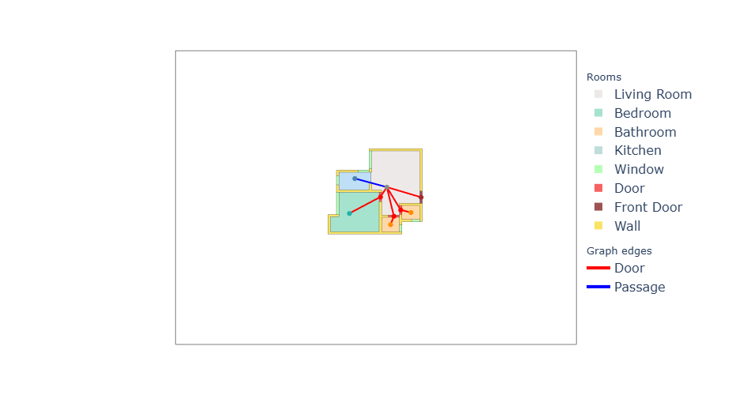
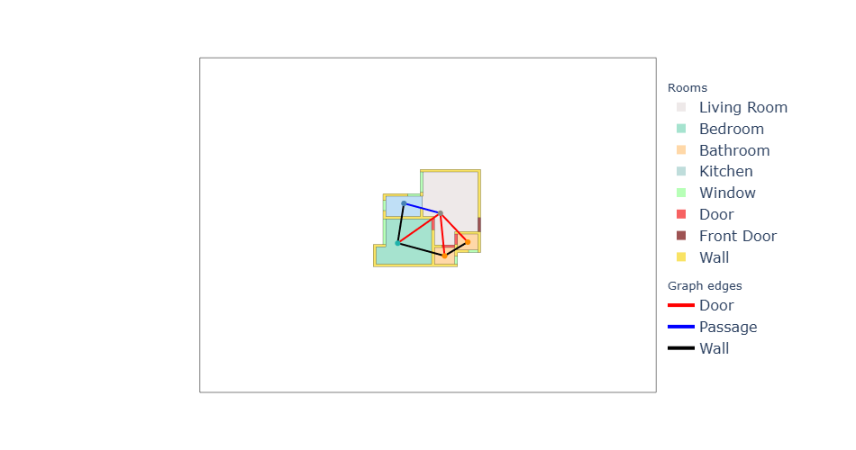
Graph – adjacency

We are using adjacency/Continuous folder data as it has real numbers, Categorical has
ordered categories

for each plan we use
Graphs/Adjacency Graphs/Continuous/JSON/adjacency_graph_XXXX.json Graphs/Adjacency Graphs/Continuous/CSV/ (graphs.csv, nodes.csv, edges.csv)
Geometry/2D/geometry_XXXX.json

Graph.csv have

Graphid label feat_0 feat1 feat2 feat3 feat4 feat5 feat6 feat7
0. 0. 58.06. 51. 33.97. 0.63 1. 0. 0. 0

coincide with adjacency_graph.json
"properties": {
"area": 58.06,
"bedrooms": 0,
"compactness": 0.63,
"net_area": 51.0,
"perimeter": 33.97,
"unit_type_0": 1,
"unit_type_1": 0,
"unit_type_2": 0,
"unit_type_3": 0
},

So basically this is what they means in both csv and json file.
feat_0 = area
feat_1 = net_area
feat_2 = perimeter
feat_3 = compactness

Next geometry.json file contains all the relevant informations,
front_door, wall, window, door, bedroom, kitchen, bathroom, living.

Now geometry.json and adjacency_graph are related by comparing the coordinate values
eg:

kitchen in geometry_0000.json is Vertex_0000 in a adjacency_graph.json along with information like "area": 5.12, "type": 3

geometry_0000.json | Points | Starts at | Adjacency JSON vertex | Type, area
kitchen (1 polygon) | 14 | 127.027021, 110.124327 | Vertex_0000 | 3, 5.12
bathroom (1st polygon) | 4 | 130.762361, 106.876138 | Vertex_0001 | 2, 2.63
bathroom (2nd polygon) | 4 | 132.528892, 106.549127 | Vertex_0002 | 2, 2.56
living (1 polygon) | 11 | 129.725707, 109.556276 | Vertex_0003 | 0, 24.42
bedroom (1 polygon) | 6 | 127.027025, 109.438282 | Vertex_0004 | 1, 16.27

Next edges.csv and adjacency.json file contents correlation

The JSON stores each edge once. The CSV stores it twice (A→B and B→A). That is why 7 JSON edges become 14 CSV rows.

Step 1: Translate CSV node numbers into JSON vertex keys
for that first nodes.csv and adjacency.json needs to be correlated. How we do this is by taking the values of nodes.csv there are 3 parameter feat_0,_1,_2 that need to be checked with area/perimeter/compactness in adjacency.json vertex and we are correlating it below by creating an intermediate table for it.

CSV node | label | feat_0 / feat_1 / feat_2 | X, Y | JSON vertex | type | area / perimeter / compactness | x, y
0 | 3 | 5.12 / 9.47 / 0.72 | 128.465339, 110.785334 | Vertex_0000 | 3 | 5.12 / 9.47 / 0.72 | 128.465339, 110.785335
1 | 0 | 24.42 / 22.26 / 0.62 | 131.257933, 109.90627 | Vertex_0003 | 0 | 24.42 / 22.26 / 0.62 | 131.257933, 109.906271
2 | 1 | 16.27 / 17.03 / 0.7 | 127.985581, 107.221128 | Vertex_0004 | 1 | 16.27 / 17.03 / 0.7 | 127.985581, 107.221128
3 | 2 | 2.63 / 6.49 / 0.79 | 131.58663, 106.078838 | Vertex_0001 | 2 | 2.63 / 6.49 / 0.79 | 131.58663, 106.078839
4 | 2 | 2.56 / 6.41 / 0.78 | 133.359903, 107.319456 | Vertex_0002 | 2 | 2.56 / 6.41 / 0.78 | 133.359903, 107.319456

Point to be noted:- Rooms 3 and 4 are both bathrooms, so the type alone can’t separate them. The area (2.63 vs 2.56) and the centroid tell them apart.

Step 2: Rewrite each CSV row with those keys, then find the JSON edge with the same endpoints and type

how we are doing this is by creating a sample for each 2 rows of edges.csv and the earlier step 1 intermediate table we formed, from that we get which vertex it matches you can check the downward example, like that we find the edges connection.

eg: For row 1 → 4, label 0:
CSV node 1 = Vertex_0003 (the living room), and CSV node 4 = Vertex_0002
So the row says Vertex_0003 → Vertex_0002, type 0 (doorway).
In JSON, Edge_5 is source: Vertex_0003, target: Vertex_0002, edge_type: 0. That’s the same pair and type, so it is the same edge.

CSV row | Rewritten with JSON keys | JSON edge with those endpoints | Type agrees
1 → 4, 0 | Vertex_0003 → Vertex_0002 | Edge_5 (V3 → V2) | 0 = 0
3 → 4, 2 | Vertex_0001 → Vertex_0002 | Edge_4 (V1 → V2) | 2 = 2
1 → 2, 0 | Vertex_0003 → Vertex_0004 | Edge_6 (V4 → V3, reversed) | 0 = 0
3 → 2, 2 | Vertex_0001 → Vertex_0004 | Edge_2 (V1 → V4) | 2 = 2
0 → 2, 2 | Vertex_0000 → Vertex_0004 | Edge_0 (V0 → V4) | 2 = 2
1 → 0, 1 | Vertex_0003 → Vertex_0000 | Edge_1 (V3 → V0) | 1 = 1
3 → 1, 0 | Vertex_0001 → Vertex_0003 | Edge_3 (V3 → V1, reversed) | 0 = 0

Node types (0 living, 1 bedroom, 2 bathroom, 3 kitchen):
- The paper lists room types 0–6 (the table says “Room Type, Categorical, 0–6”).
- Window, door and front door (types 4–6) are shown as separate polygons in the geometry file
Edge types (0 doorway, 1 passage, 2 wall):
- Each JSON edge has both an edge_type and an edge_color: type 0 is red, type 1 is blue, type 2 is black.

Room | CSV node_id | JSON key
kitchen | 0 | Vertex_0000
living | 1 | Vertex_0003
bedroom | 2 | Vertex_0004
bathroom 2.63 | 3 | Vertex_0001
bathroom 2.56 | 4 | Vertex_0002
Next step is validation
Step 2: Design the loader (modres_loader.py)
It reads the adjacency JSON for rooms and edges and the geometry JSON for the entrance and doors, and returns one Plan object
Step 3: JSON as the base, since it holds the room polygons, so we don’t need topologicpy at all.
- A room index based on the JSON key order, because the CSV uses a different node order.
- Edges stored once (u < v) with the type kept, and both directions added only when a GNN graph is built.
Design the validator (validate_modres.py)
For every plan it checks structure (room types, exactly one kitchen, connectivity), JSON against CSV, JSON against geometry (polygon by polygon, which also proves that graph i is geometry i), the entrance, and the doors.

How the loader and the validator work?
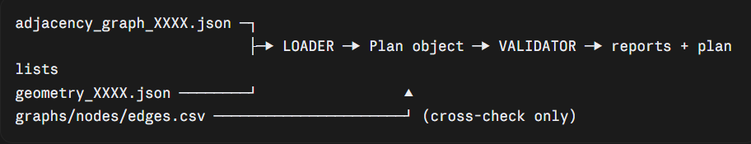
The loader (modres_loader.py) turns one plan’s files into one clean Plan object.
The validator (validate_modres.py) runs the loader on all 8,431 plans, tests each Plan and the files against each other, and writes lists of which plans are safe.
diagnose_modres.py is a helper we used to investigate failures. It isn’t part of the normal flow.

The loader
load_plan(i) does five things in order.
1. Read the adjacency JSON (parse_adjacency).
- Each entry under vertices becomes a Room: type, area, perimeter, compactness, centroid and polygon. The room’s number (rid) is its position in the JSON dictionary, not the CSV node_id.
- Each entry under edges becomes an Edge. Endpoints are looked up by dictionary key (not by the id field), stored once with u < v, with the type 0 doorway, 1 passage or 2 wall.
- Problems don’t crash the loader. Self-loops, edges to unknown vertices, duplicates and conflicting types are written to a notes list, and the validator turns them into errors or warnings.
- Polygons that aren’t valid are repaired with buffer(0) and flagged.
2. Read the geometry JSON (load_geometry_parts). Only the room shapes, the door polygons and the front_door polygons are used.
3. Find the entrance (find_entrance). It takes the first front-door polygon and computes its distance to every room. Rooms within the touch tolerance (0.03 m) are candidates. Exactly one is “ok”, more than one is “ambiguous”, none is “not_found”. The closest room becomes the entrance. For plan 0 that is room 3, the living room.
4. Match doors (match_doors). For each door polygon, it finds the rooms within the tolerance, then looks for a pair of those rooms that has a doorway edge. One pair is “ok”. Plan 0’s three doors match the pairs (2,3), (1,3) and (3,4). A door with no such pair is “no_doorway_pair”, and one with several is “ambiguous”. Door polygons are only used to cross-check, never to define what a robot sees.
5. Return a Plan with the properties, rooms, edges, entrance, doors and notes.

Step 3 in detail: finding the entrance
The idea. The geometry file draws the front door as a thin rectangle. The graph doesn’t say which room it belongs to. So we ask: which room is that rectangle touching?
How “touching” is measured. Each room is a polygon, and the front door is a polygon. distance between two polygons is the shortest gap between them, and it is 0.0 when they overlap or touch.
Plan 0’s front door sits at x 134.149–134.351, y 108.25–109.491. Its distance to each room:
Room | Distance to front door
0 kitchen | 4.355 m
1 bathroom (2.63) | 2.215 m
2 bathroom (2.56) | 0.16 m
3 living room | 0.0 m
4 bedroom | 3.504 m
Why a tolerance at all. Coordinates in these files are not perfectly exact, and walls have thickness, so we accept any room within 0.03 m as touching. At 0.03 m only the living room qualifies in plan 0.
The statuses:
- ok: exactly one room is within the tolerance.
- ambiguous: two or more are. We pick the closest and flag it, because the entrance might really be the other room.
- not_found: none is. The entrance is None, and the validator treats this as an error, since the simulator can’t start without a start room.
- no_front_door: the geometry file has no front-door polygon at all (also an error).
Why only the first front door. Some plans might have several. The loader uses the first and records n_front_doors, so the validator can warn about those plans. At 0.15 m the loader found 90 ambiguous entrances, and at 0.03 m none. All 8,419 passing plans have the living room as entrance.
The result is stored as Entrance(room=3, status="ok", distance=0.0, candidates=[3], n_front_doors=1).

Step 4 in detail: matching doors to edges
The idea. A door polygon sits in a wall between two rooms. If it touches both, it should correspond to a doorway edge between them in the graph.
Two steps per door:
- Collect the rooms the door touches (within 0.03 m). That is the near list.
- From the rooms in that list, look for a pair that has a doorway edge in the graph.
Plan 0’s door 1 (x 131.384–132.369, y 106.834–107.036) has these distances:
Room | Distance to door 1
1 bathroom (2.63) | 0.0
3 living | 0.0
2 bathroom (2.56) | 0.16
4 bedroom | 0.74
0 kitchen | 3.052
At 0.03 m only rooms 1 and 3 are near, and the graph has a doorway edge (1, 3). So door 1 matches the pair (1, 3).
All three doors in plan 0:
Door | Near rooms | Edge between them | Result
0 | 2, 3 | doorway | ok → (2, 3)
1 | 1, 3 | doorway | ok → (1, 3)
2 | 3, 4 | doorway | ok → (3, 4)
Door 0 has a nearby bathroom (2.63) at 0.228 m, which a 0.15 m tolerance would not catch, but a very loose one could. That is the reason to keep the tolerance small.
The other statuses:
- no_doorway_pair: the door touches fewer than two rooms, or the touched pair has no doorway edge. This is the common case in real data: the door leads to a space that isn’t a room in the graph.
- ambiguous: more than one doorway pair fits. This is where a loose tolerance caused trouble.
What doors are used for. Only for cross-checking: “does every doorway edge have a door polygon?” and the reverse. A robot never uses door polygons. “Seen but unopened door” comes from the doorway edges in the graph.

Step 5 in detail: the Plan object
load_plan returns one object that holds everything for the plan:
Field | Content
plan_id | the plan number
props | the JSON properties (area, net area, bedrooms, unit type)
rooms | the list of Room objects (type, area, perimeter, compactness, centroid, polygon)
edges | the list of Edge objects (u, v, type)
entrance | the Entrance result above
doors | the Door results above
raw_edge_count | how many edges the JSON listed before cleaning (7 in plan 0)
notes | problems found while parsing (self-loops, duplicates, conflicts)
It also has small helpers, such as rooms_of_type(t), edge_dict() and neighbours(rid, connected_only). The simulator will use neighbours to walk through the building.

The helpers
plan_to_tables produces plain dictionaries for later models:
- one row per room (type, area, perimeter, compactness, centroid, is_entrance)
- one row per edge (u, v, type, connected = 1 for doorway and passage, and length)
- one row for the plan’s properties
It keeps each edge once. A GNN needs both directions, so we add the reverse when building the graph.
centroid_distance is the placeholder for edge length: the straight-line distance between two room centres.
- Kitchen–bedroom (the wall edge (0, 4)): 3.596 m.
- Kitchen–living (the passage (0, 3)): 2.928 m.
It is a simple stand-in, because the real walking distance through a door could differ. It is a single function, so if the team decides to measure through the door, we replace it without touching anything else.

The validator
For each plan it runs four groups of checks. Findings are either errors (the plan is excluded) or warnings (the plan is kept but listed).
A. Structure (check_structure)
Check | Result
Every room type in 0–3 | error bad_room_type
Exactly one kitchen | error kitchen_count_not_1
At least one living room, bedroom and bathroom | error missing_required_room_type
Bad edges (unknown endpoint, self-loop, conflicting duplicate) | error
All rooms connected when walls count too | error adjacency_disconnected
All rooms reachable through doorways and passages only | warning accessible_disconnected
Bedroom count = bedrooms + 1 | warning bedroom_property_mismatch (a rule inferred from plan 0)
The two connectivity checks use a small union-find over the edges.
B. Geometry (check_geometry). For each type (living, bedroom, bathroom, kitchen):
- The number of rooms must equal the number of polygons in the geometry file (error geom_room_count_mismatch).
- Each room polygon must match one unused geometry polygon of the same type. “Match” means the area of the symmetric difference is below 1% of the room’s area (error geom_room_polygon_mismatch).
This is what supports the claim that graph i and geometry i are the same plan.
C. CSV cross-check (check_csv). The CSV is only a comparison.
- Graph level: feat_0..3 against area, net area, perimeter and compactness. A difference is an error. label against bedrooms and feat_4..7 against the unit type give warnings.
- Nodes: each JSON room needs a CSV node of the same type at the same centroid (within 0.001 m). If not, warning csv_node_mismatch. Extra or zero-area CSV nodes are also warnings.
- Edges: compared as directed sets after mapping CSV nodes to JSON rooms. Differences are warnings.
- These CSV findings are warnings because we showed the CSV is defective in about 500 plans, and the JSON agrees with the geometry and the doors.
D. Entrance and doors (check_entrance_and_doors)
- No front door or entrance not found: error.
- Ambiguous entrance, several front doors, an unmatched or ambiguous door, or a doorway edge with no door: warnings.
If the loader itself throws, the plan fails with load_failed.

What the validator produces
File | Meaning
validation_report.csv | One row per plan: status, errors, warnings, room counts, entrance type and distance
validation_summary.txt | Totals per check, with example plan IDs
usable_plan_ids.txt | Plans with no errors (8,419)
excluded_plan_ids.txt | Plans with at least one error (12)
benchmark_plan_ids.txt | Usable and not accessible_disconnected (8,098). This is the list the simulator will use

How to read a result
- PASS means the plan loads, has the expected rooms and edges, and its room shapes agree with the geometry file. The CSV, doors and entrance details can still show warnings.
- FAIL means a real defect. In the current data these are 6 room-count mismatches and 6 polygon mismatches, two of them with two kitchens.
- Benchmark means the plan is also fully walkable, so a robot starting at the entrance can in principle reach every room.

