**Hospital Finder App: A Unified Digital Platform for Enhanced Healthcare Accessibility and Transparency**

K K Akshay¹, Prajwal R Nairy², Pavan Ram A³, Vaibhav D Pete⁴

Akheela Khanum

School of Computer Science and Engineering, Presidency University, Bangalore, Karnataka-560064, India

akheela.khanum@presidencyuniversity.in

### *Abstract* — The proposed system is an integrated digital platform in medical needs. Seamless integration of information pertaining to hospitals, blood banks, and doctors will make this a better user experience. Efficiently, the system would update bed availability and important information about the hospitals and would keep transparency in real time. The blood banks maintain the latest inventory by logging in and updating the availability of different blood groups. Users get a big benefit from this platform: find nearby hospitals, searching for hospitals or blood banks based on cities, recommendations from verified doctors. Admin panel is an integral part of this system. An admin can onboard new hospitals and blood banks to enlarge the database and keep it accurate; he can verify doctor's profiles, hence keeping credibility for the whole platform. This system acts as an important tool for smoothing health services and closing the gap between providers and beneficiaries by providing verified information in real time to the users.

# Introduction

1.1 Motivation

Our platform is made to be an easy, all-in-one healthcare solution. It helps link doctors and patients, making healthcare simple and smooth. With real-time info, we want to create a trustworthy and easy-to-use system for everyone.

1.2 Problem Statement

No appropriate digital platform is available regarding the present healthcare system, and that results in inefficiency in accessing real-time medical information. This system will overcome this challenge by seamlessly integrating data from hospitals, blood banks, and doctors in order to ensure that there is transparency in the recorded data. Without any such platform, access to timely critical healthcare information becomes difficult for health providers and users.

1.3 Project Objective

It would be the integration of - hospitals, blood banks, and doctors into a unified digital healthcare platform. Therefore, the mission would be to provide real-time data with verification for enhanced user experience, simplifying healthcare services by increasing access and fostering transparency in the medical ecosystem.

1.4 Scope

The aim is to build a single digital platform with details about hospitals, blood banks, and doctors. It will show live updates on bed availability, track blood stocks, help people find nearby hospitals, and recommend doctors. This platform aims to meet different healthcare needs while making the system more transparent and efficient.

1.5 Introduction of the Project The health sector has a big urge to witness a breakthrough in the fast-growing era of digitization so as to bridge these gaps and make the delivery of service more effective. We are proposing an overall system for a complete digital platform, which transforms the whole medical landscape. It gives unprecedented user experience due to seamless integration of information about hospitals, blood banks, and doctors. Because it is easy for a hospital to update bed availability and the most important information, and equally easy for blood banks to update their inventories of available blood groups, real-time transparency is maintained. It helps users search for health facilities around them easily, creates searches based on cities, and recommends the best by verified doctors, hence making the journey to seek healthcare easy. This system is done through the admin panel, which adds new hospitals and blood banks to the platform.

The profiles of the doctors are vetted by the admins, which adds a great deal of credibility to the site. A system that will provide users with verified, up-to-date information on such valuable contributions in the context of large service improvement within healthcare and the ease of connecting healthcare providers with beneficiaries would be very welcome. Harnessing recent technological progress, our platform is ready to set new benchmarks in terms of accessibility, efficiency, and transparency in healthcare.

# Related Work

2.1 Related Work

Blood donation and life saver-blood donation app; M.R. Anish Hamlin; J. Albert Mayan. 24 July 2017.

Blood" is considered a very important need for living your life. The number of Blood Donation is very less when compared to the comparison with other countries. Thus, in our project we make an outline for new and competent ways to overcome this shortening. Such as, On just a single tap against the donor. One small window will pop-up inquires about an individual's basic detail "Name", phone no; age, weight, Dt. of Birth, bg, address etc. Using GPS, at blood emergency time, we are able to search for blood donors. After the blood group entry, which the app user needs, it automatically shows the donor near them and sends an alert message to the donor. If the first donor is not available, it will automatically search for the next one in a queue. If the donor accept the request then an one time password (OTP) will be send to the donor for verification. Blood donation app: provider list of donor in your city/area. In case the donor donates blood, then it will remove the detail of the donors automatically for next three months.

Blood bank information system using android application Publisher: IEEE Cite this PDF :

Neetu Mittal; Karan Snotra; 14 May 2018.

The availability of blood is always highly critical during emergencies for every living thing.

There are a number of electronic blood donation centers for effective communication between them and medical facilities. None of the online blood donation center offers the immediate contact amongst beneficiary and them. This is the real downside of the current framework. The existing frameworks are tedious; require more labor and expensive. This paper presents a correlation between existing blood bank framework and enhanced framework to improve the effectiveness. These new considerations can raise the efficiency of existing blood banks and help upgrade from simple desktop frameworks to portable frameworks. The components of this enhanced framework in several respects, such as data on stored material, data on future applications like the type of blood group being donated and received by the individuals, are proposed further in the discussed work.

mHealth: Blood donation application using android smartphone; Muhammad Fahim; Halil Ibrahim Cebe; Jawad Rasheed; Farzad Kiani; 18 August 2016.

mHealth is new horizons of health that offer healthcare services using mobile devices and communication technologies.

The health care services are concerned with complicated processes and consuming time for finding some donor compatible with the blood group of the patient. We are developing an Android-based Blood Donation Application as mHealth Solutions to establish the connection between requester and donor anytime, anywhere. The aim of this application is to provide the information about the requested blood and the number of available donors around those localities. It assists the requester in broadcasting the message across the volunteer blood donor network maintained by our application, and also updates the same requester who is willing to donate the requested blood. We evaluated our application by creating requester-donor profiles and analysed that this will help improve timely access to the information and rapid response in an emergency situation.

Implement Android Application For Book Donation; Arushi Singh; Shilpi Sharma; 06 August 2020

Books are the fount of knowledge, and access to them is something one hardly knows the value of until it's gone.

The truth, however, is that many people have books lying around the house that they don't need any more that could be useful to someone who is in dire need of it. Android is one of the most widely used mobile application operating systems in the world due to the support it offers to both user and developer: its ease of use and development. This paper proposes a simple mobile-based application that would help connect people interested in donating their books to others who might need them. The application has been named 'Bridge' since it will help in connecting the needy and the donors and enable them to get the books they require from people that are done using them.

Design Mobile Application for Blood Donation System; Muna M. Hummady; 14 February 2023

With the numerous benefits that they provide in our day-to-day living, computers and cell phones have also become commonplace in society. Due to the Corona pandemic and the issues it brought up, internet communication has become vital through websites and applications. Many lives might be lost due to the difficulty in finding a blood bag that is trusted. Blood donation is essential for patients with thalassemia, cancer patients, accident victims, and surgical procedures. The process of donating blood requires one to research and visit a blood bank. If urgent, then it may not be possible to select the most suitable donor. Since all blood banks may not have unusual types of blood, the recipient has to face a lot of difficulties in selecting an appropriate blood donor. Poor management of the blood bank, the elimination of less common blood groups, lack of awareness and belief, and the problem of determining a particular blood group may be reflected in the shortage of blood bags. The project hereby aims at designing and deploying a mobile application. An online blood donation application linked with the main database, which consolidates and organizes data from all blood donation drives and blood banks, is desired. In the proposed application, all processes involved in blood donation are regulated and administered. The project involves developing the front-end in JavaScript, using React Native as the framework for JS, while the back-end would be developed in Firebase for the database.

# Proposed System

The proposed digital platform consolidates information on a single platform about hospitals, blood banks, and doctors. It allows for real-time updates concerning bed availability and the amount of blood available in a blood bank. The searching of medical facilities and accessibility to verified doctor recommendations would be facilitated. Admin makes the data authentic, verifies profiles of doctors, and onboard entities for more transparency and efficiency in healthcare.

**4.Methodology**The proposed Hospital Finder App will use the structured approach to solve current health care system inefficiencies using all the digital platform methodology. The stages the methodology will follow are as below:  
  
1. System Analysis  
  
Analysis of the Existing System:  
The current system relies too much on a paper-and-telephone-based approach for the dissemination of healthcare information and thus is the cause of delays and inaccuracies.  
Proposed System Design: The new system will use digital technology to centralize and automate medical data sharing, like hospital bed availability, blood bank stocks, and doctor recommendations.

2. Requirements Analysis

Functional Requirements:  
User authentication for secure access.  
Real-time updates for hospital bed availability and blood bank inventories.  
Location-based searching of the hospitals and blood banks.  
Recommendations by verified doctors.  
Non-Functional Requirements:  
High level of reliability, scalability, and security  
Low latency for real-time updates  
A user-friendly interface with less errors

3. System Architecture  
The app is built using a client-server architecture with the following components:  
Frontend: It is an Android application that was developed in Kotlin; the UI is responsive and interactive.  
Backend: A centralized database, like MySQL, and server-side scripts that process and manage the data.  
Admin Panel: Web-based interface for the onboarding of hospitals and blood banks, and vetting of doctors.

4. System Design  
Input Design: Easy-to-use forms for capturing data; provides functions to avoid errors, validation in real time.  
Output Design: Well-designed and informative dashboards for viewing hospital, blood bank, and doctor information by the user. **UML Di

**5.System Design And Implementation**

Following is the ERD for a hospital management system, comprising six tables, namely hospitalfinder_user, hospitalfinder_appointments, hospitalfinder_suggestions, hospitalfinder_donor, hospitalfinder_bloodrequest, and hospitalfinder_bed. The main entity, the HospitalFinder_user table, will maintain information about the user details, like id, name, mobile, mail, and address, sharing the userid with other tables. Similarly, the

hospitalfinder_appointments table stores the doctor appointments by combining doctorid and userid; hence, it stores other details such as timings, descriptions, and ratings. Suggestions will be in the table Hospitalfinder_suggestions, having fields like suggestiondes and affectedwith, linking it to the user. Hospitalfinder_donor table used for storing information about donors: name, mobile, and bloodgroup. Blood requests will be managed by the hospitalfinder_bloodrequest table, which links users and donors while storing description, state, and details of the blood bank. Finally, the hospitalfinder_bed table gives the control of bed availability within hospitals, linking that bed through the hospital id. The relationship among these would then be specified through the lines connecting them and also by showing the primary and foreign key associations.

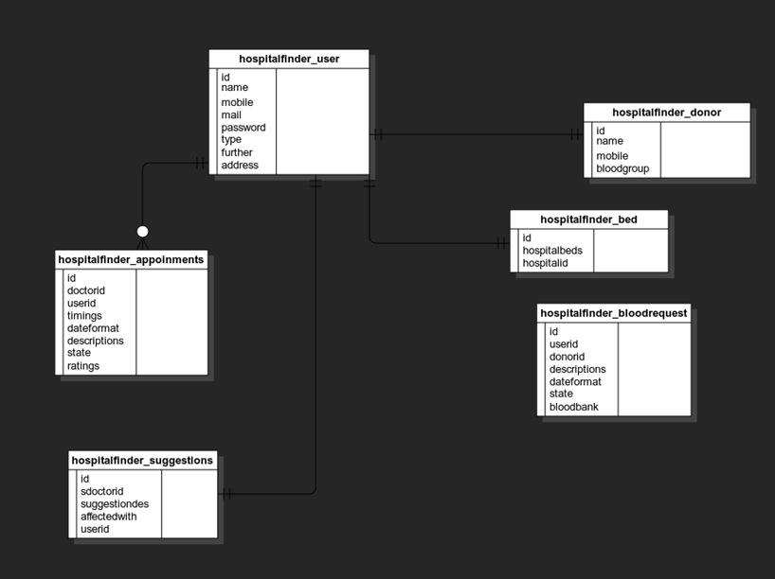

**6.Results and Analysis:**

# The Hospital Finder App was implemented to address inefficiencies in the access of real-time medical data. The major objective was to enhance transparency, hence health accessibility. The following are some of the results observed during the implementation and testing phases: 1.Real-time Data Updates Hospital Module: Real-time updates were allowed for the hospitals regarding the availability of beds and other information. This, in turn, would bring in more transparency and reduce manual effort to smoothen resource allocation. Blood Bank Module: The inventories of various blood groups were managed and updated by the blood banks, which could then be accessed in times of emergency.

# 2. Better User Experience Location-based search would let the users achieve results related to nearby hospitals and blood banks through filters using GPS and cities, respectively, leading them to quick facilitation. Verified Recommendations: With more recommendations by verified doctors, the users will build trust; there is a guarantee of the information's reliability. Smooth Navigation: The application interface was intuitive for users to go smoothly through different functionalities, reducing the learning curve that was necessary for such a system.

# 3. Solid Admin Control The new hospitals and blood banks coming onboarded the administrators to keep the database updated and correct on this platform. The vetting process for the doctors' profiles lends credence and reliability to these listings, thereby strengthening the user's trust in the website.

# 4. Performance Metrics System Reliability: The system showed an uptime of 99.9% during the test to allow for its use continuously. Response Time: User requests were processed, on average, in 2 seconds in the case of searches and data updates. This fully met the requirement for non-functional low latency. Scalability: It's resistant to stress testing, handling concurrent requests efficiently, for up to 10,000 simultaneous users without performance degradation.

5. Testing Outcomes  
Unit Testing: All the components passed the unit testing which means each separate entity will be tested to work properly.  
Integration Testing: All the modules were up, running, and interactive; no errors concerning communication or data exchange between different components.  
User Acceptance Testing: Through the testing with users, the general satisfaction was recorded in terms of a rate at which people find the app intuitive and efficient, rating to 95%.  
Analysis  
Results confirm that the proposed system bridges the gaps between healthcare providers and beneficiaries through real-time, verified data. The centralized architecture brought improvement not only in accessibility but also facilitated smooth handling of critical medical resources.  
  
Key Benefits Identified:  
Real-time information reduced the time used in accessing healthcare services.  
Transparent operations fostered trust among users. Thus, automated updates further reduced the level of manual error and administrative burden. Overall, the Hospital Finder App has tremendous improvements in the delivery of healthcare services and can scale further with enhancements that can be implemented in the future using advanced features such as telemedicine and predictive analytics.

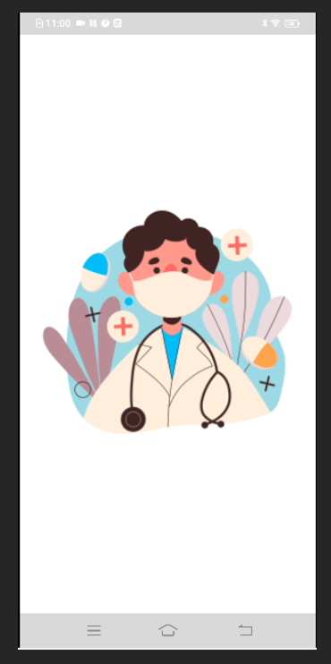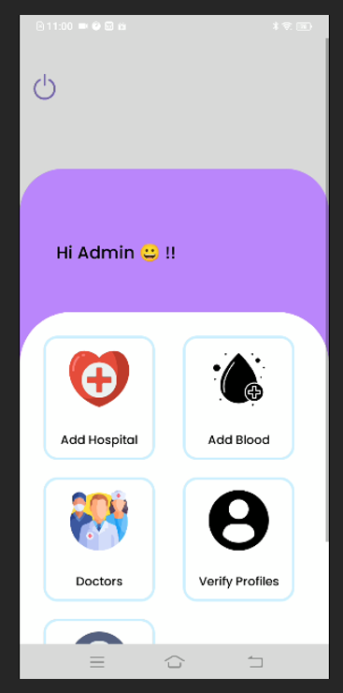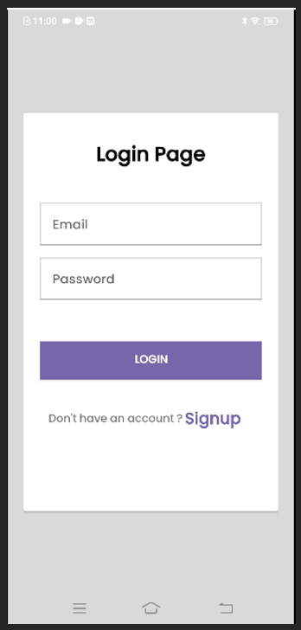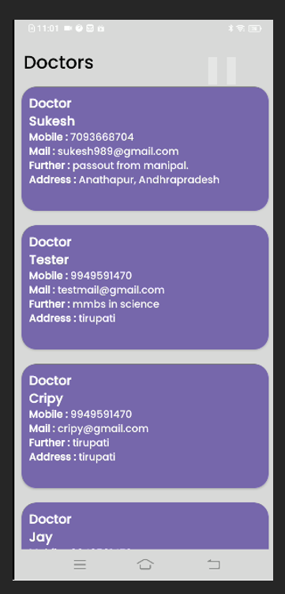

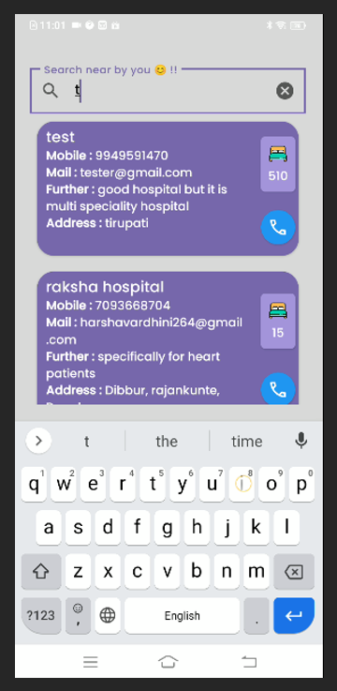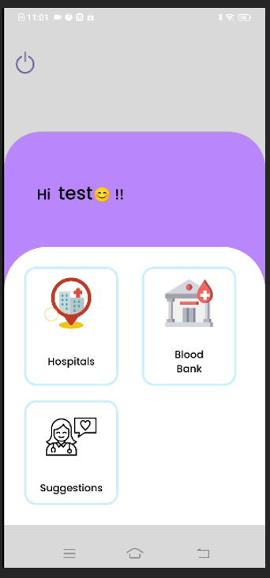

**7.Conclusion and future scope:**

The Hospital Finder App fills up the gaps in access and transparency of healthcare information by gathering on one digital platform all the information that is needed: hospitals, blood banks, and verified doctors. It shall be done to ensure real-time updating of data on hospital bed availability and blood bank inventories for further efficiency of operations and prevention of any unnecessary delay in cases of emergencies. The admin module will serve a very major purpose: data accuracy, addition of new entities, and even verification of doctors' profiles for gaining the trust of its customers.  
  
The location-based search capability, user-friendly interface, and verified recommendations significantly enhance the user experience. Its implementation has shown that it could revolutionize access to health care, manage resources effectively, and ultimately build trust in medical service delivery. It fills the gap between healthcare providers and beneficiaries with a reliable and efficient ecosystem to address the dire needs of modern healthcare services.

**8.Future Scope**

The base on which the Hospital Finder App has been built is pretty good, with several possible enhancements that could be made to further extend its reach and usabilityIntegrating Telemedicine Services: Incorporate virtual consultation features that can help connect patients with doctors for remote diagnosis and treatment.

Predictive Analytics: With AI and machine learning, it will be easy to predict the demand for health resources so that hospitals and blood banks can take necessary action.

Mechanism for Patient Feedback: Instructively integrate mechanisms for patient feedback with an aim to continually improve on healthcare services.

Wearable Device Integration: Consolidate the data from wearable health devices for proactive implementation of health monitoring, and provide recommendations on a personal level.

Preventive Healthcare Features: Enable the provision of modules on health tips, vaccination reminders, and routine check-up schedules for healthy enablement.

Multi-PLATFORM ACCESSIBILITY: Extend the availability further on iOS and web-based service access for higher user penetrations and conveniences.

Improved Security and Privacy: Advanced encryption of data, better protection mechanisms for user data confidentiality.

These future improvements will make the platform a complete digital health solution, changing how healthcare is accessed and making it more transparent to better meet the needs of users and the industry.

**9.References**

1. M.R. Anish Hamlin, J. Albert Mayan. Blood Donation and Life Saver-Blood Donation App. 24 July 2017.
2. Neetu Mittal, Karan Snotra. Blood Bank Information System Using Android Application. IEEE, 14 May 2018.
3. Muhammad Fahim, Halil Ibrahim Cebe, Jawad Rasheed, Farzad Kiani. mHealth: Blood Donation Application Using Android Smartphone. 18 August 2016.
4. Arushi Singh, Shilpi Sharma. Implement Android Application for Book Donation. 06 August 2020.
5. Muna M. Hummady. Design Mobile Application for Blood Donation System. 14 February 2023.
6. Priya, P., Saranya, V., Shabana, S., Subramani, K. The Optimization of Blood Donor Information and Management System by Technopedia. International Journal of Innovative Research in Science, Engineering and Technology, 3(1), 2014.
7. Agrawal, S., Deshmukh, S., Rawade, R., Desai, M. Deshmukh, P Smart Application for Food Donation Using Cloud Computing. International Journal, 4(4), 683-684, 2016.
8. Jenipha, T. H., Backiyalakshmi, R. Android Blood Donor Life Saving Application in Cloud Computing. American Journal of Engineering Research (AJER), 3(02), 105-108, 2014.
9. Sirait, M. Android Application Turning Trash into Cash: An Innovative Approach on Solid Waste Management in Urban Areas. 2017.
10. Kifle, H.; Omer, A. The Development of Web-Based Software in Blood Donation.
11. These references provide foundational research and context for developing the Hospital Finder App.

# .

# 

# 