

**KONARK INSTITUTE OF SCIENCE AND TECHNOLOGY**

**TECHNO PARK, JATNI, BHUBANESWAR-752050, ODISHA**

**Department of Computer Science Engineering**

**A project report on**

**“Document Server”**

**A Seminar given**

**for the partial fulfillment of the Degree of**

**Bachelor of Technology in**

**Computer Science Engineering**

**(SESSION 2018-2022)**

**Submitted by:**  Akshay Kumar (1801214006)

Khushi (1801214032)

Neha Bhagat (1801214050)

Niranjan Singh (1801214054)

**Under the Guidance of:**

Asst. Prof. SUBHASHIS MISHRA

DEPARTMENT OF COMPUTER SCIENCE AND ENGINEERING

KONARK INSTITUTE OF SCIENCE & TECHNOLOGY, BHUBANESWAR



**KONARK INSTITUTE OF SCIENCE & TECHNOLOGY, BHUBANESWAR**

**CERTIFICATE**

This is to certify that the project report entitled **“DOCUMENT SERVER”** submitted by **KHUSHI**, bearing Registration No. **1801214032** in partial fulfillment of the requirement for the award of Bachelor of Technology is a bonafide student of 7th Semester, in the Department of Computer Science & Engineering at Konark Institute of Science & Technology, Bhubaneswar affiliated to Biju Patnaik University of Technology, Rourkela is an authentic work carried out by him/her under my supervision and guidance.

To the best of our knowledge, the matter embodied in the project has not been submitted to any other University/institute to award any degree or diploma.

(Guide) (HOD/CSE) (Internal Examiner)

(External Examiner)

**ACKNOWLEDGEMENT**

I take this opportunity to express my heartfelt thanks to all those who individually as well as collectively helped us in the successful completion of this project.

In particular, I would like to take this opportunity to express my honor, respect, deep gratitude, and genuine rewards to my Guide Prof. Subhashis Mishra, Assistant Professor, Computer Science Engineering Department for giving us all the guidance required for our topic, apart from being a constant source of inspiration and motivation.

I am grateful to Prof. Dr. L. N. Padhy, Head of Department, Computer Science and Engineering Department, for providing the necessary help and encouragement whenever needed.

I also extend my sincere thanks to all the faculty members of the Computer Science Engineering Department for their support and encouragement.

I owe special thanks to my parents for their moral support and warm wishes, and finally, I would express my appreciation to all my friends for their support which helped me to complete my project successfully.

**DECLARATION**

I, **KHUSHI**, hereby declare that the project work entitled “DOCUMENT SERVER”, being submitted in partial fulfilment for the award of Bachelor of Technology Computer Science Engineering from Konark Institute of Science & Technology affiliated to the Biju Patnaik University of Technology is work carried out by me.

I further declare that no part of it has been submitted for the award, degree or diploma, or similar title of this for any other Examining Body/University or Institute previously.

**Place:** Bhubaneswar

**Date:** Feb 18th, 2022

**CONTENT**

**DESCRIPTION PAGE NO:**

# **1. Chapter -1 --------------------------------------------**1

## Introduction --------------------------------------------------2

* 1. Goals ----------------------------------------------------------12
  2. Diagram of Document Server ------------------------------13
  3. Need of the Website/Application --------------------------14
  4. Scope -----------------------------------------------------------15
  5. Platform specification Deployment ------------------------16

**2. Chapter -2 ----------------------------------------------17**

* 1. Feasibility Study ---------------------------------------------- 18
  2. System Feasibility --------------------------------------------18
  3. Economic Feasibility ----------------------------------------- 18
  4. Technical Feasibility ------------------------------------------19
  5. Operational Feasibility --------------------------------------- 19

**3. Chapter -3 -------------------------------------------- 20**

* 1. System Analysis ----------------------------------------------21
     1. PHP -----------------------------------------------------21
     2. Xampp --------------------------------------------------21
     3. Laravel ------------------------------------------------- 22
     4. Laravel Packages ------------------------------------- 22
        1. Composer------------------------------------22
        2. Jetstream ------------------------------------23
        3. Voyager --------------------------------------23
     5. PostgreSQL --------------------------------------------23

**4. Chapter – 4 --------------------------------------------24**

4.1 Design ----------------------------------------------------------24

4.1.1 Data Flow Diagram ---------------------------------25

* + - * 1. 4.1.1.1 Components -------------------26

4.1.2 Use Case Diagram------------------------------------26

**5. Chapter - 5 --------------------------------------------27**

5.1 Screenshots of Front page of the Website ------------27 5.2 Authentication System ----------------------------------27

5.2.1 Admin ---------------------------------------------27  
5.2.2 User Registration --------------------------------28 5.2.3 Login -----------------------------------------------28 5.2.4 Home Page

5.2.4.1 User ------------------------------ 29 5.2.4.2 Admin ---------------------------30

* + 1. File Management --------------------------------31
       1. Upload --------------------------------32
       2. View & Download ------------------32
       3. Edit & Delete ------------------------33

**6. Chapter – 6 ---------------------------------------------34**

* 1. Implementation ----------------------------------------32
  2. Technical Discussion ----------------------------------32

**7. Chapter – 7 --------------------------------------------36**

7.1 Testing --------------------------------------------------37

7.1.1 Unit Testing -------------------------------37

7.1.2 Integration Testing ----------------------37

7.1.3 Acceptance Testing -----------------------38

**8. Chapter - 8 --------------------------------------------39**

* 1. Challenges --------------------------------------------40

**9. Chapter - 9 ----------------------------------------------41**

* 1. Conclusions -------------------------------------------42
  2. Limitations ---------------------------------------------43
  3. Scope of Future work ---------------------------------44

**10. Chapter – 10 ------------------------------------------46**

* 1. Reference --------------------------------------47

**ABSTRACT**

Document servers are high-powered computers that enable data sharing for a network of users, devices, and clients.

One of the earliest uses of servers was for the simple storage and management of data on an on-premises network. File servers are a central database for the network where permitted devices can access files hosted by the file server, save progress after editing, and ensure the file remains secure beyond their local storage.

The basic objective of document server is to upload. view, share and download the data and documents.

1. It also provides security to our data and also gives the facility for administrator to have access control over the users and also the search operation.

2. The user can categories the data according to their need as folder. It reduces the problem of size of memory.

3. The issue of document losses due to various reason like system crash, virus, etc can be solved.

4. It can also be used for future references without any loss of data.

One of the major application of document server is data backups. Unlike when saving and jointly managing relevant files, this specifically refers to the creation and maintenance of conventional backups – of system or user files (or both) depending on the need. Storing these backup copies on a file server is both an easy and inexpensive alternative to having to plan and cover the necessary additional storage requirements on each individual client.

**CHAPTER-1**

**INTRODUCTION:**

Document server is an online suite dedicated to storing documents comprising viewers for documents. Document Server, therefore, offers users a central storage place for files on internal data media, which is accessible to all authorized clients. Here, the server administrator defines strict rules regarding which users have which access rights. For instance, the configuration or document authorizations of the respective document system enable the admin to set which files can be seen and opened by a certain user or user group, and whether data can only be viewed or also added, edited, or deleted. With Document servers connected to the internet and configured accordingly, users cannot only access the files via the local network but also benefit from remote access. This enables files to be accessed and saved on the document server even when users are on the go. All modern operating systems such as Windows, Linux, macOS, can be used on a document server, through the devices available in the network need to be compatible with the operating system. But Document Server is not only used for document storage and management. They are also often used as a repository for programs that have to be accessible to multiple network participants, and as a backup server.

Document Servers provide a faster, cheaper, and safer method of distributing/sharing documents

**GOAL:**

The investigation of the Document server is motivated because of the current file management system. In today's time, people have to manage a lot of data in their system, which takes up a lot of space. Along with this, it is not possible that similar data can be accessed from everywhere. The prime reason to make this website is to store and fetch all types of files (audio files, images, video, database, and other documents), and these files are used by all client machines which are linked over the network. A file server allows users to transfer all files over the entire network without using any physical medium of file transfer such as a pen drive, floppy diskette, or other external storage media. We can set up any computer as a host that plays the role of a file server. In other words, a document server may be a simple computer system that has abilities to send and retrieve all requests for files over the [**Computer Network**](https://digitalthinkerhelp.com/tutorial-basic-of-computer-network-introduction-what-is-uses-advantages/).

**DIAGRAM OF DOCUMENT SERVER:**



**DOCUMENT SERVER’S**

**SERVER**

Document server acts as a dedicated system like network-attached storage (NAS) devices. This dedicated [**server**](https://digitalthinkerhelp.com/what-is-server-in-networking-types-examples-functions-and-uses/) is commonly implemented in enterprise applications because they offer the fastest data access as well as offer higher storage capacity compare to non-dedicated servers. Document servers have a goal like a share information, backup, remote storage, and more.

**Need of the Website/Application:**

This project will solve the issue of document losses due to various reasons (system crash, virus, firewall breach, etc). This will also solve the issue of storage; people will not even have to store more files. They can simply save their important files in this remote storage and can also access them from anywhere, without the need for physical devices like a pen drive, floppy diskette, or other external storage media. Users will be able to share their files with others, without having to send their original files to them, etc.

**Scope:**

1. This web page is mainly designed for the company’s organizations that are in need to manage their data with security.
2. It can store as much data in document format.
3. It enables multiple users to access the stored files and free storage space for the file repository.
4. The project has an admin who will be having in charge overall the user and manage all the operations being done on the web page like authentication over the register, downloading, etc.
5. It will be easy for managing and retrieving the data by storing it in a file. No need to worry about the size of the memory for the data will be stored in the server.
6. The major application of document servers is data backups. Unlike when saving and jointly managing relevant files, this especially refers to the creation and maintenance of conventional backups of the system of system or user files depending on the need.

**PLATFORM SPECIFICATION DEPLOYMENT:**

**Hardware Specification:**

Memory: 500 MB or higher

RAM: Minimum of 1024 MB

Processor: Pentium IV processor or higher

**Software Specification:**

Programming Language: PHP

Framework: Laravel

Laravel Packages: https://advancedwebtuts.com/blog-tutorial/top-8-best-laravel-packages-in-2021

Operating System: Minimum Windows 7 or higher/macOS Sierra

**CHAPTER-2**

**FEASIBILITY STUDY:**

The feasibility study is an evaluation and analysis of the potential of a proposed project.

**SYSTEM FEASIBILITY:**

A feasibility study is a high-level capsule version of the entire System Analysis and Design Process. The study begins by classifying the problem definition. Feasibility is to determine if it’s worth doing. Once an acceptance problem definition has been generated, the analyst develops a logical model of the system. A search for an alternative is analyzed carefully. There are 3 parts to a feasibility study.

**Economic Feasibility:**

Economic feasibility attempts to weigh the costs of developing and implementing a new system against the benefits that would accrue from having the new system in place. This feasibility study gives the top management the economic justification for the new system. A simple economic analysis that gives the actual comparison of costs and benefits is much more meaningful in this case. In addition, this proves to be a useful point of reference to compare actual costs as the project progresses. There could be various types of intangible benefits on account of automation. These could include increased customer satisfaction, improvement in product quality better decision-making timeliness of information, expediting activities, improved accuracy of operations, better documentation and record-keeping, faster retrieval of information, better employee morale

**Technical Feasibility:**

Evaluating the technical feasibility is the trickiest part of a feasibility study. This is because at this point, not too many detailed designs of the system, making it difficult to access issues like performance, costs on account of the kind of technology to be deployed, etc. Several issues have to be considered while doing technical analysis. Understand the different technologies involved in the proposed system before commencing the project we have to be very clear about what are the technologies that are to be required for the development of the new system.

**Operational Feasibility:**

The proposed project is beneficial only if it can be turned into information systems that will meet the organizations operating requirements. Simply stated, this test of feasibility asks:

Early involvement reduces the chances of resistance to the system and in general and increases the likelihood of a successful project. Since the proposed system was to help reduce the hardships encountered. In the existing manual system, the new system was considered to be operationally feasible.

Has the user been involved in the planning and development of the project?

Are the current business methods acceptable to the user? If they are not, users may welcome a change that will bring about more operational and useful systems.

Is there sufficient support for the project from management from users? If the current system is well-liked and used to the extent that persons will not be able to see reasons for change, there may be resistance.

If the system will work when it is developed and installed. Are there major barriers to Implementation?

**CHAPTER-3**

**SYSTEM ANALYSIS:**

**PHP:**

PHP is an open-source, interpreted, and object-oriented scripting language that can be executed on the server-side. It is used to manage dynamic content, databases, session tracking, even build entire e-commerce sites. It is integrated with several popular databases, including MySQL, PostgreSQL, Oracle, Sybase, Informix, and Microsoft SQL Server. PHP is well suited for web development. Therefore, it is used to develop web applications (an application that executes on the server and generates the dynamic page.).

PHP supports object-oriented programming offering a whole new set of capabilities. The versatility of this scripting language results from its excellent ability to combine with other programming languages. For example, developers may write extensions to PHP using the C language, which enables adding even more functionality. Moreover, PHP has a large number of available libraries and frameworks that extend its capabilities even further. On a local computer, the XAMPP server software provides a suitable environment for testing MYSQL, PHP, Apache, and Perl projects. Because most real-world web server deployments share the same components as XAMPP, moving from a local test server to a live server is straightforward

**XAMPP:**

XAMPP is one of the widely used cross-platform web servers, which helps developers to create and test their programs on a local webserver. XAMPP helps a local host or server to test its website and clients via computers and laptops before releasing it to the main server. It is a platform that furnishes a suitable environment to test and verify the working of projects based on Apache, Perl, MySQL database, and PHP through the system of the host itself. In the process of software deployment, most of the web servers use XAMPP which provides an easy transition from local server to live server. It is available in 11 languages and supported by different platforms such as the IA-32 package of Windows & x64 package of macOS and Linux

**LARAVEL:**

Laravel is an open-source PHP framework, which is robust and easy to understand. It follows an MVC (model-view-controller) design pattern. It offers a rich set of functionalities that incorporates the basic features of PHP frameworks. It also reuses the existing components of different frameworks which helps in creating a web application. Laravel provides separation between business logic code and presentation code allowing the HTML layout designers to change the look without interacting with the developers. Laravel provides an environment of the web that makes sure that unauthorized users do not access secured and paid resources. It provides a simple way of organizing the authorization logic and controlling access to resources.

Laravel is certainly a dominant framework because it offers a large number of outstanding features which enable developers to build functional, fast, and user-friendly web applications.

**LARAVEL PACKAGES:**

**Composer** - Composer is a tool for dependency management in PHP. It allows you to declare the libraries your project depends on and it will manage (install/update) them for us. It deals with "packages" or libraries, but it manages them on a per-project basis, installing them in a directory (e.g., vendor) inside your project. By default, it does not install anything globally. Thus, it is a dependency manager. It does however support a "global" project for convenience via the global command.

**Jetstream:** Laravel 8 Jetstream is **a new package that provides scaffolding**. Jetstream helps you quickly build a web application with login, registration, email verification, two-factor authentication, session management, API support via Laravel Sanctum, and optional team management.

**Voyager:** Voyager is a Laravel Admin Package that includes BREAD(CRUD) operations, a media manager, a menu builder, and much more. Voyager has a fully functional media manager which allows you to view/edit/delete files from your storage. All files in your application will be easily accessible and will live in a single place. Compatible with local or s3 file storage. By using voyager one can easily manipulate a database (operations like add, edit, or delete tables).

**POSTGRESQL:**

Postgres is an Object-Relational Database Management System (ORDBMS), which combines features from both Relational Database Management System and Object-Oriented Programming. It is used to store data securely; support best practices, and allow recovering them when the request is processed. It supports both SQL (relational) and JSON (non-relational) querying. It is a highly stable database management system, which performs MVCC [Multi-Version Concurrency Control] feature.

PostgreSQL comes with many features aimed to help developers build applications, administrators to protect data integrity and build fault-tolerant environments and help you manage your data no matter how big or small the dataset. It is also used as the primary data store or data warehouse for many webs, mobile, geospatial, and analytics applications. PostgreSQL provides different security, authentication, and disaster recovery options

**CHAPTER-4**

**DESIGN:**

**DATA FLOW DIAGRAM:**

The DFD is also called as bubble chart. A data-flow diagram (DFD) is a graphical representation of the “flow” of data through an information system. DFD’s can also be used for the visualization of data processing. It is capable of illustrating incoming data flow, outgoing data flow and store data. The flow of data in our system can be described in the form of dataflow diagram as follows:

**COMPONENTS**

The basic notation is used to create a DFD’s are as follows:

This may be Peoples, Programs, Organizations or other entities.

Flow: The movement of data in the system is known as data flow. It is represented with the help of arrow. The tail of the arrow is source and the head of the arrow is destination.

Process: The tasks performed on the data is known as process. Process is represented by circle. Somewhere round edge rectangles are also used to represent process.

Entities: Entities include source and destination of the data. Entities are represented by rectangle with their corresponding names.

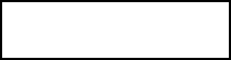

Data Store: Data storage includes the database of the system. It is represented by rectangle with both smaller sides missing or in other words within two parallel line.





**DATA FLOW DIAGRAM**

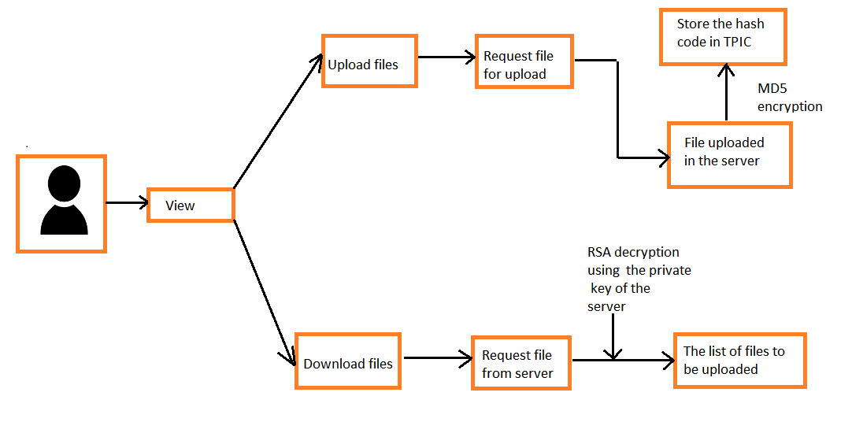

**USE CASE DIAGRAM:**

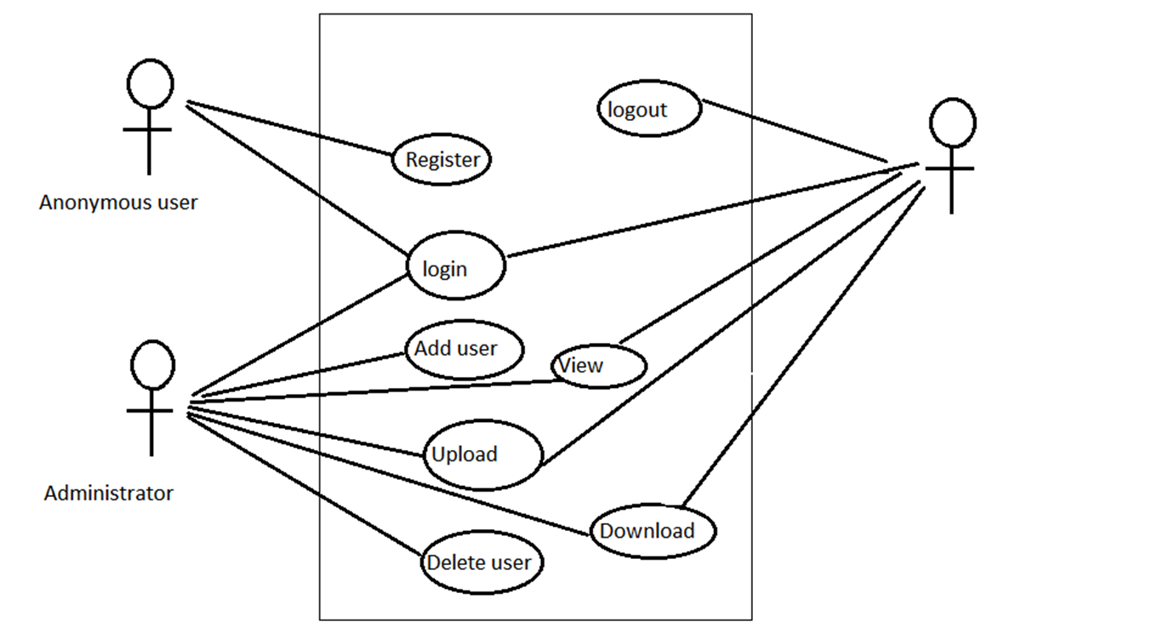

**CHAPTER-5**

**SCREENSHOTS:**

**FRONT PAGE OF THE WEBSITE:**

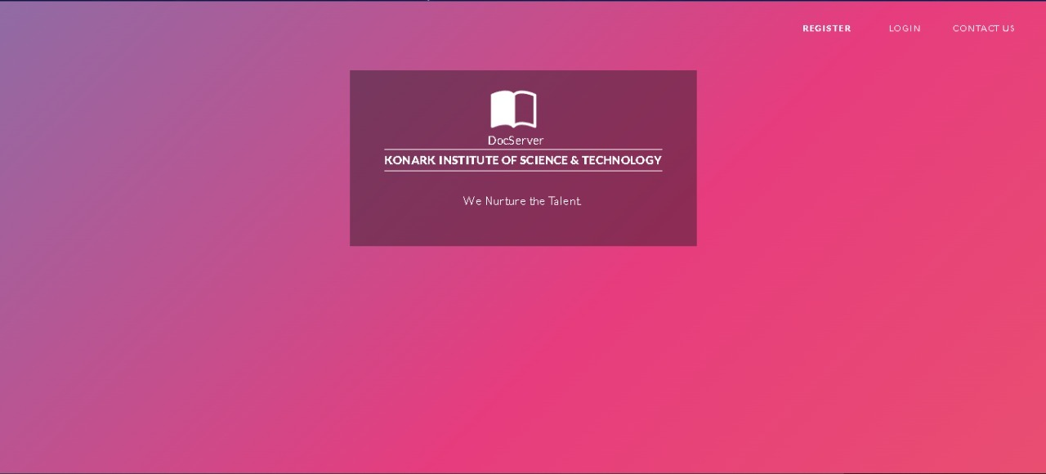

**AUTHENTICATION SYSTEM:**

**ADMIN:**

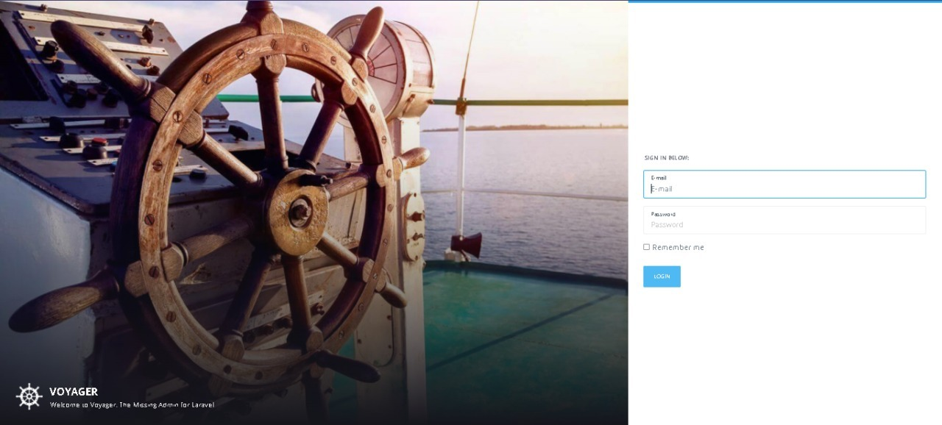

**USER:**

**REGISTRATION:**

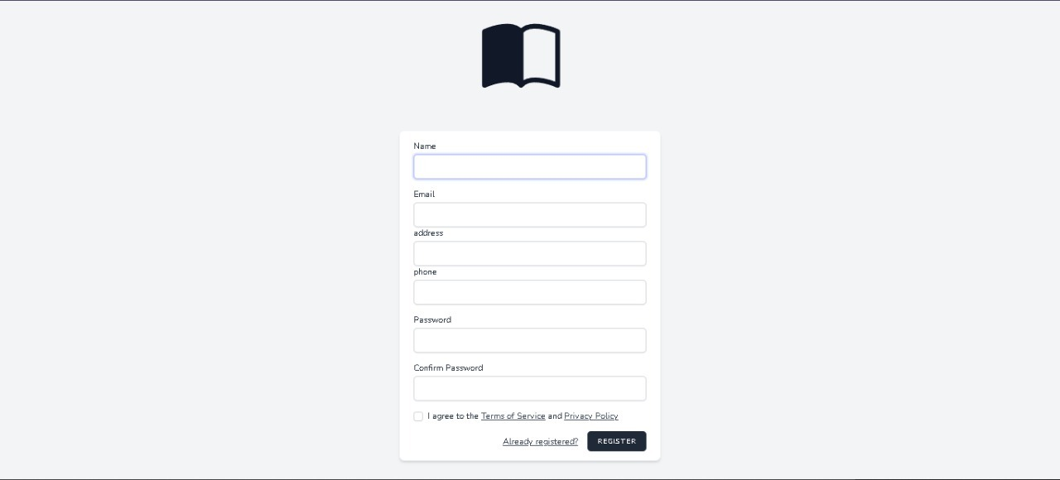

**LOGIN:**

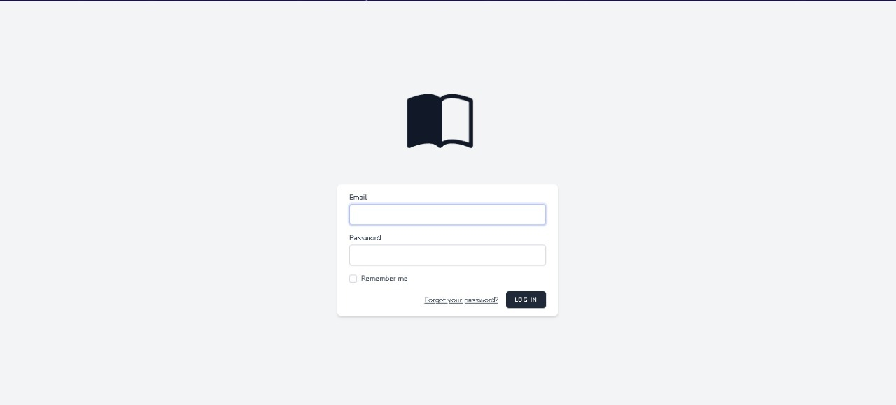

**USER:**

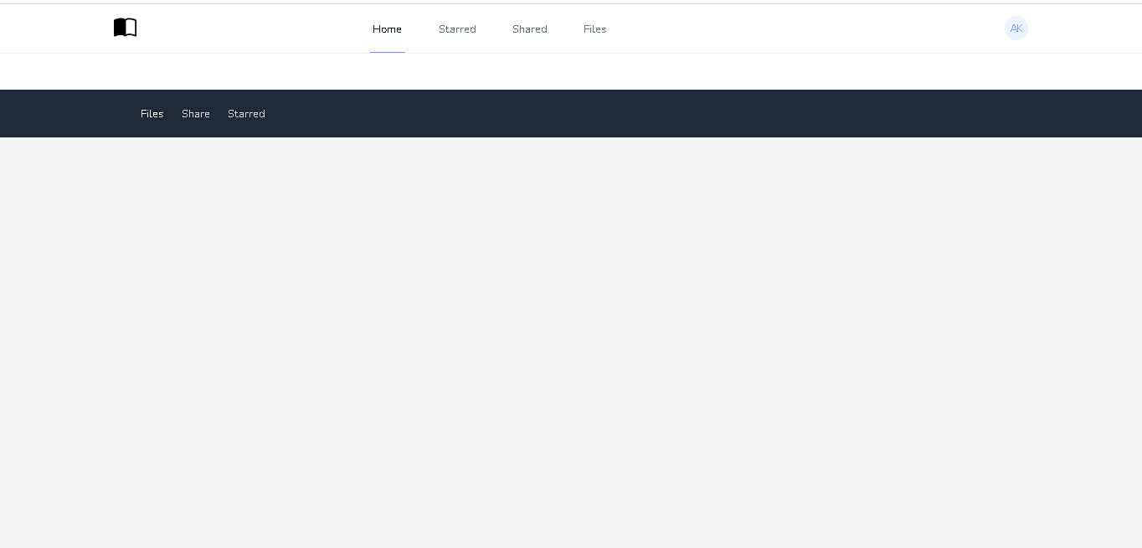

**ADMIN:**

**FILE MANAGEMENT:**



**UPLOAD:**

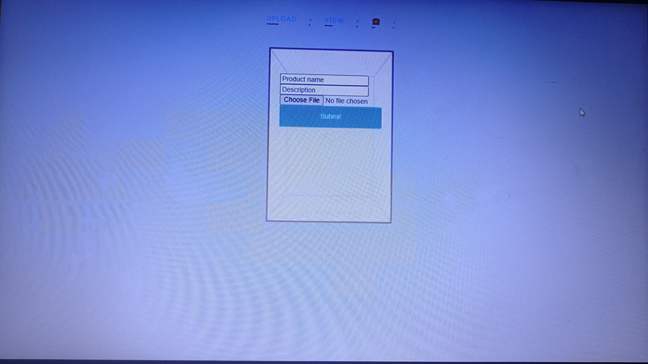

**VIEW & DOWNLOAD:**

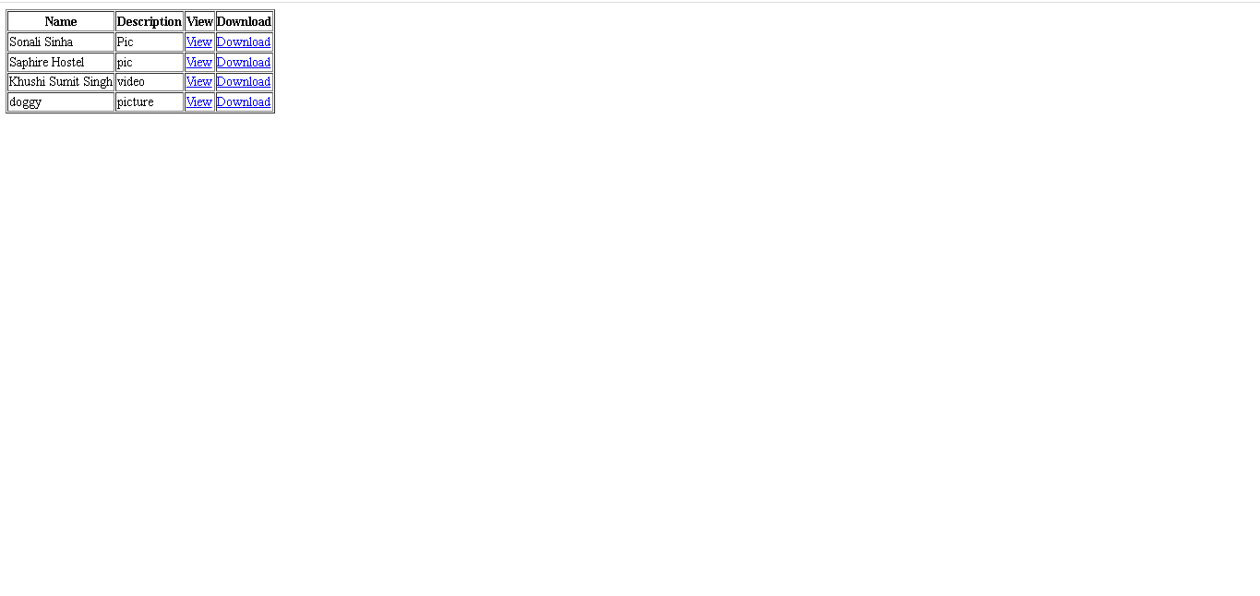

**EDIT & DELETE:**



**CHAPTER-6**

**IMPLEMENTATION:**

Today there is a real problem that users need to download files of different types, this process take a lot of the bandwidth of internet available for the users to get access to remote servers; this will make the internet service slow. A good solution for this problem is to implement a file sharing system within a local network which will reduce request time, meaning that files on the server are accessed easily and quickly. So, this will result in increasing the internet bandwidth available for the user.

**TECHNICAL DISCUSSION:**

File servers only make a remote file system accessible to clients. They can store any type of data-- for example, executable, documents, photos, videos.

They generally store the data as blobs of binary data or files. This means that they don’t perform additional indexing or processing of the files stored on them.

There may be additional plugins or server functions that can provide extra features, however.

A file server does not provide built-in ways to interact with the data and relies on the client to use it. Database are not considered file servers because databases only deal with structured data that is accessed by query.

Document Servers typically include features to enable multiple users to access them simultaneously:

* **Permission management** is used to set who can access which files and who has rights to edit or delete the files.
* **File locking** stops multiple users from editing the same file at the same time.
* **Conflict resolution** maintains data integrity in the event of files being overwritten.
* **A distributed file system** can make the data redundant and highly available by copying it to multiple servers at different locations.

**CHAPTER-7**

**TESTING:**

The purpose of testing is to discover errors. Testing is the process of trying to discover every conceivable fault or weakness in a work product. It provides a way to check the functionality of components, sub-assemblies, assemblies, and/or a finished product. It is the process of exercising software with the intent of ensuring that the software system meets its requirements and user expectations and does not fail in an unacceptable manner. There are various types of tests. Each test type addresses a specific testing requirement.

**UNIT TESTING:**

Unit testing is usually conducted as part of a combined code and unit test phase of the software lifecycle, although it is not uncommon for coding and unit testing to be conducted as two distinct phases. Test strategy and approach Field testing will be performed manually and functional tests will be written in detail. The entry screen, messages, and responses must not be delayed. Pages must be activated from the identified link. All field entries must work properly. All links should take the user to the correct page. No duplicate entries should be allowed. Verify that the entries are in the correct format.

**INTEGRATION TESTING:**

Software integration testing is the incremental integration testing of two or more integrated software components on a single platform to produce failures caused by interface defects. The task of the integration test is to check that components or software applications, ex. components in a software system or one step up software applications at the company level - interact without error.

**ACCEPTANCE TESTING:**

User Acceptance Testing is a critical phase of any project and requires significant participation by the end-user. It also ensures that the system meets the functional requirements. Test Results: All the test cases mentioned above passed successfully. No defects were encountered.

**CHAPTER-8**

**CHALLENGES:**

* **Managing Documents:**

Managing the same documents that exists in many places, when departments integrated with other departments, documents are become more difficult to manage.

* **Data Protection:**

There are several points to consider with data protection for file shares , Cases like data is corrupted , infected , or accidently deleted , and they should easily and quickly be restored to an up-to-date copy.

* **Performance:**

Shared file services serve important workloads that require a high, consistent performance and low levels of latency. Data no matter where it is requested must be immediately usable.

* **Backup & Archive:**

Preventing data loss required a sufficient method for backing up file data. Any loss of data or downtime will be too costly – in terms of lost revenue , reputation , customer churn, legal exposure, and more.

* **Security:**

Sending sensitive data to the cloud and having it accessible by vast numbers of users required that the data is protected with encryption, efficient key management , and role-based access restriction**.**

**CHAPTER - 9**

**CONCLUSION:**

The project named document server is a central server instance in a computer network that enables connected clients to access the server's storage capacities. The term encompasses both the hardware and software needed to implement such a server. As long as they have received the corresponding Authorizations, accessing users can open, read, change, delete and download files and folders on a Document server as well as even upload their own files to the server.

**LIMITATIONS:**

• Doc server can’t able to access unless user have an internet connection.

• When uploading and downloading files ,the speed become slow with many people using the website simultaneously.

• The larger network , it become more difficult to manage.

• Sometimes, it is possible that the same data/information may be duplicated in different files.

• Data is scattered in various files, also different files may have different files format.

Apart from storage, security and backup services the project will be having some extra functions of admin and users.

The security of admin and user will be upgraded to easy and convenient level.

The admin and user will be able to bookmark or add to favorite their important files.

**SCOPE OF FUTURE WORK:**

Also the common activities of admin and user such as upload, view, delete, share and download will be done.

Apart from storage, security and backup services the project will be having some extra functions of admin and users.

The security of admin and user will be upgraded to easy and convenient level.

The admin and user will be able to bookmark or add to favorite their important files.

Also the common activities of admin and user such as upload, view, delete, share and download will be done.

**CHAPTER-10**

**References:**

LARAVEL: <https://laravel.com/>

<https://www.javatpoint.com/laravel>

<https://kinsta.com/blog/laravel-tutorial/>

XAMPP: <https://www.apachefriends.org/>

<https://www.javatpoint.com/xampp>

PHP: <https://www.php.net/>

<https://www.tutorialspoint.com/php/php>

POSTGRESQL: <https://www.postgresql.org/docs/>

[https://www.javatpoint.com/postgresqltutorial](https://www.javatpoint.com/postgresql-tutorial)