Game Design Document

Fill up the following document

1. Write the title of your project.

Ans: Saving the Man

1. What is the goal of the game?

Ans: Man has to reach to his house, without touching the walls and the Monster. He has 3 chances for it.

1. Write a brief story of your game.

Ans: There is a man named Ramesh. He has lost his house but somehow he managed to find it. So now the man (Ramesh) has to reach to his house somehow without touching the walls and the Monster. The main question would be wheather he would be able to reach his house in 3 chances or not?

1. Which are the playing characters of this game?

* Playing characters are the ones who respond to the user based on the input from the user.
* Cars, monkeys, dinos, wizards, etc., are the playing characters in the game.

|  |  |  |
| --- | --- | --- |
| Number | Character Name | What can this character do? |
| 1 | Ramesh (Man) | This character can move by the arrow keys to reach to his house. |
| 2 |  |  |
| 3 |  |  |
| 4 |  |  |
| 5 |  |  |
| 6 |  |  |
| 7 |  |  |

1. Which are the Non-Playing Characters of this game?

* Non-Playing characters are the ones that don't have an action or behavior when the user interacts with the game.
* Hurdles, stones, bananas, coins, etc., are non-playing characters in the game.

|  |  |  |
| --- | --- | --- |
| Number | Character Name | What can this character do? |
| 1 | Monsters(Yellow Colour Balls) which would get Animation | This player is able to move by itself as it has its own velocity which is already defined. |
| 2 | Walls (Green Colour) which would get Animation | The player is not moving and it could not move anyhow. It is Static. |
| 3 | House (Blue Colour) which would get Animation | The player is blue in colour. It is also not moving. It is Static. Ramesh(Man) has to reach the house(this place). |
| 4 |  |  |
| 5 |  |  |
| 6 |  |  |
| 7 |  |  |
| 8 |  |  |

Draw your imagination of this game. What does this game look like?

* Draw the game either on your computer or on paper.
* Add images of the game scenes to show each of the playing and non-playing characters at least once.

Ans: Only Some changes to the game (like changing the animation etc.). Rest of them would reamin same. The final output of the game after three classes could differ from the below screenshot. The below screenshot is mostly likely it.

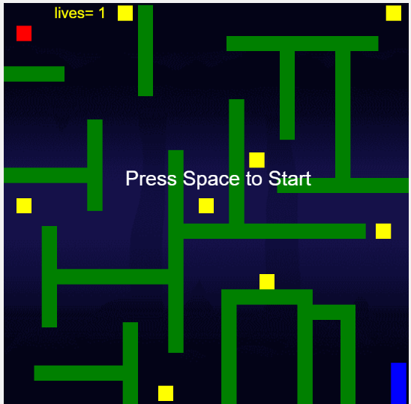

How do you plan to make your game engaging?

Ans:

1. By adding the Obstacles (Walls and Moanster), which I will be animating.
2. By giving 3 lives to the player.