**Lithium-Ion Battery as a service**

**Requirements**

Contents

Revision History 3

Introduction 4

Battery Management System 5

Embedded System 6

System Modes 6

Flow chart of mode switching 7

Flow Chart of ADD_CREDITS_MODE 8

Graphical User Interface 9

Liquid Crystal Display (LCD) 9

Keypad 13

# Revision History

|  |  |  |  |
| --- | --- | --- | --- |
| **Revision Number** | **Change Details** | **Author** | **Reviewer** |
| 0.0.1 | Initial Draft | Akshay | Soby |
| 0.0.2 | Added Requirement Details of BMS | Akshay | Sushant/Parag |
|  |  |  |  |

# Introduction

Electrification of Mobility sector by adoption of electric vehicles and renewable energy is trending. But high cost of Energy dense and longer lasting lithium battery used in energy storage hinders transition in many areas. To address this problem, we have a solution i.e., “Lithium Battery as a service”. This system will allow user to pay as you use battery service same as fuel station. Following are the features of the system:

* Intelligent Battery system built with ability to meter usage.
* Allows users access to high quality lithium battery at low upfront cost (security deposit).
* Users pre-pays for battery usage credits and enters credit code in battery system.
* Intelligent system in battery allows battery usage(discharge) for allowed credits.
* Battery discharge is disabled when credit expires.

To incorporate these features, this system will have 2 units.

1. Battery Management System (BMS)
2. Embedded System.

BMS is connected with battery pack. BMS will read battery characteristics and communicate these characteristics to embedded system with CAN protocol. Embedded system will have following tasks

1. Read data from BMS
2. Accept Credits from user with keypad
3. Display statistics on LCD display
4. If credits available expires disconnect load from battery pack

# Battery Management System

Typical BMS needs to satisfy below requirements:

|  |  |  |
| --- | --- | --- |
| **Sr No.** | **Title** | **Description** |
| 1 | Charging Statistics | - BMS provides CAN message to system about charger has been connected.  - BMS provides charging parameters like, 1] Time to full charge in hrs. and mins 2] Charging rate in current or power |
| 2 | Contactor control | - BMS provides a facility to turn off the battery connection from load with CAN message from controller such that, CAN message xyz message ID xyz data turns off the battery contactor  - BMS |
| 3 | SOC of battery pack | - BMS provides continuous CAN message for current SOC of battery pack |
| 4 | Discharge rate | - BMS provides details of current discharge rate in current or power ratings |
| 5 | Scalability and configurability | - BMS controller should be scalable to new upscaled battery pack. Ex. We deployed BMS with battery pack 36V and now we need new battery pack from same vendor BMS can be configured to new battery pack  - BMS needs to be configurable for frequency of CAN messages coming out of it. For ex. SOC message we need every 200ms or 100ms that can be configured through GUI of the vendor |

# Embedded System

Embedded system will have the following tasks to take care.

1. Read data from BMS
2. Based on the current discharge rate BMS needs to update the available credit count
3. Accept Credits from user with keypad
4. Display statistics on LCD display
5. If credits available expires disconnect load from battery pack

To accomplish above tasks, embedded system needs to be hooked up with

1. 4x4 switch matrix keypad
2. 20x4 LCD to display characters
3. Contactor to disconnect battery pack from load

## System Modes

At any point of time system will stay in one out of 5 modes:

1. ADD_CREDITS_MODE
2. CHARGING_MODE
3. CREDITS_EXPIRED_MODE
4. DEFAULT_MODE
5. POWER_DOWN_MODE

#### POWER_DOWN_MODE

When the battery state of charge reaches below threshold, the LCD is turned off to save power.

#### ADD_CREDITS_MODE

When ADD_CREDITS key is pressed the system enters into this mode. In this mode, the system accepts code from the user and validates the code entered. If code verification is successful credits stored in the system are updated. Users can press ADD_CREDITS key for 2 seconds while the system is in any other mode (not POWER_DOWN_MODE) and enters into this mode.

#### CREDITS_EXPIRED_MODE

As soon as the system is turned on, it checks if valid credits are available. If credits available goes zero, the system enters this mode and will not allow the user to discharge the battery with load.

#### CHARGING_MODE

Data read from BMS is interpreted by the system. From the information extracted if it is confirmed that charger is connected then the system enters into charging mode. In charging mode, the user can get an idea about remaining time to full charge and charging rate with the help of information displayed over GUI.

#### DEFAULT_MODE

When the system is not in any other mode, then it is the default mode of the system.  It displays discharge rate if load is connected.

### Flow chart of mode switching

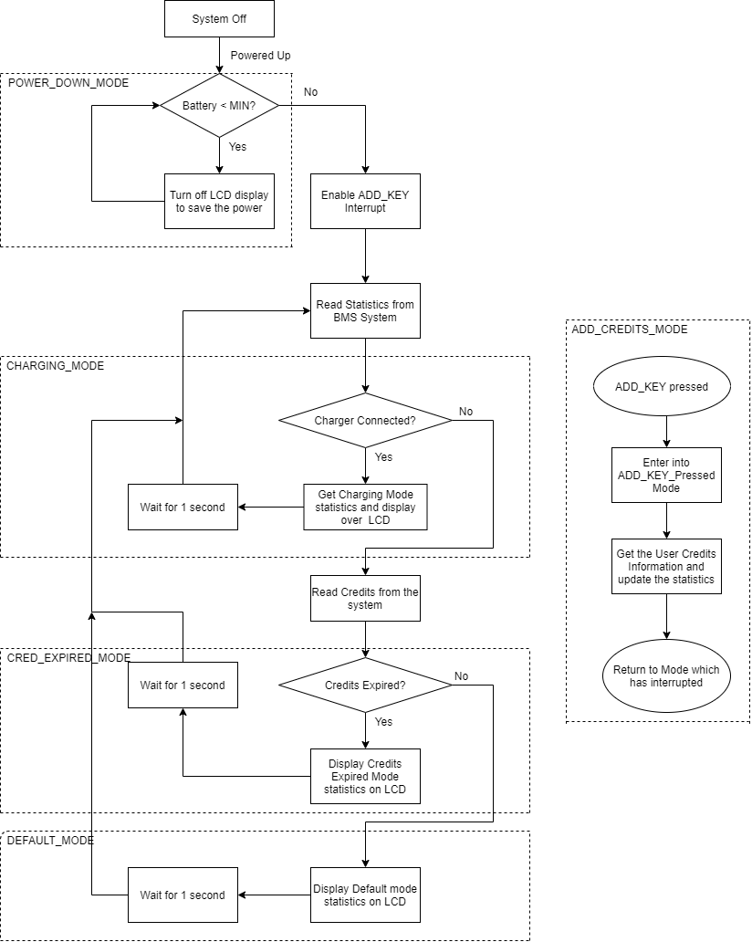

### Flow Chart of ADD_CREDITS_MODE

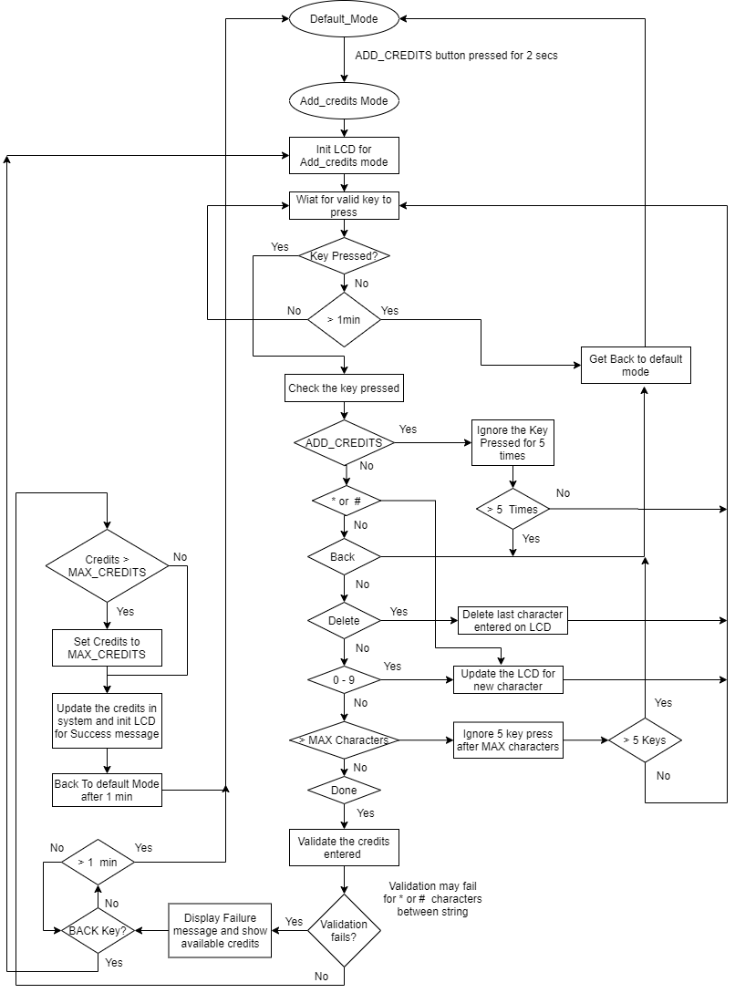

## Graphical User Interface

Graphical user interface of embedded system is as follows:

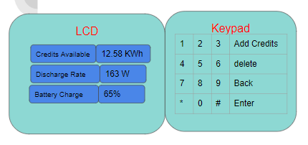

### Liquid Crystal Display (LCD)

LCD has different display messages in different system modes. Embedded system always stays in one out of the following modes.

1. ADD_CREDITS_MODE
2. CHARGING_MODE
3. CREDITS_EXPIRED_MODE
4. DEFAULT_MODE
5. POWER_DOWN_MODE

In the power down mode LCD and keypad remain off to save the power when battery SOC goes low.

ADD_CREDITS_MODE has 3 different messages to display over LCD:

1. ADD_CREDITS_MODE
2. ADD_CREDITS_MODE FAILURE
3. ADD_CREDITS_MODE SUCCESS

#### ADD_CREDITS_MODE

When the user presses the ADD_CREDITS key, the system enters into ADD_CREDITS_MODE and display is initialized to ADD_CREDITS_MODE.

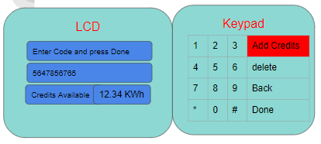

In this mode as shown in diagram above, rows display

1. “Enter Code & Done”
2. As user enters any of numbers this row should append numbers one after another
3. Credits to display with unit “KWh” and string displayed needs to be “Creds: XXXX.XX KWh“

#### ADD_CREDITS_MODE FAILURE

Once the user has entered the credits, the user presses the done button. After this process credits validation is carried out by the system. If credit validation fails, the user should display a failure message as shown in the diagram. This mode should display LCD with rows

1. String “FAILED”
2. String “BACK to enter code”
3. Credits to display with unit “KWh” and string displayed needs to be “Creds XXXX.XX KWh“

Note: When user enters * or # in between numbers code verification fails.

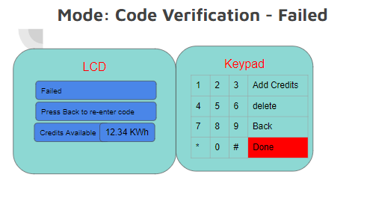

#### ADD_CREDITS_MODE SUCCESS

After the user has entered valid credits in a number code verification is carried out. If code verification succeeds, LCD display changes which displays rows:

1. String “SUCCESS”
2. String “CR ADDED XXXX.XX KW”
3. String “Creds XXXX.XX KWh”

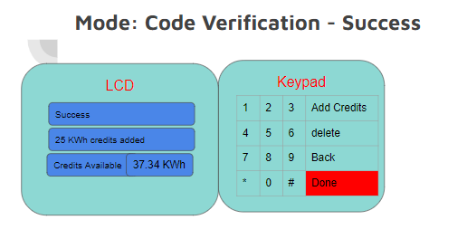

#### CHARGING_MODE

When the user has connected the charger to the battery pack, the system enters into this mode. System receives statistics from BMS and updates the LCD screen with rows:

1. String “XX hr XX min to full”
2. String “CHRGING @ XXXXXX W”
3. String “Battery XXX%”

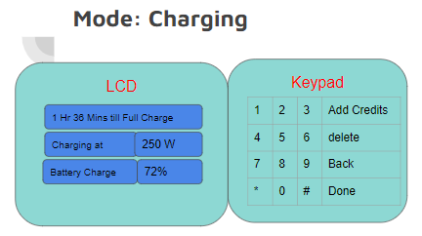

As soon as the user disconnects the charger, the user will enter into mode it was there earlier.

#### CREDITS_EXPIRED_MODE

System continuously monitors the credits available and as soon as credits available goes to zero, display changes to new message with rows

1. String “CREDS: 00.00 KWhr”
2. String “CREDS EXPIRED,ADD CR”
3. String “Battery: XXX %”

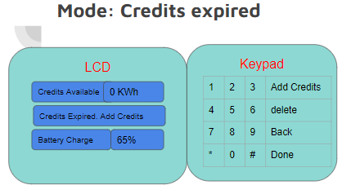

#### DEFAULT_MODE

When none of the above events happened, the system remains in default mode which is normal behavior of the system. Default mode displays statistics read from the BMS with rows on LCD as

1. String “Creds XXXX.XX KWh”
2. String “Discharge @ XXXXW”
3. String “Battery XXX%”

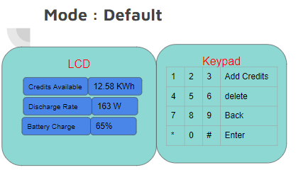

Note: Discharge rate can be zero as well when load is disconnected from battery pack in default mode. In such a case the discharge rate displayed will be 0W.

## Keypad

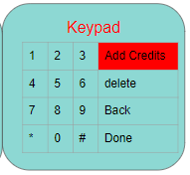

Keypad is 4x4 switch keypad with number keys 0 – 9 and special keys which has function described as below:

#### ADD_CREDITS key

The ADD_CREDITS key is pressed by the user to enter credits to the system. User needs to hold the key for 2 seconds.

#### Back Key

Back key is pressed by the user to get back to default mode from ADD_CREDITS mode.

#### Delete Key

Delete key is pressed by the user to delete one last character entered by the user.

#### Done Key

The Done key is pressed by the user to inform the system that the user has completed the process of entering credits.