Market Price Prediction

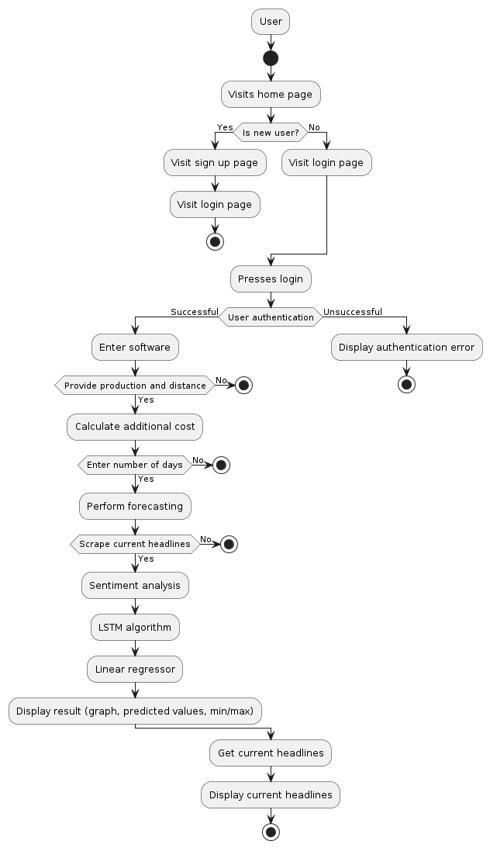

Cost for calculation of APMC market:-

Transportation cost= No_of_vehicles x 27 Rs/km (Porter)

No of vehicle = 70 bags in one vehicle

No of bags = 50 kg/ bag

Labour fee = total goods (in kgs) x 0.5 Rs

Admission fee = 350 x no of vehicle

**Total Cost = Transportation cost + Labour fee + Admission fee**