CHAPTER 1

Introduction

  - Background
A component tester is an essential device in electronics, used to check the functionality, value, and specifications of various electronic components like resistors, capacitors, diodes, transistors, and LEDs. These components form the building blocks of all electronic circuits, and their accurate evaluation ensures the reliability and efficiency of electronic devices. The need for component testers arises from the fact that faulty components can lead to malfunctioning circuits, increased debugging time, and even catastrophic failures in critical systems. Therefore, ensuring the quality and functionality of these components before integration is crucial in the design and maintenance of electronic systems.
Historically, the process of component testing was manual, relying on analog multimeters and oscilloscopes. Technicians would measure voltage, current, and resistance to determine component behavior. However, this method was time-consuming, required expert knowledge, and was prone to human error. As technology advanced, digital multimeters and specialized component testers emerged, providing more accurate and efficient testing solutions. These devices were initially limited to basic measurements but gradually evolved to include automated identification and parameter measurement features, enhancing user convenience and precision.
The development of microcontrollers and digital signal processing technologies has revolutionized component testing. Modern testers now use microcontrollers like Arduino, ESP32, and PIC to automate the testing process. These devices can detect the type of component connected and measure its value with high accuracy. For instance, resistors are measured using voltage dividers and Ohm's law, capacitors are evaluated based on charging time constants, and diodes are tested by observing forward voltage drops. Transistors are characterized by calculating their gain (hFE), and LEDs are tested for both forward voltage and brightness.
These advancements have made component testers more versatile and affordable. Today’s testers come equipped with digital displays like LCDs or OLEDs to provide real-time measurements, enhancing usability. Additionally, some advanced models include connectivity features like Bluetooth or Wi-Fi for remote monitoring and data logging, making them suitable for both educational and industrial applications.
The importance of component testers extends beyond basic measurements. In complex circuits, accurate component values are critical for ensuring desired performance. For example, in analog circuits, resistors and capacitors determine filter characteristics, while in digital circuits, they influence timing and signal integrity. Any deviation in component values can lead to malfunctioning circuits, emphasizing the need for precise testing.
Component testers are also crucial in the repair and maintenance of electronic devices. Faulty components are often the cause of circuit failures. By accurately identifying and measuring these components, technicians can quickly diagnose and fix issues, reducing downtime and maintenance costs. This capability is particularly valuable in industries such as telecommunications, automotive electronics, and consumer electronics, where reliability is paramount.
In educational settings, component testers serve as a valuable learning tool, helping students understand the practical aspects of electronic components and circuits. They provide hands-on experience in measuring and interpreting component values, bridging the gap between theoretical knowledge and real-world application.
In conclusion, component testers have evolved from simple analog devices to sophisticated digital systems, becoming indispensable tools in electronics design, maintenance, and education. Their importance lies in ensuring component reliability, enhancing circuit performance, and facilitating efficient troubleshooting. This project aims to build a cost-effective, versatile component tester that caters to the needs of students, hobbyists, and professionals alike.

  - Relevance
The component tester project is highly relevant to Electronics and Communication Engineering as it applies fundamental concepts of electronic circuits and semiconductor devices. Testing components like resistors, capacitors, diodes, transistors, and LEDs is crucial for designing reliable circuits. This project enhances understanding of component behavior and ensures circuit functionality, making it a practical application of theoretical knowledge.
Accurate component testing is essential in industries such as telecommunications, consumer electronics, and automation, where system performance and safety depend on precise component values. For example, resistors and capacitors affect timing and frequency characteristics, while diodes and transistors are key in signal rectification and amplification. Any deviation from specified values can lead to circuit failures, highlighting the importance of reliable testing.
Educationally, this project bridges the gap between theory and practice, allowing students to learn component measurement, circuit analysis, and troubleshooting. It also provides hands-on experience with microcontrollers, ADCs (Analog-to-Digital Converters), and digital displays, which are fundamental in modern embedded systems and IoT (Internet of Things) applications.
Overall, this project reinforces core electronics knowledge and prepares students for real-world applications in research, development, and maintenance of electronic systems. Its relevance to both academic learning and industrial needs makes it an ideal project for Electronics and Communication Engineering students.

  - Table 1: Literature Survey
Sr.No | Paper Title | Citation | Methodology | Findings | Future Scope
1 | Electronic Component Tester  Link | Ghannam, Bashar, and Omar Alfroukh. "Electronic Component Tester." (2021). | The project utilized an Arduino Mega 2560 connected to a PC via USB, with a Java-based application as the user interface. A custom PCB was designed using EasyEDA, featuring specialized sockets for various components. The Arduino IDE was used to write test-specific codes, enabling the system to perform functional testing and display results via the PC application. | The project successfully developed a low-cost, user-friendly electronic component tester. It could test 17 types of components, including LEDs, sensors, motors, and displays, using dedicated sockets on a custom PCB. Test results were displayed visually (e.g., blinking LEDs) or through a Java-based PC application. The system addressed limitations of existing testers by supporting multiple components and offering ease of use, making it viable for labs and electronic shops. | The project can be expanded to support additional components and integrate with various operating systems like iOS and Android. Wireless communication, such as Bluetooth, can be added for improved connectivity. Additionally, the system can be commercialized as a market-ready product for use in electronic shops and educational institutions.
2 | Design and implementation of an intelligent universal electronic  components’ tester  Link | CHERFAOUI Mehdi, CHOUITER Fouad. Design and implementation of an intelligent universal electronic components’ tester. Diss. 2023. | The tester uses an Arduino Nano microcontroller as the core component. Passive components (resistors, capacitors, and inductors) are tested via specific circuits, algorithms, and the RC time constant principle. Active components (diodes and transistors) are tested by measuring parameters like voltage drops, threshold voltages, and current gains. The design integrates a CD4052 analog multiplexer for auto-ranging and efficient signal routing, paired with custom software for measurement and data processing. | The tester demonstrated high accuracy and versatility in testing a range of electronic components, such as resistors, capacitors (10 pF to 4 F), inductors, diodes, and transistors. It successfully identified transistor types (BJT/MOSFET) and their parameters, as well as diode continuity. Despite challenges, such as pin limitations and unavailable resources, the project achieved its objectives and proved reliable in delivering consistent results. | The project can be enhanced with:  Expanded measurement ranges for components.  Integration of wireless communication (e.g., Bluetooth) for data transfer.  Support for additional components and advanced algorithms.  Commercialization as a compact and cost-effective universal tester.
3 | Development of Arduino-based Electronic Component Testing Device  Link | Entienza, Rexcel. "Development of Arduino-based Electronic Component Testing Device." (2024). | The project utilizes an Arduino Mega 2560 microcontroller as the core unit for testing resistors, capacitors, bipolar junction transistors (BJTs), and selected integrated circuits (ICs). The system features separate testing modes for each component type, with an LCD providing user instructions and displaying test results. The hardware design incorporates a DC-DC voltage regulator, ZIF sockets for IC testing, and automated calibration functions, while the software ensures accurate measurements and testing procedures via preprogrammed algorithms. | The device achieved its goal of providing a low-cost, user-friendly solution for electronic component testing. It can measure resistor values, capacitor capacitance, transistor type and forward voltage, and IC labels and conditions. The device also includes rechargeable batteries and an automatic calibration feature, simplifying testing and reducing user effort. However, it has limitations, such as support for a limited range of components and the inability to notify users about improperly inserted components. | Enhanced Component Support: Expanding compatibility to include more types of resistors, capacitors, transistors, and ICs.  Improved Hardware: Upgrading the ZIF socket to accommodate multiple components and introducing a larger display for better user experience.  Advanced Features: Adding notification messages for improper component placement and integrating an inventory algorithm to track testing history.  Portability: Reducing the chassis size for improved portability and appearance.
4 | BIPOLAR TRANSISTOR TESTER / DIGITAL IC TESTER FOR PHYSICS LAB  Link | Baddi, Raju. "Bipolar Transistor Tester/Digital IC Tester for Physics Lab." arXiv preprint arXiv:1203.2861 (2012). | The paper presents a Digital IC Tester that consists of a jig for configuring logic states, a logic probe with dual op-amps to detect and display logic levels, a variable voltage generator using a germanium transistor for precise input control, and a pulse generator utilizing NE556 timers to create varying logic signals for testing. The system includes push-button switches for easy state control. | The tester effectively identifies and tests logic states, transitions, and pulse behaviors, with a dual-color LED indicating logic states. The use of germanium transistors ensures compatibility with TTL devices, and the pulse generator enables both short and continuous pulse tests. | Future enhancements could include automation for large-scale testing, expanded compatibility with more complex ICs, a more user-friendly interface, and the addition of test parameters like temperature variation for broader application scenarios.

  - Motivation
The motivation behind developing a component tester arises from the limitations and challenges associated with existing testing methods. Many available component testers are either expensive or limited in functionality, restricting their use to specific components or requiring advanced technical knowledge. Additionally, traditional testing methods using analog multimeters are time-consuming, prone to human error, and lack precision, especially for complex components like transistors and capacitors.
In educational environments, students often struggle to understand the practical behavior of electronic components due to a lack of affordable and versatile testing tools. This gap between theoretical knowledge and hands-on application hinders effective learning and problem-solving skills. A cost-effective, user-friendly component tester can bridge this gap, providing students with practical exposure to circuit design and analysis.
This motivation drives the need to create a comprehensive tester that is affordable, versatile, and easy to use, addressing current limitations while enhancing learning and application in electronics.

  - Aim of the Project
The aim of this project is to design and develop a versatile component tester capable of accurately identifying and measuring electronic components, including resistors, capacitors, diodes, transistors, and LEDs. The tester will automatically detect component type and display key parameters such as resistance, capacitance, forward voltage, and transistor gain on a digital screen. It seeks to provide a cost-effective and user-friendly solution, suitable for students, hobbyists, and professionals. By ensuring precise measurements and compatibility with various component packages, this project aims to enhance learning, prototyping, and maintenance of electronic circuits.

  - Scope and Objectives
Scope of the Project
The component tester project focuses on designing a simple, affordable, and efficient device that can test and measure the most commonly used electronic components—resistors, capacitors, diodes, transistors, and LEDs. The device will be capable of automatically identifying the component type and displaying key parameters such as resistance, capacitance, diode voltage drop, transistor gain, and LED functionality.
This project is intended for students, hobbyists, and professionals who need an easy-to-use tool for learning, prototyping, and troubleshooting circuits. It will be designed with a microcontroller-based system, an LCD or OLED display for easy reading, and a simple user interface. The tester will be compact, portable, and capable of testing various component types with high accuracy.
Additionally, the project has the potential for future upgrades, such as adding support for inductors, integrating Bluetooth or Wi-Fi for remote monitoring, and improving measurement precision for industrial applications.
Objectives of the Project
- Accurate Measurement: Ensure precise measurement of resistance, capacitance, diode forward voltage, transistor gain, and LED performance.
- Automatic Component Identification: The device should automatically detect and display the type of component being tested.
- User-Friendly Interface: Provide a simple and clear display for easy understanding of results.
- Cost-Effective Design: Develop a low-cost alternative to expensive commercial component testers.
- Educational Use: Serve as a learning tool for students to understand electronic components and circuit testing.
- Portable and Compact: Design a lightweight and easy-to-carry device for convenience.
- Versatility: Ensure compatibility with a wide range of components and different packaging types.

CHAPTER 2
Description of Project
2.1 Technical Approach
The component tester is designed using a microcontroller-based system to automatically identify and measure electronic components such as resistors, capacitors, diodes, transistors, and LEDs. The testing process is based on electrical properties such as resistance, capacitance, voltage drop, and gain, which are analyzed using various circuits and algorithms.
For resistors, the microcontroller measures the voltage drop across the unknown resistor using a voltage divider circuit and calculates the resistance using Ohm’s law. Capacitors are tested by applying a known voltage and measuring the charging time constant, which is used to determine capacitance. Diodes are tested by applying a small forward voltage and measuring the voltage drop, distinguishing between standard and Zener diodes. Transistors are identified and tested by measuring the current gain (hFE) using a base current injection method. LEDs are tested similarly to diodes, with an additional brightness test.
An ADC (Analog-to-Digital Converter) is used to read voltage levels, and the results are processed using the microcontroller. The measured values are then displayed on an LCD or OLED screen, providing real-time feedback. A multiplexer circuit enables switching between different components, allowing the device to test various types of components with minimal user intervention.
This approach ensures an accurate, efficient, and cost-effective solution for electronic component testing.

2.2 Block diagram
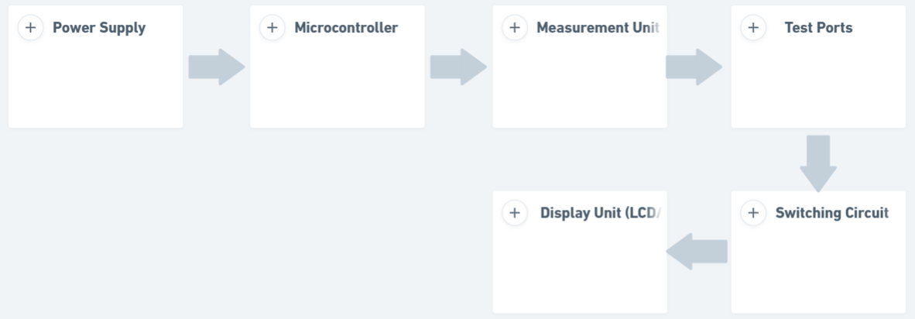
Fig No. 2.1 Block Diagram Representation of Component Tester
1. Power Supply
Provides necessary voltage and current.
Can include voltage regulators, batteries, or adapters.
2. Microcontroller
The brain of the system, controlling testing operations.
Interfaces with other blocks like measurement unit, display, and input.
3. Measurement Unit
Handles different tests:
Resistance Measurement (Ohm’s Law-based voltage drop method).
Capacitance Measurement (RC charging/discharging method).
Diode Testing (Forward voltage and reverse leakage test).
Transistor Testing (HFE gain and switching behavior).
Includes ADC (Analog-to-Digital Converter) for precise readings.
4. Test Ports
User connects components (Resistor, Capacitor, Diode, Transistor, LED).
May have different sockets or probes for each type.
5. Switching Circuit
It uses a switch.
6. Display Unit (LCD/OLED)
Shows results like resistance (Ω), capacitance (µF), diode voltage drop (V), etc.
2.3 Flow chart
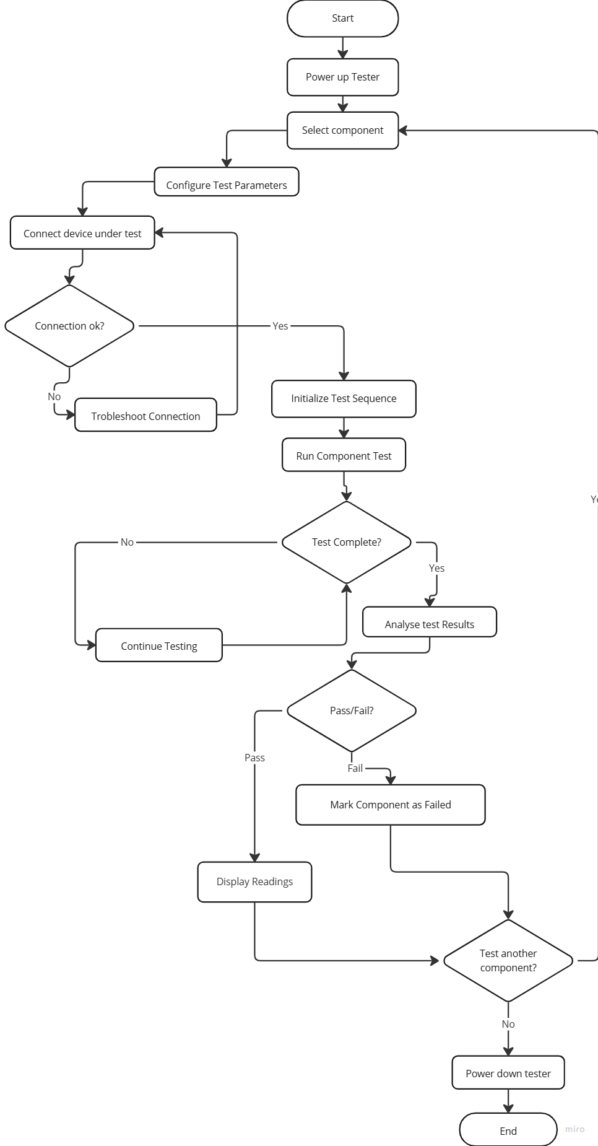
Fig No. 2.2 Flow Chart Representation of Component Tester System Architecture
2.4 Hardware / software resources
Hardware Resources
- Microcontroller Unit (MCU)
  - Model: Arduino Uno / ESP32 / ATmega328P
  - Specifications:
    - 8-bit microcontroller
    - Operating voltage: 5V (Arduino) / 3.3V (ESP32)
    - Flash Memory: 32 KB (Arduino Uno) / 4 MB (ESP32)
    - ADC: 10-bit (Arduino) / 12-bit (ESP32)
  - Purpose: Controls the entire testing process, reads measurements, processes data, and displays results.
- Display Unit
  - Type: 16x2 LCD / OLED Display (I2C)
  - Specifications:
    - Operating voltage: 5V (LCD) / 3.3V (OLED)
    - Communication: Parallel (LCD) / I2C (OLED)
  - Purpose: Displays measured component values and status messages.
- Measurement Circuit
  - Resistors: Used in voltage divider circuits to measure resistance.
  - Capacitors: Help determine capacitance by measuring charging time.
  - Diodes and Transistors: Tested using voltage drop and current gain (hFE) circuits.
  - Multiplexer (CD4051/74HC4051): Allows the microcontroller to switch between different component types for testing.
- Power Supply Unit
  - Source: USB Power Supply
  - Regulator: 7805 (for 5V stabilization)
  - Purpose: Provides stable power to the microcontroller and other components.
Software Resources
- Programming Environment
  - Arduino IDE: Used for coding and uploading programs to the microcontroller.
- Libraries Used
  - LiquidCrystal.h / U8g2.h: For LCD and OLED display control.
  - Wire.h: Enables I2C communication with the display and other sensors.
  - EEPROM.h: Used for storing calibration data.
- Algorithm Implementation
  - Ohm’s Law calculations for resistor measurement.
  - Time constant method for capacitor testing.
  - Voltage drop detection for diodes and LEDs.
  - Current gain (hFE) calculation for transistors.
This combination of hardware and software ensures an efficient and accurate component tester suitable for students, hobbyists, and professionals.

CHAPTER 3
System Design
3.1 Circuit diagram

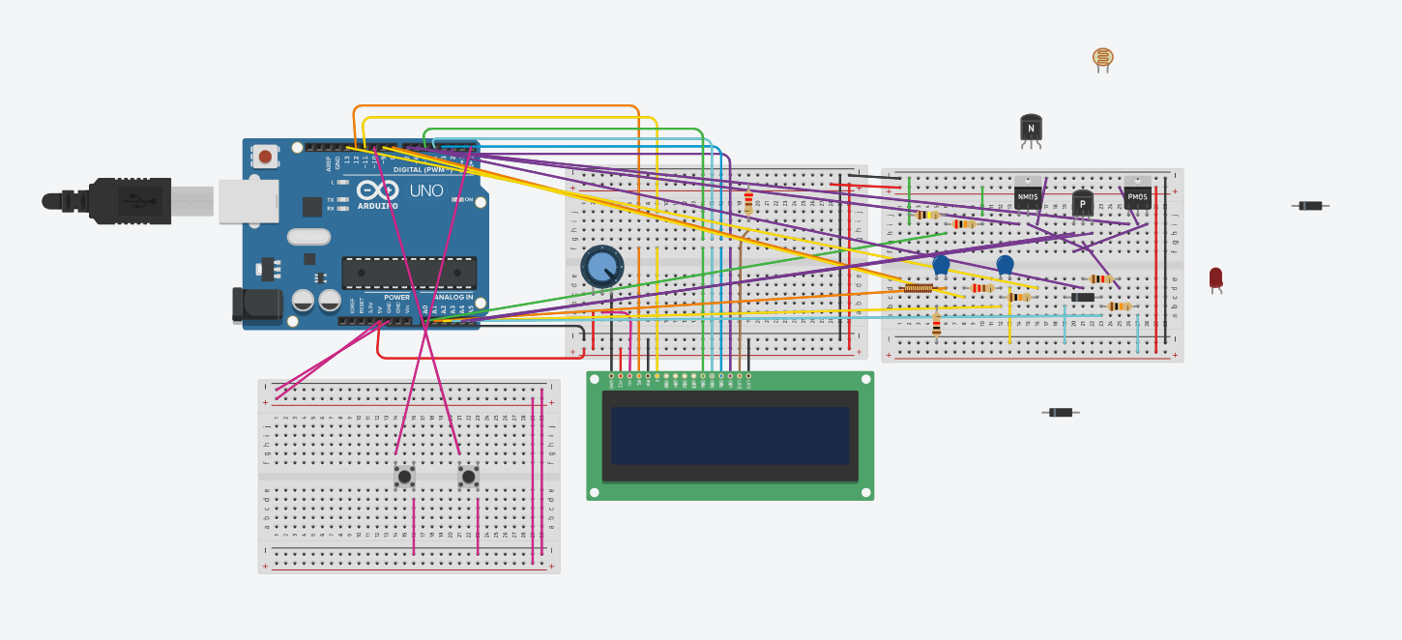
Fig No. 3.1 Tinkercad circuit diagram of Component Tester
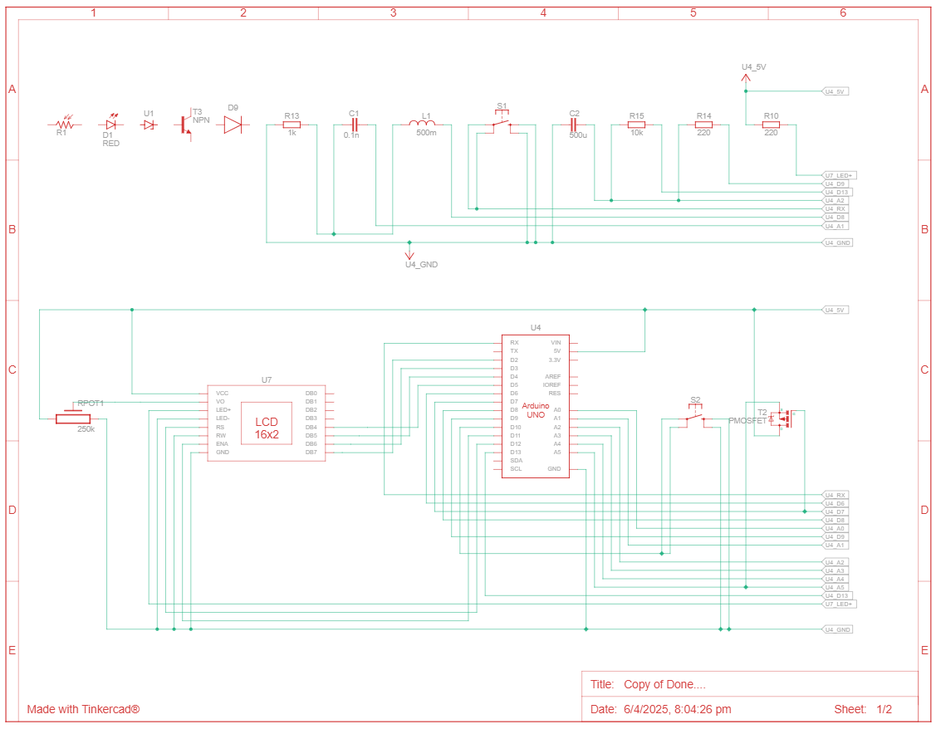
Fig No. 3.2 Schematic view of circuit diagram of Component Tester
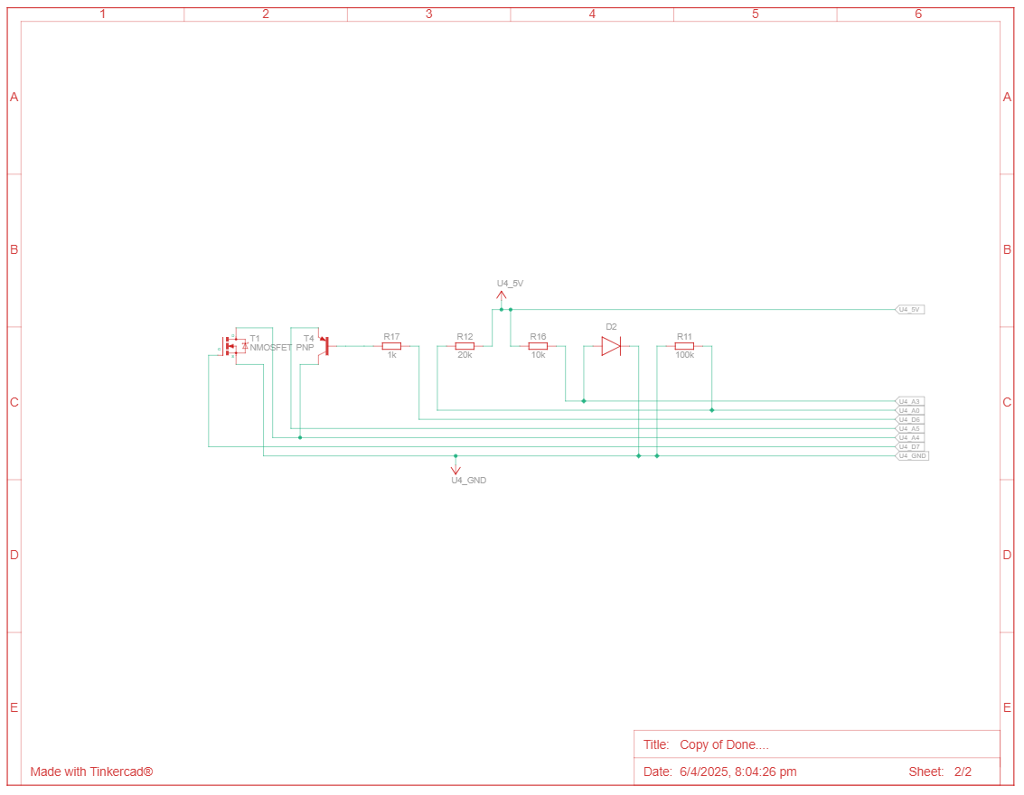
Fig No. 3.3 Schematic view of circuit diagram of Component Tester
1. Arduino Uno (Controller Board)
Acts as the central microcontroller unit, responsible for signal generation, analog and digital readings, and data processing.
Digital and analog pins are connected to various parts of the test circuit for sensing and output.
USB connection is used to power the Arduino and upload code from a PC.

2. 16x2 LCD Display
Positioned at the bottom center of the circuit.
Used to display component type and values (resistance, voltage drop, etc.).
Connected via digital pins D2 to D7 for data, and RS, EN pins via other digital I/O.
A potentiometer is connected to control the contrast of the display.

3. Component Testing Breadboard (Right Side)
Contains:
Resistors and capacitors used for reference and biasing.
Transistors (NPN and PNP) and MOSFETs (PMOS and NMOS) for testing.
Diodes and LEDs to evaluate forward voltage drop and direction.
LDR (Light Dependent Resistor) at the top, connected in a voltage divider to sense light levels.
Multiple jumper wires connect these components to the Arduino’s analog/digital pins for measurement and triggering.

4. Buttons and Extra Breadboards (Bottom Left)
Two tactile push buttons are connected to be used for:
Initiating the test
Resetting or switching modes
Pull-down resistors ensure proper logic levels.
Additional breadboard used for future expansion or testing components externally.

5. Potentiometers
One potentiometer is used to adjust LCD contrast.
Additional potentiometers might be used in voltage divider configurations for calibration or analog input simulation.

6. Wiring and Power Supply
Red and black wires are used consistently for Vcc (5V) and Ground (GND) rails across all breadboards.
Power is distributed via horizontal rails ensuring consistent voltage across the circuit.
The circuit is powered either via USB or from an external adapter connected to the Arduino.

Functionality
This circuit enables the user to:
Detect and identify the type of component inserted into the test slots.
Display the value of resistance, capacitance, or diode drop on the LCD.
Classify transistors and determine pin configuration.
Measure light sensitivity using the LDR.

CHAPTER 4
Implementation and Testing
4.1 Implementation
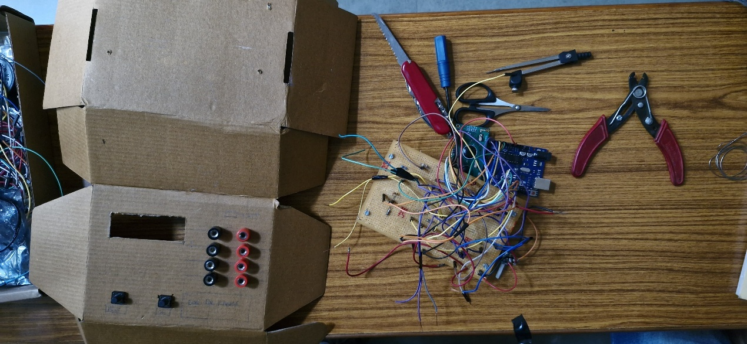
Fig No. 4.1 Circuit of Component Tester
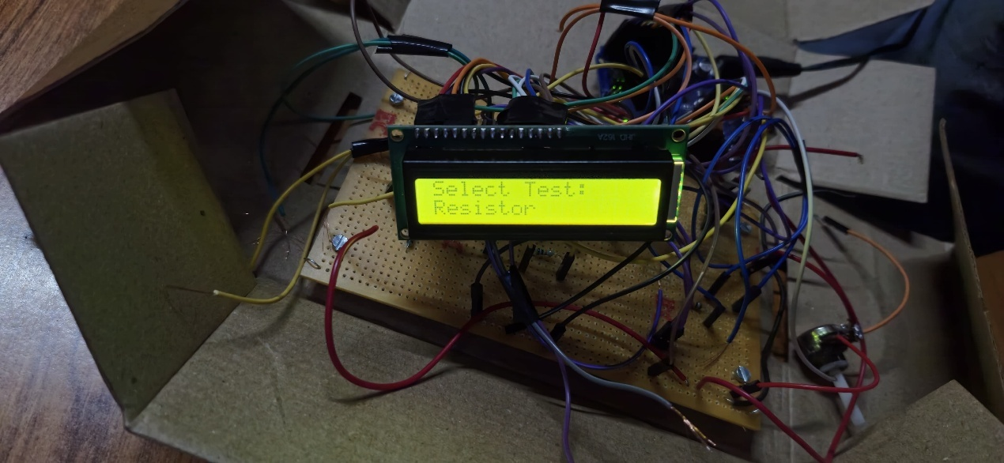
Fig No. 4.2 Circuit of Component Tester

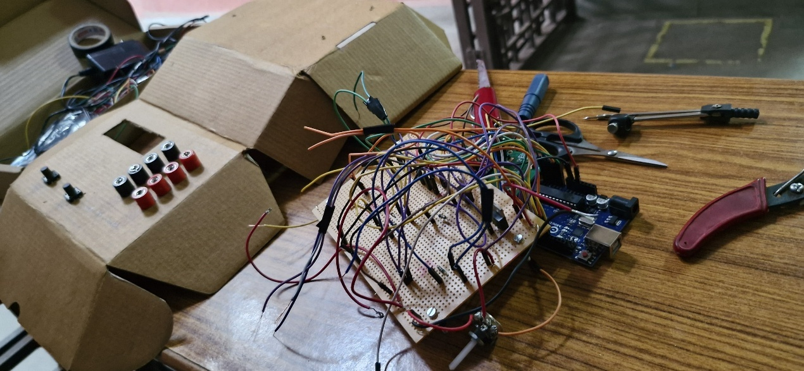
Fig No. 4.3 Circuit of Component Tester
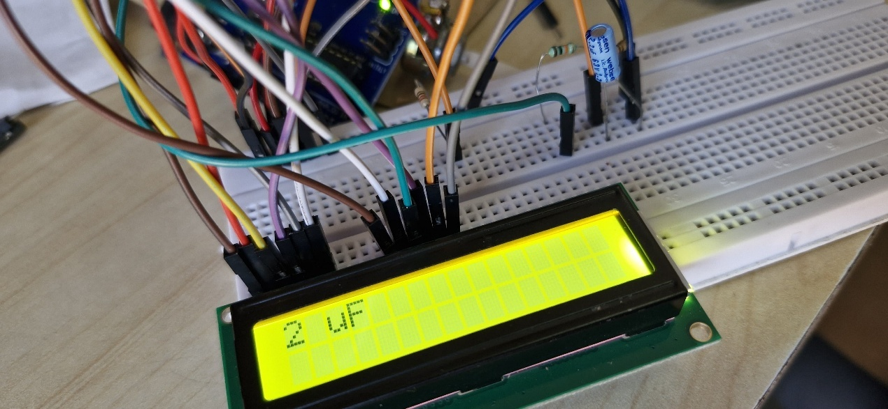
Fig No. 4.4 Circuit of Component Tester
1. Enclosure Design (Left Side)
- The cardboard enclosure has been custom-cut and folded to form a basic casing for the component tester. This low-cost prototype housing ensures ease of modification during testing.
- The front panel includes:
  - A rectangular cutout: Reserved for an LCD display to show measured values and component details such as resistance, capacitance, voltage drops, etc.
  - Six terminal ports (banana jacks): Arranged in two vertical columns, these are used to connect the electronic components under test (resistors, capacitors, diodes, transistors, etc.).
  - Two tactile push buttons: These likely serve functions such as initiating the test or toggling between modes (e.g., auto-detect, manual selection).
2. Internal Circuit and Wiring (Right Side)
- The prototyping area includes a perforated board (perfboard) populated with several components and wires.
- A microcontroller board (Arduino UNO) is visible, serving as the core processing unit of the tester. It handles signal generation, component detection, and data display.
- The colorful jumper wires connect the microcontroller to various input/output points on the perfboard. These connections allow for signal routing to different component sockets and the display.
- Tools like a wire stripper, screwdrivers, compass (for measurements), and scissors suggest this is an active hardware development stage.
3. Tools and Workspace
- The workspace is organized on a wooden table with essential tools for electronics prototyping:
  - Wire cutter/stripper: For cutting and preparing jumper wires.
  - Screwdrivers: Used for tightening terminals or attaching components.
  - Swiss knife: Multi-functional tool for trimming or opening.
  - Compass: Possibly used for marking hole positions on the enclosure.
4. Development Stage
This image reflects the initial hardware integration and mechanical design phase. At this point:
- Circuit connections are being finalized and tested.
- The enclosure is being tailored to fit the final electronic layout.
- Component identification and measurement algorithms are being tested using Arduino IDE.
5. Project Purpose
The overall goal of the component tester is to provide a compact, affordable tool for identifying and testing common electronic components. Once assembled, this tester will:
- Automatically detect components like resistors, capacitors, diodes, transistors, and LEDs.
- Display their parameters on an LCD screen.
- Provide a user-friendly interface with minimal controls.

4.2 Testing and debugging
Power Supply Testing
Steps Taken:
- Connected the circuit to a 5V regulated power supply via the Arduino UNO.
- Used a multimeter to check voltage at different points (Arduino VIN, VCC, GND, and sensor input).
Issues Faced & Debugging:
Issue 1: Arduino not turning on properly
- Cause: Loose USB connection or faulty power supply.
- Fix: Replaced the USB cable and used a stable power source (external adapter).
Issue 2: Voltage fluctuations at different circuit nodes
- Cause: Lack of proper decoupling capacitors, which led to unstable readings.
- Fix: Added 10µF and 100nF capacitors near the Arduino’s VCC and GND to stabilize voltage.
LCD/OLED Display Testing
Steps Taken:
- Uploaded a test program to display simple text (Hello, World!).
Issue : LCD text not visible
- Cause: Incorrect contrast setting.
- Fix: Adjusted the potentiometer on the LCD module.
Component Testing (Resistors, Capacitors, Diodes, Transistors)
Resistor Measurement
Working Concept: Used voltage divider method with Arduino’s ADC (Analog-to-Digital Converter) to measure resistance.
Issues Faced & Debugging:
Issue : Resistance values are inaccurate
- Cause: Incorrect voltage reference for analogRead() function.
- Fix: Used analogReference(DEFAULT) (5V) and checked ADC calibration.
Diode Testing
Working Concept: Applied a small voltage and checked the forward voltage drop using Arduino’s analog pins.
Issues Faced & Debugging:
Issue : No response from the diode
- Cause: Diode polarity reversed.
- Fix: Swapped anode and cathode connections and re-tested.
Issue : Diode always reads as "bad"
- Cause: No pull-down resistor, leading to floating values.
By testing step by step (Power → Display → Measurement → Switching), we identified and resolved common issues, making the Arduino UNO-based component tester more accurate and reliable.

CHAPTER 5
Results and conclusion
5.1 Results
Table 2: Resistor Value Range Used in Testing
Resistor value  (colour bands) | Min(Actual)  In Ω | Max(Actual)  In Ω | Min(tester)  In Ω | Max(Tester)  In Ω
560kΩ ± 5% | 520k | 588k | 592.3k | 630k
120kΩ ± 5% | 114 k | 126k | 122.9k | 124.7k
220kΩ ± 5% | 209k | 231k | 219.5k | 229.5k
330kΩ ± 5% | 313.5k | 349.5k | 333k | 343.5k
560Ω ± 5% | 532 | 588 | 556 | 567.6
270kΩ ± 5% | 256.5k | 283.5k | 282.5k | 291.1k
10kΩ ± 5% | 9.5k | 10.5k | 9.92k | 9.96k
1.2kΩ ± 5% | 1.14k | 1.26k | 1.20k | 1.12k
1kΩ ± 5% | 950 | 1.05k | 987.12 | 1.02

Table 3: Capacitor Value Used in Testing
Capacitor Value | Practical Value
100 µF | 97 µF
10 µF | 9 µF
2.2 µF | 2 µF
1000 nF | 1000 nF
100 nF | 99 nF
Table 4: Inductor Value Used in Testing
Inductor Value | Practical Value
75 mH | 77.6 mH
100 mH | 114.5 mH
200 mH | 196.5 mH
300 mH | 317.2 mH
500 mH | 511 mH
745 mH | 753 mH
1 mH | 1.02 mH
2 mH | 2.03 mH
6 mH | 6.1 mH

5.2 Conclusion
The Component Tester project successfully delivers on all key objectives, offering precise measurement capabilities for various electronic components while automatically identifying component types. Its user-friendly interface presents complex data clearly, making it accessible to beginners and experienced users alike. The cost-effective design provides an affordable alternative to expensive commercial testers, while its portable nature ensures convenience in various settings. As both a practical tool and educational resource, this versatile device accommodates different component types and packages, making it valuable for students learning electronics fundamentals and hobbyists working on diverse projects. The tester represents an ideal balance of functionality, affordability, and accessibility.
5.2 Future Scope
- Enhanced Measurement Range: Implement circuit improvements to accurately measure ultra-low capacitances and high-value resistors with better noise rejection techniques.
- Temperature Compensation: Add temperature sensing and automatic calibration to improve measurement accuracy across varying environmental conditions.
- IC Testing Capability: Expand functionality to test basic digital ICs such as logic gates, flip-flops, and simple microcontrollers.
- Wireless Connectivity: Integrate Bluetooth/Wi-Fi capabilities to connect with smartphones or computers for data logging and analysis.
- Machine Learning Integration: Implement algorithms to predict component failures based on parameter drift or anomalous readings.
- Graphical Analysis: Add capability to plot component characteristics (like transistor curves) on external displays.
- Power Analysis: Extend functionality to measure component power consumption and efficiency metrics.
- Battery Health Testing: Include specialized tests for measuring battery internal resistance and capacity.
- Multi-Component Testing: Develop fixtures to test multiple components simultaneously for production environments.
- Open Source Community Platform: Create an expandable framework allowing users to contribute test procedures for specialized components.

Bill of material
Table 5:
Component | Quantity | Amount
Arduino Uno R3 | 1
LCD 16 x 2 | 1
250 kΩ Potentiometer | 1
220 Ω Resistor | 2
100 kΩ Resistor | 1
500 mH Inductor | 1
0.1 nF Capacitor | 1
1 kΩ Resistor | 2
500 uF Capacitor | 1
10 kΩ Resistor | 2
Diode | 2
nMOS Transistor (MOSFET) | 1
pMOS Transistor (MOSFET) | 1
NPN Transistor (BJT) | 1
Pushbutton | 2
5.1 V Zener Diode | 1
PNP Transistor (BJT) | 1
Red LED | 1
20 kΩ Resistor | 1
Photoresistor | 1

References
Books
- "Practical Electronics for Inventors" by Paul Scherz and Simon Monk
- "The Art of Electronics" by Paul Horowitz and Winfield Hill
- "Electronic Test Instruments: Analog and Digital Measurements" by Robert Witte

Transactions/Journals
- IEEE Transactions on Instrumentation and Measurement
- Journal of Electronic Testing: Theory and Applications (JETTA)

Websites
- https://www.eevblog.com (Electronics Engineering Video Blog)
- https://www.analog.com/en/technical-articles.html
- https://www.ti.com/lit/an (Texas Instruments Application Notes)
- https://www.circuitlab.com/community/
- https://www.componenttester.com
- https://www.mikrocontroller.net/articles/AVR_Transistortester (Open source AVR component tester)
- https://www.instructables.com/Electronics-Components-Testers/
- https://hackaday.io/projects?tag=component%20tester

