Omnichannel Retail Sales and Inventory Analytics Dashboard

Final Project Report

Problem Statement

Retail businesses face challenges in tracking sales across multiple channels (online and offline). Due to scattered data, it becomes difficult to analyze performance, identify trends, and make data-driven decisions. This project aims to build a centralized dashboard to analyze sales performance, customer trends, and product demand.

Tools Used

  - Power BI → Dashboard creation & visualization
  - SQL → Data extraction & analysis
  - Excel → Data cleaning & preprocessing

Dataset Description

  - Order ID
  - Order Date
  - Product Name
  - Category
  - City
  - Quantity
  - Price
  - Revenue

Data Cleaning Steps

  - Removed null and duplicate values
  - Converted date column into proper format
  - Created new columns: Year, Month, Day
  - Checked data consistency (price, quantity)
  - Ensured correct data types for analysis

SQL Queries

  - SELECT DATE(order_date), COUNT(order_id) FROM sales_data GROUP BY order_day;
  - SELECT SUM(revenue) FROM sales_data;
  - SELECT product, SUM(quantity) FROM sales_data GROUP BY product ORDER BY total_sold DESC;
  - SELECT category, SUM(revenue) FROM sales_data GROUP BY category;

Dashboard Screenshot
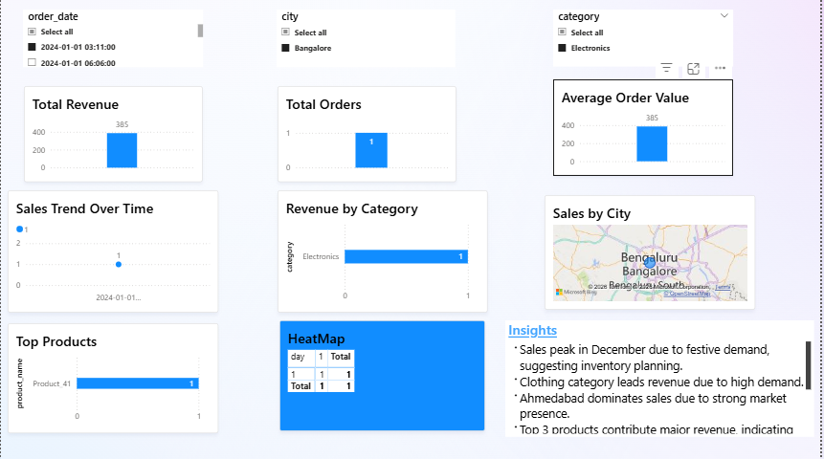

- Business Insights

  - Sales peak in December due to festive demand
  - Clothing category leads revenue
  - Ahmedabad dominates sales
  - Top 3 products contribute major revenue
  - Evening hours drive sales
  - Weekend sales are higher

Recommendations

  - Increase stock during festive season
  - Focus on high-performing categories
  - Run ads during peak hours
  - Expand in high-revenue cities

Conclusion

The dashboard provides a comprehensive view of sales performance and supports data-driven decision-making.

