Name: Akshay Tyagi
Roll number: 202401100200033
Branch: CSE(A)
Repository: https://github.com/Akshay2428/github-skills-challenge
Pull request: https://github.com/Akshay2428/github-skills-challenge/pull/1
Tests: 8 passed
Coverage: 58%
Minimum coverage threshold: 50%

Pull Request Created

This screenshot shows pull request #1 from the validate-ci branch targeting the main branch in my forked repository.
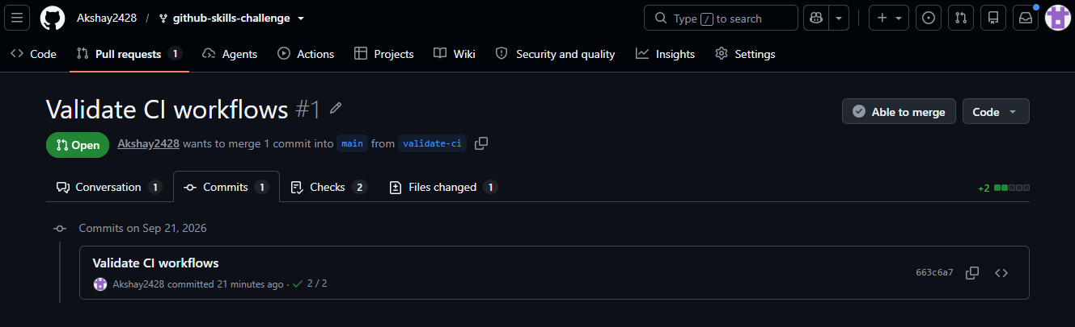

Successful Python Test Workflow

This screenshot shows the Python test workflow running successfully. It collected 8 tests, and all 8 tests passed. 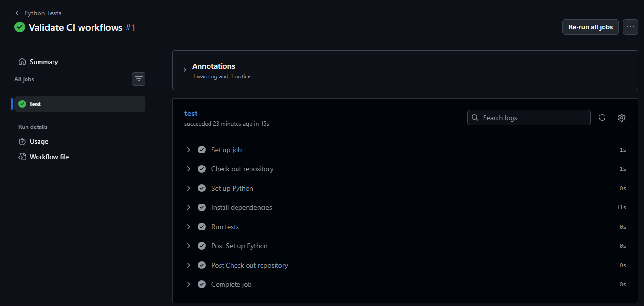
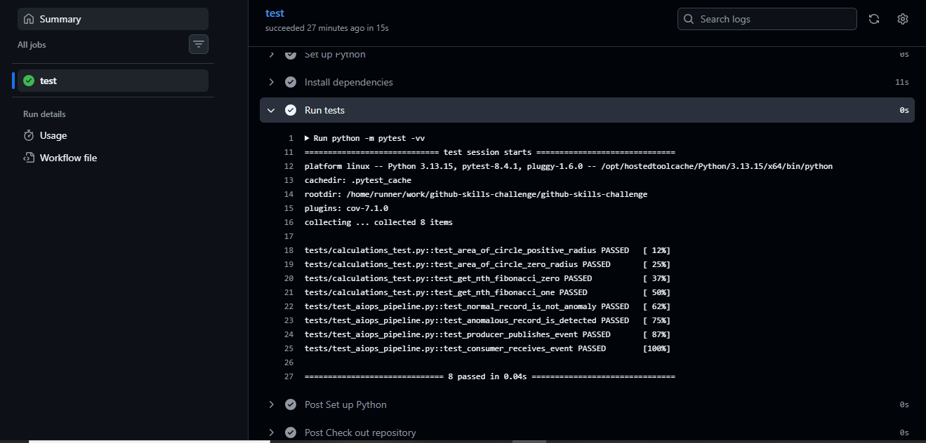
Pull Request Checks Passed

This screenshot shows that both required pull-request checks, Python Coverage and Python Tests, completed successfully.
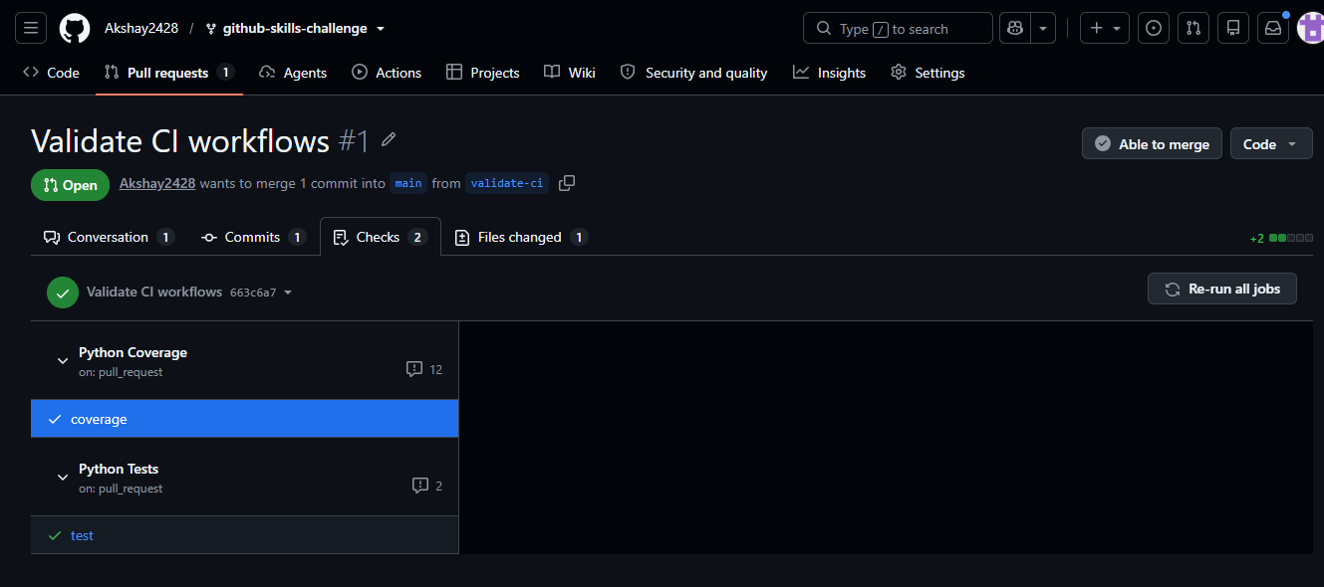
Coverage Result on Pull Request

This screenshot shows the published coverage report with 58% overall coverage, 100% pull-request coverage, and all checks passed.
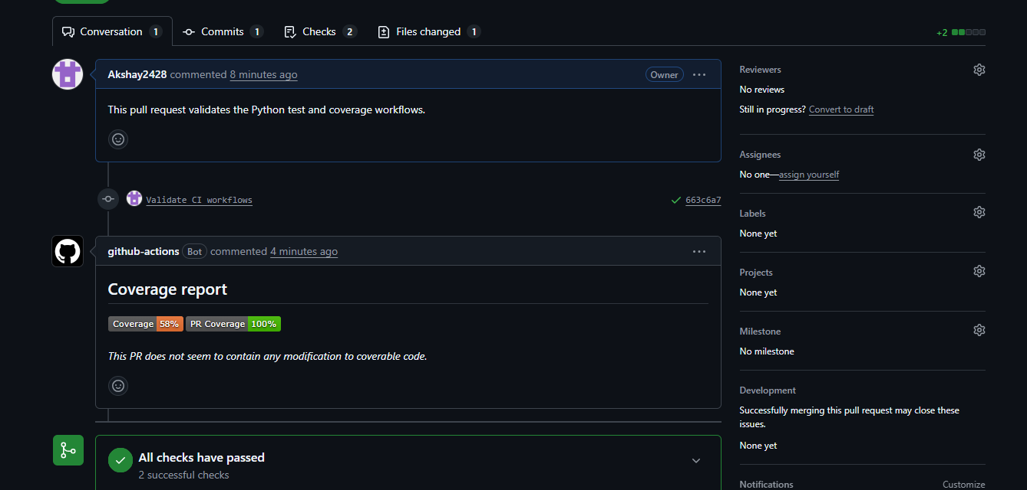
Coverage Analysis Comment

This screenshot shows the coverage analysis completion comment, the 58% coverage result, all checks passed, and no conflicts with the base branch.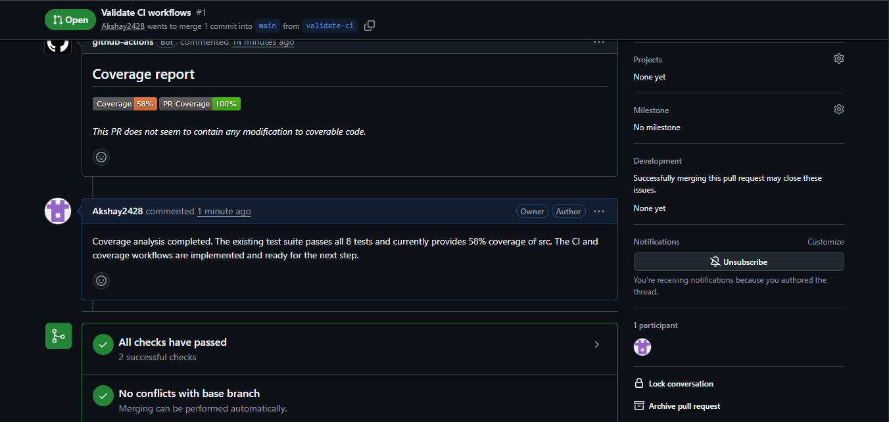 Final Repository Workflow Files
Final Repository Workflow Files

This screenshot shows the .github/workflows directory containing the created python-tests.yml and python-coverage.yml workflow files.
This screenshot shows the .github/workflows directory containing the created python-tests.yml and python-coverage.yml workflow files.