Laboratory Work

Subject: Java Technologies

Branch: B.Tech. (CE)

Semester: IV

Batch: A1

Student Roll No: CE012

Student Name: Gohel Akshay Rajendrakumar



Lab8

**Topics: Servlet,JSP**

1)Create a Simple JAVA web application to display the welcome message using JSP or servlet.

Code:-

Welcome.jsp

<%@ page language=*"java"* contentType=*"text/html; charset=UTF-8"*

pageEncoding=*"UTF-8"*%>

<!DOCTYPE html>

<html>

<head>

<meta charset=*"UTF-8"*>

<title>Insert title here</title>

</head>

<body>

<h1>Welcome </h1>

</body>

</html>

OUTPUT:-

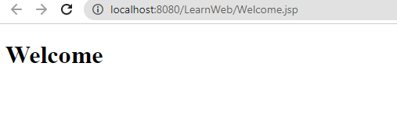

2)Write a Java web application for a login module which contains the following components:

* **index.html:** for getting input from the user.
* **ValidateServlet.java:** a servlet class for validating the user. If it is a valid user (validate from a database using PreparedStatement), it will forward the request to the WelcomeServlet. If the user is not validated then it displays an Error message along with the response from index.html.
* **Welcome.jsp:** a JSP file  for displaying the welcome message.

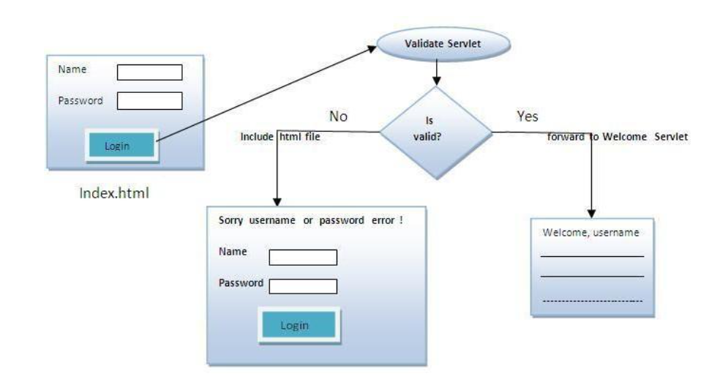

Code:-

Index.html

<!DOCTYPE html>

<html>

<head>

<meta charset=*"UTF-8"*>

<title>Login Page</title>

</head>

<body>

<h2>Login Page</h2>

<form action=*"ValidateServlet"* method=*"post"*>

<label for=*"username"*>Username:</label>

<input type=*"text"* id=*"username"* name=*"username"* required><br><br>

<label for=*"password"*>Password:</label>

<input type=*"password"* id=*"password"* name=*"password"* required><br><br>

<input type=*"submit"* value=*"Login"*>

</form>

</body>

</html>

*ValidateServlet.java*

import jakarta.servlet.ServletException;

import jakarta.servlet.annotation.WebServlet;

import jakarta.servlet.http.HttpServlet;

import jakarta.servlet.http.HttpServletRequest;

import jakarta.servlet.http.HttpServletResponse;

import java.io.IOException;

import java.io.PrintWriter;

import java.sql.Connection;

import java.sql.DriverManager;

import java.sql.PreparedStatement;

import java.sql.ResultSet;

import java.sql.SQLException;

/**

* Servlet implementation class ValidateServlet

*/

public class ValidateServlet extends HttpServlet {

private static final long serialVersionUID = 1L;

/**

* @see HttpServlet#HttpServlet()

*/

public ValidateServlet() {

super();

// TODO Auto-generated constructor stub

}

/**

* @see HttpServlet#doGet(HttpServletRequest request, HttpServletResponse response)

*/

protected void doPost(HttpServletRequest request, HttpServletResponse response) throws ServletException, IOException {

// TODO Auto-generated method stub

String username = request.getParameter("username");

String password = request.getParameter("password");

Connection conn = null;

PreparedStatement stmt = null;

ResultSet rs = null;

try {

// JDBC connection

Class.forName("com.mysql.cj.jdbc.Driver");

conn = DriverManager.getConnection("jdbc:mysql://localhost:3306/lab6", "root", "");

// Prepare SQL statement

String sql = "SELECT * FROM student WHERE username = ? AND password = ?";

stmt = conn.prepareStatement(sql);

stmt.setString(1, username);

stmt.setString(2, password);

// Execute the query

rs = stmt.executeQuery();

if (rs.next()) {

// Valid user, forward the request to WelcomeServlet

request.getRequestDispatcher("Welcome.jsp").forward(request, response);

} else {

// Invalid user, display error message

response.setContentType("text/html");

response.getWriter().print("username or password is wrong!");

request.getRequestDispatcher("index.html").include(request, response);

}

} catch (ClassNotFoundException | SQLException e) {

e.printStackTrace();

} finally {

try {

if (rs != null) rs.close();

if (stmt != null) stmt.close();

if (conn != null) conn.close();

} catch (SQLException e) {

e.printStackTrace();

}

}

}

/**

* @see HttpServlet#doPost(HttpServletRequest request, HttpServletResponse response)

*/

protected void doGet(HttpServletRequest request, HttpServletResponse response) throws ServletException, IOException {

// TODO Auto-generated method stub

Response.sendRedirect(“index.html”);

}

} //below is login.html page output

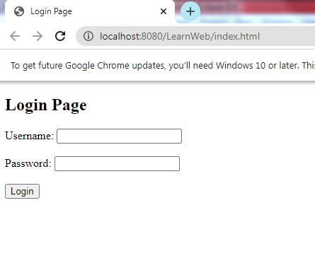

If credential is invalid

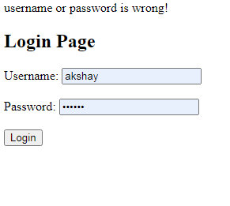

After logged in Welcome message will print

