Lab7.3 R.Akshay
2303A51933
Batch-27

Task1:FixingSyntaxErrors

Scenario
YouarereviewingaPythonprogramwhereabasicfunctiondefinitioncontains a syntax error.

Requirements:
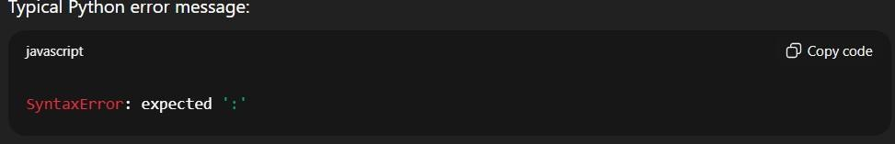
Output
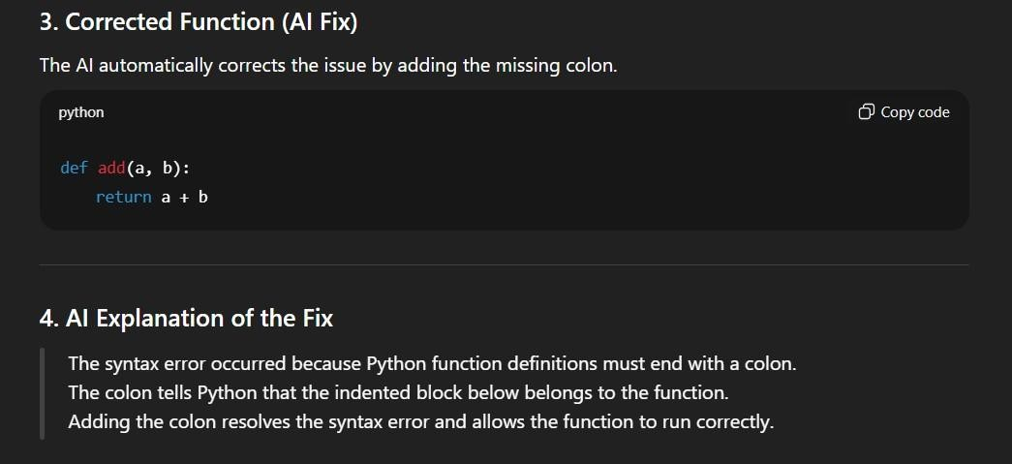

Task2:DebuggingLogicErrorsinLoops

Scenario
Youaredebuggingaloopthatrunsinfinitelyduetoalogicalmistake.

Requirements
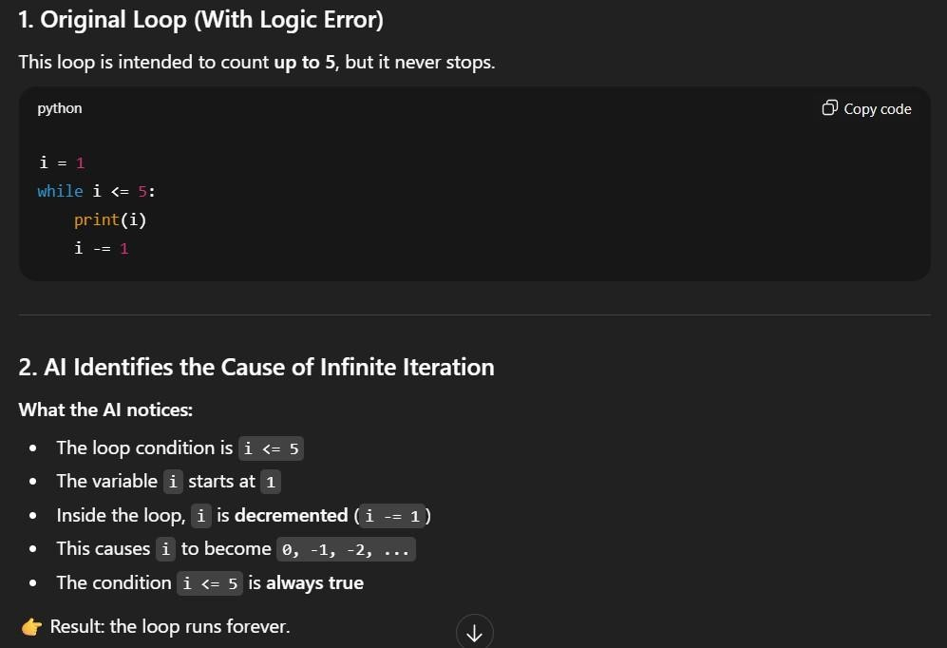

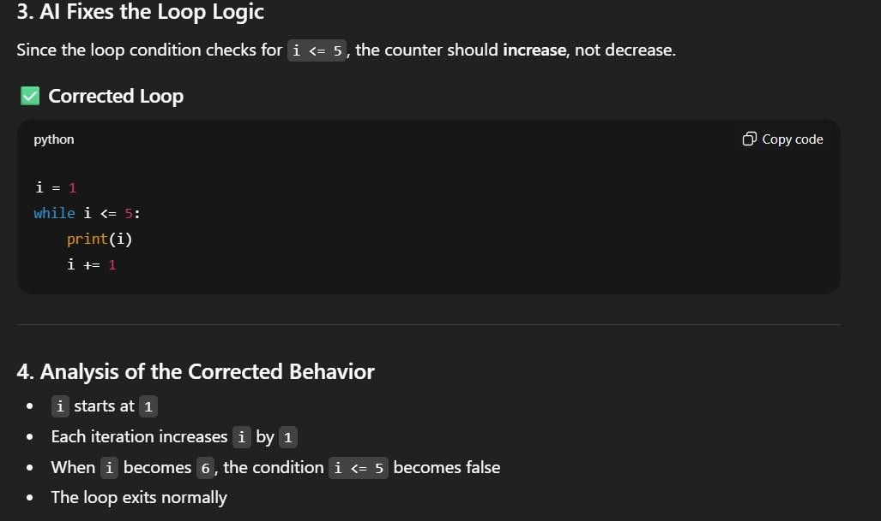

Output
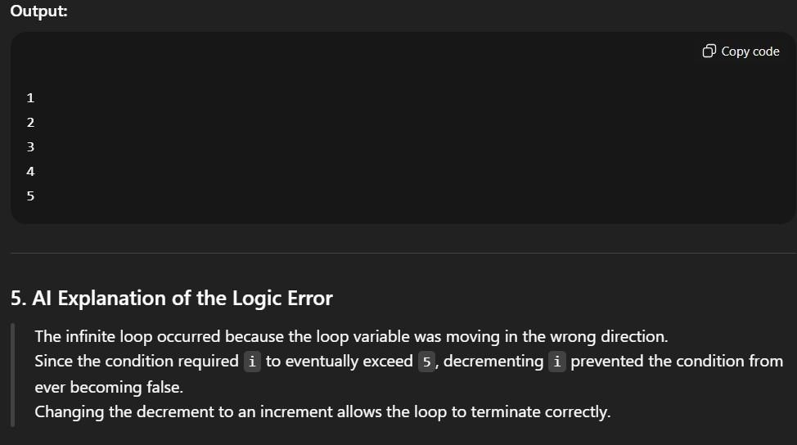

Task3:HandlingRuntimeErrors(DivisionbyZero)

Scenario
APythonfunctioncrashesduringexecutionduetoadivisionbyzeroerror.

Requriments
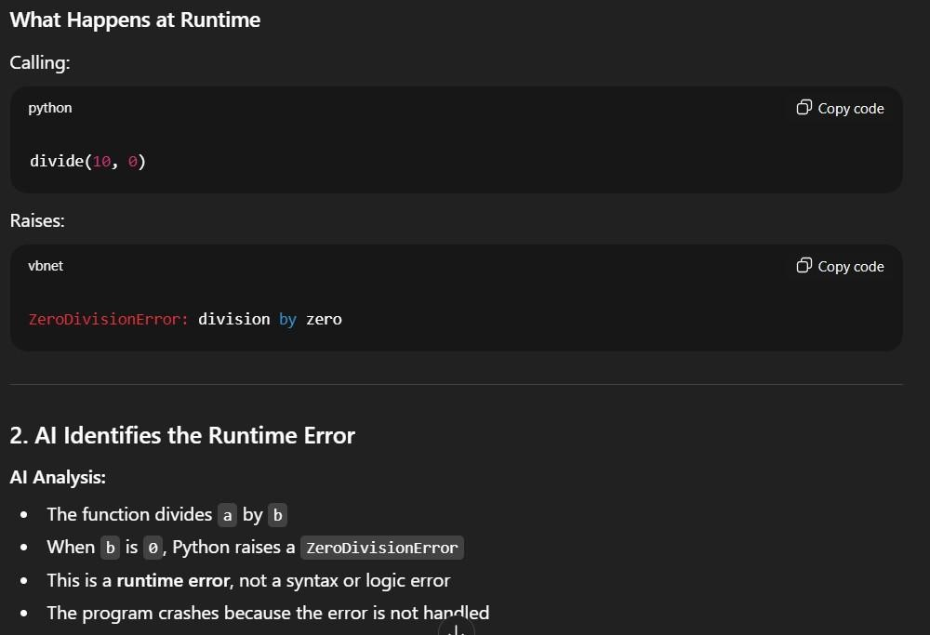

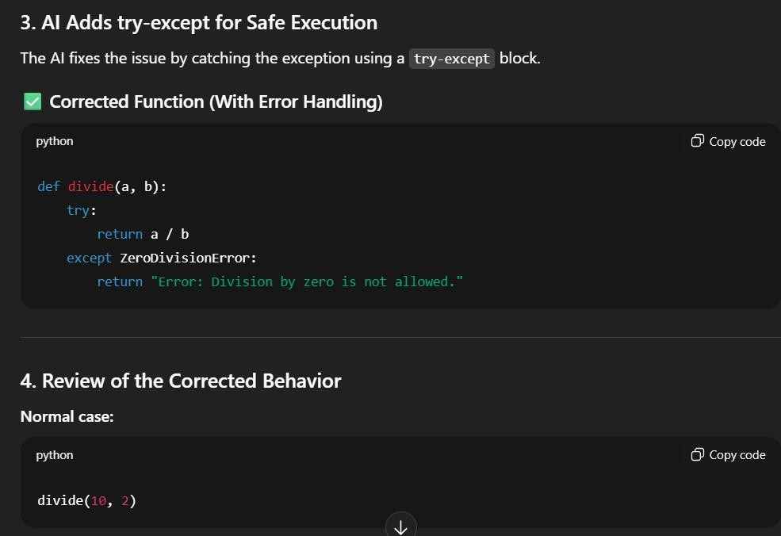
Output:
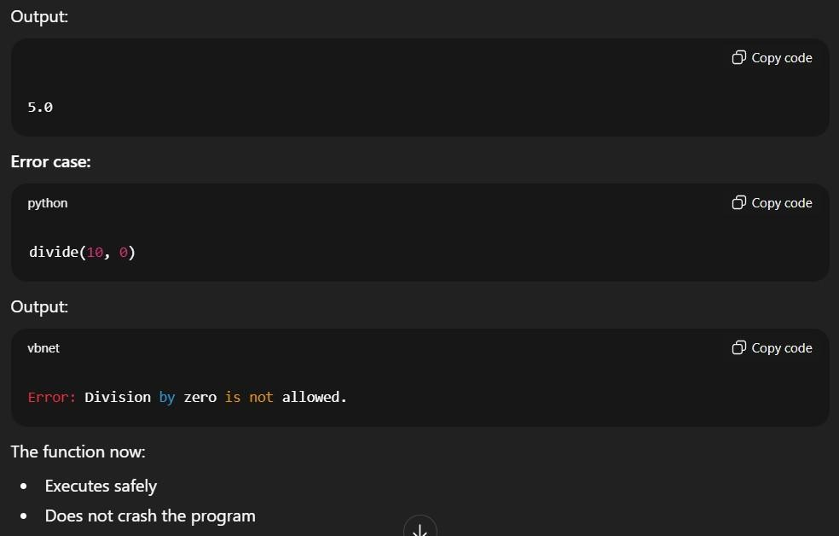

Task4:DebuggingClassDefinitionErrors

Scenario
YouaregivenafaultyPythonclasswheretheconstructorisincorrectlydefined.
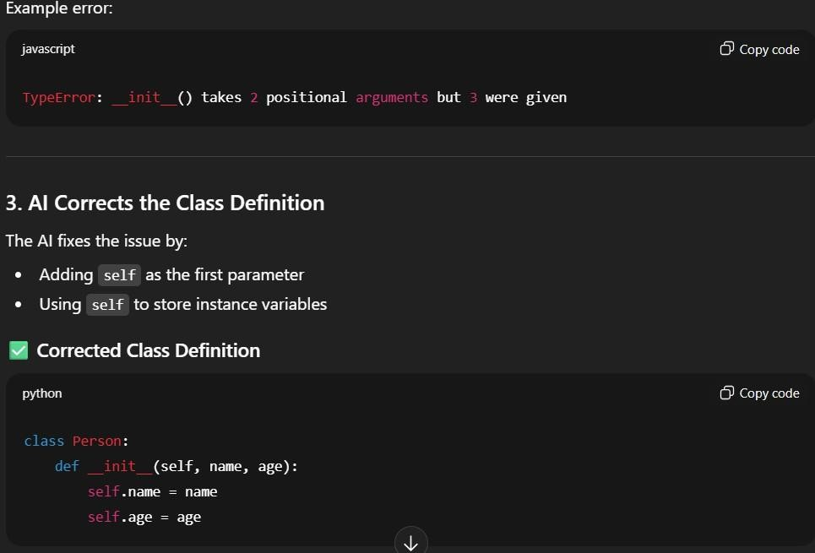

Output
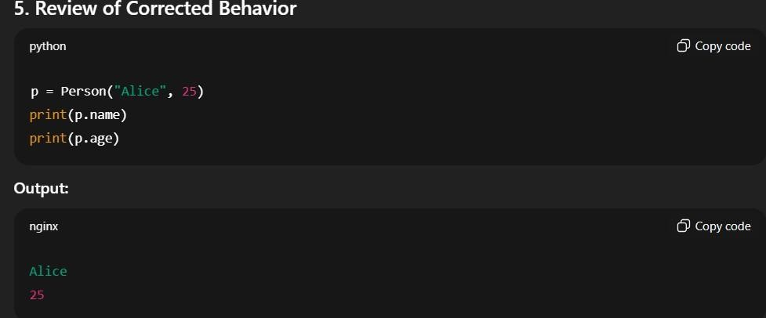

Task5:ResolvingIndexErrorsinLists

Scenario
Aprogramcrasheswhenaccessinganinvalidindexinalist.
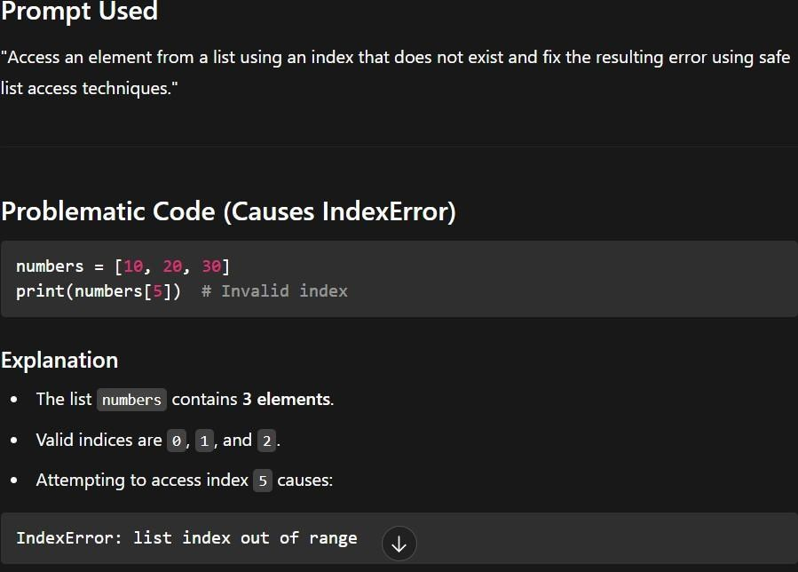
Output
