Name: K. Akshay USN: 1MS23CS091

Kubernetes Setup

docker –version
kubectl version --client
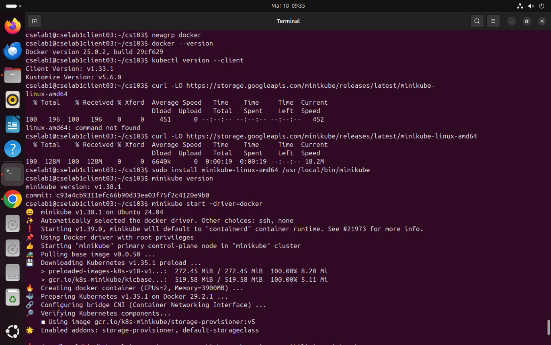

kubectl cluster-info
kubectl get nodes

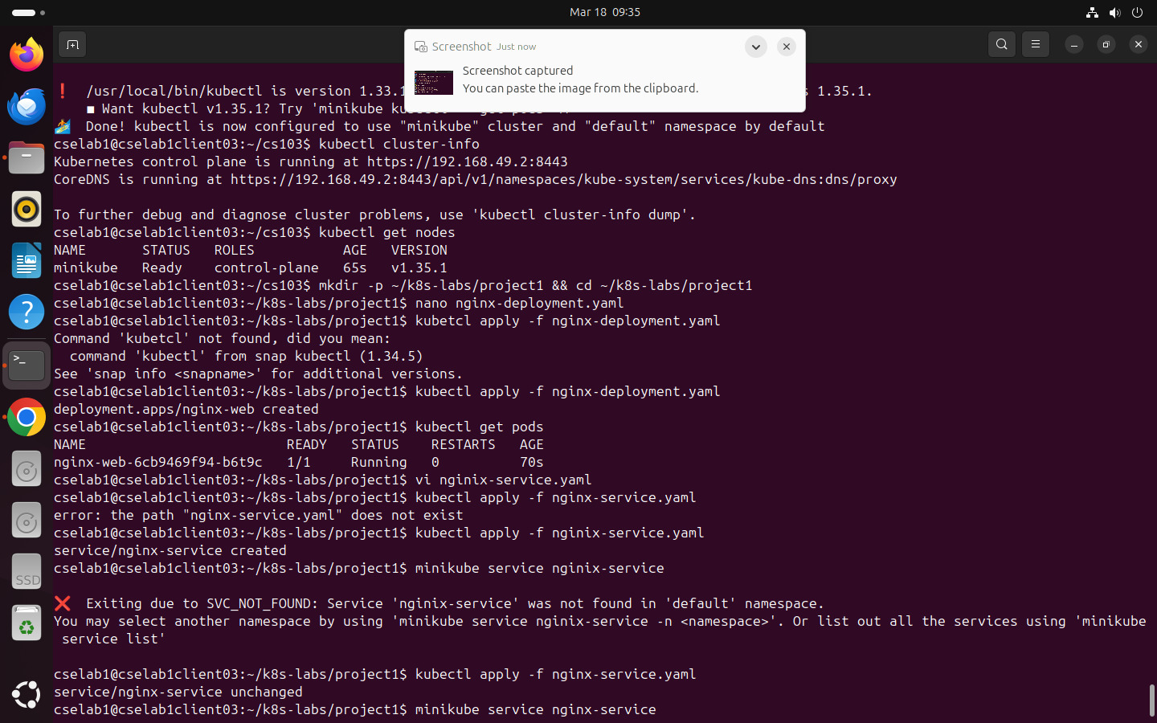

minikube service nginx-service
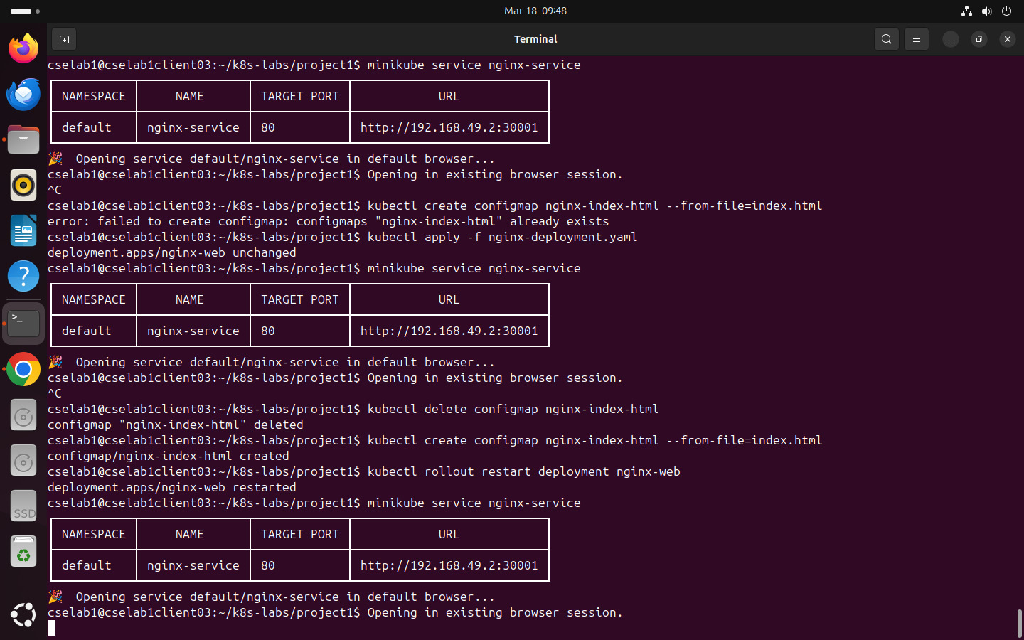
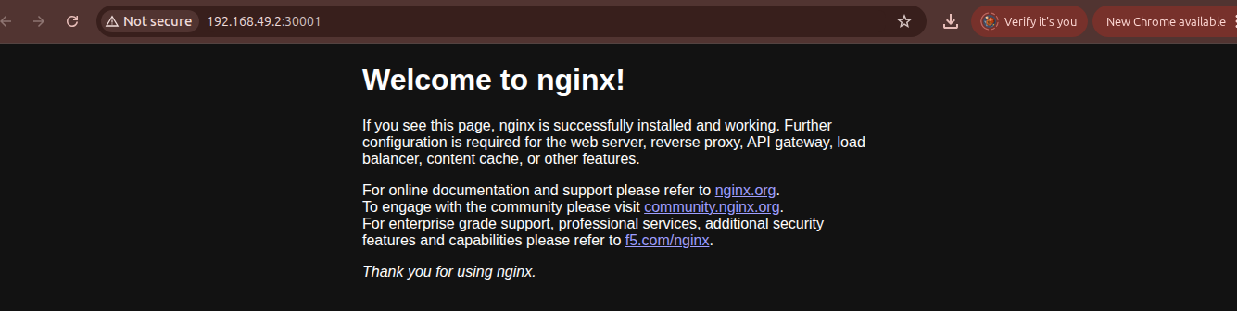
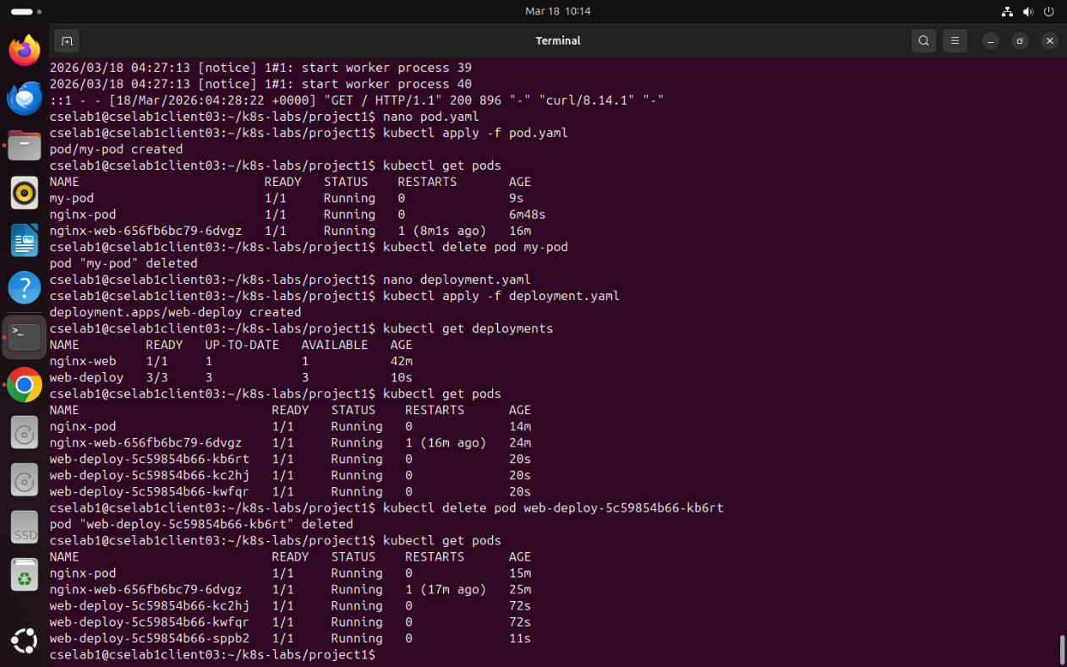
Kubernetes Task
PART 1 Cluster Setup & Pods
Exercise 1 — Verify the Cluster

kubectl version –client
minikube start
kubectl get nodes
kubectl cluster-info

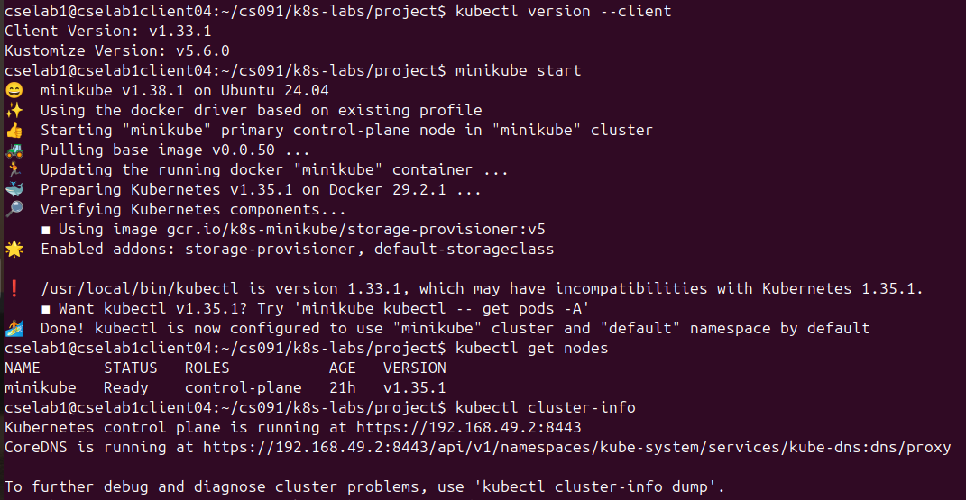
Checkpoint Questions:
1. What is Kubernetes and how does it differ from plain Docker?
> Kubernetes (sometimes shortened to K8s with the 8 standing for the number of letters between the "K" and the "s") is an open source system to deploy, scale, and manage containerized applications anywhere.
Docker simplifies creating and managing container images, while Kubernetes automates those containers' deployment, scaling, and management. This synergy reduces operational complexity, making it easier for teams to manage large-scale, containerized applications.

2. What does kubectl get nodes display, and what status should you see?
> Running a “kubectl get nodes” command can tell you what nodes are connected to your cluster. You can also see whether they're healthy, the labels that have been applied to them, and how long they've been running.

Exercise 2 — Run and Inspect a Pod
kubectl run nginx-pod --image=nginx –port=80
kubectl get pods

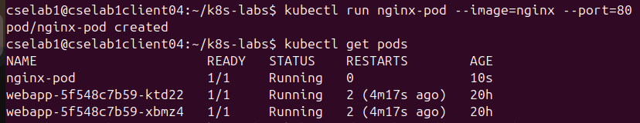

kubectl describe pod nginx-pod

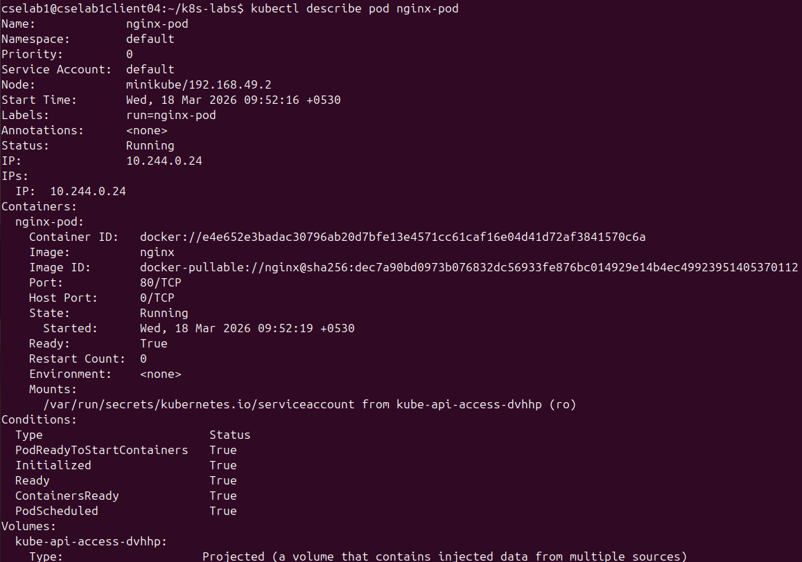
kubectl exec -it nginx-pod -- /bin/bash
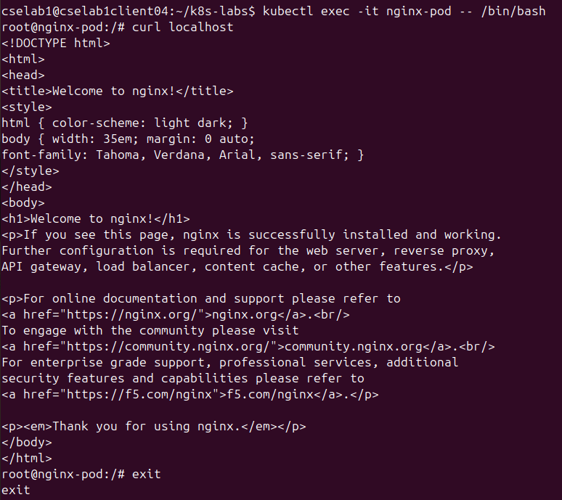
curl localhost
kubectl logs nginx-pod

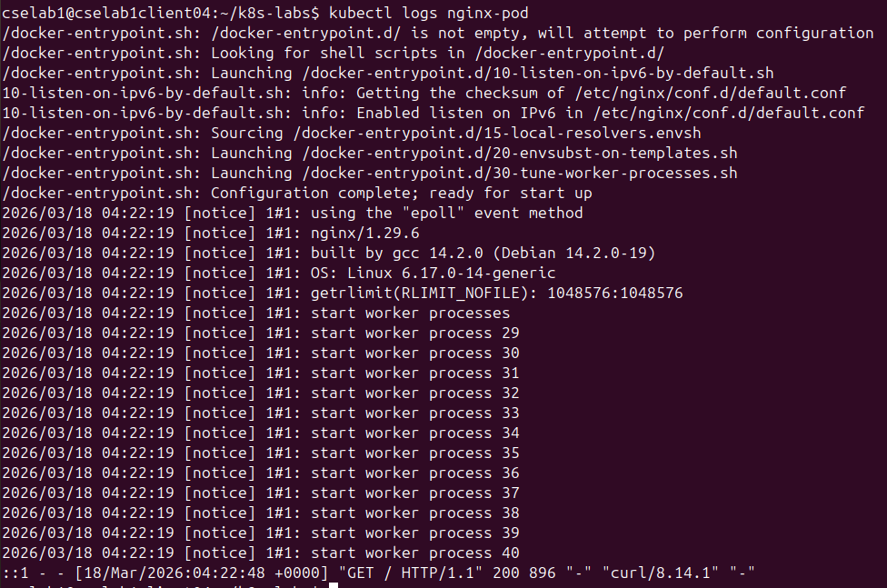
Checkpoint Questions:

1. What is a Pod? How does it differ from a Docker container?
>A container is a self-contained unit of software that packages an application and all its dependencies so it runs consistently across environments. A pod is a higher-level construct used by Kubernetes that groups one or more containers so they share storage, network resources, and a common lifecycle.

2. What does the -it flag do in kubectl exec?
>In kubectl, the -it flag used with kubectl exec is actually a combination of two flags:
-i (interactive):
Keeps STDIN open, allowing you to send input to the container.
-t (TTY)
Allocates a pseudo-terminal (TTY).
This gives you a proper terminal interface (like a shell), enabling things like:
- command prompts
- line editing
- colored output

3. What lifecycle phases can a Pod pass through?
>Pods follow a defined lifecycle, starting in the Pending phase, moving through Running if at least one of its primary containers starts OK, and then through either the Succeeded or Failed phases depending on whether any container in the Pod terminated in failure.
Exercise 3 — Declare a Pod with YAML
nano pod.yaml
kubectl apply -f pod.yaml
kubectl apply -f pod.yaml
kubectl get pods
kubectl delete pod my-pod

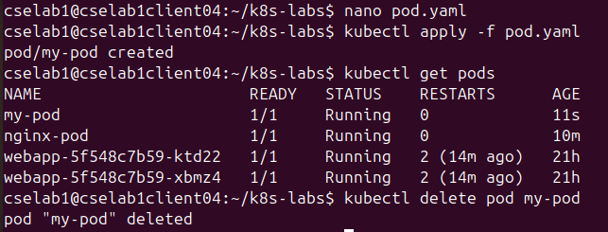
Checkpoint Questions:

1. What is the difference between imperative (kubectl run) and declarative (kubectl apply -f)
configuration?
> Imperative configuration involves creating Kubernetes resources directly at the command line against a Kubernetes cluster. Declarative configuration defines resources within manifest files and then applies those definitions to the cluster.

2. What do apiVersion, kind, metadata, and spec each define?
> apiVersion - Which version of the Kubernetes API you're using to create this object. kind - What kind of object you want to create. metadata - Data that helps uniquely identify the object, including a name string, UID , and optional namespace. spec - What state you desire for the object.

PART 2 Deployments, Services & Scaling
Exercise 4 — Create a Deployment

nano deployment.yaml
kubectl apply -f deployment.yaml
kubectl get deployments
kubectl get pods
kubectl delete pod web-deploy-5c59854b66-zt9md
kubectl get pods

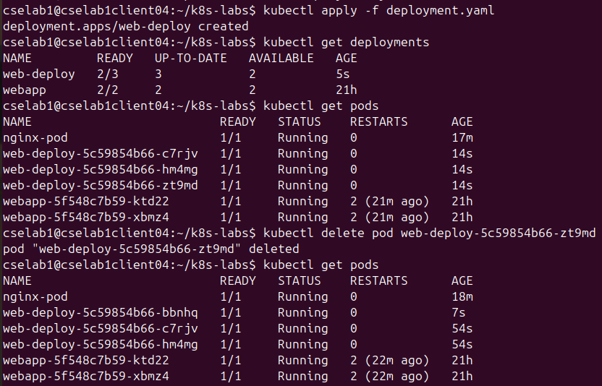
Checkpoint Questions:
1. What is a Deployment and why is it preferred over creating Pods directly?
> A Deployment manages a set of Pods to run an application workload, usually one that doesn't maintain state. A Deployment provides declarative updates for Pods and ReplicaSets. You describe a desired state in a Deployment, and the Deployment Controller changes the actual state to the desired state at a controlled rate.

2. What happened when you deleted the Pod? Explain why.
>When you run kubectl delete pod , here's what actually happens: The API Server sets a deletionTimestamp on the pod object in ETCD. The pod's status changes to Terminating. This signals all other controllers and nodes: “Stop scheduling or routing traffic here.”

3. What is a ReplicaSet and how does it relate to a Deployment?
>A ReplicaSet is a type of object that tells the Kubernetes deployment controller to maintain a specific number of copies of a Pod (for full details on how this works, check out our guide to ReplicaSets).

Exercise 5 — Expose with a Service & Scale

nano service.yaml
kubectl apply -f service.yaml
kubectl get services
minikube service web-service
kubectl scale deployment web-deploy --replicas=5
kubectl get pods
kubectl scale deployment web-deploy --replicas=2
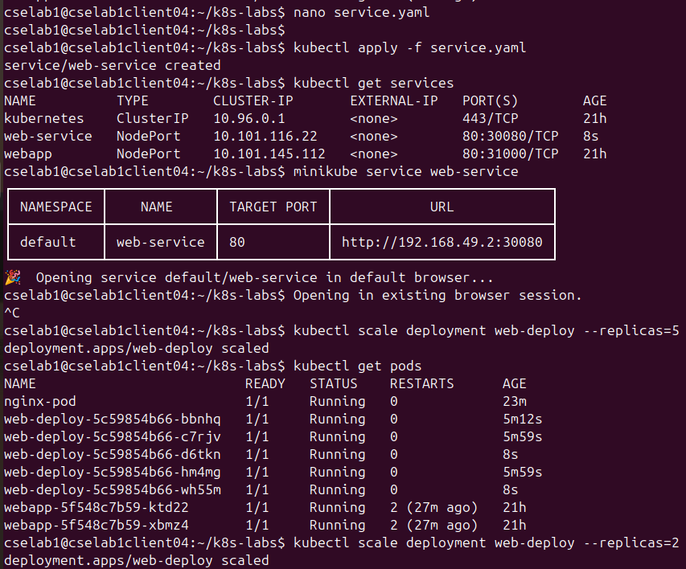
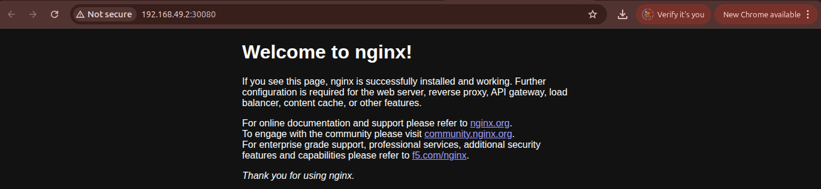
Checkpoint Questions
11. What is a Kubernetes Service? Why are Services needed when Pods have dynamic Ips?
>A Kubernetes service allows pods to communicate reliably, even as their IP addresses change. Service types include ClusterIP for internal traffic, NodePort for external access on every node, LoadBalancer for cloud-managed endpoints, and Headless for pod-to-pod connections.

12. What is the difference between ClusterIP, NodePort, and LoadBalancer?
>ClusterIP is for internal communication between pods. NodePort exposes services on a static port across all nodes for basic external access. LoadBalancer provisions a dedicated external IP for production-grade external access.

13. What does horizontal scaling mean? What is the Horizontal Pod Autoscaler (HPA)?
>A HorizontalPodAutoscaler (HPA for short) automatically updates a workload resource (such as a Deployment or StatefulSet), with the aim of automatically scaling the workload to match demand. Horizontal scaling means that the response to increased load is to deploy more Pods.

Exercise 6 — Rolling Update & Rollback

kubectl set image deployment/web-deploy web=nginx:1.25
kubectl rollout status deployment/web-deploy
kubectl rollout history deployment/web-deploy
kubectl rollout undo deployment/web-deploy
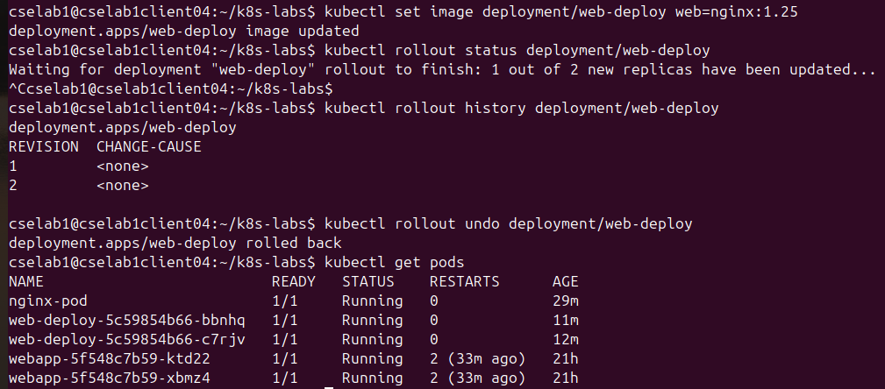
kubectl get pods
Checkpoint Questions:

What is a rolling update strategy? How does Kubernetes ensure zero downtime?
>A rolling update allows a Deployment update to take place with zero downtime. It does this by incrementally replacing the current Pods with new ones. The new Pods are scheduled on Nodes with available resources, and Kubernetes waits for those new Pods to start before removing the old Pods.

Why is rollback capability critical in production environments?
>A software rollback is the process of reverting an application to a previous stable version when a new update causes issues. It is crucial for maintaining system stability, minimizing downtime, and ensuring that any disruptive changes can be quickly undone to preserve user experience.
PART 3 CI/CD Pipeline with GitHub Actions
Task 1 — Project Setup
git clone <your-repo-url>
cd k8s-cicd-pipeline
mkdir -p k8s .github/workflows
touch app.py test_app.py requirements.txt Dockerfile
touch k8s/deployment.yaml k8s/service.yaml
touch .github/workflows/cicd.yml

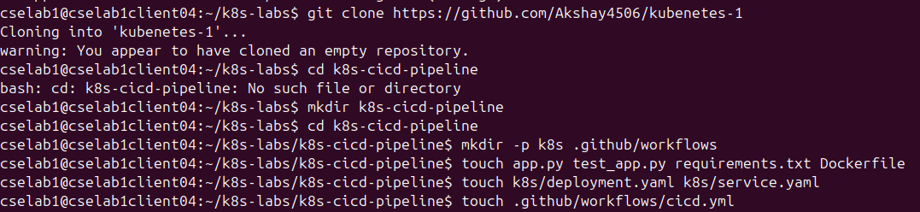
16. Why should Kubernetes manifests live in the same repository as application code?
>The manifest lives close to the code, so changes to both are versioned together. Easier rollback since a commit represents both app and infra changes.

Task 2 — Application & Tests

pip install -r requirements.txt pytest
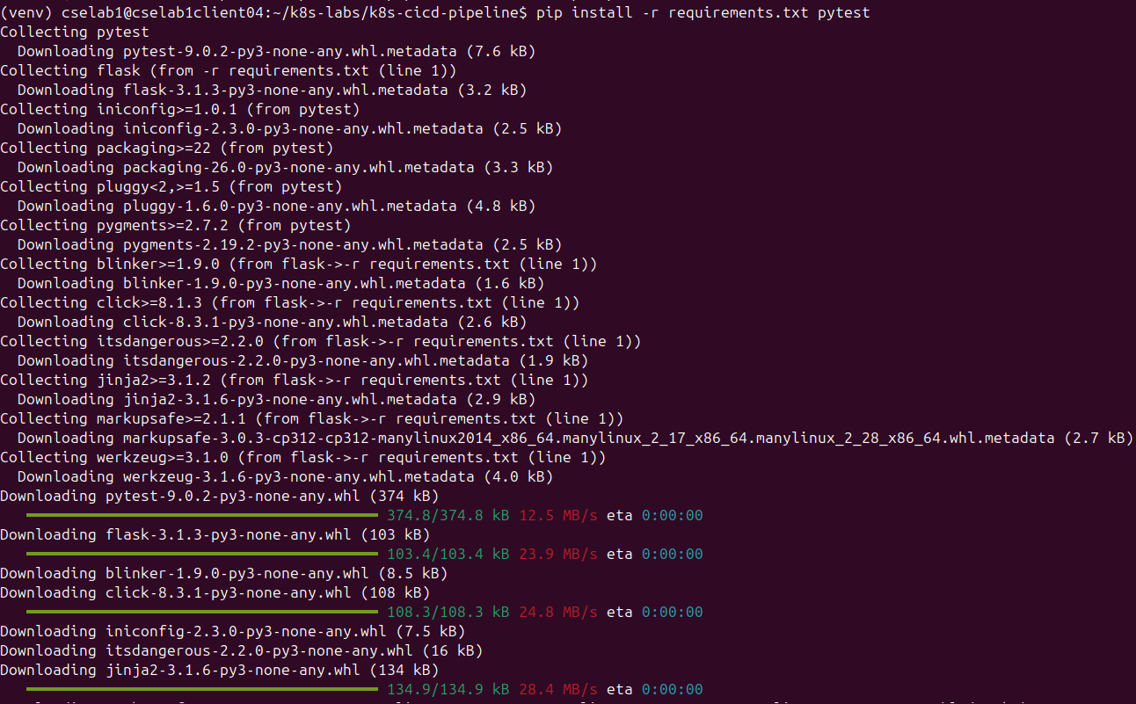

Q’s
17. What is the purpose of the /health endpoint?
The /health endpoint is used by Kubernetes to perform Probes. Kubernetes doesn't just check if your container is "running" (which only means the process hasn't crashed); it checks if the application inside the container is actually working.
- Liveness Probe: Kubernetes pings /health. If it gets a 200 OK, it knows the app is alive. If it gets a 500 or no response, Kubernetes kills the container and restarts it. This fixes "deadlocked" apps automatically.
- Readiness Probe: Kubernetes checks if the app is ready to handle traffic. If /health returns an error (perhaps because it's still loading a large database), Kubernetes stops sending user traffic to that specific Pod until it's "healthy" again.

18. Why must tests pass before Docker build and deployment are triggered?
>In a CI/CD pipeline, testing is the Gatekeeper. Running tests before the Docker build is a best practice for three main reasons:
- Fail Fast, Save Costs: Building a Docker image and pushing it to a registry takes time and compute resources (money). If the code is broken, there is no point in spending resources to package it.
- Prevent "Poisoning" the Registry: You want your Docker Registry (like Docker Hub or ECR) to be a "Source of Truth" containing only functional, production-ready images. If you build every commit—even broken ones—your registry becomes cluttered with "poisoned" images that might accidentally get deployed.
- Zero-Downtime Reliability: If a broken image makes it to deployment, Kubernetes might try to roll it out. While K8s can roll back, it's much safer to catch the bug in the CI (Continuous Integration) phase so the "broken" code never even enters the cluster environment.

Task 3 — Dockerfile & Kubernetes Manifests
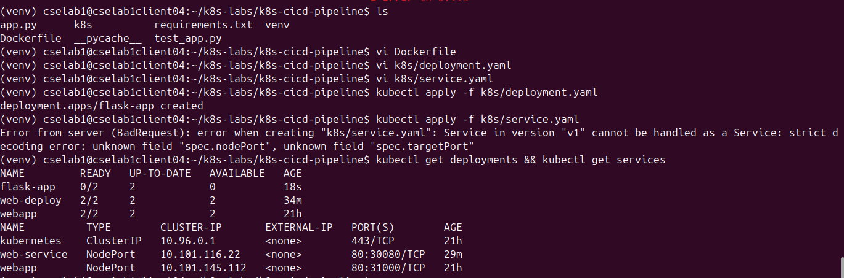
19. What does maxSurge: 1 and maxUnavailable: 0 guarantee during a rolling update?
This specific combination is the standard for Zero-Downtime Deployments.
- maxUnavailable: 0: This guarantees that at no point during the update will there be fewer than the desired number of pods (e.g., if you asked for 3, there will always be at least 3 running).
- maxSurge: 1: This allows Kubernetes to create one extra pod during the update process.
The Guarantee: Together, they ensure that a new "Version 2" pod is created and confirmed healthy before an old "Version 1" pod is killed. Your application capacity never drops below 100% during the rollout.

20. What is a livenessProbe and what happens when it fails?
A livenessProbe is a diagnostic check (like an HTTP request to /health) that Kubernetes uses to determine if a container is still running correctly.
- The Purpose: Sometimes a process is "running" but "stuck" (e.g., a deadlock or a frozen thread). The container hasn't crashed, but it’s not doing anything useful.
- When it fails: If the probe fails (e.g., returns a 500 error or times out) for a specific number of consecutive attempts, Kubernetes terminates the container and restarts it. It assumes the app is "broken" and a fresh start is the only way to fix it.

21. What is the advantage of python:3.10-slim over the full python:3.10 image?

Feature | python:3.10 (Full) | python:3.10-slim
Size | ~900MB - 1GB | ~120MB - 150MB
Contents | Includes every build tool, compiler, and library imaginable (GCC, git, etc.). | Only the bare essentials needed to run Python.
Security | Higher "Attack Surface" (more tools for a hacker to use if they get in). | Lower Attack Surface (fewer tools = more secure).
Performance | Slower to pull from Docker Hub and slower to deploy. | Faster to pull/push and starts up quickly.

Task 4 — GitHub Actions CI/CD Pipeline
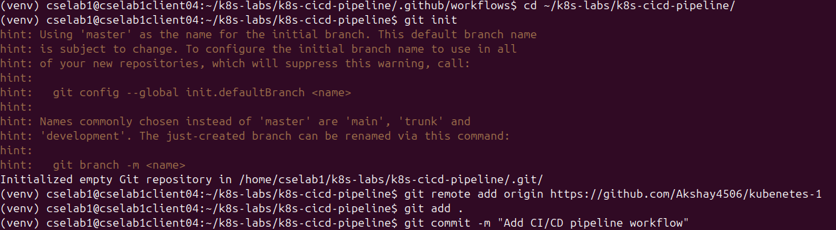
22. What is the difference between Continuous Integration, Continuous Delivery, and
Continuous Deployment?
While they sound similar, they represent different levels of automation and release maturity:
- Continuous Integration (CI): Developers frequently merge code into a central repository. Automated tests and builds run to ensure the new code doesn't break the existing application.
  - Goal: Catch bugs as early as possible.
- Continuous Delivery (CD): The code is automatically tested and built into an artifact (like a Docker image), but human intervention (a manual approval or a "Push to Deploy" button) is required to actually push it to production.
  - Goal: Ensure the code is always in a "deployable" state.
- Continuous Deployment (CD): Every change that passes the automated testing phase is automatically deployed to production without any human manual trigger.

23. Why must build-push depend on test, and deploy depend on build-push?
n your GitHub Actions YAML, build-push depends on test, and deploy depends on build-push. This creates a Fail-Safe Chain:
- If test fails: The pipeline stops immediately. We don't want to waste time or compute resources building a Docker image for broken code.
- If build-push fails: The deployment is blocked. You cannot deploy if the new image wasn't successfully uploaded to the registry.
- The Result: You guarantee that the version running in your Kubernetes cluster has passed every single check in the pipeline.

24. Why use github.sha as the image tag instead of latest?
Using the latest tag is a common "rookie" mistake in Kubernetes for two major reasons:
- Caching Issues: If you deploy an image tagged latest, then push a new image also tagged latest, Kubernetes may see the name hasn't changed and refuse to pull the new code, thinking it already has the current version cached.
- Traceability (Rollbacks): If your app crashes, github.sha (the unique Git commit hash) tells you exactly which line of code caused the problem. With latest, you lose the ability to easily "roll back" to a specific, known-good version of the code.

25. What security risk arises if credentials are written directly in the YAML file instead of GitHub Secrets?
Writing passwords, tokens, or kubeconfig data directly in your YAML file is a critical security hole:
- Exposure: Anyone with "Read" access to your GitHub repository (including former employees or potential hackers) now has your Docker Hub password and full administrative access to your Kubernetes cluster.
- Git History: Even if you delete the password later, it stays in the Git History forever. A hacker can simply look at an old commit to retrieve it.
- The Fix: GitHub Secrets encrypts the data at rest. It is only decrypted during the runner's execution and is automatically "masked" (hidden with ***) in the logs if it is ever printed.

26. What happened to the Kubernetes cluster while the test was failing? Why?
Nothing. And that is the point!
- Why: Because your build-push job had a needs: test dependency. When the test job failed, the subsequent jobs were skipped.
- The Result: The Kubernetes cluster continued running the previous stable version of your app. No new (broken) image was built, and no kubectl command was ever sent to the cluster to change the deployment.

27. How does this failure-blocking pattern protect production environments?
t creates a "Safe-to-Fail" environment.
- Prevents "Bad Code" Propagation: It ensures that bugs (like a syntax error in your Flask app) are caught in a temporary GitHub runner rather than on your production servers where users would see them.
- Maintain Availability: By blocking the deployment, you ensure your app stays up and running on the last known "Good" version.

28. Suggest two concrete ways to reduce overall pipeline execution time.
Pipelines can get slow as projects grow. To speed them up:
- Caching Dependencies: Use the actions/setup-python cache feature. Instead of downloading flask, pytest, and other libraries from the internet every single time, GitHub can "remember" them from the previous run.
- Multi-stage Docker Builds: In your Dockerfile, use a "build" stage to install heavy tools and a "run" stage (using python:3.10-slim) for the final image. This makes the image smaller and faster to push/pull.

29. What additional pipeline stages would you add for a real production Kubernetes
deployment?
basic CI/CD pipeline is a start, but production needs "The Works":
- Static Analysis (Linting): Tools like Flake8 or Black to ensure the code follows style guides before tests even run.
- Security Scanning (SAST): Tools like Snyk or Trivy to scan your Docker image for known vulnerabilities (CVEs) before pushing it to Docker Hub.
- Infrastructure as Code (IaC) Scan: Using tfsec or checkov to ensure your Kubernetes YAML files don't have security holes (like running as root).
- Post-Deployment Testing: Running "Smoke Tests" after the deployment to verify the app is reachable in the actual production environment

