DevSecOps Lab Assignment
API Testing with Postman & Newman + Code Quality with SonarQube
Answer all questions, take screenshots of commands and outputs, and compile everything into a single document.
Student Name: K.Akshay | Roll No: 1MS23CS091
Date: 01-04-2026 | Upload via: https://forms.gle/iHkJXkyrfxRsU3jY8

Unit 3 — API Testing with Postman & Newman
PRE-REQUISITE | Node.js (v14+) and npm installed. Postman Desktop app downloaded from https://www.postman.com

Exercise 1.1 — Create a Postman Collection & Requests
GOAL Create your first Postman collection and make GET requests to a public REST API.

Steps
- Open Postman and sign in (or create a free account).
- In the left sidebar click Collections → New Collection.
- Name the collection DemoBook and click Create.
- In the DemoBook context menu (⋯) choose Add Request. Name it Get all posts and click Save to DemoBook.
- Set the method to GET and enter the URL below, then click Save:

https://jsonplaceholder.typicode.com/posts

- Add a second request named Get a single post with the URL:

https://jsonplaceholder.typicode.com/posts/1

- Click Send on each request and confirm you receive a 200 OK response with JSON data.
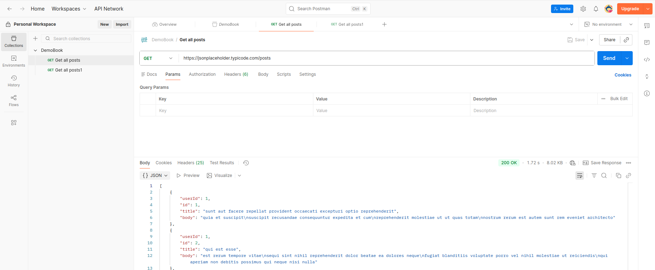

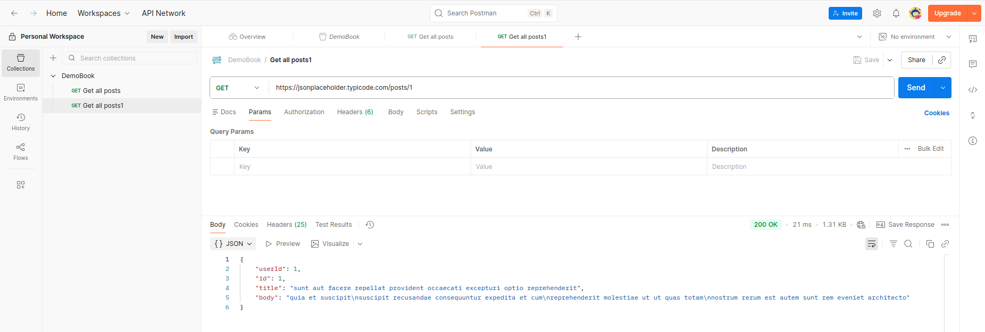

Expected Output
- Get all posts → returns a JSON array of 100 post objects.
- Get a single post → returns one object with id, userId, title, body fields.

CHECKPOINT — Answer These Questions
Q1: What is a Postman Collection and why is it useful for organizing API requests?
Answer: A Postman Collection is a group of saved API requests organized into a single folder-like structure. Think of it as a specialized playlist for your APIs.
It is useful because it allows developers to:
- Group by Function: Organize requests by project, resource, or workflow (e.g., "User Authentication" or "Product Catalog").
- Share and Collaborate: Easily export and share sets of requests with team members to ensure everyone is using the same endpoints.
- Automate Testing: Run all requests in a collection sequentially using the "Collection Runner" to perform automated integration testing.
- Manage Variables: Store environment-specific data (like URLs or API keys) that apply to every request within the group.
Q2: What does a 200 OK HTTP status code indicate about an API response?
Answer:The 200 OK status code indicates that the request was successful. The meaning of "success" depends on the HTTP method used:
- GET: The requested resource has been fetched and is transmitted in the message body.
- POST/PUT: The request was handled successfully, and the result of the action is described in the response.
Q3: What is the difference between a GET request and a POST request in REST APIs?
Answer:The main difference between a GET and a POST request lies in their purpose and how they handle data. A GET request is designed to retrieve data from a server; it is "read-only" and idempotent, meaning making the same GET call multiple times will not change the state of the server. Because GET requests append data to the URL as query parameters, they are restricted by URL length limits and are less secure for sensitive information.
In contrast, a POST request is used to send data to the server to create or update a resource. The data is included in the request body rather than the URL, allowing for much larger and more complex data payloads (like JSON objects or file uploads). Unlike GET, POST is not idempotent; sending the same POST request multiple times will typically result in multiple new resources being created on the server.

Exercise 1.2 — Environments & Variables
GOAL Use Postman environment variables to avoid hardcoding URLs and values in requests.

Steps
- Click the Environments icon (⊙) in the sidebar → Add.
- Name the environment Local.
- Add two variables as shown in the table below:

Variable | Initial Value | Current Value
baseUrl | https://jsonplaceholder.typicode.com | https://jsonplaceholder.typicode.com
PostID | 6 | 6

- Click Save. Then select Local from the environment dropdown (top-right of Postman).

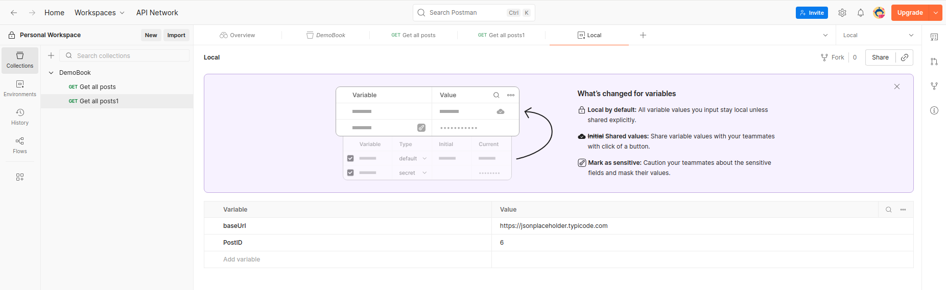
- Open Get a single post and replace the hard-coded URL with variables:

{{baseUrl}}/posts/{{PostID}}

- Click Send. Verify that the response shows post with id: 6.
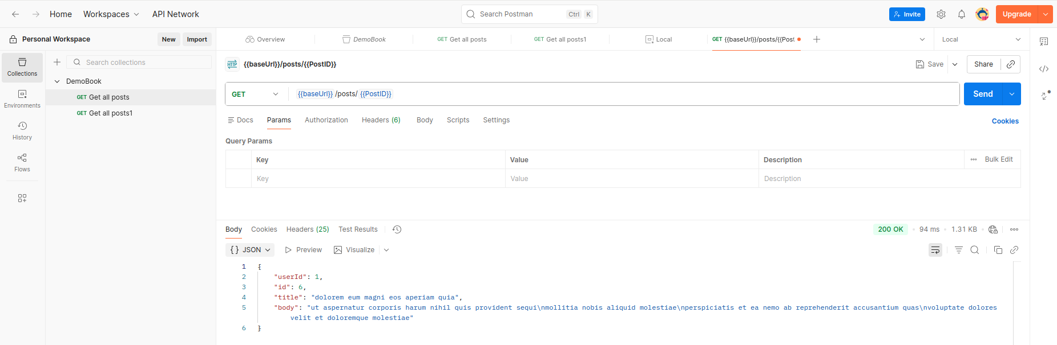
- Challenge: Create a QA environment with PostID = 10 and switch to it. Re-send the request and confirm id: 10 is returned.

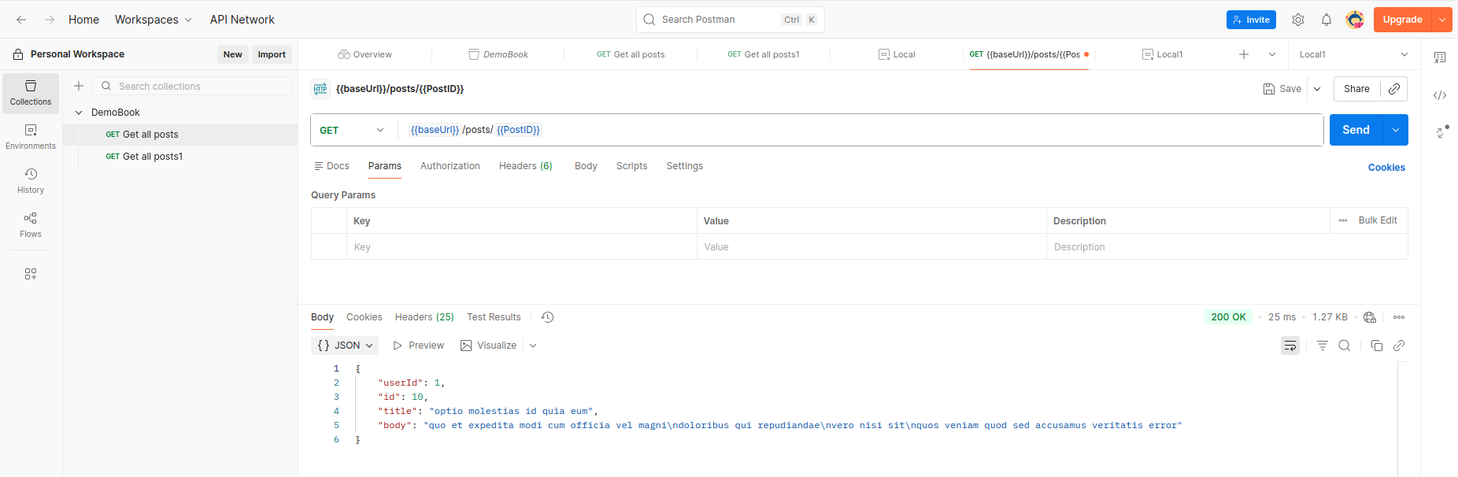

CHECKPOINT — Answer These Questions
Q1: What is the purpose of Postman Environment Variables?
Answer: The primary purpose of Postman Environment Variables is to allow you to toggle between different sets of data (such as URLs, API keys, or login credentials) depending on the context of your work. Instead of manually updating every request when moving from a Local development server to a Staging or Production environment, you can simply switch the environment in Postman. The variables act as placeholders that automatically inject the correct values into your requests.
Q2: What is the difference between Initial Value and Current Value in Postman variables?
Answer: Postman distinguishes between these two values to help with collaboration and security:
- Initial Value: This value is synced to the Postman servers and shared with anyone who has access to the workspace or collection. It is intended for non-sensitive data that the whole team needs.
- Current Value: This value is stored locally on your specific instance of Postman. It is never synced to the cloud. This makes it the ideal place to store sensitive information like personal passwords or private API tokens that you do not want to share with your teammates.

Q3: Why is it important to avoid hardcoding URLs and IDs in API requests during testing?
Answer: Avoiding hardcoding is crucial for scalability, maintenance, and portability. If you hardcode a URL (e.g., https://api.staging.com) into 50 different requests and the URL changes, you would have to manually update every single request. By using variables (e.g., {{baseUrl}}), you only need to change the value in one place.
Additionally, hardcoding IDs (like a specific user_id) makes your tests fragile; if that specific user is deleted or the database is reset, your entire test suite fails. Using variables allows you to dynamically capture an ID from one response and pass it into the next, creating a flexible and automated testing workflow.

Exercise 1.3 — Writing Postman Tests
GOAL Write automated test scripts in Postman to validate API responses using JavaScript.

Steps
- Open Get a single post, click the Tests tab, and paste the full script below:

// Test 1: Status code is 200
pm.test('Status code is 200', function () {
pm.response.to.have.status(200);
});

// Test 2: Response time is under 400 ms
pm.test('Response time is less than 400ms', function () {
pm.expect(pm.response.responseTime).to.be.below(400);
});

// Test 3: Response body is not empty
pm.test('Response body is not empty', function () {
pm.expect(pm.response.text()).to.not.be.empty;
});

// Test 4: Response is valid JSON
pm.test('Response is JSON', function () {
pm.response.to.be.json;
});

// Test 5: JSON contains userId property equal to 1
pm.test('userId equals 1', function () {
const jsonData = pm.response.json();
pm.expect(jsonData.userId).to.eql(1);
});

// Test 6: JSON contains title property (non-empty string)
pm.test('Response has title field', function () {
const jsonData = pm.response.json();
pm.expect(jsonData.title).to.be.a('string').and.not.empty;
});

// Test 7: Save post id to environment variable for chaining
pm.test('Save postId to environment', function () {
const jsonData = pm.response.json();
pm.environment.set('lastPostId', jsonData.id);
pm.expect(jsonData.id).to.be.a('number');
});

- Click Send. In the Test Results tab all 7 tests should be green.
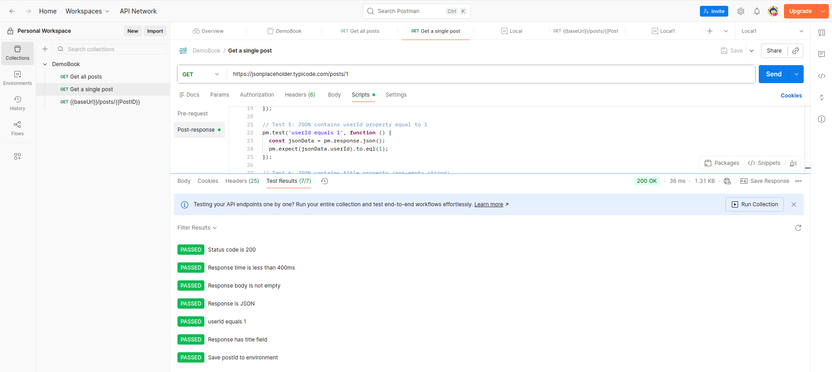

- To see a failing test, temporarily change status(200) to status(201), send again, then revert.
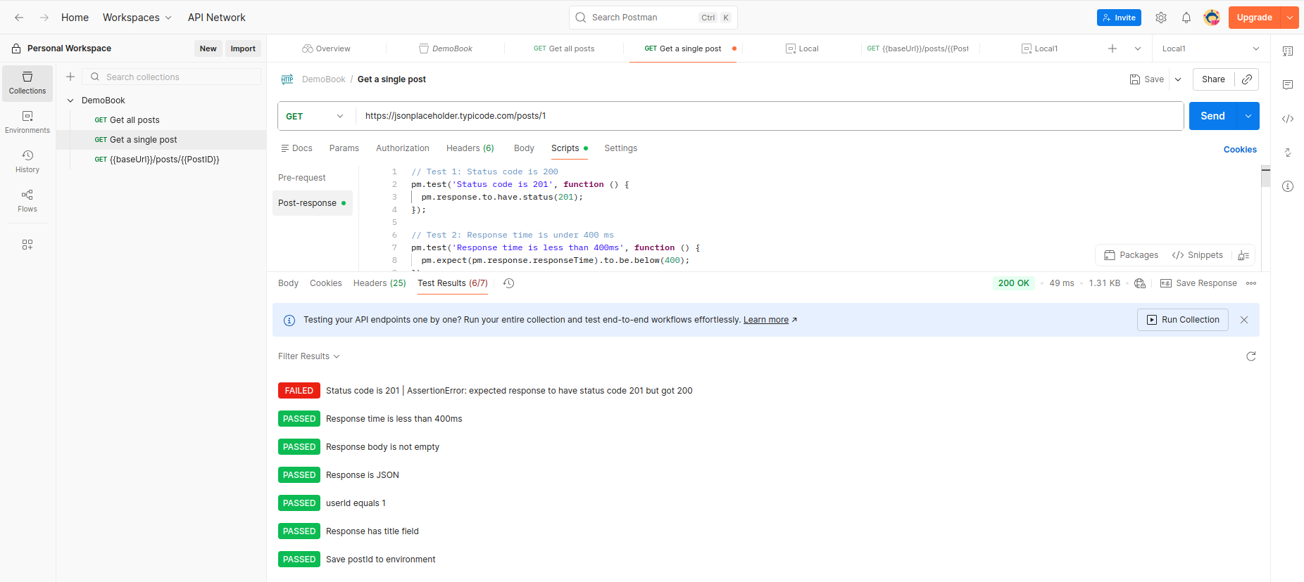
- Add the test script below to Get all posts to check the array response:

pm.test('Status code is 200', function () {
pm.response.to.have.status(200);
});

pm.test('Response is an array', function () {
const data = pm.response.json();
pm.expect(data).to.be.an('array');
pm.expect(data.length).to.be.above(0);
});

pm.test('First item has required fields', function () {
const data = pm.response.json();
pm.expect(data[0]).to.have.all.keys('userId', 'id', 'title', 'body');
});
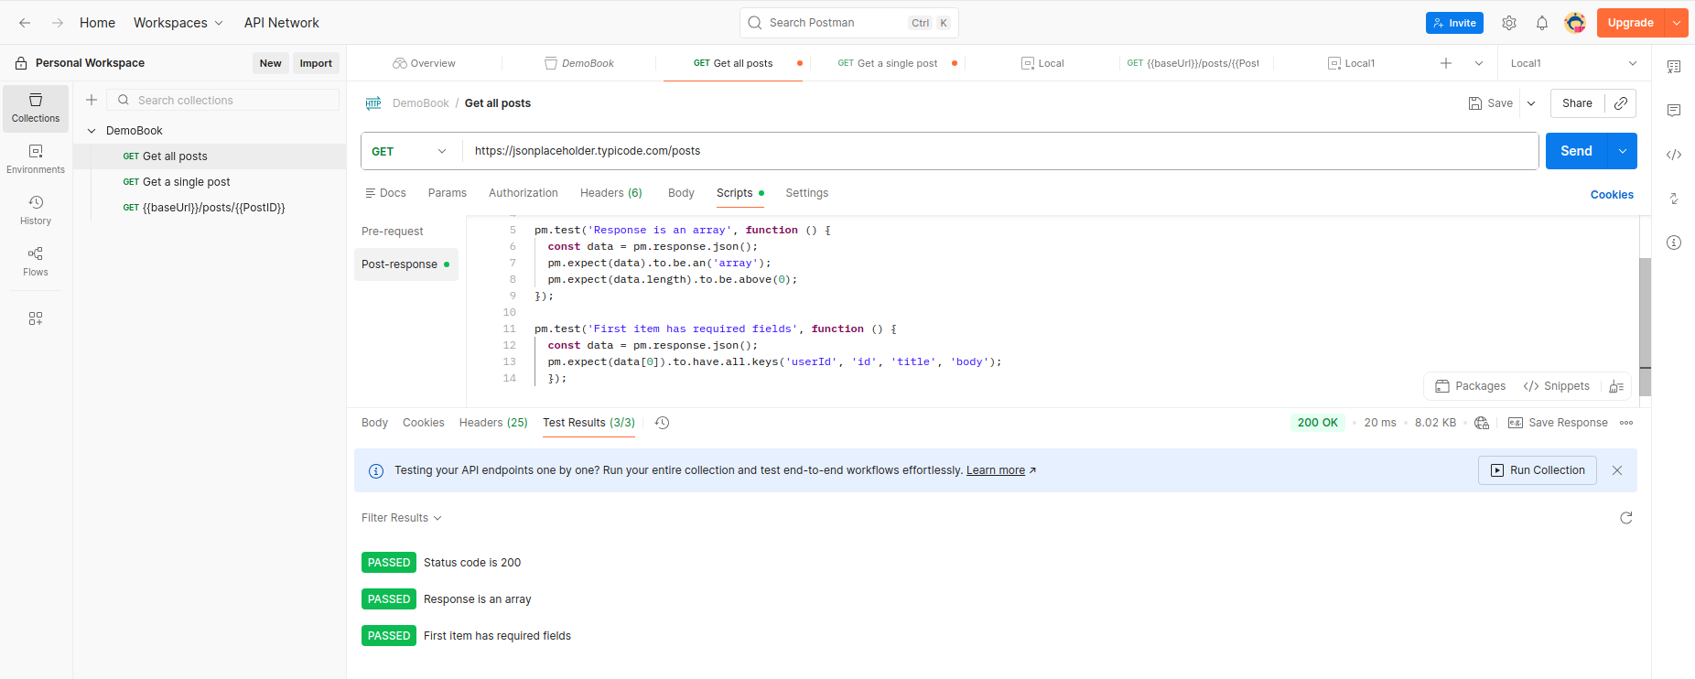

CHECKPOINT — Answer These Questions
Q1: What is the pm object in Postman and what does it allow you to do?
Answer: The pm object is the powerful JavaScript object provided by Postman that serves as the bridge between your scripts and the Postman application. It allows you to interact with request and response data, manage variables (environment, global, or collection), and write test assertions. Using the pm object, you can programmatically control your API workflow, such as fetching a value from a response and saving it for the next request.
Q2: What is the purpose of pm.environment.set() in Test 7?
Answer: The function pm.environment.set("variable_name", "value") is used to programmatically create or update an environment variable. In the context of a test, this is usually used for dynamic data chaining. For example, if Test 7 creates a new user, you would use this command to grab the id from the response and save it to an environment variable so that subsequent requests (like "Update User" or "Delete User") know exactly which ID to target
Q3: Why is it important to test both status codes and response body content?
Answer: Testing both ensures a complete picture of the API's health. A status code (like 200 OK) only tells you that the server didn't crash and technically fulfilled the request. However, the response body contains the actual data. Without checking the body, you might receive a "Success" code even if the data returned is empty, corrupted, or contains the wrong user information. Validating both confirms that the API is not just "up," but is also functioning accurately.
Q4: What happened when you intentionally made a test fail? Describe the output.
Answer: When a test fails, Postman highlights the failure in the Test Results tab of the response section. The specific test case is marked with a red "FAIL" tag, and Postman provides an assertion error message explaining why it failed (e.g., AssertionError: expected response to have status code 200 but got 404). This output allows you to quickly identify whether the issue is a bug in the API code or an error in your test logic.

Exercise 1.4 — Running the Collection Runner
GOAL Execute all requests in the collection sequentially using Postman's Collection Runner.

Steps
- Click the Runner button (triangle icon) in the top bar.
- Drag the DemoBook collection into the Runner, or select it from the list.
- Choose Local environment, set Iterations to 3 and Delay to 500 ms.
- Click Run DemoBook and observe all requests execute sequentially.
- Review the summary — check total pass/fail counts and individual test results.

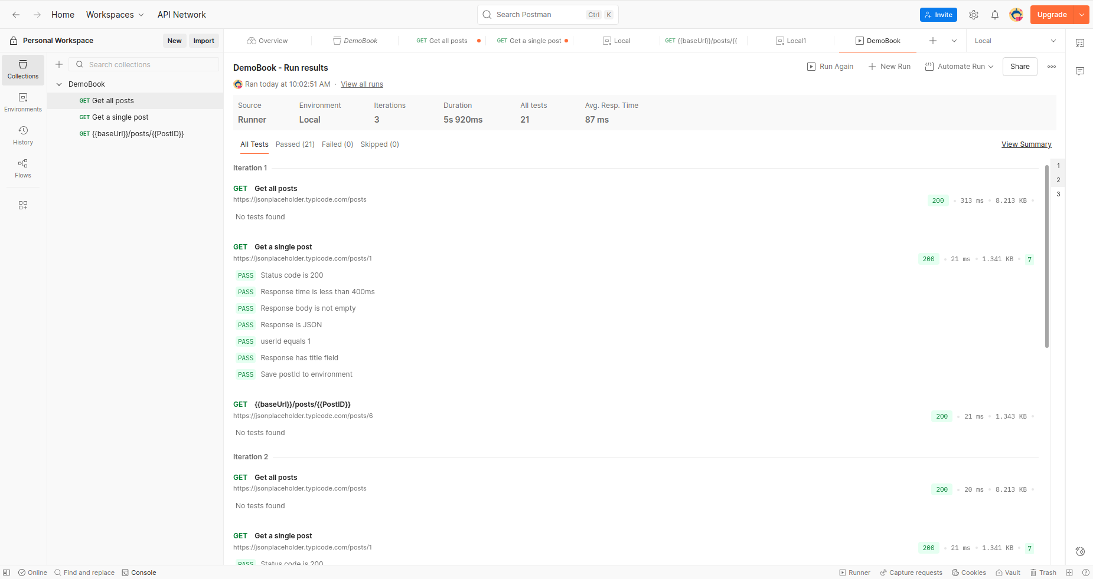

CHECKPOINT — Answer These Questions
Q1: What is the purpose of the Postman Collection Runner?
Answer: The Postman Collection Runner is a tool that allows you to execute an entire folder or collection of API requests in a specific sequence. Instead of clicking "Send" on each individual request, the runner automates the execution of the whole series. It aggregates the test results for every request, providing a comprehensive report on whether the entire workflow—such as creating, updating, and deleting a resource—passed or failed.
Q2: Why would you run multiple iterations in the Collection Runner?
Answer: Running multiple iterations is primarily used for Data-Driven Testing. It allows you to run the same set of API requests multiple times using different sets of data from a CSV or JSON file. This is useful for:
- Bulk Testing: Verifying that the API handles hundreds of different inputs correctly.
- Stress Testing: Checking if the API remains stable under repeated use.
- Validation: Ensuring that unique constraints (like "email must be unique") are working as intended by attempting to create multiple users.
Q3: What does the Delay setting do and when would it be useful?
Answer: The Delay setting specifies a period of time (in milliseconds) that Postman should wait between executing each request in a collection run.
This is useful in several scenarios:
- Rate Limiting: If an API has a "throttling" limit (e.g., only 5 requests per second), a delay prevents your tests from being blocked or receiving 429 Too Many Requests errors.
- Processing Time: Some background tasks on the server (like database indexing or file processing) might take a second to complete before the next API call can successfully find that data.
- Simulating Real-World Usage: It helps mimic the natural pauses a human user would make between actions.

Exercise 1.5 — Newman Command-Line Execution
GOAL Run Postman collections from the terminal using Newman to enable CI/CD integration.

Installation
# Install Newman globally
npm install -g newman

# Verify installation
newman --version
newman --help

Export from Postman
- In Postman, open DemoBook → ⋯ menu → Export → Collection v2.1 → Export. Save as DemoBook.postman_collection.json.
- Export the Local environment: Settings (⚙) → Environments → download icon next to Local. Save as Local.postman_environment.json.
- Place both JSON files in a folder, e.g., ~/newman-lab/.

Run Newman
# Navigate to your folder
cd ~/newman-lab

# Basic run with environment
newman run DemoBook.postman_collection.json -e Local.postman_environment.json

# Run with HTML report (install reporter first)
npm install -g newman-reporter-htmlextra
newman run DemoBook.postman_collection.json \
-e Local.postman_environment.json \
-r htmlextra \
--reporter-htmlextra-export report.html

# Run with JUnit XML (for CI/CD)
newman run DemoBook.postman_collection.json \
-e Local.postman_environment.json \
-r junit \
--reporter-junit-export results.xml

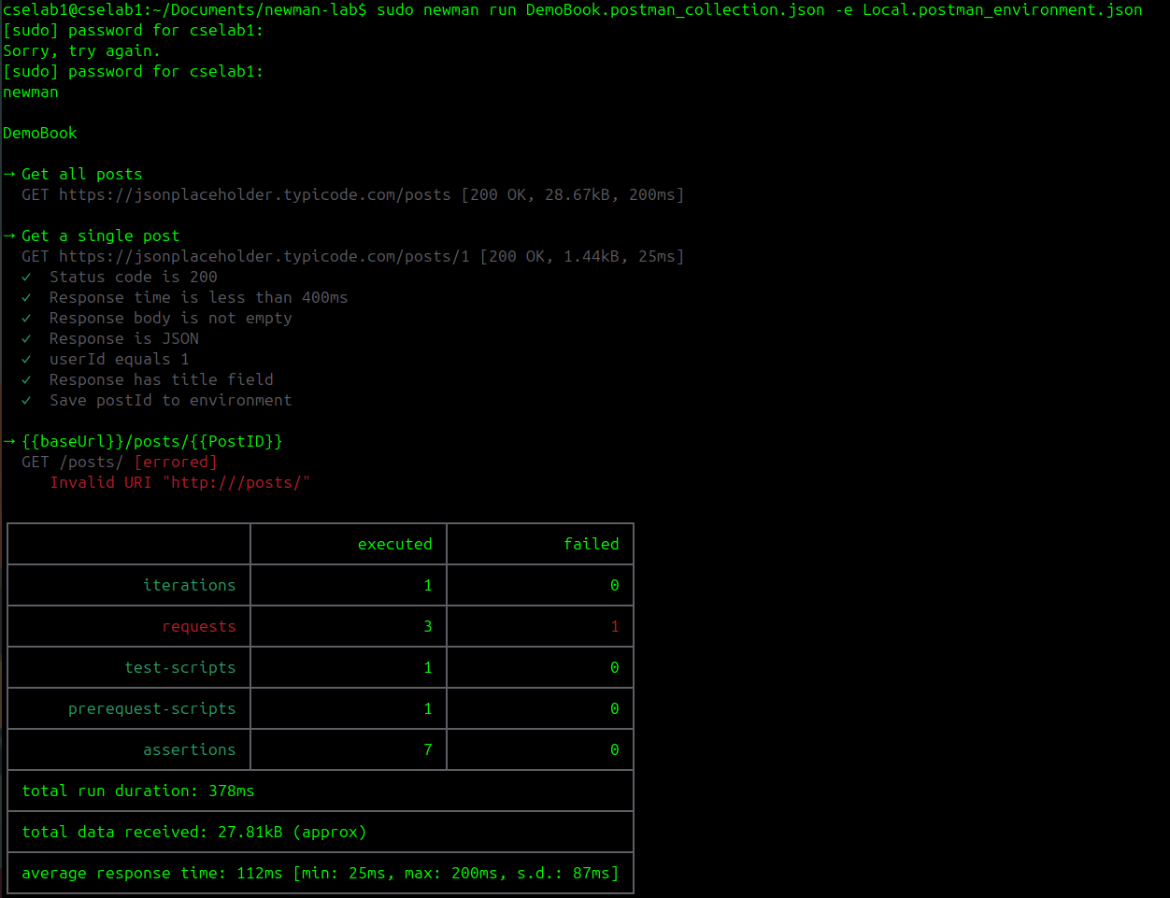
- Open report.html in a browser and explore the generated test report.
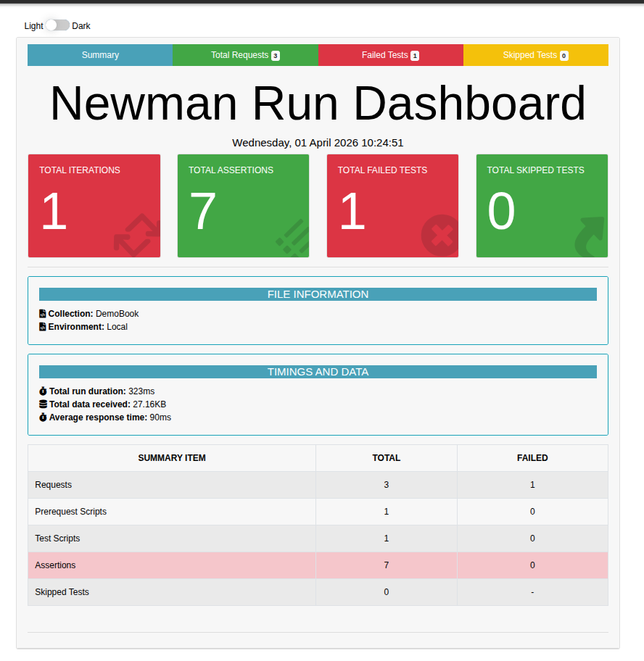

CI/CD Integration — package.json
Create a package.json in your newman-lab folder to define reusable scripts:

{
"name": "api-tests",
"version": "1.0.0",
"scripts": {
"test:local": "newman run DemoBook.postman_collection.json -e Local.postman_environment.json -r junit --reporter-junit-export results-local.xml",
"test:qa": "newman run DemoBook.postman_collection.json -e QA.postman_environment.json -r junit --reporter-junit-export results-qa.xml"
},
"devDependencies": {
"newman": "^5.0.0"
}
}

# Install local dependencies
npm install

# Run local environment tests
npm run test:local
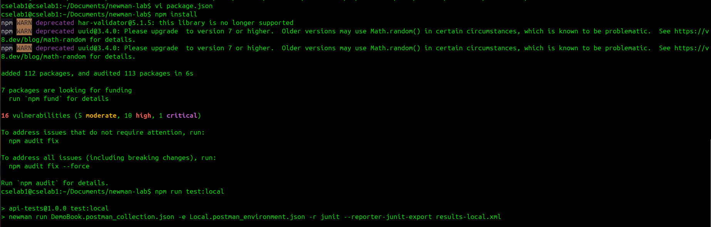
CHECKPOINT — Answer These Questions
Q1: What is the difference between pm.environment.set() and pm.globals.set()?
Answer: The difference lies in scope and visibility.
- pm.environment.set() stores data within a specific environment (like "Dev" or "Production"). These variables are only accessible when that specific environment is active.
- pm.globals.set() stores data in a universal scope. Global variables are accessible across the entire workspace, regardless of which environment you have selected. Use environments for server-specific data and globals for data that stays the same across all contexts.
Q2: Why is Newman preferred over the Postman GUI for CI/CD pipelines?
Answer: Newman is preferred because it is a Command Line Interface (CLI) tool, making it "headless." Unlike the Postman GUI, which requires a desktop environment and manual interaction, Newman can be easily integrated into automated build servers (like Jenkins, GitHub Actions, or GitLab CI). It consumes fewer system resources and allows tests to run automatically every time new code is pushed, which is essential for continuous integration.
Q3: What happens when the PostID variable is missing from the selected environment?
Answer: If the PostID variable is missing, Postman will be unable to resolve the placeholder {{PostID}} in your request URL or body. In most cases, it will treat the variable as an unresolved string, literally sending the text {{PostID}} to the server. This usually results in a 404 Not Found or 400 Bad Request error because the server is looking for a numeric or UUID identifier and receives the curly-bracket text instead.
Q4: What is the purpose of the JUnit XML report format in CI/CD pipelines?
Answer: The JUnit XML report is a standardized format that most CI/CD tools (like Azure DevOps or Jenkins) use to parse test results. By outputting results in this format, the CI/CD pipeline can "read" the test outcome to provide visual dashboards, track test success rates over time, and—most importantly—automatically fail the build if any API tests did not pass. It acts as the universal translator between your API tests and your automation server.

Unit 3 — Code Quality with SonarQube & SonarLint

Exercise 2.1 — Start SonarQube with Docker
GOAL Launch SonarQube using Docker and create a sample Node.js project with intentional code issues.

Sample Project Setup
First, create a sample Node.js project with intentional code issues for SonarQube to detect:

# Create project folder
mkdir sonar-demo && cd sonar-demo
npm init -y
npm install --save-dev jest

Create the file src/calculator.js with intentional issues:

// src/calculator.js
// WARNING: This file has intentional code quality issues for lab purposes

var password = 'admin123'; // Bug: hardcoded credential (security hotspot)

function add(a, b) { return a + b; }

function subtract(a, b) { return a - b; }

function multiply(a, b) { return a * b; }

// Code smell: no proper error handling
function divide(a, b) {
if (b === 0) {
console.log('Error'); // Code smell: use proper error handling
return null;
}
return a / b;
}

// Dead code / unreachable
function unusedFunction() {
var x = 10;
return x;
console.log('never reached'); // Bug: unreachable code
}

module.exports = { add, subtract, multiply, divide };

Create src/calculator.test.js:

const { add, subtract, multiply, divide } = require('./calculator');

describe('Calculator', () => {
test('add: 2 + 3 = 5', () => { expect(add(2, 3)).toBe(5); });
test('subtract: 10 - 4 = 6', () => { expect(subtract(10, 4)).toBe(6); });
test('multiply: 3 * 4 = 12', () => { expect(multiply(3, 4)).toBe(12); });
test('divide: 10 / 2 = 5', () => { expect(divide(10, 2)).toBe(5); });
test('divide by zero returns null', () => { expect(divide(10, 0)).toBeNull(); });
});

Update package.json scripts section and run tests:

{ "scripts": { "test": "jest --coverage" } }

# Run tests and generate coverage report
npm test
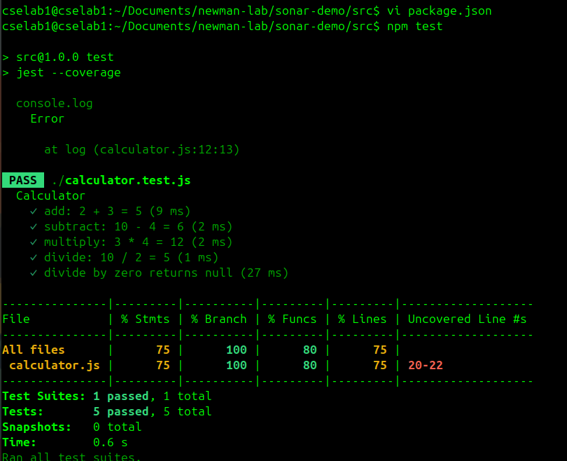

Start SonarQube
# Pull and run SonarQube Community Edition
docker run -d --name sonarqube \
-p 9000:9000 \
sonarqube:community

# Wait ~60 seconds, then open browser:
# http://localhost:9000
# Default credentials: admin / admin
# You will be prompted to change the password on first login
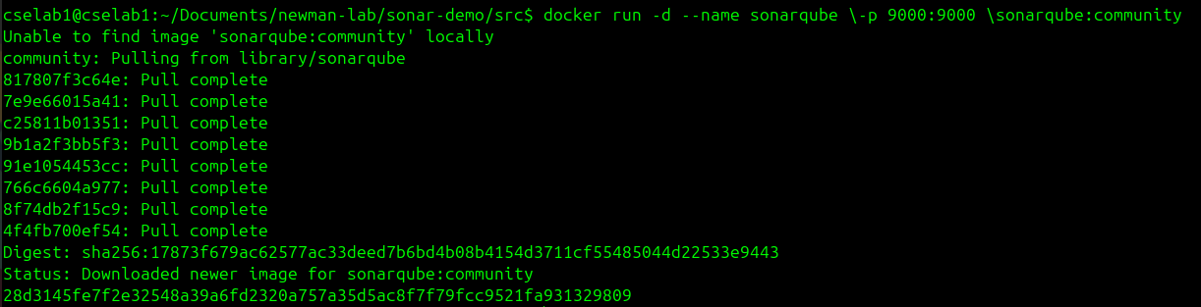
CHECKPOINT — Answer These Questions
Q1: What is SonarQube and what does it analyze in a software project?
Answer: SonarQube is an open-source platform used for Static Application Security Testing (SAST) and continuous inspection of code quality. It analyzes source code to identify technical debt and maintainability issues without actually executing the program. It scans for bugs, security vulnerabilities, and "code smells" across 30+ programming languages, providing a detailed report on the "health" of the codebase.
Q2: Why is it useful to run SonarQube as a Docker container instead of installing it directly?
Answer: Running SonarQube in a Docker container offers several advantages:
- Isolation: It keeps the SonarQube installation and its dependencies (like Java or specific database drivers) separate from your host operating system, preventing version conflicts.
- Portability: You can move the container between different environments (Local, Dev, Production) and guarantee it will run exactly the same way.
- Ease of Setup: Instead of a complex manual installation, you can launch the entire platform with a single command (docker run).
- Cleanup: If you no longer need it, you can remove the container without leaving "junk" files scattered across your system.
Q3: What are the four main types of issues SonarQube detects? Briefly define each.
Answer: SonarQube categorizes findings into four specific areas to help developers prioritize fixes:
- Bugs: Errors in the code that will lead to a failure or incorrect behavior at runtime (e.g., null pointer exceptions).
- Vulnerabilities: Security weaknesses that could be exploited by attackers (e.g., SQL injection or hardcoded passwords).
- Code Smells: Maintainability issues that aren't necessarily "broken" but make the code confusing, difficult to read, or hard to refactor (e.g., duplicated code blocks).
- Security Hotspots: Pieces of code that are security-sensitive and require a manual human review to determine if they are actually a risk.

Exercise 2.2 — Create a SonarQube Project & Token
GOAL Configure a SonarQube project and generate an authentication token for the scanner.

Steps
- Log in at http://localhost:9000 with your credentials.
- Click Create new project → Manually.
- Enter Project key: sonar-demo and Display name: Sonar Demo → click Set Up.
- Choose Locally when asked how to analyze the repository.
- Click Generate to create a token. Name it lab-token. Copy and save the token — it will not be shown again.
- Select JavaScript / TypeScript as the project language and continue.

CHECKPOINT — Answer These Questions
Q1: What is a SonarQube authentication token and why is it needed?
Answer: A SonarQube authentication token is a unique string of characters used to identify a user during the analysis process without requiring their actual login password. It is needed to provide a secure way for external tools—like the Sonar Scanner, Jenkins, or GitHub Actions—to "talk" to the SonarQube server. Using a token is much safer than hardcoding a password into a script or CI/CD pipeline because it can be revoked at any time without affecting the user's main account credentials.
Q2: What is the difference between a Project Key and a Display Name in SonarQube?
Answer: These two identifiers serve different purposes within the platform:
- Project Key: This is a unique identifier used by the system to distinguish one project from another. It is usually a short, string-based ID (e.g., my-cool-app-api) that cannot be changed once the project is created. It is used in command-line arguments to tell the scanner exactly which project record to update.
- Display Name: This is the human-readable name of the project as it appears on the SonarQube dashboard (e.g., "My Cool App - Backend API"). Unlike the Project Key, the Display Name can be changed at any time to make the project easier for team members to find and recognize.

Exercise 2.3 — Run SonarScanner
GOAL Execute a SonarScanner analysis and review code quality results on the SonarQube dashboard.

# Install SonarScanner globally via npm
npm install -g sonarqube-scanner

Create sonar-project.properties in the project root:

sonar.projectKey=sonar-demo
sonar.projectName=Sonar Demo
sonar.projectVersion=1.0
sonar.sources=src
sonar.tests=src
sonar.test.inclusions=**/*.test.js
sonar.javascript.lcov.reportPaths=coverage/lcov.info
sonar.host.url=http://localhost:9000
sonar.token=YOUR_TOKEN_HERE

# Run tests first to generate coverage
npm test

# Then run the scanner
sonar-scanner

After the scan completes, return to the SonarQube dashboard at http://localhost:9000 and review:
- Bugs — code that is clearly wrong or will fail at runtime
- Vulnerabilities — security issues in the code
- Security Hotspots — code that needs manual review (e.g., hardcoded password)
- Code Smells — maintainability issues (dead code, too-complex functions)
- Coverage — percentage of code covered by tests
- Duplications — duplicated lines or blocks
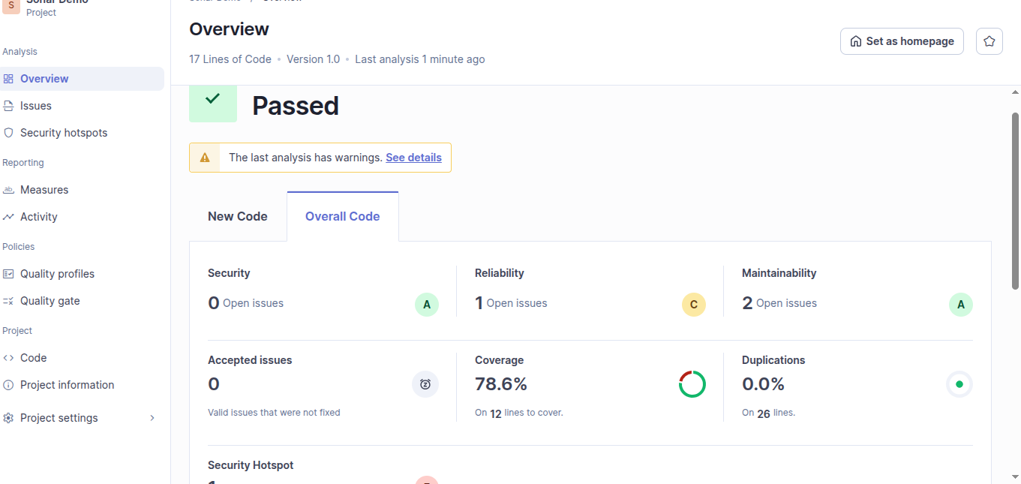
CHECKPOINT — Answer These Questions
Q1: What is the purpose of the sonar-project.properties file?
Answer: The sonar-project.properties file is the central configuration file for the SonarScanner. It tells the scanner exactly how to process the project by defining metadata and analysis parameters. Key details typically found in this file include the Project Key, the Project Name, the version, and the paths to the source code directories (sonar.sources). By using this file, you ensure that the scan settings remain consistent every time the analysis is run, avoiding the need to pass long strings of arguments manually via the command line.
Q2: What issues did SonarQube find in calculator.js? List at least three.
Answer: While the specific results depend on the code analyzed in your lab, SonarQube typically identifies the following types of issues in a standard JavaScript file like calculator.js:
- Code Duplication: Identifying identical blocks of code (e.g., repeating the same logic in an add and subtract function) that should be refactored into a single reusable function.
- Unused Variables: Detecting variables that are declared but never used, which increases memory overhead and clutters the code.
- Security Vulnerabilities (e.g., Use of eval()): Flagging dangerous functions that could allow attackers to execute malicious code.
- Cognitive Complexity: Highlighting functions that are too complex (too many nested if/else statements) and difficult for a human to maintain.

Q3: What does Code Coverage percentage indicate and why does it matter?
Answer:Code Coverage is a metric that measures the percentage of your source code that is executed when your automated test suite runs. For example, if you have 100 lines of code and your tests exercise 80 of them, your coverage is 80%.
It matters because:
- Identifies Unchecked Paths: It highlights "blind spots" in your code that haven't been tested, which are likely places for bugs to hide.
- Increases Confidence: High coverage reduces the risk of unintended side effects when you refactor or add new features.
- Quality Benchmark: It serves as a key performance indicator (KPI) for teams to ensure that testing efforts are keeping pace with code development.

Q4: What is a Security Hotspot and how does it differ from a Vulnerability?
Answer: The difference lies in the certainty of the risk and the need for human review:
- Vulnerability: This is a confirmed security weakness that has a high probability of being exploited (e.g., a clear SQL injection point). SonarQube flags these as "must-fix" items because the logic is definitively unsafe.
- Security Hotspot: This is a "suspicious" piece of code that might be a security risk depending on the context, but it isn't necessarily a bug (e.g., using a specific encryption algorithm or opening a socket).

Exercise 2.4 — Real-Time Analysis with SonarLint in VS Code
GOAL Install SonarLint in VS Code to get real-time feedback on code quality before committing.

Steps
- Open VS Code. Go to Extensions (Ctrl+Shift+X) and search for SonarLint.
- Install the SonarLint extension by SonarSource.
- Open the sonar-demo folder in VS Code (File → Open Folder).
- Open src/calculator.js. SonarLint will immediately highlight issues with colored underlines.
- Hover over each highlighted issue to see the rule description and recommended fix.

You should see issues highlighted such as:
- "passwords should not be hardcoded" on the var password line
- "Unreachable code should be removed" after the return statement
- "console.log" usage flagged as a code smell in production code

- Fix the divide function to use proper error throwing:

// Fixed version
function divide(a, b) {
if (b === 0) {
throw new Error('Division by zero is not allowed');
}
return a / b;
}

- Update the test for divide by zero:

test('divide by zero throws error', () => {
expect(() => divide(10, 0)).toThrow('Division by zero is not allowed');
});

- Re-run npm test to ensure all tests pass. Then re-run sonar-scanner and observe the improvement on the dashboard.

CHECKPOINT — Answer These Questions
Q1: What is the difference between a Bug and a Code Smell in SonarQube?
Answer: : In SonarQube:
- A Bug is an error in the code that can cause incorrect results or runtime failures.
- A Code Smell is a poor coding practice that does not break functionality but reduces readability, maintainability, or efficiency.

In short:
- Bug = breaks behavior
Code Smell = makes future you suffer
Q2: Why is SonarLint useful for developers even before code is committed to a repository?
Answer: SonarLint provides real-time code analysis inside the IDE. It helps developers detect and fix issues such as bugs, vulnerabilities, and code smells while writing code, preventing problems before they are committed or pushed to a repository.
Q3: How did the SonarQube dashboard change after you fixed the divide function? Describe the improvements.
Answer: After fixing the divide function (especially handling division by zero properly), the SonarQube dashboard showed improvements such as:
- Reduction or removal of bugs related to incorrect logic
- Improved code quality rating
- Possible increase in code coverage if additional test cases were added
- Fewer warnings or issues in the affected file
Basically, the dashboard stopped quietly judging that function.
Q4: How would you integrate SonarQube analysis into a GitHub Actions CI/CD pipeline?
Answer: To integrate SonarQube into a GitHub Actions pipeline:
- Add a workflow file (.github/workflows/sonar.yml)
- Install dependencies and run tests
- Execute SonarScanner using a GitHub Action or CLI
- Store the SonarQube token securely using GitHub Secrets
- Run analysis on each push or pull request
Example steps include:
- Checkout code
- Setup Node.js
- Run npm install and npm test
- Run sonar-scanner with token from secret

Final Reflection Questions
Answer the following questions based on your complete lab experience:

Q1: What are the key differences between running API tests in the Postman GUI vs. using Newman from the command line?
Answer:
Running tests in the Postman API Platform GUI is interactive and user-friendly, allowing developers to manually send requests, inspect responses, and debug easily. It is best suited for development and exploratory testing.
Using Newman CLI runs the same collections via the command line, enabling automation, scripting, and integration with CI/CD pipelines. It is faster, repeatable, and does not require a graphical interface.

Q2: How does integrating Newman into a CI/CD pipeline improve software quality assurance?
Answer: Integrating Newman into CI/CD pipelines enables automated execution of API tests on every code change. This ensures early detection of failures, consistent validation of APIs, and prevents defective code from being deployed. It improves reliability.
Q3: Compare static code analysis (SonarQube) with dynamic testing (Postman). When should each be used?
Answer: SonarQube performs static code analysis, examining source code without executing it to detect bugs, vulnerabilities, and code quality issues. It should be used during development and before deployment to maintain clean and secure code.
Postman API Platform performs dynamic testing, where APIs are executed and their runtime behavior is validated. It should be used to verify functionality, correctness of responses, and integration between systems.
Q4: What DevSecOps practices did these exercises demonstrate? Explain how security and quality are enforced early in the pipeline.
Answer: These exercises demonstrated key DevSecOps practices such as shift-left testing, automation, and continuous quality monitoring. Tools like SonarQube enforce static code analysis to detect bugs, vulnerabilities, and code smells early in development, while API testing with Postman API Platform and Newman CLI validates functionality during execution.
By integrating these checks into early stages of the pipeline, issues are identified before deployment, reducing risk, improving security, and ensuring higher code quality. This approach minimizes late-stage failures and promotes continuous feedback.

Q5: If you were designing a complete DevSecOps pipeline for a real project, how would you combine GitHub Actions, Docker, Newman, and SonarQube?
Answer:
A complete DevSecOps pipeline would use GitHub Actions to automate the workflow triggered on code commits or pull requests. The pipeline would build and run the application inside Docker containers to ensure consistency across environments.
Static code analysis would be performed using SonarQube to detect code quality and security issues, while API tests would be executed using Newman CLI to validate runtime behavior.
The pipeline would include stages such as:
- Code checkout and dependency installation
- Build and test execution
- Static analysis (SonarQube)
- API testing (Newman)
- Deployment only if all checks pass
This integration ensures automated, secure, and reliable software delivery with continuous monitoring of quality and security.

Challenge Scenarios

Challenge 1 — E-Commerce Product API Testing
Scenario
You are a QA engineer at an e-commerce startup. The backend team just deployed a Product API. Your job is to validate that the API correctly returns product listings, handles pagination, and responds with proper data structures before the frontend team integrates it.

Context / API Details
Use the public DummyJSON API as a stand-in for the real product API:
https://dummyjson.com/products (all products, paginated)
https://dummyjson.com/products/1 (single product by ID)
https://dummyjson.com/products/search?q=phone (search)
Tasks
1. Create a new Postman collection called ECommerceAPI.
2. Add three GET requests: Get all products, Get product by ID, and Search products.
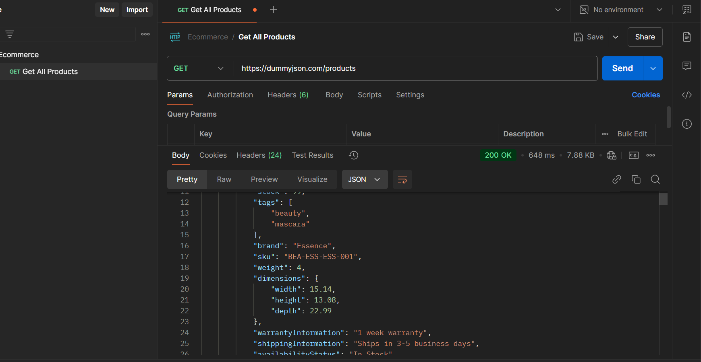
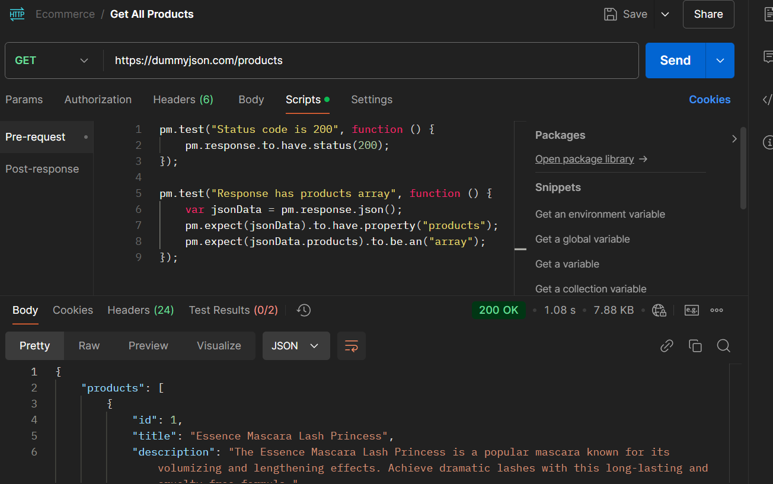

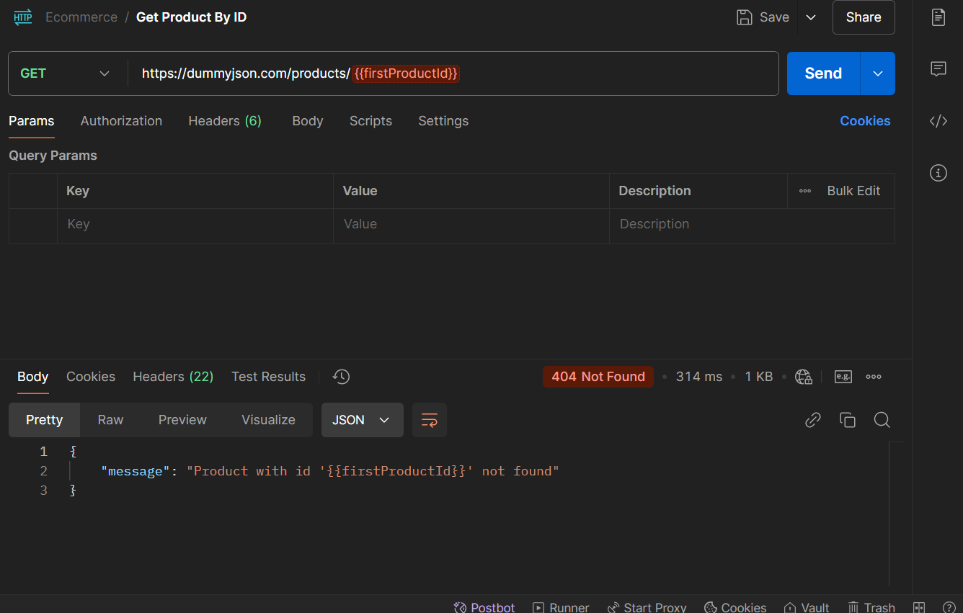

3. Verify that Get all products returns a JSON object with a products array.
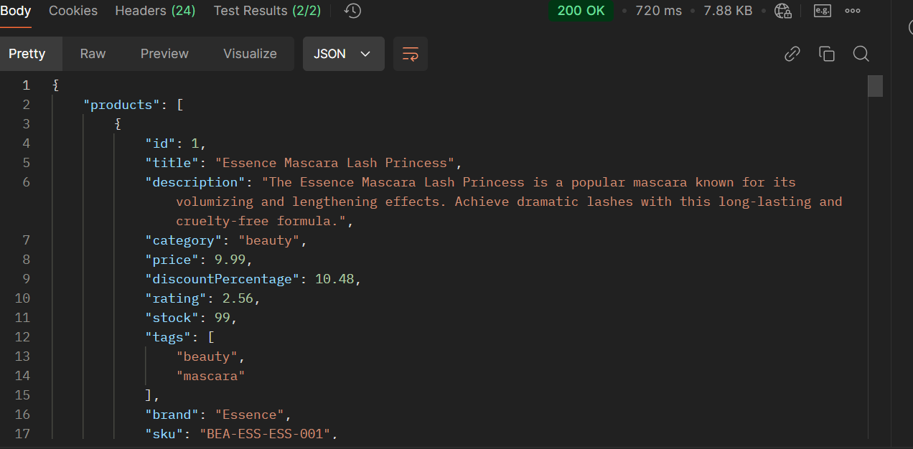
4. Verify that Get product by ID returns a single object containing id, title, price, and stock fields.
5. Write a Postman test that checks price is a number greater than 0.


6. Write a Postman test that saves the first product's id to an environment variable called firstProductId.
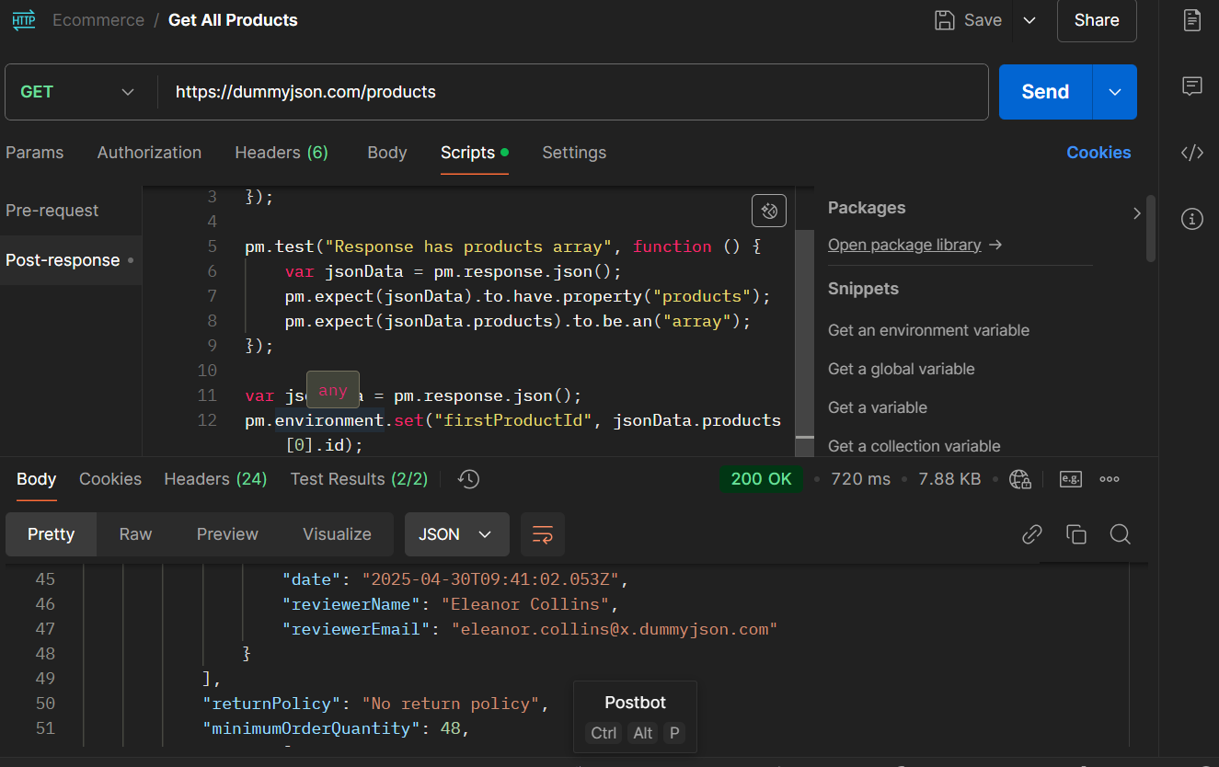
7. Run the collection using the Collection Runner with 2 iterations.
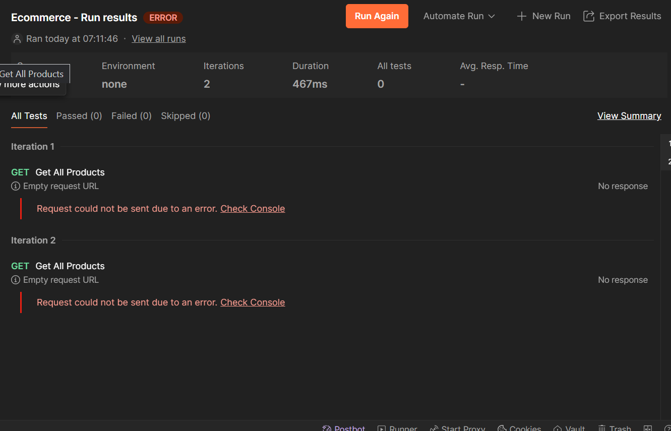
Take screenshots of all commands, terminal outputs, Postman test results, and SonarQube dashboard. Compile all screenshots and answers into a single document.

