**19CSE202-Data Base Management System**

**REPORT**

**Team_no:**35

**Team Members:**

BL.EN. U4CSE20053 GUNTURI AKSHITA

BL.EN. U4CSE20093 MALLA CHANDU

BL.EN. U4CSE20139 RATNAKARAM SASANK

BL.EN. U4CSE20153 SANDAYYAGARI AKSHAY REDDY

**Topic:** Township Management System

**Abstract**

**BRIEF DESCRIPTION OF OUR PROJECT:**

How we got this thought?

1. We wanted to be different from others
2. We wanted our project to be helpful for a large sector of people

Why we have chosen this township management system?

1. Nowadays there is a huge demand for gated communities in metropolitan cities
2. Many gated communities do not have formal database system for managing and maintaining the information of their flat or villa owners.

Working process of our system?

This application is designed to cater to the effective management of a gated community. the application also helps to maintain the databases of the community (apartments or villas), the revenue, family details, maintenance, parking facility, amenities, health details, etc.

The users of our project are management of the gated community, flat or villa owners.

The functions of our township management system are:

1. Maintenance: owners can pay their maintenance charges (monthly or annually); owners can raise issues regarding plumbing and electrical issues.
2. Security system: video phone entry, access control doors, access to CCTV footage if required.
3. Amenities: owners can book party halls, they can also use other indoor facilities like reading room, health club, gymnasium, sports area.
4. Member details: management can change (add or delete or manage) the member details if required.

**Technologies used for the Application:**

* Front End: HTML, CSS
* Server Side: Servlets, Tomcat
* Database: Oracle SQL for creating database

**ER Diagram/Table mapping**

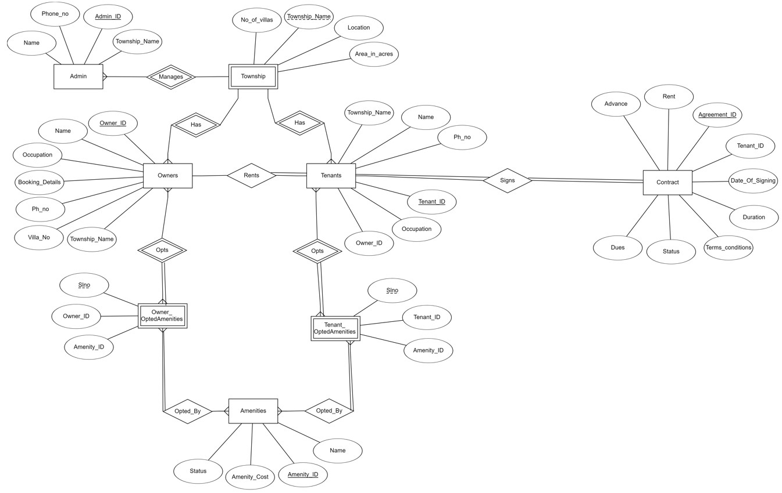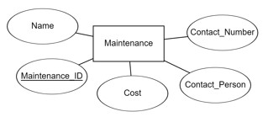

**Symbolic Representation of Cardinality Ratios:**

one-to-one relationship (1:1)

many-to-one (m:1) many-to-many(m:m)

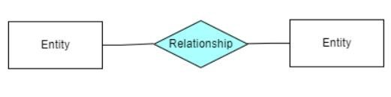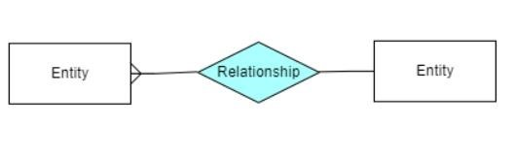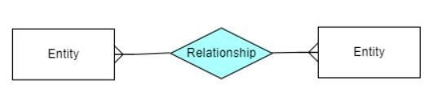

**Table Structure:**

Admin ( Admin_ID varchar(10) PRIMARY KEY, Name varchar(20) NOTNULL, Phone_no number(10) UNIQUE, Township_Name varchar(20) NOTNULL)

Township (Township_Name varchar(20) NOTNULL, No_of_Villas number(35) NOTNULL, Location varchar(100) NOTNULL, Area_in_acres number(25))

Owners ( Owner_ID varchar(10) PRIMARY KEY, Name varchar(30) NOTNULL, Booking_Details varchar(100) NOTNULL, Occupation

varchar(25), Ph_no varchar(10) UNIQUE, Villa_no varchar(10)

NOTNULL, Township_Name varchar(20) FOREIGN

KEY(Township_Name) REFERENCES Township(Township_Name)) Tenants ( Tenant_ID varchar(10) PRIMARY KEY, Name varchar(30)

NOTNULL, Ph_no number(10)UNIQUE, Occupation varchar(25),

Township_Name REFERENCES Township(Township_Name), Owner_ID REFERENCES Owners(Owner_ID))

Contract ( Agreement_ID varchar(10) PRIMARY KEY,

Date_of_Signing varchar(20) NOTNULL, Advance varchar(20) , Rent varchar(20) NOTNULL, Duration varchar(20) NOTNULL,

Terms_Conditions varchar(150), Status varchar(20), Dues varchar(20), Tenant_ID varchar(10) REFERENCES Tenants(Tenant_ID))

Maintenance (Maintenance_ID varchar(10) PRIMARY KEY, Name varchar(40) NOTNULL, Cost varchar(20) NOTNULL, Contact_Person varchar(30) NOTNULL, Contact_number varchar(8) UNIQUE)

Owner_OptedAmenities (Slno varchar(5) NOTNULL, Owner_ID

REFERENCES Owner(Owner_ID), Amenity_ID REFERENCES Amenities(Amenity_ID))

Tenant_OptedAmenities(Slno varchar(5), Tenant_ID REFERENCES

Tenants(Tenant_ID), Amenity_ID REFERENCES

Amenities(Amenity_ID))

Amenities(Amenity_ID varchar(10) PRIMARY KEY, Name varchar(30) NOTNULL, Amenity_Cost varchar(20) NOTNULL, Status varchar(30))

**Modules/Functionalities:**

Insert

Update

Delete