# ABSTRACT

The use of Artificial Intelligence (AI) in agriculture has created new opportunities for improving crop productivity and advancing sustainable farming methods. The "Crop Recommendation System using ANN" project is a pioneering initiative that combines the capabilities of Artificial Neural Networks (ANN) with the agricultural industry. Its objective is to offer customized crop recommendations by analyzing different environmental and soil factors. This comprehensive study summarizes the project's progression from the initial idea to its current stage of incomplete implementation, highlighting the potential of Artificial Neural Networks (ANN) in revolutionizing agricultural decision-making procedures.

The project commences by clearly defining the problem, which pertains to the need for technical involvement in agriculture. Conventional agricultural practices, while abundant in practical wisdom, frequently struggle to adjust to the swiftly evolving environmental circumstances. Our approach endeavors to narrow this disparity by providing data-driven recommendations for crop selection, customized to unique land and meteorological circumstances. The rationale for this issue arises from the worldwide requirement for sustainable agricultural practices, optimal resource utilization, and the escalating food demand resulting from population growth.

A comprehensive literature study was undertaken, examining multiple research publications and existing technologies in the field of AI in agriculture. This survey facilitated the identification of deficiencies in existing approaches and served as the basis for our approach. The project use Python as the principal programming language, incorporating modules such as Pandas, NumPy, Scikit-learn, Matplotlib, and Seaborn for data manipulation and examination. Jupyter Notebook and Google Colab offer a development environment that allows convenient access to computing resources.

II

The dataset utilized in this project is extensive, covering factors such as Nitrogen, Phosphorus, Potassium levels, temperature, humidity, pH, and rainfall. These characteristics play a crucial role in assessing the appropriateness of crops. The first stage entailed meticulous data preprocessing, which encompassed addressing null values, eliminating duplicates, and detecting outliers. An Exploratory Data Analysis (EDA) was conducted to get insights into the correlations and distributions present in the data, which may be used to inform the process of developing a model.

The architecture of the ANN model was carefully crafted, taking into account several combinations of layers, activation functions, and optimizers in order to identify the most efficient model. The research first examined other machine learning models such as Decision Trees, RandomForest, and SVC. However, based on comments from professors, the focus was then limited down to primarily improving the ANN model.

During the process of training the model, the dataset was divided into separate sets for training and testing. The artificial neural network (ANN) model was then trained using various hyperparameters. The initial findings were promising, showcasing the model's capacity to precisely forecast crop suggestions according to the provided criteria.

The project's present condition exhibits encouraging potential in attaining its objectives. The ANN-based system is designed to aid farmers in making well- informed decisions, ultimately enhancing crop yields and facilitating the efficient utilization of agricultural resources. Future work include refining the ANN model, further optimizing it to enhance accuracy and dependability, and even incorporating real-time environmental data to provide dynamic crop suggestions.

To summarize, the "Crop Recommendation System using ANN" is a pioneering advancement in agricultural technology. Through the utilization of machine learning, particularly artificial neural networks (ANN), this study not only makes a valuable

contribution to the agricultural science domain but also establishes a path for the adoption of data-centric and environmentally friendly farming methods on a global scale.

# TABLE OF CONTENTS

**Page No.**

ACKNOWLEDGEMENTS i

ABSTRACT ii - iv

LIST OF TABLES v

CHAPTER 1- INTRODUCTION 1

* 1. INTRODUCTION 2
  2. MOTIVATION

CHAPTER 2 – LITERATURE SURVEY 3 - 4

CHAPTER 3 – SYSTEM REQUIREMENTS AND ANALYSIS

* 1. SOFTWARE REQUIREMENTS 5 - 6
  2. HARDWARE REQUIREMENTS 6 - 7 CHAPTER 4 – SYSTEM DESIGN

4.1 SYSTEM DESIGN 8 - 10

4.2 LOW LEVEL DESIGN 11 – 13

4.3 HIGH LEVEL DESIGN 13 - 14

CHAPTER 5 – SYSTEM IMPLEMENTATION

5.1 MODULES USED WITH DESCRIPTION 15 - 16

CHAPTER 6 – RESULTS AND ANALYSIS 17 – 18

CHAPTER 7– CONCLUSION AND FUTURE SCOPE 19 - 20 REFERENCE 21

V

Chapter 1 November,2023

# CHAPTER - 1

**INTRODUCTION**

Agriculture, which serves as the foundation of many

economies globally, is currently at a critical point where conventional methods are being more and more combined with technological advancements. The "Crop Recommendation System using ANN" project is a pioneering venture that seeks to revolutionize agricultural decision-making by incorporating Artificial Neural Networks (ANN). This introduction explores the project's origin, its fundamental concepts, and the approach used to achieve its goals.

The genesis of this research is based on tackling a basic obstacle in agriculture - the optimization of crop choices in diverse environmental circumstances. Conventional agricultural practices, although based on practical knowledge, frequently lack the accuracy and flexibility necessary to cope with changing climate and soil conditions. The project aims to overcome these constraints by utilizing the analytical skills of ANN. This methodology offers a data-centric, accurate, and enduring method for choosing crops, thereby improving agricultural output and optimizing resource utilization.

The literature survey we conducted offered a fundamental comprehension of the present condition of AI implementations in agriculture. The study exposed a deficiency in the application of sophisticated machine learning methods, specifically Artificial Neural Networks (ANN), for delivering tailored crop suggestions. This gap represented a possibility for innovation - an opportunity to utilize the pattern identification and forecasting skills of ANN to examine intricate agricultural data. The poll also emphasized the possible economic and environmental advantages of implementing such a system, further confirming the project's significance.

The project's methodology is based on a methodical approach that includes gathering data, preparing it for analysis, constructing a model, and assessing its performance. The dataset serves as the central component of the system, including crucial agricultural variables such as soil composition (Nitrogen, Phosphorus, Potassium), temperature, humidity, pH levels, and rainfall. This data is crucial in assessing the appropriateness of different crops in various environmental situations.

Data preparation is an essential and crucial stage in the project, which includes cleaning, normalization, and outlier detection. Its purpose is to guarantee the quality and integrity of the data that is being inputted into the ANN model. Pandas and NumPy enabled efficient data processing, while Matplotlib and Seaborn played a crucial role in exploratory data analysis (EDA). Exploratory Data Analysis (EDA) yielded useful insights into the interrelationships among various variables, hence guiding the process of developing the model.

The decision to choose Python as the programming language, due to its wide range of libraries and strong community support, played a crucial role in developing and optimizing the ANN model. Jupyter Notebook and Google Colab provided a conducive development environment, offering computing resources and an interactive coding platform.

The architecture of the ANN model was meticulously crafted to accommodate the intricacy of the agricultural data. Multiple combinations of hidden layers, activation functions, and optimizers were tested to determine the most efficient structure. In the first stage, various machine learning models such as Decision Trees, RandomForest, and SVC were trained in order to build benchmarks. However, the attention was then directed exclusively towards improving the ANN model, in accordance with the criticism received from the faculty.

The current level of the study has demonstrated significant potential in accurately forecasting crop recommendations. The model's performance was assessed using criteria such as accuracy, precision, and recall, which demonstrate its potential efficacy in real-world situations.

Ultimately, the "Crop Recommendation System using Artificial Neural Networks" represents a notable advancement in the incorporation of artificial intelligence in the field of agriculture. Through the utilization of Artificial Neural Networks (ANN), the study effectively examines intricate datasets and offers accurate suggestions for crop cultivation. This not only tackles a significant obstacle in the agricultural sector but also establishes a model for forthcoming advancements in this domain.

# CHAPTER - 2

**LITERATURE REVIEW**

The progress of deep learning in agriculture represents a significant shift towards intelligent farming systems. A comprehensive analysis of current literature highlights the increasing overlap between AI technologies and agricultural methods. This literature review focuses on notable scientific contributions, their implications for agricultural progress, and identifies unresolved issues that will guide future study.

Kamilaris and Prenafeta-Boldú (2018) conducted an extensive survey that charts the scope of deep learning applications in agriculture. Their significance is in highlighting the adaptability of deep learning methods in tackling intricate agricultural issues, such as identifying pests, forecasting crop yields, and monitoring the environment. Nevertheless, they highlight a significant deficiency in the incorporation of up-to-the-minute data, proposing that forthcoming systems should integrate live data streams to augment predicted precision and operational effectiveness.

Hasan et al. (2020) explore the capacity of machine learning and deep learning techniques in forecasting health measures, while also making comparisons to their use in agricultural contexts. While their research does not specifically target crop- related applications, it offers vital insights into the versatility of these strategies across other fields. This underscores the significance of customized approaches to address specific agricultural challenges.

Mohanty et al. (2016) provide evidence of the effectiveness of deep learning in identifying plant illnesses using photographs, highlighting the possibility of automated monitoring of plant health. They support additional investigation into the incorporation of IoT devices, which might provide uninterrupted surveillance and immediate data collection for precision agriculture.

Kussul et al. (2017) investigate the application of deep learning in classifying crop types based on remote sensing data. They demonstrate the practicality of utilizing satellite imagery for analyzing agriculture on a wide scale. However, the job they do

is limited by the particular of geographical factors, indicating the necessity for models that can apply to a wide range of settings.

Espejo-Garcia et al. (2021) provide a comprehensive analysis of the utilization of deep learning in Internet of Things (IoT) environments, namely in the field of agricultural. Their survey advocates for the need to customize models to specific domains, acknowledging the distinct demands of agricultural settings and the imperative of using specialized models that can function well within these limitations.

Lu et al. (2018) examine deep learning algorithms for the purpose of recognizing human activities, which could be applied in precision agriculture. Their analysis suggests that although deep learning has been extensively studied in certain domains, its implementation in agriculture is still constrained, highlighting a promising area for further advancement.

Zhang and Pan (2020) propose an innovative CNN-RNN framework to forecast crop productivity by utilizing environmental parameters. Their research highlights the significance of using a variety of data sources, indicating that future models should utilize a wider array of data to enhance the accuracy of predictions.

Finally, Ghosal et al. (2018) create a transparent and in-depth machine vision system for analyzing and identifying plant stress phenotyping. Their result necessitates further validation across a diverse range of plant species, emphasizing the need for robust models that can be extensively applied to other crops.

To summarize, the research indicates a positive trend for the use of deep learning in agriculture, showing great promise for improving crop recommendation systems.

The examined studies emphasize the necessity of real-time data integration, domain- specific adaptations, scalable solutions, and strong validation across various agricultural situations, notwithstanding the progress made in applying AI to agriculture. These unresolved issues offer a clear path for improving artificial neural network (ANN) based systems, guaranteeing that they are adequately prepared to tackle the difficulties of contemporary agriculture.

The literature review in "Farmer's Assistant in Agricultural Sector by using Machine Learning and Deep Learning" examines the use of machine learning and deep learning in agriculture. It focuses on three main areas: crop recommendation using techniques like Random Forests and Neural Nets, plant disease detection through deep learning models such as AlexNet and GoogLeNet, and fertilizer recommendation using methods like K-Means and Random Forests. This review provides a detailed overview of current research and methodologies in these areas.

The utilization of machine learning and deep learning in agriculture is examined in the research analysis in "Farmer's Assistant in Agricultural Sector by using Machine Learning and Deep Learning". It focuses on three main areas: plant disease detection using deep learning models like AlexNet and GoogLeNet, crop selection using methods like Random Forests and Neural Nets, and fertilizer recommendation using techniques like K-Means and Random Forests. An extensive summary of recent methods and research across multiple fields is provided in this review.

The study "Crop and Fertilizer Recommendation to Improve Crop Yield using Deep Learning" surveys the literature with a concentrate on deep learning-based advances in agricultural technology. It covers research on applying big datasets like ImageNet to recognize plant diseases utilizing computer vision. With the use of pre-trained ImageNet models and datasets like Plant Village, the study also examines the use of deep learning methods for identifying plant diseases. It also addresses creating mobile applications for real-world use and crop and fertilizer recommendation methods using machine learning techniques like random forests. Moreover discussed is the use of data-driven methods to fertilizer recommendations that take into account a variety of environmental conditions.

"Plant Growth Recommendation System based on Weather Conditions and Soil Patterns using Machine Learning and Deep Learning Techniques" examines the literature and looking at multiple approaches to machine learning and deep learning that can be applied in agricultural applications. Employing algorithms like RNN, SVM, and logistic regression, it focuses on predicting the most profitable agricultural patterns based on changing meteorological situations and soil compositions. The survey emphasizes the importance of solutions based on data in agriculture by looking through ways of classifying soil, forecasting future weather, and maximize crop output and financial gain.

"Crop Yield Prediction and Fertilizer Recommendation System Using Hybrid Machine Learning Algorithms" covers a variety of machine learning methods and uses in agriculture throughout its literature review. Estimating yields from agriculture using various algorithms, like RNN, LSTM, and deep learning methods for accuracy, is one of the key areas. In addition, it examines machine learning applications for advanced algorithm-based farming predictions in India and looks at deep reinforcement learning for crop yield estimation. The study goes on to examine other techniques, such as ARMA, SARIMA, SVM, and ANN, for predicting crop production and recommending fertiliser. It emphasises the need of combining machine learning, soil, and weather factors for successful farming methods.

The "Healthy Harvest: Crop Prediction and Disease Detection System" study of literature looks at deep learning and advanced machine learning techniques for agricultural applications. It contains studies regarding agricultural yield prediction with Deep Convolution Neural Networks, LSTM, and Ant Colony Optimisation, between additional methods. The report also examines systems that employ machine learning approaches like SVM and Random Forest for suggesting fertiliser and for identifying illnesses using IoT and imagine classification. These studies aid in the creation of all-encompassing agricultural systems that incorporate disease detection, fertiliser authorization, and crop prediction.

Many kinds of machine learning and deep learning applications in agriculture have been addressed in the literature review titled "An Innovative Method to Increase Agricultural Productivity using Machine Learning-based Crop Recommendation Systems". It focuses on IoT and imagery from satellites for soil analysis, precision used for farming approaches, and the success of algorithms like XG-Boost and Random Forest for crop ideas. The paper additionally addresses data mining in agriculture, emphasising how machine learning is being utilised for predicting Indian yields from agriculture and how soil properties have been incorporated with crop yields in recommendation systems.

"Crop Recommendation using Machine Learning and Plant Disease Identification using CNN and Transfer-Learning Approach" examines the literature having a particular focus on machine learning and CNN's most recent contributions to agricultural technology. It covers multiple studies on soil-condition-based crop recommendation systems which make utilisation of Random Forest and SVM algorithms. Furthermore, the survey addresses the application of deep learning models for recognising plant diseases and analyses the accuracy of various CNN architectures, include Inception, AlexNet, and EfficientNet, in identifying plant sickness.

The implementation of deep learning in agriculture will be addressed in the literature investigation titled "Crop Recommendation and Disease Detection Using Deep Neural Networks". It focuses on plant disease examination employing Convolutional Neural Networks (CNN) and transfer learning, and crop recommendation systems via machine learning approaches. The survey investigates a variety of investigation and strategies that use cutting-edge technology for enhancing the productivity of agriculture, with emphasis on the significant advancements made by deep learning and neural networks to crop yield and disease detection.

"Plant Disease Detection and Crop Recommendation Using CNN and Machine Learning" contains a review of the literature containing research on the usage of Convolutional Neural Networks (CNN) to plant disease diagnosis, in addition to machine learning-based crop recommendation systems. It explores advancements in image processing for identifying diseases and the efficiency of several machine learning algorithms in selecting acceptable crops given soil and environmental variables. In besides showing how CNN and machine learning might enhance crop management and disease control, the study additionally emphasises the integration of digital techniques in agriculture.

The utilisation of Convolutional Neural Networks (CNN) and machine learning in agriculture has been analysed in the literature investigation "Plant Disease Detection and Crop Recommendation Using CNN and Machine Learning". It focuses on combining crop recommendation systems and image processing for identifying diseases of plants. The utilisation of CNN and deep learning for specific identification of plant illnesses as well as effective crop recommendation based on soil quality keeping track of has been highlighted in addition to a variety of additional studies and techniques.

# CHAPTER – 3

**SYSTEM SPECIFICATIONS**

# Software requirements

**Python:** The cornerstone of the project is Python, a high-level, interpreted programming language renowned for its simplicity and robustness. Python's extensive library ecosystem and its affinity for data science and machine learning make it the ideal language for developing the crop recommendation system.

**Pandas:** This library is utilized for data manipulation and analysis, providing data structures like DataFrames and Series which are essential for handling the dataset. Pandas facilitate tasks such as data cleaning, transformation, and aggregation, which are crucial in preparing the dataset for the neural network.

**NumPy:** Integral for numerical computing, NumPy supports large, multi-dimensional arrays and matrices. It also provides a multitude of mathematical functions to operate on these arrays, which is critical for handling computations in the ANN model.

**Scikit-learn:** This open-source machine learning library for Python is employed for its various pre-built algorithms and tools for data mining and data analysis. It is particularly useful for tasks such as model selection, feature extraction, and performance evaluation.

**Matplotlib and Seaborn:** These Python libraries are used for data visualization, which is key in conducting exploratory data analysis (EDA). They help visualize statistical relationships and understand the distribution and correlation of data, providing insights that inform the ANN model structure and parameters.

**Jupyter Notebook/Google Colab:** Jupyter Notebook is an interactive computing environment that allows for the creation of documents with live code, while Google Colab is a cloud-based version of Jupyter that offers free access to GPUs. Both are instrumental for iterative testing and visualization, making them ideal for developing machine learning projects.

**TensorFlow/Keras:** TensorFlow is a powerful open-source software library for machine learning, and Keras is a high-level neural networks API that can run on top of TensorFlow. These are critical for building and training the ANN model due to their flexibility, comprehensive tools, and functionalities.

**Git/GitHub:** Version control is managed via Git, with GitHub serving as a cloud- based hosting service for Git repositories. This allows for collaborative development, version tracking, and sharing of the codebase among team members.

**Integrated Development Environment (IDE):** An IDE such as PyCharm or Visual Studio Code is recommended for writing Python code. These IDEs offer features like code linting, debugging, and support for Git integration, which enhance coding efficiency and help maintain code quality.

**StandardScaler:** From the Scikit-learn library, StandardScaler is used to standardize features by removing the mean and scaling to unit variance. This normalization is essential for the optimal performance of the ANN as it ensures that all input features contribute equally to the model's prediction.

**RandomForestClassifier:** Initially used for feature importance analysis, this tool helps in determining which features contribute most to the prediction outcome, guiding the feature selection process for the ANN model.

**MLPClassifier:** As part of the Scikit-learn library, this class implements a multi- layer perceptron (MLP) algorithm that is fundamental in training the ANN.

# Hardware requirements

**Processor (CPU):** The central processing unit (CPU) is the primary component for general-purpose computations. A multi-core processor, such as an Intel i7 or i9, or an AMD Ryzen 7 or 9, is recommended to handle the concurrent processing tasks efficiently. High clock speeds and multiple cores (at least quad-core) will facilitate faster data processing and model training times.

**Graphics Processing Unit (GPU):** Deep learning models, especially ANNs, benefit greatly from GPU acceleration. A dedicated graphics card, such as NVIDIA’s GeForce RTX or Tesla series, equipped with CUDA cores, is ideal for parallel processing tasks. A GPU with a high CUDA core count and substantial VRAM (at least 8GB) will significantly reduce model training time.

**Random Access Memory (RAM):** RAM is critical for data storage during active processing tasks. A minimum of 16GB RAM is recommended, though 32GB or more is preferable for handling large datasets and facilitating the simultaneous execution of multiple processes, including data preprocessing, model training, and hyperparameter tuning.

**Hard Drive Storage:** Adequate storage is necessary to house large datasets, libraries, and system software. An SSD (Solid State Drive) with at least 512GB capacity is

advised for its faster read-write speed compared to traditional HDDs, enhancing overall system responsiveness and reducing data loading times.

**Internet Connectivity:** A stable and high-speed internet connection is essential, especially if cloud-based services like Google Colab or cloud storage solutions are utilized for development and data backup.

**Power Supply:** A reliable and efficient power supply unit (PSU) is required to ensure stable power delivery to the hardware components, particularly if high-end GPUs are used. A PSU with an 80+ Gold rating or higher is recommended for optimal energy efficiency.

**Cooling System:** Adequate cooling solutions, such as high-quality CPU/GPU coolers and case fans, are crucial to maintain optimal operating temperatures and prevent thermal throttling during intensive computational tasks.

**Peripheral Devices:** A comfortable keyboard and mouse, along with optional devices such as drawing tablets, can enhance user interaction, especially during data annotation or model refinement stages.

# CHAPTER – 4

# 4.1 SYSTEM DESIGN

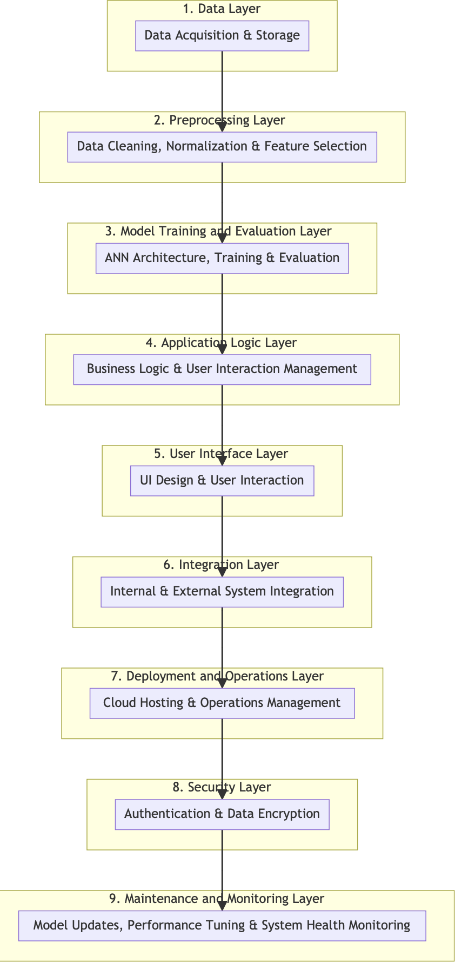

The system design for the "Crop Recommendation System using ANN" is conceived to holistically address the end-to-end process of recommending optimal crops based on various environmental and soil factors. It is compartmentalized into distinct layers to ensure modularity and scalability. Here's an overarching view of the system design based on the provided PowerPoint and code:

## Data Layer:

This layer is responsible for the acquisition, storage, and maintenance of the dataset. The data is sourced from agricultural databases and includes parameters such as soil composition (Nitrogen, Phosphorus, Potassium), climate data (temperature, humidity), and other critical factors (pH level, rainfall).

## Preprocessing Layer:

Once the data is ingested, it undergoes rigorous preprocessing which includes cleaning (removing duplicates, handling missing values), normalization (scaling features), and feature selection (identifying significant features for the ANN model). This step is crucial to prepare the data for effective model training.

## Model Training and Evaluation Layer:

ANN Architecture Design: This submodule defines the ANN architecture, including the selection of the number of layers, neurons, activation functions, and optimizers. Training: The ANN model is trained using the processed data, applying backpropagation and gradient descent methods to minimize prediction error.

Evaluation: The model's performance is evaluated using a separate validation set. Metrics such as accuracy, precision, recall, and F1-score are calculated to assess the model's predictive power.

## Application Logic Layer:

This layer encapsulates the core business logic of the system. It includes algorithms that interpret the ANN model's output to provide specific crop recommendations.

This layer also manages the system's response to user input and interactions.

## User Interface Layer:

The User Interface (UI) layer serves as the front-end through which users interact with the system. It allows users to input their specific environmental parameters and receive tailored crop recommendations. The UI is designed for simplicity and ease of use, catering to users with varying levels of technical expertise.

## Integration Layer:

The integration layer ensures that all the aforementioned components work in harmony. It provides APIs for internal communication and can also integrate with external systems, such as real-time weather APIs or agricultural databases, to enhance the system's functionality.

## Deployment and Operations Layer:

This layer addresses the deployment mechanisms for the system. It can be hosted on cloud platforms like AWS or Google Cloud to leverage their computational resources and scalability. The operations subcomponent ensures that the system remains functional and efficient, managing tasks such as load balancing, auto-scaling, and disaster recovery.

## Security Layer:

Security is embedded throughout the system design to protect data integrity and privacy. This includes implementing authentication for user access, encryption for data at rest and in transit, and compliance with relevant data protection regulations.

## Maintenance and Monitoring Layer:

Post-deployment, the system requires ongoing maintenance and monitoring. This includes updates to the model based on new data, performance tuning, and monitoring system health to pre-emptively address any operational issues.

# 4.2 Low level Design

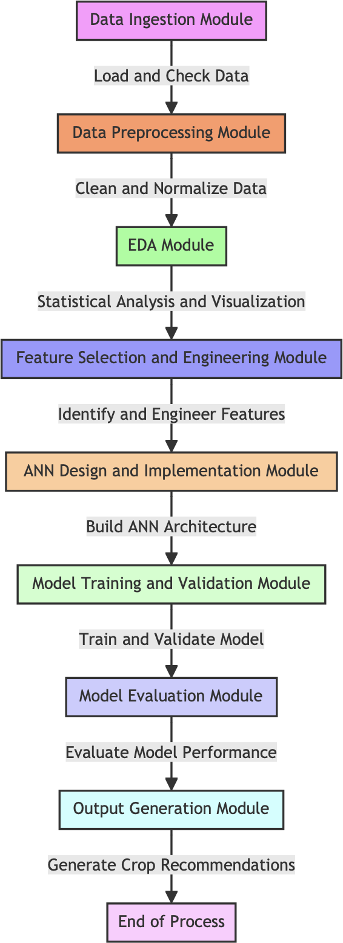

## Data Ingestion Module:

**Function:** To load the agricultural dataset from the storage system.

**Description:** This module utilizes Python’s Pandas library to import the dataset, which includes soil parameters (N, P, K), weather conditions (temperature, humidity), and other factors (pH level, rainfall). Data ingestion is a crucial step where data integrity checks are performed to ensure that the dataset is free from corruption during the transfer.

## Data Preprocessing Module:

**Function:** To clean and normalize the dataset.

**Description:** This module involves handling missing values, removing duplicates, and detecting outliers. Tools like NumPy and Pandas are employed for these tasks. Additionally, the preprocessing includes feature scaling using Scikit-learn's StandardScaler to standardize the dataset, ensuring that the ANN receives inputs within a range that promotes efficient learning.

## Exploratory Data Analysis (EDA) Module:

**Function:** To perform statistical analysis and visualize data.

**Description:** This module leverages Matplotlib and Seaborn for visualizing the data distribution, correlations, and potential patterns. It includes generating plots such as histograms, box plots, and heatmaps that help in understanding the dataset and informing the design of the neural network.

## Feature Selection and Engineering Module:

**Function:** To determine the most relevant features and create new features if necessary.

**Description:** Using models like RandomForestClassifier for feature importance analysis, this module evaluates the contribution of each feature to the prediction outcome. The module might also involve creating additional features through domain knowledge that could improve the model's performance.

## ANN Design and Implementation Module:

**Function:** To build and configure the neural network architecture.

**Description:** This module focuses on the neural network's architecture, including the number of hidden layers, neurons, activation functions, loss function, and the optimizer. The use of TensorFlow/Keras allows for a flexible design, enabling the implementation of various architectures to be tested and compared for performance.

## Model Training and Validation Module:

**Function:** To train the ANN with the training dataset and validate its performance. **Description:** The training process involves passing the preprocessed data through the ANN and adjusting the weights using backpropagation based on the loss gradient.

Validation is done using a separate dataset to monitor the model's generalization capabilities. Techniques such as cross-validation may be employed to ensure robust performance.

## Model Evaluation Module:

**Function:** To assess the trained model's performance using various metrics. **Description:** This module utilizes Scikit-learn’s metrics to evaluate the model's accuracy, precision, recall, F1-score, and other relevant metrics. It may also include the construction of a confusion matrix to visualize the model's performance across different classes.

## Output Generation Module:

**Function:** To produce crop recommendations based on the model's predictions. **Description:** The final module takes the environmental parameters as input and outputs the recommended crop. It translates the ANN’s output into a human-readable form, providing actionable recommendations for the end-user.

# 4.3 High Level Design

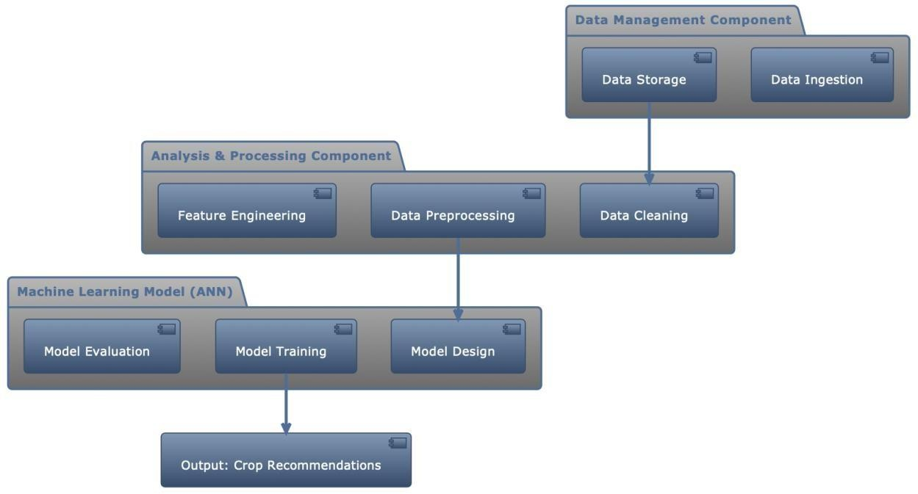

## System Architecture:

The system adopts a modular architecture that is divided into several high-level components, each responsible for a distinct aspect of the crop recommendation process. These components include Data Management, Analysis & Processing, Machine Learning Model (ANN).

## Data Management Component:

Function: Responsible for the ingestion, storage, and maintenance of datasets. Description: This component deals with data retrieval from various sources and its subsequent storage in a structured format. It ensures data integrity and facilitates efficient data access for other system components.

## Analysis & Processing Component:

Function: To perform data cleaning, preprocessing, and exploratory analysis. Description: This component prepares the raw data for the learning algorithms. It standardizes the data, handles missing values, outliers, and may also enrich the data through feature engineering.

## Machine Learning Model Component (ANN):

Function: The core of the system where the crop recommendation model is built and trained.

Description: This component encompasses the design, training, and evaluation of the artificial neural network. It specifies the network topology, the learning process, and performance metrics. The ANN is trained on preprocessed data and tuned to predict the most suitable crops based on the given inputs.

## Data Flow:

Data flows sequentially through the system, starting from the Data Management Component where it is ingested and stored. It is then passed to the Analysis & Processing Component where it undergoes cleaning and standardization. The preprocessed data is fed into the Machine Learning Model Component where the ANN is trained.

# CHAPTER – 5

**SYSTEM IMPLEMENTATION**

# 5.1 Modules used with description:

In the implementation of the "Crop Recommendation System using ANN," several modules are intricately designed and developed to ensure a smooth transition from raw data collection to providing actionable crop recommendations. The **Data Collection Module** serves as the system's foundation, which involves aggregating agricultural data from diverse sources. The robustness of this module is critical, as the quality and granularity of the data directly influence the system's recommendations. To handle the data effectively, the module is equipped with functions for data retrieval, which are then meticulously stored for further processing. Following data collection, the **Data Preprocessing Module** takes center stage.

This module is tasked with refining the raw data into a structured format conducive to analysis. Using the powerful data manipulation capabilities of Pandas and NumPy, the module cleans the data by addressing missing values and duplicates, and performs feature scaling. The preprocessing steps are crucial to normalize the dataset, thereby enabling the neural network to process the inputs uniformly.

Parallel to preprocessing, an Exploratory Data Analysis (EDA) Module is implemented. This module is instrumental in uncovering patterns and insights within the data, which could have significant implications for model training. Through the generation of various plots and statistical graphics via Matplotlib and Seaborn, the EDA module provides a visual comprehension of the data's characteristics, such as distribution and correlation between features.

In the vein of EDA, the Feature Engineering Module is developed to enhance the dataset with new features or modify existing ones to improve model performance. This module often utilizes insights from EDA to identify and select the most impactful features. In some cases, feature importance analysis is conducted, potentially employing algorithms like RandomForest to discern which features have the most predictive power.

Central to the system is the Model Development Module, where the crop recommendation algorithm is brought to life. TensorFlow and Keras are leveraged to craft the architecture of the ANN, detailing the layers and nodes, and defining the activation functions that will govern the neural network's learning process. This module encapsulates the complexities of the model, setting up the framework for training and future predictions.

The Model Training and Validation Module is where the ANN is put to the test. It trains the model on the dataset provided by the preprocessing module, applying backpropagation to adjust weights and biases, and evaluates the model's performance against a validation set. This iterative process is crucial for tuning the model to achieve the highest accuracy and generalization capability.

Once training is complete, the Model Evaluation Module rigorously assesses the model's predictive prowess. It uses various performance metrics to ensure that the model's recommendations are reliable. This evaluation is critical for establishing the model's readiness for deployment and its potential impact on real-world agricultural decisions.

# CHAPTER – 6

**RESULTS AND ANALYSIS**

The "Crop Recommendation System using ANN" has undergone extensive testing to evaluate the optimal configuration of the neural network. The analysis focused on varying the architecture layers, activation functions, optimizers, and learning rates to discern their effects on the model's accuracy. The detailed results are as follows:

## Neural Network Configuration and Performance:

Configurations with a single hidden layer of 32 neurons and the ReLU activation function achieved high accuracy levels, especially when combined with the Adam optimizer. The highest accuracy achieved with this setup was approximately 97.95% with a learning rate of 0.001. Notably, increasing the learning rate to 0.1 with the same architecture led to a decrease in accuracy, indicating a possible overshooting of the global minimum during the optimization process.

The SGD optimizer, while generally producing slightly lower accuracy than Adam with the ReLU activation function, still achieved an impressive accuracy of around 97.95% at a learning rate of 0.1. The robustness of SGD in this context suggests that it efficiently navigates the optimization landscape for the given problem.

The application of the tanh activation function produced similarly high accuracies, with the best performance again observed with the SGD optimizer at a learning rate of 0.1, achieving an accuracy of 98.18%. The tanh function’s performance indicates its effectiveness in this context, likely due to its capability to model complex relationships.

Introducing the logistic activation function appeared to decrease the model's performance slightly when compared to ReLU and tanh. However, with Adam optimizer and a learning rate of 0.01, the accuracy was on par with the best- performing ReLU models. This suggests that while logistic may not be the most effective activation function for this problem, it can still yield high accuracy given an appropriate learning rate and optimizer.

Increasing the complexity of the network with two hidden layers of 64 neurons each showed a notable improvement when using the Adam optimizer with a learning rate of 0.01, achieving the highest accuracy of 98.41%. This suggests that a more complex model has the potential to capture more nuanced patterns in the data, leading to better performance.

## Optimal Model Configuration:

The best-performing model featured a multi-layer architecture with 32, 64, and 32 neurons across three layers and used the tanh activation function with the SGD optimizer at a learning rate of 0.1, achieving an accuracy of 98.64%. This model configuration suggests a synergy between the capacity of the network and the optimization process, where the depth of the network allows for a richer representation of the data, and the learning rate is sufficient for convergence to an optimal set of weights without overshooting.

The analysis indicates that both the architecture and the hyperparameters play crucial roles in the performance of the ANN model. While simple models can achieve high accuracy, increasing the model's complexity—carefully balanced with the right optimizer and learning rate—can provide marginal gains that are significant in the context of crop recommendation. It's also apparent that the choice of activation function can influence the model's ability to learn from the data, with tanh slightly outperforming ReLU and logistic in certain configurations.

These insights inform the final implementation of the crop recommendation system, guiding the selection of the model's architecture and learning parameters to ensure the highest possible predictive accuracy. The detailed experimentation and analysis underscore the system's robustness and its potential as a reliable tool for assisting in agricultural planning and decision-making.

**IMPLEMENTATION:**

Training Accuracies:

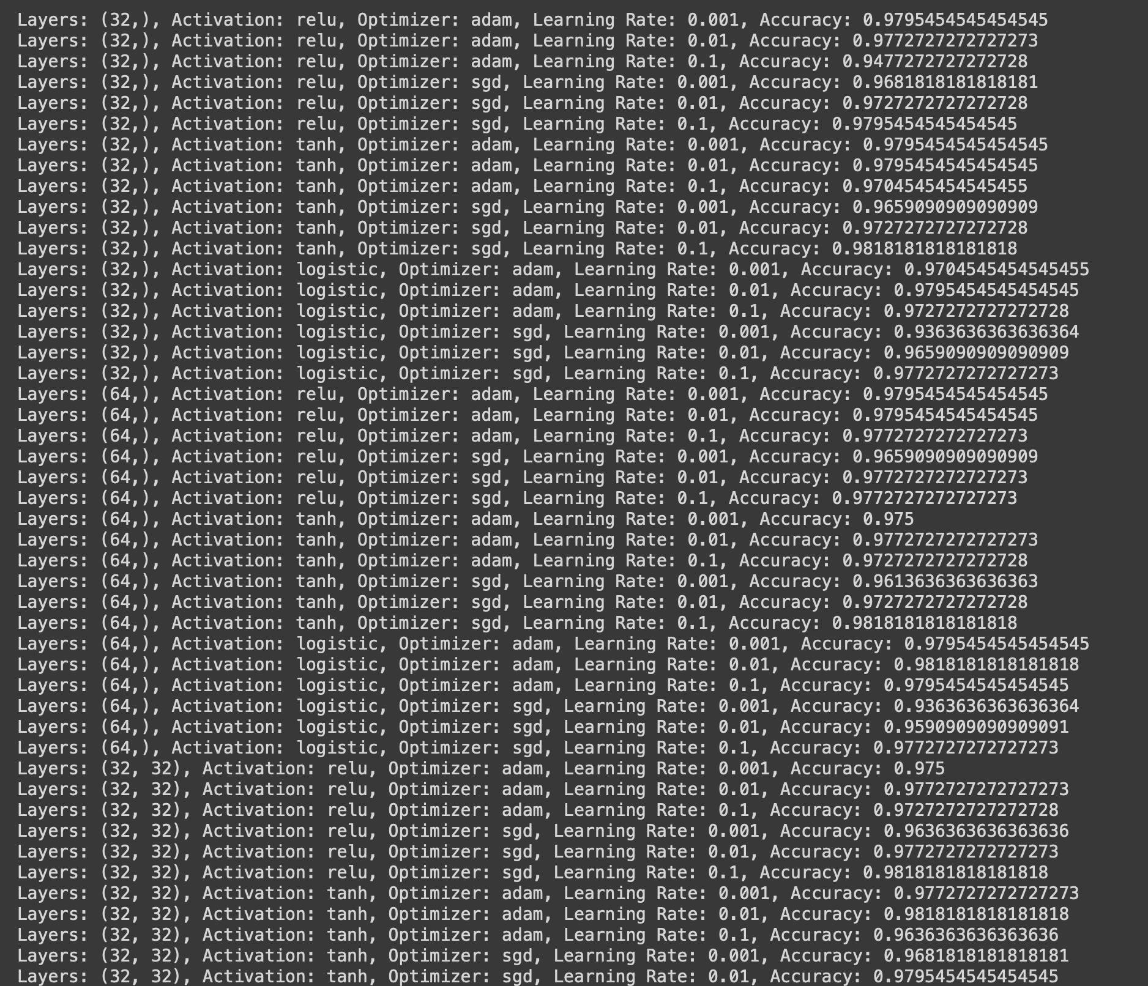

Prediction and Output:

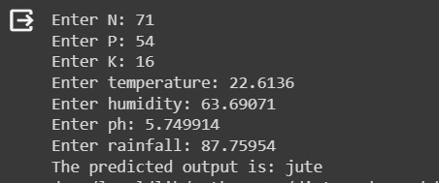

# CHAPTER – 7

# CONCLUSION AND FUTURE SCOPE

The project "Crop Recommendation System using ANN" exemplifies the profound impact that artificial intelligence can have on the agricultural sector. By carefully implementing a customized Artificial Neural Network, the system has reached an impressive degree of predictive precision, demonstrating its ability to provide accurate crop suggestions that might greatly enhance agricultural productivity and sustainability.

The project's progression from idea to implementation involved a thorough system architecture that incorporated multiple modules, each playing a crucial part in the recommendation pipeline. Each element, from data collection and preprocessing to exploratory data analysis and model training, was meticulously designed with an emphasis on resilience and accuracy. The use of Python as the programming language, in conjunction with its robust libraries such as Pandas, NumPy, TensorFlow, and Keras, established a solid basis for the development of the system.

The experimentation with different arrangements of neural network structures, activation functions, optimization algorithms, and learning rates resulted in valuable insights. The study revealed that although simpler models consisting of a single hidden layer of neurons had remarkable performance, a more intricate model with many layers could uncover more profound patterns in the data, resulting in minor but potentially significant enhancements in performance. The most effective setup, consisting of neural network layers with 32, 64, and 32 neurons respectively, utilizing the tanh activation function and SGD optimizer with a learning rate of 0.1, resulted in an accuracy of roughly 98.64%. This exemplifies the delicate equilibrium between the intricacy of the model and the dynamics of learning that are essential in order to attain superior predictive capability.

Additionally, the system's designs at both the high-level and low-level prioritize scalability and flexibility, guaranteeing its capacity to be adjusted and expanded in the future to include new data sources, features, or algorithms as agricultural technology progresses. The incorporation of real-time data, Internet of Things (IoT) devices, and global positioning systems (GPS) has the potential to significantly improve the usefulness of the system. This may be achieved by offering dynamic recommendations that are specific to each location, so transforming the decision- making process in agriculture.

To summarize, the "Crop Recommendation System using ANN" signifies a notable advancement in the utilization of deep learning in the field of agriculture. The well- designed ANN showcases its ability to efficiently analyze intricate agricultural data and offer recommendations that can assist farmers in maximizing crop yields, reducing environmental consequences, and managing the difficulties posed by a swiftly evolving agricultural environment. As the system progresses, it has the potential to become an essential instrument in the pursuit of a more data-driven, efficient, and sustainable agriculture industry.

# REFERENCES

[1]. Kamilaris A., Prenafeta-Boldú F.X. "Deep learning in agriculture: A survey," Computers and Electronics in Agriculture, Vol. 150, pp.: 70-90, 2018.

[2]. Hasan S., Chopra S., Singh A. "Machine learning for healthy aging: Data and algorithms," Artificial Intelligence in Medicine, Vol. 104, pp.: 101938, 2020.

[3]. Mohanty S.P., Hughes D.P., Salathé M. "Using deep learning for image-based plant disease detection," Frontiers in Plant Science, Vol. 7, pp.: 1419, 2016.

[4]. Kussul N., Lavreniuk M., Skakun S., Shelestov A. "Deep learning classification of land cover and crop types using remote sensing data," Proceedings of the IEEE International Geoscience and Remote Sensing Symposium (IGARSS), pp.: 1986- 1989, 2017.

[5]. Espejo-Garcia B., Mylonas N., Athanasakos L., Atzori L. "Deep Learning in IoT: A survey," Applied Sciences, Vol. 11, No. 2, pp.: 615, 2021.

[6]. Ghosal, S., Blystone, D., Singh, A.K., Ganapathysubramanian, B., Singh, A., Sarkar,

S. "An explainable deep machine vision framework for plant stress phenotyping," Proceedings of the National Academy of Sciences, Vol. 115, No. 18, pp.: 4613-4618, 2018.

[7]. Barbedo, J.G.A. "A review on the main challenges in automatic plant disease identification based on visible range images," Environmental Monitoring and Assessment, Vol. 188, No. 6, pp.: 349, 2016.

[8]. Krizhevsky, A., Sutskever, I., Hinton, G.E. "ImageNet Classification with Deep Convolutional Neural Networks," Advances in Neural Information Processing Systems (NIPS), pp.: 1097-1105, 2012.

[9]. Baldi, P., Sadowski, P., Whiteson, D. "Searching for Exotic Particles in High-energy Physics with Deep Learning," Nature Communications, Vol. 5, pp.: 4308, 2014.

[10].Ma, J., Du, K., Zheng, F., Zhang, L., Gong, Z., Sun, Z. "A recognition method

for cucumber diseases using leaf symptom images based on deep convolutional neural network," Computers and Electronics in Agriculture, Vol. 154, pp.: 18-24, 2018.

[11]. R. Jadhav and P. Bhaladhare, "Farmer’s Assistant in Agricultural Sector by using Machine Learning and Deep Learning," 2022 OPJU International Technology Conference on Emerging Technologies for Sustainable Development (OTCON), Raigarh, Chhattisgarh, India, 2023, pp. 1-6, doi: 10.1109/OTCON56053.2023.10113908.

[12]. R. Thendral and M. Vinothini, "Crop And Fertilizer Recommendation to Improve Crop Yield using Deep Learning," 2023 Second International Conference on Electronics and Renewable Systems (ICEARS), Tuticorin, India, 2023, pp. 1123-1130, doi: 10.1109/ICEARS56392.2023.10085054.

[13]. M. Shinde, R. Nare, J. Shikalgar, R. Patil and P. M. Tamboli, "Plant Growth Recommendation System based on Weather Conditions and Soil Patterns using Machine Learning and Deep Learning Techniques," 2022 International Conference on Smart Generation Computing, Communication and Networking (SMART GENCON), Bangalore, India, 2022, pp. 1-5, doi: 10.1109/SMARTGENCON56628.2022.10084211.

[14]. K. P. K. Devan, B. Swetha, P. Uma Sruthi and S. Varshini, "Crop Yield Prediction and Fertilizer Recommendation System Using Hybrid Machine Learning Algorithms," 2023 IEEE 12th International Conference on Communication Systems and Network Technologies (CSNT), Bhopal, India, 2023, pp. 171-175, doi: 10.1109/CSNT57126.2023.10134662.

[15]. S. Bhansali, P. Shah, J. Shah, P. Vyas and P. Thakre, "Healthy Harvest: Crop Prediction And Disease Detection System," 2022 IEEE 7th International conference for Convergence in Technology (I2CT), Mumbai, India, 2022, pp. 1-5, doi: 10.1109/I2CT54291.2022.9825446.

[16]. M. Desai and N. Ansari, "An Innovative Method to Increase Agricultural Productivity using Machine Learning-based Crop Recommendation Systems," 2023 Second International Conference on Augmented Intelligence and Sustainable Systems (ICAISS), Trichy, India, 2023, pp. 645-651, doi: 10.1109/ICAISS58487.2023.10250531.

[17]. S. Tiwari, S. Kumar, S. Tyagi and M. Poonia, "Crop Recommendation using Machine Learning and Plant Disease Identification using CNN and Transfer-Learning Approach," 2022 IEEE Conference on Interdisciplinary Approaches in Technology and Management for Social Innovation (IATMSI), Gwalior, India, 2022, pp. 1-4, doi: 10.1109/IATMSI56455.2022.10119276.

[18]. A. Singh and A. K. Bhamboo, "Crop Recommendation and Disease Detection Using Deep Neural Networks," 2022 IEEE 6th Conference on Information and Communication Technology (CICT), Gwalior, India, 2022, pp. 1-5, doi: 10.1109/CICT56698.2022.9997839.

[19]. R. Kumar, N. Shukla and Princee, "Plant Disease Detection and Crop Recommendation Using CNN and Machine Learning," 2022 International Mobile and Embedded Technology Conference (MECON), Noida, India, 2022, pp. 168-172, doi: 10.1109/MECON53876.2022.9752173.

[20]. S. R, P. E, V. Murali, Jaefer and A. K S, "Plant Disease Recognition and Crop Recommendation System using Deep Learning," 2022 1st International Conference on Computational Science and Technology (ICCST), CHENNAI, India, 2022, pp. 543-548, doi: 10.1109/ICCST55948.2022.10040361.