BookHaven User Documentation
Welcome to the BookHaven User Guide. This document provides a comprehensive overview of how to use the BookHaven application, both from a consumer's perspective and an administrator's perspective.

Part 1: Consumer Guide

1. Home Page
The home page is your gateway to a vast collection of books. You can see featured events, new arrivals, and popular categories.
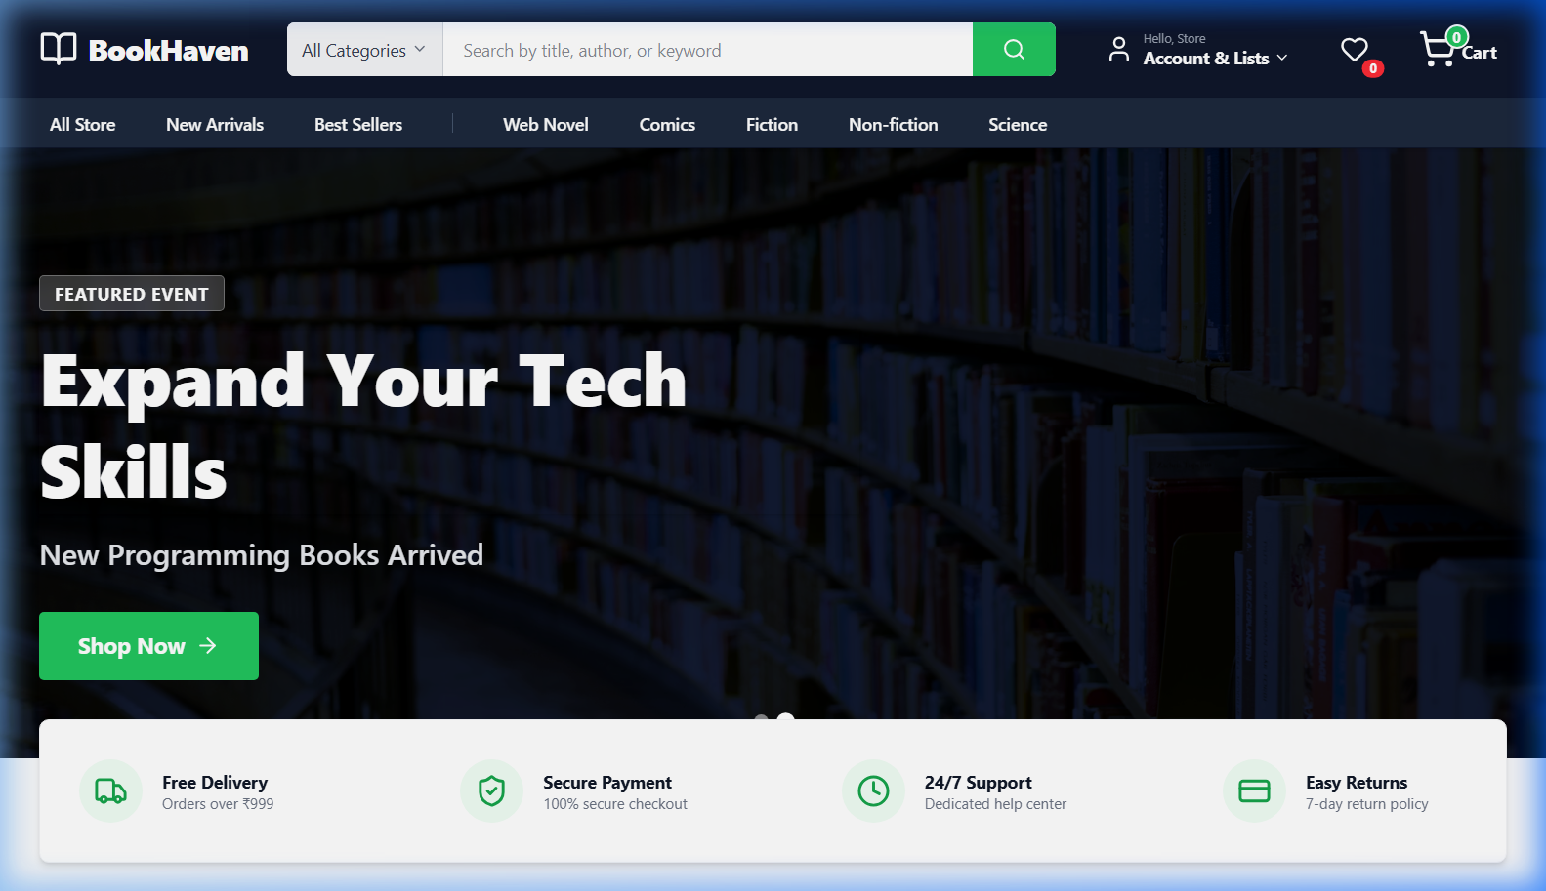

2. Browsing and Searching
Navigate to the Shop page to browse the entire collection. Use the search bar or category filters to find exactly what you're looking for.
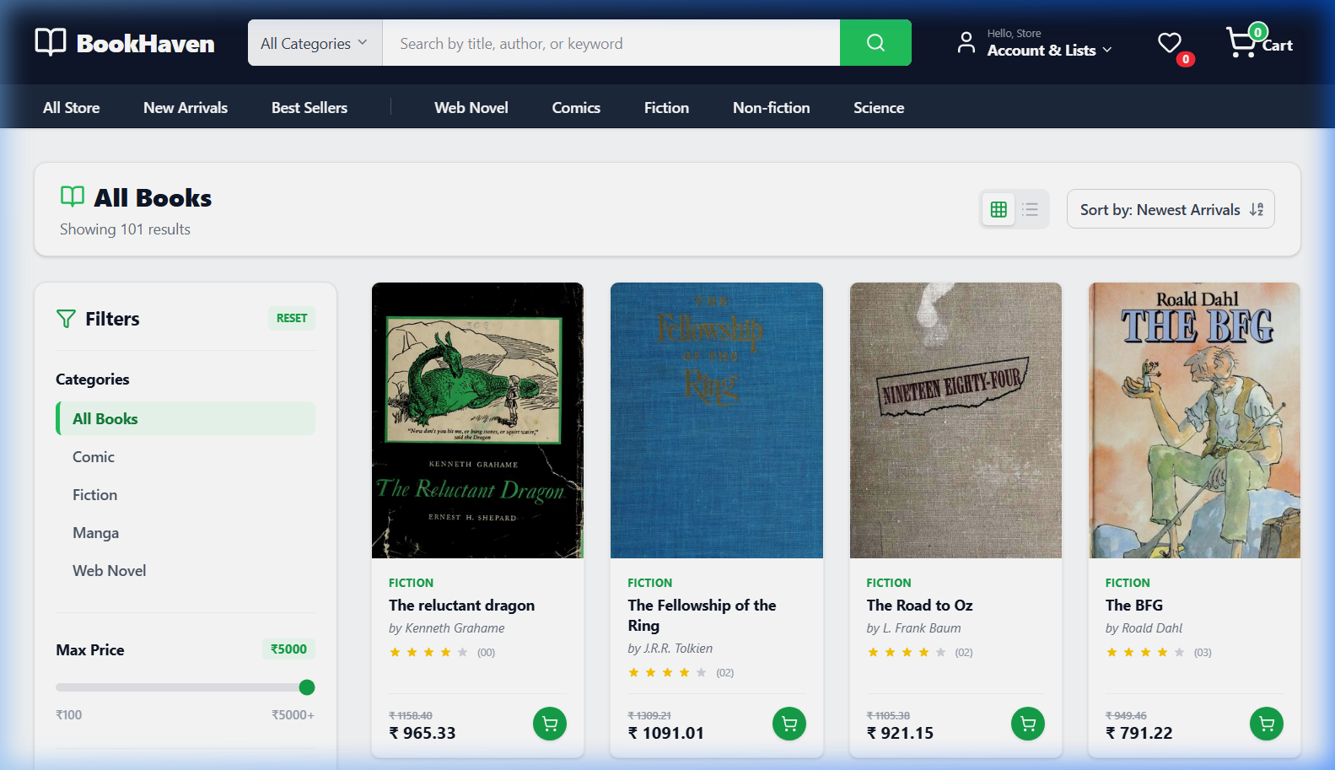

3. Book Details
Click on any book to view detailed information, including its description, price, and gallery images.
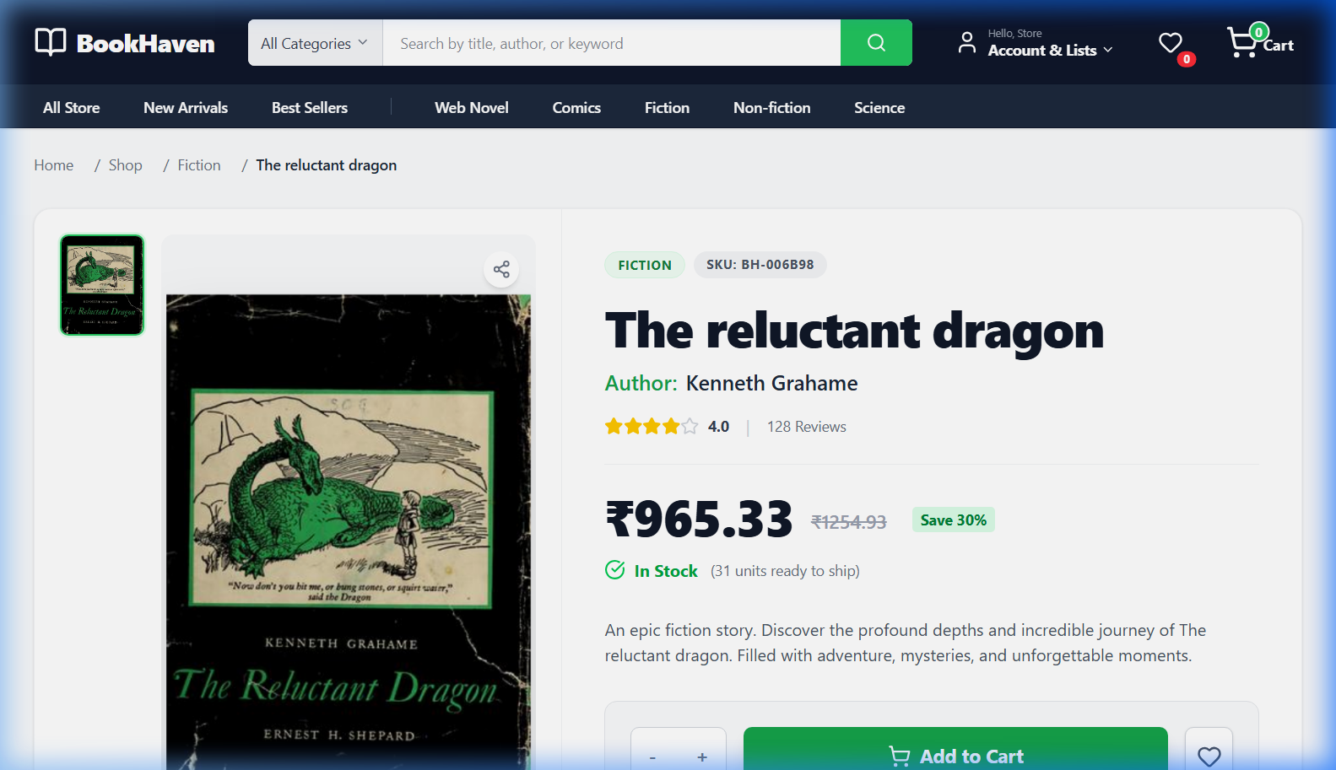

4. Shopping Cart
Add items to your cart and review them before proceeding to checkout. You can adjust quantities or remove items here.
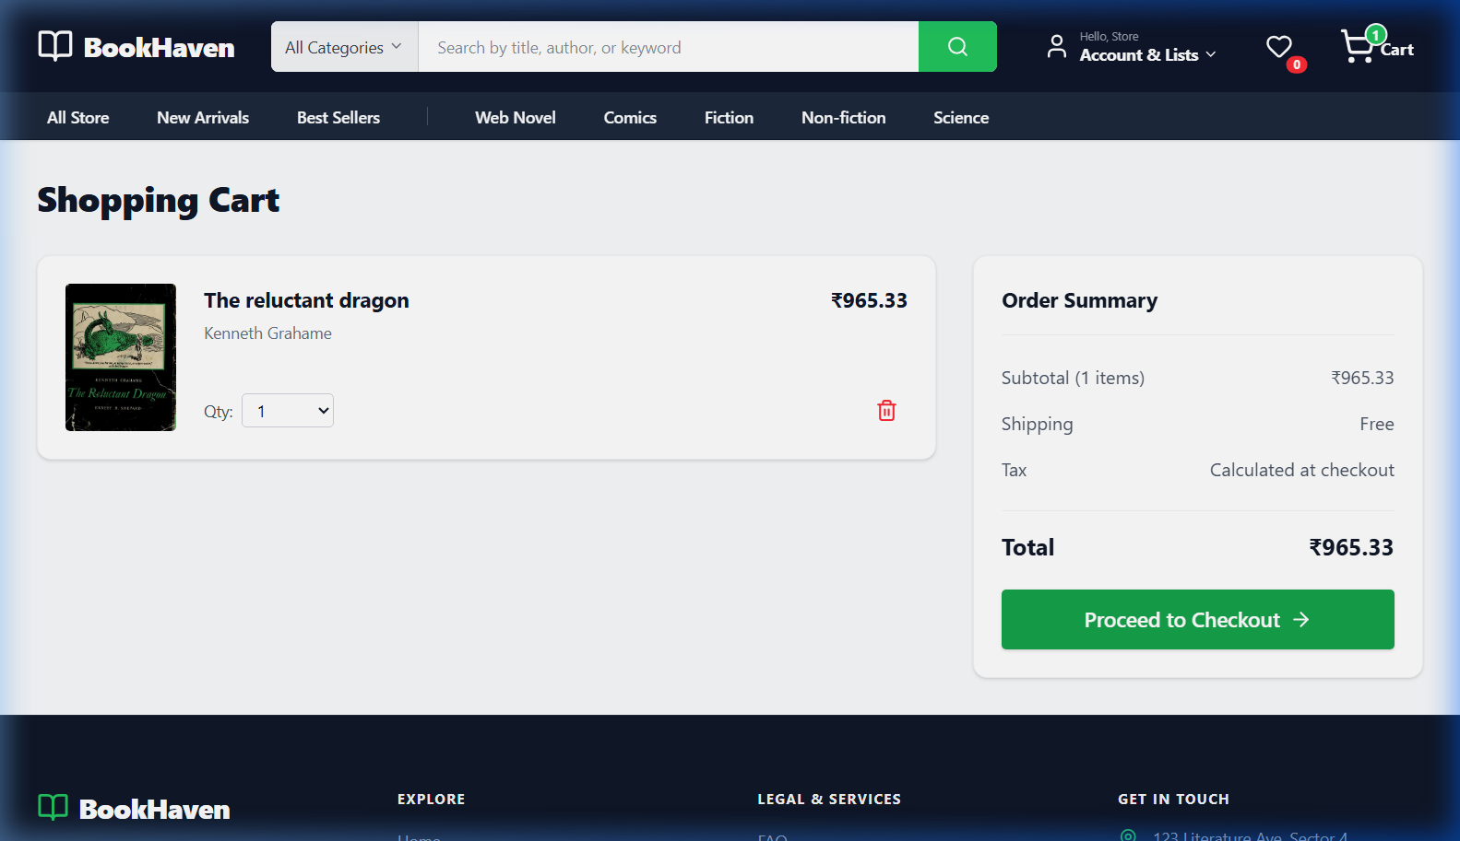

5. Checkout Process
Securely complete your purchase by providing your shipping details and selecting a payment method.
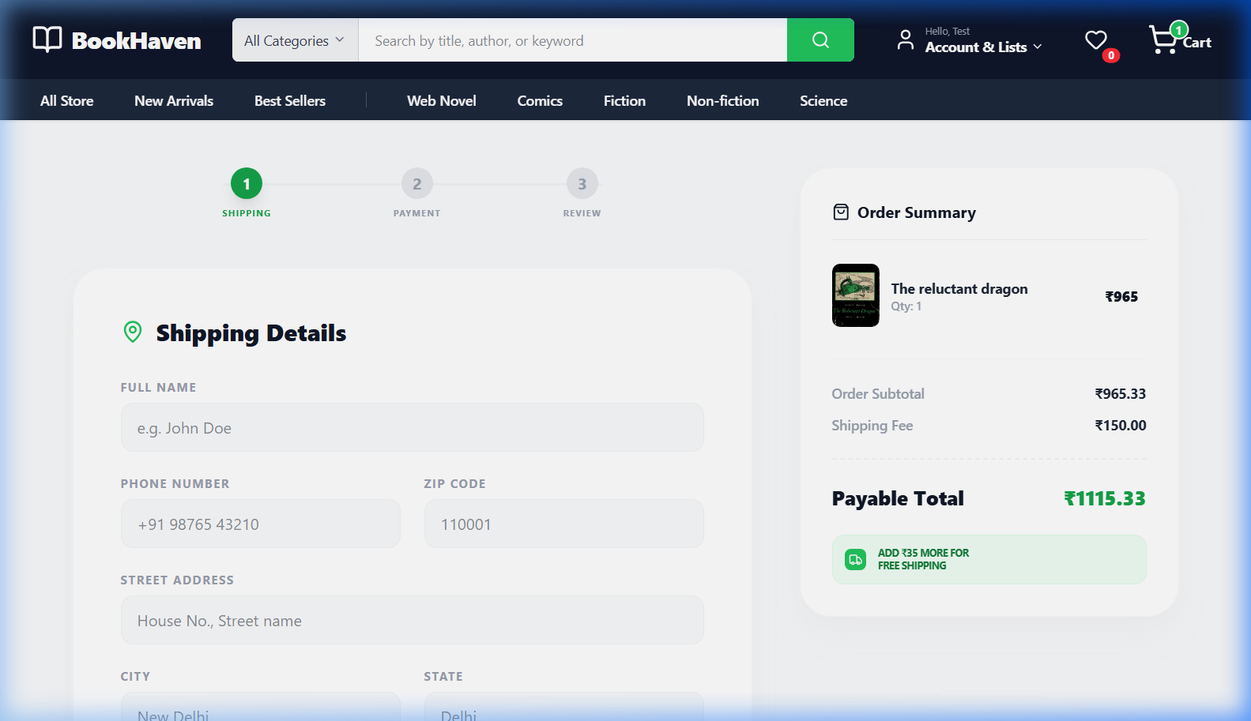

6. Order Confirmation
Once your order is placed, you will receive a confirmation message and a unique order ID.
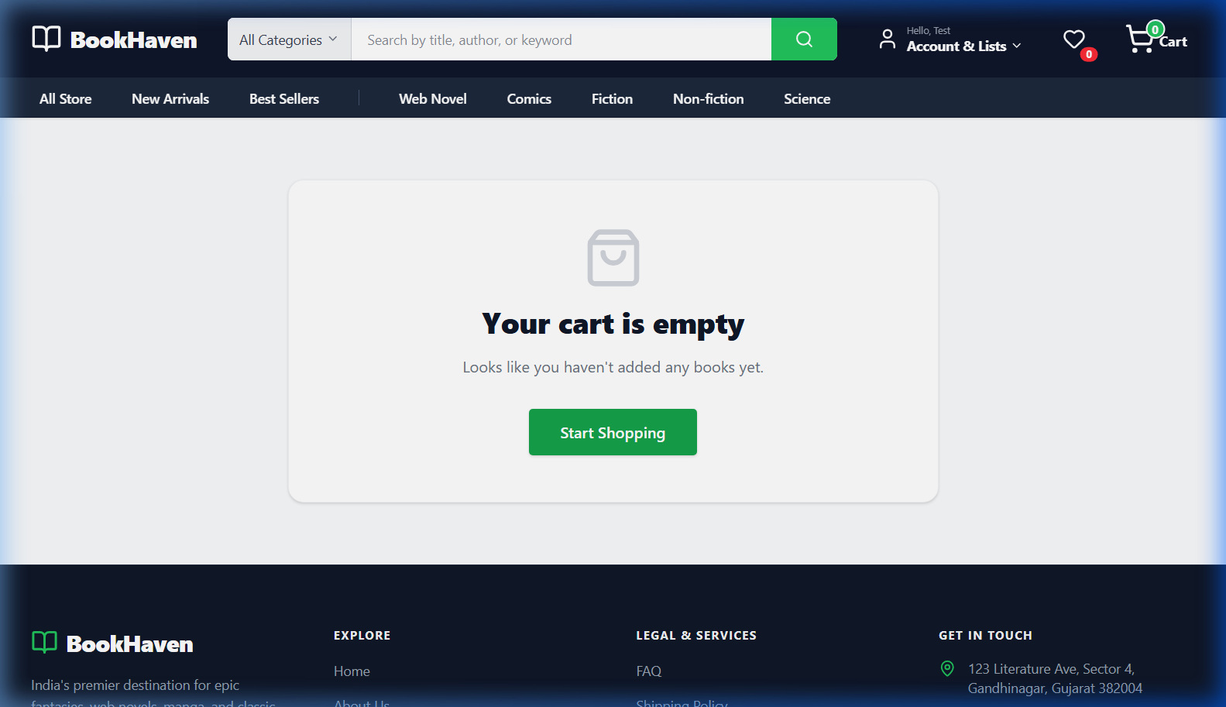

Part 2: Admin Guide

1. Admin Dashboard
The dashboard provides a high-level overview of store performance, including total revenue, orders, and low-stock alerts.
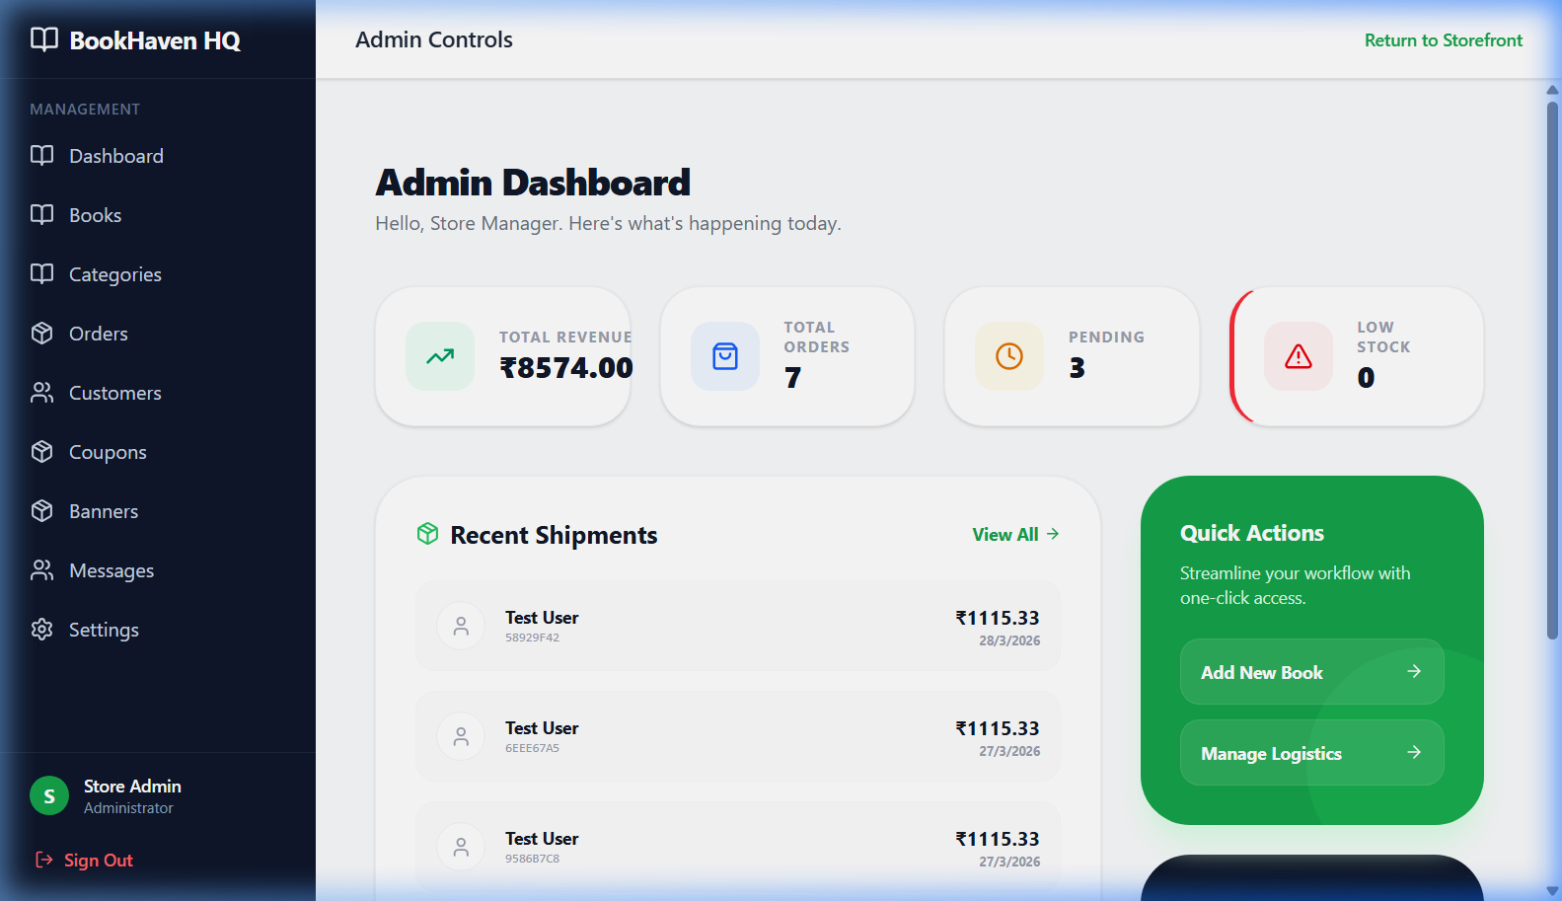

2. Managing Books
Easily add new books or update existing ones. Manage book covers, gallery images, and inventory levels.
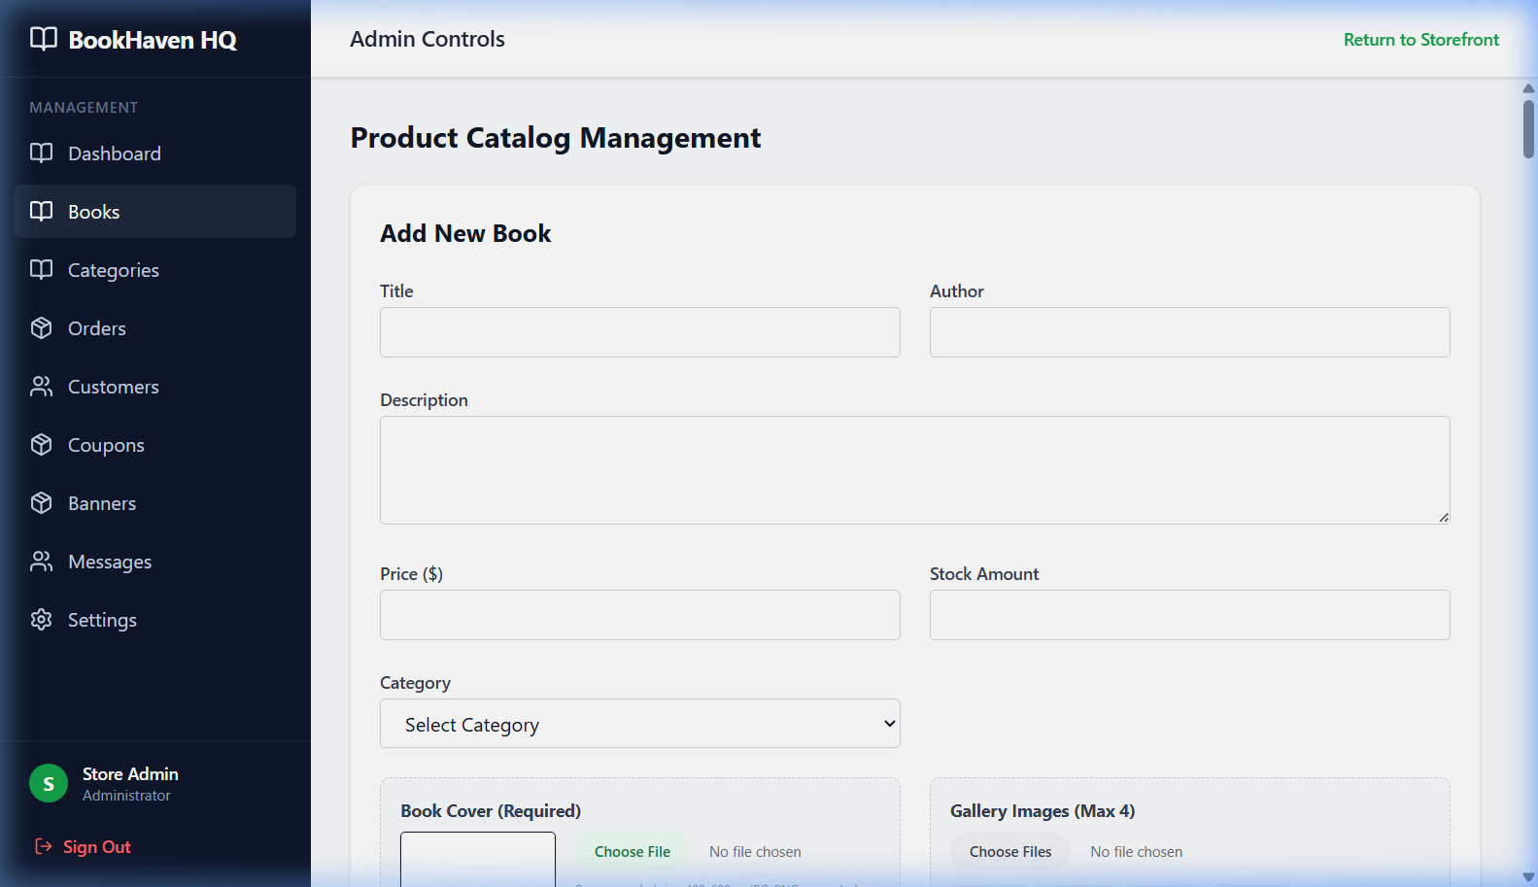

3. Category Management
Organize your catalog by creating and managing categories.
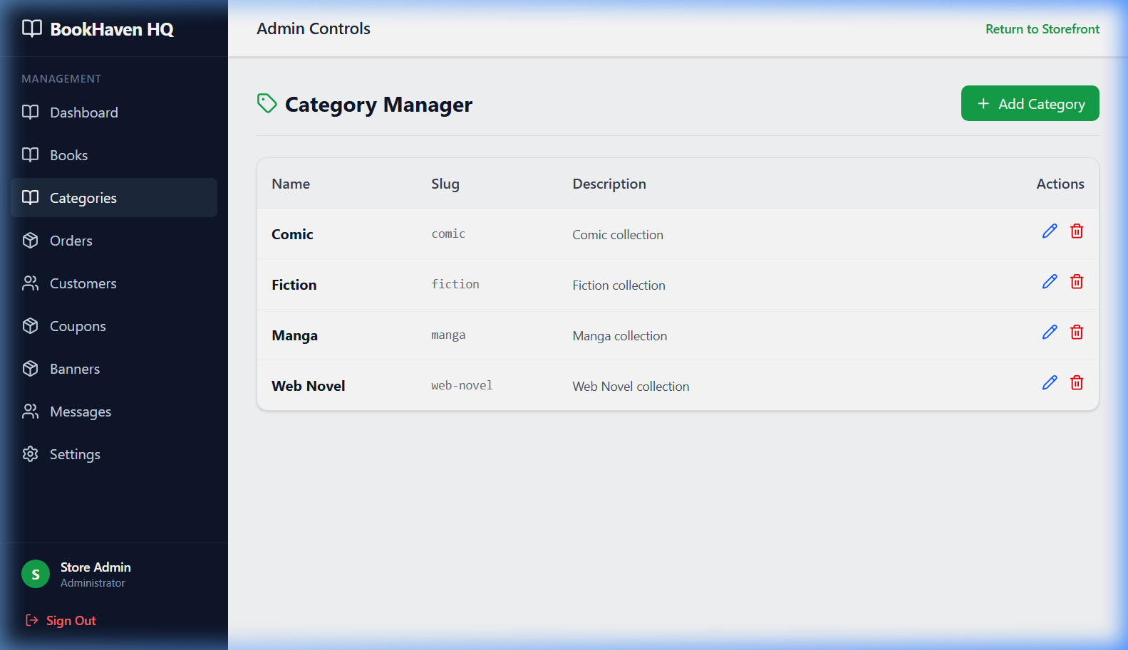

4. Order Management
Track and process customer orders. Update order statuses to keep customers informed.
