**CPP Lab 1**

Roll no. 248121

PRN: 240841220016

Name: Akshay Chavan

**Day 1**

1. write program to test Hello World.

**Code:**

`

#include <iostream>

using namespace std;

int main()

{

cout << "Hello, Akshay";

return 0;

}

`

**Output:**

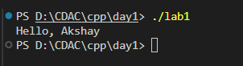

1. Write a program to adddition of two numbers.

**Code:**

`

#include <iostream>

using namespace std;

int main()

{

int n1, n2;

cout << "Enter two numbers n1 and n2: ";

cin >> n1 >> n2;

cout << n1 << " + " << n2 << " = " << n1 + n2 << endl;

return 0;

}`

**Output:**

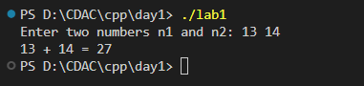

1. Write a program to swap two numbers.

**Code:**

`

// Basic swap: 3 methods

// 1. Normal swapping(which isn't efficient)

// 2. Using refrence variables

// 3. Using Pointers

#include <iostream>

using namespace std;

void swapNormal(int a, int b)

{

    // THIS SWAPPING DOESN'T WORK

    cout << "----Doing normal swapping----" << endl;

    int temp = a;

    a = b;

    b = temp;

    // cout << "In swap function a = " << a << " and b = " << b << endl;

}

void swapByRef(int &a, int &b)

{

    cout << "----Doing swapping using reference vars----" << endl;

    int temp = a;

    a = b;

    b = temp;

    cout << "Internally in swap fxn, a = " << a << " and b = " << b << endl;

}

void swapByPtr(int *a, int *b)

{

    cout << "----Doing swapping using pointers----" << endl;

    int temp = *a;

    *a = *b;

    *b = temp;

    cout << "Internally in swap fxn, a = " << *a << " and b = " << *b << endl;

}

int main()

{

    int n1 = 4, n2 = 8;

    cout << "Before swapping n1 = " << n1 << " and n2 = " << n2 << endl;

    swapByRef(n1, n2);

    cout << "After  swapping n1 = " << n1 << " and n2 = " << n2 << endl;

    cout << "_______________________________________________" << endl;

    n1 = 4, n2 = 8; // reassign n1 and n2 after first swap

    cout << "Before swapping n1 = " << n1 << " and n2 = " << n2 << endl;

    swapByPtr(&n1, &n2);

    cout << "After  swapping n1 = " << n1 << " and n2 = " << n2 << endl;

    return 0;

}

`

**Output:**

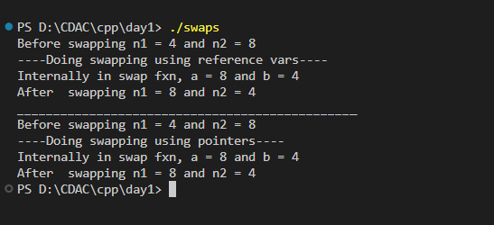

**Conditionals: Q 4, 5, 6**

1. Write a program to accept an integer and check if it is even or odd.
2. Write a program to accept a number and check if it is divisible by 5 and 7.
3. Write a program, which accepts annual basic salary of an employee and calculates and displays the

Income tax as per the following rules.

Basic: < 1, 50,000 Tax = 0

1, 50,000 to 3,00,000 Tax = 20%

> 3,00,000 Tax = 30%

**Code for 4, 5, 6:**

`

// has If-else problems and switch statements, loops - do while

#include <iostream>

using namespace std;

int main()

{

    int ch;

    cout << "1.Even-odd \n2.Num divisible by 5 and 7 \n3.Income tax from salary \n ";

    do

    {

        cout << "Enter choice ";

        cin >> ch;

        switch (ch)

        // Added scoping {} to cases avoid runtime errors

        {

        case 1:

        {

            cout << "----Even-odd-----\n";

            int num;

            cout << "Enter number to check even or odd: ";

            cin >> num;

            if (num % 2 == 0)

                cout << "Even" << endl;

            else

                cout << "Odd" << endl;

            break;

        }

        case 2:

        {

            cout << "----Divisibility-----\n";

            int num;

            cout << "Enter number to check if divisible by 5 and 7: ";

            cin >> num;

            if ((num % 5 == 0) && (num % 7 == 0))

                cout << "Divisible by both 5 and 7" << endl;

            else

                cout << "Not divisible by both 5 and 7" << endl;

            break;

        }

        case 3:

        {

            cout << "----Salary taxes-----\n";

            int sal;

            cout << "Enter your salary: ";

            cin >> sal;

            if (sal <= 150000)

                cout << "Tax = 0" << endl;

            else if (sal > 150000 && sal < 300000)

                cout << "Tax is 20% : Rs. " << sal * 20 / 100 << endl;

            else if (sal > 300000)

                cout << "Tax is 30% : Rs. " << sal * 30 / 100 << endl;

            break;

        }

        }

    } while (ch != 0);

}

`

**Output for 4, 5, 6:**

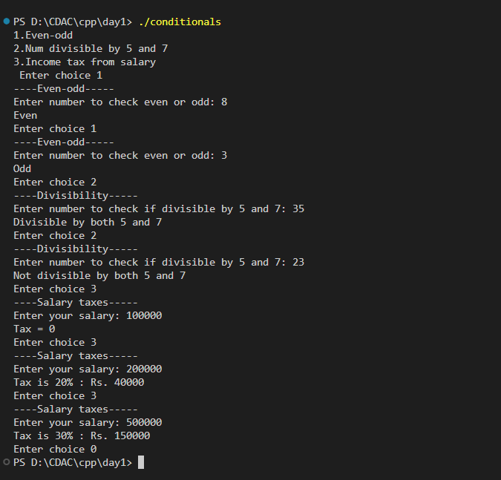

**Day 2**

**7, 8, 9, 10 together in switch**

1. (note:Daye 2 lab) Accept a lowercase character from the user and check whether the character is a vowel or consonant.

(Hint: a, e, i, o, u are vowels)

1. Write a program to input angles of a triangle and check whether triangle is valid or not.
2. Write a program to find factorial of a given number. ex:no5 fact=5*4*3*2*1=120
3. Write a program to find m to the power n. m=3 and n=4 so 3*3*3*3

**Code:**

#include <iostream>

using namespace std;

int main()

{

    int ch;

    cout << "1.Vowel-consonant \n2.Valid triangle \n3.Factorial \n4.m to the power n \n5.Exit \n";

    do

    {

        cout << "Enter choice: ";

        cin >> ch;

        switch (ch)

        {

        case 1:

        {

            char c;

            cout << "----Vowel or consonant----\nEnter a character: ";

            cin >> c;

            if (c == 'A' || c == 'E' || c == 'I' || c == 'O' || c == 'U' || c == 'a' || c == 'e' || c == 'i' || c == 'o' || c == 'u')

            {

                cout << "Vowel" << endl;

            }

            else

                cout << "Consonant" << endl;

            break;

        }

        case 2:

        {

            int a1, a2, a3;

            cout << "----Valid Triangle----\nEnter angles of triangle as a1, a2, a3: ";

            cin >> a1 >> a2 >> a3;

            if (a1 + a2 + a3 != 180)

            {

                cout << "Not a valid triangle!!" << endl;

            }

            else

                cout << "Valid triangle." << endl;

            break;

        }

        case 3:

        {

            int n, factorial = 1;

            cout << "----Factorial----\nEnter number: ";

            cin >> n;

            while (n > 0)

            {

                factorial = factorial * n;

                n--;

            }

            cout << "Factorial of is " << factorial << endl;

            break;

        }

        case 4:

        {

            int m, n, answer = 1;

            cout << "----m to the power n----\nEnter m and n to calculate m^n: ";

            cin >> m >> n;

            for (int i = 0; i < n; i++)

            {

                answer = answer * m;

            }

            cout << m << "^" << n << " = " << answer << endl;

            ;

            break;

        }

        }

    } while (ch != 5);

}

**Output:**

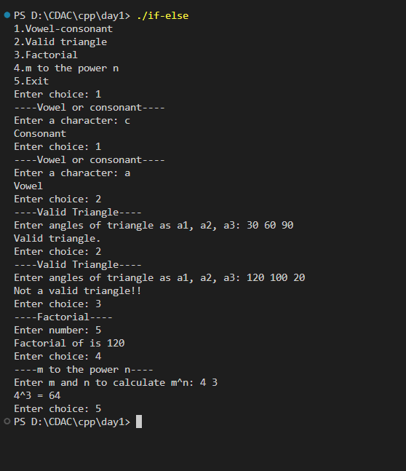

1. Check if number is a prime number or not.:

**Code:**

#include <iostream>

using namespace std;

int main()

{

    int num;

    cout << "Enter number to check if prime or not: ";

    cin >> num;

    bool isPrime = true;

    for (int i = 2; i < num / 2; i++)

    {

        if (num % i == 0)

        {

            isPrime = false;

            break;

        }

    }

    if (isPrime)

        cout << "Prime" << endl;

    else

        cout << "Not Prime" << endl;

}

**Output:**

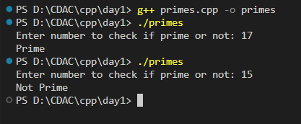

1. Sum of series :

1+2+3+….+n

**Code:**

#include <iostream>

using namespace std;

int main()

{

    int n, sum;

    cout << "Enter number: ";

    cin >> n;

    for (int i = 1; i <= n; i++)

    {

        sum += i;

    }

    cout << "Sum of numbers from 1 to " << n << " is " << sum << endl;

    return 0;

}

**Output:**

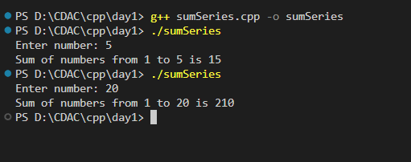

1. Check whether the number is palindrome or not?

**Code:**

// Palindrome number

#include <iostream>

using namespace std;

int main()

{

    int num;

    cout << "Enter number: ";

    cin >> num;

    int reverse = 0, x = num;

    while (num > 0)

    {

        int rem = num % 10;

        reverse = reverse * 10 + rem;

        num /= 10;

    }

    if (reverse == x)

        cout << "Palindrome" << endl;

    else

        cout << "Not a palindrome" << endl;

    return 0;

}

**Output:**

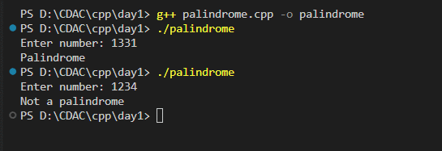

1. Write a program to find sum of all even and odd numbers between 1 to n.

**Code:**

#include <iostream>

using namespace std;

int main()

{

    int n, oddSum = 0, evenSum = 0;

    cout << "Enter number: ";

    cin >> n;

    for (int i = 1; i <= n; i++)

    {

        if (i % 2 == 0)

            evenSum += i;

        else

            oddSum += i;

    }

    cout << "Sum of even numbers from 1 to " << n << " is " << evenSum << endl;

    cout << "Sum of odd numbers from 1 to " << n << " is " << oddSum << endl;

    return 0;

}

**Output:**

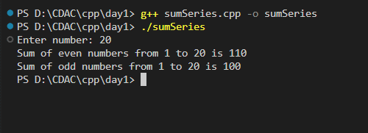

1. Write a program to enter a number and print its reverse.

**Code:**

// Palindrome number

#include <iostream>

using namespace std;

int main()

{

    int num;

    cout << "Enter number: ";

    cin >> num;

    int reverse = 0, x = num;

    while (num > 0)

    {

        int rem = num % 10;

        reverse = reverse * 10 + rem;

        num /= 10;

    }

    cout << "Reverse of the number is: " << reverse << endl;

    return 0;

}

**Output:**

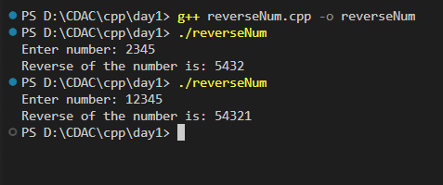

1. Write a program to print all Prime numbers between 1 to n.

**Code:**

#include <iostream>

using namespace std;

int main()

{

    int n;

    cout << "Prime numbers till n\nEnter n: ";

    cin >> n;

    int iterate = 2;

    while (iterate < n)

    {

        bool Prime = true;

        for (int i = 2; i < iterate / 2; i++)

        {

            if (iterate % i == 0)

            {

                Prime = false;

                break;

            }

        }

        if (Prime)

            cout << iterate << "\t";

        iterate++;

    }

    cout << endl;

}

**Output:**

