MySQL assign Day 2

Roll no. 248121   
PRN :

Name : Akshay Chavan

**Aggregate fxns**

12. find max sal and min sal for each job

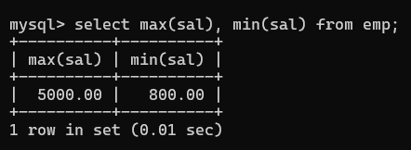

13. find how many employess have not received commission

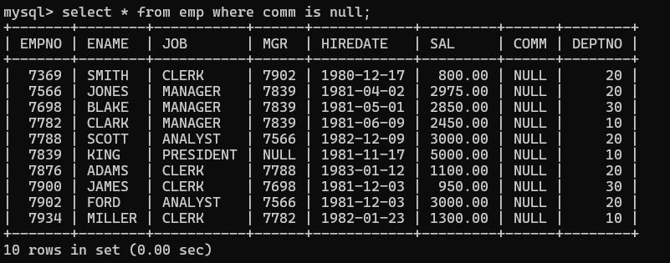

14. find sum of sal of all employees working in dept no 10

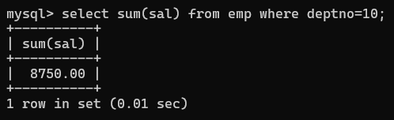

15. find maximum salary,average sal for each job in every department

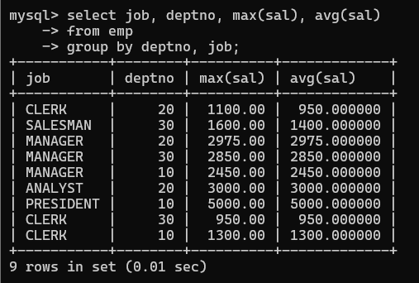

16. find max salary for every department if deptno is > 15 and arrange data in deptno order.

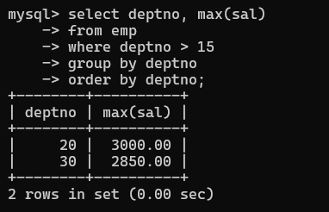

17. find sum salary for every department if sum is > 3000 //*Cool que!*

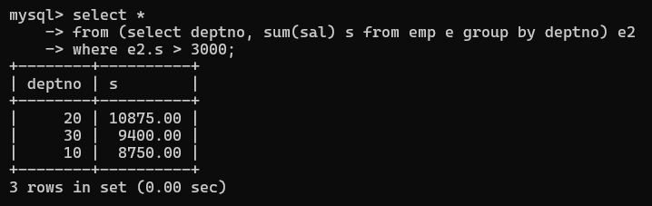

18. list all department which has minimum 5 employees

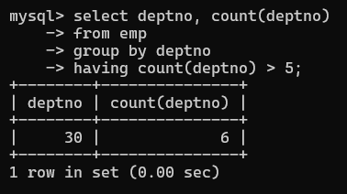

19. count how many employees earn salary more than 2000 in each job

**create Table, DML , subquery and joins**

55. create following tables and solve following questions(primary keys are marked in yellow) foreign keys are marked in green

faculty(fid,fname,sp.skill1,sp.skill2)

courses(cid,cname,rid,fid)

room(roomid,rname,rloc)

faculty

fid fname spskill1 spskill2

10 kjzhcjhz a b

11 sdd x z

12 lksjk a x

13 ksdjlkj a b

courses

cid cname rid fid

121 DBDA 100 10

131 DAC 101

141 DTISS

151 DIOT 105 12

Room

roomid rname rloc

100 jasmin 1st floor

101 Rose 2nd floor

105 Lotus 1st floor

103 Mogra 1st floor

1. list all courses for which no room is assigned and all rooms for which are available
2. list all faculties who are not allocated to any course and rooms which are not allocated to any course

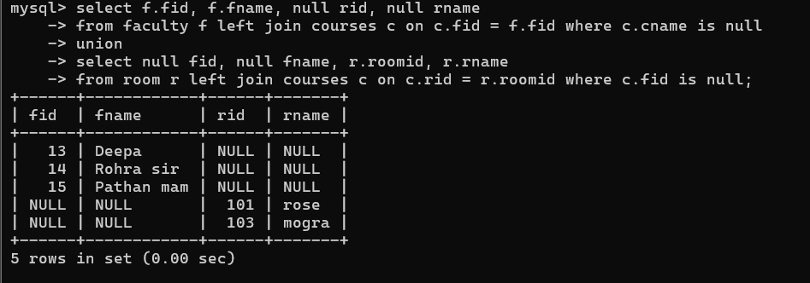

1. list all rooms which are allocated or not allocated to any courses

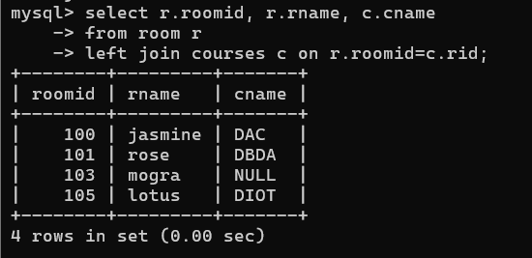

1. list all rooms which are not allocated to any courses

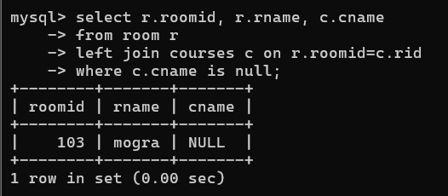

1. display courses and faculty assigned to those courses whose special skill is database

(*have added the skill as ‘Databases’ instead of ‘database’*)

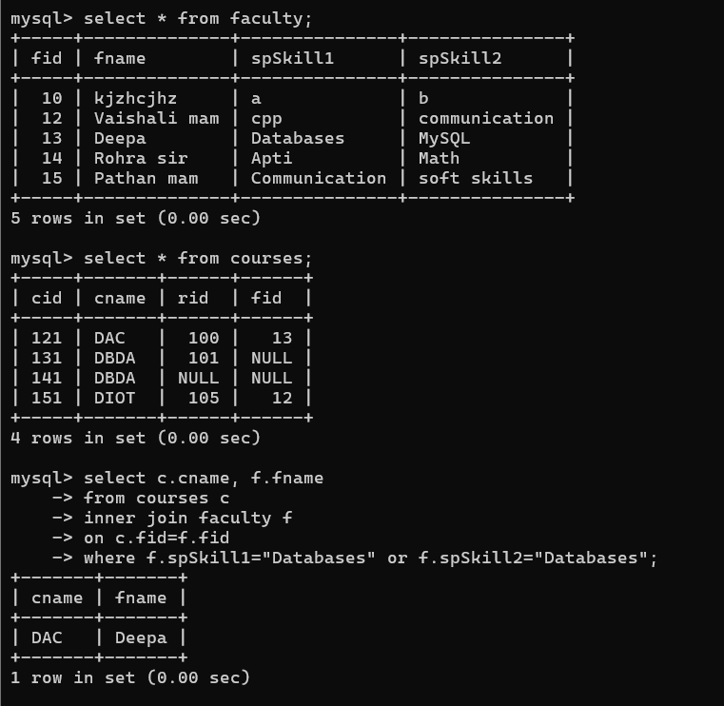

1. display time table --- it should contain course details , faculty and room details

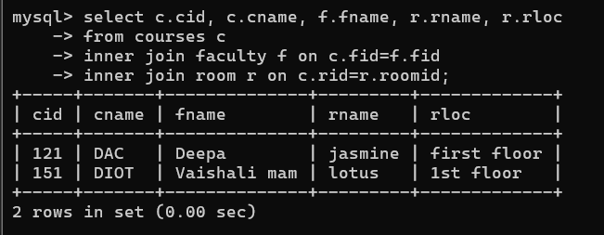

56. create following tables with given constraints:

product---- qty >0, default 20.00,pname not null and unique

saleman ----- sname -----not null

category ---- cname unique and not null

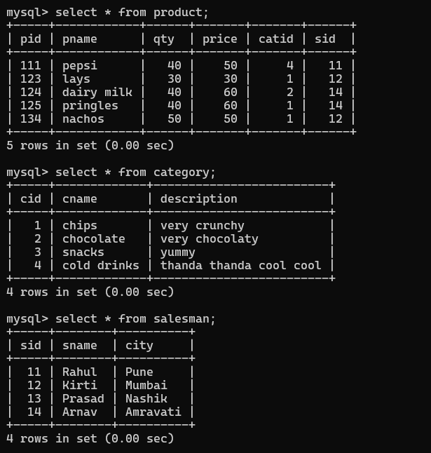

1. List all products with category chips

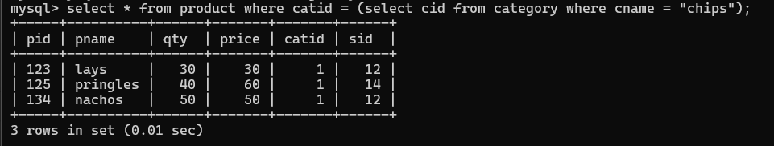

1. display all products sold by kirti

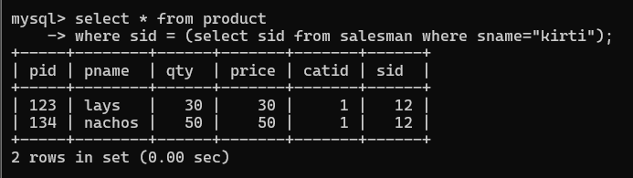

1. display all salesman who do not sold any product

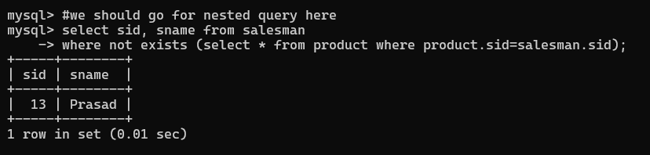

1. display all category for which no product is there

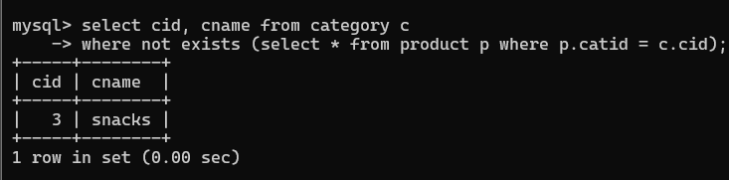

1. display all products with no category assigned



1. list all salesman who stays in city with name starts with P or N

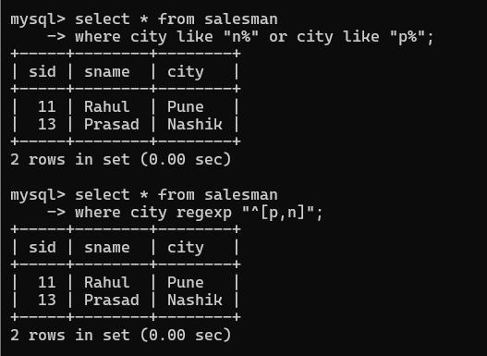

1. add new column in salesman table by name credit limit

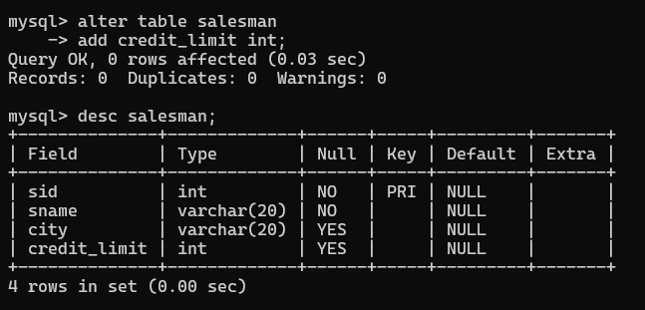

**Lab 3**

Tables : Vehicle, customer, salesman, cost-vehicle

*#in Vehicle table the ‘desc’ column is renamed as ‘description’ coz we cant use ‘desc’ for a column as it’s a reserved keyword in mysql.*

*Also, table for salesman is created as ‘salesmanV’ as I already had salesman table in the db.*

1. Create all given tables.