Database Assignment 1

Roll no. 248121

PRN:

Name: Akshay Chavan

Note : Use Emp, dept and salgrade table

1. To list all records with sal > 2000 and comm>200

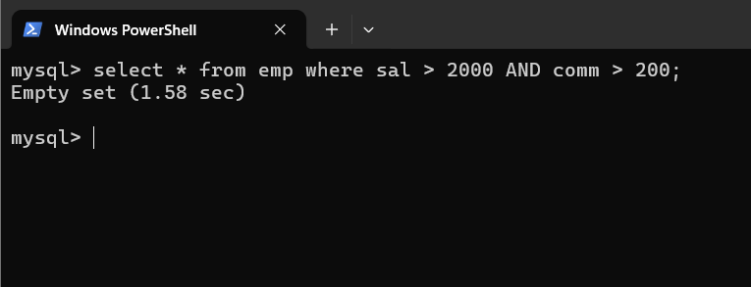

1. To list all record with job=’Clerk’ or sal>2000

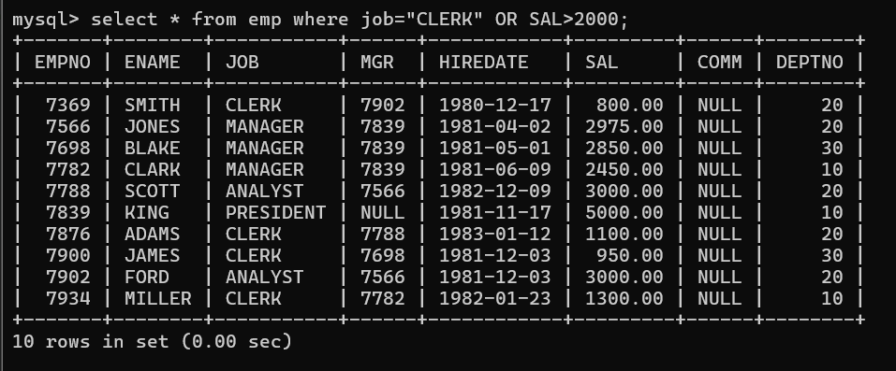

1. To list all the record with sal=1250 or 1100 or 2850

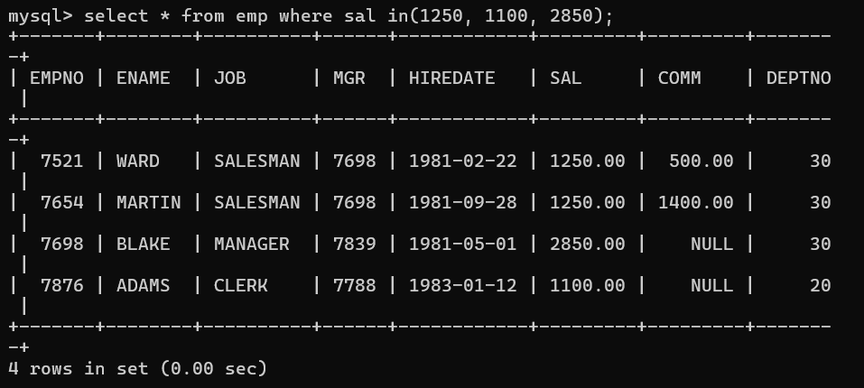

1. To list all employees with sal>1250 and <2850

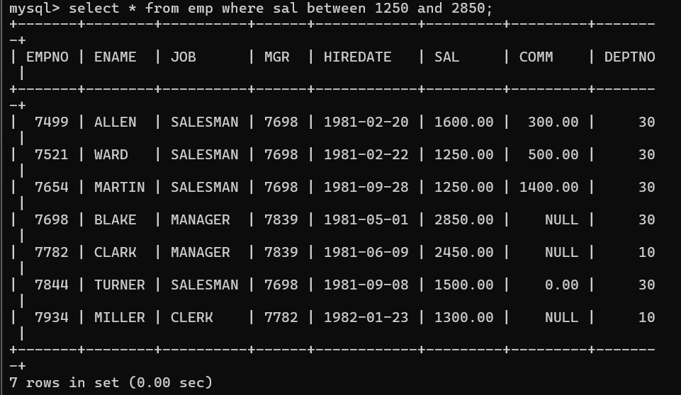

1. To list all employees with name ends with AS
2. To list all employees with job starts with C and ends with K
3. To list all employees with job contains L at third position and

M at third last position

1. To list all the record with sal not equal to 1250 or 1100 or 2850

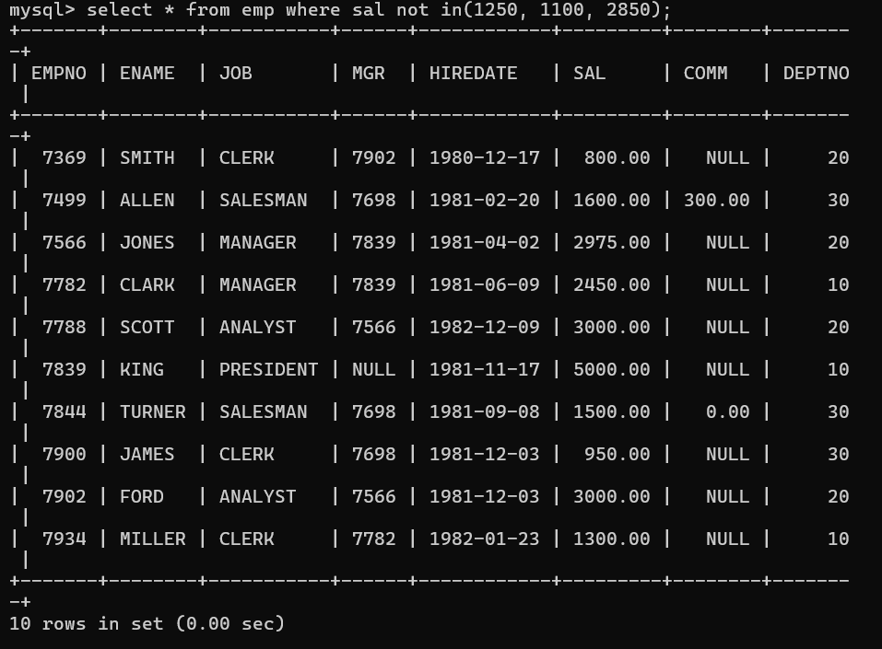

1. To list all employees with sal not >1250 and <2850

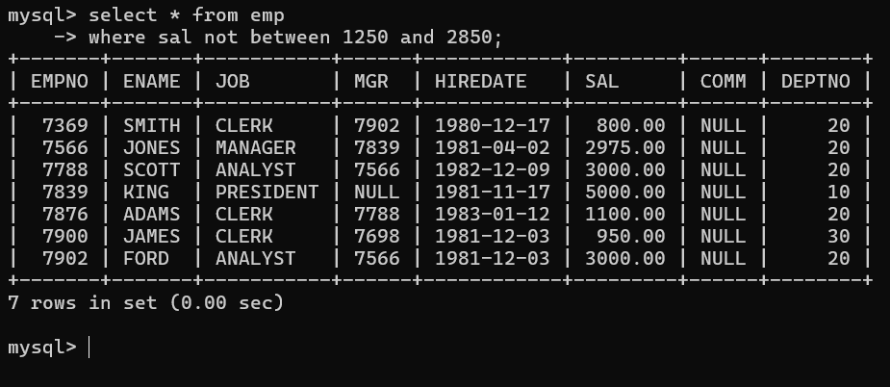

1. X
2. To list all rows with comm is null

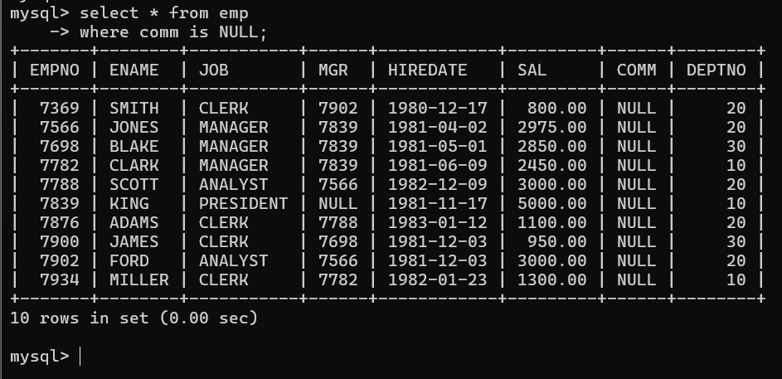

1. To list all employees with sal is null and name starts with ‘S’
2. X
3. X

Q2. Solve the following

1. Retrieve the details (Name, Salary and dept no) of the emp who are working in department code 20, 30 and 40.

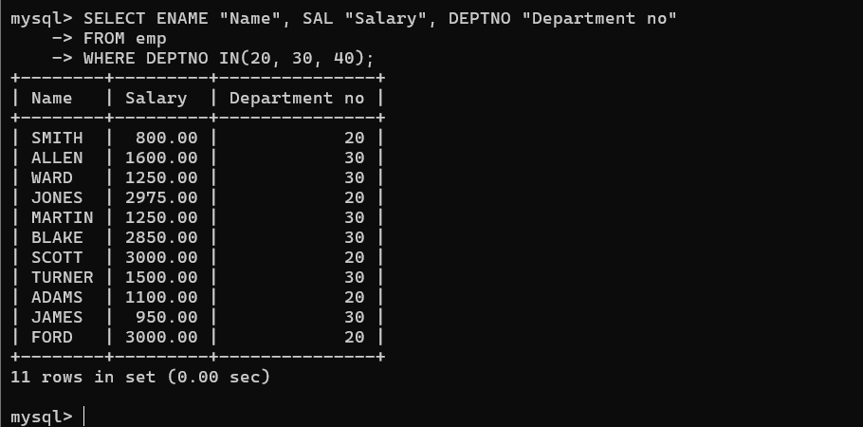

1. Display the total salary of all employees . Total salary will be calculated assal+comm+sal\*0.10

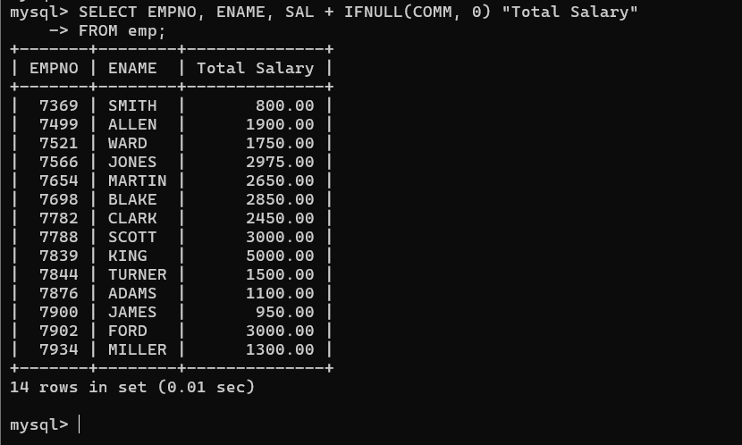

1. List the Name and job of the emp who have joined before 1 jan 1986 and whose salary range is between 1200and 2500. Display the columns with user defined Column headers.



1. List the empno, name, and department number of the emp works under manager with id 7698