A MAJOR-PROJECT REPORT



ON

**“CLAIMS AND PROOF OF DELIVERY AUTOMATION”**

Submitted to

KIIT, deemed to be UNIVERSITY

In Partial Fulfillment of the Requirement for the Award of

DEGREE OF BACHELOR OF TECHNOLOGY IN COMPUTER SCIENCE & COMMUNICATION ENGINEERING

BY

AKSHAY KUMAR

ROLL NUMBER: 2029045

UNDER THE GUIDANCE OF

Mr. Satya Teja Venkata Padmanabhuni

SCHOOL OF COMPUTER ENGINEERING

KALINGA INSTITUTE OF INDUSTRIAL TECHNOLOGY DEEMED TO BE UNIVERSITY BHUBANESWAR, ODISHA - 751024

2023-2024

1

## KALINGA INSTITUTE OF INDUSTRIAL TECHNOLOGY



**Deemed to be University School of Computer Engineering Bhubaneswar, ODISHA 751024**

**CERTIFICATE**

This is to certify that the project entitled “**Claims and Proof of Delivery Automation**” submitted by

### Akshay(2029045),

is a record of bonafide work carried out by him, in the partial fulfillment of the requirement for the award of Degree of Bachelor of Technology (Computer Science & Communication Engineering) at Kalinga Institute of Industrial Technology (Deemed to be University) Bhubaneswar. This work was done during the year 2020-2021, under our guidance. He worked with the team of ***CPA (Claims and POD Automation)*** for ***HighRadius Technologies Private Limited***, Bhubaneswar during the Internship period at the company and sincerely completed all the assigned tasks. The matter embodied in this project is original and has not been submitted for the award of any other degree.

Date: 27-04-2021

(Mr. Satya Teja Venkata Padmanabhuni) (Project Manager – CPA)

(HighRadius Technologies)

2

Acknowledgement

I would like to take this opportunity to thank all my sources of aspiration during the course of the internship.

First and foremost, I am grateful to **Mr. Satya Teja Venkata Padmanabhuni** and **Mr. Nilesh Kumar**, who gave an opportunity to work on projects at **HighRadius Technologies** and for their continuous support during the internship and for their patience, motivation and immense knowledge. They helped us and guided us throughout the internship and development.

I am also thankful to my senior developers and team leads for their valuable guidance, support, and cooperation extended by them. Then I would like to thank my project team members for their kind cooperation, help and never- ending support.

I am also thankful to KIIT Bhubaneswar for providing me technical skills and facilities which proved to be very useful for our project.

AKSHAY

2029045

3

# ABSTRACT

Account receivables is one of the main challenges any business' operation. Managing the deductions claimed by the customers has always been a major challenge for any Business Organization. Companies receive thousands of deductions every day. Aggregating claims and proofs of delivery for validation from web portals or mails is a tough task. With poor management of claims and deduction, not only company’s valuable time is wasted, but also the efficiency and moral of the analyst and team goes down.

Applying payments to invoices accurately and properly identifying deductions taken by customers is critical to audit performance and cash forecasting. Inaccuracy in the cash application process can lead to slowdowns and problems throughout the entire receivables life-cycle. Customer satisfaction is enhanced by more accuracy in the way invoices, collections, and deductions are handled.

HighRadius offers a Deduction Cloud which enables a proactive deduction management operation which aims at streamlining the process, shortens resolution cycle time, reduces processing costs and increase recovery rates on invalid deduction. A very significant role of any Deduction Management System is to capture deduction data from customers and supply the information required for resolution. Backup documentation, such as Proofs of Delivery (PODs) and Bills of Lading (BOLs) are captured automatically and linked to the corresponding deductions to reduce manual research.

Thus, the main aim of this project was to collect and index claims from paper submissions, email, EDI or customer websites and automate traversing through other websites to retrieve backup documentation, for example PODs and BOLs from carrier sites. This will help High Radius' clients to take better and more informed decisions and optimize their deductions process.

Keywords: Account receivables, Payments, Claims, Deductions, Aggregation

4

# Contents

|  |  |
| --- | --- |
| **Acknowledgement** | **3** |
| **Abstract** | **4** |
| **1. Introduction** | **7-10** |
| 1.1 Company Overview | 7 |
| 1.2 Career at HighRadius | 8 |
| 1.3 Account Receivables and Business Analytics | 9-10 |
| **2. HighRadius Deductions Cloud** | **11-14** |
| 2.1 The Challenge | 11 |
| 2.2 The Solution | 12 |
| 2.3 How it Works | 13 |
| 2.4 Deduction Management System | 14 |
| **3. Terminologies and Technologies Involved** | **15-16** |
| 3.1 Basic Terminology | 15 |
| 3.2 Claims & POD Aggregation in HighRadius Portal | 17 |
| **4. Literature Survey** | **18-20** |
| 4.1 Phases of Implementation | 18 |
| 4.2 HighRadius’ Roles and Responsibilities | 20 |
| **5. Problem Definition** | **21** |
| **6. Requirement Gathering** | **22** |
| **7. Implementation** | **23–27** |
| 7.1 Tools used for Implementation | 25 |
| 7.2 Development of the Agent | 25-26 |
| 7.3 Unit Testing of the Agent | 27 |
| 7.4 Testing by QA | 27 |
| **8. Integration Testing Cycle and Deployment** | **28-30** |
| **9. Conclusion and Future Scope** | **31** |
| **References** | **32** |

5

# List of Figures

Fig. 1 – Career at HighRadius 7

Fig. 2 – Account Receivables System Flow 9

Fig. 3 – Claims and POD Automation 11

Fig. 4 – Dispute Identification 13

Fig. 5 – Client and Customer 14

Fig. 6 – Claims and POD 15

Fig. 7 – Aggregation of Claims 16

Fig. 8 – Aggregation of Proofs of Delivery 16

Fig. 9 – Project Implementation 17

6

## Chapter 1 Introduction

* 1. **Company Overview**

HighRadius is a Fin-tech enterprise Software-as-a-Service (SaaS) company that provides an Integrated Receivables Platform to optimize receivables and payments functions such as credit, collections, cash application, deductions, and electronic billing and payment processing. The Integrated Receivables platform allows suppliers to digitally connect with buyers via the RadiusOne network, closing the loop from supplier receivable processes to buyer payable processes. HighRadius solutions have a proven track record of reducing Days Sales Outstanding (DSO) and bad debt, and increasing operation efficiency, enabling companies to achieve an ROI in just a few months.

The goal is to help A/R and credit departments adopt innovative processes supported by high levels of automation so they may become more strategic, more streamlined, and more successful. It operates on three core principles: to reduce the total cost of ownership (TCO) of receivables solutions, to deliver a concrete return on investment (ROI) and fast payback periods to our customers, and to provide innovative functionality to the market. HighRadius is trusted by some of the world’s largest corporations and is consistently named one of the fastest growing technology companies in Houston, where it is headquartered.

HighRadius offers two product lines as well as implementation services. Receivables Cloud and Payments Cloud are SaaS-based solution suites that automate and improve cash application, invoicing, and credit, collections, and deductions management. HighRadius Accelerators are certified solutions for SAP that enhance the automation available in the Receivables Management modules and reside natively in the application.

Customer satisfaction is enhanced by more accuracy in the way invoices, collections, and deductions are handled. These improvements all contribute to the exceptional return on investment that our customers experience and the very high level of repeat business they give us.

7

## Career at HighRadius

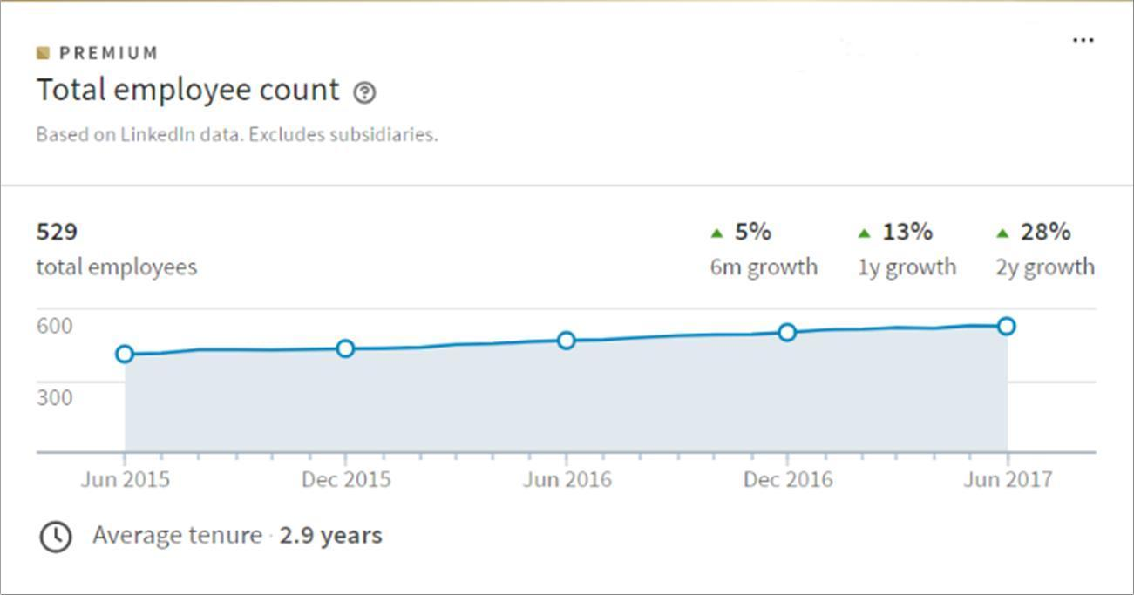

HighRadius is an early-stage company providing software solutions for automating a business’ order-to-cash cycle. For most businesses, accounts receivable is either the largest or the second largest asset on their balance sheet (in fact, it accounts for 40%, on average, of all the assets by value). Efficient management of accounts receivable has a direct impact on the financial health of a business. HighRadius is dedicated to helping businesses efficiently manage this asset.

The products, uniquely complement traditional ERP systems and are delivered both as a service over the web, deployed as software-as-a-service (SaaS) in the cloud, and as add-ons to standard ERP functionality, deployed on-premises in the business’ ERP landscape. Over the last few years, these innovative products have gained significant traction in the market and the company is now in an accelerated growth phase.

HighRadius seeks great minds, across different functions, to be a part of the growth story. At HighRadius, you get:

* + - an opportunity to build innovative products that customers love
    - a challenging work environment.

Fig.1: Career at HighRadius

8

## Account Receivables and Business Analytic

Accounts receivable is a legally enforceable claim for payment held by a business for goods supplied and/or services rendered that customers/clients have ordered but not paid for. These are generally in the form of invoices raised by a business and delivered to the customer for payment within an agreed time frame. Accounts receivable is shown in a balance sheet as an asset. It is one of a series of accounting transactions dealing with the billing of a customer for goods and services that the customer has ordered. These may be distinguished from notes receivable, which are debts created through formal legal instruments called promissory notes.

Business analytic is used to be the practice of iterative, methodical exploration of an organizations data with emphasis on statistical analysis. It is used by companies

with systematic data collection procedure to make data-driven decisions. However,

over the last 15 years the business analytic field went through a great transition, as

the amount of data available increased significantly. Specifically, this deluge of data

calls for automated methods of data analysis, where researchers looked machine for

help. Therefore, it is not surprising machine learning algorithm began to emerge as a dominating force in the business analytic industry. According to Murphy, machine learning is a set of methods that automatically detect patterns in data and then use the uncovered data patterns to predict future data, or to perform decision making under uncertainty based on knowledge from data.

Machine learning empower one's ability to transform the data into actionable knowledge.

The transformational potential of predictive analytic are as follows:

* Creating transparency of business information
* Enabling experimentation to discover needs, expose variability, and improve performance
* Segmenting populations to customize actions
* Replacing/supporting human decision making with automated algorithms
* Innovating new business models, products, and services

With these characteristics of business analytic, it is found a general pattern that customers, consumers, and citizens benefit from the economic surplus enabled by data they are both direct and indirect beneficiaries of big-data-related innovation. It is also, worth noticing that some sectors are expected to enjoy bigger gain when powering by business analytic. Because of the abundance of

9

data, computer and electronic product is no doubt the leading sector for its strong productivity growth and potential gain from the use of business analytic.

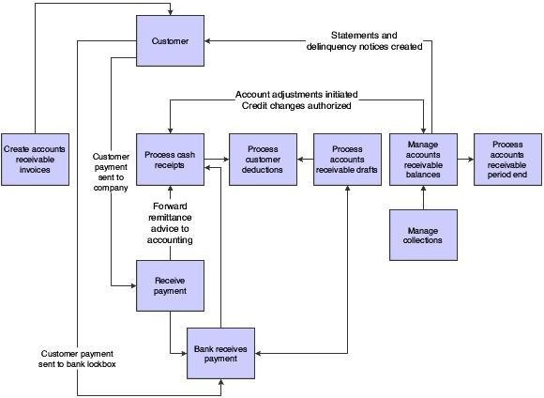

Fig. 2: Account Receivables System Flow

10

## Chapter 2

**HighRadius Deductions Cloud**

Claims and POD Automation empowers Deduction Management Software for identifying and resolving invoice disputes and short payments to improve profitability.

## The Challenge

In Business to Business (B2B) scenarios, retrieving backup documentation for deductions and collections is labor intensive and time consuming. Specialists must manually find, retrieve, and print debit memos for hundreds or thousands of deductions and then find the corresponding backup documentation, for example Bills of Lading (BOL) or Proofs of Delivery (POD). This information is pulled from external sources such as freight carrier websites one document at a time.

Often, documents are lost and time is wasted requesting copies by mail or fax. All of this inefficiency has a direct negative impact on Days Deductions Outstanding (DDO) and Days Sales Outstanding (DSO) and consumes significant analyst time which otherwise could be dedicated to identifying issues and resolving disputes.

Companies receive thousands of deductions every day. And while most of them are valid, deduction analysts still spend countless hours executing routine steps to confirm deduction validity for each one.

Credit analysts perform credit reviews on blocked orders which for the most part result in releasing the order in an unconfirmed expectation of future payments.

11

## The Solution

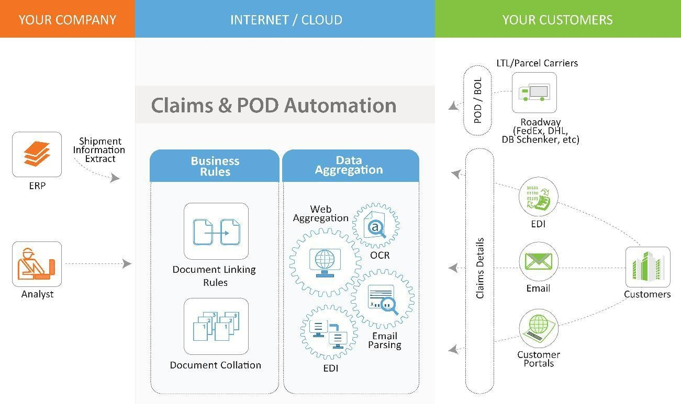

### Proactive deduction management operation that recovers revenue normally lost to invalid deductions

Claims & POD Automation is driven by a robust web aggregation engine that identifies and captures the documentation needed for managing collections and deductions. The solution collects and indexes claims from paper submissions, email, EDI or customer websites and automatically traverses through other websites to retrieve backup documentation, for example PODs and BOLs from carrier sites. The documents are automatically matched and collated, making all information required to research and resolve a dispute available in one place.

The captured documents are stored on the cloud in a searchable document repository, making them easy to retrieve and integrate into collections and deduction management workflows. The result is the near-complete elimination of manual work involved in identifying, downloading, and attaching backup documentation.

Corresponding trade promotions are also identified and suggested for settlement. Workflow and automated correspondence engines streamline communication and approval processes. The result is a proactive deduction management operation that recovers revenue normally lost to invalid deductions.

Fig. 3: Claims and POD Automation

12

## How it Works

### Key features of Claims and POD Automation

* + - Data aggregation engine automates the monitoring of relevant websites, email, EDI, and paper submissions to pull new backup documentation such as debit memos, PODs, BOLs, etc.
    - Auto-attachment matches backup documentation to the relevant collections or deduction case.
    - Document storage provides an image of the original document for reference or disputes.
    - Collation – We pick up all item levels of same invoice number and club them together.
    - Document Linking is done based on invoice number
    - Document storage provides an image of the original document or reference or disputes.
    - HR portal-Client can download claims from every Customer portal just by logging into HR portal.
    - It provides a DM (debit memo) extract. All claims attachments along with an index file for a day.
    - For Deductions Management System, it converts all these claims into pre- deductions.

### Benefits

* + - Eliminate manual tasks that consume 20-40% of a specialist’s time, allowing them to focus on higher value research and analysis.
    - Reduce Days Deduction Outstanding (DDO) by speeding deduction research and making backup documentation readily available for settlement.
    - Reduce Days Sales Outstanding (DSO) by speeding up payment.

13

## Deduction Management System

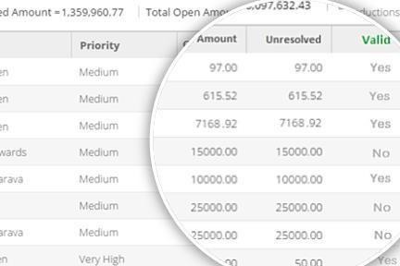

### Dispute Identification

HighRadius Deductions Cloud provides automation, process standardization, and a platform for cross-departmental and customer collaboration. The solution provides the most robust automation engine available to capture deduction data from customers and supply the information required for resolution. Backup documentation, such as Proofs of Delivery (PODs) and Bills of Lading (BOLs) are captured automatically and linked to the corresponding deductions to reduce manual research. Corresponding trade promotions are also identified and suggested for settlement. Workflow and automated correspondence engines streamline communication and approval processes. The result is a proactive deduction management operation that recovers revenue normally lost to invalid deductions.

Fig. 4: Dispute Identification

14

## Chapter 3

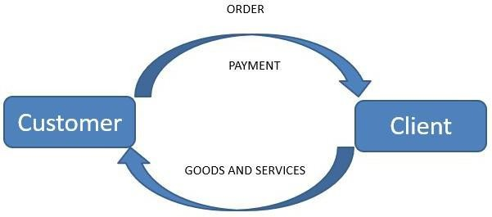

**Terminology and Technologies Involved**

## 3.1. Basic Terminology

**Client-** Client or Account is the company that buys and uses our product. Example- Hershey’s, P&G etc.

**Customer-** HighRadius Client's end-customers will be called customers. Example- Walmart, K-mart etc.

Fig. 5: Client and Customer

**Provider-** The companies that provide service to the customer and data about the customer’s transactions are service providers and data providers.

**POD & BOL**- Proof of delivery (POD) is a method to establish the fact that the recipient received the contents sent by the sender.

A bill of lading is a document issued by a carrier (or his agent) to acknowledge receipt of cargo for shipment.

These documents are mostly found on web portals.

15

**Claims-** When a customer pays less than the amount specified in the invoice because of any related issue with the goods received. These are the documents containing the list of items that they want a refund or rebate on.

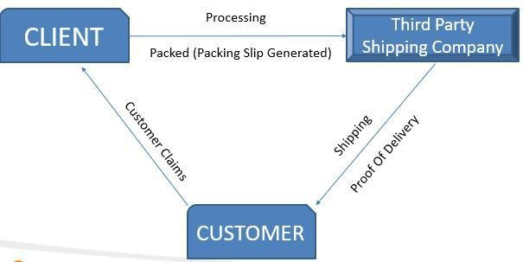

The reason maybe delivering wrong product, damage or any other reason.

And these documents contain quantity, unit price and reference field for each line item.

These can come in the form of Emails, Web portals, Image batches and EDIs (812).

**Claims Aggregation** – Claim details and the claim documents from the select customers shall be aggregated into the HighRadius portal.

**Debit Memo Extract** – Outbound extract with the claim details shall be sent to the customer.

**Payment-** Money paid by Customer to Client for some product or service they bought and got billed for. Payment can be in the form of: Checks, ACH or Credit or Debit Card transactions.

Fig. 6 – Claims and POD

16

## Chapter 4 Literature Survey

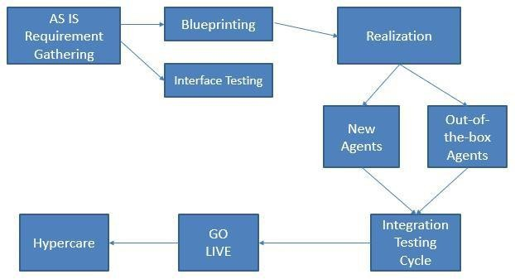

### Claims from Customer Portals, E-mails and Third-party websites

Automate download and information capture for claim documents from emails, paper claims, customer websites, and popular A/P networks and link these documents to open deductions using robotic process automation.

### PODs and BOLs from Carrier Portals and E-mails

Automate collection, information capture, and collation for PODs and BoLs while linking them to corresponding open deductions.

### Push Data to Customer Portals

Automatically post denial correspondence to the customer web portals for easier notification and communication.

Fig. 9 – Project Implementation

18

## Phases of Implementation

|  |  |  |  |
| --- | --- | --- | --- |
| **Phases** | **Activities** | **Prerequisite** | **Objective** |
| Preparation | Review Client Data | Contracts are signed | Get good understanding of customer as is process and data to be prepared for the blueprint phase. |
| Blueprint | Design | Preparation phase is complete | Conduct series of workshops to understand and document As-is process |
|  |  |  | Develop future state design and fit gap analysis |
| Realization | Configuration, Build & Unit Testing | Process Design Document signed off | Develop functional specifications for interfaces and enhancements |
|  |  |  | Develop interfaces and enhancements |
|  |  |  | Configure and unit test the solution |
| Testing | End-to-End Scenario | Completion of all build activities | Perform end-to-end integration testing |
|  | Testing |  | Fix bugs |
|  |  |  | Perform User Acceptance Testing |
| Cut-over/ Go- | Transition to | Completion of | Perform cut-over Activities |
| Live | Production | testing phase | Training of end-users |
|  |  |  | Introduction to the ticketing system |
| Hypercare | Stabilization | Go-Live | 4 weeks of Consulting Support to stabilize the application |

19

## HighRadius’ Roles and Responsibilities

At a high-level, HRC will be responsible for all the implementation activities within the solution from an implementation standpoint. Following is the summary of these activities:

* + - Understand the client requirements and prepare the Process Design Document (PDD) that will comprise of future state design for the solution.
    - Design interfaces for outbound data from the ERP system.
    - Configure and build solution as per the PDD document.
    - Unit test the solution.
    - Develop integration test scripts.
    - Conduct integration and User Acceptance Testing (UAT).
    - Perform cutover task to move system into production.

20

## Chapter 5 Problem Definition

The project scope is to implement the HighRadius Claims and POD Automation module for customers to automate and optimize the claims aggregation. The objective is to gather the claims data proactively and aggregate these automatically. The customer will also receive these claims on a daily basis along with an index file which contains the aggregated data at an item level.

The Process Definition Document aims to document the business processes related to Claims automation for the customer. The PDD describes the Claims automation process that the customer follows using HighRadius Claims module and the method of extracting and transferring this claim information to the customer. Furthermore, the PDD enumerates and explain the various design decisions and field mappings for each customer.

Project Scope:

* Implement the following modules for Claims Automation
  + Claims Aggregation
  + Debit Memo Extract

Claims automation process retrieves documents such as customer Debit Memos and Claims from various sources such as web portals, emails, EDI and OCR debit memos without requiring any human intervention which significantly improves the performance and accuracy.

All the claims that are aggregated will be sent to the customer. This is referred to as the DM extract. The DM extract will consist of these claims in PDF format along with an index file in XML format. The index file will contain all the data aggregated at the item level for each claim.

21

## Chapter 6

**Requirement Gathering**

* The consultants do research on the no. of customers the client has, the volume of deductions to decide the top customers based on their volume and the value of deductions, i.e., above or below a certain value they want to consider. Eg: claims only above $30.
* They decide the no. of Agents – how many are out-of-the-box and how many should be created
* The developers receive the validated Navigation document and field mappings (which fields should be mapped to which columns)
* After receiving all information through the FS (Functional Specification) sent by the consultant, the developer first manually navigates through the web portal or e-mail inbox to understand the process clearly.
* Feasibility testing is done by the developer to understand and decide if the development of the agent is possible or not.
* The claim documents or POD/BOL documents are fetched manually to view and understand their format and feasibility for the agent.
* In case of claims, the documents are converted to HTML or Text format to retrieve data from the document for aggregation in the portal.
* The development of the agent is begun by writing Java and XML codes and preparing SQL queries.

22

## Chapter 7 Implementation

HighRadius portal would be a one-stop solution to view Claims information along with the related tracking information.

Customer’s claim or POD information will be aggregated from customer Web portals. The aggregation process for the customers being automated is explained below.

### New Web Agent

The claims or PODs from customer are pulled using Web mode of aggregation. The customer places a file containing a list of claim numbers or tracking numbers in the customer’s SFTP server on a daily/weekly basis. This file may be in csv format and contains claim number and vendor number with other details about the claim. HighRadius uses this file to aggregate all the claim or POD documents in this file from the customer’s website.

Alternatively, the customer places its claims directly in its web portal in multiple pages which may or may not be able to be extracted to a csv file. In such cases the agent has to navigate through the portal and through each page to aggregate all claims or PODs for the given date range.

### Enhancement in a Web Agent

There are many reasons an agent would require an enhancement. Some of the reasons are changes in the customer’s website, changes in navigation, modifications required in field mappings, new formats of documents, addition of requirements from the same portal, etc. All the changes mentioned in the FS are developed by the developer and assigned to QA for testing.

### New Email Agent

23

The claims or PODs are available on the customer’s email portal, which are forwarded to the email portal of HighRadius specific to an account. Different customers have different labels in an email portal. For the development of an email agent, it must first be known whether aggregation is required from the e- mail subject, from the e-mail body or from the e-mail attachment. The agent is developed to fetch attachments or email body data from the unread mails from a particular label in the email portal. After downloading data and attachments, another agent known as the Parser agent parses data from the email body or from the attachment for aggregation.

### Enhancement in an Email Agent

An email agent may require enhancements when there is requirement of change in or additional field mappings by the customer, or when there are documents of new format/s. The agent is enhanced to aggregate these new kinds of attachments so that the automation process is not downgraded.

### Bugs in Web/Email Agents

Bugs are raised by QA or by consultants when the agent does not function as required by the customer. The developer has to find the issue in the agent and resolve it for the proper functioning of the agent. It may be due to website issue, changes in format of claim documents, mistakes by developer, etc.

24

## 7.1 Tools Used for the implementation

Operating System: Windows 10

Programming Language: Java 1.8, XML

IDE Used: Eclipse Mars Tools: Excel, SQLyog

## Development of the Agent

In case of web claim agent, there are two types of agents involved – auto agent and regular agent. The auto agent is configured to search claims in a particular date range and aggregate those claims. The regular agent is configured to search a particular claim based on claim number and aggregate that claim only. The auto agent extends the regular agent. The auto agent is developed to fetch the invoice numbers from the portal and then the regular agent is called to process each claim based on the invoice numbers sent by request attributes through the auto agent.

In case of web POD agent, there is only a regular agent involved, i.e., there is no date range search through the agent in this case. The POD or BOL is searched by the agent in the portal through a particular tracking number.

The agent is developed by referring to the navigation document to first enter the web portal and perform each navigation one by one by providing proper parameters and request headers till it reaches the page where the claims or PODs/BOLs are present. Then the agent either exports all data to a csv file or performs page-wise navigation for all the records.

Now that the agent has the invoice numbers, it performs regular agent search for each invoice number. When the agent finds the particular claim, it fetches and aggregates information about that claim from the portal through regexes written in the agent. It then navigates into the claim to fetch the required claim document. In case of POD agent, after the agent

25

finds the record for the particular tracking number, it further navigates to fetch the POD or BOL document for that tracking number.

The document is aggregated for the particular claim number or tracking number. For claims, information from inside the claim document may also be required by the client. So, the agent is further developed to aggregate header level data and item level data from the claim document. These header level and item level field mappings are provided by the consultant. This defines which field in the document should be aggregated as which field in the HighRadius portal.

In case of email agent, there are two types of frameworks – old email agent and new email agent. The old email framework consists of two agents – the download agent and the parser agent. The download agent is a common agent used by all email agents in the old framework to download attachments and email body from the unread emails in the email portal for a particular label. Parser agent is different for each provider. The parser agent is developed to fetch data from the attachments or the email body and aggregate the same.

The new email framework has 3 agents – download agent, qualifier agent and parser agent. All these agents are common across all providers. This email framework is developed only through queries and there is no need of extra coding. Queries are raised in SQL to download attachments or email body through the download agent, qualify those attachments or email bodies through the qualifier agent and then parse the data through the parser agent to aggregate data. The regexes for parsing of the data is also given through queries which is stored in the database. The agent refers to the database for its functioning.

The developer also enables the agent to create a Debit Memo extract or a Tracking Information Extract if required by the customer. This extract consists of the claims or PODs aggregated per day by the agent in a tabular format.

26

## Unit Testing of the Agent

After development of the agent, the developer does unit testing of the agent. The agent is run multiple times to check its functionality across various claims or PODs and across various formats. The developer checks whether correct data has been aggregated into the database by the agent by the following queries:

SELECT * FROM `customer_claim`

WHERE `account_id` = ‘27’ AND `provider_datatype_id` = ‘195’ ORDER BY `update_time`;

SELECT * FROM `tracking_information`

WHERE `account_id` = ‘10’ AND `provider_datatype_id` = ‘629’ ORDER BY `update_time`;

## Testing by QA

* + - The QA team receives the functional specification document from the consultant and understands the requirement of the customer from the agent.
    - The tester tests all the test cases mentioned in the FS across all the accounts affected by that provider agent.
    - The DM extract or TI extract is also validated by the QA and each column is checked for proper massaging executed by the agent.
    - In case of any issues the tester asks the developer to resolve it.
    - When QA approves the agent, the agent is sent to production.
    - Now the consultant can give the client a demo of how the agent functions.

27

## Chapter 8

**Integration Testing Cycle and Deployment**

* Internal Testing is done by the consultant for all agents with the sample extracts.
* Demo for the client is scheduled to ensure that all inbound and outbound operations are intended.
* ITC Sign-off - Acceptance from the Client
* Migration of all queries and data to the production environment is done.
* Configuring Super Agents according to observed timeouts is done.
* Crons are configured to run the agent at specific intervals.
* Dry run on decided amount of data is performed.
* Once the output from Dry Run is accepted as intended, it can be moved to Go Live.
* Hypercare
  + Manual triggering for first few days.
  + Testing with crons.
* Support
  + Bug fixes are done.
  + Agents are triggered if necessary.

### Visibility of Claims and PODs in the HighRadius UI:

All claims aggregated by HRC will be available in the Claims module in HRC UI. Only data that is directly extracted will be visible to the user. Any derived fields are not directly visible in the UI. These fields are populated in the outbound file to the client.

The client will be able to search for claims by customer name.

The client can also search for claims with other fields of the claim like Claim Number or claim amount. Wildcard searches can be given for string-based fields.

28

### Notifications to be sent to the customer

* All claims with a ‘success’ status type will be sent in the output file to the client. The system will then try to re-aggregate all the other claims next day. This will happen for 7 days (No. of days can be configured from 1 to 7). If the system is unable to aggregate the claim after 7 days, it will be marked as ‘Failed’.
* A reconciliation report will be sent to the client every day.
* The system does not automatically send a list of failed claims but only gives the number. Users should login to the UI and filter based on date and Status to get the list of failed claims.
* Login failure notifications will also be sent to certain email addresses that can be configured.
* The reconciliation email and login failure notification email should be sent to the client’s email.

### OutBound Extracts

Outbound Extracts are the files sent from HighRadius to the client. Claim Extracts are files that contain the extracted information of all the Claims records that are aggregated successfully by HighRadius.

The extracted files will be pushed to the client’s FTP server.

### SHARP Interfaces

* + HRC will provide Customer Invoice (Claim) File on a daily basis. The transmission will contain the following:

29

o One zip file containing all the claim documents and any associated supporting documents such as deal sheet that are available and linked to the claim/customer invoice. The zip file will also contain one XML file that has the indexed header and line level data for each of the customer invoice copies or other supporting documents with reference to the invoice copy or other supporting documents.

30

## Chapter 9

**Conclusion and Future Scope**

* An automated deduction process goes through the same procedure as the manual deduction system but is able to aggregate claims and PODs at a much faster speed. As the CPA process has grown more and more complex, many companies have moved to an automated process thereby reducing the staff work load, cost and work burnout.
* Speed-up deduction resolution is possible with customizable workflows for research and approvals with internal and external stakeholders across A/R, sales, customer service, and broker teams.
* As the Claims and POD Automation develops, it will eliminate most of the work of valuable human resources at the Client’s end, avoiding errors, freeing up resources, and reducing costs. With the right technology in place, businesses can resolve any challenges they face in their time- sensitive deductions process.
* In the entire Order to Cash flow, business processes can be extremely simplified by using such automated systems in place of valuable human resources for more innovative and useful purposes. Not only the Claims and POD Automation system, but also other manual systems in place, such as Cash Application management, Credit management, Invoice presentment and payment, Collections management as well as the Discounts and Dispute settlement systems can be highly automated and synchronized with each other to deliver a complete solution for managing the Cash flow in the Accounts Receivables section of the Financial Supply Chain Management (FSCM) for every business.

31

## References

[www.highradius.com](http://www.highradius.com/) - For all the information about the company

https://[www.highradius.com/uk/integrated-receivables-](http://www.highradius.com/uk/integrated-receivables-) solutions/cloud/deductions-cloud/ - For information about HighRadius'

Deductions Platform

[https://www.highradius.com/integrated-receivables-](https://www.highradius.com/integrated-receivables-solutions/receivablesradius/pod-claims-automation/) solutions/receivablesradius/pod-claims-automation/ - For information about HighRadius’ Claims and POD Automation system

M. He, C. Ren, B. Shao, Q. Wang and J. Dong, "Financial supply chain management," *Proceedings of 2010 IEEE International Conference on Service Operations and Logistics, and Informatics*, Qingdao, Shandong, 2010, pp. 70- 75.

32