**Boston University**

**Metropolitan College**

**CS521 Information Structures with Python**

Project Report on

**“Python based Car Rental System”**

Submitted By:

**Akshay Ankush Kapare (BU ID – U50485521)**

Under the guidance of –

**Prof. Jie Lu**

# **Introduction**

Project is Python based Car Rental system. User can book the car for any purpose on rental bases. User will get three option to rent the car first is Hourly bases, second is daily bases and third is weekly bases. According to the selection of type user will get charged. While returning the car user will get all the billing information like what amount user has to pay. Is there any late fee applied?

# **Project Flow**

After running the program user has to enter First name and last name all this information will be stored in file so next time, we can use this information to collect the data. If user is new user program will print “Hello New user!!! “And if user is already register program will print “Hey User Welcome back!!!” and ask user for rent or return option.

If user selected rent car option then user has to select number of car user has to rent and once user selected number of car then program will ask user to select on which bases, he has to rent the car like hourly bases, daily bases or weekly bases. Once all this is done all the information will be stored which we can use while returning the car

If user selected return car option then as we have name of the user all the billing information will display and user can pay accordingly.

# **Sample outputs:**

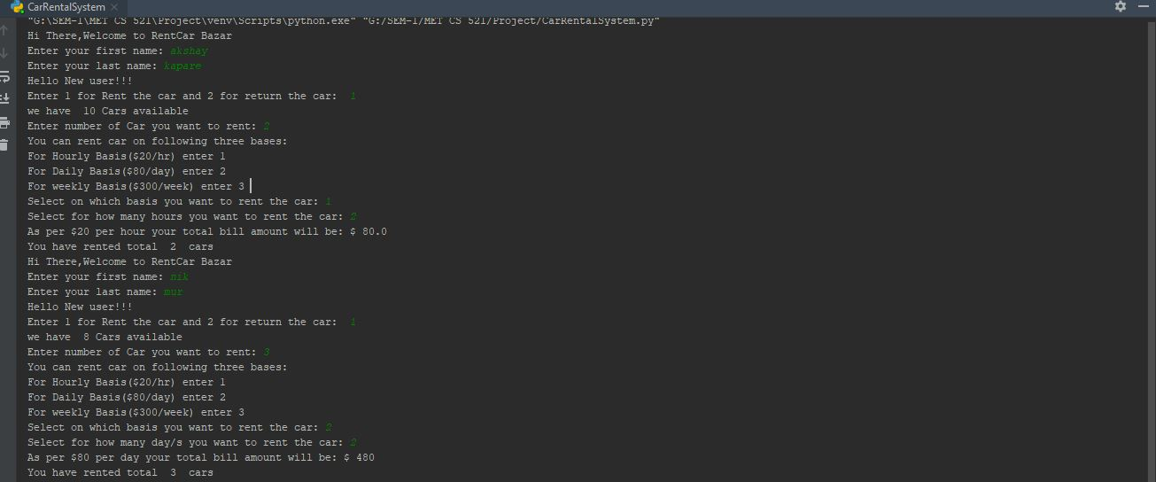

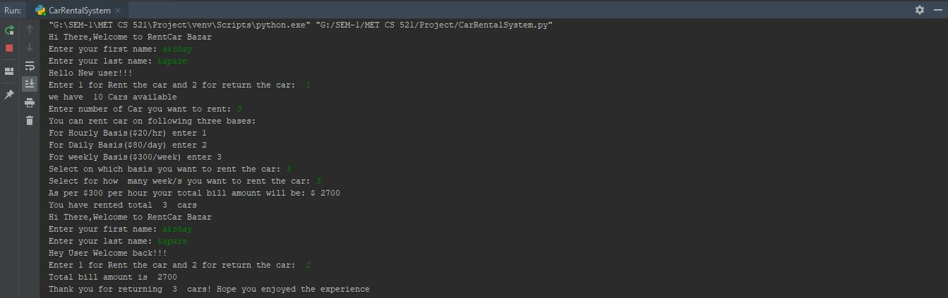

# **Enhancements**

# By using application like Django we can extend the system to be a standalone web application.

# We can link with Database to store all the user data permanently.

# We can add different types of car so user can select car of their choice.