## **OPERATING SYSTEM PROJECT**

**(GROUP - 8)**

**PROBLEM STATEMENT :**

Implementing Interprocess Communication using Shared Memory.

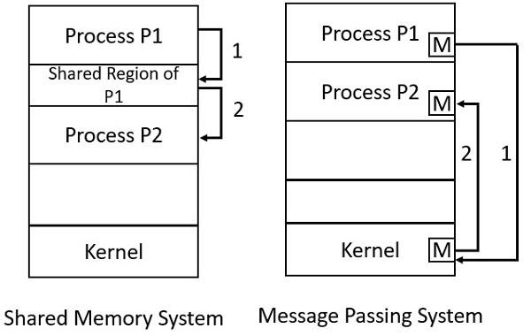

**OVERVIEW** :

A system can have two types of processes i.e. independent or cooperating. Cooperating processes affect each other and may share data and information among themselves.

**Objective :**

The main aim or goal of this mechanism is to provide communications in between several processes. In short, the intercommunication allows a process letting another process know that some event has occurred.

**Why IPC :**

IPC helps achieve these things:

Computational Speedup

Modularity

Information and data sharing

Privilege separation

Processes can communicate with each other and synchronize their action.

**Why we need interprocess communication :**

There are numerous reasons to use inter-process communication for sharing the data. Here are some of the most important reasons that are given below:

It helps to speedup modularity

Computational

Privilege separation

Convenience

Helps operating system to communicate with each other and synchronize their actions as well.

**ADVANTAGES** :

* Interprocess communication helps send messages efficiently between processes.
* The program is easy to maintain and debug.
* Programmers can perform a variety of other tasks at the same time.
* Data can be shared between different programs at the same time.

**DISADVANTAGES** :

* The program cannot write to similar locations.
* Processes must make sure that they are not writing to similar memory locations.
* The shared storage model can cause problems such as storage synchronization and protection that need to be addressed.
* It’s slower than a direct function call.