PROJECT REPORT
ON
TRAVELLING SALESMAN PROBLEM USING
ANT COLONY OPTIMIZATION
A Dissertation submitted in partial fulfillment of the
requirements for the award of the degree of
BACHELOR OF TECHNOLOGY
in
COMPUTER SCIENCE AND ENGINEERING
Submitted By
A. AKSHAY KUMAR 15B81A0513
V. BHANU SREE 15B81A0533
R. GOUTHAM KRIHSNA 15B81A0554
Under the esteemed guidance of
Mr. Ch Ram Mohan
Associate Professor-CSE

DEPARTMENT OF COMPUTER SCIENCE AND ENGINEERING
CVR COLLEGE OF ENGINEERING
(UGC Autonomous Institution)
Accredited by NBA & NAAC ‘A’ Grade
(Approved by AICTE & Govt. of Telangana and Affiliated to JNT University, Hyderabad)
Vastunagar, Mangalpally (v), Ibrahimpatanam (M), R.R.Dist-501 510.Telangana. Ph.08414-252222, 252369/79

Cherabuddi Education Society’s
CVR COLLEGE OF ENGINEERING
(An Autonomous Institution)
ACCREDITED BY NBA, NAAC ‘A’ Grade
(Approved by AICTE & Government of Telangana and Affiliated to JNTU Hyderabad)
Vastunagar, Mangalpalli (V), Ibrahimpatnam (M), R.R.District.
Web: http://www.cvr.ac.in, email: info@cvr.ac.in
Ph : 08414 – 252222, 252369, Office Telefax : 252396, Principal : 252396 (O)

DEPARTMENT OF COMPUTER SCIENCE & ENGINEERING
CERTIFICATE
This is to certify that the project entitled “TRAVELLING SALESMAN PROBLEM USING ANT COLONY OPTIMIZATION” being submitted by A. AKSHAY KUMAR (15B81A0513), V. BHANU SREE (15B81A0533) & R. GOUTHAM KRISHNA (15B81A0554) in partial fulfillment of the requirement for the award of degree of Bachelor of Technology in Computer Science and Engineering to Jawaharlal Nehru Technological University (JNTUH), Hyderabad, is a bonafide work carried out by him under my guidance and supervision. The results provided in this report have not been submitted to any other university or institution for the award of any degree.

Mr. Ch Ram Mohan Prof. K. Venkateshwara Rao
Associate Professor HOD CSE Department of CSE CVR College of Engineering CVR College of Engineering

External Examiner

DECLARATION

We hereby declare that the project entitled “TRAVELLING SALESMAN PROBLEM USING ANT COLONY OPTIMIZATION” submitted by us to CVR College of engineering, in the partial fulfillment of the requirement for the award of degree of Bachelor of Technology in Computer Science and Engineering is a record of bonafide project work carried out by us under the guidance of Mr. Ch Ram Mohan. We further state that the work reported in this report, to the best of our knowledge has not been submitted to any other university or institution for the award of any degree.

A. Akshay Kumar
(15B81A0513)

V.Bhanu Sree
(15B81A0533)

R. Goutham Krishna
(15B81A0554)

ACKNOWLEDGEMENT

Apart from the efforts of the team, the success of my project depends largely on the encouragement and guidelines of many others. We take this opportunity to express our gratitude to the people who have been instrumental in the successful completion of this project.
We are also thankful to the Head of the Department Prof. K. Venkateshwara Rao, for providing excellent infrastructure and a nice atmosphere for completing the project successfully.
We take this opportunity to express our profound gratitude and deep regards one more time to our guide Mr. Ch Ram Mohan of CSE Department for his exemplary guidance and monitoring and constant encouragement throughout the project work. The help and guidance given by him, time to time shall carry us a long way in the journey of life on which we are about to embark.
The guidance and support received from all the members of CVR College of engineering who contributed to this project work, was vital for the success of the project. We are grateful for the content support and help.
Finally, we would like to take this opportunity to thank our families for their constant encouragement without which this assignment would not be possible. We sincerely acknowledge and thank all those who gave support directly and indirectly in the completion of this project;
A. Akshay Kumar
(15B81A0513)

V.Bhanu Sree
(15B81A0533)

R. Goutham Krishna
(15B81A0554)

ABSTRACT

Ant Colony Optimization (ACO) is a heuristic algorithm which has been proven a successful technique and applied to a number of combinatorial optimization (CO) problems. The traveling salesman problem (TSP) is one of the most important combinatorial problems. ACO is taken as one of the high-performance computing methods for TSP.
It still has some drawbacks such as stagnation behavior, long computational time, and premature convergence problem of the basic ACO algorithm on TSP. Those problems will be more obvious when the considered problems size increases. The proposed system based on basic ACO algorithm with well distribution strategy and information entropy which is conducted on the configuration strategy for updating the heuristic parameter in ACO to improve the performance in solving TSP.
Features:

The features of this text editor can be outlined as follows-

- It gives a random path through all the cities.
- It gives the shortest path for give ‘n’ cities.

Table of Contents
DECLARATION 3
ACKNOWLEDGEMENT 4
ABSTRACT 5
INTRODUCTION 7
1 LITERATURE SURVEY 8
1.1 Travelling Salesman Problem: 8
1.1.1 Introduction: 8
1.1.2 As a graph problem: 9
1.1.3 Asymmetric and Symmetric: 9
1.1.4 Algorithms for solving TSP 10
1.2 Swarm Intelligence 10
1.3 Ant Colony Optimization 11
1.3.1 Overview 12
1.3.2 Artificial Pheromone System 12
1.3.3 Common extensions of ACO 13
1.4 Travelling Salesman Problem using Ant Colony Optimization 13
1.4.1 Algorithm 14
1.4.2 Formulas used 15
2 SOFTWARE REQUIREMENTS AND SPECIFICATIONS 16
2.1 GNU Octave 16
2.1.1 Introduction 16
2.1.2 Technical Details 17
2.1.3 Programming Language 17
2.1.4 Notable Features 17
2.1.5 MATLAB compatibility 18
2.1.6 Packages 18
3 IMPLEMENTATION 19
3.1 Generate Cities 19
3.2 Distance between cities 20
3.3 Generate random cities 20
3.4 Heuristic function “eta” 21
3.5 TCP using ACO 21
4 OUTPUT 24
5 CONCLUSION 27

INTRODUCTION

Travelling salesman problem (TSP) consists of finding the shortest route in complete weighted graph G with n nodes and n(n-1) edges, so that the start node and the end node are identical and all other nodes in this tour are visited exactly once.

The most popular practical applications of TSP are: regular distribution of goods or resources, finding of the shortest of costumer servicing route, planning bus lines etc., but also in the areas that have nothing to do with travel routes.

We will mention some of them as an illustration:

- Drilling holes for electrical circuits for flat machines
- Starlight interferometer satellite positioning
- Applications in crystallography
- Chain diagram optimization
- Computer motherboard components layout
- Industrial robot control

LITERATURE SURVEY

Travelling Salesman Problem:

1.1.1 Introduction:
The travelling salesman problem (TSP) asks the following question: "Given a list of cities and the distances between each pair of cities, what is the shortest possible route that visits each city and returns to the origin city?" It is an NP-hard problem in combinatorial optimization, important in operations research and theoretical computer science.

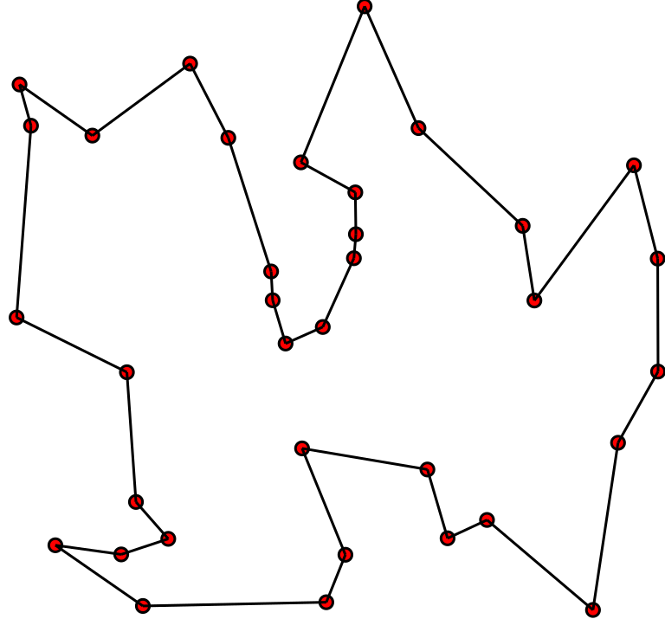
The line shows the solution of TSP

1.1.2 As a graph problem:
TSP can be modelled as an undirected weighted graph, such that cities are the graph's vertices, paths are the graph's edges, and a path's distance is the edge's weight. It is a minimization problem starting and finishing at a specified vertex after having visited each other vertex exactly once. Often, the model is a complete graph (i.e. each pair of vertices is connected by an edge). If no path exists between two cities, adding an arbitrarily long edge will complete the graph without affecting the optimal tour.

1.1.3 Asymmetric and Symmetric:

In the symmetric TSP, the distance between two cities is the same in each opposite direction, forming an undirected graph. This symmetry halves the number of possible solutions. In the asymmetric TSP, paths may not exist in both directions or the distances might be different, forming a directed graph. Traffic collisions, one-way streets, and airfares for cities with different departure and arrival fees are examples of how this symmetry could break down.

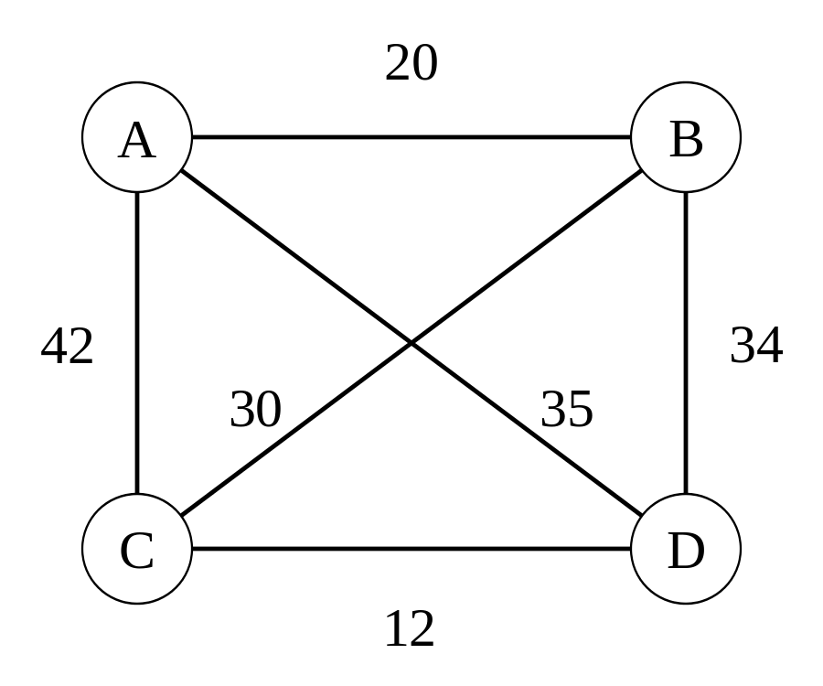

1.1.4 Algorithms for solving TSP
There are various algorithms for solving the Travelling Salesman Problem (TSP).
A few of them as follows:
- Branch and Bound algorithms
- Progressive Improvement algorithms
- Branch and Cut algorithm
- Constructive heuristics
- Christofides’ algorithm
- Pairwise exchange
- K-opt heuristic
- V-opt heuristic
- Ant Colony Optimization

Swarm Intelligence

Swarm intelligence is an emerging field of biologically-inspired artificial intelligence based on the behavioral models of social insects such as ants, bees, wasps, termites etc. TechFerry has published this article to nail down what research has been done on Swarm Intelligence. This article covers Swarm Intelligence Basic Overview, Swarm Aspects, Swarm Machinery, Swarm Technologies, Swarm Languages, Swarm Frameworks, Swarm Tools, Swarm Use Cases.
A Swarm is a configuration of tens of thousands of individuals that have chosen their own will to converge on a common goal. Swarm Intelligence is the Complex Collective, Self-Organized, Coordinated, Flexible and Robust Behavior of a group following the simple rules.
Various Algorithms is Swarm Intelligence are as follows:
Advantages:

1) Flexible: The colony respond to internal disturbances and external challenges.
2) Robust: Tasks are completed even if some agents fail.
3) Scalable: From a few agents to millions
4) Decentralized: There is no central control in the colony.
5) Self-organized: The solutions are emergent rather than pre-defined.
6) Adaptation: The swarm system can not only adjust to predetermined stimuli but also to new stimuli.
7) Speed: Changes in the network can be propagated very fast.
8) Modularity: Agents act independently of other network layers.
9) Parallelism: Agents' operations are inherently parallel.

Ant Colony Optimization

In computer science and operations research, the ant colony optimization algorithm (ACO) is a probabilistic technique for solving computational problems which can be reduced to finding good paths through graphs. Artificial Ants stand for multi-agent methods inspired by the behavior of real ants. The pheromone-based communication of biological ants is often the predominant paradigm used.^{[2]} Combinations of Artificial Ants and local search algorithms have become a method of choice for numerous optimization tasks involving some sort of graph, e.g., vehicle routing and internet routing.

Overview
In the natural world, ants of some species (initially) wander randomly, and upon finding food return to their colony while laying down pheromone trails. If other ants find such a path, they are likely not to keep travelling at random, but instead to follow the trail, returning and reinforcing it if they eventually find food (see Ant communication).
Over time, however, the pheromone trail starts to evaporate, thus reducing its attractive strength. The more time it takes for an ant to travel down the path and back again, the more time the pheromones have to evaporate. A short path, by comparison, gets marched over more frequently, and thus the pheromone density becomes higher on shorter paths than longer ones. Pheromone evaporation also has the advantage of avoiding the convergence to a locally optimal solution. If there were no evaporation at all, the paths chosen by the first ants would tend to be excessively attractive to the following ones. In that case, the exploration of the solution space would be constrained. The influence of pheromone evaporation in real ant systems is unclear, but it is very important in artificial systems.
The overall result is that when one ant finds a good (i.e., short) path from the colony to a food source, other ants are more likely to follow that path, and positive feedback eventually leads to many ants following a single path. The idea of the ant colony algorithm is to mimic this behavior with "simulated ants" walking around the graph representing the problem to solve.

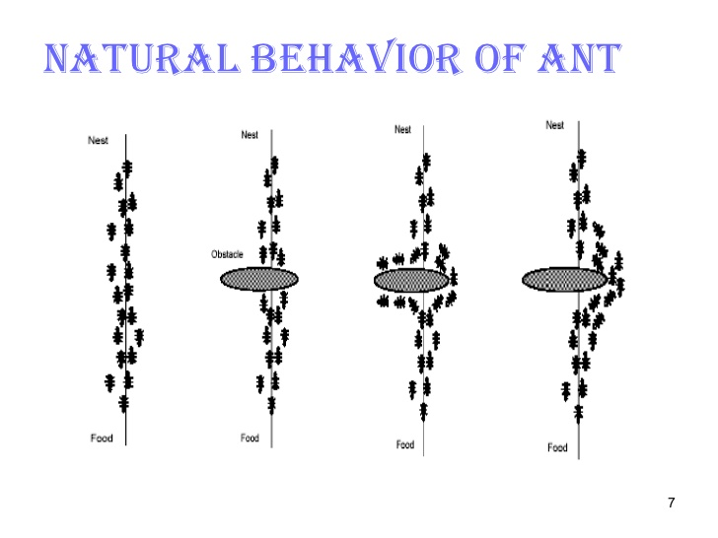

Artificial Pheromone System
Pheromone-based communication is one of the most effective ways of communication which is widely observed in nature. Pheromone is used by social insects such as bees, ants and termites; both for inter-agent and agent-swarm communications. Due to its feasibility; artificial pheromones have been adopted in multi-robot and swarm robotic systems. Pheromone-based communication was implemented by different means such as chemical or physical (RFID tags, light, sound) ways. However, those implementations were not able to replicate all the aspects of pheromones as seen in nature.
Using projected light was presented in is an experimental setup to study on pheromone-based communication with micro autonomous robots. Another study that proposed a novel pheromone communication method, COSΦ for a swarm robotic system based on precise and fast visual localization. The system allows to simulate virtually unlimited number of different pheromones and provides the result of their interaction as a gray-scale image on a horizontal LCD screen that the robots move on. In order to demonstrate the pheromone communication method, Colias autonomous micro robot was deployed as the swarm robotic platform.

Common extensions of ACO
- Elitist Ant System: The global best solution deposits pheromone on every iteration along with all the other ants.
- Max-Min Ant System: The global best solution deposits pheromone on every iteration along with all the other ants.
- Ant Colony System
- Ranked based Ant System: All solutions are ranked according to their length. The amount of pheromone deposited is then weighted for each solution, such that solutions with shorter paths deposit more pheromone than the solutions with longer paths.
- Recursive Ant Colony Optimization: It is a recursive form of ant system which divides the whole search domain into several sub-domains and solves the objective on these subdomains. The results from all the subdomains are compared and the best few of them are promoted for the next level. The subdomains corresponding to the selected results are further subdivided and the process is repeated until an output of desired precision is obtained. This method has been tested on ill-posed geophysical inversion problems and works well.

Travelling Salesman Problem using Ant Colony Optimization

Ant colony optimization (ACO) belongs to the group of metaheuristic methods. The idea was published in the early 90s for the first time. The base of ACO is to simulate the real behavior of ants in nature. The functioning of an ant colony provides indirect communication with the help pheromones, which ants excrete. Pheromones are chemical substances which attract other ants searching for food. The attractiveness of a given path depends on the quantity of pheromones that the ant feels. Pheromones excretion is governed by some rules and has not always the same intensity. The quantity of pheromones depends on the attractiveness of the route. The use of more attractive route ensures that the ant exudes more pheromones on its way back and so that path is more also attractive for other ants. The important characteristic of pheromones is evaporation. This process depends on the time. When the way is no longer used, pheromones are more evaporated and the ants begin to use other paths.

What is important for ACO algorithm the moving of ants. This motion is not deterministic, but it has stochastic character, so the ants can find the path, which is firstly unfavourable, but which is ultimately preferable for food search. The important characteristic is that a few individuals continuously use non-preferred path and look for another best way.
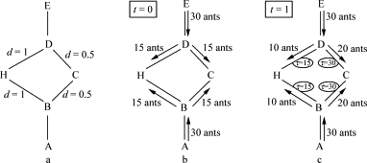

Algorithm
The general algorithm is relatively simple and based on a set of ants, each making one of the possible round-trips along the cities. At each stage, the ant chooses to move from one city to another according to some rules:
- It must visit each city exactly once.
- A distant city has less chance of being chosen (the visibility).
- The more intense the pheromone trail laid out on an edge between two cities, the greater the probability that that edge will be chosen.
- Having completed its journey, the ant deposits more pheromones on all edges it traversed, if the journey is short.
- After each iteration, trails of pheromones evaporate.

The algorithm proceeds in the following manner:

while score_not_good_enough
for ant_k in colony
place ant_k at random city
while ant has not visited all cities
with probabily q_0, ant_k will move to the city with best tau and eta
otherwise, ant_k will move to a random city based on p_k
end
for edge in edge_set
if (edge is traversed)
tau(edge) = (1 - rho) * tau(edge) + delta-tau
else
tau(edge) = (1 - rho) * tau(edge)
end
end
If there is a score higher than currMax, update
End

Formulas used

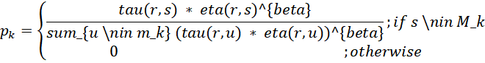

Where
k is an ant
r is a current city (it is supposed that k is at r)
s is a destination city
M_k is the memory of ant k, keeps track of past visits
tau is pheromone vector such that tau (r, u) is the amount of pheromone on edge (r, u) where r and u are cities
eta is a heuristic function which assigns some value to edges such that eta(r, u) is the heuristic value of edge (r,u). For TSP, this function is often the inverse distance between cities
beta is a parameter which determines the weight of the heuristic function eta
q_0 is a parameter determining how often we take the route with the best tau and eta values vs a random route
S is a random variable which is governed by the p_k distribution

SOFTWARE REQUIREMENTS AND SPECIFICATIONS

GNU Octave

Introduction
GNU Octave is software featuring a high-level programming language, primarily intended for numerical computations. Octave helps in solving linear and nonlinear problems numerically, and for performing other numerical experiments using a language that is mostly compatible with MATLAB. It may also be used as a batch-oriented language. Since it is part of the GNU Project, it is free software under the terms of the GNU General Public License.
Octave is one of the major free alternatives to MATLAB, others being Scilab and FreeMat. Scilab, however, puts less emphasis on (bidirectional) syntactic compatibility with MATLAB than Octave does.

Technical Details
- Octave is written in C++ using the C++ standard library.
- Octave uses an interpreter to execute the Octave scripting language.
- Octave is extensible using dynamically loadable modules.
- Octave interpreter has an OpenGL-based graphics engine to create plots, graphs and charts and to save or print them. Alternatively, gnuplot can be used for the same purpose.
- Octave includes a Graphical User Interface (GUI) in addition to the traditional Command Line Interface (CLI); see #User interfaces for details.

Programming Language
The Octave language is an interpreted programming language. It is a structured programming language (similar to C) and supports many common C standard library functions, and also certain UNIX system calls and functions. However, it does not support passing arguments by reference.
Octave programs consist of a list of function calls or a script. The syntax is matrix-based and provides various functions for matrix operations. It supports various data structures and allows object-oriented programming.
Its syntax is very similar to MATLAB, and careful programming of a script will allow it to run on both Octave and MATLAB.
Because Octave is made available under the GNU General Public License, it may be freely changed, copied and used.^{[12]} The program runs on Microsoft Windows and most Unix and Unix-like operating systems, including macOS.

Notable Features
- Command and variable name completion
- Command history
- Data Structures
- Short-circuit Boolean operators
- Increment and decrement operators
- Unwind-protect
- Variable-length argument lists
- Variable-length return lists
- C++ integration

MATLAB compatibility
Octave has been built with MATLAB compatibility in mind, and shares many features with MATLAB:
- Matrices as fundamental data type.
- Built-in support for complex numbers.
- Powerful built-in math functions and extensive function libraries.
- Extensibility in the form of user-defined functions.

Packages
- bim
- cgi
- database
- data frame
- general
- geometry
- image
- io
- mpi
- optics
- parallel
- strings
- struct
- video
- windows

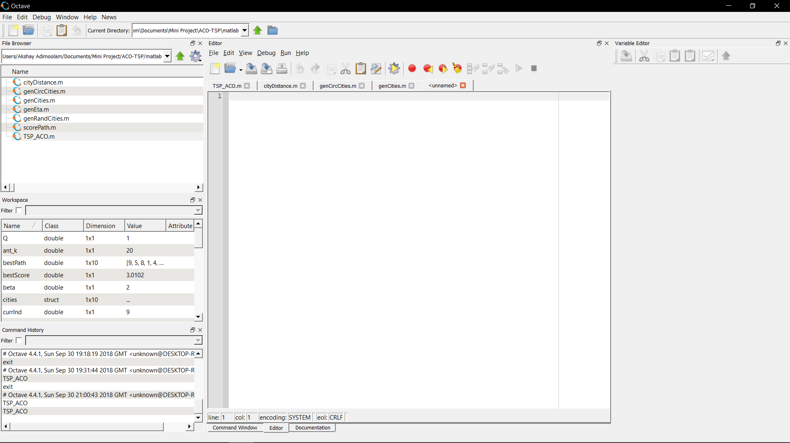
GNU Octave

IMPLEMENTATION

Generate Cities

Create list of cities and plot which will simply be a circle for now

function cities = genCities(numCities, type)
if (type == 'circ')
cities = genCircCities(numCities);
else
cities = genRandCities(numCities);
end
end

Distance between cities

function distance = cityDistance(city1, city2)
distance = sqrt(abs([city1(:).x] - [city2(:).x]).^2 + abs([city1(:).y] - [city2(:).y]).^2);
end

Generate random cities

Plots the cities randomly

function cities = genRandCities(numCities)
cities = repmat(struct('x', 0, 'y', 0, 'id', 0), 1, numCities);
for i = 1:numCities
cities(i).id = i;
cities(i).x = rand;
cities(i).y = rand;
end
end

Heuristic function “eta”

A heuristic function which assigns some value to edges such that eta(r, u) is the heuristic value of edge (r,u). For TSP, this function is often the inverse distance between cities.

function eta = genEta(cities)
numCities = length(cities);
eta = zeros(numCities, numCities);
for fromCity = 1:numCities
for toCity = fromCity:numCities
if (fromCity == toCity)
continue;
else
eta(fromCity, toCity) = 1.0/cityDistance(cities(fromCity), cities(toCity));
end
end
end
eta = eta + eta';
end

3.5 TCP using ACO

q_0 = .2770;
numAnts = 20;
beta = 2;
maxIts = 1000;
numCities = 10;
Q = 1;
rho = .4817;
params = struct('q_0', q_0, 'numAnts', numAnts, 'beta', beta, 'Q', Q, 'rho', rho);
fprintf('Running Ant Colony Optimization on %i cities with the following parameters:\n', numCities);
disp(params);
% Create list of cities and plot (will simply be a circle for now)
cities = genCities(numCities, 'rand');
figure(1);
plot([cities(:).x],[cities(:).y], 'bo-')
% Tau will be populated dynamically, blank for now
tau = ones(numCities, numCities);
% Eta is a static matrix based on a known heuristic with known inputs so we can simply populate it now in advance
eta = genEta(cities);
% Creates an ititial path
bestPath = 1:numCities;
bestScore = scorePath(bestPath, cities);
fprintf('Initial Score: %f', bestScore);
numIts = 1;
scores = zeros(1, maxIts);
while numIts < maxIts;
for ant_k = 1:numAnts
% Init empty path and place ant_k at a random starting index
path = zeros(1, numCities);
currInd = 1;
path(currInd) = randi(numCities);
% Need to track of where we have not been
unvisited = 1:numCities;
unvisited(path(1)) = [];
% While ant has not visited all cities
for currInd = 1:(numCities - 1)
r = path(currInd);
% Here we find the destination city s
if (rand < q_0)
[~, sInd] = max(tau(r, unvisited) .* eta(r, unvisited).^beta);
s = unvisited(sInd);
else
vec = tau(r, unvisited) .* (eta(r, unvisited).^beta);
probs = vec ./ sum(vec);
% Sometimes prob vec is a zero vector, giving nans. In this case they are all equally bad so we choose 1st
if any(isnan(probs))
sInd = 1;
else
sInd = find(cumsum(probs) > rand, 1);
end
s = unvisited(sInd);
end
% Add s to the path and remove it from the unvisited list
path(currInd + 1) = s;
unvisited(sInd) = [];
end
score = scorePath(path, cities);
if (score < bestScore)
bestScore = score;
bestPath = path;
end
% Now we need to update tau with the pheromones left by this ant:
toCities = circshift(path, [0,1]);
for ind = 1:numCities
fromCity = path(ind);
toCity = toCities(ind);
tau(fromCity, toCity) = tau(fromCity, toCity) + Q / score;
end
end
scores(numIts) = bestScore;
% Perform the pheromone evaporation
tau = (1 - rho) * tau;
numIts = numIts + 1;
end

OUTPUT

Test Case 1:

q_0: 0.3158
numAnts: 22
beta: 1
Q: 1
rho: 0.6825
Score: 8.17

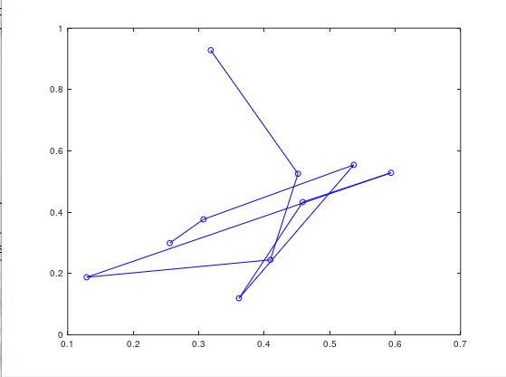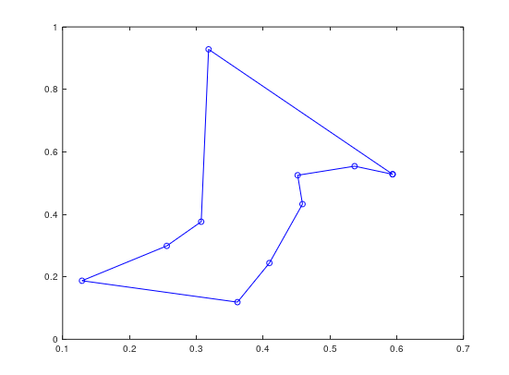

Random path Shortest Path

Test Case 2:

q_0: 0.1704
numAnts: 14
beta: 1
Q: 1
rho: 0.3533

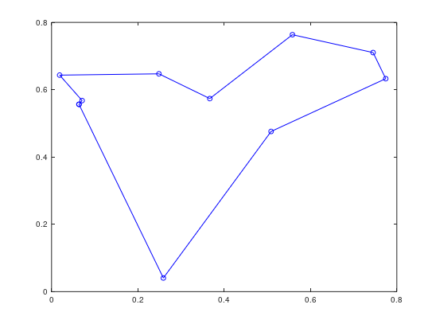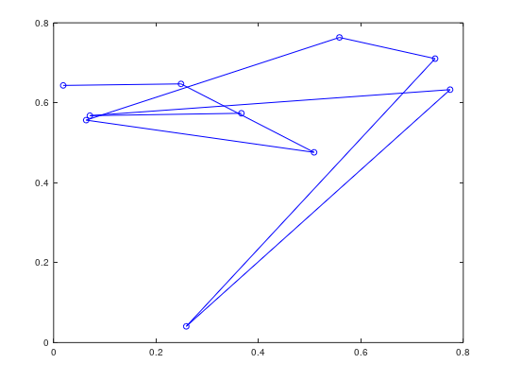

Random path Shortest path

Test Case 3:

q_0: 0.2770
numAnts: 18
beta: 1
Q: 1
rho: 0.4817

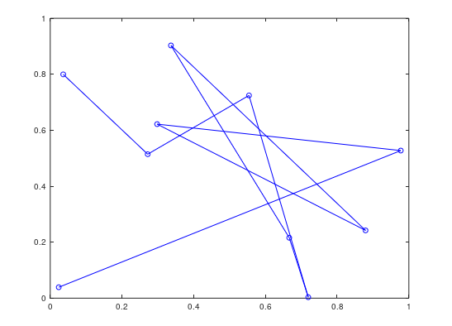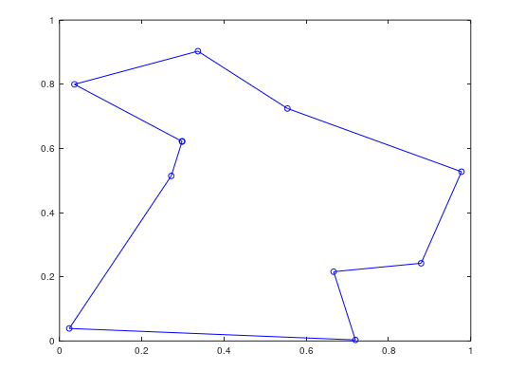

Random path Shortest path

CONCLUSION

Based on the experiments, it can be concluded that the quality of solutions depends on the number of ants. The lower number of ants allows the individual to change the path much faster. The higher number of ants in population causes the higher accumulation of pheromone on edges, and thus an individual keeps the path with higher concentration of pheromone with a high probability.
The great advantage over the use of exact methods is that ACO algorithm provides relatively good results by a comparatively low number of iterations, and is therefore able to find an acceptable solution in a comparatively short time, so it is useable for solving problems occurring in practical applications

