

**UAV (DRONE) FOR MILITARY ASSISTANCE.**

**A PROJECT REPORT SUBMITTED IN PARTIAL FULFILLMENT OF THE**

**DEGREE OF**

**Bachelor of Engineering**

**In**

**Mechanical Engineering**

**Submitted By**

Akshay Anandkar B150310807

Arshjeet Barkade B150310815

Laxmikant Kale B150310874

Vaibhav Patthe B150310928

Under the guidance of

**Prof.R.D.Shelke**



**During the Academic Year 2020-21**

**Department of Mechanical Engineering,**

**PES’s Modern College of Engineering**

**Pune – 411 005**

**[2020-21]**

**Progressive Education Society’s**

**Modern College of Engineering, Pune**



**C E R T I F I C A T E**

This is to certify that the project work (402051) report entitled

**UAV(DRONE) FOR MILITARY ASSISTANCE.**

**Has Successfully Completed By**

**Akshay Anandkar B150310807**

**Arshjeet Barkade B150310815**

**Laxmikant Kale B150310874**

**Vaibhav Patthe B150310928**

In the partial fulfilment of degree of

**BACHELOR OF MECHANICAL ENGINEERING**

In

**SAVITRIBAI PHULE PUNE UNIVERSITY**

Under the guidance of

**PROF. R.D.Shelke**

**During the Academic Year 2020-21**

**Prof. S. S. Darewar**

Asst. Professor

(Guide)

**Prof. S. Y. Bhosale**

Associate Professor & Head of

Mechanical Engineering Department

**Prof. Dr. Mrs. K. R. Joshi** Principal,

PES’s MCOE, Pune

**Progressive Education Society’s**

**Modern College of Engineering, Pune**



**C E R T I F I C A T E**

This is to certify that the project work (402051) report entitled

**UAV(DRONE) FOR MILITARY ASSISTANCE.**

**Has Successfully Completed By**

**Akshay Anandkar B150310807**

**Arshjeet Barkade B150310815**

**Laxmikant Kale B150310874**

**Vaibhav Patthe B150310928**

In the partial fulfilment of degree of

**BACHELOR OF MECHANICAL ENGINEERING**

In

**SAVITRIBAI PHULE PUNE UNIVERSITY**

Under the guidance of

**PROF. R.D.Shelke**

**During the Academic Year 2020-21**

**External Examiner**

**Internal Examiner**

**Contents**

Abstract

List of Figures

List of Tables

1 Introduction . . . . . . . . . . . . . . . . . . . . . . . . . . . . . . . . . . . . . . 8

2 Background. . . . . . . . . . . . . . . . . . . . . . . . . . . . . . . . . . . . . . 9

2.1 UAV Quad copter . . . . . . . . . . . . . . . . . . . . . . . . . . . . . . . 10

2.1.1 Flight Control . . . . . . . . . . . . . . . . . . . . . . . . . . . . . . . . 10

2.1.2 Advantages of a Quad copter . . . . . . . . . . . . . . . . . . . . ..12

2.2 Specifications and Goals . . . . . . . . . . . . . . . . . . . . . . . . . . 14

3. Problem Definition, Objective and Scope…………………..14

3.1 Problem Definition………………………………………...14

3.2 Objectives of Project…………………………………….....15

3.3 Scope of the Project………………………………………...15

3.4 Methodology…………………………………………….….15

4 System Design/ Calculations………………………………..17

4.1 Project Overview . . . . . . . . . . . . . . . . . . . . . . . . . . . . . ... ..18

4.1.1 The Research Stage . . . . . . . . . . . . . . . . . . . . . . . . . . . . . 18

4.1.2 Building & Interfacing Stage…………………………… 19

4.1.3 The Tuning/Calibration Stage . . . . . . . . . . . . . . . .. . . . . 19

4.1.4 The Programming Stage . . . . . . . . . . . . . . . . . . . . . . . . . 19

4.2 Quadcopter Kit . . . . . . . . . . . . . . . . . . . . . . . . . . . . . . . . . . 20

4.3 Physical Components . . . . . . . . . . . . . . . . . . . . . . . . . . . . . . . 22

4.3.1 Aero quad Cyclone Frame . . . . . . . . . . . . . . . . . . . . . . . . . . . 22

4.3.2 Electric Motors . . . . . . . . . . . . . . . . . . . . . . . . . . . . . . . . . .... .23

4.4 Electronic Speed Controllers . . . . . . . . . . . . . . . . . . . . . . . . . . 25

4.4.1 Aeroquad Control Board v2.1 . . . . . . . . . . . . . . . . . . . . . . . . 26

4.4.2 Transmitter and Receiver . . . . . . . . . . . . . . . . . . . . . . . . .. . . 27

4.4.3 GPS Module . . . . . . . . . . . . . . . . . . . . . . . . . . . . . . . . . . . ... 30

4.4.4 Battery/Power Supply . . . . . . . . . . . . . . . . . . . . . . . . . . . . . . 31

4.5 Software . . . . . . . . . . . . . . . . . . . . . . . . . . . . . . . . . . . . . . . . 33

4.5.1 Adriano IDE . . . . . . . . . . . . . . . . . . . . . . . . . . . . . . . . . . . . 33

4.5.2 Aeroquad Flight Software & Configurator . . . . . . . . . . . . . . . 34

5.1.1 Aeroquad Control Board v2.1 . . . . . . . . . . . . . . . . . . . . . . . . . 34

5.1.3 Motors and Electronic Speed Controller . . . . . . . . . . . . . . . . . 35

5.1.4 GPS and Data

5.3.1 Difficulties . . . . . . . . . . . . . . . . . . . . . . . . . . . . . . . . . . . . . 35

6. Conculsion………………………………………………………36

7. References. . . . . . . . . . . . . . . . . . . . . . . . . . . . . . . . . . . . . . . . . . .36

**List of Figures**

1.1 Flying Quadcopter. . . . . . . . . . . . . . . . . . . . . . . . . . . . . . . . . . . . . . 9

2.1 Quadcopter: Motor rotation directions. . . . . . . . . . . . . . . . . . . . . 10

2.2 Quadcopter: Vertical thrust movement. . . . . . . . . . . . . . . . . . . . . 10

2.3 Quadcopter: Pitch movement. . . . . . . . . . . . . . . . . . . . . . . . . . . . . 11

2.4 Quadcopter: Roll movement. . . . . . . . . . . . . . . . . . . . . . . . . . . . . . 11

2.5 Quadcopter: Yaw movement. . . . . . . . . . . . . . . . . . . . . . . . . . .. . . . 11

3.1 Aeroquad Cyclone Kit . . . . . . . . . . . . . . . . . . . . . . . . . . . . . . . . . . . 17

3.2 BP A2217-9 electric brushless motor. . . . . . . . . . . . . . . . . . . . . . . 18

3.3 30A Hobbywing Flyfun brushless ESC. . . . . . . . . . . . . . . . . . . . . . 19

3.4 Aeroquad Control Board v2.1 . . . . . . . . . . . . . . . . . . . . . . . . . . .. . . 20

3.5 Spektrum DX7S receiver(left) and transmitter(right). . . . . . . . . . 23

3.7 Battery and Balancer. . . . . . . . . . . . . . . . . . . . . . . . . . . . . . . . . . . . 26

3.8 Arduino IDE . . . . . . . . . . . . . . . . . . . . . . . . . . . . . . . . . . . . . . . . 21

4.3 Diagram of the the frame representations . . . . . . . . . . . . . . . . . . . . 17

4.4 Motor & ESC test bench: (a) Block diagram. (b) Test bench. . . . . . . .19

**List of Tables**

1.1. Flow Chart………………………………………...................................12

3.1 GPS comparision table. . . . . . . . . . . . . . . . . . . . . . . . . . . . . . . . . 23

**ABSTRACT**

The purpose of this project is to develop a prototype of drone ambulanceto assist the ambulances in saving human lives. According to a study conducted by the Centre or Science and Environment (CSE*), traffic in it’s 'peak hours’* on an average does not exceed 30-40 km/h 92% of the times. In existing systems, a drone carries only the defibrillator to the emergency spot.

Thus, it takes into account only a single parameter. This paper aims at developing a system that would be able to fly to the emergency spot earlier than ambulance and take into account multiple real time health parameters of the patient such as temperature,heart rate and heartbeat. The values of these essential parameters are then transmitted to the ambulance.

The range of the drone ambulance is approximately 500m and the range of Zigbee which is 2.4GHz is 10-20m. This helps the doctor to evaluate the situation better to provide FIRST-AID KIT.

Keywords -drone, sensors

A quadcopter can achieve vertical flight in a stable manner and be used to monitor or collect data in a specific region such as mapping terrains. Technological advances have reduced the cost and increase the performance of the low power microcontrollers that allowed the general public to develop their own quadcopter. The goal of this project is to build, modify, and improve an existing quadcopter kit to obtain stable flight, gather and store GPS data, and perform autocommands, such as auto-landing. The project used an Aeroquad quadcopter kit that included a frame, motors, electronic speed controllers, Arduino Mega development board, and sensor boards and used with the provided Aeroquad software. Batteries, a transmitter, a receiver, a GPS module, and a micro SD card adaptor were interfaced with the kit. The aeroquad software was modified to properly interface the components with the quadcopter kit. Individual components were tested and verified to work properly. Calibration and tuning of the PID controller was done to obtain proper stabilization on each axis using custom PID test benches. Currently, the quadcopter can properly stabilize itself, determine its GPS location, and store and log data.

**1.INTRODUCTION**

In today’s world, there is a lot of traffic on roads which leads to congestion in the whole city. So in the time of emergency crisis situation, an ambulance which travels via road may not be able to reach the destination in time and the patient might lose his or her life.

Thus, it is necessary to introduce a distinct means that would take the objective of saving human life one step closer. A drone or a quadcopter takes aerial route and is not driven by human. Using more number of motors and propellers will produce more thrust.

The quadcopter which consists of four BLDC motors and propellers attached to it makes it the optimal design and provides the necessary thrust. Four 2200mAh batteries provide power supply to the drone. The drone comprises of a med box which is capable reaching emergency situations faster than ambulance to help in emergency situation.

The various sensors in this prototype comprises drone path ,weight of instrument ,the drone also used in various conditions like emergency medical support, food supply in natural disasters, in war used as a material supplier. In advanced situations heartbeat sensor, temperature sensor, and ECG sensor can be used.

The use of drones in healthcare is the purpose of the proposed prototype. For this reason, the first step is to develop a quadcopter. Both the thrust and the torque are produced by every quadcopter and it is produced about its COR (Centre of Rotation). In addition to this, a drag force is also produced in the opposite direction to its flight .

Every quadcopter tries to achieve lift, yaw, roll and pitch via the thrust produced by the four motors attached to it. This way, the propellers fixed on the motors can be used for the flight of the quadcopter in all directions [3]By differentiating the four rotors‟s thrust, the pitch and roll of the quadcopter can be controlled. The moment arm of each rotor‟s thrust about the CG, in steady state of the UAV should be equal.

**1.1 SENSOR LIST**

Direction sensor

Proximity sensor

Accelerometer

Arduino Board

GPS Sensor

PID controller

ESC :Electronic speed controller

Gyroscope sensor



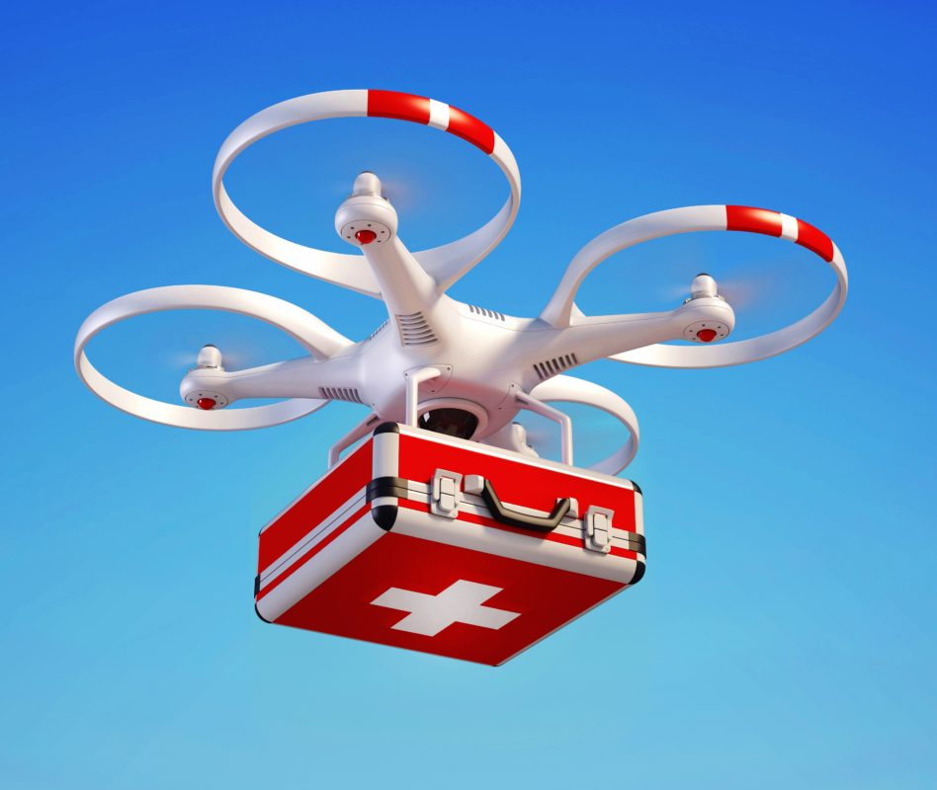

**2. Background**

This section includes the general background information on an unmanned aerial vehicle (UAV)

quadcopters. This section also covers our goals and specifications for the project undertaken.

2.1 UAV Quadcopter

A UAV quadcopter is an unmanned aerial vehicle with four rotating rotors used for lift and

movement. It uses an electronic control system and electronic sensors to help stabilize itself.

Quadcopter parts have been decreasing in price over the past couple of years due to technological advances. As a result more hobbyists, universities, and industries are taking advantage of this opportunity to design and develop applications for the quadcopter.

2.1.1 Flight Control

A quadcopter consists of four motors evenly distributed along the quadcopter frame as can be

seen in figure 2.1 below. The circles represent the spinning rotors of the quadcopter and the arrows represent the rotation direction. Motors one and three rotate in a clockwise direction using pusher rotors. Motor two and four rotate in a counter-clockwise direction using puller rotors. Each motor produces a thrust and torque about the center of the quadcopter. Due to the opposite spinning directions of the motors, the net torque about the center of the quadcopter is ideally zero, producing zero angular acceleration. This eliminates the need for yaw stabilization.

A vertical force is created by increasing the speed of all the motors by the same amount of throttle. As the vertical forces overcome the gravitational forces of the earth, the quadcopter begins to rise in altitude. Figure 2.2 shows the vertical movement of the quadcopter. As above, the circles represent the spinning rotors, the larger arrows represent the direction the rotors are spinning, and the black arrows represent the forces caused by the spinning rotors.

Pitch is provided by increasing (or decreasing) the speed of the front or rear motors. This

causes the quadcopter to turn along the x axis. The overall vertical thrust is the same as hovering

due to the left and right motors; hence only pitch angle acceleration is changed. Figure 2.3 shows

an example of pitch movement of a quadcopter. As the front motor slows down, the forces created by the corresponding rotor are less then the forces created by the back rotor. These forces are represented by the blue arrows. These forces cause the quadcopter to tip forward and this movement is represented by the red arrow.

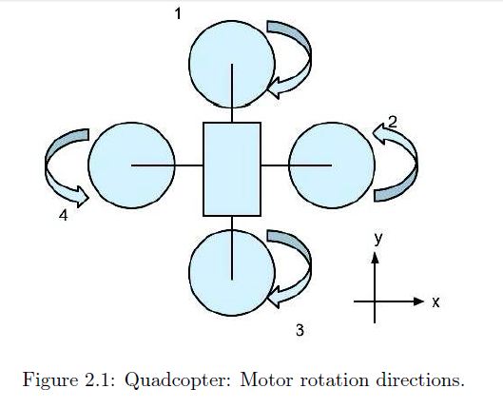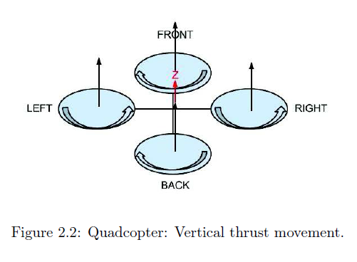

Roll is provided by increasing (or decreasing) the speed of the left rotor speed and right motors.

This causes the quadcopter to turn along the y axis. The overall vertical thrust is the same as

hovering due to the front and back motors; hence only roll angle acceleration is changed. Figure 2.4 shows an example of roll movement of a quadcopter. As the right motor slows down, the forces created by the corresponding rotor are less then the forces created by the left rotor. These forces are represented by the blue arrows. This causes the quadcopter to tip to the right and this movement is represented by the red arrow.

Yaw is provided by increasing (or decreasing) the speed of the front and rear motors or by

increasing (or decreasing) the speed of the left and right motors. This causes the quadcopter to

turn along its vertical axis in the direction of the stronger spinning rotors. Figure 2.5 shows anexample of yaw movement of a quadcopter. As the front and back motor slows down, the forces created by the corresponding rotors are less then the forces created by the left and right rotors. The quadcopter will begin to rotate in the same direction as the faster spinning rotors due to the differencen in torque forces. This movement is represented by the red arrow.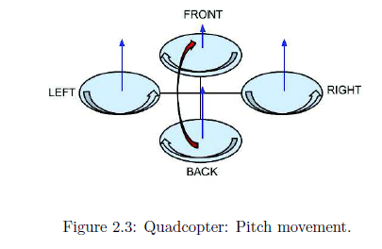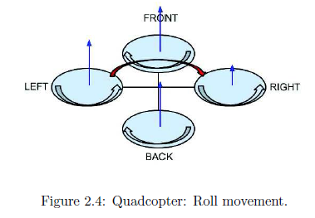

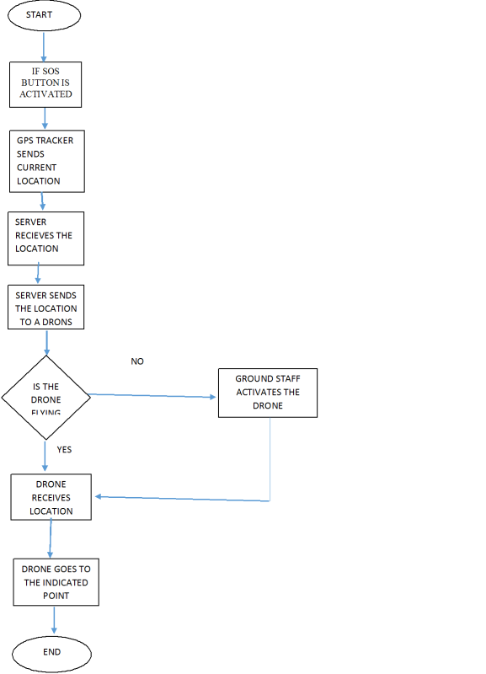

**2.3 Specifications and Goals**

The goal of our project is to design, implement, and test a stable flying UAV quadcopter that

can be used to collect and save Global Positioning System (GPS) data. Our plan was to choose an existing quadcopter kit and add the required components to give the quadcopter the capabilities to gather and log data autonomously. A GPS module will be used to determine the current position and an SD card will be used to store the information needed. If this goal is accomplished, our team would also like to design and implement some autonomous commands that may help aid a user in collecting the data. These commands include the auto-landing command, auto-move command, auto-homing command, and hold position command.

The final quadcopter design had to meet the following specifications:

1. The quadcopter must be capable of flying and landing in stable manner.

2. The quadcopter must be capable of determining its current location using GPS data.

3. The quadcopter must be capable to storing and logging data and capable to carry weight.

4. The quadcopter must be able to perform the following commands:

• auto-landing

• auto-move

• auto-homing

• hold position

• Carrying the weight upto 2KG

Another reason that we wanted to research ambulance drones was because of the emergence of delivery drones. Although the technology to deliver small items using drones is quickly emerging, rules and regulation have not been as quick to catch up. We were working under the hypothesis that life-saving technology will make legislators more eager to change the rules. This would in turn pave the way for more mundane task, such as rapid pizza delivery.

**3. PROBLEM DEFINITION, OBJECTIVE AND SCOPE**

**3.1 Problem defination**

1) What is important to be aware of when creating a simulated environment, for a zhexacopter, to provide a foundation for later construction stages?

2) What is important to consider when constructing a hexacopter with a gripping module, and how does the module affect the multicopters performance

3) We wanted to research ambulance drones because of the emergence of delivery drones and for military purpose.

**3.2 Objective of the project**

* Military assistance
* Fly air ambulance
* The hexa-copter must be able to remain stable and balance itself.
* The copter must be able to rise and descend The copter must be able to signal when power is running low (audible and visual).
* It must carry at least load of 2kg .
* Increased flight time up to 10-20min

**3.3 Scope of the project-**

This project created a platform to learn about unmanned aerial vehicles such as a quadcopter.

This expands the scope of the computer engineering education to include the control and the understanding of the mechanical components. The quadcopter has many applications that we are

interested to develop like mapping and reconnaissance especially in a disaster and dangerous area. It also open up the possibilities to broaden the understanding and applications of control systems, stabilization, artificial intelligence and computer image processing as it applies to the quadcopter.

3.4Methodology

* step 1- Unstanding the stucture
* Step 2- Assembly of Parts
* Steps 3- Test GUI Runs Brashless moters
* Step 4- Test motion of Hexacopter
* Step 5- Working Model
* Step 6-Conclusion

**4. System Design**/ **Calculations:**

This section explains in details how the project was approached. All hardware and software

components that will be used will be explained in this section of the report. Problems encountered and solutions to these problems will not be mentioned in this section of the report.

**Calculations:**

**1.Requirement for Quadcopter to carry load upto 1.5kg.**

> Required thrust for lift the weight 1.5kg in air

>Total weight of expanded quadcopter is with camera or first aid box or delivery products upto 2 to 2.5kg

>Total upward thrust required the take off the quadcopter is

Mg*2=w*1.5

Take off force(thrust)=2*weight

W=1.5kg

Therfore, thrust =2*1.5=3Kg.(Required).

Quadcopter have 4 motor can generate thrust.

Indivisual thrust of motor is Rmt=3000/4

Rmt=750g per motor

Required thrust per motor is 750g per motor.

**2.Selection of the motor can generate the thrust greater than 750g for safe load application.**

>Select the A22/2/13 1000Kv Brushless motor.

>Specification: No load current =10v:0.5A.

>Current capacity:12A/60s

>Battery type:25-35 Lipo

>Motor Dimension:27.5*30mm

**>**Minimum ESE specification :18A(30A suggest)

**>**Thrust @35 with 1045 propeller 800g (Approx)

**>**Thrust @35 with 0945 propeller 475g (Approx)

**>**Thrust @35 with 0845 propeller 475g (Approx)

The total thrust required using 4 of these motors on quadcopter with 10 *4.5 in propeller give maximum thrust upto 3.2kg.

4*800=3200gms

Required thrust 3000gms < Actual thrust 3200gms.

It is within limit.

**Design is safe load upto 1.5kg.**

**4.1 Project Overview**

The ultimate goal of this project is to design a UAV quadcopter that is able to store and log

information. This project could be used in many applications, ranging from checking the condition of power lines to searching for survival victims in a disaster area. The end result of this project could be used for these applications in future developments in this field.

Due to the time constraints of our project, it was not possible to design and build a quadopter

from scratch. Therefore, it was decided that our group would purchase an existing quadcopter kit

and interface the necessary components to fly, stablize and log data. This project was split into

four main stages; the research stage, the building and interfacing stage, the tuning and calibration

stage, and the programming stage. Each stage will be explained more thoroughly in the following

sections of this document.

**4.1.1 The Research Stage**

The research stage was a critical stage that provided our team with the knowledge necessaryto complete the other stages of our project. This stage was an ongoing process that our team had to return to many times during the development process to gain the knowledge needed to continue on with the project. Our research encompassed a wide range of sources, which included studies done at different universities and hobby enthusiast sources. Our reseach included the aerodynamics of the quadcopter, theory and principle of each quadcopter component, and how the Aeroquad software should be modified to fit the purposes of our project.

4**.1.2 Building & Interfacing Stage**

This stage started when the ordered parts started arriving. During this stage we focused on

verifying and testing each component thoroughly. The testing process will be explained in greater detail in a later section in this document. After each part was verified to be working correctly, we combined the components together. The frame and control board were assembled, the motors and electronic speed controllers (ESC) were mounted, and the GPS module, SD card adapter, and the transmitter and receiver were interfaced. The next step was to tune and calibrate the quadcopter.

**4.1.3 The Tuning/Calibration Stage**

During this stage the quadcopter proportional-integral-derivative (PID) control system was

tuned. A tuning stand was built to mount the quadcopter on to help us tune the PID system of

the quadcopter. This was a tedious process. After some initial tuning, the quadcopter was ready

for its first flight test. The PID testing process and results of the flight test will be explained in

greater detail later section in this document.

**4.1.4 The Programming Stage**

In this stage of our project we were to design four different commands for our quadcopter.

The preliminary designs for these commands have been drawn out and will be explained in greater

detail in a later section of this document. Unfortunately we did not get very far in this stage and

programming for these commands has yet to be started.

**4.2 Quadcopter Kit**

Below is a list of quadcopter kits that we considered purchasing to use for our project. Each

kit had its advantages and disadvantages. We compared each kit and explain why we chose the

Aeroquad Cyclone kit over the others.

AeroQuad Cyclone quad-copter was selected as the platform for the quad-copter dynamics modeling. (Fig. 1) It features an aluminum frame with four APC 12×3.8 propellers powered by 950KV motors. The onboard sensors include an ITG-3200 gyro, ADXL345 accelerometer, HMC5883L magnetometer, BMP085 barometer, and MaxSonars EZ0 ultrasonic sensor. The main controller is an ATmega 2560 Arduino™-based computing platform. A pair of Digi ® XBee-PRO

**AR Drone 2.0**

• comes with camera and smart phone capability

• Programmable, comes with software development kit

• Replacement parts are rare, hard to modify

• Does not support RF equipment

• Support a maximum altitude of 50m

**Parallax Elev-8 Quadcopter Kit**

• no battery and RF radio equipment

• Open source hardware, design files available online

• Modular, easy to modify and replace parts

• No room to add GPS and OSD

• Out of stock from September to October

**Aeroquad Cyclone Kit**

• no battery and RF radio equipment

• Open source hardware, design files available online

• Open source software, software available online

• Arduino Mega used as microcontroller

• Many available ports for additional add-ons

• Modular, easy to modify and replace parts

The three different quadcopters included the AR drone 2.0, the ELEV-8 quadcopter kit developed by Parallax, and the Cyclone kit developed by Aeroquad. The AR Drone 2.0 was did not need any assembly and was ready-to-fly out of the box. It also comes with a software development kit that can be used to program the quadcopter. However for our applications a GPS module and SD card adaptor were needed for data collection. These components would be extremely hard to interface with the AR Drone due to the lack of space and available ports on the quadcopter. The AR Drone was not chosen due to this reason.

The ELEV-8 quadcopter kit and Cyclone quadcopter kit both had very similar advantages.

Both came with similar components at similar price range. Both quadcopter kits were built in

a modular design that allowed for easy modification of hardware. The main reason we chose the

Aeroquad Cyclone kit over the Parallax ELEV-8 kit because the Aeroquad Cyclone kit used an

Arduino Mega as its controller board. An Arduino is a development board that has easy to use

hardware and software. Both members of the group is familiar with this development board. This

would save time of having to learn in a different development environment used by the controller

of the Parallax kit. Furthermore, parts of the frame of the Aeroquad quadcopter were made ofsimple parts that could be found at any local hardware store. Therefore replacement parts could

be easily found for repair and maintenance. In addition, the ELEV-8 quadcopter was out of stock

for the months of September and early October. Thus, the Aeroquad Cyclone kit was chosen over the Parallax ELEV-8 kit.

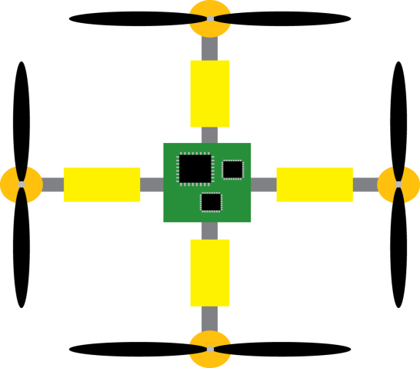

The Aeroquad Cyclone frame that comes with the kit is strong and durable. It uses a combination

of carbon fiber plates and aluminum arms for strength and durability. The frame is designed

in such a way that many different configurations could be used, supporting up to eight different

motors in an octocopter configuration. The design is also very modular, in a way that you could

easily add components to the frame by adding an extra carbon plate onto the quadcopter. The

arms are made of regular 5/8 inch hollow square aluminum bars and uses common nuts and bolts

to hold the frame together. Other than the carbon fiber plates, everything can be found at a local

hardware store. This allows easy accessible replacement parts for replacement or maintenance.

**4.3 Physical Components**

This subsection describes all the physical components of our project and how they work. As

well as the reasoning for choosing the GPS module, SD card, battery, and transmitter and receiver that were not included with the Aeroquad Cyclone kit.

4.3.1 FRAME

Goals:

* Create a lightweight chassis for the Quad-Copter
* The chassis must support all batteries, external sensors, motors, and the main board
* Cost Effective

Requirements:

* Create a chassis with a mass of 1000g or less
* The area the Quad-Copter cannot exceed a radius of 18in.
* Must be able to support at least a 3kg load

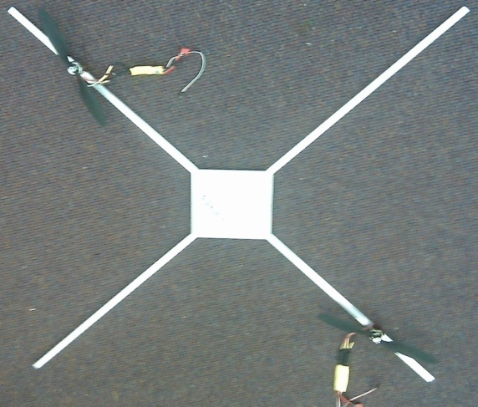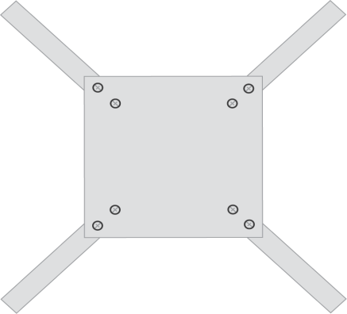

**4.3.2 Electric Motors**

There are two types of motors, brushless and brushed. A basic brushless motor has three

electromagnetic windings separated evenly on the stationary part of the motor, called a stator.

Permanent magnets are located on the rotating part of the motor, called a rotor. The rotor will

begin to rotate when two of the three windings are supplied with a voltage, creating a magnetic

field. The magnetic field created by the windings pushes and pull against the magnetic field created by the magnets on the rotor. When the magnetic fields are aligned, two different windings are driven and a new magnetic field is created causing the rotor to continue to turn. A controller is used to determine the current rotor position relative to the windings and drive the necessary windings in certain sequence to turn the rotor in the proper direction. The rotor will turn in the opposite direction if the sequence is reversed.

A brushed motor works in a similar fashion. A brushed motor has the opposite orientation

of brushless motor. The electromagnetic windings are located on the rotor and the magnets are

located on the stator. Like a brushless motor, the rotor on a brushed motor turns due to the

attractive and repulsive forces of the two magnetic fields created by the windings and the magnets. The main difference between these two motors is that a brushed motor uses a mechanical switch to change the polarity of the windings to turn the rotor. A brushed motor is more susceptible to wear and tear because it uses a mechanical mechanism to check and change the polarity of its windings.

It is also limited in speed due to the same reason.

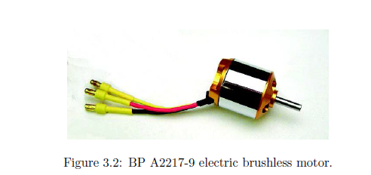

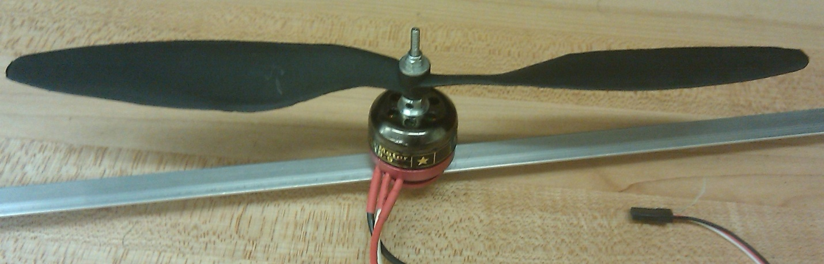

**4.4 Electronic Speed Controllers**

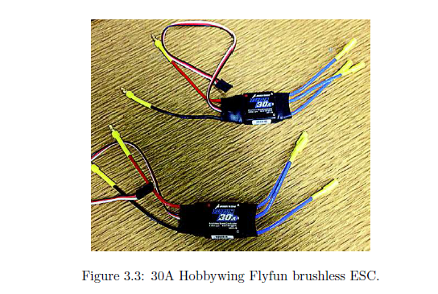

The Aeroquad kit came with four Hobbywing FlyFun brushless ESC rated at 30 amperes. These

ESC can be seen in figure 3.3. These ESC can push 30 amperes of current continuously, can pushcurrents up to 40 amperes for ten seconds based on voltage output, and handle speeds up to 210,000rotations per minute (RPM).

One ESC was found to be malfunctioning during testing and extraESCs were purchased. We will go into more details about this later in the document.

An electronic speed controller is an electrical circuit that controls the speed of an electric motor

and the direction a motor rotates. A motor turns because of the magnetic forces created by the

windings and the magnets within the motor.For a brushless motor, the speed of the motor will depend on the frequency of the winding drivesequence.

On a basic brushless motor, there are three windings that are controlled using pulsewidth modulated (PWM) signals. Two windings will be driven at a time to create the necessarymagnetic forces to turn the rotor. The greater the frequency sent to the motors, the faster therotor will turn due to the magnetic forces. The frequency of the signals is adjusted by changingthe pulse width of the signal. Smaller pulse widths will increase the frequency of a PWM signalbecause more pulses can be sent to the windings in the same time duration, and vice versa for large pulse widths. A brushed ESC works in the same manner but only two control signals are used.

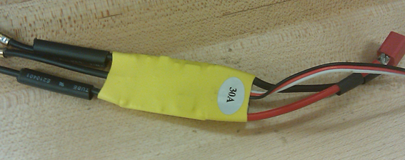

4.4.1 Aeroquad Control Board v2.1

The controller board that came with the quadcopter kit purchased consists of an Arduino Mega

2560 development board, an Aeroquad shield, a barometric sensor, and 9 degrees of freedom (9DOF)sensor board, which includes a 3-axis gyroscope, a 3-axis accelerometer, and a 3-axismagnetometer.The assembled control board can be seen in figure 3.4.

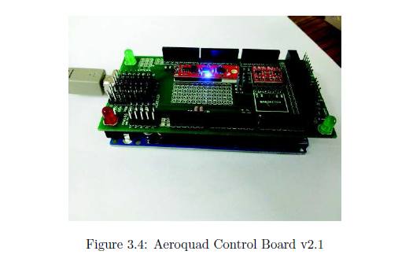

The 9DOF board measures roll, pitch, and yaw by measuring orientation, angular momentum,

and magnetic forces by using the 3-axis gyroscope, a 3-axis accelerometer, and a 3-axis magnetometerrespectively. The barometric sensor measures the surrounding air pressure. After assemblingthe Aeroquad shield, testing on the each of the sensors was done. Example test programs wereprovided with our quadcopter kit to help test the precision and accuracy of each sensor. Therewere some problems with the software though. These issues will be explained in detail later in the document.

**4.4.2 Transmitter and Receiver**

Our group came up with three different options for wireless communication system for our

quadcopter. There are three main options to choose from which include a radio transmitter and

receiver, a WiFi module, or a Bluetooth module. For our purposes we would need at least six

channels to control our quadcopter. The six channels correspond to throttle, roll, yaw, pitch, one

channel to switch between acrobatic mode and stable mode, and one or more channels for our

auto-commands. More details of the of the two different modes will be discussed in a the PID

tuning section. Below is a list of the options we looked at.

**Spektrum DX7S transmitter and AR800 receiver**

• Support up to 7 channels at 2.4 GHz

• Range up to 305 meters (1000 feet)

• Support DSM2

• Easy to interface

**Sparkfun WiFi module**

• Smartphone compatibility

• Support up to 8 channels

• Range only up to 50 meters

**BLTE Arduino Bluetooth shield**

• Bluetooth 4.0

• Low power consumption

• Range only up to 10 meters

Our group decided to choose the Spektrum DX7S transmitter and the AR800 receiver because

it had the required amount of channels needed for our quadcopter purposes. The transmitter and

receiver also had the greatest range of transmission was also easy to interface with our control

board. If we were to interface the other WiFi module or the Bluetooth module, separate channels

need to be programmed and large amounts of programming would be needed. Therefore the Spektrum transmitter and receiver was chosen and shown in figure 3.5.

The Spektrum DX7S transmitter and receiver were properly interfaced with the quadcopter

controller board. Some difficulties encountered during interfacing were that both the controller

board and receiver used male pins. The quadcopter kit that was purchased did not come with the

necessary cables to connect these two components together. Female-to-female servo cables were

purchased to solve this problem.

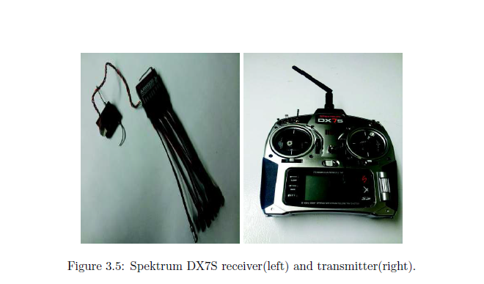

.Wireless telecommunication is the transfer of information between two or more points that are

not physically connected. Radio is the transmission of signals through free space by electromagneticwaves. The frequency range in radio is from 3 kHz to 300 GHz [9]. There are different techniques used in electronic communication; which include Amplitude modulation (AM), frequency modulation(FM), DSSS, DSM, and DSM2.

AM works by varying the strength of the transmitted signal in relation to the information being

sent. In the other hand, FM works by varying the frequencies of the transmitted signal.

In the past, radio technologies like FM are widely used in radio control (RC). The 27 MHz

to 49 MHz frequencies bands are designated by law for use with RC airplanes and aircraft. The

designated frequencies for RC planes or aircraft fall into the 72 MHz band and each separate frequencyhas been given a unique channel number. The dedicated remote control frequencies avoidinterference by unlicensed use [10]. Frequency checker is used to make sure no one is occupying thesame channels. If there are two people using the same channel to control the aircraft, interferencewould occur and aircraft might crash.In RC control the latest technology to avoid interference of signal occurs is Direct Sequencing Spread Spectrum (DSSS). DSSS operates within the 2.4GHz frequency band. This new technologywas a form of secure radio signal transmission. DSM and DSM2 are applications of DSSS. A GloballyUnique Identification Code (GUIC) is assigned to every radio transmitter during manufacture. The receiver is programmed to identify that unique in what is known as the ”‘binding process”’

and so the transmitter and receiver lock together with the same code which will block out other

code. The binding process occurs a couple of seconds every time the system is powered up.

Once the transmitter and receiver locked together, the transmitted signal is spread out over a wideband before being identified, collected and re-assembled by the receiver.

**4.4.3 GPS Module**

Our quadcopter needed a GPS module that was small, fast and accurate, consume as little

power as possible, and was easy to interface with the existing control board. We looked at three

different GPS receivers and chose the best one that would meet our requirements. Table 3.6 showsa list of features we looked at when comparing the GPS modules.

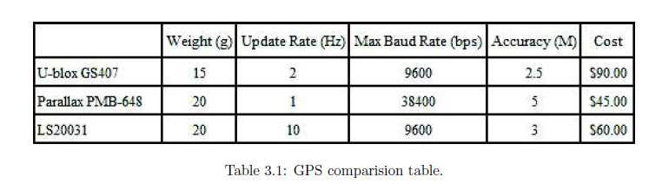

We initially chose the GS407 Helical GPS receiver because it was the smallest, lightest, andmost accurate module. Although it did not have the fastest baud rate, we thought that it was quick enough for the purposes we were using it for. Another reason why we chose the GS407 receiver over the others was because it came with a break out board that was specifically made to directly connect to the Aeroquad control board. This allowed for easy interfacing between the two components. Unfortunately we ran into a few problems that we will mention in further detail later in this document. The second GPS receiver module purchased was the Parallax PMB-648 receiver using the SiRFstarIII chipset. Although this module was slower and heavier than the GS407 module, the PMB-648 receiver cost less and was readily available at time of purchase. The module was also easy to interface because it came with a connector with wires already connected to the module instead of a fragile break out board. A GPS is a satellite network operated by the United States of America Department of Defense. This network of satellites transmits data about its current location and time. A GPS receiver passively retrieves this data from multiple satellites to estimate its position. By estimating the distance between more than three satellites, a GPS receiver can determine its current position in three dimension.

**4.4.5 Battery/Power Supply**

For our project we need a power supply that is low cost, light weight, reusable, and has enough

power for at least ten minutes of flight. Rechargeable batteries were chosen for our project due to

reuse value. Currently there are three main types of rechargeable batteries available commerciallyfor radio controlled models, nickel-cadmium (NiCad), nickel-metal hydride (NiMH), and lithiumpolymer (LiPo) batteries.NiCad batteries have a low internal resistance that allows for high-power output, can operate alarge temperature range, but suffers from “memory” loss. This term memory refers to the amountof capacity the battery can store after each discharge. The overall capacity of the NiCad battery will decrease over a duration of time. NiMH batteries are similar to NiCad batteries except they can hold 30% more capacity, but suffer from a larger memory loss.

LiPo batteries can hold 30% more capacity and are much lighter than a NiMH battery. LiPo

batteries also suffer from a lower memory loss compared to the NiMH battery. The disadvantages to this battery are that these type of batteries are prone to overheating and overcharging the batteriescould lead to fire. Extreme care must be taken when using these type of batteries.Due to these reasons, our group has chosen to use a LiPo battery. At this point and time wehad just started choosing parts for our quadcopter. To choose the size of battery we had to makesome calculations. All calculations and measurements were based on datasheet specifications. To calculate the amount of thrust we needed to overcome gravity, the overall weight of the quadcopter and all its components was found to be about 1550 grams. We may want to add extra components in the future, so we made these calculations with that in mind and assumed the total weight to be 1800 grams. Our quadcopter has four motors, therefore 450 grams of thrust was needed for each motor to overcome the forces of gravity.Using the data sheets we estimated the amount of power needed to run the motors and other components to be about 70 watts. Using the following equation,

I = P/V = 70W/11.1V= 6.3A.

where I is current in amperes, P is power in watts, and V is voltage in volts. We calculated the

amount of current needed for a 3 celled LiPo battery running at 11.1 volts to be about 6.3 amperes. Multiply this by the amount of motors and we needed about 22.2 amperes to fly the quadcopter.

Using Peukert’s Law , we can determine the capacity amount needed for a estimated flight

duration of about 10 minutes.

Goals and Objectives:

* The ability to efficiently and safely deliver power to all of the components of the quadcopter

Requirements:

* The total mass of the batteries should be no more than 500g
* A total of 3 low-power regulators are to be used
* Must be able to sustain flight for at least 10 minute

C =T × Ik/60 = 10min × 22.2A/60 = 3.7AH

C is battery capacity measured in amperes-hour, k is Peukert’s constant which we assumed to

be 1, and T is time measured in minutes. The calculated capacity per hour was calculated to be

3.7 amperes-hour. We rounded this value up and chose to purchase the Turnigy 3 cell LiPo battery with a capacity of 4000 milliamperes-hour. All these calculations were based on rough estimates, since we did not any components available for testing at the time of purchase of the battery. We over specified the weight to make had enough power to fly ourquadcopter. The estimated weight was 1800 grams. The final measured weight of the quadcopter kit and all of its components were measured to by 1684 grams. Figure 3.7 shows the battery we chose and the balancer needed to charge the battery safely.

**Specifications on the EM-35**

* Rated at 11.1V
* Charge Capacity: 2200mAH
* Continuous Discharge: 35C, which delivers 77A, typically.
* Mass: 195g

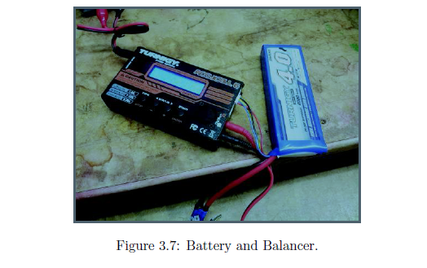

**4.5 Software**

This subsection describes all the software components of our project and how they work. The

GPS and data logging routines, and AI commands will also be mentioned in this section of the

document.

**4.5.1 Arduino IDE**

For our project we will be focusing on programming in the Arduino IDE. The Arduino IDE is

a development environment that uses a simple user interface for adding and editing in the Arduino coding language, which is a based on the C++ programming language. Figure 3.8 shows the Arduino

**IDE.**

**4.5.2 Aeroquad Flight Software & Configurator**

The included Aeroquad software is a combination of two programs, the Aeroquad flight software

and Aeroquad configurator. The Aeroquad flight software can be directly uploaded to an Arduino

board via the Arduino IDE. Aeroquad flight software also included some test programs for the

various sensors. This flight software supports multiple flight configurations.

* **4.5.3 GPS**
* Goals/Objectives
  + Needed for autonomous flight mode
  + The system could establish an external reference to position (latitude and longitude)
  + The system would have a serial output
  + Should be compact, requiring minimal external support (internal antenna)
* Requirements/Specifications:
  + The system would need to be accurate to within 3 meters (latitude and longitude).
  + The update rate should be at least 1Hz.

**5.1.1 Motors and Electronic Speed Controller**

Testing of the motors and ESC was done to verify that each component was working properly.

The ESC needed some assembly, barrel connectors were soldered onto the ends of the ESC. A motor was mounted to an arm of the quadcopter and securely attached the arm to a table edge using a C-clamp. The motor was then wired up according to the block diagram of Figure 4.4.

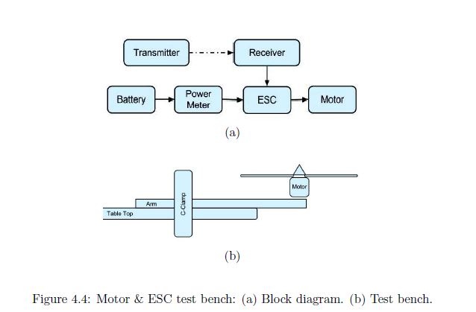

Before starting the test, each ESC was programmed to the same settings and throttle range.

For verification, the voltage, current, and power were measured using a power meter. The measurements .

were made at throttle speeds at 10% increments. This was done three to five times for

each motor and ESC.

**5.2 Flight Test**

In this section of the document we will discuss how our initial flight test went and the problems

we encountered during this flight test.

**5.3 Discussion**

5.3.1 Difficulties

1. There were many safety issues during testing the quadcopter with rotors. The spinning rotors

could spin quick enough to cause serious harm to a person. Before each test with the rotor

attached, our group would have to clear the room and make sure that no one would come

into contact with the rotors of the quadcopter. During testing of the motors, all non-group

members were told to leave the room. The room was locked and testing was done only carefully

starting at minimum throttle. If the quadcopter ran properly for a duration of time,

then we would increase the throttle by 10%. This tedious process was used to ensure safety.

2. There was a problem with the battery connectors being different. We did not notice the difference in connectors at the time of purchase. The JST-HX connectors on the battery did not

match the EC3 connectors on the quadcopter. Fortunately we were able to find the necessary

connectors at a local RC hobby shop and we were able to re-solder the new connectors to the

battery.

3. Setting up the channels of the transmitter and receiver was also very important. The initial

transmitter channel configurations did not match the quadcopter channel configurations. To

solve this problem each channel of the transmitter needed to be tested separately to identify

what it was controlling on the quadcopter and set to the correct corresponding channels.

**6. CONCLUSION:**

Prototype of drone is used for “MILITARY ASSISTANCE”. These drone can be used for simultaneous large attacks on enemy tanks, infantry combat vehicles and trucks, as well can be used for supplying medicines and other equipments

**7. REFRENCES:**

1. A. Josephin Arockia Dhivya, Dr. J. Premkumar, “Quadcopter based technology for an emergency healthcare,” 2017 3rd International Conference on Biosignals, images and instrumentation (ICBSII),16-18 March 2017.
2. International Journal of Pure and Applied Mathematics Volume 119 No. 15 2018, 1813-1818 ISSN: 1314-3395 (on-line version) url: <http://www.acadpubl.eu/hub/>

1. [www.radio-electronics.com](http://www.radio-electronics.com)
2. [www.ni.com](http://www.ni.com)
3. [www.wikipedia.org](http://www.wikipedia.org/)
4. Drone Ambulance Support System, P.Anand1, P.Arjun2, N.Bharath Kumar3, K.Gowtham4 1Assistant Professor ,2, 3, 4Student of R.M.K Engineering College