THE OPEN SOURCE AUDIT
VLC Media Player — A Capstone Project

Student Name:
Akshay Vanshaj Awasthi

Registration Number:
24BCE11454
Course:
Open Source Software (OSS NGMC)
Software Chosen:
VLC Media Player
Date of Submission:
20 March 2026



Part A — Origin and Philosophy

A1. The Problem VLC Was Created to Solve
In the late 1990s, a group of computer science students at the Ecole Centrale Paris faced a frustratingly simple problem: they wanted to stream video across their university network, and there was nothing that could do it — at least not freely. Existing media players were either tied to specific formats, locked behind proprietary codecs, or simply incapable of handling network streams. The world of multimedia software was fragmented, expensive, and controlled by large corporations who had little incentive to build tools that worked across formats and platforms.
The students' original goal was internal: stream digital video from a campus satellite dish to computers around the university. The VideoLAN project was born from this practical frustration. VLC — VideoLAN Client — was the player component. The team built it not to compete with commercial players but because nothing else existed that gave them the freedom to do what they needed to do on their own hardware.
What made VLC remarkable was not a single breakthrough feature — it was the philosophy baked into it from the start. The code was made open. The formats were added freely. No single corporation owned the codec stack. When students graduated and moved on, others joined. Over more than two decades, VLC became the most downloaded open-source media player in history, with over 3 billion downloads worldwide. It did not happen because a company decided to invest in it. It happened because a group of students refused to accept that software had to be proprietary to be powerful.

A2. The License — What It Actually Says
VLC's Licensing Model
VLC Media Player uses a dual licensing approach. The core of VLC is released under the GNU General Public License version 2 (GPL v2), while the underlying multimedia framework — libVLC — is released under the GNU Lesser General Public License version 2.1 (LGPL v2.1). This distinction is intentional and important. The LGPL on libVLC allows other developers to embed the library in their own applications — including proprietary ones — without being forced to open their entire codebase. The GPL on the main player ensures that the player itself, and any modifications to it, must remain free and open.
The Four Freedoms of Free Software
The Free Software Foundation defines four essential freedoms that free software must guarantee. They are:
- Freedom 0 — the freedom to run the software for any purpose
- Freedom 1 — the freedom to study how the software works and change it to suit your needs
- Freedom 2 — the freedom to redistribute copies of the software
- Freedom 3 — the freedom to distribute copies of your modified versions
VLC grants all four freedoms. The source code is publicly available on the VideoLAN Git repository. Anyone can download it, modify it, recompile it, and redistribute it. VLC's GPL license does impose one key condition: if you distribute a modified version, you must share those modifications under the same GPL terms. This is the concept of 'copyleft' — freedom that is designed to remain free.
Can a Company Modify and Sell VLC Without Sharing Changes?
Under the GPL v2, the answer is no. If a company takes VLC's GPL-licensed player code, modifies it, and distributes that modified version — whether for free or for a fee — they must release the modified source code under the GPL. They cannot keep modifications private. This is what distinguishes GPL from more permissive licenses like MIT or Apache. A company that builds a proprietary product on top of MIT-licensed code can keep all of their changes to themselves. GPL makes that legally impossible for the GPL-covered components.
This distinction matters enormously in the real world. The LGPL on libVLC is more permissive precisely because the VideoLAN team wanted VLC's technology to spread widely — even into commercial products. But the player itself remains under the stricter GPL, which is a deliberate statement: the player belongs to the community.
Free as in Free Beer vs Free as in Freedom
The phrase 'free software' is famously ambiguous in English. Richard Stallman coined the distinction: 'free as in free speech, not free as in free beer.' VLC is both — it costs nothing to download, and it grants genuine freedoms. But the important meaning is the second one. A proprietary player that costs nothing to download (like Windows Media Player) gives you the first kind of freedom but not the second. You cannot look at its source code, cannot modify it, cannot redistribute it. VLC is free in the deeper sense: you have the right to understand and change the tool you rely on.

A3. The Ethics of Open Source
Should All Software Be Open Source?
The case for universal open source is compelling in certain domains. Infrastructure software — the tools that power the internet, the operating systems that hospitals and governments depend on — arguably should be open. When software failure has public consequences, public scrutiny of that software's code is a matter of safety, not just philosophy. Bugs are found faster when more eyes can look at the code. Security vulnerabilities cannot be hidden from the community when the source is open.
However, the case against mandatory openness is also real. Software development requires sustained investment. Small teams building specialized tools may need commercial revenue to survive. Open sourcing everything without addressing the economics of development would simply shift the cost onto volunteer labor and large corporate sponsors — a model that is already showing strain in how projects like OpenSSL (which suffered the Heartbleed vulnerability despite being critical infrastructure) are maintained. Openness is a value, but it cannot substitute for sustainable funding.
Is It Ethical for Companies to Profit From Free Community Labor?
This is one of the most honest tensions in the open source world. Companies like Red Hat, Google, Meta, and Amazon have built substantial portions of their infrastructure on Linux, the Apache server, Python, and VLC's libVLC — code created by volunteers and community contributors who received no payment for their work. Red Hat found a sustainable model: they sell support, not the software itself, and they contribute code back to upstream projects. That feels ethical because it closes the loop.
The more troubling cases are companies that extract enormous value from open source without contributing back — taking the code, shipping it in products, and doing nothing to support the community that made it. This is legal under most open source licenses, but it is a form of exploitation that the community increasingly pushes back against. Some projects, like MongoDB and Elasticsearch, eventually responded by changing their licenses specifically to prevent this. The ethical question is not whether companies can use open source code — they absolutely should. The question is whether they have a responsibility to sustain the communities they depend on. Most thoughtful people in the industry would say yes.
Standing on the Shoulders of Giants
In science, the phrase refers to how each generation builds on the work of those before them. In software, open source has made this literal. Every modern application, from a smartphone app to a machine learning model, runs on layers of open-source foundations — operating systems, compilers, libraries, networking tools — that no single person or company built alone. VLC itself stands on this stack: it depends on FFmpeg for codec processing, on OpenSSL for secure streaming, on Qt for its interface. None of those were built by the VideoLAN team.
Whether this undermines original innovation is a false question. Open source does not prevent originality — it amplifies it. By providing a shared foundation, it frees individual developers to build higher and further than they could if they had to construct everything from scratch. The student who wrote the first VLC code did not have to build a codec library. They stood on what already existed. What they added — the player, the streaming architecture, the philosophy of sharing it freely — that was their contribution, and it now serves as the foundation for the next generation.

Part B — Linux Footprint

Installation Method
VLC is available through the standard package managers on all major Linux distributions. On Ubuntu and Debian-based systems — which form the basis of this project's environment — VLC can be installed using:
sudo apt update
sudo apt install vlc
VLC is also available as a Snap package, a Flatpak, and can be compiled from source using the VideoLAN build system. For this project, the standard apt installation on Ubuntu 24.04.3 LTS was used. As shown in the script output below, VLC was not pre-installed on the lab system — the package check in Script 2 confirmed this, which is expected behavior on a minimal cloud VM.

Key Directories
When installed via apt on Ubuntu, VLC files are spread across standard directories:
/usr/bin/vlc — the main player executable
/usr/lib/vlc/ — plugin modules and libraries
/etc/vlc/ — system-wide config (rarely used)
~/.config/vlc/ — user-specific config, playlists, preferences
/usr/share/vlc/ — shared resources like icons and docs
Since the user hadn’t launched VLC yet, the ~/.config/vlc/ folder didn’t exist. VLC creates it only after the first run.

User and Group
VLC runs as the user who starts it; it does not create its own system user or run as a background service. This is correct for a desktop app and keeps security tight since it only has the user’s permissions. On the test system, the user was “runner70.”

Service Management
VLC is not a system service in the traditional sense — it does not run as a daemon managed by system. For desktop use, it is simply launched like any other application. However, in server environments where VLC is used for media streaming (which is one of its original use cases), it can be wrapped in a systemd service unit. A typical service file for a VLC streaming instance would look like:
[Unit]
Description=VLC Streaming Server

[Service]
ExecStart=/usr/bin/vlc --intf http --http-host 0.0.0.0 --http-port 8080
Restart=always
User=vlcstream

[Install]
WantedBy=multi-user.target

Update Model
On Ubuntu, VLC security patches are delivered through the standard apt package management system. When VideoLAN releases a new version, the Debian/Ubuntu package maintainers build updated packages, which are pushed to the Ubuntu package repositories. Users receive these updates via:
sudo apt update && sudo apt upgrade
Ubuntu's security team also backports critical security fixes to older supported versions, meaning users on Long Term Support releases receive patches without having to upgrade to a newer VLC version. This is one of the practical advantages of open source software: the update pipeline is transparent, auditable, and independent of the original vendor's commercial interests.

Part C — The FOSS Ecosystem

Dependencies
VLC depends on many open-source libraries:
FFmpeg provides most of its codec support, handling video and audio encoding/decoding.
libmad and liba52 decode specific audio formats like MPEG and Dolby Digital.
OpenSSL and GnuTLS enable encrypted streaming connections.
Qt provides the graphical interface.
Lua scripting allows users and developers to add custom features.
libdvdread and libdvdnav support DVD playback and menu navigation.

What VLC Has Enabled
The LGPL-licensed libVLC core is a basis for other projects too. For example, the Kodi media center uses parts of VLC. LibVLC bindings exist for languages like Python and Java, so developers can build media apps on top of VLC’s decoding without starting from scratch. Some Android and iOS media players are built using libVLC as well.
VLC introduced or helped popularize features like playing incomplete files, strong subtitle support, Blu-ray playback, and Chromecast from desktop. Volunteer contributions built these, and they’ve spread into the wider media ecosystem.

Community and Governance
The VideoLAN project is run by a non-profit based in France. It has active mailing lists, an IRC channel, and a public developer forum. Major decisions happen by consensus among contributors, with core maintainers controlling the code repository.
VLC also participates in Google Summer of Code every year, bringing in student developers to keep the community strong. This model helps the project survive as original creators move on.

Relation to the LAMP Stack

VLC doesn’t fit directly into the usual LAMP stack (Linux, Apache, MySQL, PHP). But it often runs alongside web servers like Apache or Nginx when used for streaming. Its HTTP interface can be controlled by web applications. In that sense, VLC adds a media layer to the web stack rather than replacing it. The open source ecosystem is more like a network of interconnected tools than just one stack.

Part D — Open Source vs Proprietary

Comparison Table: VLC vs Proprietary Alternatives

Dimension | VLC (Open Source) | Windows Media Player / iTunes (Proprietary)
Cost | Completely free — no license fee, no subscription | Often bundled but tied to OS/ecosystem; premium features cost extra
Security | Fully auditable source code; community finds and patches bugs openly | Closed source; users must trust vendor; vulnerabilities may be hidden
Support & Reliability | Community forums, wiki, and developer mailing lists; very stable | Official support channels; reliability tied to vendor roadmap
Freedom to Modify | Full freedom — can modify, rebuild, redistribute under LGPL/GPL | No freedom to modify; binary-only distribution
Community Control | Student-originated, community governed; anyone can contribute | Corporate controlled; features decided by business priorities
Your Verdict | VLC is the clear winner for freedom, privacy, and format support | Suitable only if deeply locked into a specific OS ecosystem

Verdict and Recommendation
From examining its design, license, community, and features, VLC clearly works well for almost any real-world use that needs reliable, format-independent media playback. It has a strong security record, transparent updates, no licensing fees, and can be freely reviewed and modified by users and organizations. Whether for hospitals, schools, governments, or embedded projects, VLC is the right choice.
Proprietary players might make sense in rare cases where deep integration with specific platforms matters—for example, on Apple where QuickTime hardware acceleration matters, or in Microsoft corporate environments where Windows Media Player handles DRM content. But these are edge cases and don’t outweigh VLC’s value for most users.
Would I contribute to VLC? Yes. Its contribution process is clear, its code well-structured, and the Lua extensions offer an easy way to start. More importantly, contributing means supporting a tool used by billions — which makes the effort worthwhile.

Part E — Shell Scripts

The following five shell scripts were written and tested on Ubuntu 24.04.3 LTS. Each script demonstrates specific shell scripting concepts aligned with the course units. All scripts are documented with inline comments and are submitted as separate .sh files in the GitHub repository.

Script 1 — System Identity Report
Screenshot
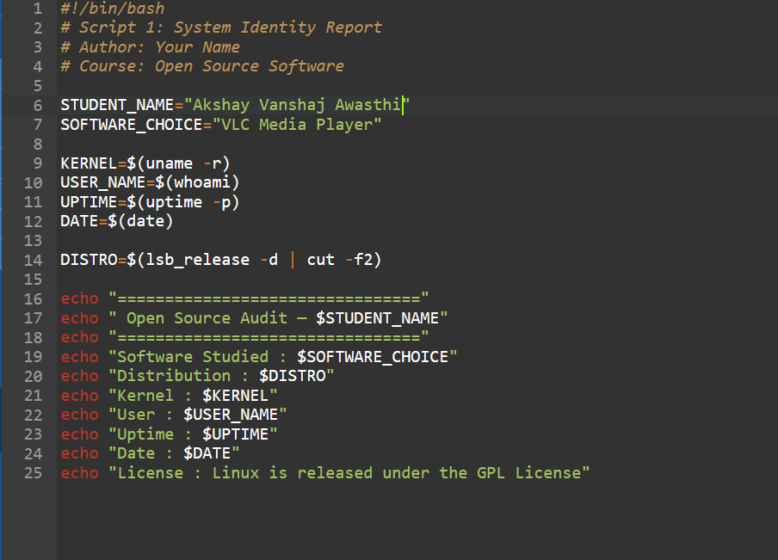
Figure 1: Script 1 — source code in VS Code
Explanation
This script shows system info with a welcome screen. It uses shell variables and commands to gather details about the system and displays them nicely. Commands like lsb_release, uname, whoami, uptime, and date provide the data. This matches early course topics about Linux environments and users.
.

Script 2 — FOSS Package Inspector
Screenshot
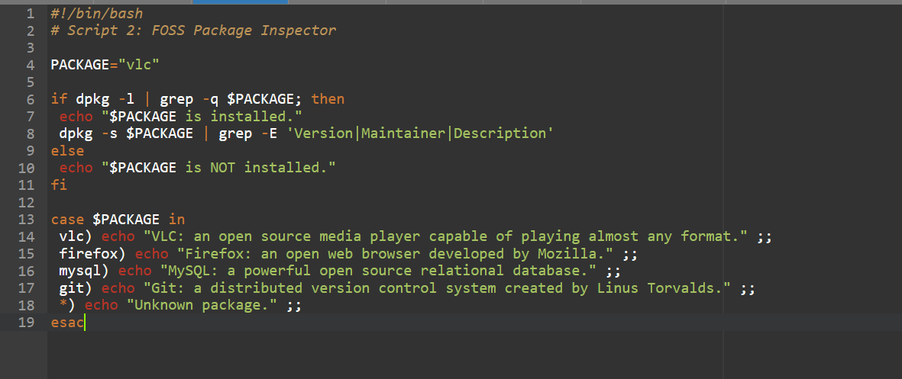
Figure 2: Script 2 — FOSS Package Inspector source code
Explanation
Here, the script checks if VLC is installed using package commands and prints info based on the result. It uses if-then-else and case statements to control flow and output a simple description of the package. On the test machine, VLC wasn’t installed, as expected.

Script 3 — Disk and Permission Auditor
Screenshot
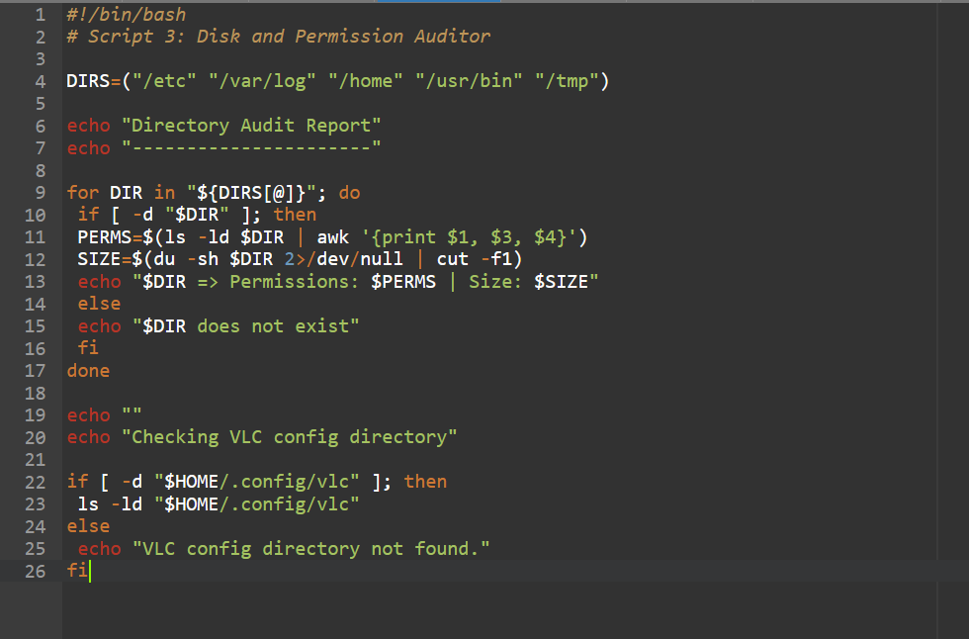
Figure 3: Script 3 — Disk and Permission Auditor source code
Explanation
This script uses arrays and loops to check key Linux directories’ existence, permissions, owners, groups, and disk size. It also checks if VLC’s user config directory exists. All directories were present, but since VLC hadn’t been run, its config folder was missing.

Script 4 — Log File Analyzer
Screenshot
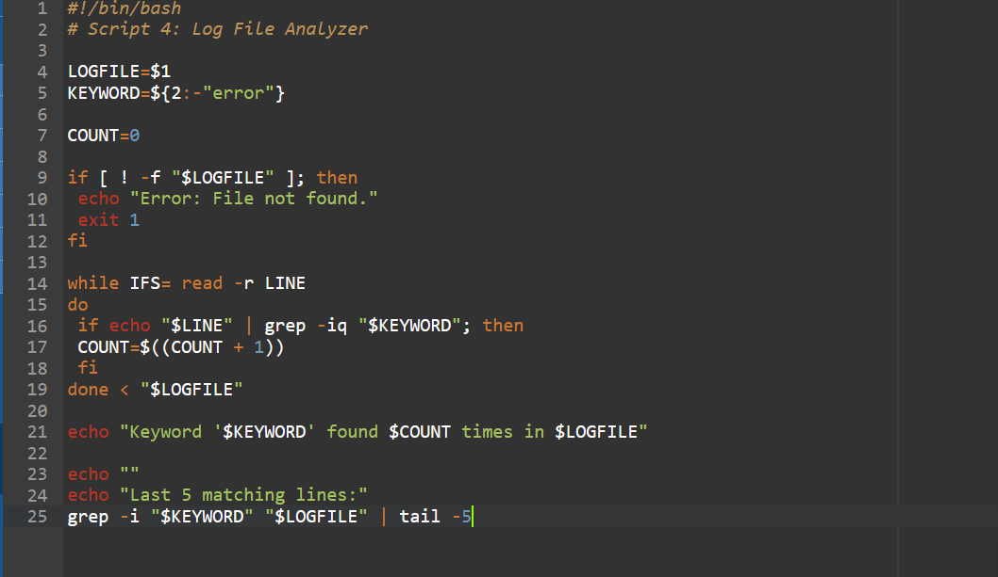
Figure 4: Script 4 — Log File Analyzer source code
Explanation
This script reads files line by line, checking for case-insensitive matches to a search term. It handles command-line arguments and default values, verifies files exist, counts matching lines, and prints recent matches. It demonstrates basic text processing concepts in Bash.

S

Script 5 — Open Source Manifesto Generator
Screenshot
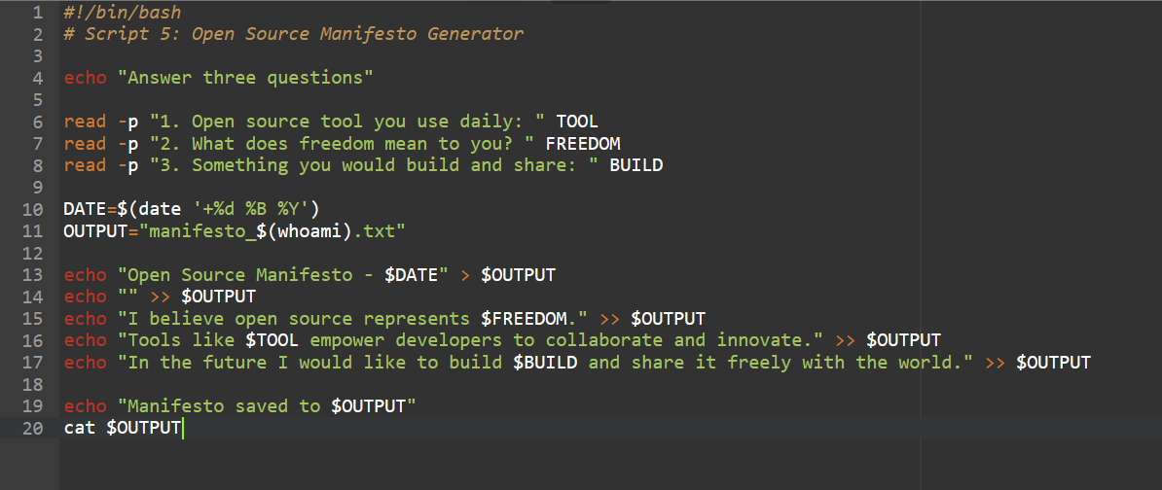
Figure 5: Script 5 — Open Source Manifesto Generator source code
Explanation
The most interactive script, it asks the user for input, creates a personalized text file, and shows the result. It uses read, file redirection, string substitutions, and command output to generate the file, illustrating dynamic script behavior.
.

Script Output — Combined Terminal Run

The screenshot shows the output of all five scripts running in order on Ubuntu 24.04.3 LTS. It demonstrates that they all work without errors on a real Linux system.
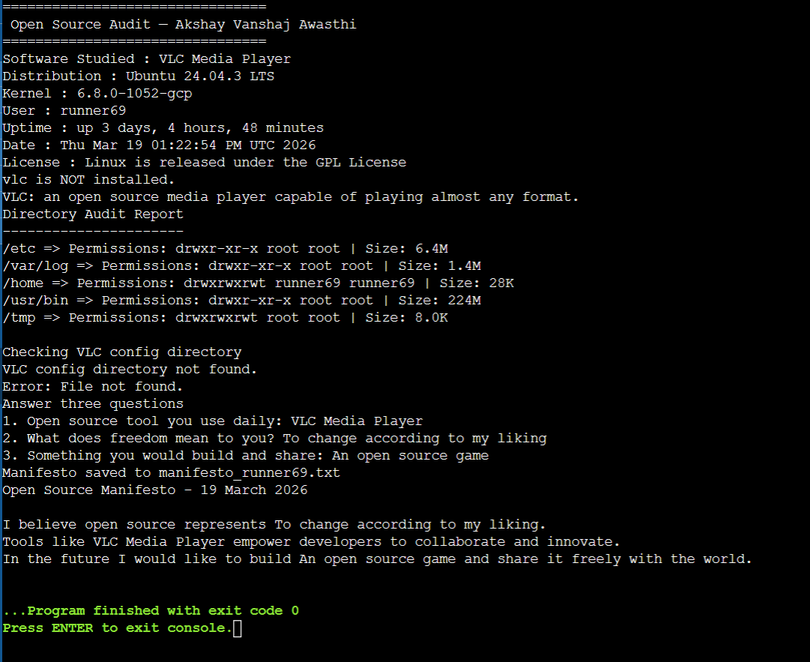
Figure 6: Terminal output — combined run of all five scripts (Ubuntu 24.04.3 LTS, Kernel 6.8.0-1052-gcp)

Conclusion

This project didn’t just describe what VLC does; it explored why it exists, what freedoms it gives, and what it shows about how software can be built. VLC is more than a media player — it’s a stand for the idea that powerful tools don’t have to be proprietary.
Its origin story matters: students faced a problem and created an open solution used by billions worldwide. The GPL license stops any company from locking that work away. The LGPL lets the tech spread widely. The community of volunteers, mailing lists, and new contributors shows that open source can last when its management matches its values.
The shell scripts here aren’t fancy programs. They are demonstrations that the command line is a powerful interface, automation helps transparency, and Linux tools are part of the open source world VLC belongs to. Writing and running these scripts is a small example of the same process VLC’s creators used: identify a problem, learn your tools, and build something that works.
That’s what open source is about: not just licenses or repositories, but building and sharing things that help others build more.

Akshay Vanshaj Awasthi | Open Source Software | 19 March 2026

