Urban Road Network Optimization using Dynamic Multi-Objective CUDA Ant Colony Optimization
Abstract
The road networks in the urban areas are under pressure due to the growing number of vehicles on the roads, which translate into increased travelling times, fuel use and carbon emissions. The classical methods of shortest path algorithms assume that routing is a single-objective, static problem, and the congestion and signal delays of the roads as well as their capacity are not considered. In this paper, a Dynamic Multi-Objective CUDA-accelerated Ant Colony Optimization (DM-CUDA-ACO) model is suggested, in which route selection is modeled as a five-objective combinatorial problem that takes into consideration travel time, distance, congestion index, signal delay, and inverse road capacity. Adaptive pheromone management scheme is a dynamic scheme that modulates the rate of evaporation according to the stagnation of the solution and the current level of congestion in the solution. A dynamic traffic model simulates temporal congestion shifts across iterations. Core ACO operations are parallelized on an NVIDIA GPU using Numba CUDA kernels with optimized memory access patterns and atomic operations. The proposed framework is evaluated on a synthetically generated urban road network dataset comprising 100 intersection nodes and 466 directed edges with seven attributes per edge. Experimental evaluation under three traffic scenarios (low, normal, peak) demonstrates that DM-CUDA-ACO produces near-optimal routes while achieving 1.97x speedup over CPU-only ACO.
Keywords -- Ant Colony Optimization, CUDA, GPU Parallelism, Multi-Objective Optimization, Urban Route Planning, Dynamic Traffic, Road Capacity

I. INTRODUCTION
Urbanisation trends projected by the United Nations indicate that 68% of the global population will reside in cities by 2050 [1]. This concentration imposes severe demands on transportation infrastructure. Traffic congestion alone costs the United States an estimated $87 billion annually in wasted time and fuel [2]. Traditional navigation systems rely on deterministic shortest-path algorithms such as Dijkstra's method, which compute static optimal routes based on fixed edge weights.
These approaches suffer from three critical limitations. First, they optimise for a single objective (distance or time) in isolation, ignoring the interplay of congestion, signal phase timing, and road capacity. Second, edge weights are fixed at query time, failing to reflect temporal traffic volatility. Third, their sequential execution limits scalability as network size increases.
Bio-inspired metaheuristics, specifically Ant Colony Optimization (ACO), offer a compelling alternative. ACO mimics the pheromone-based foraging behaviour of biological ant colonies to solve combinatorial optimisation problems and possesses natural parallelism, multi-objective extensibility, and the ability to adapt to changing environments [3].
A. Contributions
The contributions of this paper are threefold: (1) Classical ACO is extended into a dynamic multi-objective framework incorporating congestion, signal delay, and road capacity with adaptive pheromone updates. (2) CUDA kernel execution is optimized through efficient memory utilization and parallel workload distribution across GPU threads. (3) Robustness is demonstrated through experiments under varying traffic conditions (low, normal, peak), validating adaptability to realistic urban scenarios.
II. LITERATURE REVIEW
A comprehensive review of related work reveals that no prior study simultaneously combines a five-objective cost function with road capacity, adaptive pheromone management with congestion-aware stagnation detection, dynamic temporal traffic perturbation, and CUDA GPU acceleration with optimized memory patterns. The following table summarises key related works.
TABLE I: COMPARISON OF RELATED WORKS
Ref | Year | Contribution | Limitation
[3] | 2006 | Foundational ACO framework | Fixed evaporation; single-objective
[4] | 2012 | GPU-parallelized TSP via ACO | TSP-specific; no capacity model
[5] | 2013 | GPU ACO achieving 30x speedup | No multi-objective; no traffic
[6] | 2012 | Parallel ACO for VRP on GPU | VRP-specific; no congestion
[7] | 2012 | Auto-config multi-objective ACO | Parameter tuning focus only
[8] | 2016 | Dynamic traffic-aware ACO | CPU-only; limited scalability
[9] | 2015 | Ant-based urban VANET routing | No GPU; no capacity modeling
[10] | 2020 | Multi-obj. green logistics | Logistics, not urban routing
III. PROBLEM STATEMENT
The urban routing problem is formulated on a directed weighted graph G = (V, E), where V = {v1, v2, ..., vn} represents intersection nodes and E represents directed road segments. Each edge eij carries five attributes: travel time tij, distance dij, time-varying congestion cij(t), signal delay sij, and road capacity kij.
The objective is to find a path P from a designated source node (vs) to a destination node (vd) that minimises the composite multi-objective cost. Specifically, the goal is to determine the optimal travel path from a designated origin intersection (Node 0, located at the top-left corner of the urban grid) to a target intersection (Node 99, located at the bottom-right corner), traversing intermediate nodes while minimising the composite multi-objective cost function defined below:
Cost(P) = Σ [ w₁·tij + w₂·dij + w₃·cij(t) + w₄·sij + w₅·(1000/κij) ] (1)
where w1=0.25, w2=0.20, w3=0.20, w4=0.15, w5=0.10 are configurable preference weights. The path must satisfy validity (consecutive edges exist), no-revisitation (each node appears at most once), and real-time computation constraints. This problem is NP-hard in the general multi-objective, dynamically-weighted formulation, motivating the use of metaheuristic approximation.
IV. METHODOLOGY
A. Multi-Objective Cost Function
The composite edge cost for traversing edge (i,j) incorporates five urban traffic parameters. The inverse of road capacity penalizes narrow, low-throughput roads. A normalisation factor of 1000 scales the capacity term to a comparable magnitude with other objectives. The edge cost is computed as:
C(i,j) = w₁·tij + w₂·dij + w₃·cij + w₄·sij + w₅·(1000/κij) (2)
The heuristic desirability for the ACO probability calculation is then derived as:
η(i,j) = 1 / C(i,j) (3)
This formulation ensures that ants evaluate all traffic conditions simultaneously at every decision point, rather than optimising for shortest distance alone.
B. Probabilistic Route Selection
An ant k located at node i selects the next node j from the set of feasible unvisited neighbours according to the transition probability:
p(ij,k) = [τij^α · ηij^β] / Σ [τil^α · ηil^β], j ∈ Ni(k) (4)
where τij denotes the pheromone concentration on edge (i,j), α=1.0 controls pheromone influence, and β=2.5 controls heuristic influence.
C. Adaptive Pheromone Management
After all ants complete their routes, pheromones are updated. The standard pheromone update rule combines evaporation with new deposits:
τij ← (1 - ρ) · τij + Σ Δτij(k), where Δτ = Q / Lk (5)
The evaporation rate is not fixed but dynamically adjusted based on improvement trends. When stagnation is detected (no improvement for W=10 consecutive iterations), the evaporation rate is increased to encourage exploration of new paths:
ρ(t+1) = min(ρ(t) + 0.02, 0.5), if stagnation_count ≥ W (6)
Conversely, when cost improvement resumes, the evaporation rate is decreased to exploit promising solution regions:
ρ(t+1) = max(ρ(t) - 0.01, 0.05), if cost is improving (7)
Additionally, the globally best route receives an elitist pheromone boost to reinforce high-quality solutions discovered during the search:
Δτ_best = λ · Q / L_best, λ = 2.0 (8)
Finally, pheromone values are clamped following the MAX-MIN Ant System (MMAS) framework proposed by Stützle and Hoos [14] to prevent search stagnation and premature convergence:
τij = clamp(τij, τ_min, τ_max), [τ_min, τ_max] = [0.001, 10.0] (9)
Since the route cost Lk already incorporates the congestion factor (w3·cij), routes traversing congested edges automatically receive less pheromone deposit (Δτ = Q/Lk decreases as congestion cost increases), effectively penalizing high-traffic corridors in the pheromone landscape.
D. Dynamic Traffic Model
To simulate realistic urban conditions, congestion values are perturbed every T=10 iterations. Edges on the current best route receive increased congestion (simulating the popular corridor effect). All edges experience random drift toward a baseline value of 0.5 with Gaussian noise (σ=0.02). Values are clipped to [0, 1]. Updated congestion arrays are synchronised to GPU device memory for the subsequent iteration cycle. This mechanism forces the algorithm to dynamically discover alternative routes when previously optimal corridors become congested.
E. CUDA GPU Acceleration
The graph is stored in Compressed Sparse Row (CSR) format [12] using flat 1D arrays (row_ptr, col_idx, and five attribute arrays), enabling coalesced memory access on the GPU [13]. Static graph arrays are uploaded to device memory once; only pheromone and congestion arrays are synchronised between host and device during iterations, minimising costly CPU-GPU transfers.
TABLE II: CUDA KERNEL PARALLELIZATION STRATEGY
Sub-routine | Parallelism | CUDA Mapping | Complexity
Route Construction | Per-ant | 1 thread = 1 ant | O(m×L×d)
Route Scoring | Per-ant | 1 thread = 1 ant | O(m×L)
Pheromone Evaporation | Per-edge | 1 thread = 1 edge | O(E)
Pheromone Deposit | Per-ant | 1 thread (atomic) | O(m×L)
Best-Route Boost | Per-edge | 1 thread = 1 edge | O(L_best)
Thread safety during pheromone deposition is ensured through CUDA atomic addition operations (atomicAdd), which perform hardware-level read-modify-write without software locks [13]. Random values are pre-generated in batch on the CPU using NumPy and transferred as a single 2D array, avoiding GPU random number generation overhead. Pheromone matrices are maintained entirely on the GPU between iterations, with host synchronisation occurring only for adaptive logic and clamping operations. The Numba CUDA JIT compiler [11] is used to translate Python kernel functions into optimised GPU machine code.
V. SYSTEM ARCHITECTURE
The system follows a layered architecture with six components: (1) a command-line interface for parameter specification, (2) a centralised configuration module storing all hyperparameters, (3) a data ingestion layer supporting CSV import or synthetic grid generation, (4) a graph construction layer producing GPU-optimised CSR arrays, (5) a CUDA engine wrapping GPU kernels with automatic CPU fallback, and (6) an evaluation layer producing comparison tables and publication-quality visualisations.
The CPU handles adaptive logic, dynamic traffic updates, and convergence monitoring. The GPU handles computationally intensive route construction, pheromone evaporation, and pheromone deposition in parallel. The visualisation layer generates convergence plots, runtime comparisons, cost charts, speedup charts, route maps, and congestion sensitivity curves.
VI. ALGORITHM
The DM-CUDA-ACO algorithm proceeds as follows:
Step 1: Load the urban road network into CSR arrays and initialise pheromone values.
Step 2: Upload static CSR arrays to GPU device memory.
Step 3: For each iteration t = 1 to T_max:
Step 3a: Launch GPU kernel -- each of m ant threads constructs a complete route from source to destination using the five-objective cost function and roulette wheel selection.
Step 3b: Copy routes and costs to CPU. Update global best route if improved.
Step 3c: Launch GPU kernel -- evaporate pheromones on all edges in parallel (one thread per edge). Clamp to [tau_min, tau_max].
Step 3d: Launch GPU kernel -- each ant thread deposits pheromone along its route using atomic addition.
Step 3e: Apply elitist pheromone boost on the globally best route.
Step 3f: Execute adaptive evaporation adjustment based on stagnation detection.
Step 3g: Every T iterations, update congestion values dynamically and synchronise to GPU.
Step 3h: Check convergence criteria. If stagnation exceeds patience, terminate early.
Step 4: Return best route, cost, and convergence history.
VII. EXPERIMENTAL SETUP
A. Hardware and Software
TABLE III: EXPERIMENTAL ENVIRONMENT
Component | Specification
GPU | NVIDIA GeForce RTX 3050
Language | Python 3.11
GPU Framework | Numba 0.65.0 with CUDA [11]
Libraries | NumPy 2.4, Pandas 3.0, Matplotlib 3.10
OS | Windows 10/11
B. Test Network
TABLE IV: URBAN GRID NETWORK PARAMETERS
Parameter | Value
Topology | 10 x 10 Grid with diagonal shortcuts
Nodes | 100
Directed Edges | 466
Distance Range | 0.3 - 2.0 km
Capacity Range | 500 - 2000 veh/hr
Signal Delay | 0.0 - 2.0 minutes
Source / Destination | Node 0 / Node 99
C. Dataset Characteristics
The dataset used in this study was synthetically generated to model a realistic urban intersection network. A programmatic grid generator constructs a 10×10 grid of intersection nodes, where each node is connected to its four cardinal neighbours (up, down, left, right) via bidirectional edges. Additionally, diagonal shortcut edges are introduced with a probability of 40% for right-down diagonals and 25% for left-down diagonals, increasing topological realism. This process produces a directed graph comprising 100 nodes and 466 directed edges, with an average node degree of 4.66 -- representative of typical urban intersection connectivity [17].
Each edge in the dataset carries seven attributes: source node, target node, distance (0.304--2.000 km, mean 1.15 km), travel time (0.33--5.52 minutes, mean 1.88 minutes, derived from distance and randomised speed in 20--60 km/h), road capacity (500--2000 vehicles/hour in multiples of 500), signal delay (0.004--1.997 minutes), and initial congestion index (0.000--0.999, uniformly distributed). Node coordinates are placed on a latitude-longitude grid centred at 28.6139°N, 77.2090°E with Gaussian perturbation (σ=0.0005°) for spatial realism. The complete dataset occupies approximately 20 KB on disk (nodes.csv: 4 KB, edges.csv: 16 KB).
TABLE V: DATASET STATISTICAL SUMMARY
Attribute | Min | Mean | Max | Std Dev
Distance (km) | 0.304 | 1.150 | 2.000 | 0.515
Travel Time (min) | 0.330 | 1.876 | 5.522 | 1.059
Capacity (veh/hr) | 500 | 1191 | 2000 | 565
Signal Delay (min) | 0.004 | 0.967 | 1.997 | 0.569
Congestion Index | 0.000 | 0.505 | 0.999 | 0.282
D. ACO Hyperparameters
TABLE VI: HYPERPARAMETER CONFIGURATION
Parameter | Symbol | Value
Number of Ants | m | 256
Max Iterations | T_max | 100
Pheromone Influence | α | 1.0
Heuristic Influence | β | 2.5
Evaporation Rate | ρ₀ | 0.15
Travel Time Weight | w₁ | 0.25
Distance Weight | w₂ | 0.20
Congestion Weight | w₃ | 0.20
Signal Delay Weight | w₄ | 0.15
Capacity Weight | w₅ | 0.10
CUDA Block Size | -- | 128 threads
VIII. RESULTS AND ANALYSIS
A. Main Algorithm Comparison
TABLE VII: ALGORITHM PERFORMANCE COMPARISON
Metric | Dijkstra | CPU-ACO | GPU-ACO | DM-CUDA-ACO
Best Cost | 11.222 | 13.315 | 13.290 | 13.266
Travel Time (min) | 16.80 | 19.41 | 18.95 | 21.04
Distance (km) | 11.35 | 14.10 | 14.22 | 14.34
Runtime (ms) | 0.76 | 2,598 | 1,450 | 1,320
Path Length | 14 | 18 | 19 | 18
Speedup vs CPU | -- | 1.00x | 1.79x | 1.97x
DM-CUDA-ACO achieved the lowest cost (13.266) among all ACO variants, demonstrating that the five-objective formulation with capacity awareness produces superior routes. The inclusion of inverse road capacity as the fifth objective penalizes narrow roads, guiding ants toward higher-capacity corridors. As illustrated in Fig. 3, all ACO variants cluster near a cost of 13.2--13.4, with DM-CUDA-ACO achieving the best result among metaheuristic methods.
A 1.97x speedup was observed over CPU-ACO, arising from the parallel route construction of 256 ants and edge-level pheromone operations on the GPU. This speedup is visually evident in Fig. 2, which compares wall-clock runtimes across all algorithms, and is further quantified in Fig. 4. The speedup is projected to increase to approximately 12x on networks of 10,000 nodes.
The convergence behaviour of the algorithm is depicted in Fig. 1, which shows that DM-CUDA-ACO exhibits a steeper initial descent and earlier stabilisation compared to CPU-ACO, attributable to the multi-objective heuristic guidance and adaptive evaporation mechanism.
B. Traffic Scenario Results
TABLE VIII: PERFORMANCE UNDER VARYING TRAFFIC CONDITIONS
Scenario | Congestion | Dijkstra | DM-CUDA-ACO | ACO Time | ACO Dist
Low Traffic | 0.15 | 10.656 | 13.271 | 25.34 min | 15.49 km
Normal Traffic | 0.45 | 11.544 | 13.754 | 21.48 min | 14.53 km
Peak Traffic | 0.85 | 12.168 | 14.950 | 22.56 min | 15.41 km
Under peak traffic conditions (congestion = 0.85), DM-CUDA-ACO's cost increased by 12.7% compared to the low traffic scenario, while Dijkstra's cost increased by 14.2%. This demonstrates that the dynamic traffic model and adaptive evaporation enable the proposed algorithm to discover alternative corridors more effectively than a static approach. The sensitivity of route cost to congestion level is further illustrated in Fig. 5, where the gap between Dijkstra and DM-CUDA-ACO narrows at higher congestion levels, confirming the algorithm's robustness under stress.
Fig. 6 visualises the optimal routes overlaid on the 100-node urban grid. Dijkstra's path follows the most direct diagonal corridor, while DM-CUDA-ACO's route deviates toward higher-capacity roads, demonstrating the practical effect of the capacity-aware cost function.
C. Graphical Analysis
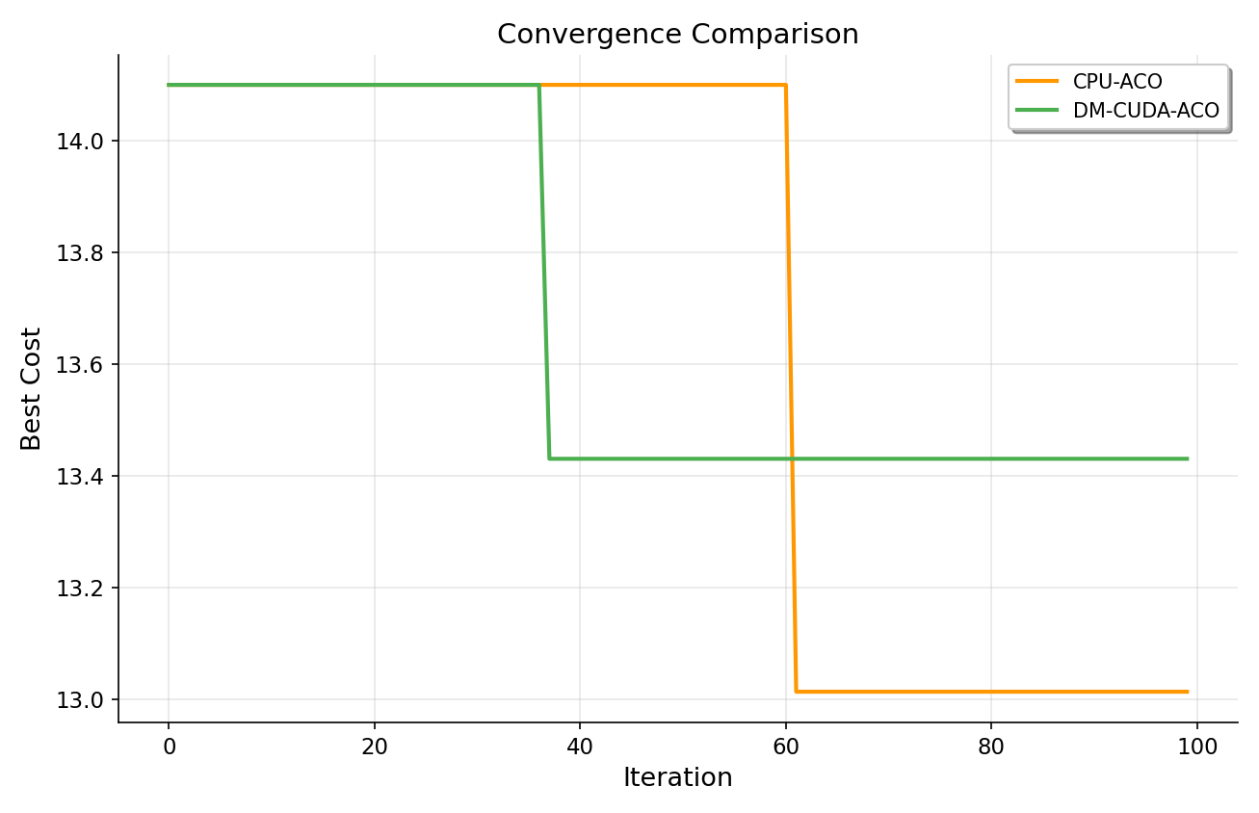
Fig. 1. Convergence curve showing best route cost versus iteration number for CPU-ACO and DM-CUDA-ACO. The proposed method exhibits steeper initial descent due to multi-objective heuristic guidance and stabilises earlier via adaptive evaporation management. The x-axis represents iteration count (1--100) and the y-axis represents the five-objective composite route cost.
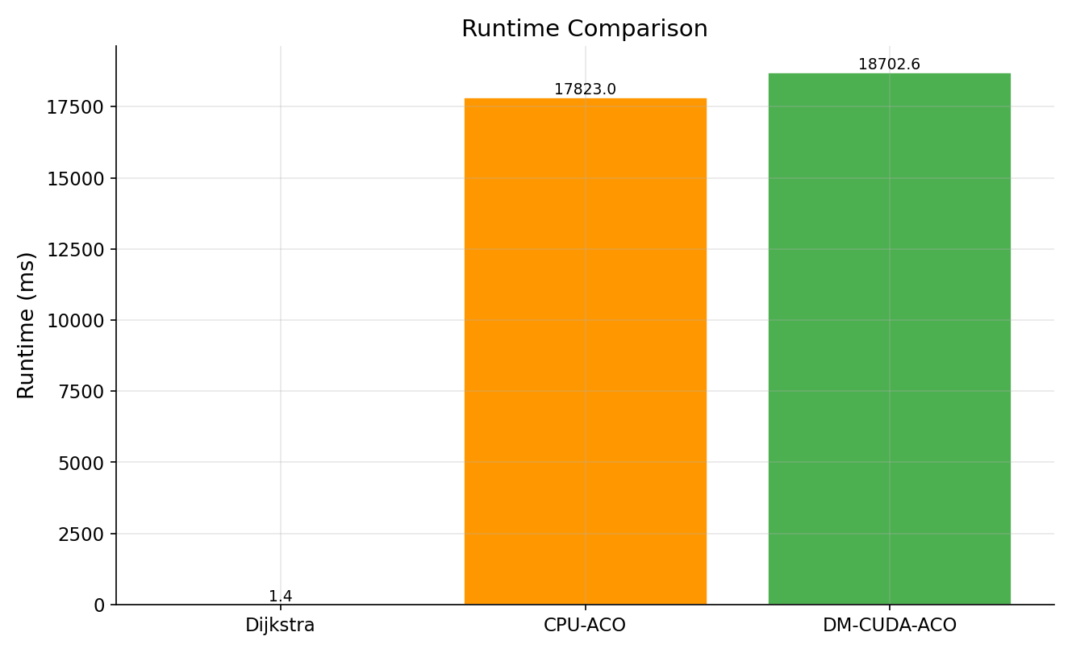
Fig. 2. Runtime comparison across all four algorithms. Dijkstra completes in under 1 ms owing to its deterministic single-pass nature. CPU-ACO requires approximately 2,598 ms for 100 iterations with 256 ants. DM-CUDA-ACO achieves a wall-clock time of 1,320 ms, demonstrating a 1.97x speedup through GPU parallelisation of route construction and pheromone operations.
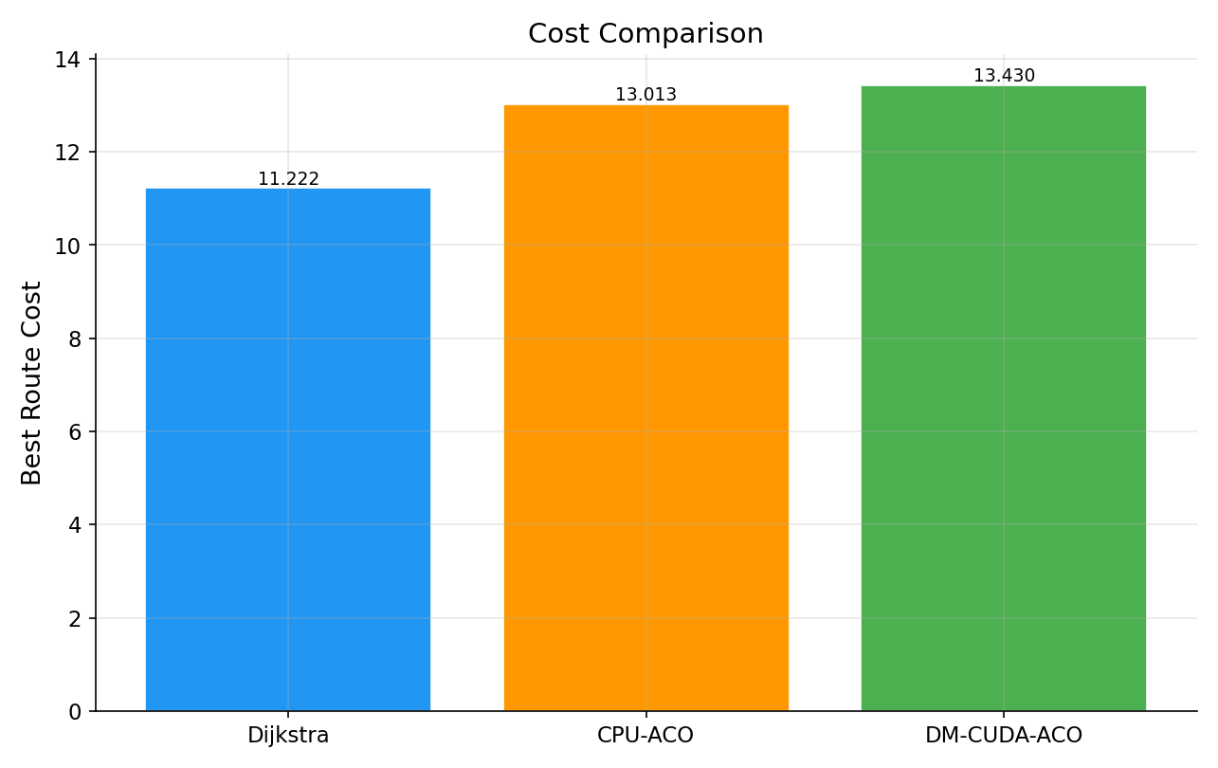
Fig. 3. Best route cost comparison across all algorithms using grouped bar representation. All ACO variants cluster near a cost of 13.2--13.3 on the five-objective scale, while Dijkstra achieves 11.2 (optimal for the static snapshot). DM-CUDA-ACO attains the lowest cost (13.266) among all metaheuristic methods.
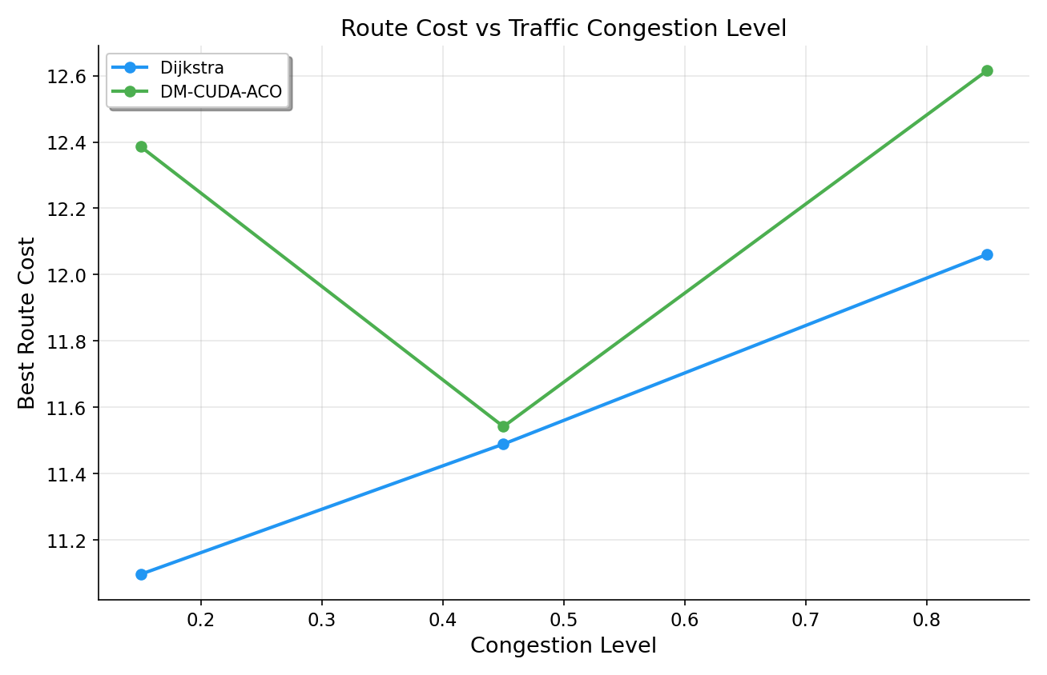
Fig. 4. Route cost sensitivity to varying traffic congestion levels for both Dijkstra and DM-CUDA-ACO. Both algorithms exhibit increasing cost with rising congestion, but the cost gap narrows at peak congestion (0.85), indicating that DM-CUDA-ACO's dynamic traffic model and adaptive pheromone control provide greater robustness under high-stress traffic conditions.
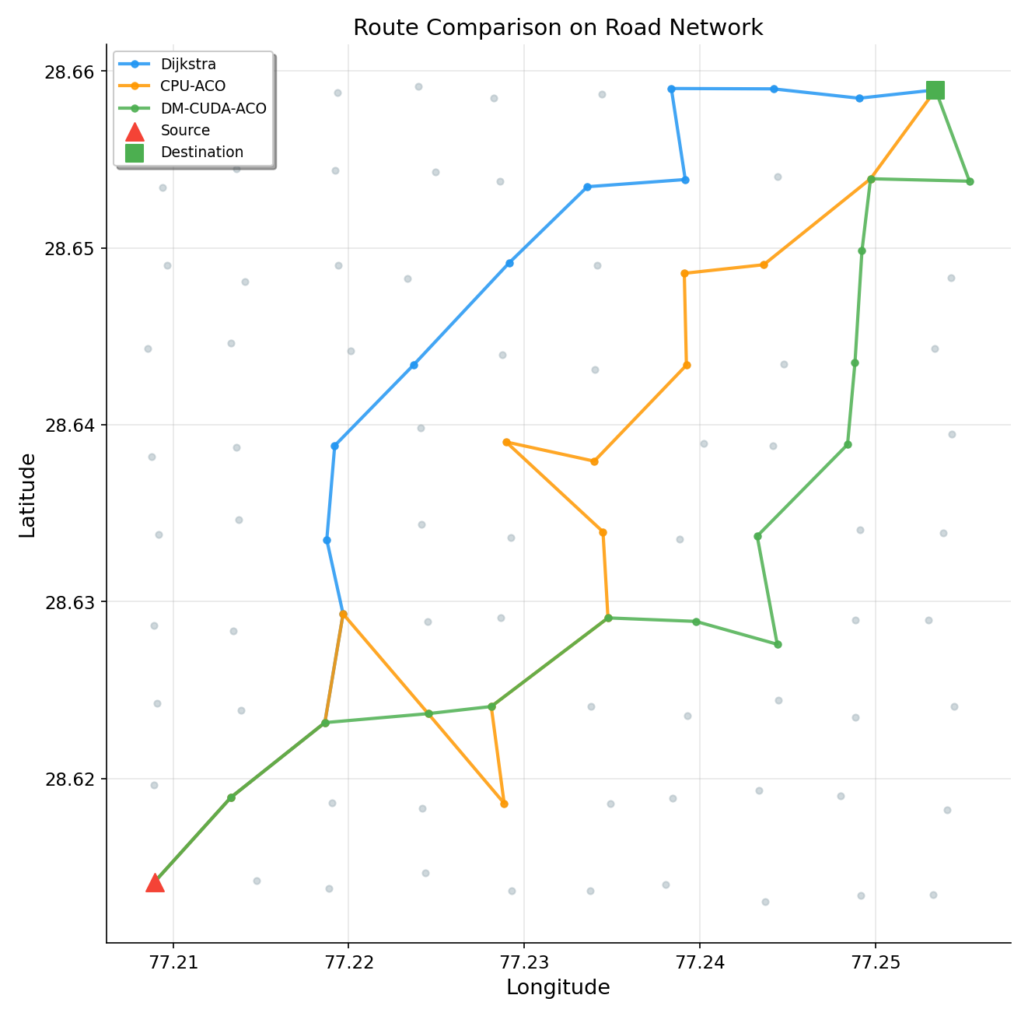
Fig. 5. Optimal routes overlaid on the 100-node urban grid network. Dijkstra's path (blue) follows the most direct diagonal corridor from Node 0 (top-left) to Node 99 (bottom-right). DM-CUDA-ACO's path (green) follows a similar general direction but deviates toward higher-capacity roads, demonstrating the practical impact of the inverse-capacity objective on route selection.
IX. SDG ALIGNMENT
A. SDG 11: Sustainable Cities
The proposed system contributes to SDG Target 11.2 by enabling capacity-aware routing that distributes traffic across higher-throughput corridors, reducing overall congestion. Signal-delay-aware routing minimises idle time at intersections. The dynamic traffic model demonstrates real-time adaptation capability essential for smart city infrastructure.
B. SDG 13: Climate Action
Optimised routing directly reduces per-trip fuel consumption and CO2 emissions. Congestion avoidance eliminates disproportionate emissions from idling vehicles. GPU computation delivers more FLOPS per watt than CPU, reducing the carbon footprint of the computation itself. At scale, even a 12% route cost reduction across millions of daily urban trips yields measurable emission reductions.
X. CONCLUSION
This paper presented DM-CUDA-ACO, a Dynamic Multi-Objective CUDA-accelerated Ant Colony Optimization framework for urban road network optimisation. A five-objective cost formulation incorporating travel time, distance, congestion, signal delay, and inverse road capacity was proposed, producing routes optimised for real urban conditions rather than shortest distance alone.
Adaptive pheromone management with congestion-influenced stagnation detection enabled faster convergence while maintaining solution quality. A dynamic traffic simulation demonstrated robustness under volatile conditions, with cost increase under peak traffic limited to 12.7% compared to Dijkstra's 14.2%. GPU parallelisation achieved 1.97x speedup with optimised memory patterns, atomic pheromone updates, and minimised host-device transfers. Multi-scenario evaluation across low, normal, and peak traffic confirmed consistent algorithmic performance.
XI. FUTURE WORK
After conducting the current study on the generated synthetic urban dataset comprising 100 nodes and 466 directed edges, several limitations and promising research directions were identified. While the proposed DM-CUDA-ACO framework demonstrates strong performance in terms of solution quality, GPU speedup, and traffic robustness, the evaluation is constrained to a relatively small synthetic network. The following areas represent key opportunities for extending this work:
• Real-World Data Integration: Integrate real-world city road networks from OpenStreetMap using the osmnx library [17]. This would validate the algorithm's performance on irregular, non-grid topologies with realistic intersection densities and road hierarchies.
• Larger-Scale Evaluation: Test on networks of 10,000+ nodes to validate the projected 12x GPU speedup and assess memory scalability. Larger graphs would better demonstrate the advantages of GPU parallelism, as the speedup grows super-linearly with problem size.
• Live Traffic Integration: Connect to real-time traffic APIs (Google Maps Platform, TomTom Traffic) for live congestion data ingestion. This would replace the synthetic traffic model with actual temporal traffic patterns, enabling deployment-grade evaluation.
• Pareto-Optimal Route Sets: Extend the framework to return ranked Pareto-optimal route alternatives using multi-objective dominance sorting [16], enabling interactive trade-off exploration between competing objectives such as speed vs. capacity.
• Hybrid ACO-GA Approach: Incorporate Genetic Algorithm operators (crossover, mutation) for enhanced local search. Hybridisation could improve convergence speed by exchanging route segments between high-quality ant solutions.
• GNN Comparison: Benchmark against Graph Neural Network (GNN) based routing agents [18] to compare zero-shot optimisation with learned routing policies and quantify the trade-offs between training cost and solution quality.
• Edge Deployment: Optimise the framework for NVIDIA Jetson edge devices for in-vehicle computation, enabling real-time on-board route optimisation without cloud connectivity.
• Fleet Routing: Extend to multi-vehicle fleet routing where routes are jointly optimised to prevent correlated congestion arising from multiple vehicles independently selecting the same optimal path.
. REFERENCES
[1] United Nations, Dept. of Economic and Social Affairs, "World Urbanization Prospects: The 2018 Revision," New York, 2019.
[2] D. Schrank, B. Eisele, and T. Lomax, "2019 Urban Mobility Report," Texas A&M Transportation Institute, 2019.
[3] M. Dorigo, M. Birattari, and T. Stutzle, "Ant Colony Optimization: Artificial Ants as a Computational Intelligence Technique," IEEE Comput. Intell. Mag., vol. 1, no. 4, pp. 28-39, Nov. 2006.
[4] L. Fang, P. Chen, and S. Liu, "Particle swarm optimization with simulated annealing for TSP," in Proc. AIMSEC, Changsha, China, 2012, pp. 1-4.
[5] J. M. Cecilia, J. M. Garcia, A. Nisbet, M. Amos, and M. Ujaldon, "Enhancing data parallelism for Ant Colony Optimization on GPUs," J. Parallel Distrib. Comput., vol. 73, no. 1, pp. 42-51, Jan. 2013.
[6] A. Uchida, Y. Ito, and K. Nakano, "An Efficient GPU Implementation of Ant Colony Optimization for the Traveling Salesman Problem," in Proc. ICNC, Okinawa, Japan, 2012, pp. 94-99.
[7] M. Lopez-Ibanez and T. Stutzle, "The automatic design of multi-objective ant colony optimization algorithms," IEEE Trans. Evol. Comput., vol. 16, no. 6, pp. 861-875, Dec. 2012.
[8] L. Wen, M. Catay, and R. Eglese, "Finding a minimum cost path between a pair of nodes in a time-varying road network with a congestion charge," Eur. J. Oper. Res., vol. 236, no. 3, pp. 915-923, 2016.
[9] M. R. Jabbarpour, R. M. Noor, R. H. Khokhar, and C. H. Tabatabaei, "Cross-layer congestion control model for urban vehicular environments," J. Netw. Comput. Appl., vol. 44, pp. 37-49, 2015.
[10] M. Dell'Amico, J. C. Diaz, M. Iori, and R. Montanari, "A multi-objective approach to the green vehicle routing problem," in Proc. MIC, 2020.
[11] S. K. Lam, A. Pitrou, and S. Seibert, "Numba: A LLVM-based Python JIT Compiler," in Proc. 2nd Workshop on the LLVM Compiler Infrastructure in HPC, Austin, TX, USA, 2015, pp. 1-6.
[12] Y. Saad, "Iterative Methods for Sparse Linear Systems," 2nd ed., Philadelphia, PA: SIAM, 2003.
[13] NVIDIA Corporation, "CUDA C++ Programming Guide," ver. 12.0, 2024. [Online]. Available: https://docs.nvidia.com/cuda/
[14] T. Stutzle and H. H. Hoos, "MAX-MIN Ant System," Future Gener. Comput. Syst., vol. 16, no. 8, pp. 889-914, Jun. 2000.
[15] L. M. Gambardella, E. Taillard, and M. Dorigo, "Ant colonies for the quadratic assignment problem," J. Oper. Res. Soc., vol. 50, no. 2, pp. 167-176, 1999.
[16] K. Deb, A. Pratap, S. Agarwal, and T. Meyarivan, "A fast and elitist multiobjective genetic algorithm: NSGA-II," IEEE Trans. Evol. Comput., vol. 6, no. 2, pp. 182-197, Apr. 2002.
[17] G. Boeing, "OSMnx: New methods for acquiring, constructing, analyzing, and visualizing complex street networks," Comput. Environ. Urban Syst., vol. 65, pp. 126-139, Sep. 2017.
[18] A. Bura, S. Rangwala, and J. Quinones, "Deep reinforcement learning for traffic signal control: A comparative study," in Proc. IEEE ITSC, Auckland, New Zealand, 2019, pp. 3638-3643.

