**Practical No :- 02**

**Practical Name :- Implements the find-s inductive learning algorithm**

------------------------------------------------------------------------------------------------

Code:

import pandas as pd  
print(pd.__version__)

import numpy as np  
print(np.__version__)  
  
data = pd.read_csv("C:/Users/Khemangi/Desktop/dataset1.CSV")  
print("Given Data set")  
print(data,"n")  
  
d=np.array(data)[:,:-1]  
print("n the attributes are:",d)  
  
target=np.array(data)[:,-1]  
print("n the target is :",target)  
  
def train(c,t):  
 for i,val in enumerate(t):  
 if val=='yes':  
 sp_hp = c[i].copy()  
 break  
 print("initially hypothesis=")  
 print(sp_hp,"\n")  
  
 for i,val in enumerate(c):  
 if t[i]=='yes':  
 for x in range(len(sp_hp)):  
 if val[x]!=sp_hp[x]:  
 sp_hp[x]='?'  
 else:  
 pass  
 print("hypothesis is ",i,"=",sp_hp)  
 return sp_hp  
print("\n the final hypothesis is :",train(d,target))

**Practical No:- 03**

**Practical Name:- Implement the Candidate-Elimination Inductive Learning algorithm.**

------------------------------------------------------------------------------------------------

import numpy as np  
import pandas as pd  
data = pd.read_csv('C:/Users/comp/Desktop/datafile.csv')  
concepts = np.array(data.iloc[:,0:-1])  
print("\nInstances are:\n",concepts)  
target = np.array(data.iloc[:,-1])  
print("\nTarget values are: ",target)  
def learn(concepts,target):  
 specific_h = concepts[0].copy()  
 print("\nInitialization of specific_h and general_h")  
 print("\nSpecific Boundary: ", specific_h)  
 general_h = [["?"for i in range(len(specific_h))] for i in range(len(specific_h))]  
 print("\nGeneric Boundary: ",general_h)  
 for i,h in enumerate(concepts):  
 print("\nInstance",i+1 , "is ", h)  
 if target[i] == "Yes":  
 print("Instance is positive ")  
 for i in range(len(specific_h)):  
 if h[x]!= specific_h[x]:  
 specific_h[x] ='?'  
 general_h[x][x] ='?'  
 else:  
 print("Instance is Negative")  
 for x in range(len(specific_h)):  
 if h[x]!= specific_h[x] and specific_h[x]!='?':  
 general_h[x][x] = specific_h[x]  
 else:  
 general_h[x][x] = '?'  
 print("Specific Boundary after",i+1,"Instance is",specific_h)  
 print("Generic Boundary after", i + 1, "Instance is",general_h)  
 print("\n")  
  
 indices = [i for i,val in enumerate(general_h) if val == ['?','?','?','?','?','?']]  
 for i in indices:  
 general_h.remove(['?','?','?','?','?','?'])  
 return specific_h,general_h  
s_final,g_final = learn(concepts,target)  
  
print("Final Specific_h:",s_final,sep="\n")  
print("Final General_h:",g_final,sep="\n")

C:\Users\comp\AppData\Local\Programs\Python\Python310\python.exe C:/Users/comp/Desktop/ml.py/ml2.py

**Practical No:- 04**

**Practical Name:- Implementation Linear Regression Algorithm.**

------------------------------------------------------------------------------------------------

import numpy as np

def estimate_coef(x, y):

# number of observations/points

n = np.size(x)

# mean of x and y vector

m_x = np.mean(x)

m_y = np.mean(y)

# calculating cross-deviation and deviation about x

SS_xy = np.sum(y * x) - n * m_y * m_x

SS_xx = np.sum(x * x) - n * m_x * m_x

# calculating regression coefficients

b_1 = SS_xy / SS_xx

b_0 = m_y - b_1 * m_x

return (b_0, b_1)

def main():

# observations / data

x = np.array([0, 1, 2, 3, 4, 5, 6, 7, 8, 9, 10])

y = np.array([1, 3, 2, 5, 7, 8, 8, 9, 10, 12, 15])

# x = np.array([1, 2, 4, 6, 8, 10])

# y = np.array([2, 5, 8, 12, 15, 21])

# estimating coefficients

b = estimate_coef(x, y)

print("Estimated coefficients:\nb_0 = {} \

\nb_1 = {}".format(b[0], b[1]))

print(b)

# plotting regression line

#plot_regression_line(x, y, b)

y_pred = b[0] + b[1] * x

print("x input :", x)

print("Original Y:", y)

print("Y_pred:", y_pred)

er = np.mean(np.square(y-y_pred))/2

print("Error=", er)

y_prr = y_pred

for i in range(len(y_pred)):

y_prr[i] = y_pred[i] + er

print("Improved Y_pred adding error:", y_prr)

if __name__ == "__main__":

main()

**Practical No :- 05.1**

**Practical Name:- Write A Program To Implement Decision Tree Using Python/R/Programming Language Of Your Choice**

------------------------------------------------------------------------------------------------

import matplotlib.pyplot as plt  
import pandas as pd  
import sklearn.datasets  
data_b = sklearn.datasets.load_iris()  
df=pd.DataFrame(data_b.data,columns=data_b.feature_names)  
df['target'] = data_b.target  
#df['target']  
print(df)  
#print(data_b)  
print("Dataset Labels=",data_b.target_names)  
from sklearn.tree import DecisionTreeClassifier  
from sklearn import metrics  
from sklearn import tree  
from sklearn.model_selection import train_test_split  
x_train, x_test, y_train, y_test = train_test_split(df[data_b.feature_names], df['target'])  
print(x_train)  
print(x_test)  
print(y_train)  
print(y_test)  
clf = DecisionTreeClassifier(max_depth = 5,random_state=1, criterion='gini') #'gini'  
clf = clf.fit(x_train, y_train)  
y_pred = clf.predict(x_test)  
print(y_test, y_pred)  
print("Accuracy:",metrics.accuracy_score(y_test, y_pred))  
fn=['sepal length (cm)','sepal width (cm)', 'petal length (cm)', 'petal width (cm)']  
cn=['setosa', 'versicolor', 'virginica']  
  
fig, axes = plt.subplots(nrows = 1, ncols = 1, figsize = (4, 4), dpi = 300)  
tree.plot_tree(clf, feature_names = fn, class_names = cn,filled = True); fig.savefig('dstimq.png')

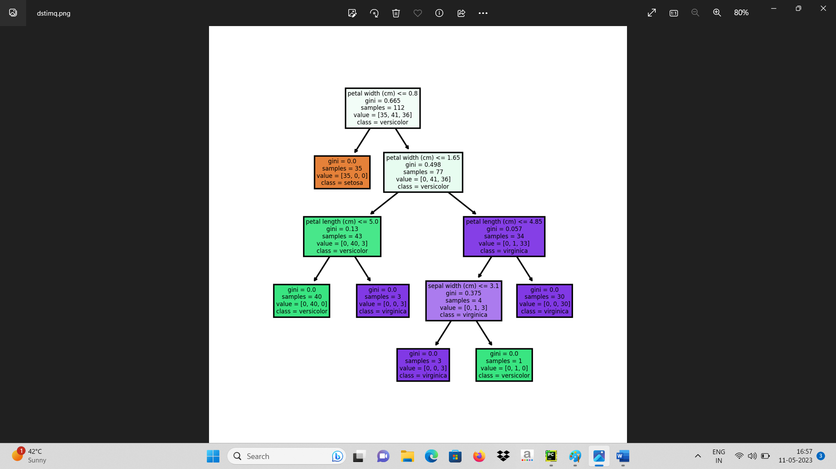

**Practical No. :- 06**

**Practical Name :- . Implement Simple KNN Using Euclidean Distance In Python.**

------------------------------------------------------------------------------------------------

from pandas import DataFrame  
from sklearn.datasets import load_iris  
data_b = load_iris()  
df= DataFrame(data_b.data, columns=data_b.feature_names)  
df['target'] = data_b.target  
#print(df)  
#print(data_b.DESCR)  
print("Dataset Labels=",data_b.target_names)  
from sklearn.neighbors import KNeighborsClassifier  
from sklearn import metrics  
from sklearn.metrics import confusion_matrix  
from sklearn.model_selection import train_test_split  
X_train, X_test, Y_train, y_test = train_test_split(df[data_b.feature_names], df['target'], random_state=1)  
print(X_train.head(6))  
print(Y_train.head(6))  
print(X_test.head())  
clf = KNeighborsClassifier(n_neighbors=6)  
clf.fit(X_train, Y_train) # model is trained  
y_pred=clf.predict(X_test)  
#print(y_test, y_pred)  
print("Accuracy:",metrics.accuracy_score(y_test, y_pred))  
cm = confusion_matrix(y_test, y_pred)  
print("Confusion Matrix:")  
print(cm)

**Practical No. :- 07**

**Practical Name :- Write A Program To Implement K-Nearest Neighbour Algorithm To Classify The Iris Dataset. Print Both Correct And Wrong Predictions. Java/Python Ml Library Classes Can Be Used For This Problem.**

------------------------------------------------------------------------------------------------

**CODE: FOR BREAST CANCER DATA SET**

from pandas import DataFrame  
# from sklearn.datasets import load_iris  
from sklearn.datasets import load_breast_cancer  
from sklearn.neighbors import KNeighborsClassifier  
from sklearn import metrics  
from sklearn.metrics import confusion_matrix  
data_b = load_breast_cancer()  
df= DataFrame(data_b.data, columns=data_b.feature_names)  
df['target'] = data_b.target  
#print(df)  
#print(data_b.DESCR)  
print("Dataset Labels=",data_b.target_names)  
from sklearn.model_selection import train_test_split  
X_train, X_test, Y_train, y_test = train_test_split(df[data_b.feature_names], df['target'], random_state=1)  
print(X_train.head(6))  
print(Y_train.head(6))  
print(X_test.head())  
clf = KNeighborsClassifier(n_neighbors=6)  
clf.fit(X_train, Y_train) # model is trained  
y_pred=clf.predict(X_test)  
#print(y_test, y_pred)  
print("Accuracy:",metrics.accuracy_score(y_test, y_pred))  
cm = confusion_matrix(y_test, y_pred)  
print("Confusion Matrix:")  
print(cm)

**Practical No:- 08**

**Practical Name:- Write a Program for Confusion Matrix and calculate Precision, Recall, F-Measure**

------------------------------------------------------------------------------------------------

**Code:**

from sklearn.datasets import load_iris, load_breast_cancer

from sklearn.model_selection import train_test_split

from sklearn.neighbors import KNeighborsClassifier

from sklearn.metrics import confusion_matrix, precision_score, recall_score, f1_score

# Load the Irish dataset

iris = load_iris()

X_iris = iris.data

y_iris = iris.target

# Split the Irish dataset into training and testing sets

X_train_iris, X_test_iris, y_train_iris, y_test_iris = train_test_split(X_iris, y_iris, test_size=0.2, random_state=42)

# Train the KNN classifier on the Irish dataset

knn_iris = KNeighborsClassifier()

knn_iris.fit(X_train_iris, y_train_iris)

# Make predictions on the Irish testing set

y_pred_iris = knn_iris.predict(X_test_iris)

# Calculate the confusion matrix for Irish dataset

cm_iris = confusion_matrix(y_test_iris, y_pred_iris)

print("Confusion Matrix (Irish Dataset):")

print(cm_iris)

# Calculate precision, recall, and F-measure for Irish dataset

precision_iris = precision_score(y_test_iris, y_pred_iris, average='macro')

recall_iris = recall_score(y_test_iris, y_pred_iris, average='macro')

f1_iris = f1_score(y_test_iris, y_pred_iris, average='macro')

print("Precision (Irish Dataset):", precision_iris)

print("Recall (Irish Dataset):", recall_iris)

print("F-measure (Irish Dataset):", f1_iris)

# Load the Breast Cancer dataset

cancer = load_breast_cancer()

X_cancer = cancer.data

y_cancer = cancer.target

# Split the Breast Cancer dataset into training and testing sets

X_train_cancer, X_test_cancer, y_train_cancer, y_test_cancer = train_test_split(X_cancer, y_cancer, test_size=0.2, random_state=42)

# Train the KNN classifier on the Breast Cancer dataset

knn_cancer = KNeighborsClassifier()

knn_cancer.fit(X_train_cancer, y_train_cancer)

# Make predictions on the Breast Cancer testing set

y_pred_cancer = knn_cancer.predict(X_test_cancer)

# Calculate the confusion matrix for Breast Cancer dataset

cm_cancer = confusion_matrix(y_test_cancer, y_pred_cancer)

print("\nConfusion Matrix (Breast Cancer Dataset):")

print(cm_cancer)

# Calculate precision, recall, and F-measure for Breast Cancer dataset

precision_cancer = precision_score(y_test_cancer, y_pred_cancer)

recall_cancer = recall_score(y_test_cancer, y_pred_cancer)

f1_cancer = f1_score(y_test_cancer, y_pred_cancer)

print("Precision (Breast Cancer Dataset):", precision_cancer)

print("Recall (Irish Dataset):", recall_cancer)

print("F-measure (Irish Dataset):", f1_cancer)

**Practical No.:- 9**

**Practical Name:- Write a program for linear regression and find parameters like Sum of Squared Errors (SSE), Total Sum of Squares (SST), R2, Adjusted R2, etc.**

------------------------------------------------------------------------------------------------

import numpy as np

from sklearn.linear_model import LinearRegression

from sklearn.metrics import r2_score

# Input data

X = np.array([[1, 1], [1, 2], [2, 2], [2, 3]])

y = np.array([3, 4, 5, 6])

model = LinearRegression() # Create a linear regression model

model.fit(X, y) # Fit the model to the data

y_pred = model.predict(X) # Predict the output

sse = np.sum((y_pred - y) ** 2) # Calculate SSE (Sum of Squared Errors)

sst = np.sum((y - np.mean(y)) ** 2) # Calculate SST (Total Sum of Squares)

r2 = r2_score(y, y_pred) # Calculate R2 score

# Calculate adjusted R2

n = X.shape[0] # Number of samples

p = X.shape[1] # Number of predictors

adjusted_r2 = 1 - (1 - r2) * (n - 1) / (n - p - 1)

# Print the results

print("Sum of Squared Errors(SSE):- ", sse)

print("Total Sum of Squares(SST):- ", sst)

print("R Square(R2):- ", r2)

print("Adjusted Square(R2):- ", adjusted_r2 )

**Practical No:- 10**

**Practical Name:-Write the program to implement the naive Bayesian Classifier for a sample training dataset stored as a .CSV file. Compute the accuracy of the classifier considering a few test dataset.**

------------------------------------------------------------------------------------------------

import numpy as np  
import pandas as pd  
import matplotlib.pyplot as plt  
from sklearn.model_selection import train_test_split  
from sklearn import datasets  
from sklearn.naive_bayes import GaussianNB  
from sklearn.metrics import confusion_matrix  
iris = datasets.load_iris() *#load dataset*x = iris.data *#input*y = iris.target *#traget*print("Features :", iris['feature_names'])  
  
x_train, x_test, y_train, y_test = train_test_split(x, y, test_size = 0.25, random_state = 0)  
NB = GaussianNB()  
NB.fit(x_train, y_train)  
y_pred = NB.predict(x_test)  
cm = confusion_matrix(y_test,y_pred)  
print("Confusion Matrix")  
print(cm)

**OUTPUT:**

Features : ['sepal length (cm)', 'sepal width (cm)', 'petal length (cm)', 'petal width (cm)']

Confusion Matrix

[[13 0 0]

[ 0 16 0]

[ 0 0 9]]

**Practical No.:- 11.2**

**Practical Name :- Write a Program for Fuzzy c-means clustering in python.**

------------------------------------------------------------------------------------------------

import numpy as np

import skfuzzy as fuzz

from skfuzzy import control as ctrl

# Generate some example data

np.random.seed(0)

data = np.random.rand(100, 2)

# Define the number of clusters

n_clusters = 3

# Apply fuzzy c-means clustering

cntr, u, u0, d, jm, p, fpc = fuzz.cluster.cmeans(

data.T, n_clusters, 2, error=0.005, maxiter=1000, init=None)

# Predict cluster membership for each data point

cluster_membership = np.argmax(u, axis=0)

# Print the cluster centers

print('Cluster Centers:', cntr)

# Print the cluster membership for each data point

print('Cluster Membership:', cluster_membership)

**Practical No. :- 12**

**Practical Name :- Implement the non-parametric locally weighted regression algorithm in order to fit data points. select the appropriate data set for your experiment and draw graphs.**

------------------------------------------------------------------------------------------------

from math import ceil  
import numpy as np  
from scipy import linalg  
  
  
def lowess(x, y, f, iterations):  
 n = len(x)  
 r = int(ceil(f * n))  
 h = [np.sort(np.abs(x - x[i]))[r] for i in range(n)]  
 w = np.clip(np.abs((x[:, None] - x[None, :]) / h), 0.0, 1.0)  
 w = (1 - w ** 3) ** 3  
 yest = np.zeros(n)  
 delta = np.ones(n)  
 for iteration in range(iterations):  
 for i in range(n):  
 weights = delta * w[:, i]  
 b = np.array([np.sum(weights * y), np.sum(weights * y * x)])  
 A = np.array([[np.sum(weights), np.sum(weights * x)], [np.sum(weights * x), np.sum(weights * x * x)]])  
 beta = linalg.solve(A, b)  
 yest[i] = beta[0] + beta[1] * x[i]  
  
 residuals = y - yest  
 s = np.median(np.abs(residuals))  
 delta = np.clip(residuals / (6.0 * s), -1, 1)  
 delta = (1 - delta ** 2) ** 2  
  
 return yest  
  
  
import math  
  
n = 100  
x = np.linspace(0, 2 * math.pi, n)  
y = np.sin(x) + 0.3 * np.random.randn(n)  
f = 0.25  
iterations = 3  
yest = lowess(x, y, f, iterations)  
  
import matplotlib.pyplot as plt  
plt.plot(x, y, "r.")  
plt.plot(x, yest, "b-")  
plt.show()

**OUTPUT:**

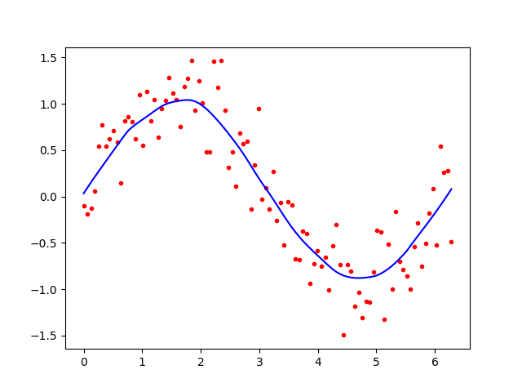

**Practical No.: 13.1**

**Practical Name: Construction Of simple Neural Network using Python**

**Code:**

import numpy as np

from scipy.special import expit as activation_function

from scipy.stats import truncnorm

# define the network

# generate numbers within a truncated (bounded)

# normal Distribution

def truncated_normal(mean=0, sd=1, low=0, upp=10):

return truncnorm((low - mean) / sd, (upp - mean) / sd, loc=mean, scale=sd)

# creat the Network class and define the arguments:

# set the no. of neurons/nodes for each layer

# and initialize the weight matrices

class Nnetwork:

def __init__(self, no_of_in_nodes, no_of_out_nodes, no_of_hidden_nodes, learning_rate):

self.no_of_in_nodes = no_of_in_nodes

self.no_of_out_nodes = no_of_out_nodes

self.no_of_hidden_nodes = no_of_hidden_nodes

self.learning_rate = learning_rate

self.create_weight_matrices()

def create_weight_matrices(self):

"""A method to initialize the weight matrices of the neural network"""

rad = 1 / np.sqrt(self.no_of_in_nodes) # rad = 0.2707

x = truncated_normal(mean=0, sd=1, low=-rad, upp=rad)

self.weight_in_hidden = x.rvs((self.no_of_hidden_nodes, self.no_of_in_nodes))

print("weights_in_hidden = ", self.weight_in_hidden)

rad = 1/np.sqrt(self.no_of_hidden_nodes)

x = truncated_normal(mean=0, sd=1, low=-rad, upp=rad)

self.weight_in_hidden_out = x.rvs((self.no_of_out_nodes, self.no_of_hidden_nodes))

print("weights_in_hidden_out = ", self.weight_in_hidden_out)

def train(self, input_vector, target_vector):

pass

def run(self, input_vector):

input_vector = np.array(input_vector, ndmin=2).T

print("Input = ", input_vector)

input_hidden = activation_function(self.weight_in_hidden @ input_vector)

print("Hidden = ", input_hidden)

output_vector = activation_function(self.weight_in_hidden_out @ input_hidden)

print("Output = ", output_vector)

return output_vector

simple_network = Nnetwork(no_of_in_nodes=2, no_of_out_nodes=2, no_of_hidden_nodes=4, learning_rate=0.6)

#run simple network for arrays, lists and tuples with shape (2):

y = simple_network.run([2,3])

print("Y = ", y)

**Practical No: 13.2**

**Practical Name: Build an Artificial Neural Network by implementing the Backpropagation algorithm and test the same using appropriate data sets.**

------------------------------------------------------------------------------------------------

# classification of iris data set by aplying artificial neural network using Back-propogation algorithm

**import** numpy **as** np

**import** pandas **as** pd

**from** sklearn.datasets **import** load_iris

**from** sklearn.model_selection **import** train_test_split

**import** matplotlib.pyplot **as** plt

# load dataset

data = load_iris()

# Get features and target

x = data.data

y = data.target

print(**"Y="**, y)

y = pd.get_dummies(y).values

print(y[:3])  
# split data into train and test data

x_train, x_test, y_train, y_test = train_test_split(x, y, test_size=20, random_state=4)

# initialize variable

learning_rate = 0.1

iteration = 6000

N = y_train.size

# number of input features

input_size = 4

# number of hidden layers neurons

hidden_size = 2

# mo. of neurons at output layers

output_size = 3

results = pd.DataFrame(columns=[**"mse"**, **"accuracy"**])

# initialize weights

np.random.seed(10)

# initialiizing weight for the hidden layers

W1 = np.random.normal(scale=0.5, size=(input_size, hidden_size))

print(**"weight 1"**, W1)

# initializing weight for the output layers

W2 = np.random.normal(scale=0.5, size=(hidden_size, output_size))

print(**"weight 2"**, W2)

**def** sigmoid(x):

**return** 1/(1 + np.exp(-x))

**def** mean_squared_error(y_pred, y_true):

**return** (((y_pred - y_true) ** 2).sum()) / (2 * y_pred.size)

**def** accuracy(y_pred, y_true):

acc = y_pred.argmax(axis=1) == y_true.argmax(axis=1)

**return** acc.mean()

**for** itr **in** range(iteration):

# feedforward propagation

# on hidden layer

Z1 = np.dot(x_train, W1)

A1 = sigmoid(Z1)

# on output layer

Z2 = np.dot(A1, W2)

A2 = sigmoid(Z2)

# calculating error

mse = mean_squared_error(A2, y_train)

acc = accuracy(A2, y_train)

results = results._append({**"mse"**: mse, **"accuracy"**: acc}, ignore_index=**True**)

# backpropagation

E1 = A2 - y_train

dw1 = E1 * A2 * (1 - A2)

E2 = np.dot(dw1, W2.T)

dw2 = E2 * A1 * (1 - A1)

# weight updates

W2_update = np.dot(A1.T, dw1) / N

W1_update = np.dot(x_train.T, dw2) / N

W2 = W2 - learning_rate * W2_update

W1 = W1 - learning_rate * W1_update

results.mse.plot(title=**"Mean squared Error"**)

results.accuracy.plot(title=**"Accuracy"**)

# feedforward

Z1 = np.dot(x_test, W1)

A1 = sigmoid(Z1)

Z2 = np.dot(A1, W2)

A2 = sigmoid(Z2)

acc = accuracy(A2, y_test)

print(**"Accuracy: {}"**.format(acc))