**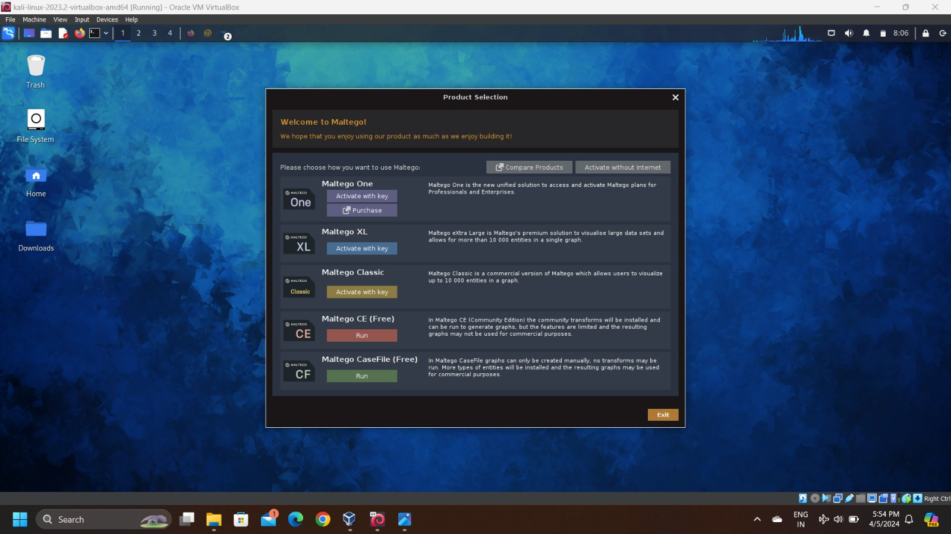***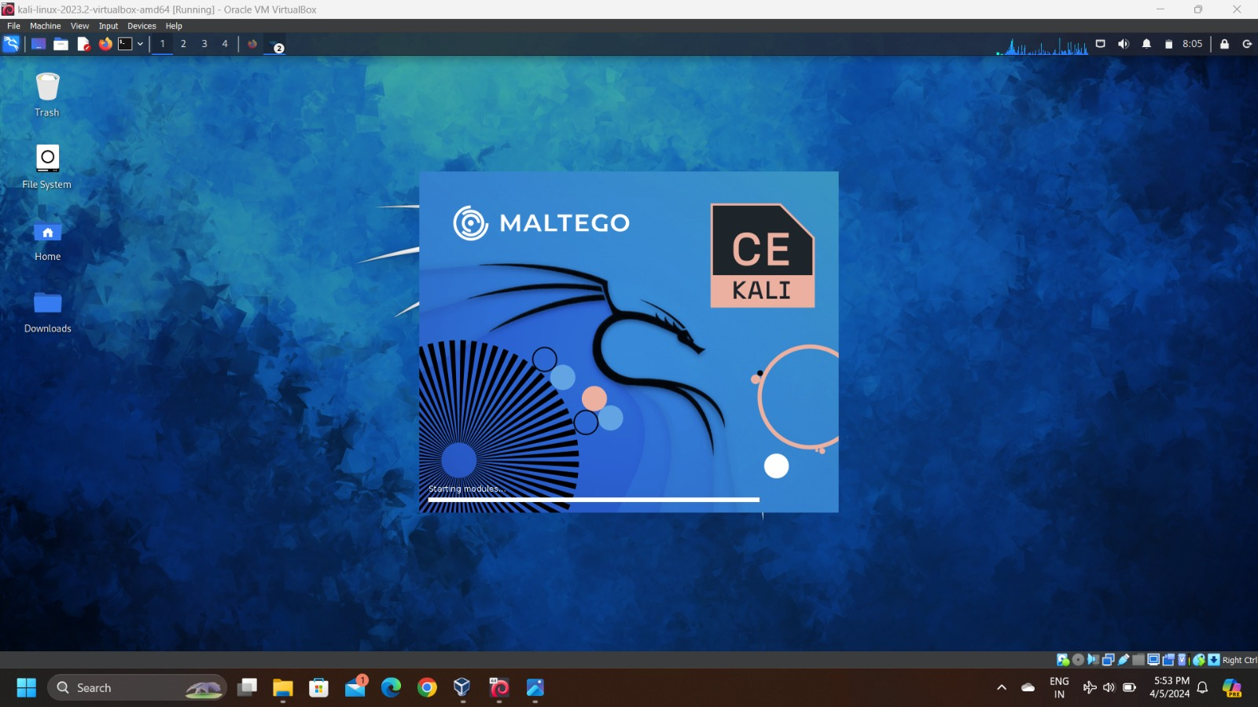*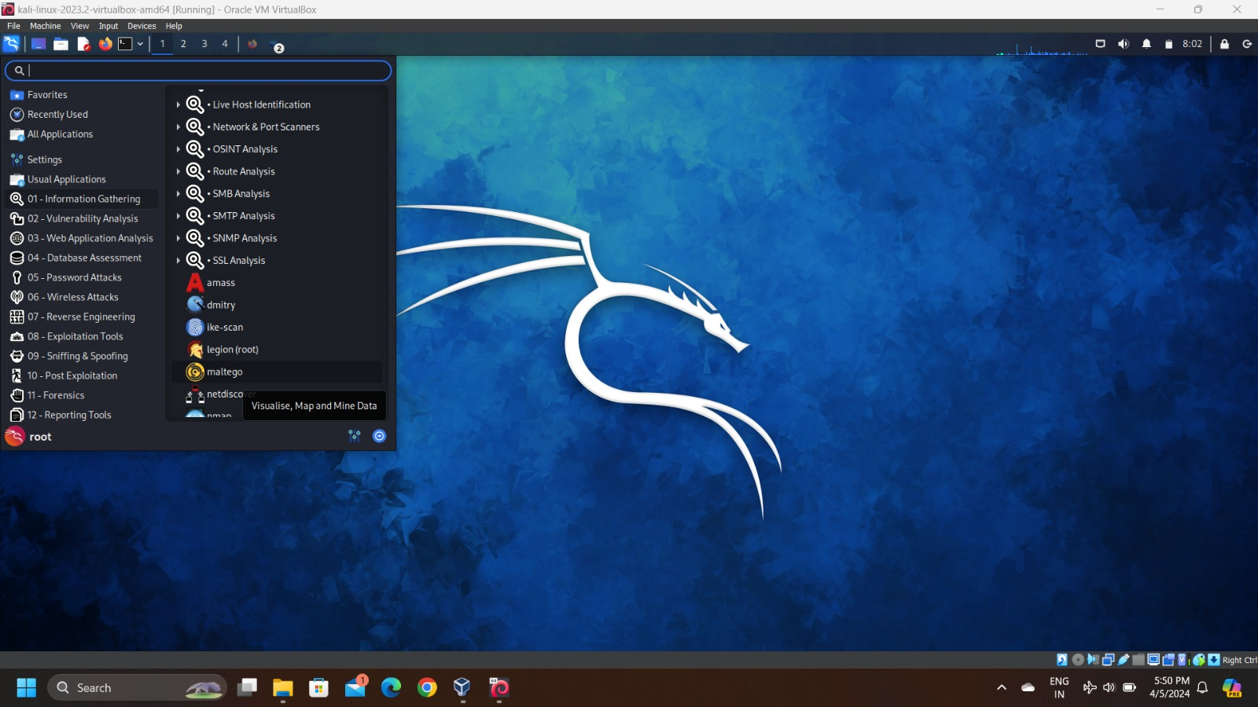**Step** 1: open your Kali Linux system,search for maltega in the tools menu.

**Step 2: Open the maltego tool ,if it is not installed in your computer then update and upgrade the operating system to use the tool**

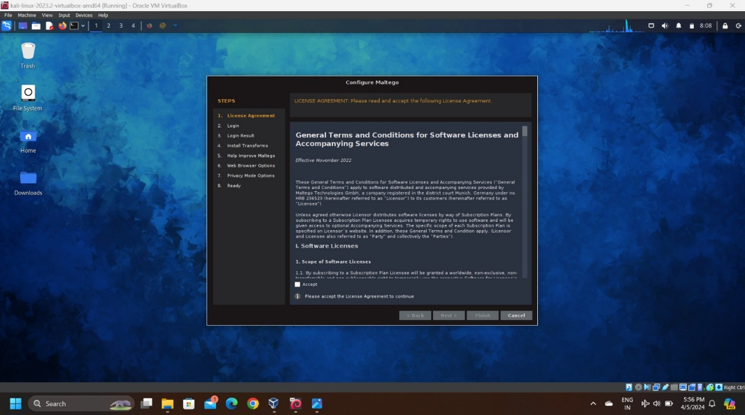**Step 3: *Select free version in above given ,Maltego CE free is the free tool used for all users to gateher information***

**Step 4: So accept the terms and conditions of the tools to grant access to use it,**

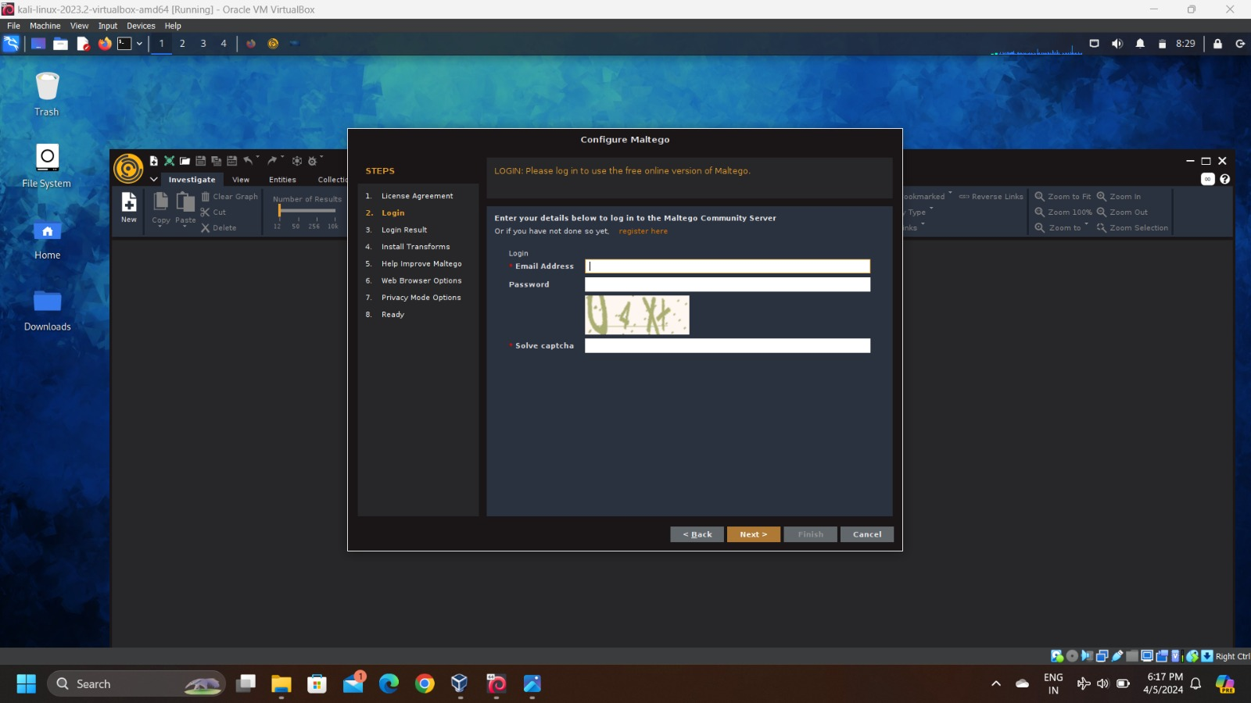

**Step 5: We need to have an account in Maltego ,so if there is no account you have to create a Maltego account and register into it**

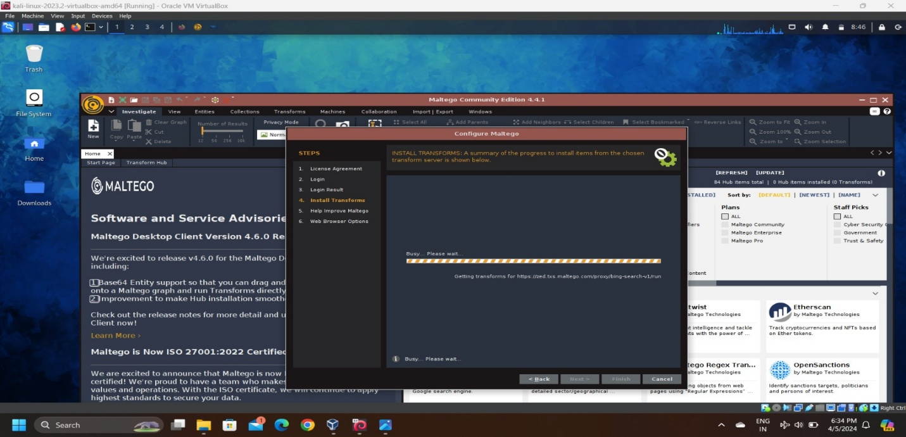

**Step 7: *you have to install all the transforms present in the Maltego tool.so we have to complete the following steps in the above figure***

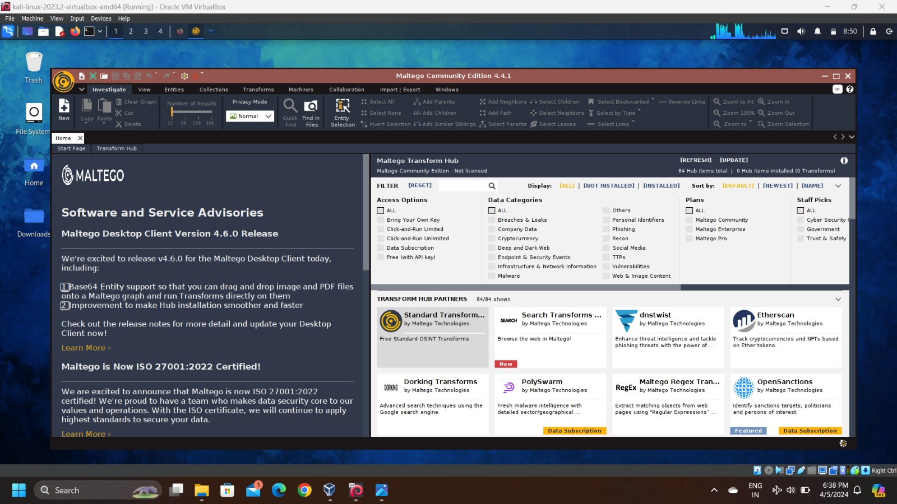***Step 8: After following all the steps ,we can the following displayed interface where we are ready to gather information*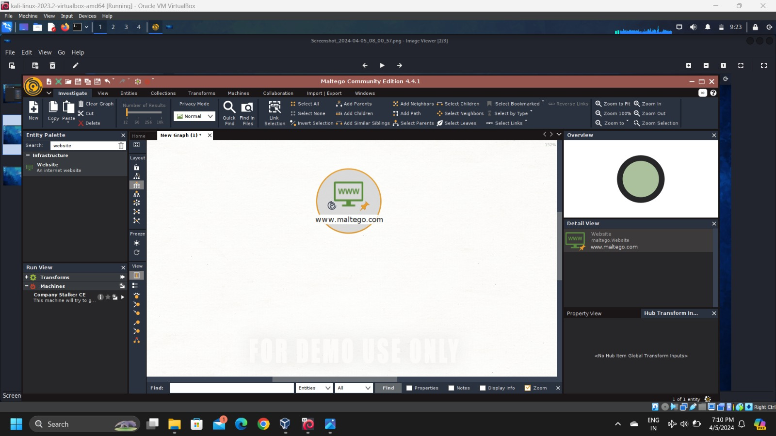**

**Step 9: In the left corner, you can observe a “new “ page click that to get fresh page to start a particular gathering information**

**Step 10: From the above picture,there is a search button type website into it ,you get an result and drag the result into new page**

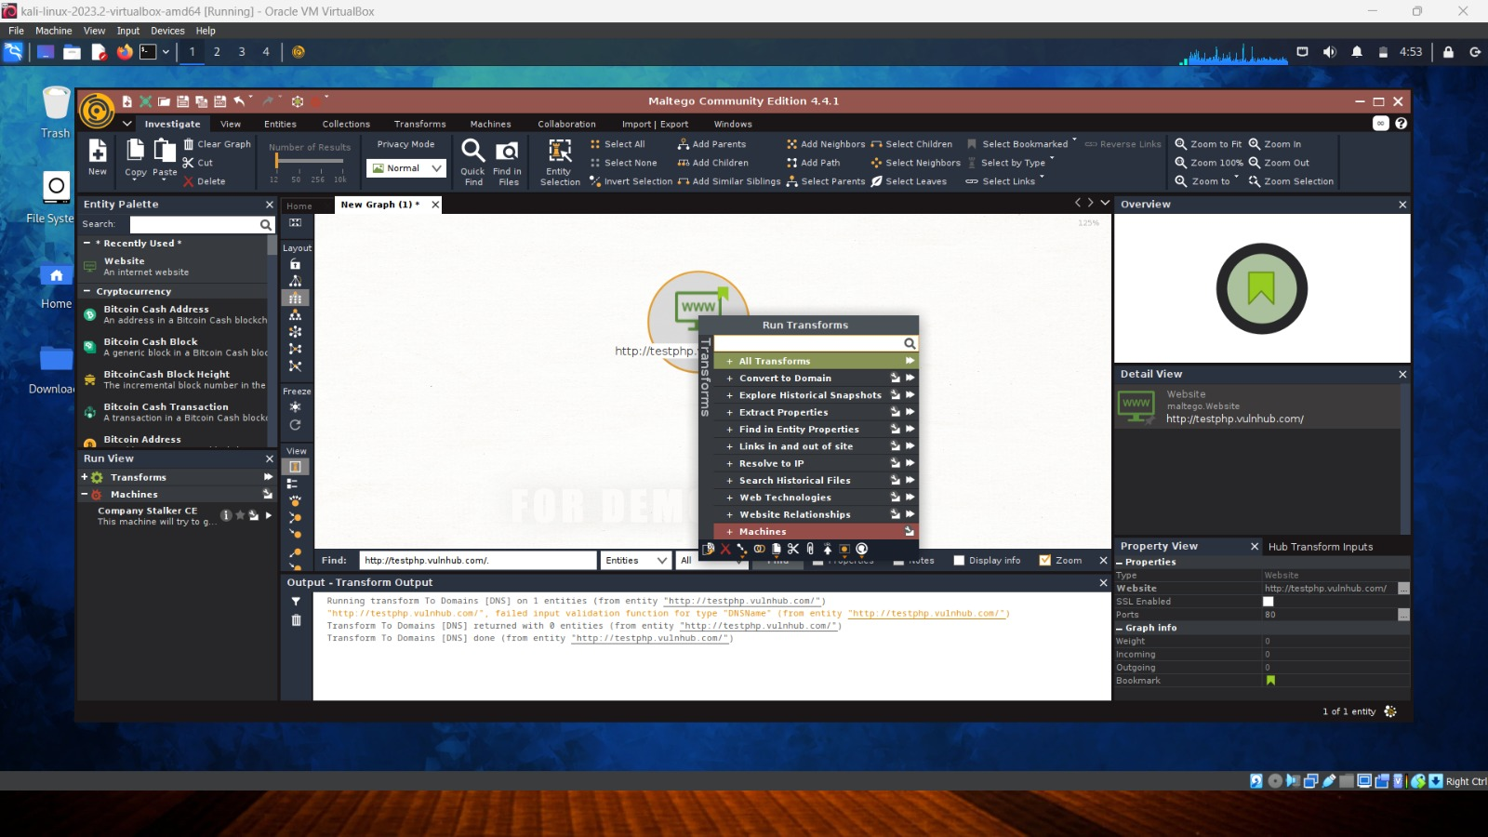

**Step 11: In the side down you can see a name called “properties “ enter url:** [**http://testphp.vulnhub.com**](http://testphp.vulnhub.com) **and press enter**

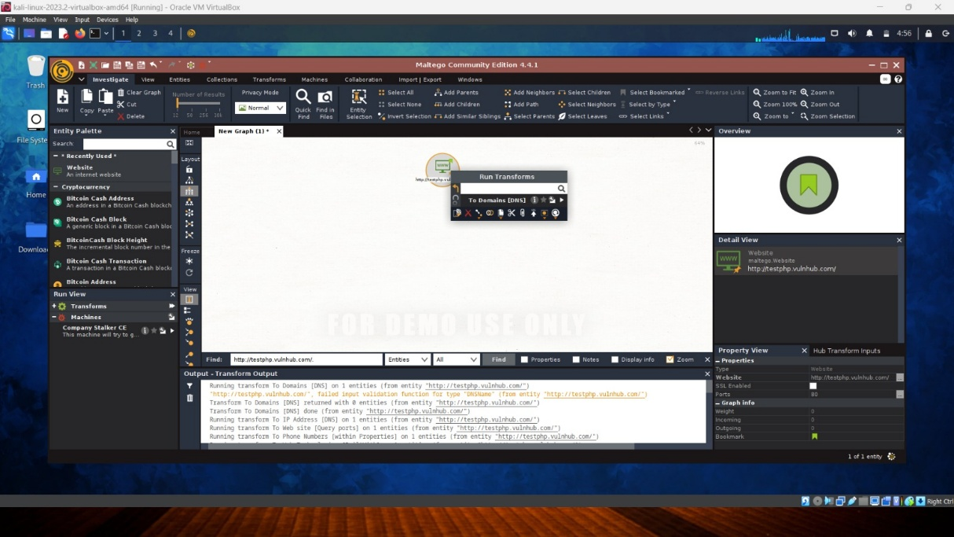

**Step 12: select the object in the page and select domains(DNS) and press enter to get the result on the page**

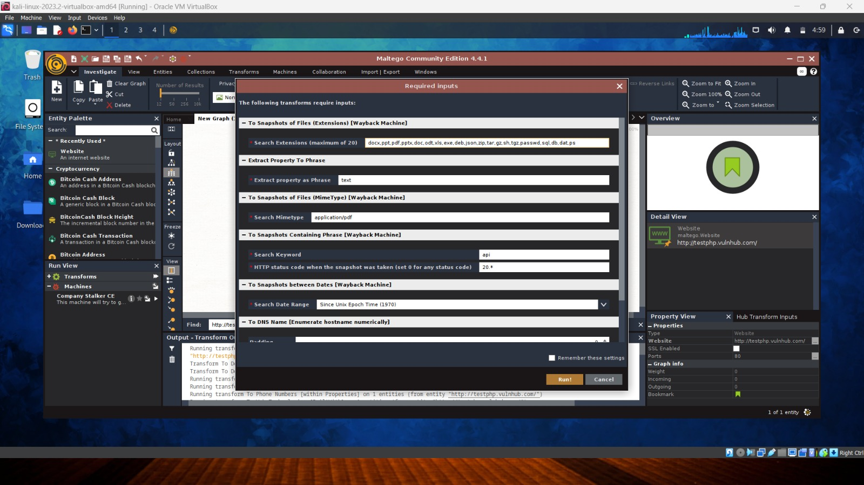

**Step 13: *after pressing enter,the following image will be displayed,there are inputs for following transforms,select wisely and press “Run” to run the domain function***

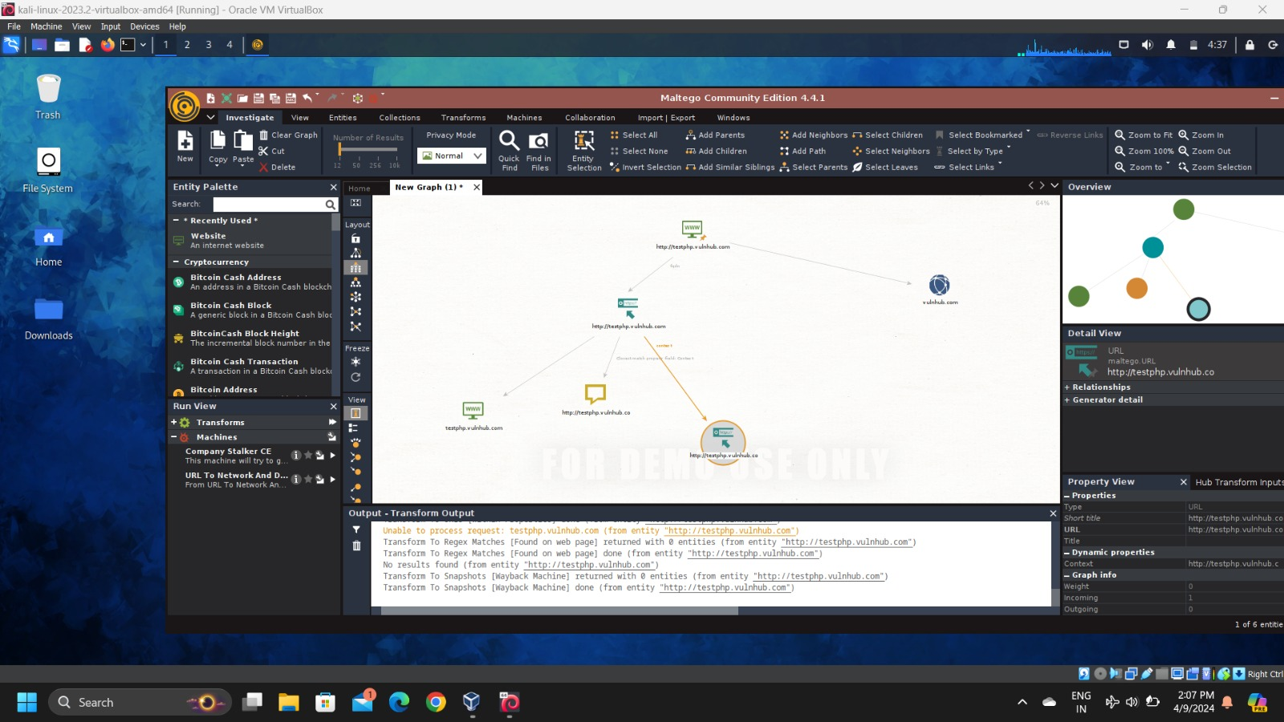

***Step 14: you can see in the above image you will get ithe related information of the website or domain. It is in the form of tree***

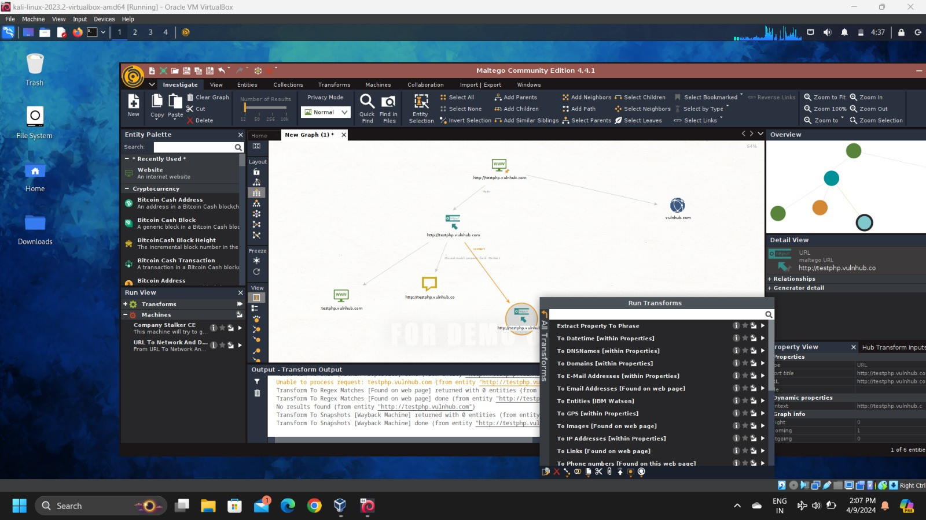

**Step 15: From the above image you will observe what can be extracted from the given url. It can be email addresses, entities, date and time, ip’s, sub domains, gps, related images etc.**

***Conclusion : From the above project we were able to understand about the Maltego tool and it’s function in Kali linux***