Note: Consider only the year 2017 for analysis and not the Fiscal year.

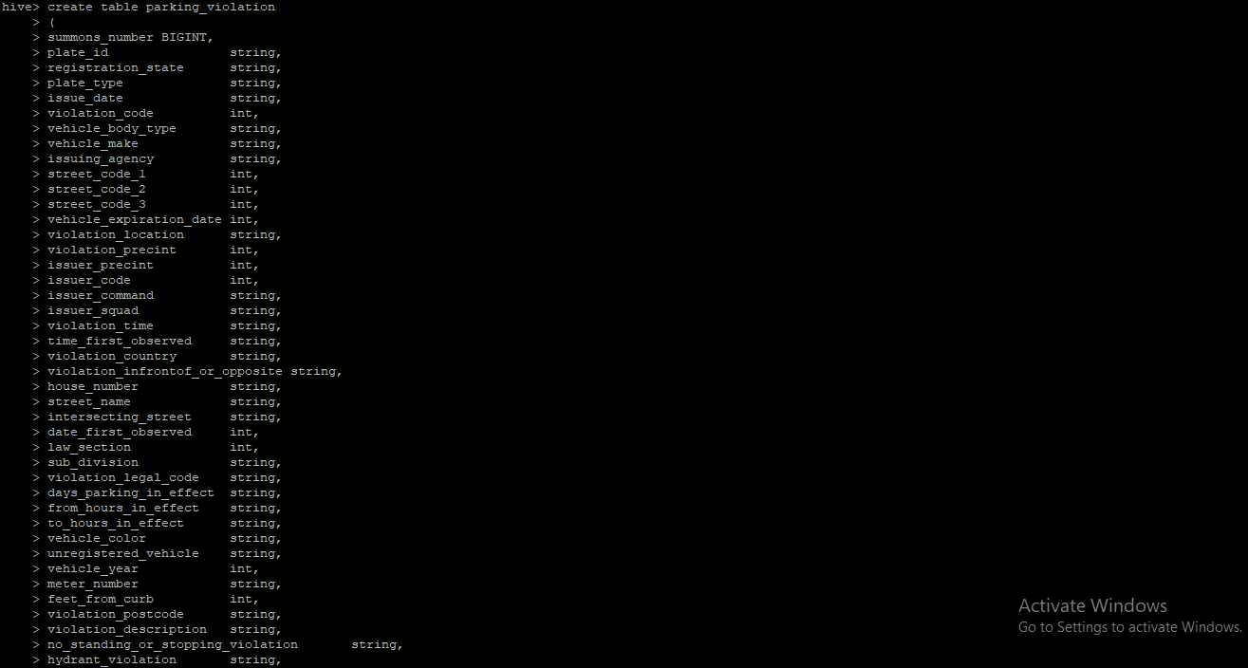

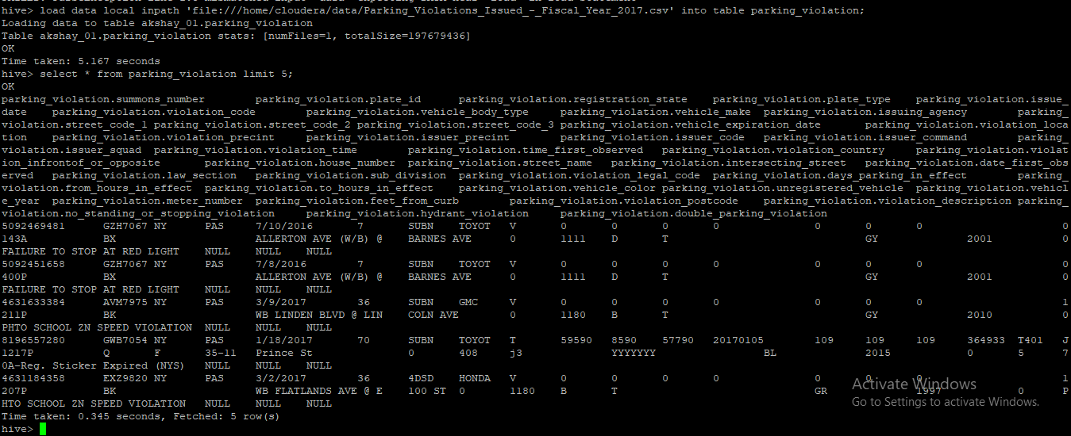

The analysis can be divided into two parts:

Part-I: Examine the data

1. Find the total number of tickets for the year.

select count(summons_number), issue_date from parking_violation group by issue_date;

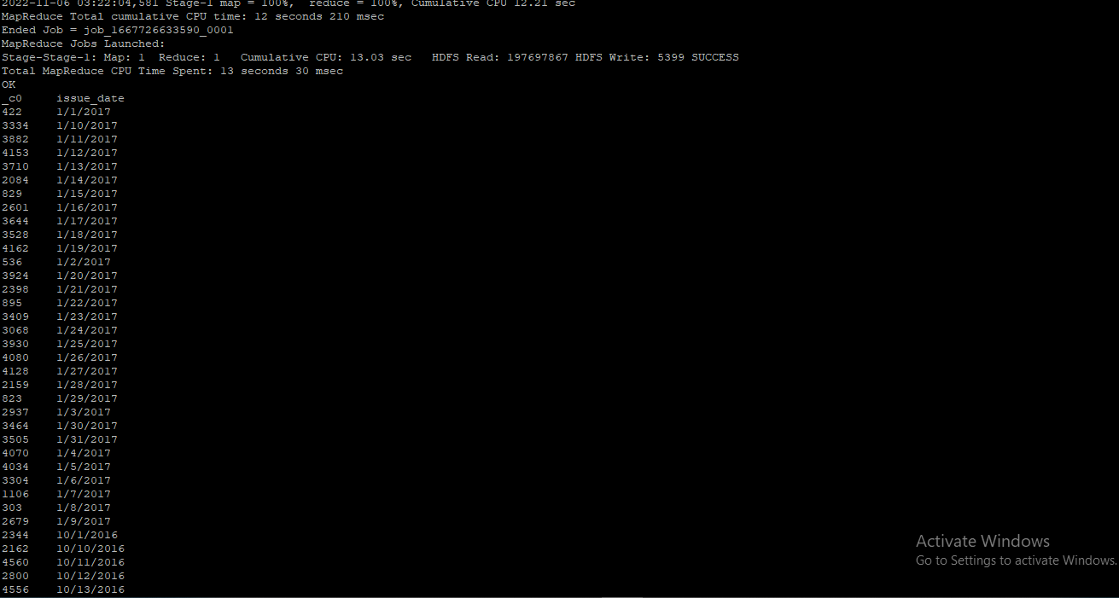

1. Find out how many unique states the cars which got parking tickets came from.

select distinct(registration_state) from parking_violation where summons_number is not null;

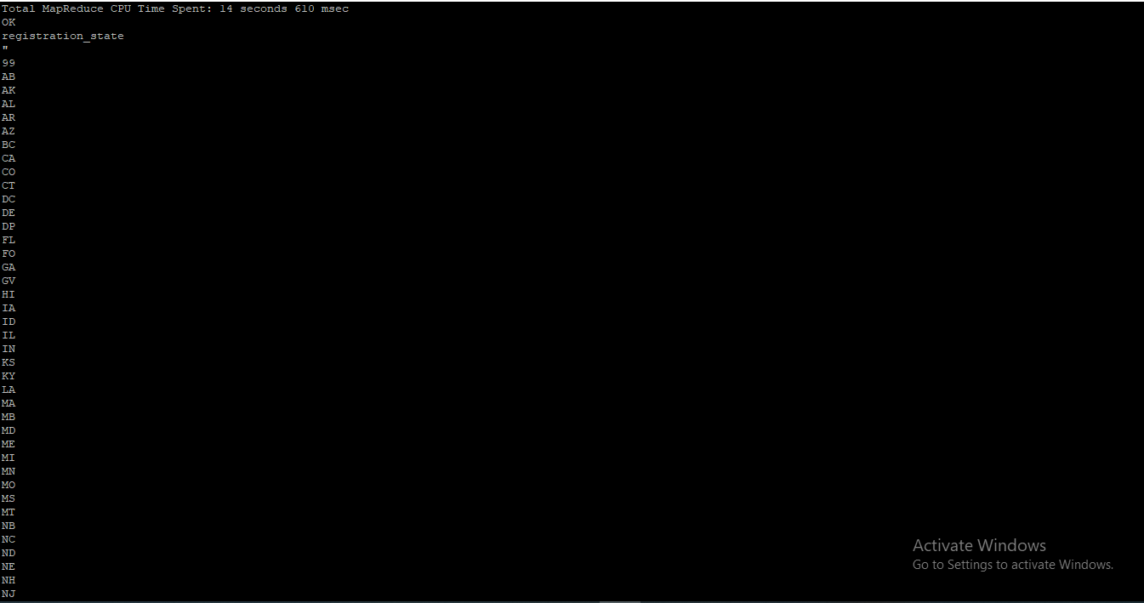

1. Some parking tickets don’t have addresses on them, which is cause for concern. Find out how many such tickets there are(i.e. tickets where either "Street Code 1" or "Street Code 2" or "Street Code 3" is empty )

select count(summons_number) from parking_violation where street_code_1 is not null or street_code_2 is not null or street_code_3 is not null

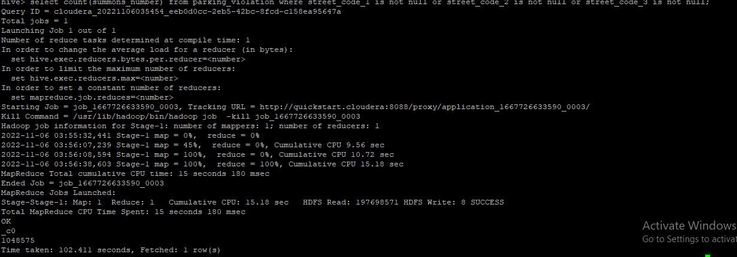

Part-II: Aggregation tasks

1. How often does each violation code occur? (frequency of violation codes - find the top 5)

select count(violation_code),violation_code from parking_violation group by violation_code order by violation code desc limit 5;

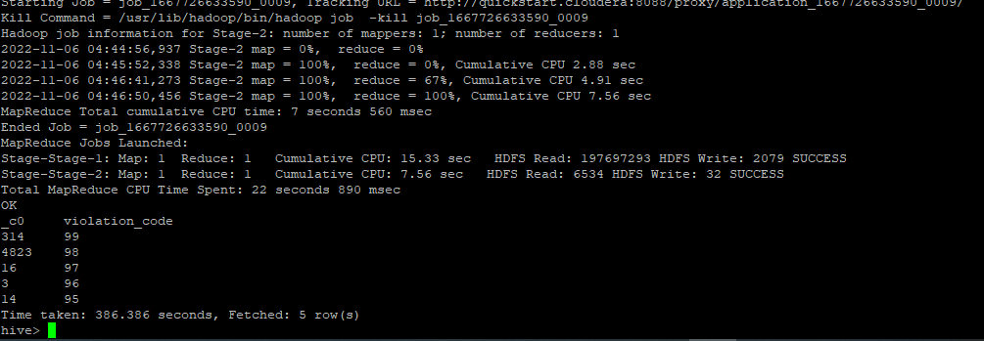

1. How often does each vehicle body type get a parking ticket? How about the vehicle make? (find the top 5 for both)

select count(summons_number)AS countA,vehicle_body_type from parking_violation group by vehicle_body_type order by countA desc limit 5;

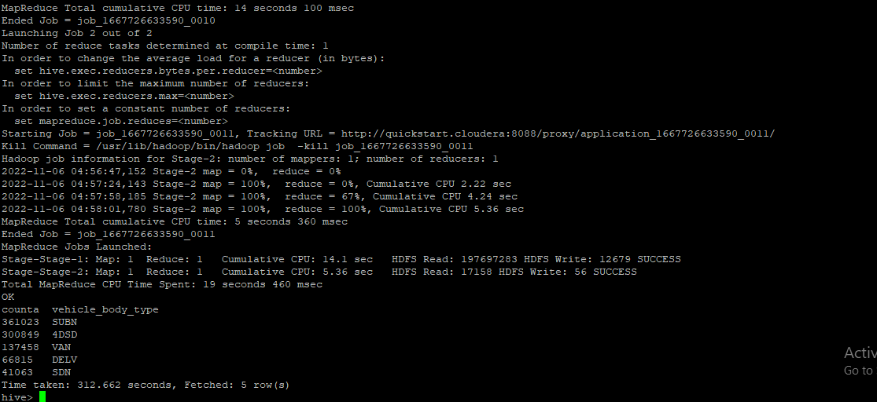

select count(summons_number)AS countA,vehicle_make from parking_violation group by vehicle_make order by countA desc limit 5;

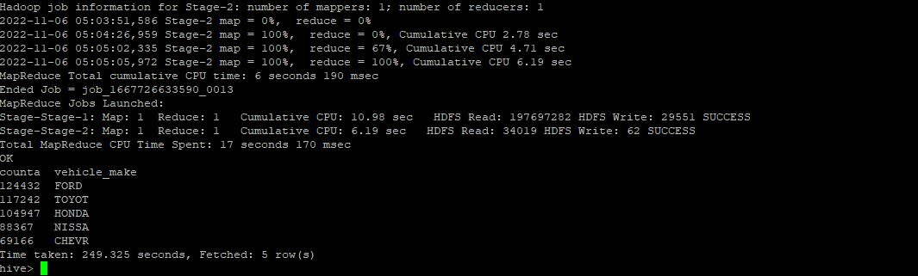

3.) A precinct is a police station that has a certain zone of the city under its command. Find the (5 highest) frequencies of:

a.) Violating Precincts (this is the precinct of the zone where the violation occurred)

select count(violation_precint), violation_precint from parking_violation group by violation_precint order by violation_precint desc limit 5;

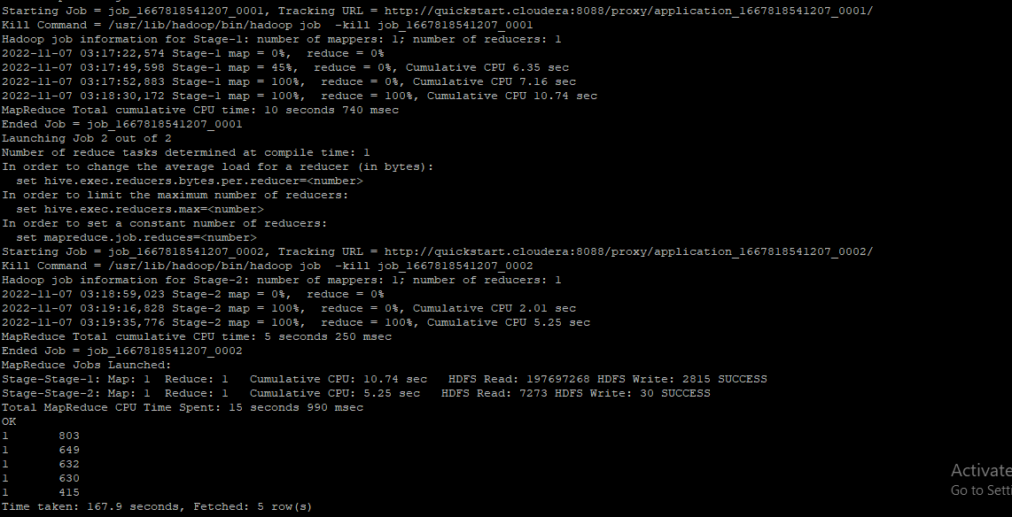

b.) Issuer Precincts (this is the precinct that issued the ticket)

select count(issuer_precint), issuer_precint from parking_violation group by issuer_precint order by issuer_precint desc limit 5;

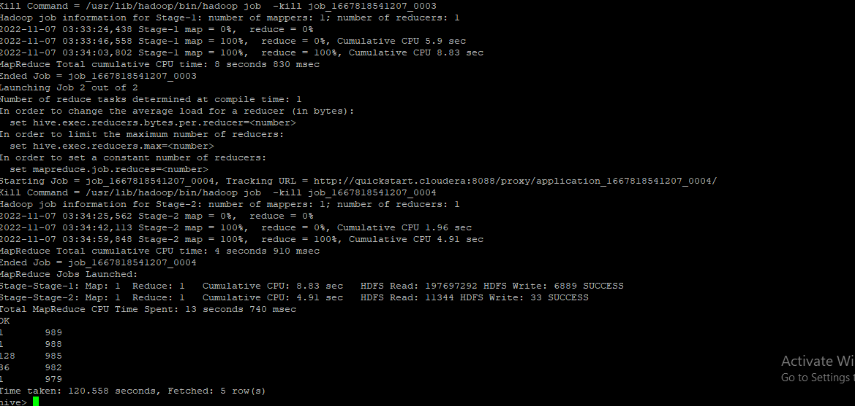

4.) Find the violation code frequency across 3 precincts which have issued the most number of tickets - do these precinct zones have an exceptionally high frequency of certain violation codes?

select count(summons_number),violation_code, issuer_precint from parking_violation group by issuer_precint,violation_code order by issuer_precint desc limit 3;

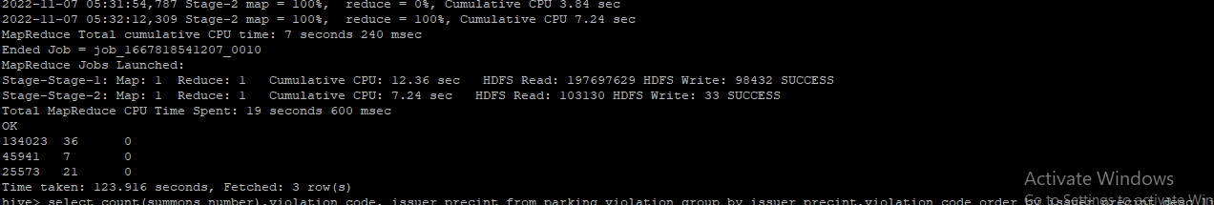

Issuer_precint with value 0 has issued maximum number of tickets. They have violation codes of 36,7,21 with a frequency of 1 each.

5.) Find out the properties of parking violations across different times of the day: The Violation Time field is specified in a strange format. Find a way to make this into a time attribute that you can use to divide into groups.

6.) Divide 24 hours into 6 equal discrete bins of time. The intervals you choose are at your discretion. For each of these groups, find the 3 most commonly occurring violations

To divide the 24 hrs into 6 equal discrete bins of time , First created view on partitioned table:

hive> create view vw_parking_violations_partitoned_2017

partitioned on (Violation_Code)

as

SELECT

Summons_Number,

Violation_Time,

Issuer_Precinct,

case

when substring(Violation_Time,1,2) in ('00','01','02','03','12') and upper(substring(Violation_Time,-1))='A' then 1

when substring(Violation_Time,1,2) in ('04','05','06','07') and upper(substring(Violation_Time,-1))='A' then 2

when substring(Violation_Time,1,2) in ('08','09','10','11') and upper(substring(Violation_Time,-1))='A' then 3

when substring(Violation_Time,1,2) in ('12','00','01','02','03') and upper(substring(Violation_Time,-1))='P' then 4

when substring(Violation_Time,1,2) in ('04','05','06','07') and upper(substring(Violation_Time,-1))='P' then 5

when substring(Violation_Time,1,2) in ('08','09','10','11') and upper(substring(Violation_Time,-1))='P'then 6

else null

end as Violation_Time_bin,

Violation_Code

from parking_violations_2017

where

Violation_Time is not null

or (length(Violation_Time)=5 and upper(substring(Violation_Time,-1))in ('A','P')

and substring(Violation_Time,1,2) in ('00','01','02','03','04','05','06','07', '08','09','10','11','12'));

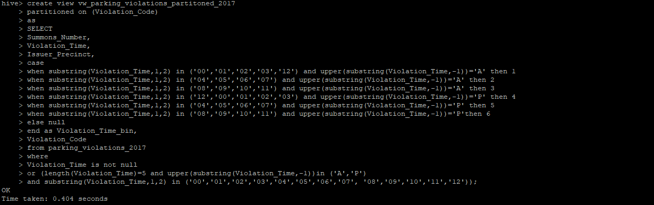

select Violation_Code,Violation_Time_bin, count(*) frequency_violation from vw_parking_violations_partitoned_2017 group by Violation_Code,Violation_Time_bin limit 5;

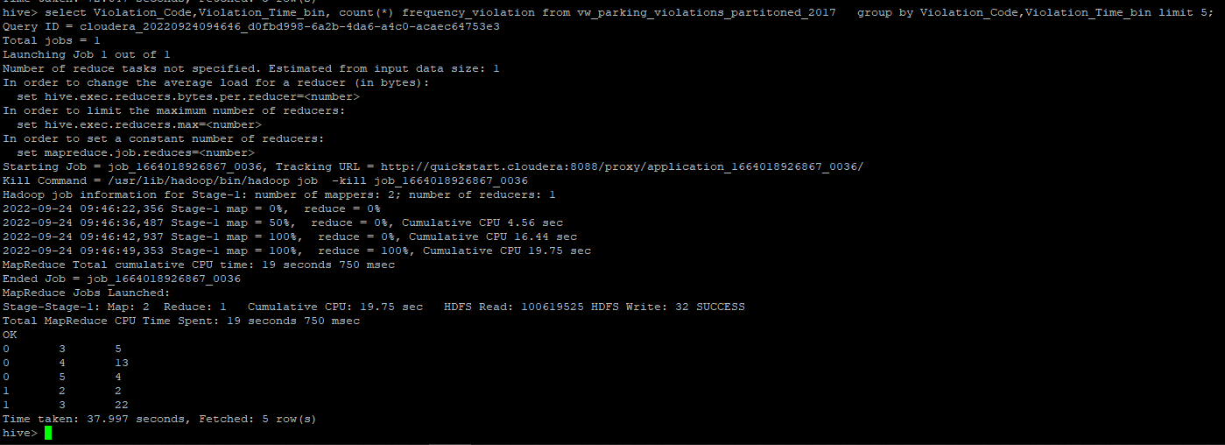

🡺bin1

select Violation_Code,count(*) frequency_violation from vw_parking_violations_partitoned_2017 where Violation_Time_bin =1 group by Violation_Code order by frequency_violation desc limit 3;b

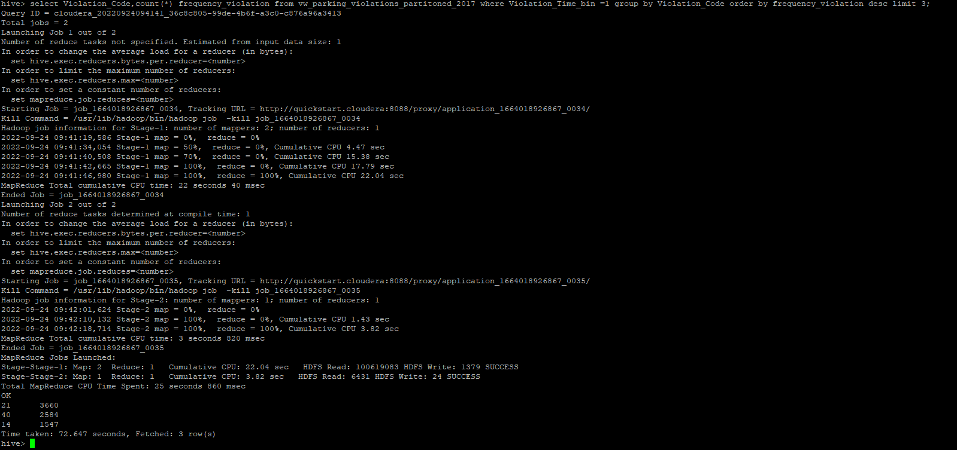

|  |  |
| --- | --- |
| **Violation_code** | **frequency_violation** |
| **21** | **3660** |
| **40** | **2584** |
| **14** | **1574** |

🡺bin 2

select Violation_Code,count(*) frequency_violation from vw_parking_violations_partitoned_2017 where Violation_Time_bin =2 group by Violation_Code order by frequency_violation desc limit 3;

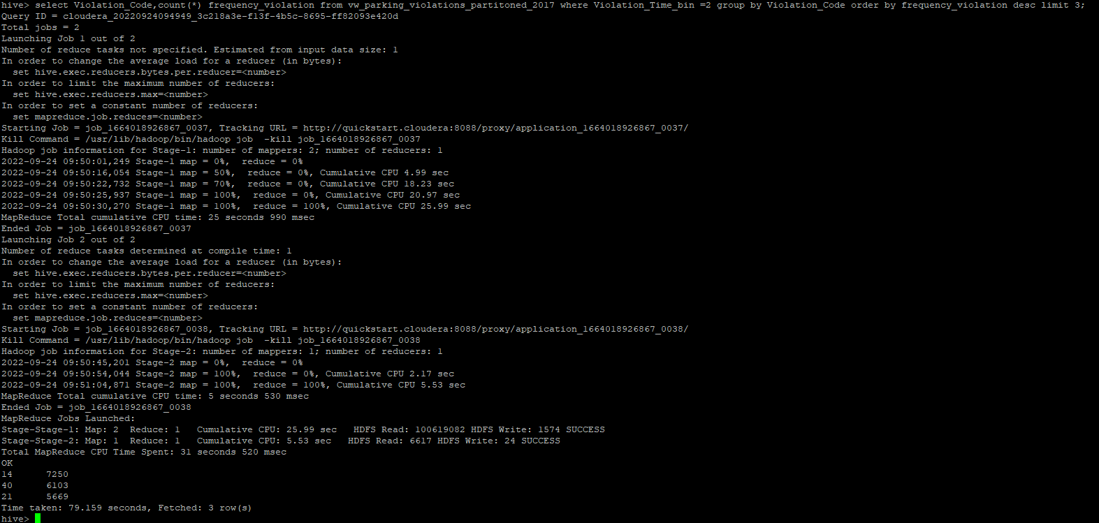

|  |  |
| --- | --- |
| Violation_code | frequency_violation |
| 14 | 7250 |
| 40 | 6403 |
| 21 | 5669 |

🡺bin 3

select Violation_Code,count(*) frequency_violation from vw_parking_violations_partitoned_2017 where Violation_Time_bin =3 group by Violation_Code order by frequency_violation desc limit 3;

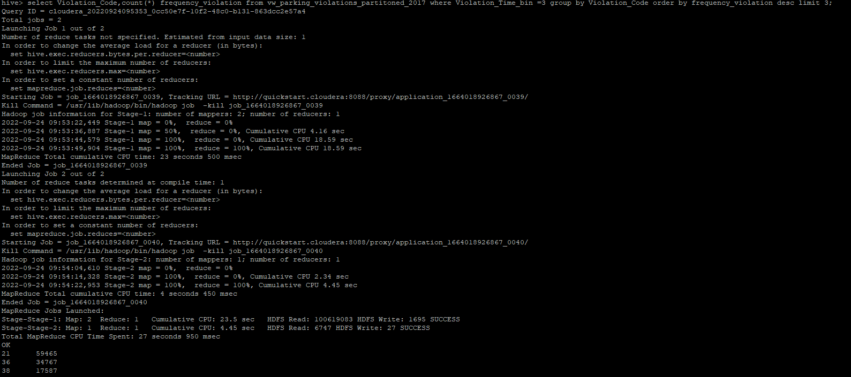

|  |  |
| --- | --- |
| Violation_code | frequency_violation |
| 21 | 59465 |
| 36 | 37767 |
| 38 | 17587 |

🡺bin 4

select Violation_Code,count(*) frequency_violation from vw_parking_violations_partitoned_2017 where Violation_Time_bin =4 group by Violation_Code order by frequency_violation desc limit 3;

|  |  |
| --- | --- |
| Violation_code | frequency_violation |
| 36 | 28600 |
| 38 | 23877 |
| 37 | 16777 |

🡺bin 5

select Violation_Code,count(*) frequency_violation from vw_parking_violations_partitoned_2017 where Violation_Time_bin =5 group by Violation_Code order by frequency_violation desc limit 3;

|  |  |
| --- | --- |
| Violation_code | frequency_violation |
| 38 | 10148 |
| 14 | 7609 |
| 37 | 6944 |

🡺bin 6

select Violation_Code,count(*) frequency_violation from vw_parking_violations_partitoned_2017 where Violation_Time_bin =6 group by Violation_Code order by frequency_violation desc limit 3;

|  |  |
| --- | --- |
| Violation_code | frequency_violation |
| 7 | 2602 |
| 40 | 2159 |
| 14 | 2091 |

7.) Now, try another direction. For the 3 most commonly occurring violation codes, find the most common times of day (in terms of the bins from the previous part)

Hive> select Violation_Time_bin, count(*) frequency_times from vw_parking_violations_partitoned_2017 where Violation_Code in (21, 38,36)

group by Violation_Time_bin order by frequency_times desc limit 3;

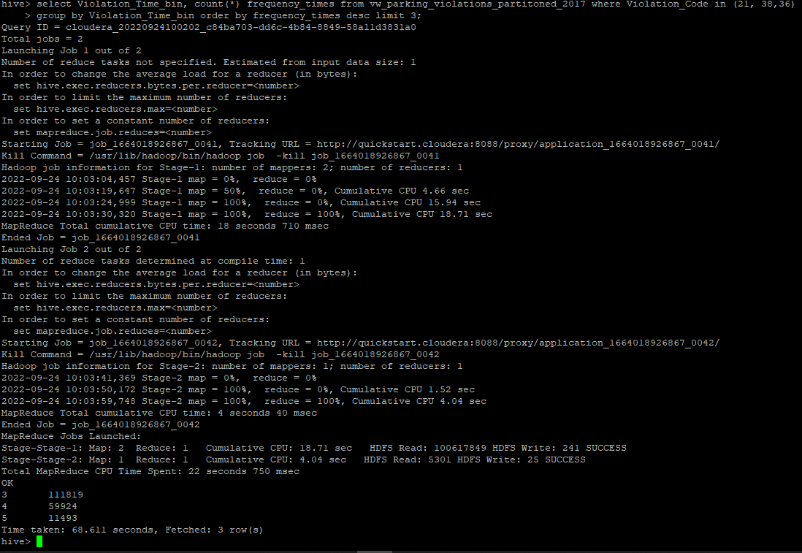

|  |  |
| --- | --- |
| Violation_Time_bin | frequency_times |
| 3 | 116785 |
| 4 | 76701 |
| 5 | 18437 |

8.) Let’s try and find some seasonality in this data

a.) First, divide the year into some number of seasons, and find frequencies of tickets for each season. (Hint: A quick Google search reveals the following seasons in NYC: Spring(March, April, March); Summer(June, July, August); Fall(September, October, November); Winter(December, January, February))

b.)Then, find the 3 most common violations for each of these seasons.

🡺Created View to divide the year into Seasons:

Hive> create view vw_tickets_issued_2017

partitioned on (Violation_Code)

as

select Issuer_Precinct,

case

when MONTH(Issue_Date) between 03 and 05 then 'spring'

when MONTH(Issue_Date) between 06 and 08 then 'summer'

when MONTH(Issue_Date) between 09 and 11 then 'autumn'

when MONTH(Issue_Date) in (1,2,12) then 'winter'

else 'unknown'

end as season,

Violation_Code

from parking_violations_2017;

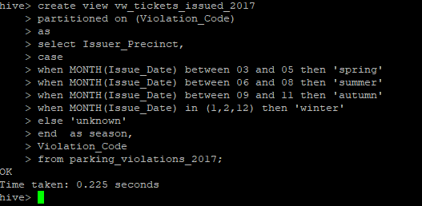

Hive> select season, count(*) as frequency from vw_tickets_issued_2017 group by season order by frequency desc;

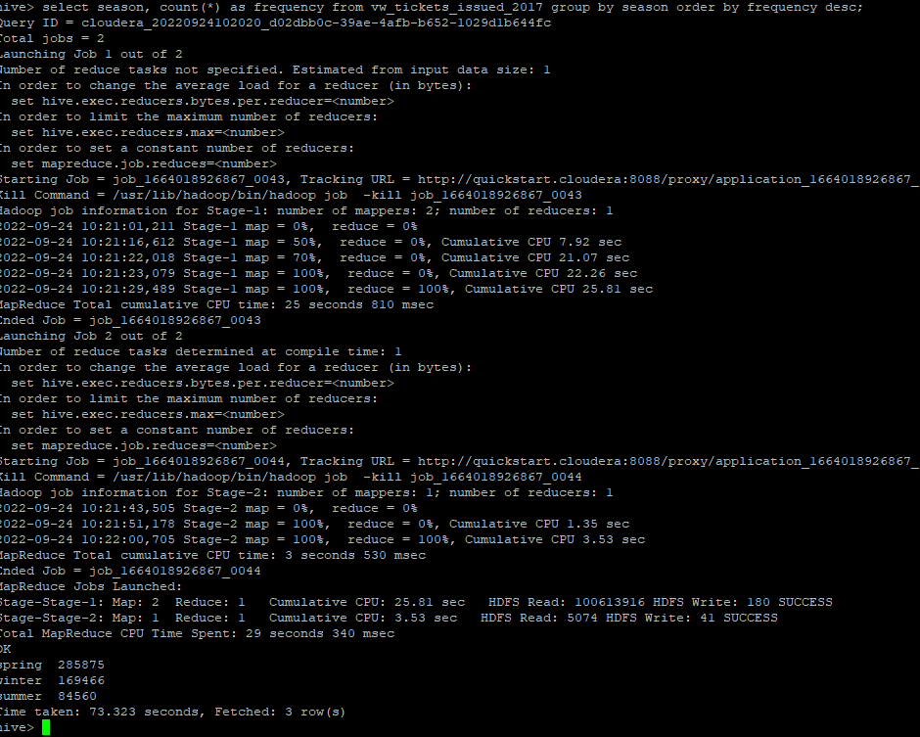

|  |  |
| --- | --- |
| Season | frequency |
| Spring | 285875 |
| Winter | 169466 |
| Summer | 84560 |
| autumn | 0 |

b.)Then, find the 3 most common violations for each of these seasons.

🡺spring season

select Violation_Code, count(*) as frequency from vw_tickets_issued_2017 where

season = 'spring' group by Violation_Code order by frequency desc limit 3;

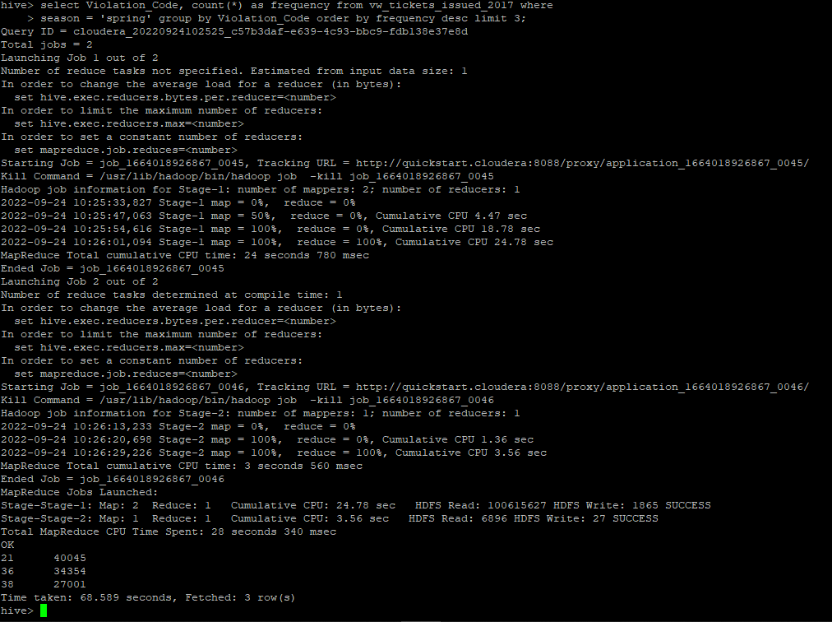

|  |  |
| --- | --- |
| Violation_Code | frequency |
| 21 | 40045 |
| 36 | 34354 |
| 38 | 27001 |

🡺winter season

select Violation_Code, count(*) as frequency from vw_tickets_issued_2017 where

season = 'winter' group by Violation_Code order by frequency desc limit 3;

|  |  |
| --- | --- |
| Violation_Code | frequency |
| 21 | 23684 |
| 36 | 22084 |
| 38 | 18450 |

🡺 summer season

select Violation_Code, count(*) as frequency from vw_tickets_issued_2017 where

season = 'summer' group by Violation_Code order by frequency desc limit 3;

|  |  |
| --- | --- |
| Violation_Code | frequency |
| 21 | 12565 |
| 36 | 9655 |
| 38 | 8331 |

🡺 autumn season

select Violation_Code, count(*) as frequency from vw_tickets_issued_2017 where

season = 'autumn' group by Violation_Code order by frequency desc limit 3;

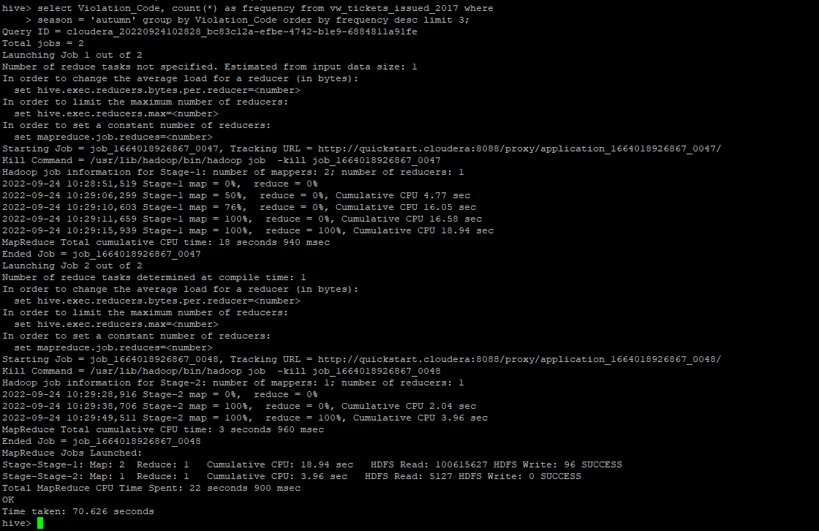

|  |  |
| --- | --- |
| Violation_Code | frequency |
|  |  |

Note: Please ensure you make necessary optimizations to your queries like selecting the appropriate table format, using partitioned/bucketed tables. Marks will be awarded for keeping the performance also in mind.

