1. Create a schema based on the given dataset

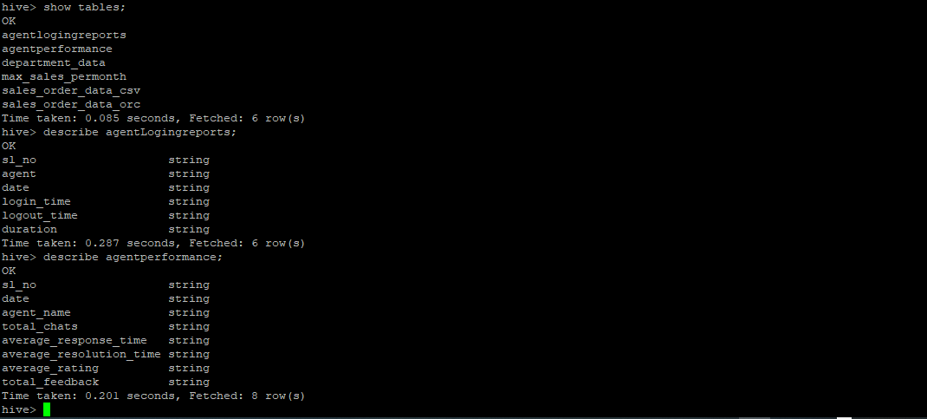

1. Dump the data inside the hdfs in the given schema location.
2. List of all agents' names.

select distinct(Agent) from agentlogingreport inner join

agentperformance on agentlogingreport.Agent = agentperformance.Agent_Name;

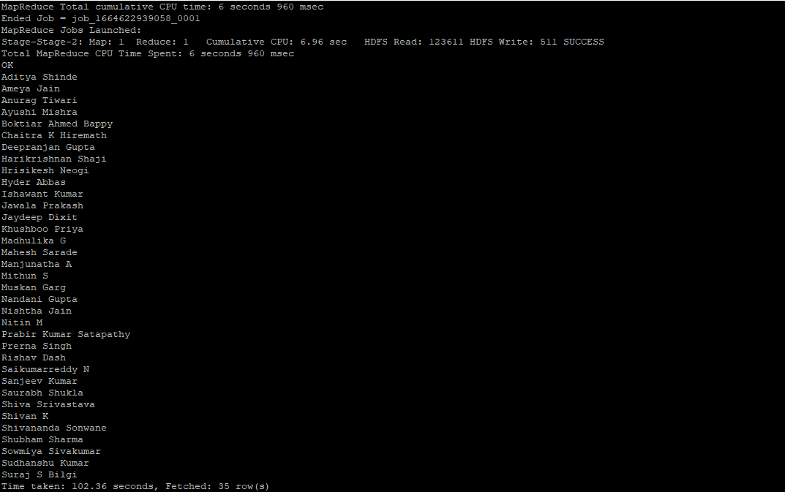

1. Find out agent average rating.

Select distinct(Agent_Name), Average_Rating from agentperformance inner join

agentlogingreports on agentlogingreports.Agent = agentperformance.Agent_Name

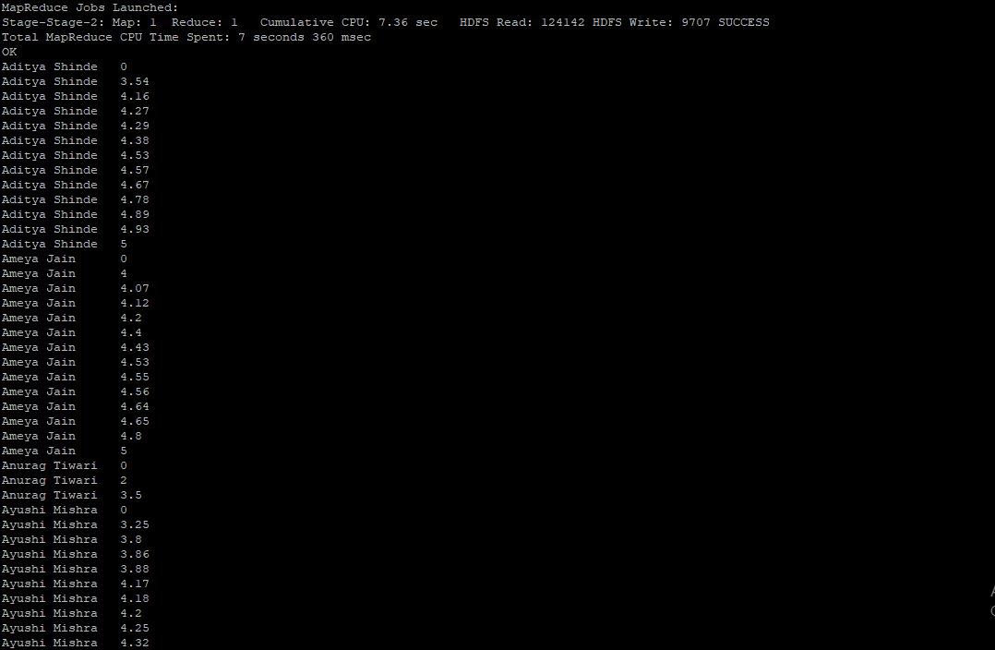

1. Total working days for each agents

Select Agent, count(Date) from agentlogingreports

group by Agent;

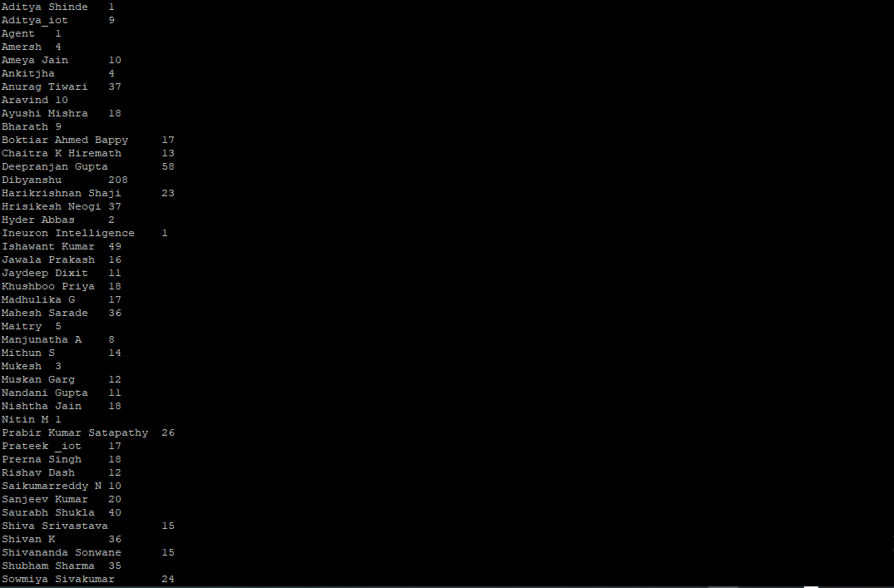

1. Total query that each agent have taken

Select Agent_Name , sum(Total_Chats) from agentperformance

group by Agent_Name;

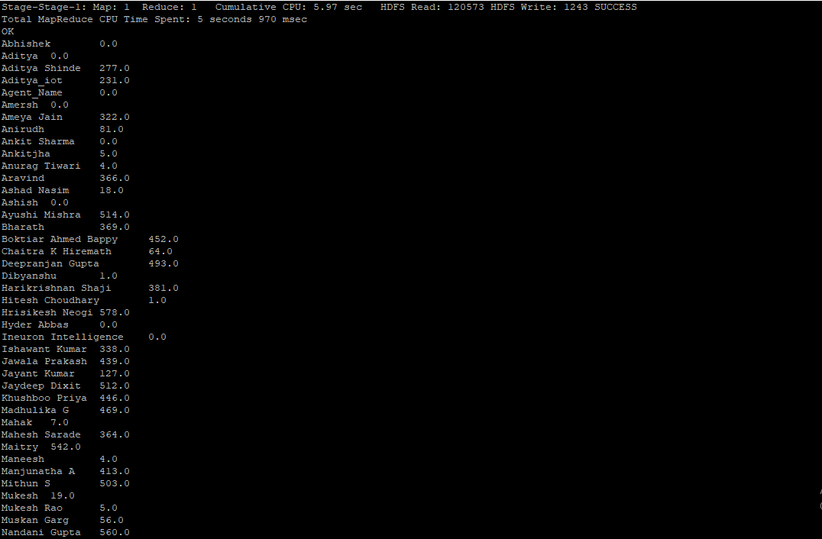

1. Total Feedback that each agent have received

Select Agent_Name , sum(Total_Feedback) from agentperformance

group by Agent_Name;

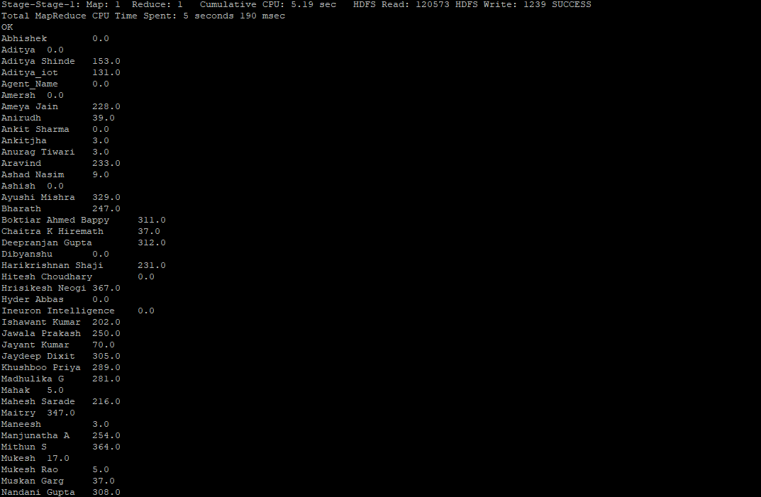

1. Agent name who have average rating between 3.5 to 4

select Agent_Name , Average_Rating from agentperformance where Average_Rating

between 3.5 and 4 group by Agent_Name, Average_Rating;

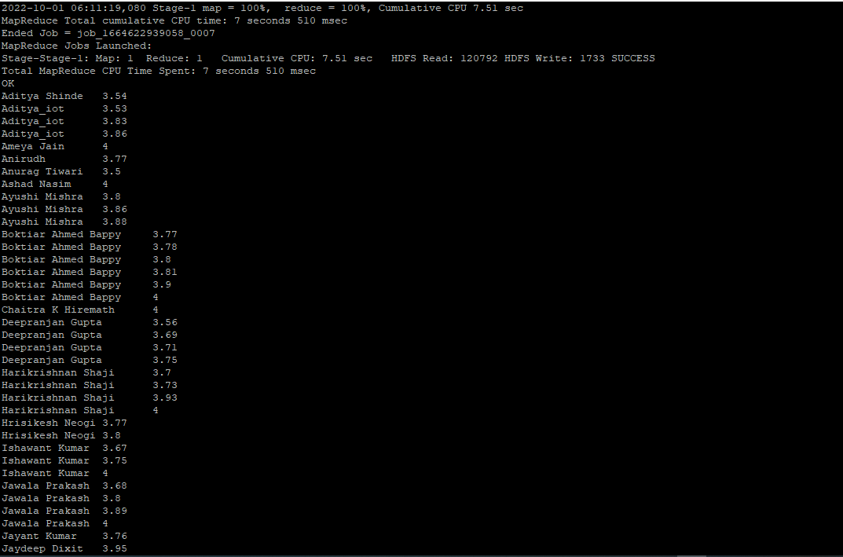

1. Agent name who have rating less than 3.5

select Agent_Name , Average_Rating from agentperformance where Average_Rating < 3.5

group by Agent_Name, Average_Rating;

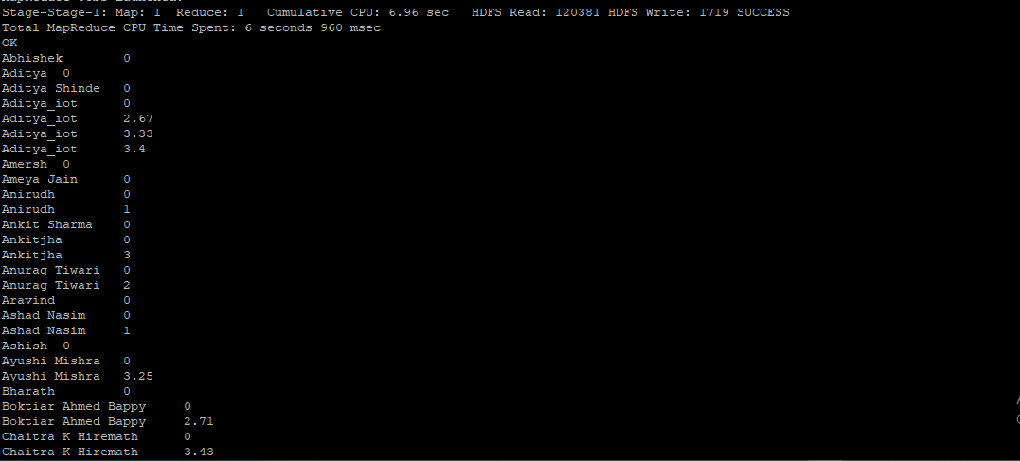

1. Agent name who have rating more than 4.5

select Agent_Name , Average_Rating from agentperformance where Average_Rating >4.5

group by Agent_Name, Average_Rating;

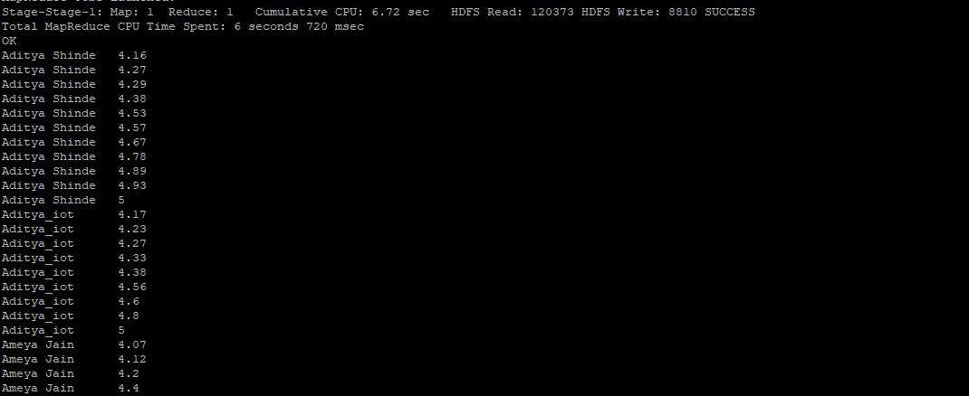

1. How many feedback agents have received more than 4.5 average

Select Agent_Name , sum(Total_Feedback) from agentperformance

where Average_Rating > 4.5 group by Agent_Name;

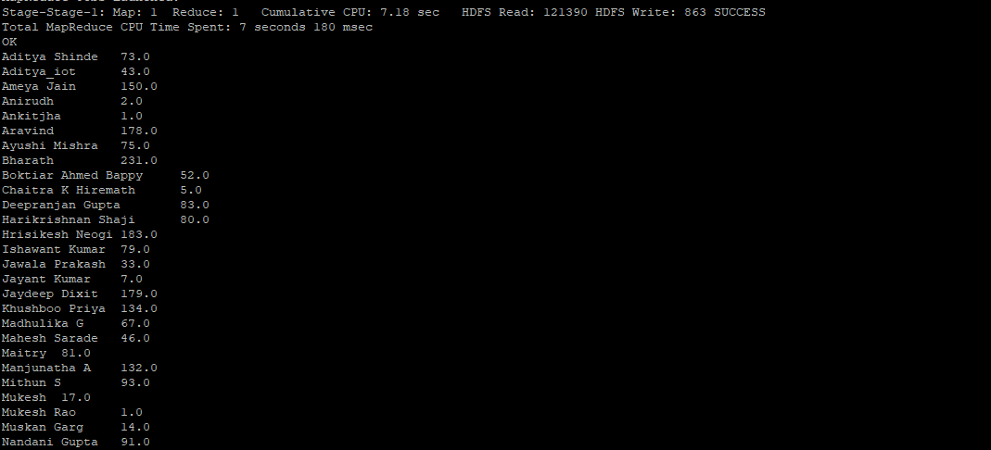

1. average weekly response time for each agent

Select Agent_Name, Average_Response_Time from agentperformance

group by Agent_Name, Average_Response_Time;

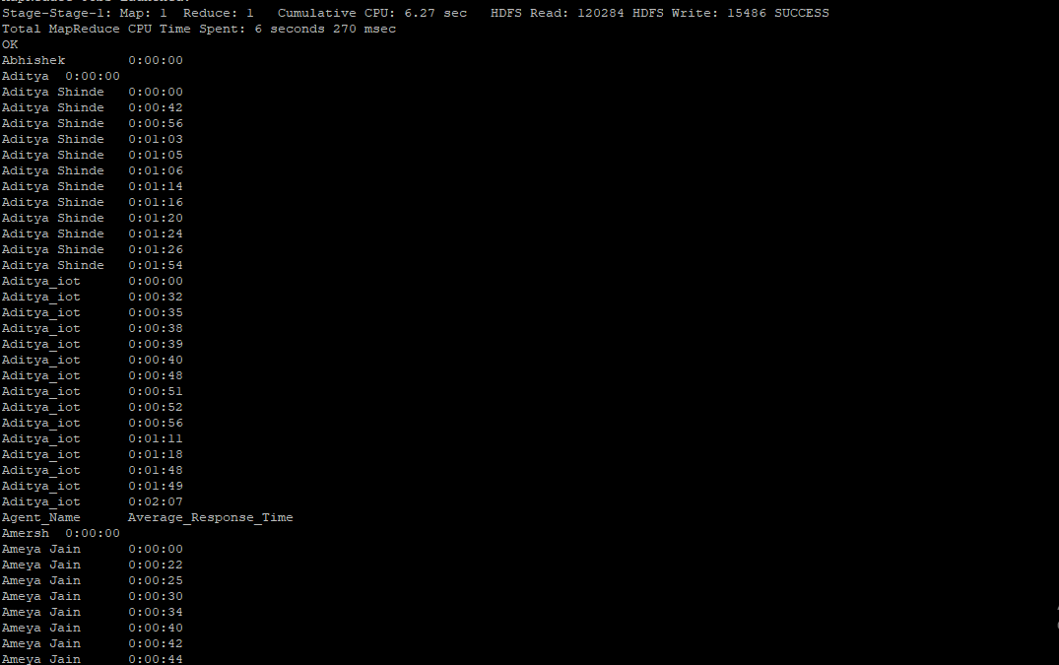

1. average weekly resolution time for each agents

Select Agent_Name, Average_Resolution_Time from agentperformance

group by Agent_Name, Average_Resolution_Time;

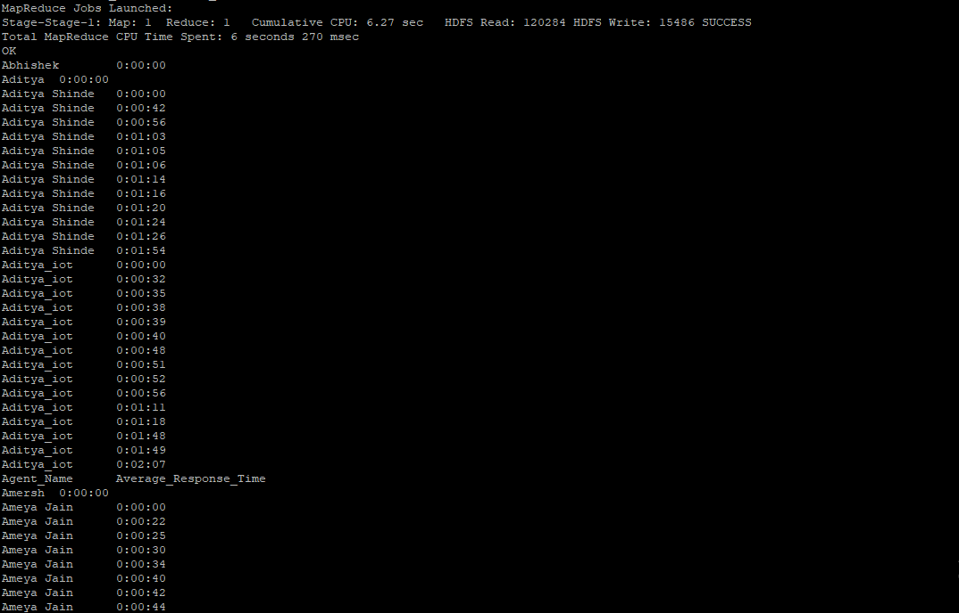

1. Find the number of chat on which they have received a feedback

select Agent_Name, Total_Chats from agentperformance where Total_Feedback is not null

group by Agent_Name,Total_Chats;

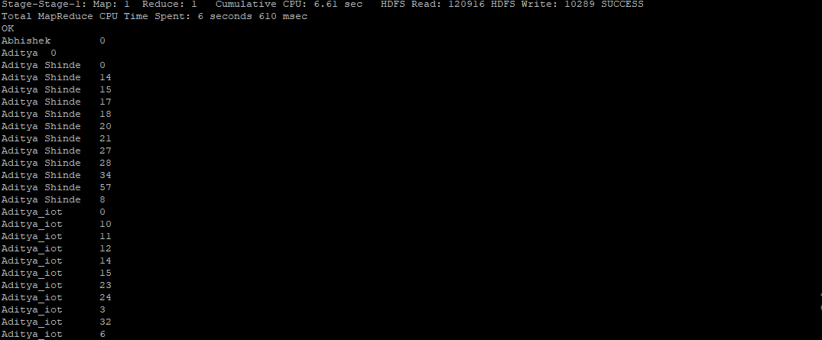

15. Total contribution hour for each and every agents weekly basis

16. Perform inner join, left join and right join based on the agent column and after joining the table export that data into your local system.

Innerjoin: Select * from agentlogingreports inner join agentperformance

on agentlogingreports.Agent = agentperformance.Agent_Name

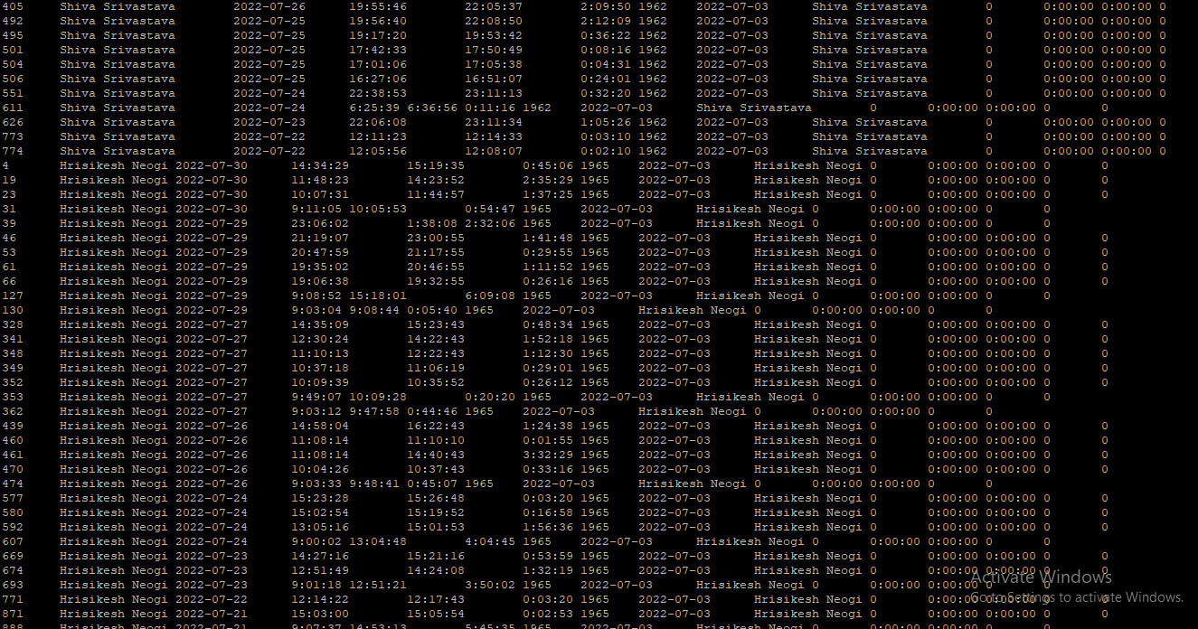

Left join:

Select * from agentlogingreports left join agentperformance on agentlogingreports.Agent = agentperformance.Agent_Name limit 50;

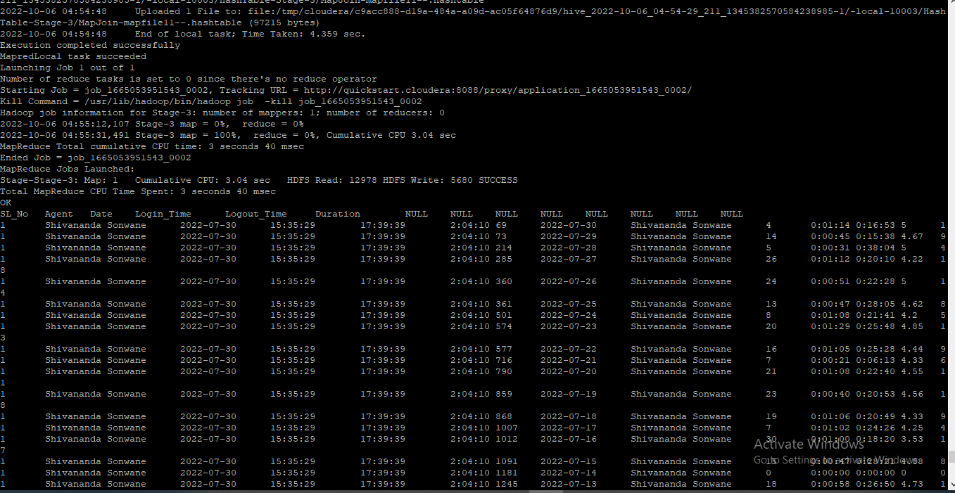

Right join:

Select * from agentlogingreports right join agentperformance

on agentlogingreports.Agent = agentperformance.Agent_Name limit 50;

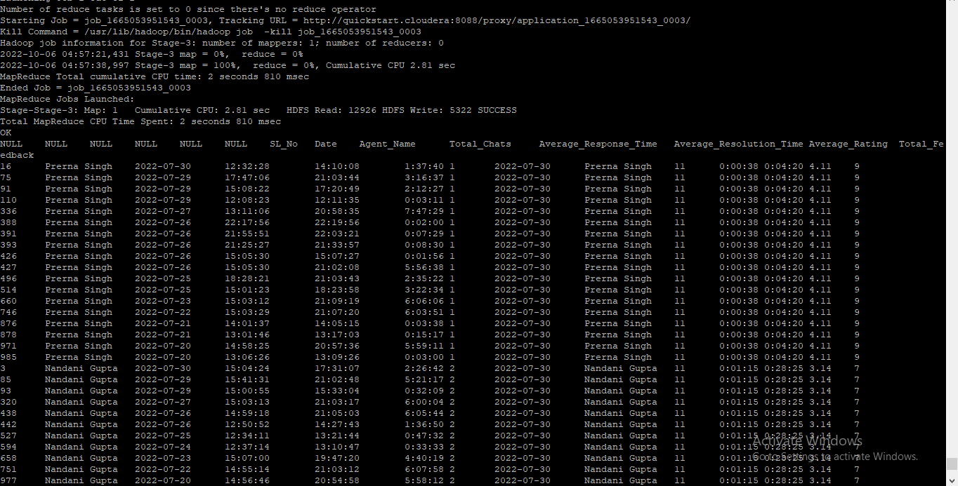

17. Perform partitioning on top of the agent column and then on top of that perform bucketing for each partitioning.

Creation of static partition table based on agent

hive> create table agent_partition

> (

> SL_No string,

> Date string,

> Login_time string,

> Logout_time string,

> Duration string

> )

> partitioned by (Agent string);

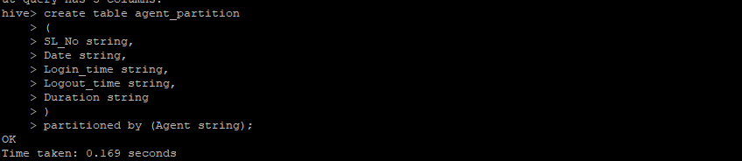

Overwriting the data into the newly created table based on the partition criteria

Query: insert overwrite table agent_partition partition(Agent = 'Mukesh') select sl_no,date,login_time,logout_time,duration from agentlogingreports where agent = 'Mukesh';

