**Project on WordPress Blog Hosting on AWS**

**Abstract**

This project presents a comprehensive solution for hosting a WordPress instance on AWS for a global media company. The company requires a scalable and resilient infrastructure to publish blogs and provide documentation services. The proposed solution includes setting up a live WordPress environment and a separate development environment, implementing media storage using S3, integrating with RDS for database management, and employing auto-scaling to optimize resource utilization. Additionally, Route 53 is configured to monitor the health of the WordPress instance. The following document outlines the project agenda, solution architecture, detailed implementation steps, technical concepts, benefits, challenges, and future scope.

**1. Introduction**

In the digital era, global media companies rely on efficient content management systems to publish blogs, articles, and documentation. The objective of this project is to set up a reliable, secure, and scalable WordPress hosting solution on AWS that supports both live and development environments. As a cloud architect, the responsibility involves designing a robust architecture that integrates AWS services while ensuring optimal performance and high availability. This thesis details the complete setup process, focusing on leveraging AWS services to maximize uptime and resource management.

**2. Project Agenda  
  
The goal of this project is to establish a WordPress hosting environment suitable for a global media company. The setup must include both a live instance for publishing blogs and a separate development instance for testing and updates. The live instance will be available 24/7, while the development instance will be restricted to business hours (9 AM - 6 PM IST). To optimize media management, AWS S3 will be integrated for efficient media storage, and AWS RDS will be used for database hosting to ensure data persistence. To further enhance efficiency, auto-scaling will be implemented to automatically start and stop instances based on a schedule. Additionally, AWS Route 53 will be configured to monitor the health of the WordPress instance to ensure consistent availability.**

The primary objectives of the project are as follows:

* Deploy a live WordPress instance for blog publishing.
* Deploy a separate WordPress instance for development and testing, restricted to business hours (9 AM - 6 PM IST).
* Integrate AWS S3 for efficient media storage and management.
* Utilize RDS for database hosting to ensure data persistence.
* Implement auto-scaling for the EC2 instance to optimize usage.
* Set up Route 53 for monitoring the health of the WordPress instance.

**3. Detailed Project Solution**

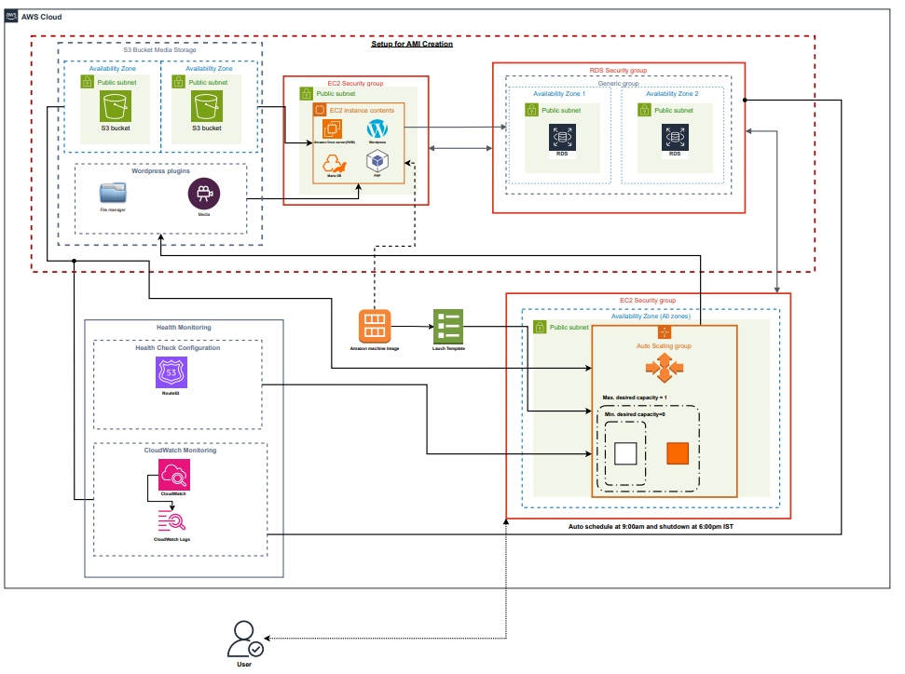

**3.1 AWS Service Selection and Architecture  
  
The primary services utilized in this project are EC2, RDS, S3, IAM, Auto Scaling, and Route 53. EC2 serves as the primary hosting platform for the WordPress application, offering the flexibility to scale based on demand. RDS provides a managed database solution that ensures reliable data storage and retrieval. AWS S3 is integrated for media storage, allowing for scalable and cost-efficient handling of media files. IAM is used for secure access management, while Auto Scaling helps manage instance availability efficiently. Finally, Route 53 ensures that the instance's health is continuously monitored.**

* **EC2 (Elastic Compute Cloud):** Primary hosting for WordPress.
* **RDS (Relational Database Service):** Managed database to store WordPress data.
* **S3 (Simple Storage Service):** Media storage and management.
* **IAM (Identity and Access Management):** Access control for S3 and EC2.
* **Auto Scaling:** Manage instance availability based on schedules.
* **Route 53:** Health checks and domain management.

**3.2 Setting Up the WordPress Instance**

**To start, an EC2 instance is launched using the Amazon Linux AMI. Essential components like Apache, MySQL, and PHP are installed, forming the LAMP stack required to run WordPress. Once the server environment is set up, the WordPress software is downloaded and configured. The wp-config.php file is updated with database credentials to connect to the RDS instance, ensuring that the website content and data are securely stored and managed.**

* Launch an EC2 instance with the Amazon Linux AMI.
* Install Apache, MySQL, and PHP (LAMP stack).
* Download and configure WordPress on the EC2 instance.
* Connect WordPress to RDS by updating the wp-config.php file with database credentials.

**3.3 Configuring Media Storage with S3**

**For efficient media management, an S3 bucket is created and configured to allow public read access. Within the WordPress dashboard, the WP Offload Media plugin is installed to seamlessly offload media files to the S3 bucket. To grant WordPress the necessary permissions, an IAM user is created with AmazonS3FullAccess. The API keys generated for this user are stored in the wp-config.php file, facilitating secure integration. To verify the setup, media files are uploaded through WordPress, and the URLs are checked to ensure they point to the S3 bucket, confirming proper offloading.**

* Create an S3 bucket and enable public read access.
* Install the **WP Offload Media** plugin in WordPress.
* Create an IAM user with **AmazonS3FullAccess** and generate API keys.
* Add access keys to wp-config.php for secure integration.
* Verify media upload to ensure proper S3 integration.

**3.4 Database Configuration using RDS**

**An RDS instance is launched to serve as the database backend for WordPress. The database instance is configured with MySQL, and a security group is set up to allow inbound connections specifically from the EC2 instance. After configuring RDS, the WordPress application is connected to the database, and a sample blog post is created to test database functionality.**

* Launch an RDS instance with MySQL.
* Set up a security group to allow inbound connections from the EC2 instance.
* Configure the database to accept connections from the WordPress EC2 instance.

**3.5 Setting Up Auto Scaling**

**To optimize resource usage, a custom Amazon Machine Image (AMI) is created from the configured WordPress instance. This AMI serves as the template for launching new instances during auto-scaling. A launch template is created using this AMI, followed by configuring an Auto Scaling group with a schedule that aligns with business hours. The desired capacity is set to 1 during active hours and 0 during off-hours, ensuring that the instance is only running when needed, thus reducing costs.**

* Create a custom AMI of the configured WordPress EC2 instance.
* Set up a launch template with the custom AMI.
* Create an Auto Scaling group with a schedule from 9:00 AM to 6:00 PM IST.
* Configure the desired capacity to 1 during business hours and 0 otherwise.

**3.6 Route 53 Health Check Configuration**

**Route 53 is configured to continuously monitor the health of the EC2 instance. The health check is set to verify that the instance is running and responding correctly. If the health check detects any issues, notifications are sent, allowing for timely intervention. This ensures the website remains accessible and functional, minimizing downtime.**

* Create a Route 53 health check for the auto-scaled EC2 instance.
* Set up a monitoring interval and define the expected response time.
* Link the health check to the EC2 instance to receive real-time status updates.

**4. Technical Concepts and Best Practices**

**One of the critical aspects of this setup is configuring security groups correctly. Allowing inbound connections only from specific IP addresses mitigates security risks. Additionally, assigning IAM roles with minimal permissions is crucial to maintaining a secure environment. Performance tuning is another essential aspect, where selecting the appropriate instance size, like t2.micro for development, helps reduce costs. For scaling, integrating an Elastic Load Balancer (ELB) can distribute traffic evenly when the site expands.**

* **Security Group Configuration:** Ensuring restricted access to the database by allowing only specific IP addresses.
* **IAM Role Management:** Assigning minimal required permissions to enhance security.
* **Performance Tuning:** Optimizing the EC2 instance size (t2.micro for development) to reduce costs.
* **Load Balancing (optional):** Integrating an ELB to distribute traffic if the site scales.

**5. Benefits of the Proposed Solution**

**The proposed setup offers cost efficiency by leveraging auto-scaling to limit resource usage outside of business hours. High availability is ensured through scheduled uptime and consistent monitoring via Route 53. Media management is streamlined using S3, and data security is maintained with IAM-controlled access. Moreover, the setup’s scalability allows for future expansion, accommodating increased traffic and content volume.**

* **Cost Efficiency:** Auto-scaling minimizes resource utilization outside business hours.
* **High Availability:** Scheduled uptime ensures the site is available during business hours.
* **Data Security:** S3 with IAM-controlled access reduces the risk of unauthorized data exposure.
* **Scalability:** The setup can easily be extended to multiple instances as demand grows.

**6. Challenges and Mitigations**

**One challenge is managing the complexity of IAM and security group configurations. This can be addressed by following AWS best practices and implementing strict policies. Additionally, scheduled downtime might trigger health check failures, which can be mitigated by configuring Route 53 to recognize the schedule. Ensuring data consistency is critical, and enabling automatic backups for RDS helps maintain data integrity.**

* **Configuration Complexity:** Setting up IAM and security groups can be daunting. To mitigate, use AWS best practices and policies.
* **Health Check Downtime Alerts:** Scheduled instance downtime may trigger false health alerts. Proper configuration in Route 53 mitigates this.
* **Data Consistency:** Configuring the RDS instance for automatic backups ensures data integrity.

**7. Future Improvements**

**As the platform scales, implementing multi-AZ RDS for higher availability is recommended. CloudFront can be integrated to improve content delivery speeds, and automating backup and restore processes will further enhance data security and disaster recovery capabilities.**

* Implementing multi-AZ RDS for higher availability.
* Integrating CloudFront for faster content delivery.
* Automating backup and restore processes for the WordPress database.

**8. Conclusion**

This project outlines the structured process of setting up a WordPress hosting environment using AWS. The combination of EC2, RDS, S3, IAM, and Route 53 provides a comprehensive solution for managing a scalable and efficient blog hosting platform. The proposed setup not only enhances performance and scalability but also significantly reduces operational costs by leveraging auto-scaling and scheduled uptime. The document provides a solid foundation for further improvements, including advanced monitoring and multi-region deployment.

Hosting WordPress on AWS offers a robust, scalable, and cost-efficient solution for global media companies. By leveraging EC2, RDS, S3, IAM, Auto Scaling, and Route 53, this setup ensures reliable performance and high availability. Future improvements will further enhance the platform's resilience and scalability, providing a flexible foundation for growing content management needs.