**Automated Jenkins Backup and Restore System using AWS S3 and Docker Multi-Container Setup**

**Real-time scenario:**

You are a DevOps Engineer at TechNova Inc., which relies heavily on Jenkins for continuous integration and deployment of its various applications. The company recently experienced a critical incident where the Jenkins server crashed, resulting in the loss of important build configurations and job data. To mitigate the risk of future data loss and ensure business continuity, you are tasked with implementing a backup and restore solution for Jenkins using AWS S3. This solution must securely store Jenkins data in S3, automate backups, and facilitate a quick restore process in case of server failure. Your tasks include setting up automated scripts for backups, configuring IAM roles for secure access, and testing the restore process to ensure that Jenkins can be rapidly restored with minimal downtime.

Industry Relevance

The tools used in this project each serve specific purposes within the industry:

1. Jenkins: It is a leading automation tool for CI/CD, streamlining the build, test, and deployment process in DevOps workflows. It is widely adopted across industries due to its extensibility through plugins and robust community support.
2. Git: It is the industry standard for version control, enabling efficient collaboration, code tracking, and integration in CI/CD pipelines. Its versatility and open-source nature make it essential for modern software development.
3. AWS: It is the top cloud service provider, offering scalable and secure cloud infrastructure for businesses of all sizes. It supports high availability, compliance, and a wide range of services that drive innovation and operational efficiency.

**Solution:**

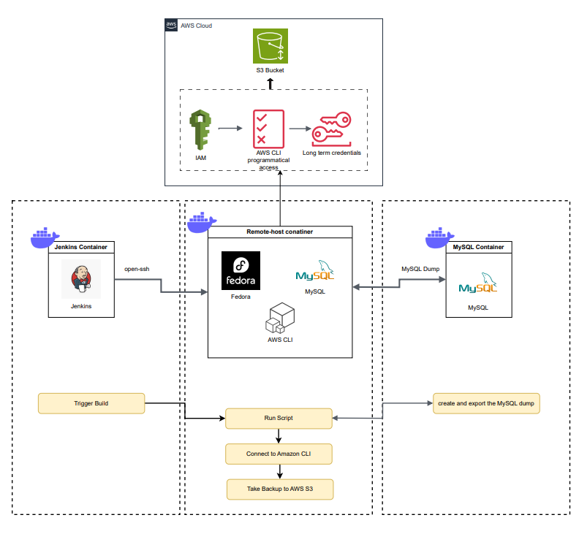

Solution Approach

To solve this, a multi-container Docker application was developed, orchestrating Jenkins, MySQL, and a Fedora-based remote host to manage automated backups and S3 interactions.

Architecture Components:

* Jenkins Container: Hosts the CI/CD server. Connected to the remote-host to trigger the backup job.
* MySQL Container: Stores Jenkins-related data, simulating a production database.
* Remote-Host Container (Fedora OS): Runs AWS CLI and MySQL client tools via a custom Dockerfile. Executes the backup script.

Core Workflow:

1. Jenkins Build Trigger:
   * Jenkins initiates a build which connects to the remote-host container.
   * This is parameterized within Jenkins UI for flexible automation.
2. Remote Backup Execution:
   * The remote-host runs a shell script that:
     + Connects to the MySQL container via Docker's internal network.
     + Executes a mysqldump to capture a snapshot of the database.
     + Uploads the compressed dump file to a pre-configured Amazon S3 bucket using the AWS CLI.
3. Automation & Security:
   * IAM roles and access keys are carefully configured to grant secure, least-privileged access to S3.
   * Backups are timestamped and stored in an organized structure for easy retrieval.
   * Restore scripts can be run manually or scheduled for automated restoration.

Key Features

* 🛠️ Multi-Container Architecture: Isolated services running in Docker containers for better scalability and manageability.
* 🔐 Secure S3 Integration: IAM credentials and roles are managed securely for S3 operations.
* 🕒 Automated Backups: No manual intervention is required; backups occur on build triggers.
* 💾 Disaster Recovery Ready: Quick restoration process with minimal downtime.
* 📦 Scripted and Reproducible: Infrastructure and scripts are version-controlled and reusable.

**Breakdown of the project:**  
**Step 1: Create the Jenkins Container**

* We used Docker to spin up a **Jenkins container**.
* Logged in through the browser at localhost:8080.
* Set up credentials and made it ready to trigger jobs.

**Step 2: Set Up Multi-Container System using Docker Compose**

* Created a docker-compose.yml file to define all our services.
* This included:
  + **Jenkins** service
  + **MySQL** service (later added)
  + **Remote Host (Fedora)** service

**Step 3: Create the Remote Host (Fedora) Container**

* Built a custom **Fedora-based Docker container** using a Dockerfile.
* Added a new Linux user: remote_user.
* Configured SSH so Jenkins can connect securely.
* Named this service remote_host in the docker-compose.yml so that Jenkins can talk to it easily over Docker’s internal network.

**Step 4: Connect Jenkins to Remote Host via SSH**

* Logged into the Jenkins container and **SSH’d into the remote-host** to verify connection.
* On Jenkins, generated an **RSA SSH key pair**.
* Stored the **private key in Jenkins credentials** for secure script triggering.

**Step 5: Set Up MySQL**

* Added the **MySQL container** in docker-compose.yml.
* Used a MySQL image and exposed ports.
* On startup:
  + Created a sample **database and a table** (for testing backup).

**Step 6: Add AWS CLI and MySQL Client to Remote Host**

* Updated the Fedora container to install:
  + **MySQL client** – to take database dumps.
  + **AWS CLI** – to upload the dumps to an **S3 bucket**.

**Step 7: Write the Backup Script**

The script:

* Connects to MySQL using the container’s internal name.
* Dumps the data into a .sql file.
* Uploads it to the S3 bucket using the AWS CLI.

**Step 8: Trigger the Script from Jenkins**

* On the Jenkins web dashboard:
  + Created a **parameterized Jenkins job**.
  + Added a **build step that SSHs into the remote_host**.
  + Jenkins then runs the backup script on the Fedora container.

Every time the Jenkins job runs, it connects to the remote-host, takes a MySQL backup, and uploads it to S3—**automatically**.

**Details on the setup**:

* **Automated:** No more manual backups.
* **Dockerized:** Isolated environments are easy to manage.
* **Secure:** SSH keys and AWS IAM policies make it safe.
* **Scalable:** You can extend this to backup other apps or databases.
* **Disaster-Proof:** If Jenkins crashes, you can restore from the S3 backup quickly

**Working of the project:**The working of this project revolves around creating an automated backup solution using Jenkins and a multi-container Docker setup, with the final backup being securely uploaded to Amazon S3. It all begins with setting up a Jenkins container using Docker. Once the container is up, Jenkins is accessed through the browser (typically on port 8080), where the initial setup, including credentials and configurations, is completed to prepare the Jenkins environment for automation tasks.

After Jenkins is running, we define our services using a docker-compose.yml file. Alongside Jenkins, a second container is created using a custom Dockerfile. This container is based on the Fedora operating system and is designed to act as a "remote host." Inside this Fedora container, a new user called remote_user is added, and SSH is configured so that Jenkins can securely connect and trigger scripts inside this container. The docker-compose.yml file is then updated to include this new container as a service named remote_host, allowing other containers, particularly Jenkins, to recognize and communicate with it using Docker’s internal network.

With both containers defined, we run docker compose build followed by docker compose up to bring the entire setup online. Once everything is up and running, we log into the Jenkins container and test the SSH connection to the remote_host container. On the Jenkins web interface, we then generate an SSH key pair using ssh-keygen and store the private key within Jenkins credentials. This setup allows Jenkins to automate tasks by securely logging into the remote-host container without requiring passwords each time.

The remote-host container needs to perform the actual backup operation. For this, we install both MySQL client tools and the AWS CLI inside the Fedora container. These tools allow it to connect to a MySQL database, perform a data dump using mysqldump, and then upload the backup file to an Amazon S3 bucket using the AWS CLI.

Next, we add a third container to our Docker Compose setup — the MySQL service. This container is configured with the necessary MySQL image, and upon startup, we create a sample database and table inside it. Once the MySQL container is running, we write a shell script inside the remote-host container. This script connects to the MySQL container over Docker’s internal network, dumps the database contents into a .sql file, and uses the AWS CLI to upload this file to a specified S3 bucket.

Back in Jenkins, we configure a parameterized build job that, when executed, connects to the remote-host container over SSH and triggers the backup script. The job is parameterized so users can customize inputs (like database name or file prefix) from the Jenkins UI. This creates a seamless and fully automated pipeline: Jenkins triggers the script, the remote-host takes the backup, and the data is safely stored in the cloud.

Through this approach, we have built a resilient, automated backup system using Jenkins, Docker, and AWS S3. The entire system runs inside isolated containers, ensuring it's modular, secure, and easy to manage. This setup not only ensures data safety through off-site backups but also makes disaster recovery quick and efficient, with just a few clicks in Jenkins.

**Conclusion**

This project successfully demonstrates how to build a fully automated and containerized backup solution using Jenkins, Docker, and AWS S3. By leveraging a multi-container architecture, we isolated services for better management and security, while allowing seamless communication between them using Docker Compose. Jenkins acts as the central automation engine, securely triggering scripts on a remote Fedora container that handles the backup process. The integration of MySQL and AWS CLI within this setup ensures that critical data is not only dumped reliably but also safely stored in the cloud for disaster recovery.

This solution is scalable, reproducible, and secure—ideal for real-world environments where CI/CD pipelines must be protected against data loss. With minimal manual intervention, we now have a system that can back up vital information and restore it when needed, ensuring business continuity and operational resilience. This project lays a strong foundation for future enhancements, such as scheduled backups, monitoring, and integration with more services.