**Filtering on Time Frame.**

In the following paragraph, various methods regarding filtering with time frames are present. For each of the methods, the log and Pandas Dataframe methods are revealed.

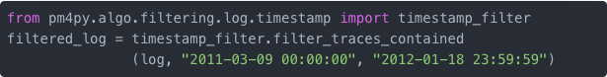

One might be interested in only keeping the traces that are **contained** in a specific interval, e.g. 09 March 2011 and 18 January 2012. The first code snippet works for a log object, the second one for a dataframe object.

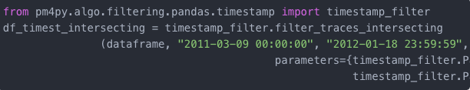

However, it is also possible to keep the traces that are **intersecting** with a time interval. The first example is again for log objects, the second one for dataframe objects.