Assignment-1

Connect and disconnect with login Access

* What happens when you login a non-existent users or username?
  + Provide Screenshot and What you understand, explain in short brief?

Solution

When I tried to login with the non-existent users, I am getting the message as “Sorry, that didn’t work. Please try again”.

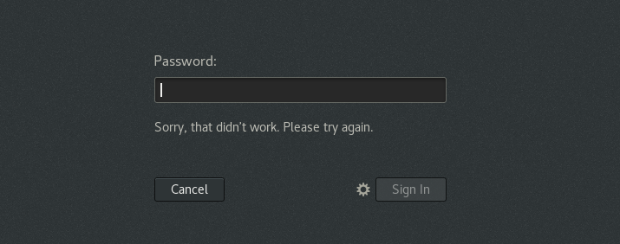

We can login into the system only if we are listed in the system or we are a root user.

On Successful login I am getting the home page as shown below

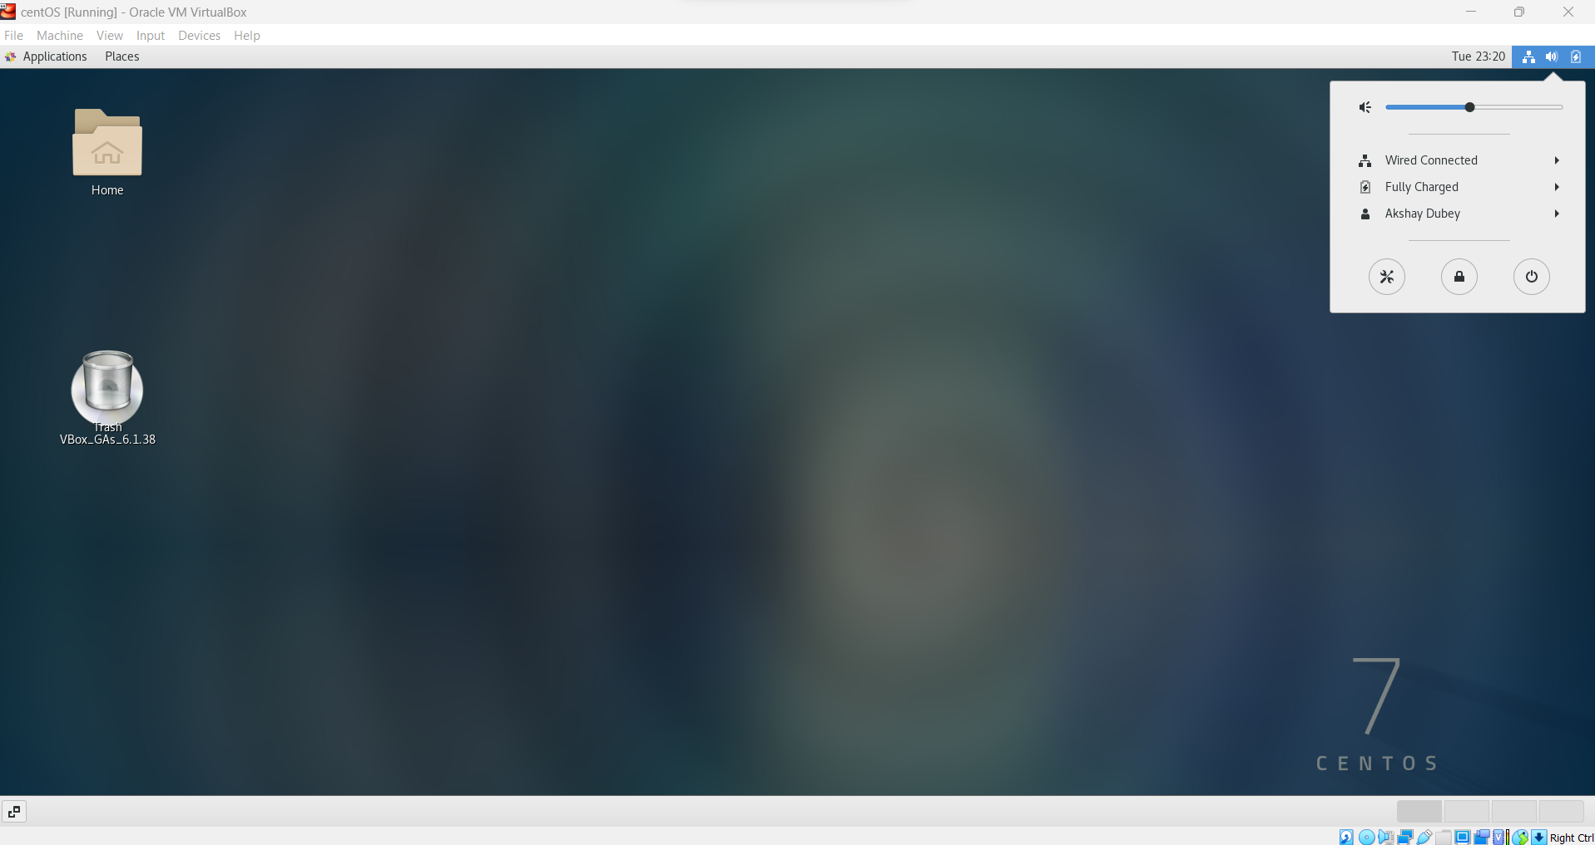

**Assignment-2**

Password changing

* Login into your account and then change password?
  + Change your password into ***IneuR0n#42*** and hit the **Enter** key
    - Explain what happen and give screenshot?

Solution

On changing the password to **IneuROn#42** password changed successfully.

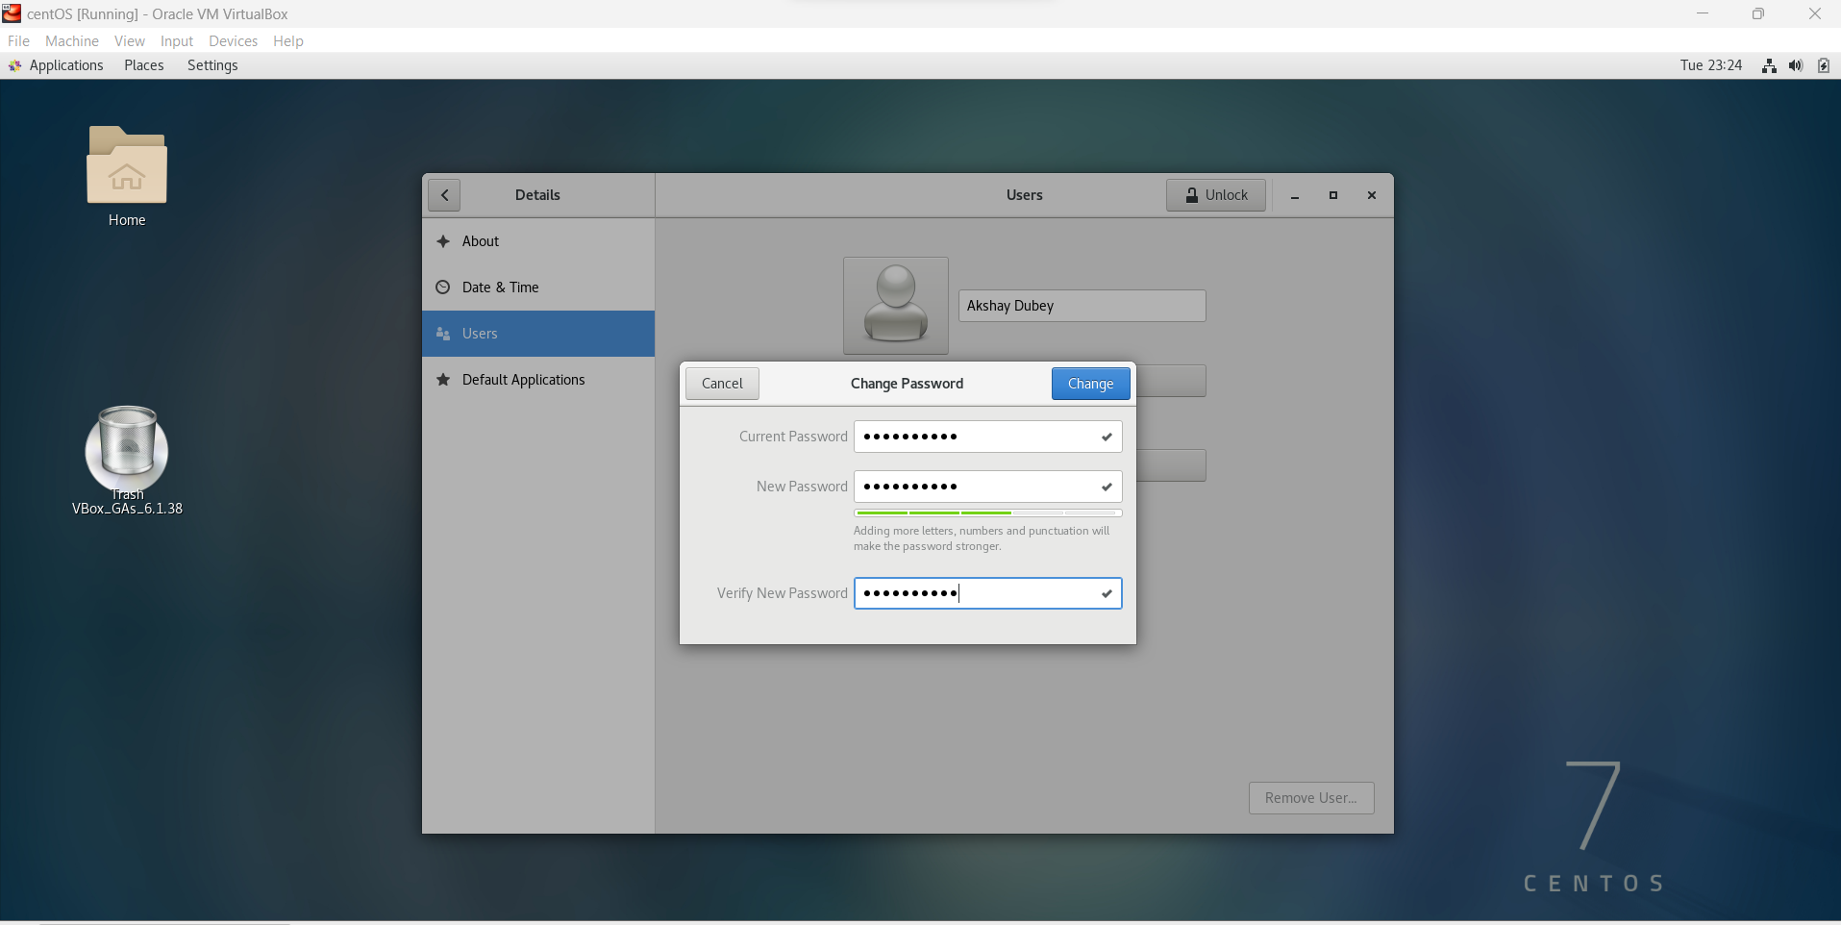

After that when logging into the system it requires new password for authorization and if I am giving the old password then I am getting the output as shown below with message “Sorry, that didn’t work. Please try again”

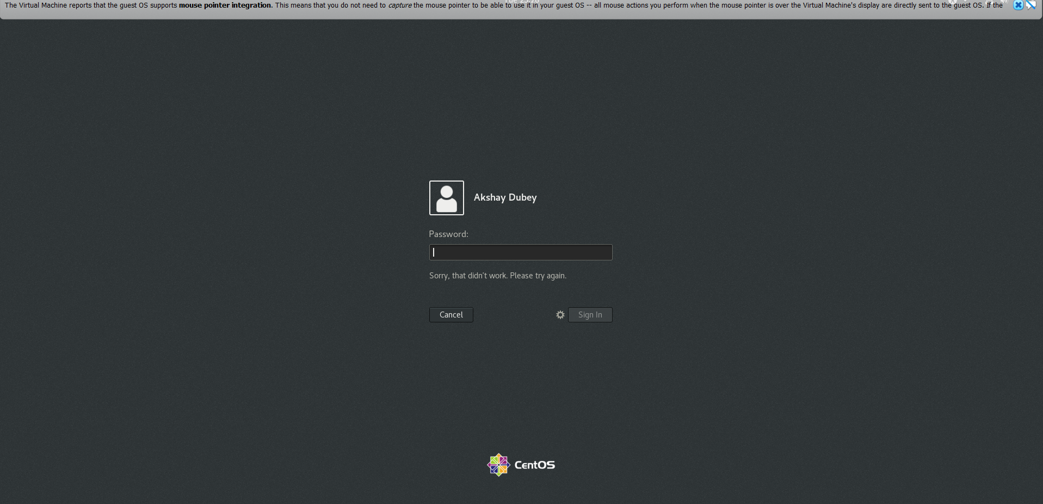

* **Try again to change password but use like password *1234* or *abcd***
  + **Explain what happen and give screenshot?**

Solution:

Password is not filling the required constraints like length, numbers and punctuation. And hence unable to change the password

* **Try again to change password but now don’t use any password just hit Enter key**
  + **Explain what happen and give screenshot?**

Solution

Nothing happens

But If I am clicking the icon, it is creating a default one for me as shown in below image

**Assignment-3**

Working with Directories

* **Enter the command cd / and then ls and then hit Enter key**
  + **Take screenshot and explain what output we got?**

Solution

I am getting the content inside the root directory /. Basically, it is showing all the directories available under the hierarchy of /.

* Enter the command now **cd /home** and then hit **Enter** key
  + Do **ls,** provide screenshot and explain what is **/home** directory used for?

Solution :

The home directory is used as working area for the users present in the system except for root.

* **Enter cd .. and hit Enter key [ *Note: here we have space after cd then use double dot*]**
  + **Check what happen and give screenshot?**

Solution

It is used to go one directory back from present working directory

* **Now enter cd /var/www/html and then type cd and hit Enter key**
  + **Explain what happen and give screenshot?**

**Solution:**

On typing cd /var/www/html – I am getting No such file or directory found but when I do cd and then enter it basically takes me to /home/akshay directory.

* **Now type cd /root and then hit Enter key**
  + **Do ls, check any output we have on screen if yes then take screenshot?**

Solution:

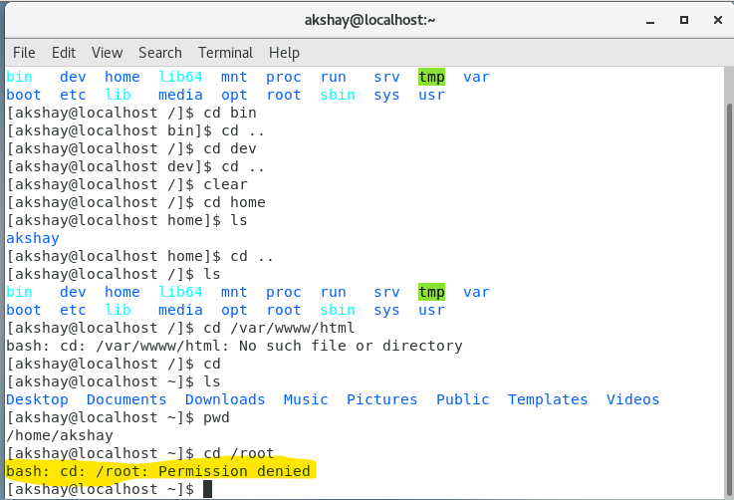

Getting Permission Denied.

**Assignment-4**

Working with File Listing

* **Go to cd /etc and type ls**
  + **Take screenshot and explain what files you have seeing?**
  + **Take screenshot and explain what different output you found compare to previous command you used?**

Solution :

Getting the information related to system configuration.

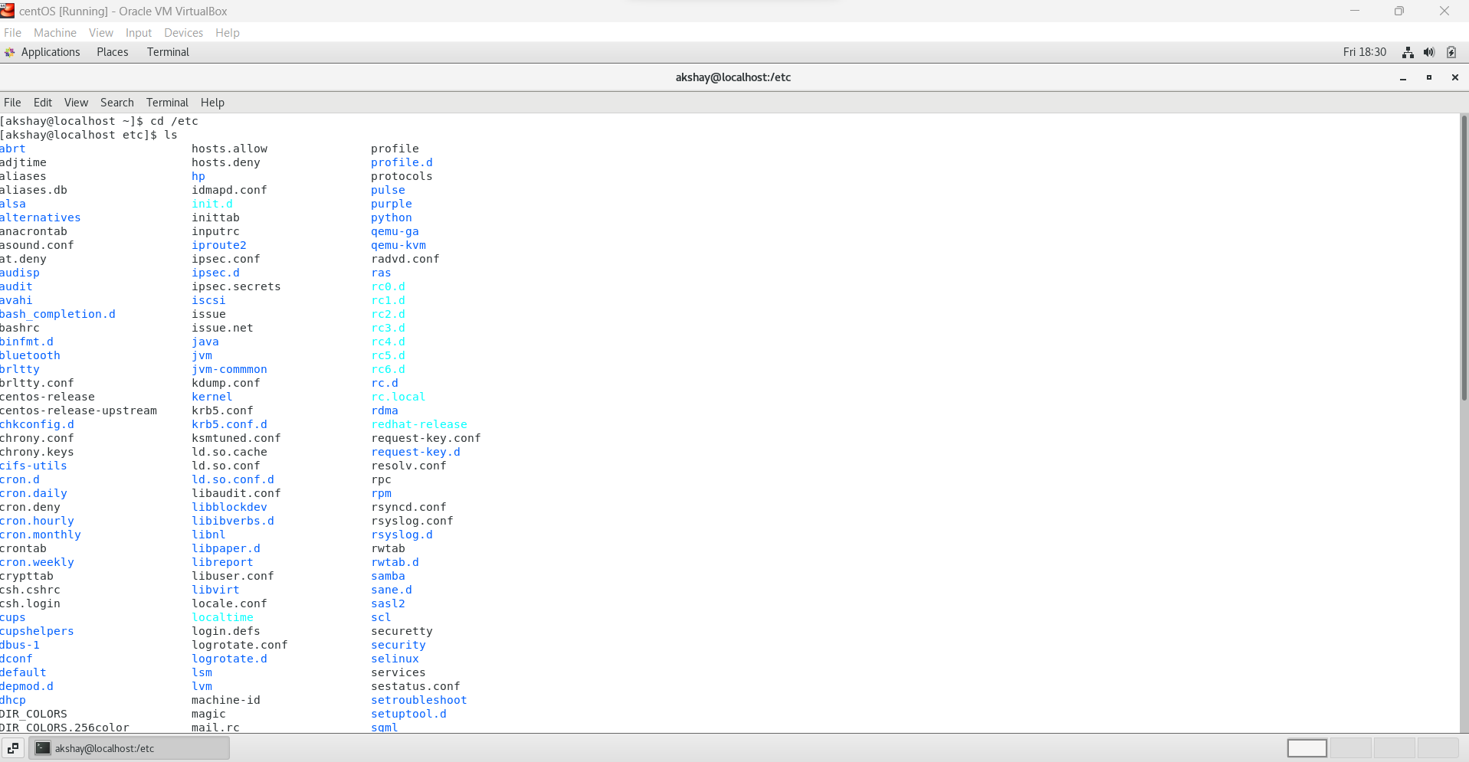

Seeing many lists of files and directories

* **Then type ls -al and hit Enter key**
  + **Take screenshot and explain what new file or directory you found?**

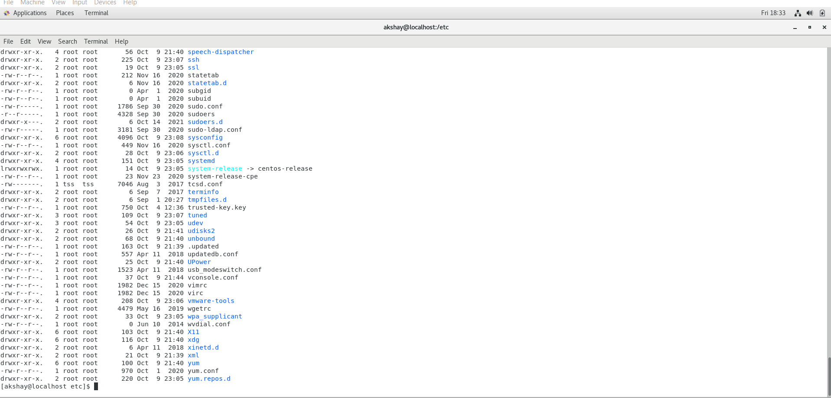

Getting the data back this time with more details like (file permission etc.)

* **Then use ls -i and hit Enter key**
  + **Now see what different output its shows and take screenshot?**

Solution:

* **Then use ls –help and see other options about ls command**

**Explore it and try with other attribute we can use with ls command**

Solution :

**Assignment-5**

Know where you are and where you working

*Here we use* ***pwd, cd and ls*** *as combine task to understand where you working on terminal and how you can switch from one directory to another one.*

* **Open terminal after restart the linux**
  + **Check which location you working, type pwd and take screenshot**

Solution

* Now use **cd /var** and hit **Enter** key
  + Do **ls,** and see what output comes, give screenshot?

Solution

* **Do explore other help options of each command to learn more other things we can do with these commands**

Solution

ls -l // shows the file in long format

ls -a//shows hidden file as well

ls -la // shows files in long format as well as hidden files in the same way

ls -R //lists file Recursively

ls /etc //list the file in specified directory (here in etc directory)