# Logical Volume Manager

### To perform the practical add 2 HDD in VM

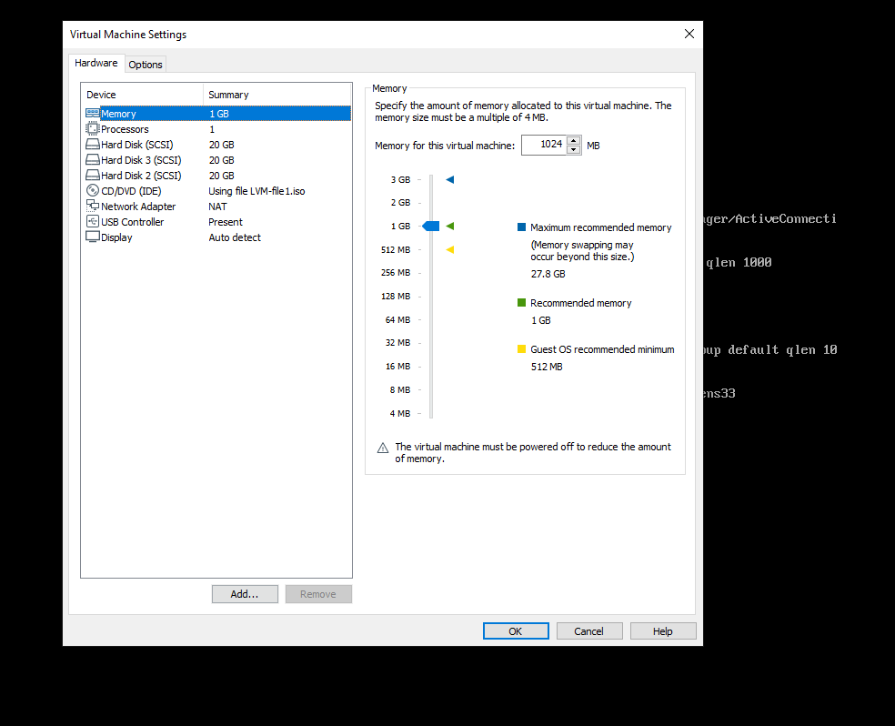

## Step 1:- Identify the new hard disks:

 using the lsblk command. lsblk lists information about all available or the specified block devices. It reads the sysfs filesystem and udev db to gather information.

[root@localhost ~]# lsblk

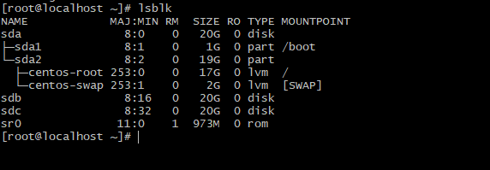

Here, sdb and sdc are the new hard disks that you want to add.

## Step 2:- Create physical volumes:

with pvcreate. This initializes physical volume(s) for later use by the Logical Volume Manager (LVM). Each physical volume can be a disk partition, whole disk, meta-device, or loopback file.

[root@localhost ~]# **pvcreate /dev/sdb /dev/sdc**

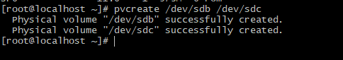

pvdisplay command for view volumes

[root@localhost ~]# **pvdisplay**

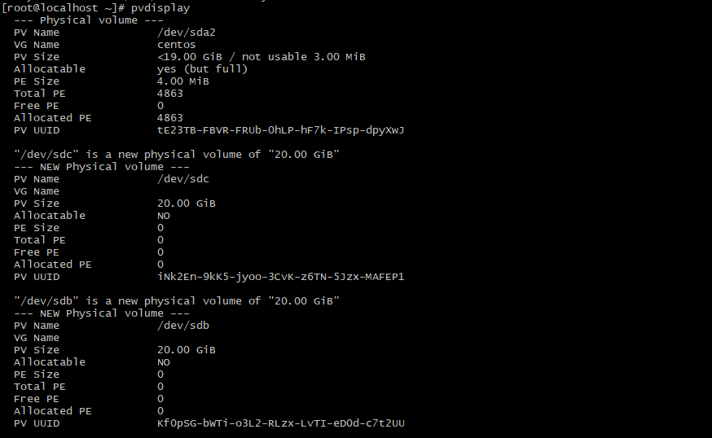

## Step 3:- Create a volume group:

vgcreate creates a new volume group named HPCSA on physical volumes /dev/sdb and /dev/sdc

[root@localhost ~]# **vgcreate HPCSA /dev/sdb /dev/sdc**

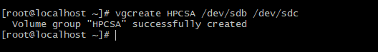

vgdisplay to view

[root@localhost ~]# **vgdisplay**

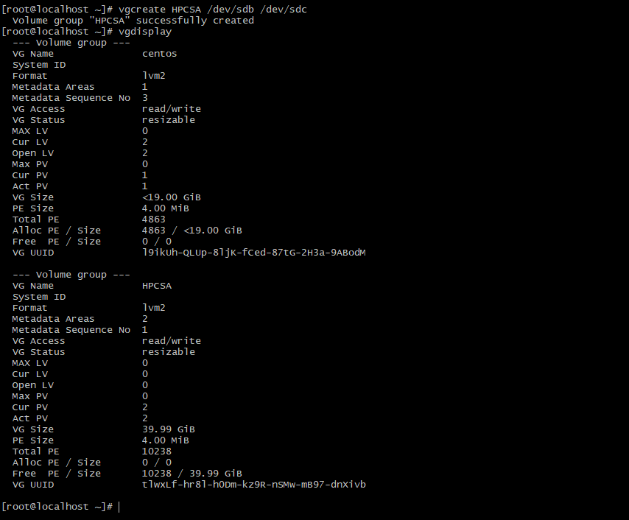

## Step 4:- Create a logical volume:

lvcreate creates a logical volume in a volume group. In this case, it's creating a logical volume named demo_lab with a size of 1G in the volume group HPCSA

[root@localhost ~]# **lvcreate -n demo_lab --size 1G HPCSA**

6.PNG

Step 5:- lvdisplay to view

[root@localhost ~]# lvdisplay

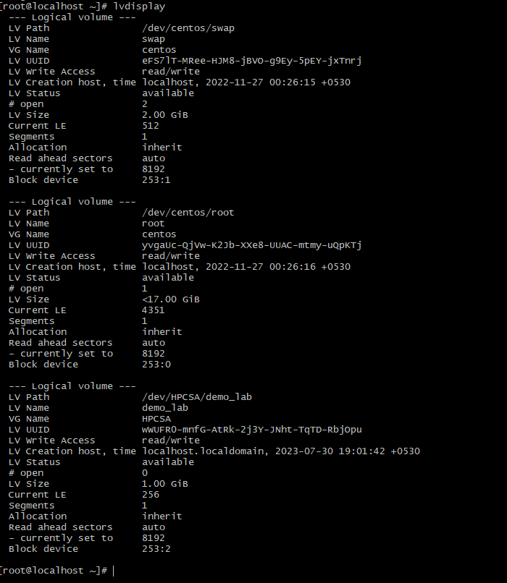

## Step 5. Partition the new logical volume:-

fdisk is a dialogue-driven command-line utility that creates and manipulates partition tables and partitions on a hard disk.

[root@localhost ~]# fdisk /dev/mapper/HPCSA-demo_lab

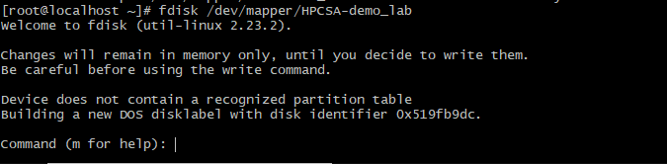

press n to create a new partition. then press p for primary then mention size or press enter , enter then again will ask for option press w to write and exit

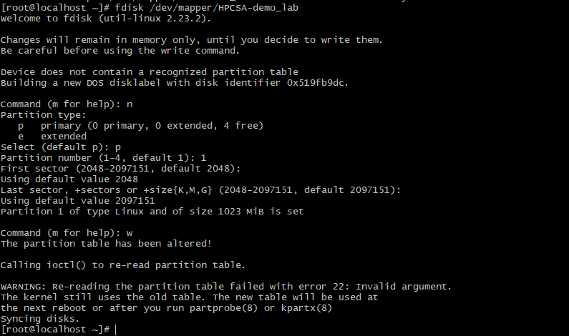

Error:

WARNING: Re-reading the partition table failed with error 22: Invalid argument.

The kernel still uses the old table. The new table will be used at

the next reboot or after you run partprobe(8) or kpartx(8)

Syncing disks.

[root@localhost ~]# partprobe /dev/HPCSA/hpcsa_lab

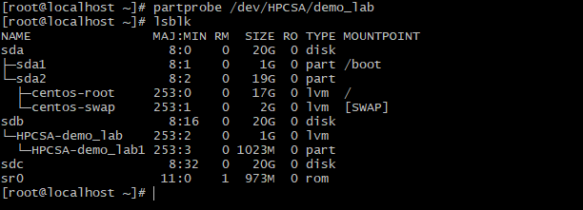Step 6: - Creat e a filesystem: 

12.1.PNG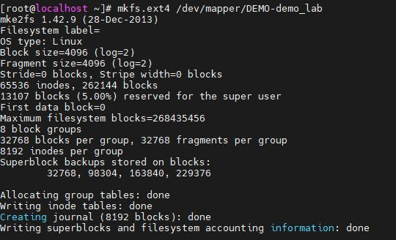

mkfs.ext4 is used to create an ext4 filesystem on the partition.

[root@localhost ~]# mkfs.ext4 /dev/mapper/HPCSA-demo_lab

## Step 7:- Create a mount point and mount the logical volume:

Create a directory that will serve as the mount point, and then use the mount command to mount the logical volume.

[root@localhost ~]# mkdir our-demo

[root@localhost ~]# mount /dev/mapper/HPCSA-demo_lab our-demo

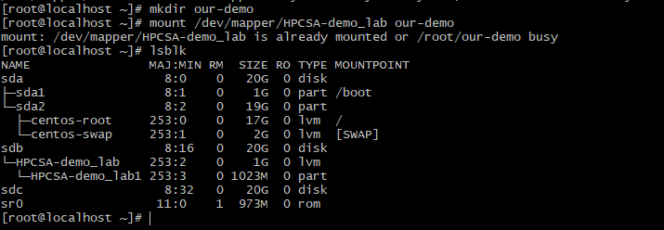

## Step 8:- Extend the logical volume:

lvextend allows you to extend the size of a logical volume. Here, you're extending the logical volume hpcsa_lab by an additional 2G.

[root@localhost ~]# lvextend -L +2G /dev/mapper/HPCSA-demo_lab

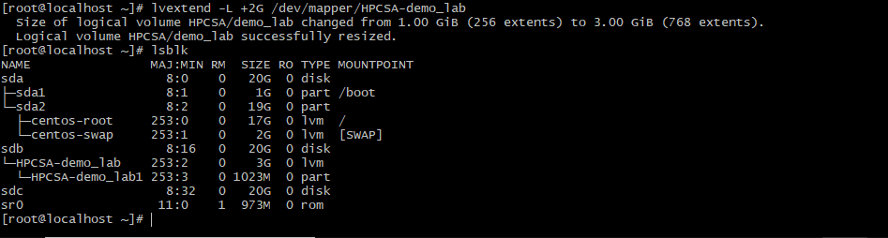

## Step 9:- Resize the filesystem:

resizefs resizes the filesystem on the logical volume to use all of the available space.

[root@localhost ~]# resize2fs /dev/mapper/HPCSA-demo_lab

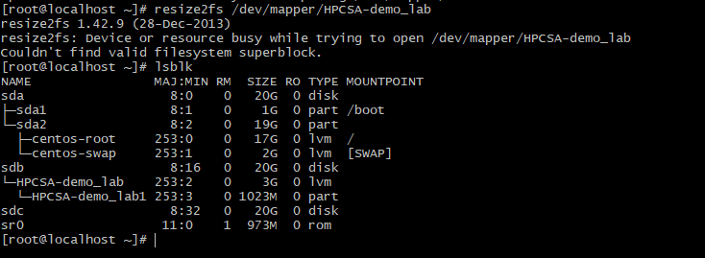

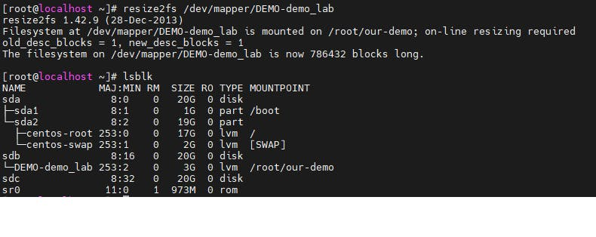

Step 10:- lvcreate with -s creates a snapshot logical volume, which is a read-only copy of another logical volume.

[root@localhost ~]# lvcreate -L 1GB -s -n demo_lab_snap /dev/mapper/HPCSA-demo_lab16.PNG

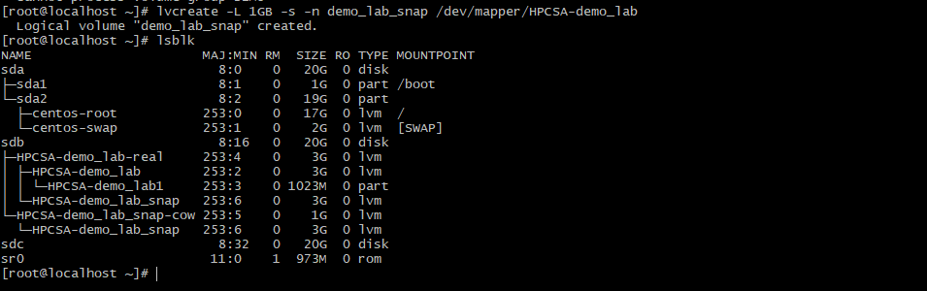

## Step 11:- Merge the snapshot:

lvconvert with --merge will merge the snapshot back into its origin volume. If both origin and snapshot volume are not open the merge will start immediately, otherwise, it will be delayed until the origin volume becomes inactive.

[root@localhost ~]# lvconvert --merge /dev/mapper/HPCSA-demo_lab_snap



Remember to add the disks to /etc/fstab if you want them to be mounted automatically at system startup.

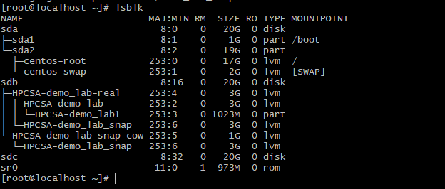

## 12. Mirror

It creates mirror of data in all physical drives

[root@localhost ~]# lvcreate -L 2GB -m1 -n testmirror HPCSA

20.PNG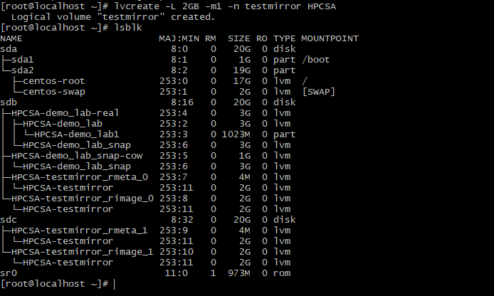

Logical volume "testmirror_lv" created.

## 13. Remove a logical volume

The command lvremove can be used to remove logical volumes. We should make sure a logical volume does not have any valuable data stored on it before we attempt to remove it. Moreover, we should make sure the volume is not mounted.

[root@localhost ~]# lvremove /dev/mapper/HPCSA-demo_lab

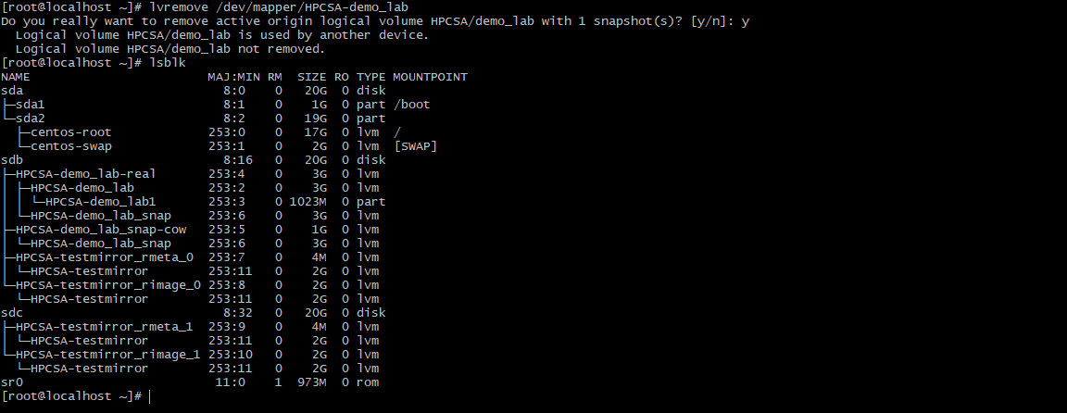

Now to remove the DEMO volume

[root@localhost ~]# lvremove /dev/mapper/HPCSA

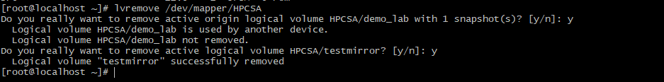

Terminal logs:-

[root@localhost ~]# history

1 lsblk

2 pvcreate /dev/sdb /dev/sdc

3 pvdisplay

4 vgcreate HPCSA /dev/sdb /dev/sdc

5 vgdisplay

6 lvcreate -n demo_lab --size 1G DEMO

7 lvcreate -n demo_lab --size 1G HPCSA

8 lvdisplay

9 fdisk /dev/mapper/DEMO-demo_lab

10 fdisk /dev/mapper/HPCSA-demo_lab

11 partprobe /dev/HPCSA/hpcsa_lab

12 partprobe /dev/HPCSA/demo_lab

13 lsblk

14 mkfs.ext4 /dev/mapper/HPCSA-demo_lab

15 mkdir our-demo

16 mount /dev/mapper/HPCSA-demo_lab our-demo

17 lsblk

18 lvextend -L +2G /dev/mapper/HPCSA-demo_lab

19 lsblk

20 resize2fs /dev/mapper/DEMO-demo_lab

21 resize2fs /dev/mapper/HPCSA-demo_lab

22 lsblk

23 lvcreate -L 1GB -s -n demo_lab_snap /dev/mapper/DEMO-demo_lab

24 lvcreate -L 1GB -s -n demo_lab_snap /dev/mapper/HPCSA-demo_lab

25 lsblk

26 lvconvert --merge /dev/mapper/HPCSA-demo_lab_snap

27 lsblk

28 lvcreate -L 2GB -m1 -n testmirror DEMO

29 lvcreate -L 2GB -m1 -n testmirror HPCSA

31 lvremove /dev/mapper/HPCSA-demo_lab

32 lvremove /dev/mapper/HPCSA

33 lsblk