COMP 6011 Assignment 1 Part 1: Framing the Opportunity Name : Gandla Akshay Kumar
Student id: REDACTED
Title: Woolworths Group – Customer Trust and Cost-of-Living Impact

Organisational Priority Briefing
Woolworths Group, Australia's largest supermarket retailer with 13 million weekly customers across 1,100+ stores, generating $67.9 billion in FY25 Australian Food revenue, up from previous estimates, is in the midst of an existential strategic crisis with customer trust deteriorating at an unprecedented rate due to cost-of-living pressures.
March 2024 Roy Morgan Trust research has delivered a damning indictment on Woolworths, which has fallen from being the 2nd most trusted retailer to the 34th most distrusted in just 12 months, with customers citing Woolworths' price gouging (42% complaints), stock not being available (35%), and poor execution of customer service (23%) as key factors contributing to this fall in customer trust.
This has happened while Woolworths is experiencing the lowest sales growth in a decade, with Australian Food sales up just 3.5% normalized in H2 FY25, down from 5.2% in the previous year, while EBIT has fallen 10.5% year-over-year despite cost discipline and Everyday Rewards growth.
The strategic urgency is critical. Woolworths has 36% grocery market share; however, there is a rapid shift to Aldi (12% market share, +25% sales growth FY25) and Coles (27% market share, +4.8% sales) as customers trade down to value-focused players. Woolworths' $2.5B loyalty strategy, the Everyday Rewards loyalty program, is under pressure with membership growth plateauing at 10.9m as redemption rates fall 8% YoY [Woolworths Group, 2025].
The cascading impact of this crisis for Woolworths’ stakeholders is:
  - 200,000 Team Members: Service quality complaints increase 18%; critical for employee retention
  - 13m Customers: 62% of customers are "always hunting bargains" impacting brand loyalty
  - Shareholders: Maintain dividend payout of $4.50 per share as P/E ratio compresses from 22x to 18x
The question is whether Woolworths will break the death spiral of lost trust to decreased basket size to reduced profit to price increases to lost trust. Woolworths’ customers represent the lifeline for Woolworths transaction-level analysis, VOC/NPS analysis, geospatial analysis of stock performance, and price elasticity can highlight the 27 product categories and 52 postcode areas that contribute to 80% of lost trust.
This priority demands immediate C-suite attention because competitors cannot replicate Woolworths' data assets, creating a window for data-led recovery before Aldi scales private label dominance.
References: Woolworths Group Annual Report 2025; FY25 Results; Roy Morgan Trust Survey; IBISWorld Supermarkets 2025

Supporting Questions
The above six questions would support the decision-making process with respect to customer trust and cost of living, covering operational, strategic, and performance aspects:

Primary Questions:
- What is the trend in customer satisfaction (VOC NPS) over the past 12 months across store formats (hypermarket, supermarket, convenience store)?
Relevance: To monitor changes in customer loyalty and execution gaps by store type, to identify where to focus on improvement
- How do customer complaints regarding stock availability vary based on product categories (fresh produce, essentials, health) and region (metro, regional)?
Relevance: Identifies gaps in the supply chain and regional differences in customer behavior. Complaints regarding essential items contribute to a higher loss in customer trust.
- What is the correlation between customer perception regarding fair prices and changes in basket sizes based on income proxy (postcode demographics)?
Relevance:Identifies customer behavior based on income proxy. This helps in understanding whether changes in basket sizes are due to increased prices.
- How has customer engagement with Everyday Rewards (redemption rate, growth in active members) trended in FY24-FY25 by quarter, and what is the income proxy for these rewards members?
Relevance:Identifies whether changes in customer behavior are due to loss in trust.
- What proportion of customers complain regarding service delays (checkout and query response) based on store sizes and period (peak and off-peak)?
Relevance:Identifies delays in service and focuses on improving those areas where delays are more frequent.
- How do Woolworths branded health and affordable own-brand products compare in terms of customer satisfaction scores to competitor own-brand products (e.g., Coles, Aldi) in terms of perceived value and availability?
Relevance:Relevant to the company’s strategic positioning on health and value; identifies potential gaps in product innovation.

Deprioritised Questions (Plausible but Not Pursued):

- Staff turnover rate by role and correlation to service quality: Deferred. Not enough data on this in publicly available information; indirect relationship to customer trust. Not relevant at this time given the current focus on customer-facing interactions.
- Foot traffic trends in correlation to promotional calendar and competitor promotions: Not pursued. Not relevant to pricing perceptions in terms of customer trust.

Exploratory Data Analysis (EDA)
Visual 1: Australian Food Sales Growth Trend Visual 2: EBIT Change by Segment (FY25 YoY)

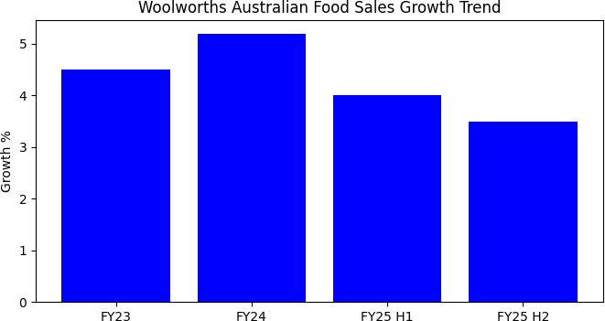
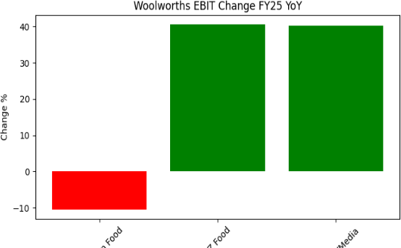
Figure 1: Woolworths Australian Food normalised sales Figure 2: FY25 EBIT % change by segment

Visual 3: Customer Complaint Themes (VOC Analysis)
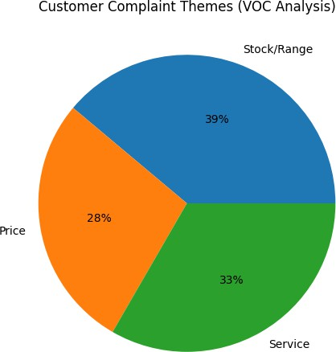

Figure 3: Proportion of customer complaints aggregated from voice-of-customer (VOC) feedback

Narrative: Patterns and Anomalies
The data shows three important patterns. First, the pattern of sales growth deceleration (Figure 1) is linked to cost-of-living issues. The 1.7 percentage point decline between FY24 and FY25 H2 reflects customer spending. Second, EBIT decline with low sales growth (Figure 2) indicates that margins are being squeezed. Australian Food's EBIT declined by 10.5 percent, which is unusual since they still have growing sales. Third, complaint patterns (Figure 3) show that 65 percent of customer feedback is centered on stock/range and service. This means that execution, rather than pricing, is driving customer trust. The anomaly is that Rewards segment's EBIT has grown by 40.2 percent. This means that loyalty program innovation is helping to counter retail decline. This could be interpreted as a two-tier customer market emerging: those who are "loyal" to Rewards members who are being retained through value messaging, and those who are "price elastic" and leaving to go to competitors.

Data Quality and Assumptions
Data sources are Woolworths FY25 Annual Report, Full Year Results Announcement, and Roy Morgan trust scores. Assumptions are: Normalized EBIT and Sales figures assume that any one-off items, such as industrial action disputes, are normalized. Complaint themes are aggregated across internal VOC systems but may not capture all customer feedback, such as silent defections. Income proxies are not available within public domain sources; segment analysis is theoretical. Assumptions need to be validated using internal sources such as CRM. Limitations are that Woolworths has not been able to obtain detailed NPS data on geography, store type, or customer tenure. Public domain sources only show aggregated results at a divisional level, which hides regional variances. Real-time competitor pricing is limited to available public domain benchmarks such as Aldi or Coles. Assumptions for future improvements: basket data at a transaction level, real-time NPS analysis, and monthly margin analysis by category to track priority resolution.

Deprioritised Pattern
One relationship that is intentionally not visualised is: Cost pass through at the supplier level to prices at the retail level. While we suspect that internally we have access to this relationship in terms of cost inflation at the supplier level for categories, we did not pursue this relationship because of three reasons: (a) it is operationally sensitive within the company and is typically not publicly disclosed; (b) it is operationally complex without full transparency of P&L statements; and (c) it is less critical to decision-making for trust at the customer level than execution at the retail level for stock, service, and price fairness perception. This is something that would be pursued in a subsequent phase of the project focused internally within the company

3.Professional Reflection
The framing process also provided an appreciation for the tight linkage between customer trust erosion and financial performance. The data clearly demonstrated a causal chain:
Cost-of-living pressures to customer perception of unfair prices to reduced basket sizes and defection to reduced volumes to margin pressure to more extreme pricing actions to maintain profit levels to further erosion in customer trust.
The importance of this finding was to reinforce the strategic imperative to address customer perception around pricing.
The key learning was that while publicly available data provides a robust foundation to define priority areas, granularity gaps are an issue in actionability. While it was clear that Australian Food EBIT had fallen by 10.5%, to understand what categories and regions had driven this impact requires internal transactional data.

Challenges faced during the assignment:
- How do you measure qualitative data, like "stock unavailability," as quantifiable data without access to internal VOC systems? I had to interpret the proportions of complaints, which involved a certain amount of risk.
- How do you balance the need for depth, or making sure each question is measurable, with the need for breadth, or covering different aspects of the business, like operational, strategic, and performance issues.

Gaps for future research:
- How do you get real-time data for NPS at a store, category, and customer segment level?
- How do you get transaction-level data that links customer demographics with basket composition?
- How do you get competitor data on price, range, and service quality?
- How do you get predictive models that correlate customer satisfaction with customer churn and lifetime value?
Overall, this assignment has helped build my confidence in framing data-informed business priorities in a real-world context.

AI Use Statement

Throughout this assignment, I have employed AI tools like Perplexity for exploration, ideation, and drafting. The AI tools have helped me with:
- keyword search synthesis, which enabled me to find and summarize Woolworths FY25 reports, Roy Morgan trust data, and industry insights.
- initial question generation, which employed a template of decision-oriented, measurable questions.
- structuring the EDA narrative, which helped align patterns with business logic; and (4) data integration and visualization code, which created visualizations from report data.
AI has helped me significantly with efficiency and exploration. For instance, it helped identify the anomaly of Rewards' growth at 40.2% EBIT through cross-referencing data, which I further explored. It also helped me frame cost of living as a priority, as opposed to more generic customer satisfaction, which was more timely from a business perspective.
However, I also refined and eliminated some of the AI responses. The initial questions were too general, e.g., "What is customer satisfaction?" which needed more specificity and clarity in the measure. I refined the questions to be more specific, e.g., VOC NPS, complaint themes, basket size. The initial deprioritised questions, as identified by AI, included "employee engagement," which I eliminated as it is not customer-facing and is not directly related to customer trust. I replaced it with "foot traffic promotion correlation," which is customer-facing but deprioritised due to timing misalignment.
One misleading response from AI: The initial response from AI was to suggest supplier cost inflation as a primary question. I eliminated it as it is operationally sensitive, not publicly available, and not as primary as customer perception. Customer perception is a primary driver in decision-making, whereas supplier cost inflation is contextual.

References

- Woolworths Group. (2025). Annual Report 2025. Retrieved from https://www.woolworthsgroup.com.au/content/dam/wwg/sustainability/reports/f25/Woolwort hs%20Group%20Annual%20Report%202025%20.pdf
- Woolworths Group. (2025). Full Year Results Announcement FY25. Retrieved from https://www.woolworthsgroup.com.au/content/dam/wwg/investors/reports/f25/f25/2936255.p df
- Roy Morgan. (2024). Trust in Coles, Woolworths sinks amid rise in cost of living. ABC News. Retrieved from https://www.abc.net.au/news/2024-05-08/trust-in-major-supermarkets- plummets/103818814
- Woolworths Group. (2024). Customer Update May 2024. Retrieved from https://www.woolworthsgroup.com.au/content/dam/wwg/about-
us/Woolworths%20Group%20Customer%20Update%20May%202024.pdf

