Assignment 1 Part 2
Name: Gandla Akshay Kumar
Id : REDACTED

Summary
The following dashboard prototype illustrates the issue of trust in Woolworths' customers and the cost-of-living dilemma faced by identifying the priority set out in the first part of Assignment 1 (Gandla Kumar 2026). This prototype dashboard is aimed at decision-makers internally such as those working on strategy, customer experience, and operations, requiring a fast overview on issues relating to trust, satisfaction, grievances, and shop performance (COMP 6011 Assignment Guide 2026). This prototype dashboard is exploratory and designed for pattern recognition and analysis purposes (COMP 6011 Assignment Guide 2026).
Questions
1) How has customer trust changed over time?
2) How does satisfaction differ by store format?
3) Which regions and complaint categories show the highest complaint intensity?
4) Where are customer issues geographically concentrated?
5) How does perceived price fairness relate to basket value across income bands?
6) How does service complaint rate differ by store size and period?
These questions were refined from the broader analysis in Part 1 so that they could be translated into a clearer visual narrative (Gandla Kumar 2026).
Dashboard enables decision-making through the inclusion of key performance indicator (KPI) widgets, trend analysis, comparison, and geographical visualization. Through such a platform, one is able to drill down to specific problematic areas, such as low levels of trust, geographical clusters of complaints, and disparities between stores. In such a way, the decision-maker will be able to identify what is going on, instead of being pushed towards a preconceived decision. Such a methodological approach is consistent with the course requirement in that the design should concentrate on “what is going on?” (COMP 6011 Assignment Guide 2026).
The mock or prototyped data is used in some of the fields due to the lack of data regarding customer complaints or satisfaction at the store level since no public data is available. The limitations of this assignment are acceptable based on certain guidelines (COMP 6011 Assignment Guide 2026). In comparison with the first part of Assignment 1, the focus of this design has moved away from the written analysis to the visual presentation of the connection between the level of trust and signals like customer complaints, pricing pressures, and service problems.
Dashboard
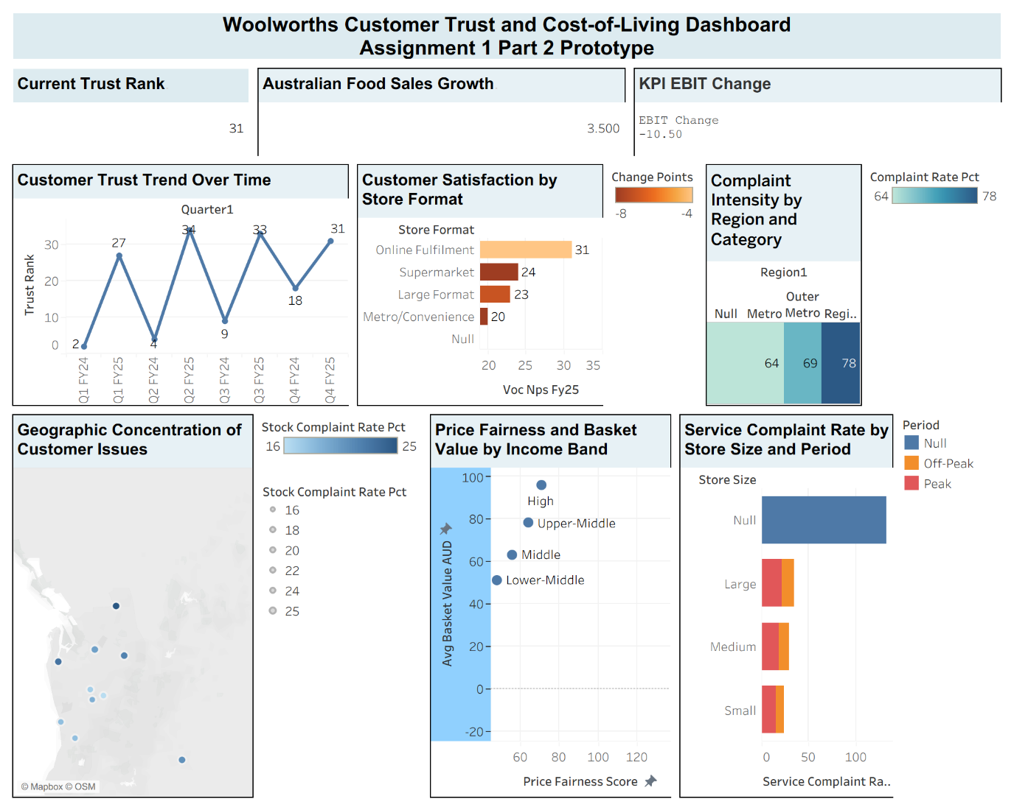

AI Use Statement
The assistance of AI in structuring and shaping the narrative of the dashboard, wording, and suggestions on linking the visual prototype to the assessment requirements proved to be helpful. AI was additionally utilized to organize the information into sections and maintain the word count in the summary section. The application of AI was mostly geared towards improving clarity, conciseness, and distinguishing exploratory visuals of Part 2 from an executive dashboard in Part 3.
The AI-generated suggestions that were altered or discarded in some cases were those that seemed either too generic or too refined for a prototype task. Adjustments were made to ensure that the work complies with the COMP 6011 Assignment Guide of 2026, focusing on experimental and broad approaches, and not presenting a finished executive piece of work. An AI-generated suggestion which was not incorporated involved exaggerating the confidence level of the insight gained. This was considered irrelevant since the dashboard contained prototype data and was supposed to be used for experimentation purposes only.

References and Data Sources
Data Sources
- Woolworths Group FY25 Full Year Results Announcement, for company performance context and retail background.
- Roy Morgan “Woolworths and Coles: From Most Trusted to Most Distrusted,” for trust and distrust context.
- ACCC Supermarkets Inquiry consumer survey release, for evidence that grocery prices are forcing households to change shopping habits.
- Australian grocery/cost-of-living commentary, for broader market context on changing shopping behaviour

References
- ACCC 2024, Higher grocery prices force many consumers to make sacrifices: ACCC hears, Australian Competition and Consumer Commission, viewed 20 April 2026.
- COMP 6011 2026, Assignment 1 Part 2 Visualising the Opportunity, course guide, viewed 20 April 2026.
- Roy Morgan 2025, Woolworths and Coles: From Most Trusted to Most Distrusted, Roy Morgan, viewed 20 April 2026.
- Woolworths Group 2025, Full Year Results Announcement, Woolworths Group, viewed 20 April 2026.

