Investment Prediction

***Wireframe Documentation***

**Wireframe Document: Stock Trend Prediction System**

**1. Landing Page**

* **Header Section:**
  + Logo of the Stock Trend Prediction System.
  + Navigation menu with links to Home, About, Services, Blog, and Contact.
* **Main Content:**
  + Hero section with a brief introduction to the system and a call-to-action button for exploring stock trends.
  + Key features section highlighting historical data analysis, real-time stock prices, and moving averages.
  + Testimonials or client quotes section to build credibility.
  + Footer with contact information, social media links, and privacy policy.

**2. Dashboard Page**

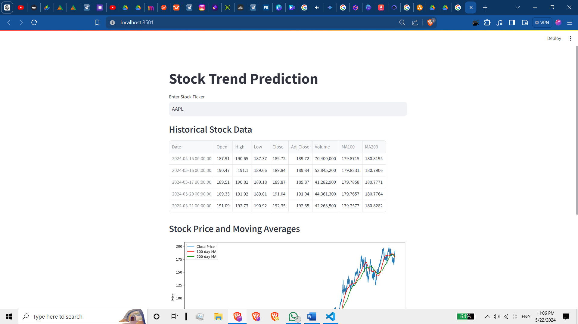

* **Header Section:**
  + Logo and navigation menu for quick access.
  + Dropdown menu to select different stock symbols for analysis.
* **Main Content:**
  + Interactive charts displaying historical stock prices, moving averages (100-day and 200-day), and real-time stock prices.
  + Date range selector to filter data based on a specific time period.
  + Insights section with key observations and trends.
  + Download options for exporting chart data.

**3. Stock Prediction Page**

* **Header Section:**
  + Logo, navigation menu, and stock symbol input field.
  + Date range selector for predicting stock trends.
* **Main Content:**
  + Prediction results displayed in charts showcasing forecasted stock prices.
  + Comparative analysis between predicted and actual stock prices.
  + Insights section highlighting notable trends and predictions.
  + Download options for exporting prediction data.

**4. About Us Page**

* **Header Section:**
  + Logo and navigation menu.
  + Overview of the Stock Trend Prediction System and its purpose.
  + Team members' profiles with photos and roles.
* **Main Content:**
  + Mission and vision statements of the system.
  + History of the system's development and milestones.
  + Testimonials from clients or users.

**5. Contact Page**

* **Header Section:**
  + Logo and navigation menu.
  + Contact form for users to submit inquiries or feedback.
* **Main Content:**
  + Address and contact details of the Stock Trend Prediction System.
  + Contact form with fields for name, email, subject, and message.
  + A screenshot of a computer screen

    Description automatically generatedSubmit button to send inquiries to the system's administrators.

**6. Blog Page**

* **Header Section:**
  + Logo and navigation menu.
  + Blog categories dropdown for filtering articles.
* **Main Content:**
  + List of blog posts with titles, summaries, and publication dates.
  + Read more links to view full blog posts.
  + Search bar for searching blog content by keywords.

**Conclusion**

The wireframes outlined above provide a visual representation of the Stock Trend Prediction System's key pages and functionalities. These wireframes serve as a guide for designing the user interface and user experience of the system, ensuring ease of navigation, accessibility of information, and interactive data visualization for users.