**CW4:** Using json.stringify and ~~WriteFileSync~~ (ReadFileSync), read one of the data files used in the Mongo module and display some of the data on the screen. Comment and explain the code.

**NODE.JS - CODE**

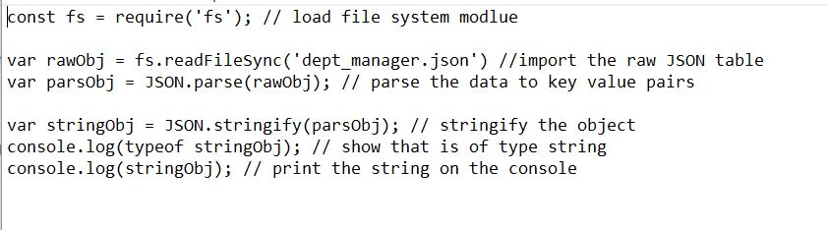

Summary: We loaded the file system module and imported the dept_manager.json file. We then parsed the data and converted it into a string. We outputted the type(string), and the contents of stringObj.

